Indian Institute of Information Technology, Allahabad

Software Engineering

SOFTWARE REQUIREMENT

SPECIFICATION

GUI enabled real-time automatic **door open and close system**

VERSION 1.0

GROUP MEMBERS -

IIT2019215 RAVUTLA RUTHVIK

IIT2019224 SHIVANGI VERMA

IIT2019236 NOONSAVATH SRAVANA SAMYUKTA

BIM2015003 TAUHID ALAM

# **Table of Contents :**

**Table of Contents**

**1. Introduction**

1.1 Purpose

1.2 Document Conventions

1.3 Intended Audience and Reading Suggestions

1.4 Product Scope

1.5 References

**2. Overall Description**

2.1 Product Perspective

2.2 Product Functions

2.3 User Classes and Characteristics

2.4 Operating Environment

2.5 Design and Implementation Constraints

2.6 User Documentation

2.7 Assumptions and Dependencies

**3. Specific Requirements**

3.1 User Interfaces

3.2 Hardware Interfaces

3.3 Software Interfaces

3.4 Communications Interfaces

**4. Other Non-functional Requirements**

4.1 Non functional Requirements

4.2 Safety and Security Attributes

4.3 Performance Requirements

1. INTRODUCTION:

1.1 Purpose:

1. The purpose of this document is to provide a view of requirements and specifications of the project that we are required to develop i.e. GUI enabled real-time automatic **door open and close system** for CC3 building.
2. Goal of this project is to display the transition from each state based on the input value of the person being approaching, crossing, or leaving.
3. This document discusses the whole system from backend to user interactions.

1.2 Document Conventions:

1. All important terms or main features are in bold .
2. TBD means “To be Decided”, there are some components that are not yet decided.

1.3 Intended Audience and Reading Suggestions

1. Anyone with basic knowledge of programming and UML/GUI can understand this document. The document is intended for Developers, Software architects, Testers, Project managers and Documentation Writers
2. It’s divided into 4 sections .Section 3&4 gives technical insights of our projects and is meant for developers.

1.4 Product Scope

We are required to develop GUI enabled real-time automatic **door open and close system** for CC3 building.

The doors can be in the following states: closed, currently opening, currently closing and open. The change of state, each time the controller button is pressed is given below:

doors closed - doors currently opening,

doors currently opening - doors currently closing,

doors current closing - door currently opening

and door open - doors currently closing.

1. The system will display the transition from each state based on the input value of the person being approaching, crossing, or leaving.
2. Name of the Project is “Automatic **door open and close system**” or ADOC, and it is App based.

1.5 References

* IEEE (IEEE Std 830-1998 IEEE Recommended Practice for Software Requirements Specifications. IEEE Computer Society, 1998.)

2. Overall Description

2.1 Product Perspective

2.2 Product Functions

2.3 User Classes and Characteristics

1. The user should be familiar with the operations of computer softwares and analysis.

USE CASE DIAGRAM

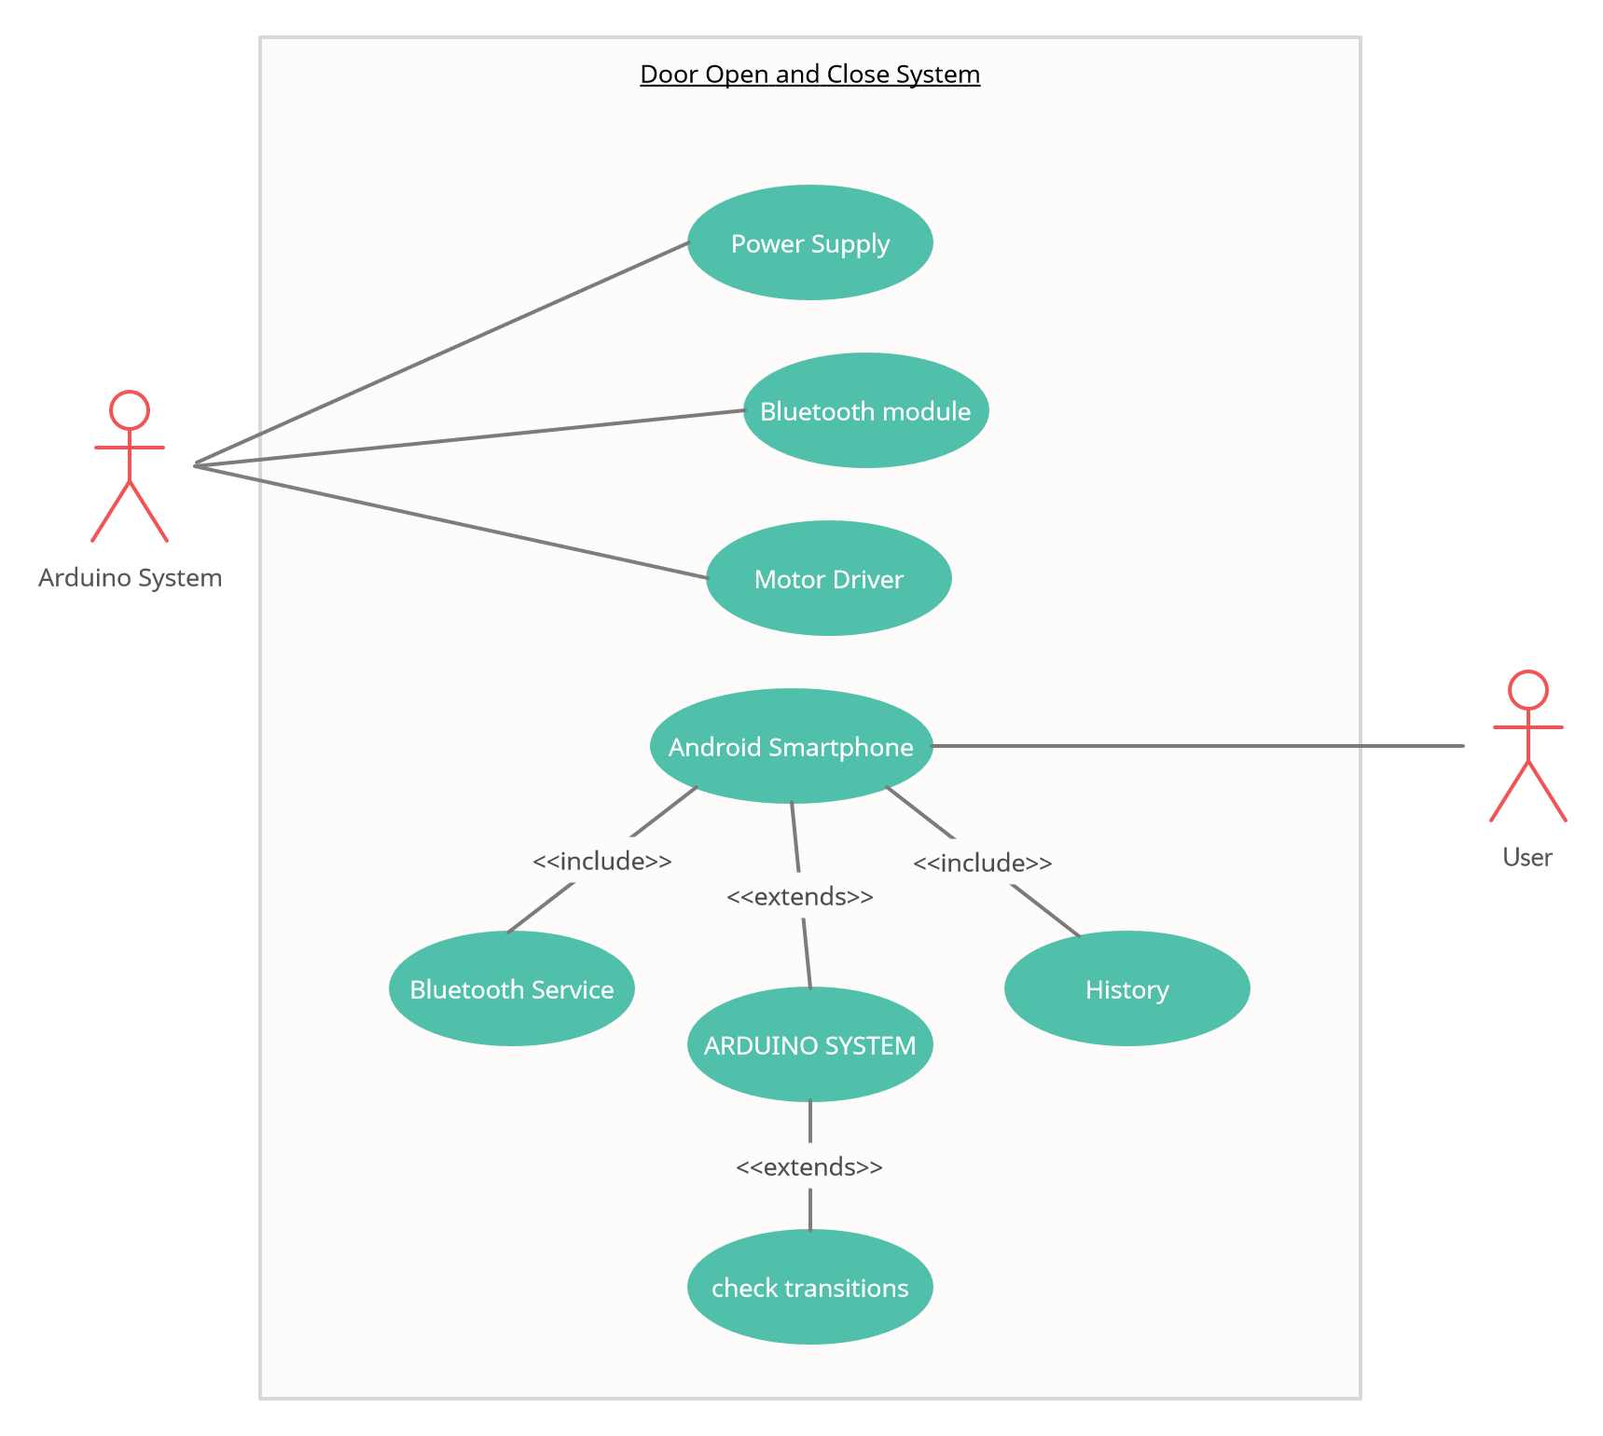

2.4 Operating Environment

2.5 Design and Implementation Constraints

Our main software implementation includes android application development. Android app development and coding we would be doing in Android Studio IDE available on Internet free for developers. In the project we have created 7 activities, namely MainActivity which would be displaying animation of 3 dots as loading flash screen and then would initiate second activity. Connect in this activity a button which on click would ask for Bluetooth turn on permission and would enable bluetooth. BlueList in this activity a textarea which would be displaying 20 to “Select HC – 05” and would display list view with available paired Bluetooth device. GetStatus in this activity a button would be displayed to fetch the data from Lock System whether the system is locked or unlocked.

2.6 User Documentation

2.7 Assumptions and Dependencies

1. Working of "ADOS" is dependent on the availability of Internet connection.
2. User must be active to insert all the required information on the app.

3. Specific Requirements

3.1 User Interfaces

3.2 Hardware Interfaces

* Device:
  + Mobile phone, or Desktop to run application
* Processor:
  + Minimum 1 GHz;
  + Recommended 2GHz or more
* Ethernet connection (LAN) OR a wireless adapter (Wi-Fi)
* Hard Drive:
  + Minimum 32 GB;
  + Recommended 64 GB or more
* Memory (RAM):
  + Minimum 1 GB;
  + Recommended 4 GB or above

3.3 Software Interfaces

* Operating System:
  + Android, or Mac
* Application:
  + Web browser to access application;
  + Recommended Chrome, Safari, or Brave.

3.4 Communications Interfaces

The communication between the different parts of the system is important, since they depend on each other. However, in what way the communication is achieved is not important for the system and is therefore handled by the underlying operating systems for web application. But, any transaction on the web deals with the following protocols.

* TCP/IP
* HTTP

4. Other Non-functional Requirements

4.1 Non Functional Requirements

* The system should alert the users for errors consistent with appropriate error handling.
* Minimum recovery time in case of any system failure with different alternative paths for essential activities.
* Backup of the overall system should be maintained to ensure safety

4.2 Safety and Security Attributes

Fault Tolerance:

* + It should not become corrupted in case of system crash or power failure.

4.3 Performance Requirements

* Since the system is web based, a stable internet connection is required at all times for any activity to be performed successfully.
* The User Interface is made really simple and efficient.