# Data Sources:

This project's data source has been collected through a survey of graduate students attending the Robert H. Smith School of Business. Each subject was asked to share their own playlist of songs from Spotify. The information about each song including the genre, artist, awards, and recording company has been added using an internet search.

# References:

1. Spotify Database Management System by kggurram on GitHub. (Link - https://github.com/kggurram/spotify-dbms)

# How to test the project:

## Step 1:

In Microsoft SQL, use the following command to get access to the tables in the database:-

USE BUDT703_Project_0506_08

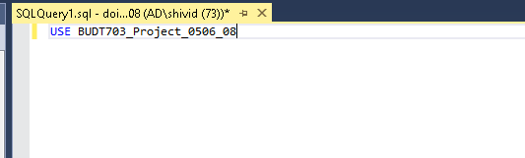

## Step 2:

To test out the first business question, “What are the top 5 most popular songs list?”, use the following code snippet:

SELECT TOP 5 s.sngName AS 'Song', s.sngPlayCount AS 'Times Played'

FROM [Spotify.Song] s

ORDER BY s.sngPlayCount DESC

The output of this code should be:

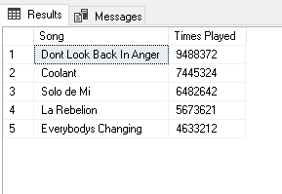

The output in Tableau:-

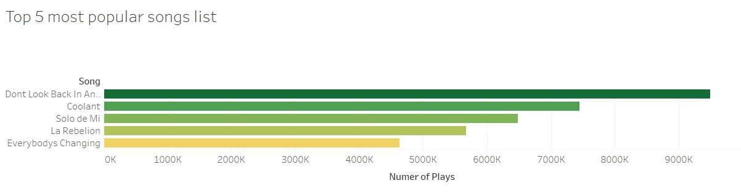

## Step 3:

To test out the second business question, “Which artist has the most likes in each genre?”, use the following code snippet:

SELECT t2.artName, t2.sngLike,t2.gnrName

FROM ( SELECT Row_Number() OVER ( PARTITION BY t1.gnrName ORDER BY

t1.sngLike DESC ) AS row_number, *

FROM (SELECT a.artName, s.sngLike, g.gnrName

FROM [Spotify.Artist] a, [Spotify.Release] r, [Spotify.Song] s,

[Spotify.Classify] c,[Spotify.Genre] g

WHERE a.artId = r.artId AND r.sngId = s.sngId AND s.sngId =

c.sngId AND c.gnrId = g.gnrId)t1) t2

WHERE t2.row_number = 1

The output of this code should be:

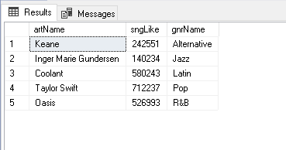

The output in Tableau:-

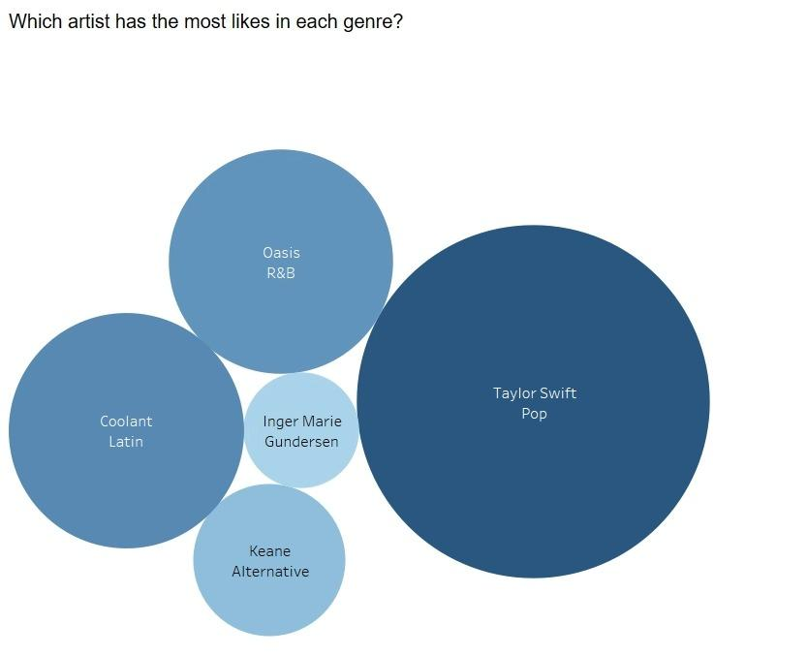

## Step 4:

To test out the third business question, “How many songs are in each genre category?”, use the following code snippet:

**How many song in each genre category?**

SELECT g.gnrName AS 'Genre Name',COUNT(s.sngId) AS 'Number of songs'

FROM [Spotify.Classify] c,[Spotify.Song] s,[Spotify.Genre] g

WHERE g.gnrId = c.gnrId AND s.sngId = c.sngId

GROUP BY g.gnrName

ORDER BY COUNT(s.sngId) DESC

The output of this code should be:

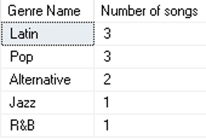

The output in Tableau:-

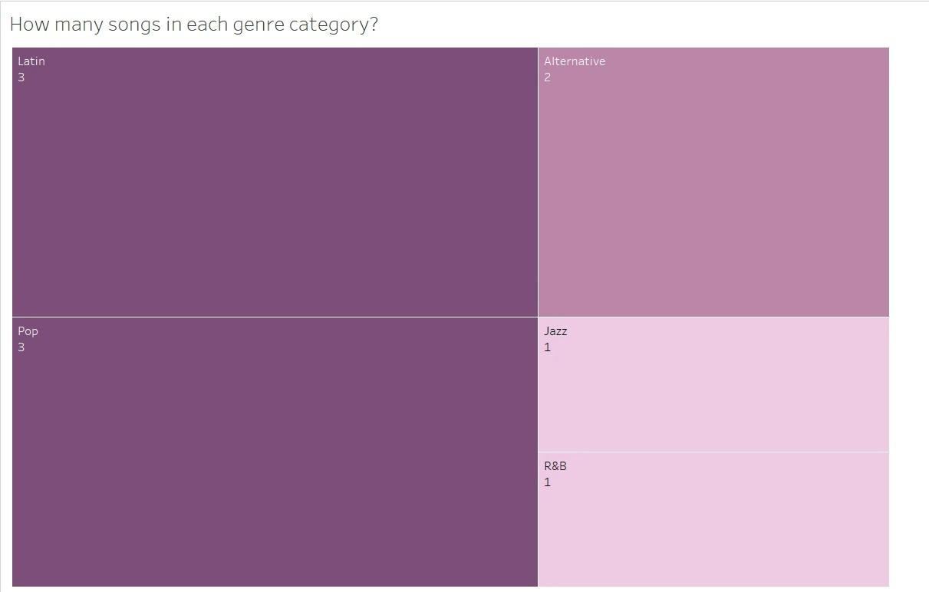

## Step 5:

To test out the fourth business question, “What are the total likes for each artist?” use the following code snippet:

SELECT a.artName AS 'Artist Name',SUM(s.sngLike) AS 'Number of total likes'

FROM [Spotify.Artist] a, [Spotify.Release] r,[Spotify.Song] s

WHERE a.artId = r.artId AND r.sngId = s.sngId

GROUP BY a.artName

ORDER BY SUM(s.sngLike) DESC

The output of this code should be:

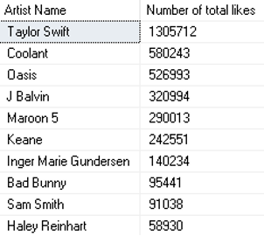

The output in Tableau:-

