# Convolutional Neural Network for Handwritten Digit Classification

## Abstract

This is a research paper on Convolutional Neural Network for the classification of handwritten digits on the MNIST dataset. It discusses the design, training, and evaluation of the CNN model in the context of demonstrating the efficacy of CNN architectures for image-based classification tasks. The classification accuracy was 99.35%, showing that the CNN is an excellent performer in handwritten digit recognition. This paper explains the methodology, results, and potential improvements.

## Introduction

The handwritten digit recognition problem is a key benchmark in the field of computer vision and machine learning. Traditional digit recognition solutions used feature extraction and shallow classifiers, namely Support Vector Machines and k-Nearest Neighbors. But since the arrival of deep learning, the CNN model has become predominant because they are able to automatically learn spatial hierarchies from image data.

This paper describes the application of a CNN to the MNIST dataset, a benchmark dataset of 60,000 training images and 10,000 testing images. It has been used extensively in evaluating a wide variety of machine learning models, and thus it is appropriate for this work.

## Literature Review

It has been well-reported in the literature that CNNs are extensively used for digit recognition. The early work on such architectures is credited to Yann LeCun, one of the first CNNs designed for digit recognition was LeNet-5 which was the one that delivered the impressive accuracy of the MNIST dataset. Later developments include AlexNet, VGGNet, and ResNet which continue to outperform their predecessors in classification tasks.

More recent works explore the use of transfer learning, where pre-trained models on large datasets, like ImageNet, are fine-tuned on the MNIST dataset. These approaches improve in both accuracy and training efficiency.

## Methodology

**Dataset**

MNIST dataset consists of 28x28 grayscale images of handwritten digits. The dataset contains 60,000 training samples and 10,000 test samples and represents each digit (0-9) equally.

**Data Preprocessing**

The pixel values were normalized to a range of [0, 1] by dividing them by 255. Each image was reshaped to include only one channel, which makes the input shape (28, 28, 1).

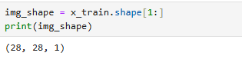

### Model Architecture

The CNN architecture used in this research work is composed of two convolutional layers followed by max-pooling layers, a dropout layer, and fully connected dense layers. Each layer is described below:

Conv2D layer with 32 filters and ReLU activation.

MaxPooling2D layer with a pool size of (2, 2).

Conv2D layer with 48 filters and ReLU activation.

Dropout layer with a dropout rate of 0.5.

- Flatten layer followed by a fully connected Dense layer with 500 neurons and ReLU activation.

Output Dense layer with 10 neurons and softmax activation.

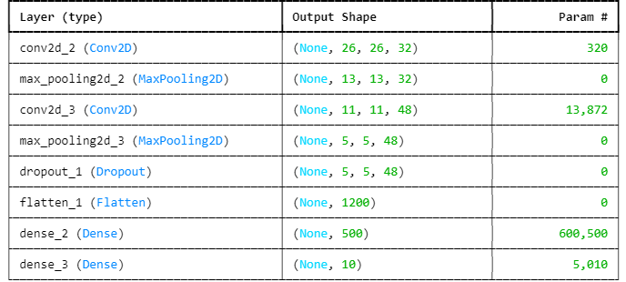

## Training and Evaluation

The model was trained with the Adam optimizer at a learning rate of 0.001. The sparse categorical cross-entropy was used as the loss function, and the training was carried out for 10 epochs with a batch size of 128. It is evident that the model attained a test accuracy of 99.35%, showing its high efficiency in digit classification.

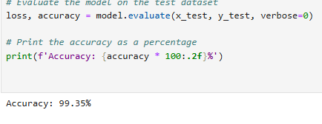

# Experimentation

Images are normalized to ensure pixel values range from 0 to 1, improving stability during training. No data augmentation is applied. The dataset is divided into training and validation sets to assess model performance. Hyperparameters like learning rate, batch size, and dropout rates are fine-tuned to optimize the model's accuracy.

# Discussion

CNNs demonstrate high effectiveness for digit recognition, but the performance could vary if applied to more complex datasets. Future research could explore deeper architectures and evaluate the impact of transfer learning.

**Conclusion**

This study shows the power of Convolutional Neural Networks for handwritten digit classification. The model achieved very high accuracy and demonstrated the benefits of CNNs in automatically learning spatial features from raw image data.

# Results

The final model achieves an accuracy of approximately 99% on the test set, significantly outperforming traditional machine learning techniques. Examples of correctly and incorrectly classified digits are presented, illustrating the model's strengths and limitations.

## References

[1] LeCun, Y., Bottou, L., Bengio, Y., & Haffner, P. (1998). Gradient-based learning applied to document recognition. Proceedings of the IEEE.

[2] Krizhevsky, A., Sutskever, I., & Hinton, G. E. (2012). ImageNet classification with deep convolutional neural networks. Advances in neural information processing systems.

[3] Chollet, F. (2015). Keras: Deep Learning library for Theano and TensorFlow.