Product Design
Team | 18  Saurabh Agrahari  Anshu Singh Rajpoot  Shivin Yadav  Adarsh Sanjeev

Design Model

Home | Class state  Class behavior(method)  - login()  - register()
Login | Class state  - Enter number : integer  - Password : password  Class behavior(method)  - login()  - forgotPassword()
Register | Class state  - Name : String  - Email id : String  - Password : password  - Confirm Password : password  - Phone number : integer  Class behavior(method)  - Register()
Forgot | Class state  - Phone number : integer  Class behavior(method)  - forgotPassword()
Invite | Class state  - Phone number : integer  Class behavior(method)  - addFriend()
Packages | Class state  - Coupon number : String  Class behavior(method)  - Discount()
Wallet | Class state  Class behavior(method)  - OnCreate()  - updateWallet()
Payment | Class state  Class behavior(method)  - RechargeRequest()
.

Class Diagram

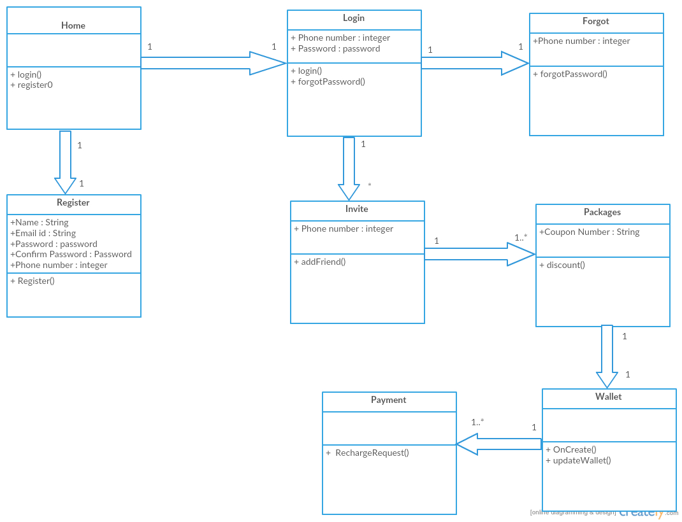

Sequence Diagram(s)

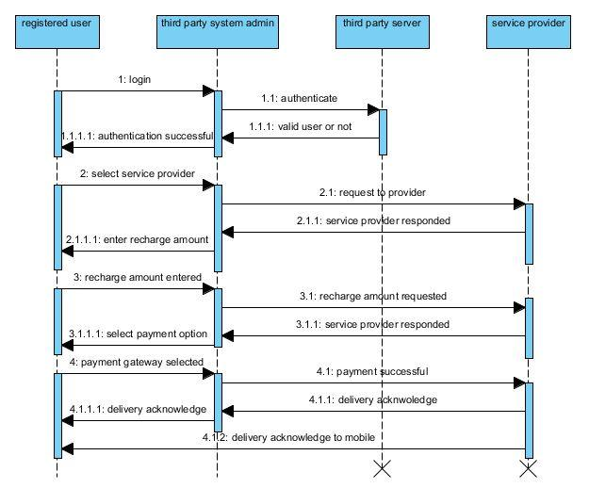

Design Rationale

The application requires a system of user authentication and online payment ability. Hence different classes have been used to implement Login, Register and Forgot Password features. Similarily, classes have also been used to add the ability to make get packages, make payments, and access the wallet.

