
Submitted to
School of Computer Science and Engineering
IILM University, Greater Noida, U.P.

In partial fulfilment of the requirement of degree of
BTech CSE


BY
Roll no.- 25scs1003003649
Name of the student: SHIVI PANCHAL
Batch: 2025-29

INTERNSHIP REPORT
In partial fulfilment of the requirement of degree of Btech CSE

Table of Contents

Candidates Declaration…………………………………………………………………….2
Acknowledgement…………………………………………………………………………3
Internship Completion Certificate…………………………………………………………5
- Project Description…………………………………………………………………….6
  - Introduction……………………………………………………………………………6
  - Organizational Profile…………………………………………………………………6
  - Problem Statement…………………………………………………………………….6
  - Project Objectives……………………………………………………………………..6
  - Scope of the Project……………………………………………………………………7
  - Technologies and tools used…………………………………………………………...7
1.7System architecture……………………………………………………………………….. 7
1.8 Methodology ………………………………………………………………………….8
1.9 Expected Outcomes……………………………………………………………………… 8
- Bibliography/References ………………………………………………………………9

CANDIDATE’S DECLARATION

I, Shivi Panchal do hereby declare that the internship report titled “Topic” has been completed by me to fulfil the requirement for the award of the degree of Bachelor of Technology in CSE. All the references have been quoted and I have not taken as such any material from any other source. I affirm to you that this report is my own and has not been submitted to any other institute for any degree/diploma requirement and further I shall be solely responsible for any kind of copyright violation in this regard.

Signature
Student Name______
Roll No.______

ACKNOWLEDGEMENT
I want to sincerely thank COMM4 Telecom Pvt. Ltd. for hosting my internship in July 2026. Working with the Network Operations team completely changed how I understand enterprise and telecom networks.
- The Mentorship: My mentor guided me through complex Cisco concepts with incredible patience, especially when I needed extra help understanding subnetting.
- The Team: Everyone on the team welcomed me into their daily discussions and answered my questions without ever making me feel like a burden.
- The University: I am also grateful to my department at IILM University for making this internship part of our curriculum, which pushed me to see how classroom theories work in the real world.

Signature
Student Name______
Roll No.. ______

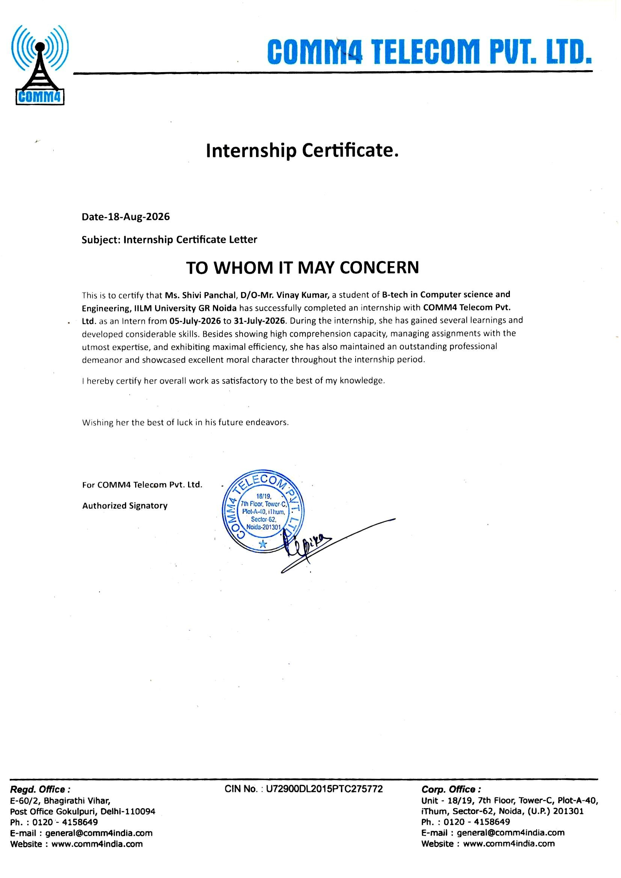
Internship Completion Certificate
- Project Description

  - Introduction
Around week 3, once we were mostly done with Cisco and had started GSM, my mentor brought up that the team always struggles a bit when a new intern joins because there's no proper document, it's just old slides, some notes from way back, and stuff explained on the spot whenever someone asks. He asked me to try putting something together for the next interns before I left. That ended up being my "project," if you can call it that. Wasn't anything big, but it was actually useful, and writing it down made me understand the stuff better than just sitting in the sessions did.

1.2 Organizational profile
As covered in Section 1, COMM4 Telecom Pvt. Ltd. works on the infrastructure and networking side of telecom services, with its corporate office in Sector-62, Noida. This project was carried out specifically within the Network Operations team, the same team I was placed with for the internship, under the guidance of my mentor there.

  - Problem Statement
The team's onboarding material for new interns and junior trainees was scattered — a mix of old slide decks, whiteboard photos, and informal explanations passed down verbally. There wasn't a single, simplified document that walked a newcomer through both the enterprise networking basics (routing, switching, IP addressing) and how those concepts connect to GSM/telecom architecture, which is the specific overlap COMM4's work sits in. New interns were effectively relearning things the slow way each time.

  - Project Objectives
- Consolidate core Cisco networking concepts (routing vs. switching, IP addressing, subnetting basics) into a single, simplified reference
- Document GSM network architecture (BTS, BSC, MSC) in a way that connects back to the enterprise networking concepts already covered
- Keep the language accessible enough for someone with little to no networking background to follow without needing a mentor present
- Produce something the team could actually reuse for future interns, rather than a one-off assignment
  - Scope of the Project
The project was limited to conceptual documentation — it did not involve configuring live devices, writing router/switch configurations, or covering advanced topics like routing protocols, VLANs, or newer mobile network standards (4G/5G core architecture). It was scoped specifically as an internal onboarding resource for COMM4's Network Operations team, not a production or client-facing deliverable.

Technologies and Tools used

- MS Word — for compiling and formatting the final reference document
- MS Excel — for organizing notes and tracking topics covered vs. pending
- Existing internal training slides and whiteboard notes — as source material
- Basic diagramming (hand-drawn/whiteboard references translated into simple digital notes) to illustrate network layers and GSM call flow

System architecture

LAYER | COMPONENT | FUNCTION
Enterprise Network | Router | Directs traffic between different networks; handles IP-level routing
Enterprise Network | Switch | Connects devices within the same local network; operates at the data-link layer
Enterprise Network | IP Addressing/ Subnetting | Organizes and segments devices into logical, manageable groups
Telecom (GSM) | BTS (Base Transceiver Station) | Handles the radio link between a mobile handset and the network
Telecom (GSM) | MSC (Mobile Switching Centre) | Routes calls and connects the mobile network to other networks

  - Methodology

Reviewed existing internal training slides and notes used by the Network Operation team.

Attended structured learning sessions and took detailed notes on Cisco and GSM concepts as they were covered

Cross-checked understanding with my mentor after each session to catch gaps or misunderstandings early

Drafted the reference document section by section, starting with networking basics and building up to GSM architecture

Shared the draft with my mentor for review and corrected inaccuracies or unclear explanations based on feedback

Finalized the document and handed it over at the end of the internship.

Expected Outcomes

Main thing is the team has something to hand future interns instead of starting over each time. For me personally, I understood the material a lot better after writing it out than I did just sitting through the sessions — you notice the parts you're actually fuzzy on once you try explaining them.

- Bibliography/ References
- Cisco Systems, Inc. Cisco Networking Academy — Introduction to Networks. Available at: https://www.netacad.com
- Cisco Systems, Inc. Cisco IOS Command Reference. Available at: https://www.cisco.com/c/en/us/support/ios-nx-os-software
- Odom, W. CCNA 200-301 Official Cert Guide, Volume 1. Cisco Press.
- Forouzan, B. A. Data Communications and Networking. McGraw-Hill Education.
- Mishra, A. R. Fundamentals of Cellular Network Planning and Optimization: 2G/2.5G/3G... Evolution to 4G. Wiley.
- GSMA. An Introduction to GSM Architecture. Available at: https://www.gsma.com
- Rappaport, T. S. Wireless Communications: Principles and Practice. Prentice Hall.
- COMM4 Telecom Pvt. Ltd. — Internal training material and reference slides used by the Network Operations team (used with permission for internal learning purposes during the internship).
- Tutorialspoint. GSM Architecture Tutorial. Available at: https://www.tutorialspoint.com/gsm/gsm_architecture.htm

