-3rd OUTPUT

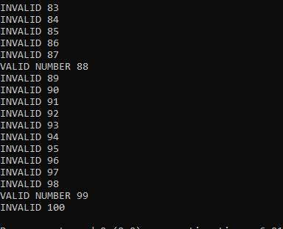

WE COMPARED EVERY DIGIT WITH THE NUMBER TO CHECK ITS DIVISIBILITY.

AND SHOWING THE NUMBERS AS VALID AND INVALID NUMBERS.

TIME COMPLEXITY IS O(n)