

External Penetration Testing Report
prepared for
  - Pinnacle
October 29, 2026

CONFIDENTIALITY STATEMENT
This document and the information contained in this document are “Confidential.” It may not be duplicated, published, or disclosed without Cyderes written permission. For purposes of this engagement, any technical or business information of a third person furnished or disclosed by one party to the other shall be deemed “Confidential Information” of the disclosing party unless otherwise specifically indicated in writing to the contrary.
Copyright © 2025. Cyderes. All rights reserved.
180 Duncan Mill Road, 7th Floor
Toronto, Ontario, Canada, M3B 1Z6
(416) 639-2193

13333 Holmes Road
Kansas City, Missouri 64146
(855) 404-8324
connect@cyderes.com

Table of Contents
Executive Summary 4
Goals 4
Scope 4
Conclusion 4
Recommendations 5
Findings Summary 9
External Network 9
Attack Narrative 11
External Penetration Testing 11
Reconnaissance 11
TCP Port Scanning 11
UDP Port Scanning 13
Service Enumeration and Exploitation 15
FTP 15
SSH 15
Telnet 18
SNMP 20
NFS 20
VNC 21
Oracle 21
R-Services (RSH/Rexec) 22
MongoDB 23
PostgreSQL 24
Redis 25
IMAP 27
JetDirect 28
RTSP 28
Memcached 29
SMB 31
DNS 34
NTP 36
ICMP Timestamp 36
TLS/SSL 38
Automated Vulnerability Identification & Attack Surface Mapping 45
Nessus 45
Nikto 45
BurpSuite 46
Nuclei 47
SHCHECK 47
Web Application Enumeration and Exploitation 48
HTTPX 48
EyeWitness 49
Dirsearch 50
IIS Default Page Enabled 51
Web Server HTTP Header Internal IP Disclosure 52
HTTP Host Header Attacks 52
Outdated Software Components in Use 53
Stack Traces in Error Messages 54
Web Server Password Auto-Completion 54
Cisco SSL VPN Login Page 55
Exploitation Attempts 55
PHP to Web Shell (PHP2Shell) 55
Node.js to Web Shell (Node2Shell) 56
Key Vulnerabilities 58
External Network 58
Appendix 111
Vulnerability Severity Key 111
Methodology 112
Missing Security Headers by IP 144
SSL Vulnerable Cipher Suites Supported 145
TLS Version 1.1 Deprecated Protocol 148
TLS Version 1.0 Protocol Detection 148
ICMP Timestamp Request Remote Date Disclosure 149
Web Server HTTP Header Internal IP Disclosure 150
External Scope 118

Executive Summary
From 10/01/26 to 11/14/26, Cyderes conducted External Penetration Testing for Pinnacle (Pinnacle). The objective was to identify and exploit vulnerabilities across the organization’s attack surface. This report summarizes the findings, outlines the methods used, and provides actionable recommendations to support remediation and strengthen Pinnacle’s security posture.

Goals
The goal of this assessment was to determine whether an external attacker could achieve initial access using techniques that bypass existing controls and, if access was achieved, whether it enabled a meaningful attack path resulting in material risk. If no viable attack path exists, that outcome is explicitly documented.

Scope
- Refer Appendix: External Scope

Conclusion
During this external infrastructure assessment, Cyderes identified one medium-severity and several low-severity security findings within Pinnacle’s externally accessible environment, including legacy SSL/TLS protocol and weak cipher support (SSLv2/SSLv3, TLS 1.0/1.1, SWEET32, RC4 and POODLE), expired and self-signed certificates, weak SSH algorithms and password authentication, HTTP Host header handling, internal IP address and stack trace disclosure, default IIS pages, outdated client-side components, and missing HTTP security headers. Cyderes tested common remote services, including FTP, Telnet, SNMP, NFS, VNC, Oracle, R-Services, MongoDB, PostgreSQL, Redis, Memcached, SMB, DNS and NTP, as well as the Cisco SSL VPN login page and PHP and Node.js web shell exposure, and no vulnerabilities were identified that would allow unauthorized access, privilege escalation, or direct compromise of the environment. No viable attack path was identified. However, the observed weaknesses may facilitate reconnaissance, information disclosure, service enumeration, or traffic interception and decryption by an attacker positioned on the network. Remediation of these findings is recommended to reduce the external attack surface, limit unnecessary information exposure, and further strengthen the overall security posture of Pinnacle’s internet-facing systems.
This assessment for Pinnacle identified 22 finding(s) across the tested environment, including issues related to External Network. The breakdown includes 1 Medium, 21 Low severity finding(s). These findings reflect the security posture observed during the engagement and highlight areas where enhancements can be made to improve overall resilience.
Cyderes recommends that Pinnacle address the Recommendations listed below and remediate vulnerabilities covered in the Key Vulnerabilities section of this report, in order of severity. Additionally, Cyderes recommends Pinnacle engage in continual testing to confirm remediations and strengthen security posture proactively.

Recommendations
The following are strategic recommendations for mitigating the attack methods used throughout the assessment and cyberattacks in general:
- Use TLS 1.2 (with approved cipher suites) or higher instead. [Medium]
- Applications should validate the Host header and all supported host-related headers against an explicit allowlist of trusted hostnames. Reverse proxies and load balancers should remove or overwrite client-supplied forwarding headers before forwarding requests to backend applications. Applications should use a trusted, server-side canonical hostname when generating password-reset links, redirects, absolute URLs, and other security-sensitive content instead of relying on client-controlled headers. [Low]
- Windows: A self-signed certificate is an identity certificate that is signed by the same entity whose identity it certifies. The X.509 certificate chain for this service is not signed by a recognized certificate authority. In public key infrastructure (PKI) arrangements, a digital signature from a certificate authority (CA) attests that a particular public key certificate is valid. Each CA has one or more root keys, and the certificates associated with those public keys are "trust anchors" that use a special type of self-signed certificates. Linux: If the remote host is a public host in production, this nullifies the use of SSL as anyone could establish a man-in-the-middle attack against the remote host. [Low]
- Reconfigure the affected application if possible to avoid use of medium strength ciphers. [Low]
- Disable SSH password authentication and enable key-based authentication instead. Implement account lockout or rate-limiting mechanisms to mitigate brute-force attacks. Restrict SSH access using firewall rules or allow access only from trusted IP addresses. [Low]
- Regularly monitor and audit all SSL/TLS certificates to identify those nearing expiration and ensure timely renewal. Immediately replace any expired certificates to maintain secure, trusted, and uninterrupted communications. [Low]
- Add the attribute 'autocomplete=off' to these fields to prevent browsers from caching credentials. [Low]
- Windows: The remote service supports the use of medium strength SSL ciphers such as: DES, 3DES etc. Any encryption suite that uses key lengths at least 64 bits and less than 112 bits, or else that uses the 3DES encryption suite is regarded as a medium strength cipher suite. Linux: The DES and Triple DES ciphers, as used in the TLS, SSH, and IPSec protocols and other protocols and products, have a birthday bound of approximately four billion blocks, which makes it easier for remote attackers to obtain cleartext data via a birthday attack against a long-duration encrypted session, as demonstrated by an HTTPS session using Triple DES in CBC mode, aka a "Sweet32" attack. [Low]
- Enable support for TLS 1.2 and/or 1.3, and disable support for TLS 1.1. [Low]
- Windows: The remote servers supports SSLv3/TLS 1.0 with at least one CBC cipher suite, indicating that these servers were vulnerable. It also appears that TLS 1.1 and TLS 1.2 is supported on servers. However, the Fallback SCSV mechanism was not supported which allowed connections to be "rolled back" to SSLv3. Linux: The remote host is affected by a man-in-the-middle (MitM) information disclosure vulnerability known as POODLE. The vulnerability is due to the TLS server not verifying block cipher padding when using a cipher suite that employs a block cipher such as AES and DES. The lack of padding checking can allow encrypted TLS traffic to be decrypted. This vulnerability could allow for the decryption of HTTPS traffic by an unauthorized third party. A MiTM (Man-in-the-Middle) attacker can decrypt a selected byte of a ciphertext in as few as 256 tries if they are able to force a victim application to repeatedly send the same data over newly created SSL 3.0 /TLS 1.0 connections. [Low]
- Implement the security-related HTTP headers to improve the overall security posture of the application. [Low]
- Enable support for TLS 1.2 and 1.3, and disable support for TLS 1.0. [Low]
- Firewall Filtering: Block inbound ICMP Type 13 (Timestamp Request) and outbound Type 14 (Timestamp Reply) at the network perimeter. Host-Level Configuration: Configure the operating system firewall to drop these specific ICMP packets. Disable ICMP Timestamp Responses: Modify OS kernel parameters to ignore timestamp requests. [Low]
- Windows: The remote SSH server is configured to allow weak encryption algorithms such as arcfour and 3des. With reference to RFC4251 ciphers which includes 3DES, ARCFOUR, twofish, serpent, and blowfish have certain security flaws associated with them. Linux: The "arcfour128" and "arcfour256" algorithm is the same algorithm i.e. the RC4 cipher using a 128-bit key and 256-bit key respectively. Arcfour (and RC4) has problems with weak keys, and should not be used anymore. RFC 4253 also advises against using Arcfour due to an issue with weak keys. [Low]
- Windows: It was observed that the SSH on the host is configured to allow either MD5 or 96-bit MAC algorithms which is considered a weak algorithm. Linux: Remote SSH host is configured with a default list of ssh MAC algorithms including MD5 and SHA1. These algorithms are no longer considered to be secure for message authentication codes. [Low]
- Windows: Custom error messages, that are displayed through error handling done by the programmer, must not contain details from framework exception objects. Error messages inside exception objects often contains sensitive information such as stack traces, internal path disclosure, etc. Linux: The sensitive information could be displayed in the error messages which in turn can aid the attacker in other type of attacks such as directory traversal, buffer overflow, etc. which can adversely affect the confidentiality and integrity of the application. [Low]
- Windows: SSH when using a block cipher algorithm in Cipher Block Chaining (CBC) mode, makes it easier for remote attackers to recover certain plaintext data from an arbitrary block of ciphertext in an SSH session via unknown vectors. Linux: A remote user with control of the network between the client and the server can inject connection errors and monitor the SSH error handling response to recover up to 32 bits of plain text from an SSH-protected connection. The attack process will terminate the SSH connection.*Note: - CBC mode connections are affected. - CTR mode connections are not affected. [Low]
- Windows: The remote host supports the use of RC4 cipher suites. The RC4 cipher is flawed in its generation of a pseudo-random stream of bytes so that a wide variety of small biases are introduced into the stream, decreasing its randomness. If plaintext is repeatedly encrypted (e.g., HTTP cookies), and an attacker is able to obtain many (i.e., tens of millions) ciphertexts, the attacker may be able to derive the plaintext. Linux: Remote attackers may be able to conduct plaintext recovery attacks against the initial bytes of a stream by sniffing network traffic. The weak RC4 cipher has following vulnerabilities: 1. The RC4 algorithm, as used in the TLS protocol and SSL protocol, has many single-byte biases, which makes it easier for remote attackers to conduct plaintext recovery attacks via statistical analysis of cipher text in a large number of sessions that use the same plaintext (CVE-2013-2566). 2. The RC4 algorithm, as used in the TLS protocol and SSL protocol, does not properly combine state data with key data during the initialization phase, which makes it easier for remote attackers to conduct plaintext recovery attacks against the initial bytes of a stream by sniffing network traffic that occasionally relies on keys affected by the Invariance Weakness, and then using a brute force approach involving LSB values, aka the "Bar Mitzvah" issue (CVE-2015-2808) [Low]
- Windows: The remote host allows SSL/TLS connections with one or more Diffie-Hellman moduli less than or equal to 1024 bits. Through cryptanalysis, a third party may be able to find the shared secret in a short amount of time (depending on modulus size and attacker resources).Linux: Logjam is a security vulnerability against a Diffie-Hellman key exchange ranging from 512-bit (US export-grade) to 1024-bit keys. [Low]
- It is recommended to upgrade outdated software components to the latest vendor-supported versions that contain applicable security fixes. It is also recommended to maintain an inventory of software dependencies and regularly assess these components for known vulnerabilities. Security updates should be prioritized based on the severity and exploitability of the associated vulnerabilities. [Low]
- Windows: It was observed that the version of Microsoft IIS on the remote host can be retrieved from the respective IIS default page. Linux: Default pages of the server should be removed or should be configured such that the information about the system is not disclosed as well as the services running on the server should not be allowed in public visibility. Using this information the attacker can craft an attack to sabotage the website as well as the services running on it. It also ensures that sensitive Information is not leaked through these pages. [Low]
- Mask the IP address information from the HTTP headers. Apply configuration suggested by vendor. [Low]

Findings Summary

External Network
ID# | Title | Severity
EXT-001 | SSL Version 2 and 3 Protocol Detection | Medium
EXT-002 | HTTP Host Header Attacks | Low
EXT-003 | SSL Self-Signed Certificate | Low
EXT-004 | SSL Medium Strength Cipher Suites Supported (SWEET32) | Low
EXT-005 | SSH Authentication Method | Low
EXT-006 | SSL Certificate Expiry | Low
EXT-007 | Web Server Allows Password Auto-Completion | Low
EXT-008 | SSL Vulnerable Cipher Suites Supported | Low
EXT-009 | TLS Version 1.1 Deprecated Protocol | Low
EXT-010 | SSL Vulnerable to Padding Oracle Attack | Low
EXT-011 | Missing Security-Related Headers | Low
EXT-012 | TLS Version 1.0 Protocol Detection | Low
EXT-013 | ICMP Timestamp Request Remote Date Disclosure | Low
EXT-014 | SSH Weak Algorithms Supported | Low
EXT-015 | SSH Weak MAC Algorithms Enabled | Low
EXT-016 | Stack traces in error messages | Low
EXT-017 | SSH Server CBC Mode Ciphers Enabled | Low
EXT-018 | SSL RC4 Cipher Suites Supported (Bar Mitzvah) | Low
EXT-019 | SSL Certificate Chain Contains Weak Diffie-Hellman key | Low
EXT-020 | Outdated Software Components in Use | Low
EXT-021 | IIS Default Page Enabled | Low
EXT-022 | Web Server HTTP Header Internal IP Disclosure | Low

A vulnerability severity key is located in the Appendix of this report.

Attack Narrative
The attack narrative is a chronological breakdown of events that occurred during the penetration test. This includes low-level technical information regarding how each attack was carried out. This format affords Pinnacle a view into the attacker's mindset and provides insight into how a real-world adversary may have executed a cyberattack against the organization. Steps to mitigate each discovered vulnerability are provided in the Key Vulnerabilities section of this report.

External Penetration Testing

Reconnaissance
Reconnaissance consists of techniques involving actively or passively gathering information that can support targeting. Such information may include details of the victim organization, infrastructure, or staff/personnel. This information can be leveraged by the adversary to aid in other phases of the adversary lifecycle, such as using gathered information to plan and execute Initial Access, to scope and prioritize post-compromise objectives, or to drive and lead further reconnaissance efforts.

TCP Port Scanning
Cyderes utilized the Nmap network discovery tool to perform comprehensive port scanning and service enumeration across all identified IP addresses within Pinnacle's external network perimeter. The scan was configured to identify open ports, running services, and underlying operating systems to establish an accurate attack surface inventory. The majority of identified hosts reported scanned ports as filtered, indicating that access to these services is restricted by firewalls, access control lists, or other network security controls, limiting further enumeration of those hosts.
Refer Appendix: TCP Open Ports
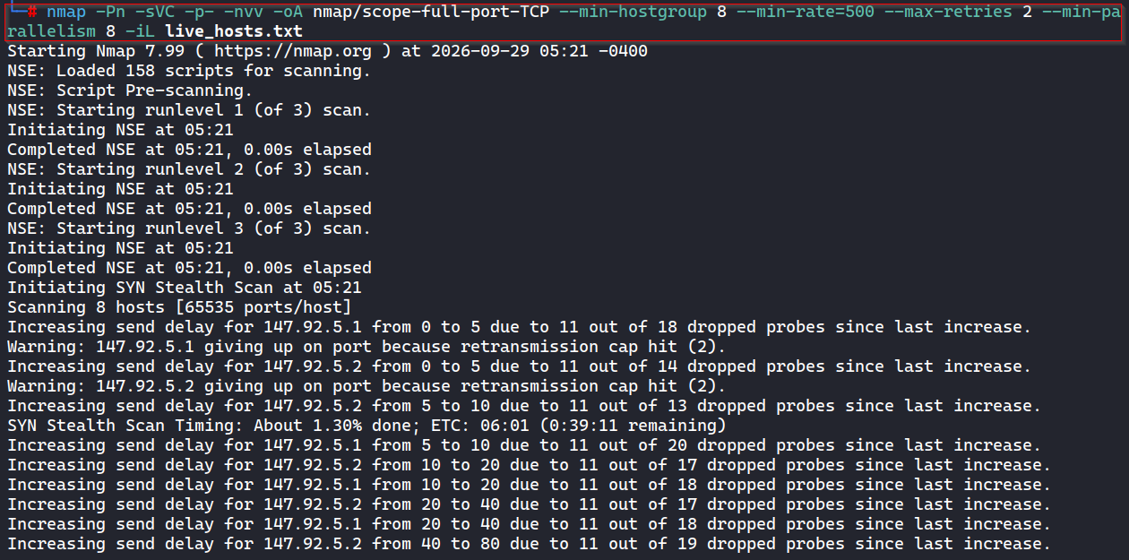
Figure 1 : Nmap Open Port Scan

Cyderes reviewed the Nmap network discovery results and observed that most identified hosts reported all scanned ports as filtered, indicating that access to these services was restricted by firewalls, access control lists, or other network security controls. As a result, further service enumeration and verification could not be performed on those hosts.
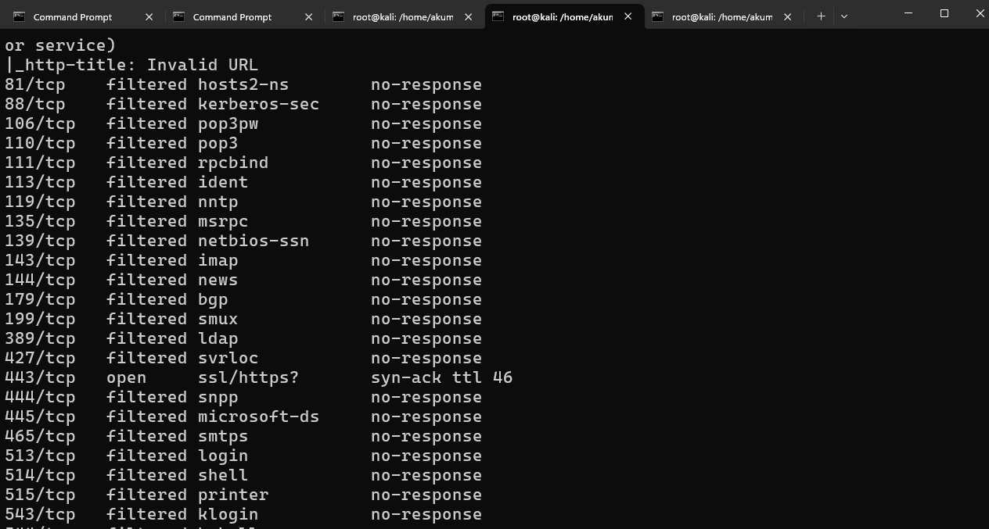
Figure 2 : All TCP Port Show Filtered
Cyderes also performed a full-port TCP scan with Nmap service version and default script detection against the live hosts, using a limited scan rate and retry count. Nmap repeatedly increased its probe send delay on multiple hosts because of dropped probes, indicating rate limiting or filtering controls on the perimeter.
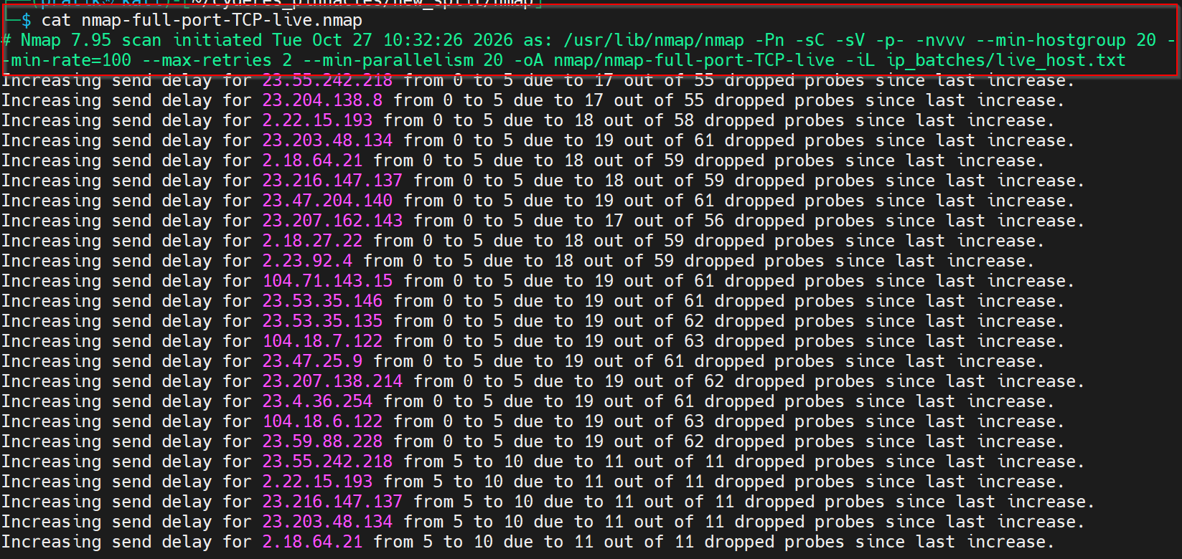
Figure 3 : Nmap Full Port TCP Scan

UDP Port Scanning
Cyderes utilized udp-proto-scanner, a lightweight UDP protocol scanning tool, to enumerate common UDP-based services across all in-scope hosts. The scanner was configured to probe for widely deployed UDP services, including DNS, NTP, SNMP, IKE, NetBIOS, and RPC. Multiple hosts responded to DNS probes on UDP port 53, including 208.91.197.27 and other identified hosts, identifying DNS services for further enumeration.
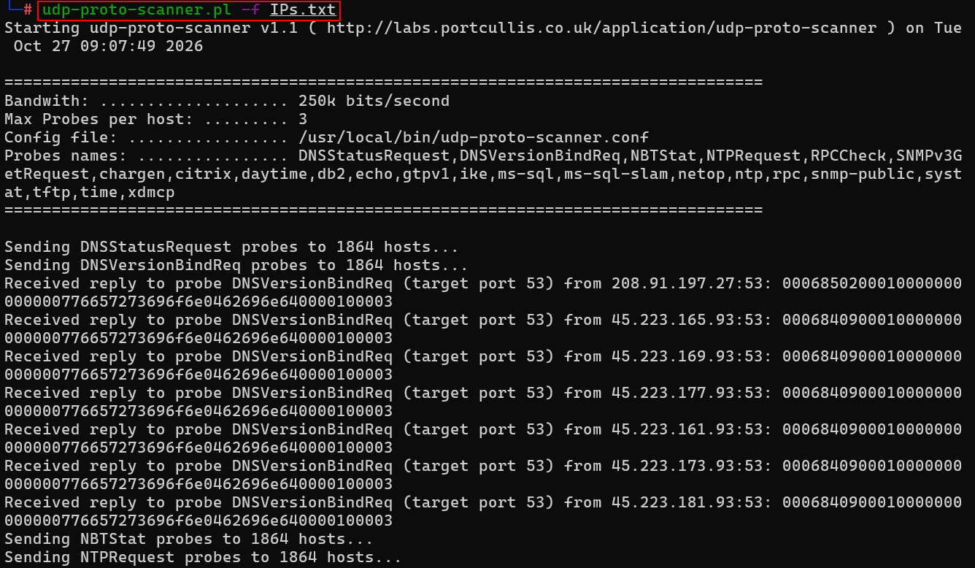
Figure 4 : Common UDP Port Scan

Service Enumeration and Exploitation
Service enumeration and exploitation consist of steps taken by the Cyderes team to further enumerate discovered services and test for weaknesses in those services that can lead to possible exploitation.

FTP
Cyderes used the Metasploit Framework ftp_anonymous auxiliary module against the identified FTP services to test for anonymous authentication. The module scanned the identified hosts, but no anonymous FTP login was permitted on any of the assessed hosts.
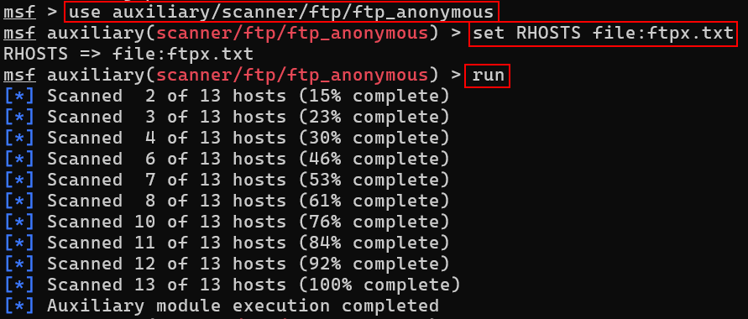
Figure 5 : FTP Anonymous Login Testing

SSH
Cyderes performed service enumeration against the identified SSH services using Nmap. An SSH service was identified on 69.64.24.135:22, running SCS sshd 9.8.1.0_openssh using SSH protocol 2.0. A second SSH service, identified as an SSH-2.0-SFTP file transfer service, was also found listening on a non-standard port 22000 and is covered below. The enumeration disclosed the supported authentication methods and cryptographic algorithms.
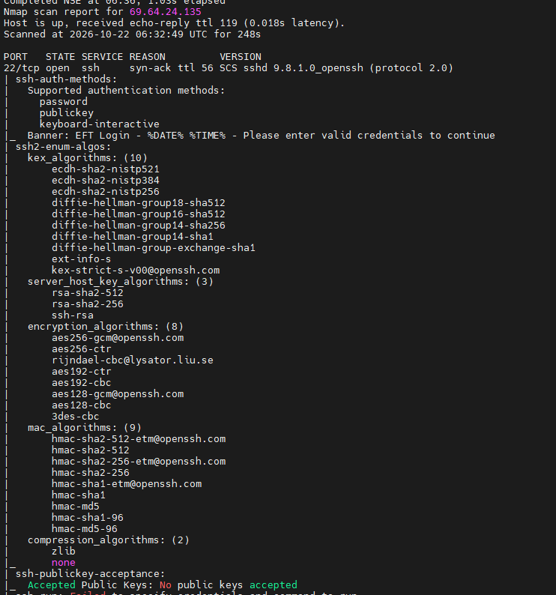
Figure 6 : SSH Service Enumeration
Cyderes used ssh-audit to assess the key exchange algorithms on the identified SSH services, as shown for 69.64.24.135:22. Both services were found to support weak key exchange algorithms, including SHA-1 based algorithms and the NIST-curve ECDH algorithms ecdh-sha2-nistp256, ecdh-sha2-nistp384 and ecdh-sha2-nistp521.
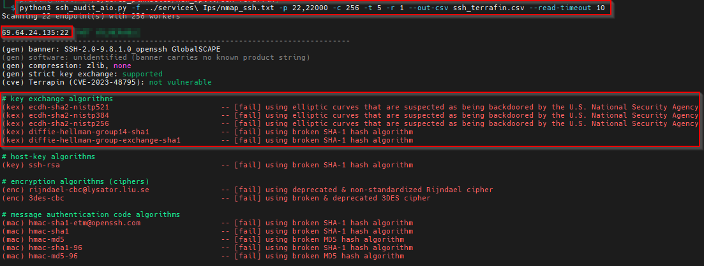
Figure 7 : SSH Weak Key Exchange Algorithms
Cyderes used ssh-audit to review the MAC algorithms on 69.64.24.135:22 and identified weak MD5 and SHA-1 based message authentication code algorithms.
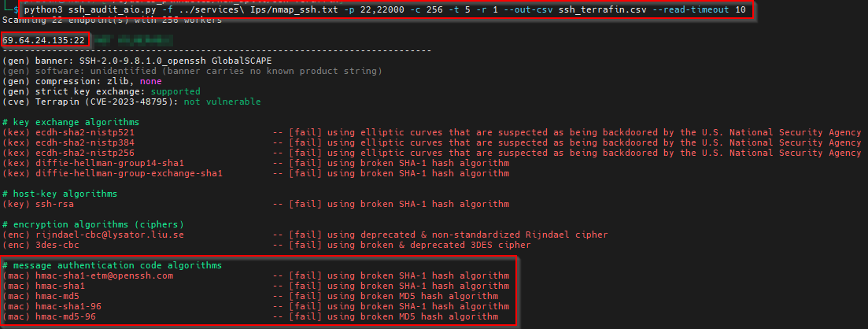
Figure 8 : SSH Weak MAC Algorithms on 69.64.24.135
Cyderes reviewed the encryption algorithms on 69.64.24.135:22 and identified the use of CBC-mode ciphers, including the deprecated Rijndael-CBC and 3DES-CBC ciphers.
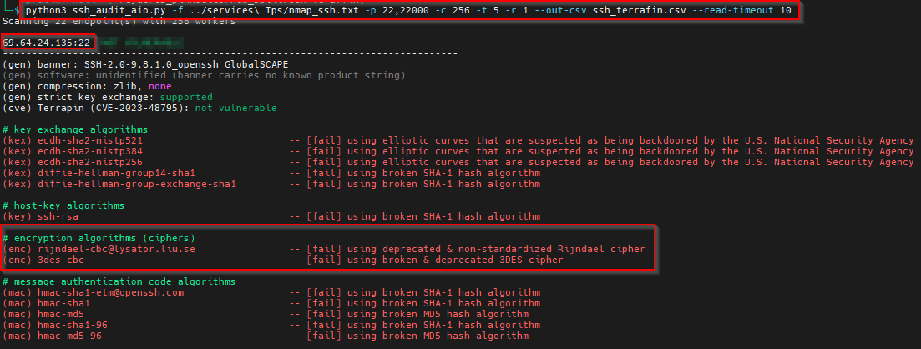
Figure 9 : SSH CBC Mode Ciphers on 69.64.24.135
Cyderes used the Nmap ssh-auth-methods NSE script against 69.64.24.135:22 to enumerate supported authentication methods, confirming support for password, public-key, and keyboard-interactive authentication. Password-based authentication increases exposure to brute-force attacks.
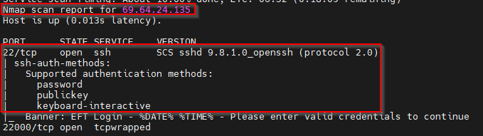
Figure 10 : SSH Supported Authentication Methods
Cyderes also used the Nmap ssh-auth-methods NSE script against 199.187.144.52:22000. The service was identified as an SFTP 2.0 server displaying the banner "Welcome to Pinnacle Financial Partners Secure File Transfer" and supporting both password and public-key authentication.
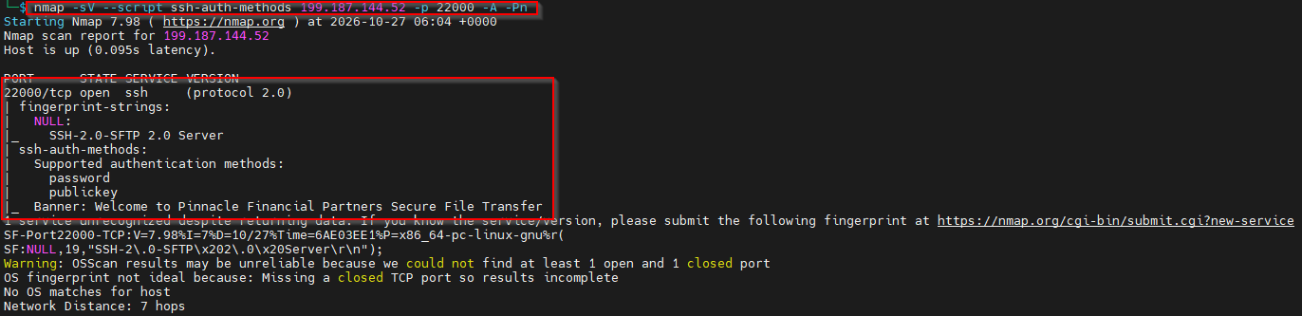
Figure 11 : SSH Supported Authentication Methods on 199.187.144.52:22000

Telnet
Cyderes used the Metasploit telnet_version auxiliary module to enumerate Telnet services exposed on TCP port 23. Telnet was identified as open and responsive on multiple hosts, including 69.64.24.138, 69.64.24.139, 69.64.24.141, 69.64.24.144, 69.64.24.146, 69.64.24.150, 69.64.24.152, and 69.64.24.213.
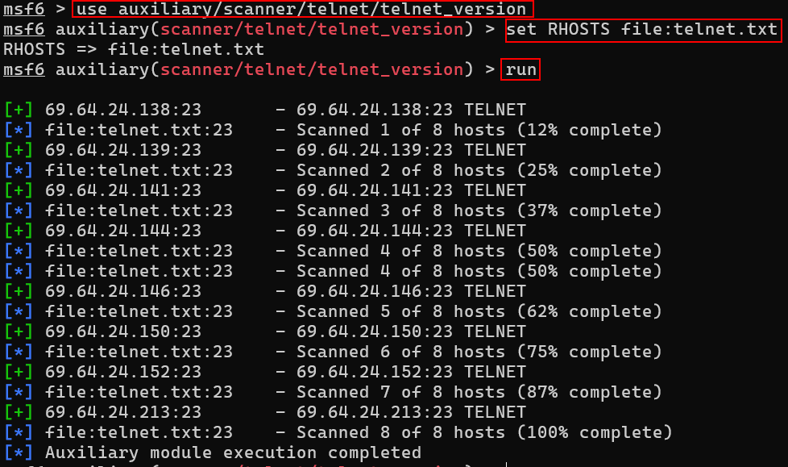
Figure 12 : Telnet Service Enumeration
Cyderes conducted credential testing against the identified Telnet services using the telnet_login module with username and password wordlists. Every attempt returned a LOGIN FAILED result, and no valid credentials were identified.
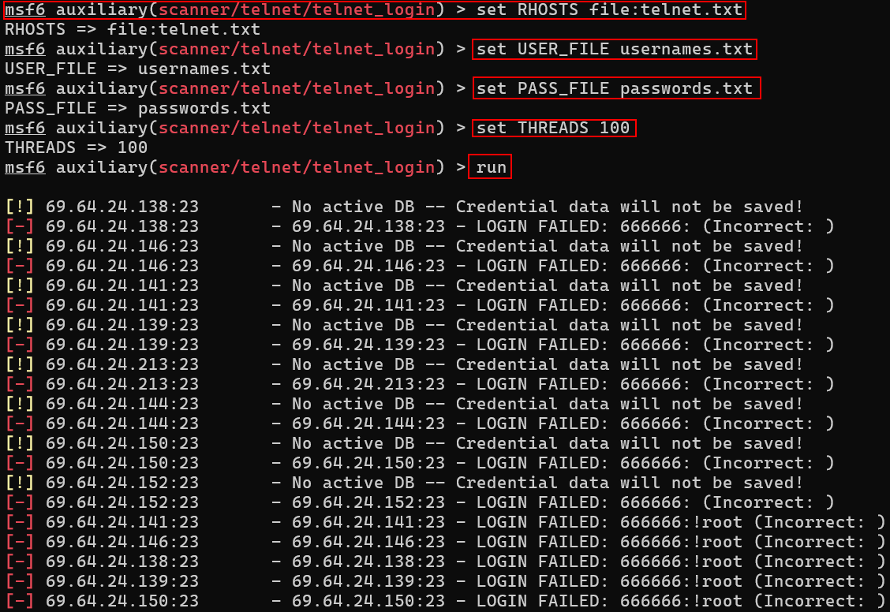
Figure 13 : Telnet Authentication Testing

SNMP
Cyderes used onesixtyone to test the identified hosts for the use of default or commonly used SNMP community strings across the in-scope address space. The testing did not identify any valid SNMP community string or successful SNMP authentication.
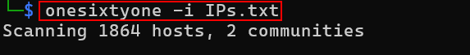
Figure 14 : SNMP Community String Testing
Cyderes tested SNMPv3 on 184.80.142.245 using snmpget with the noAuthNoPriv security level, first with an empty user name and then with the default user name cisco. Both requests were rejected with the errors No securityName specified and Unknown user name, and no unauthenticated SNMPv3 access was obtained.
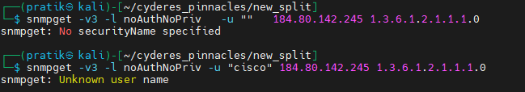
Figure 15 : SNMPv3 Authentication Testing

NFS
Cyderes used the Metasploit nfsmount auxiliary module to enumerate accessible NFS exports across the identified hosts. No accessible or exported NFS shares were identified.
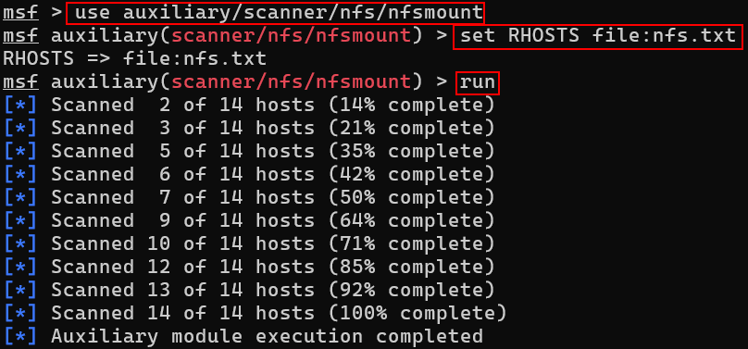
Figure 16 : NFS Export Enumeration

VNC
Cyderes used the Metasploit vnc_none_auth auxiliary module to test hosts exposing the VNC service on TCP port 5900 for unauthenticated access. The handshakes failed and no unauthenticated VNC access was achieved.
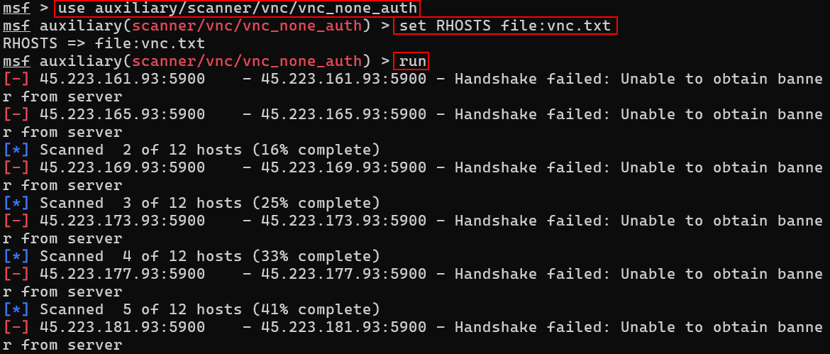
Figure 17 : VNC Authentication Testing

Oracle
Cyderes used the Metasploit tnslsnr_version auxiliary module to enumerate Oracle TNS listener version information across the identified hosts exposing TCP port 1521. The Oracle service version could not be determined and was reported as Unknown for all assessed hosts.
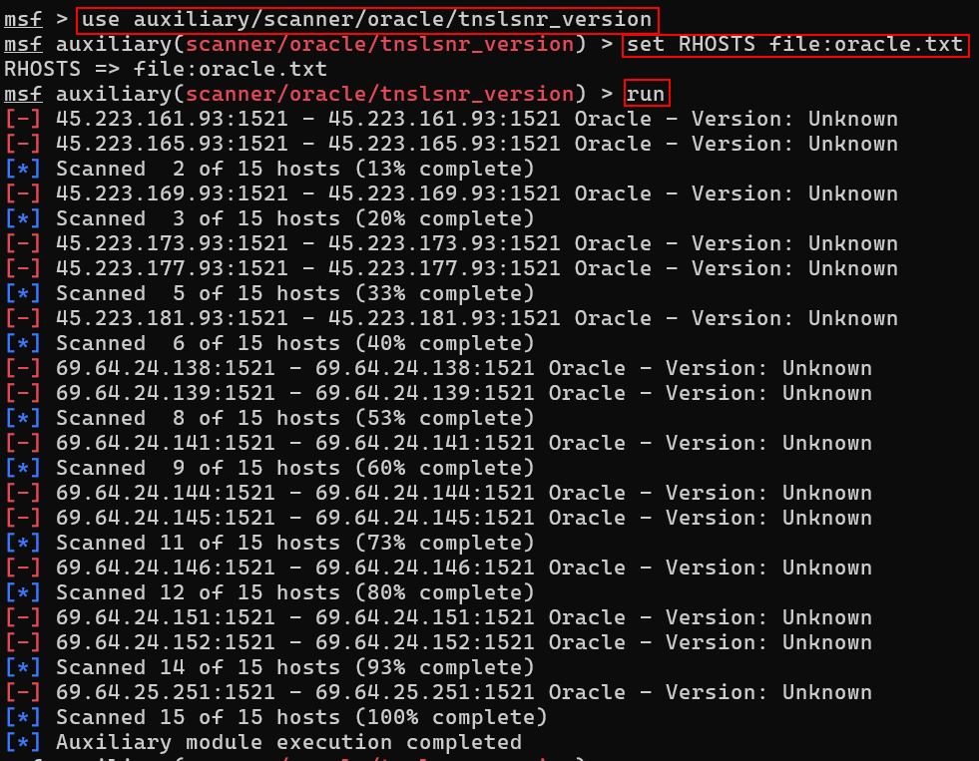
Figure 18 : Oracle TNS Listener Enumeration

R-Services (RSH/Rexec)
Cyderes identified TCP port 514, used by r-services, open on identified hosts. Nmap service/version detection confirmed the port was open and responsive on 45.223.161.93.
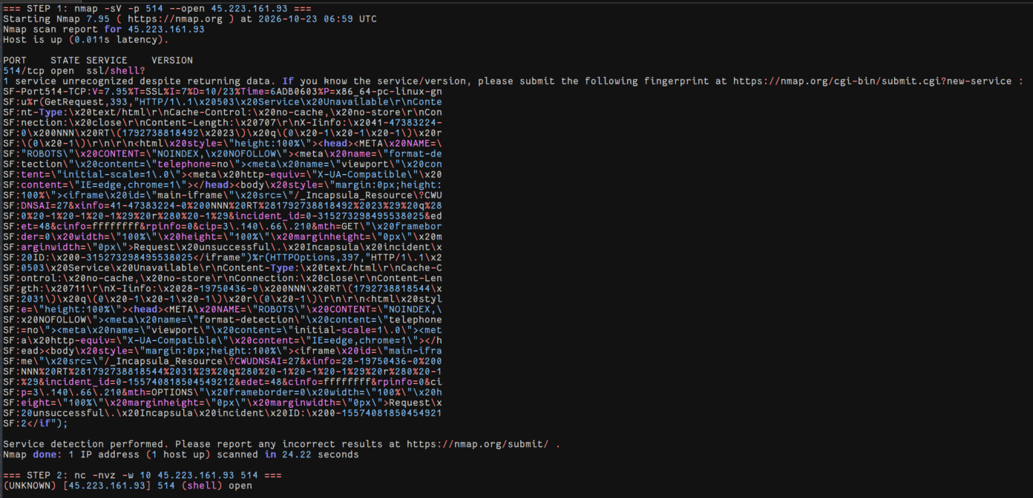
Figure 19 : R-Services Port 514 Enumeration
Cyderes further confirmed the open r-services port using a direct Netcat connection to 45.223.177.93:514.
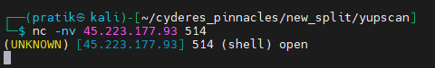
Figure 20 : R-Services Port Confirmation
Cyderes used the Metasploit rexec_login auxiliary module to perform an authentication sweep against the identified r-services host at 45.223.181.93:514. The sweep completed, but no credentialed access was obtained.
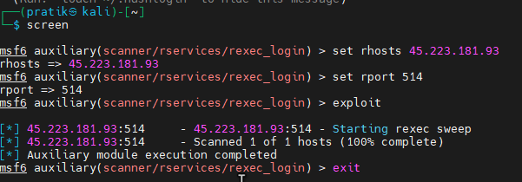
Figure 21 : Rexec Login Testing

MongoDB
Cyderes used the Metasploit mongobleed module, which targets CVE-2025-14847, to test the identified hosts for exposed MongoDB services. The targets did not appear to be MongoDB services, and no exposed MongoDB instances were confirmed.
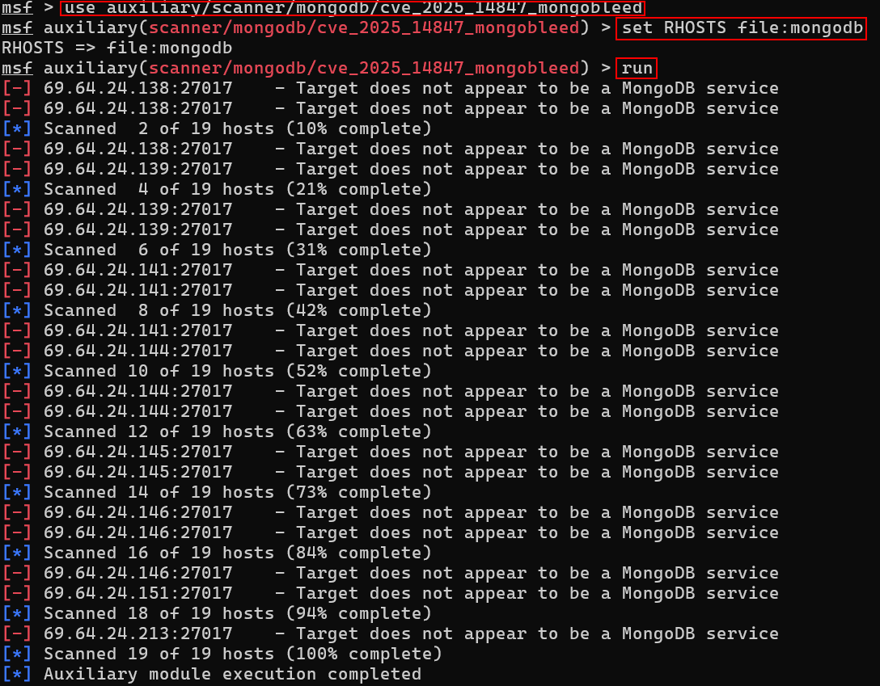
Figure 22 : MongoDB Service Testing

PostgreSQL
Cyderes used the Metasploit postgres_login auxiliary module to perform authentication testing against the identified hosts exposing PostgreSQL on TCP port 5432. Every attempt returned a LOGIN FAILED result, and no valid credentials were identified.
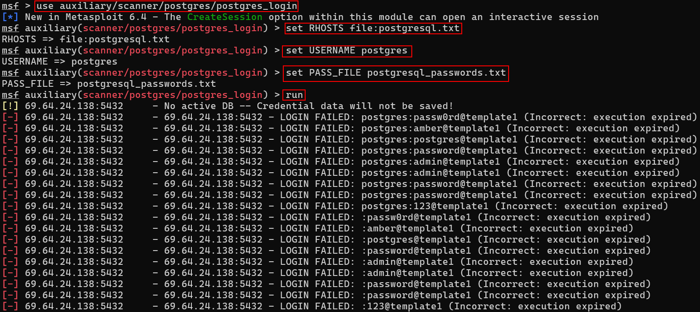
Figure 23 : PostgreSQL Authentication Testing

Redis
Cyderes identified TCP port 6379, the default Redis port, open on identified hosts. The Metasploit redis_server module reported "Found redis with INFO command"but the data returned was an Imperva Incapsula block page rather than Redis INFO output.
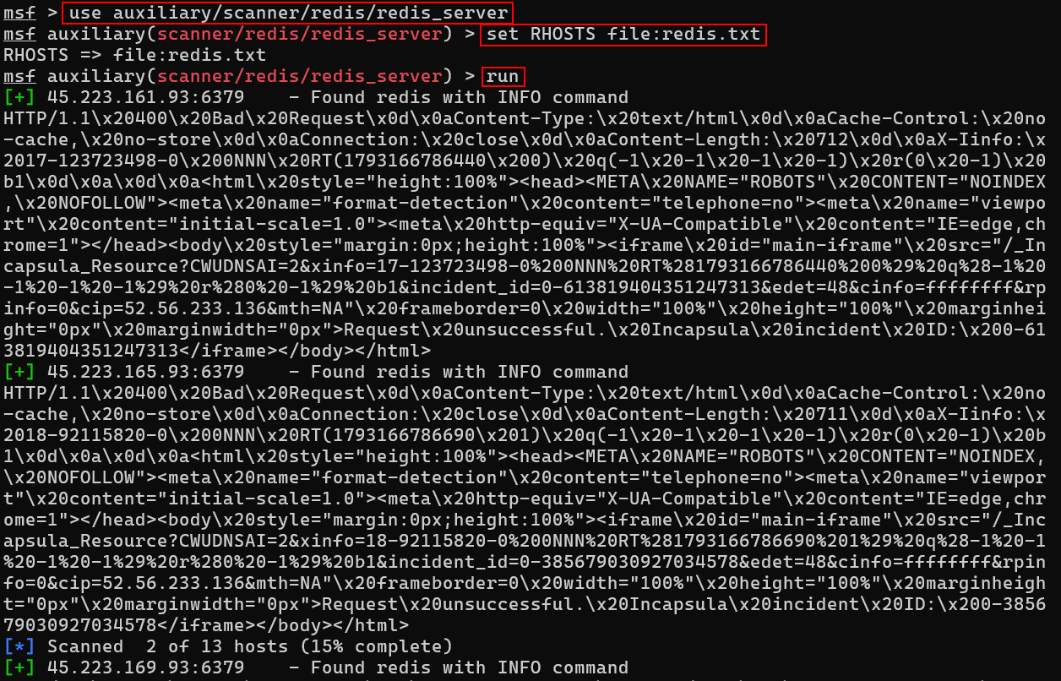
Figure 24 : Redis Server Detection
Cyderes then used the Metasploit redis_login module, which reported that no password was required to access the Redis service on the identified hosts.
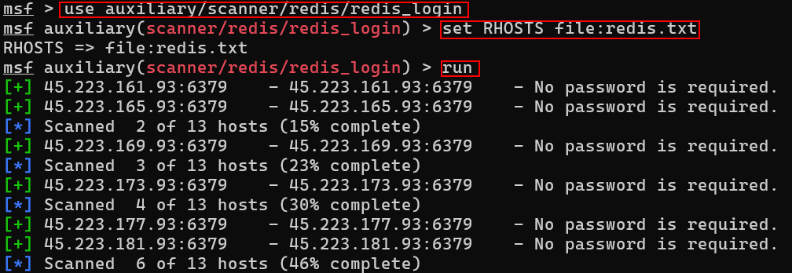
Figure 25 : Redis Authentication Testing
During manual verification using curl and redis-cli, the hosts responded like an HTTP proxy rather than Redis. An HTTP request to port 6379 returned an HTTP/1.1 503 Service Unavailable Incapsula page, redis-cli PING returned a protocol error because the first reply byte was H, and a redis-cli scan returned an I/O error.
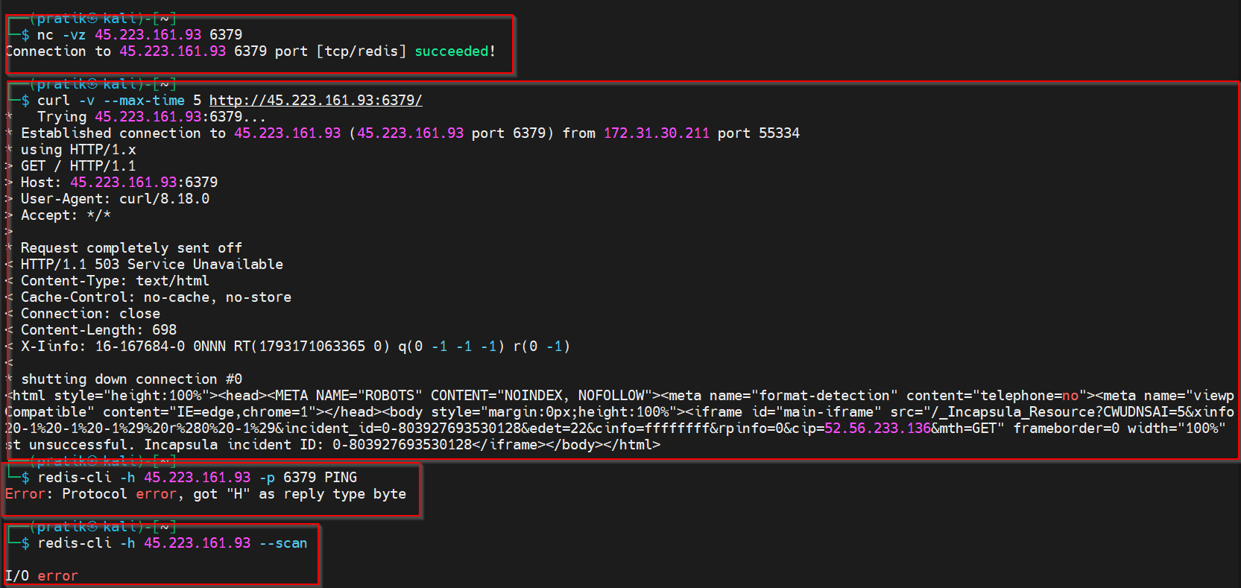
Figure 26 : Redis Manual Validation
An Nmap redis-info scan returned the same Incapsula responses. Passwordless access to a Redis service could not be independently confirmed and the result remains inconclusive.
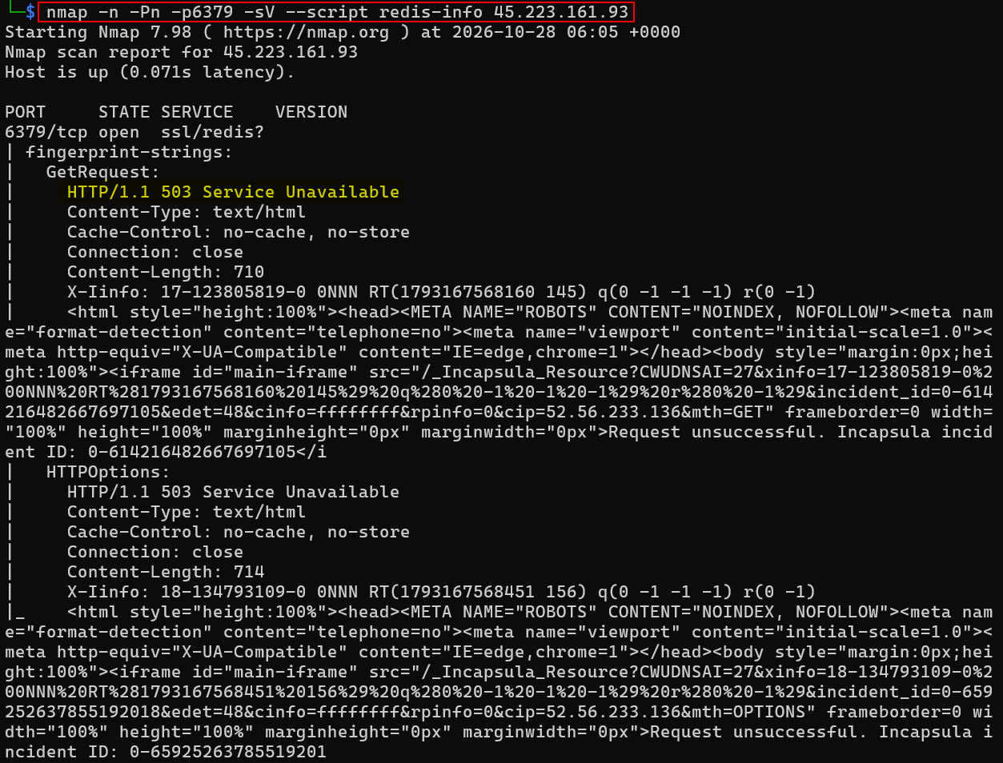
Figure 27 : Nmap Redis Service Detection

IMAP
Cyderes tested IMAP on 45.223.161.93, on ports 143 and 993, using openssl s_client and telnet. The STARTTLS negotiation ended with an unexpected EOF on both ports, a direct TLS connection to port 993 presented a certificate issued to imperva.com, and a raw connection to port 993 returned an HTTP/1.1 400 Bad Request Incapsula page. No IMAP banner was returned, indicating that the ports are answered by the Imperva Incapsula proxy.
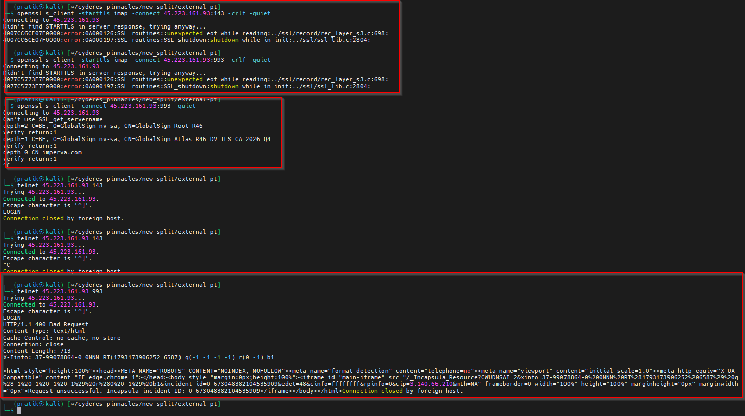
Figure 28 : IMAP Service Validation

JetDirect
Cyderes identified TCP port 9100, used by JetDirect, open on 69.64.24.146. The Nmap pjl-ready-message script timed out with no response from the printer, and a direct Netcat connection followed by PJL INFO STATUS and INFO ID commands also returned no data.
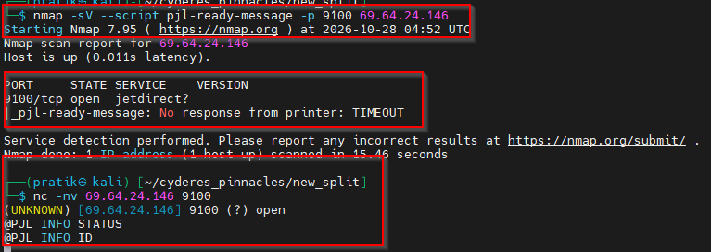
Figure 29 : JetDirect Port 9100 Testing

RTSP
Cyderes scanned TCP port 554 using the Nmap rtsp-methods and rtsp-url-brute scripts to identify supported RTSP methods and stream endpoints. Port 554 was reported as open, but the rtsp-methods script failed to execute and the URL enumeration did not confirm any valid stream paths. A manual RTSP OPTIONS request sent with Netcat returned an HTTP/1.1 400 Bad Request response with Imperva/Incapsula headers instead of an RTSP response.
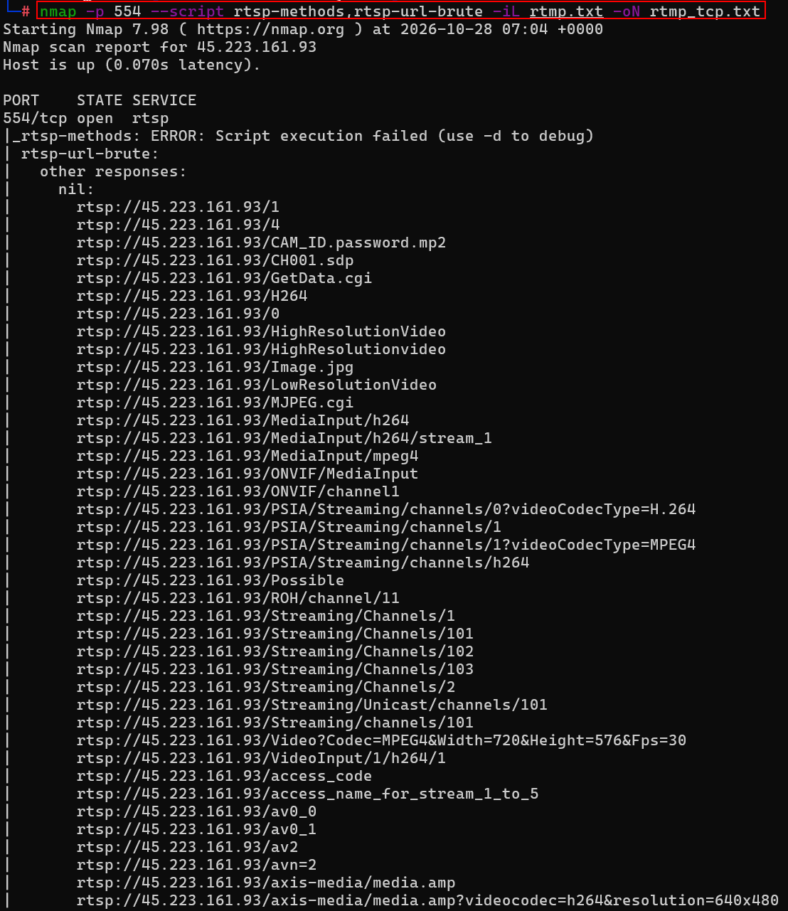
Figure 30 : RTSP Enumeration

Memcached
Cyderes identified TCP port 11211, used by Memcached, open on identified hosts. The Nmap memcached-info script was run against the identified hosts and reported the port as open with the memcache service.
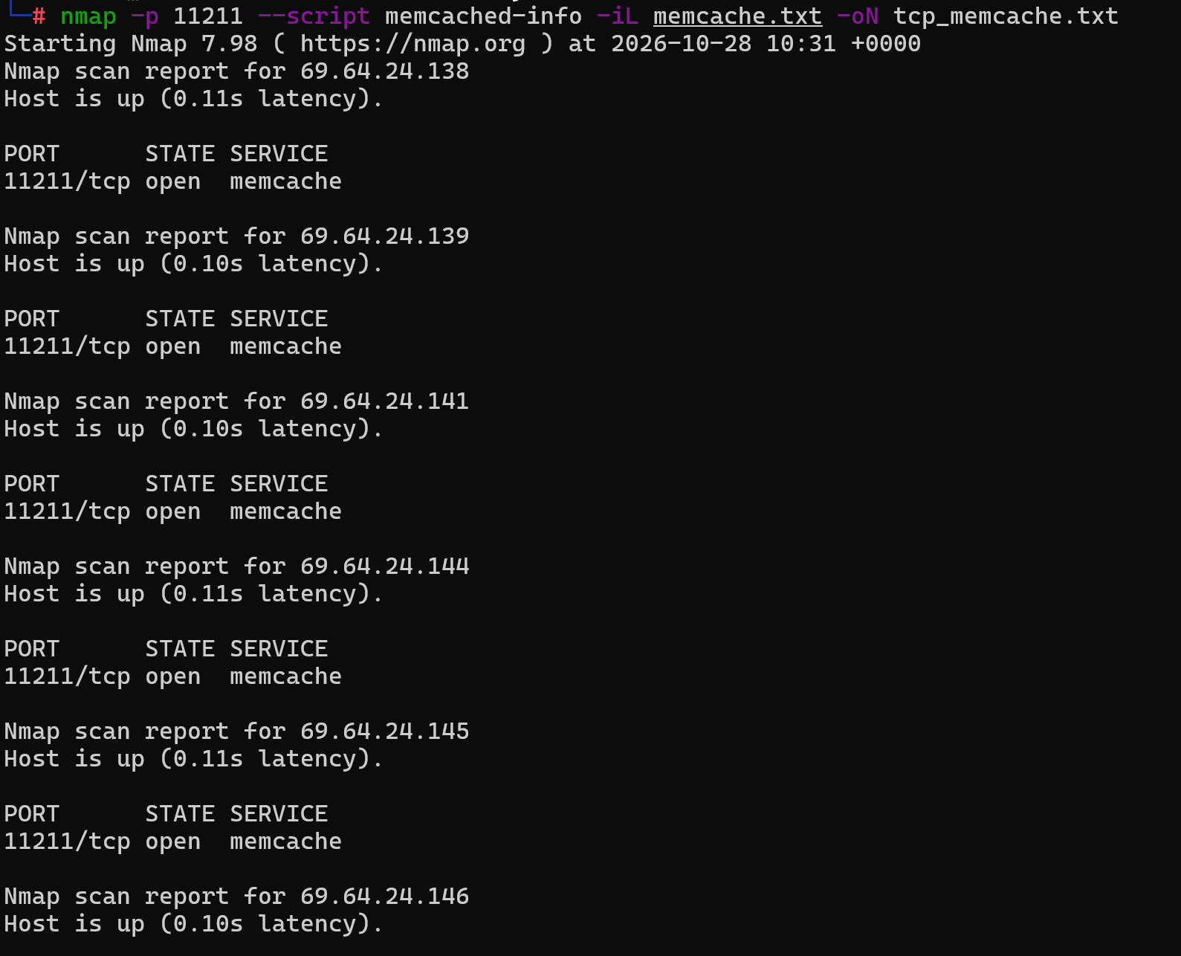
Figure 31 : Nmap Memcached Service Detection
Cyderes then attempted to enumerate cached keys on 69.64.24.138:11211 using a PHP Memcached client. The getAllKeys call returned false and no keys were retrieved.
Figure 32 : Memcached Key Enumeration Attempt
Cyderes also used the libmemcached tools against 69.64.24.138. The memcstat and memcdump commands failed with a timeout, memccat returned no keys, and a raw Netcat connection to port 11211 succeeded without returning any data.
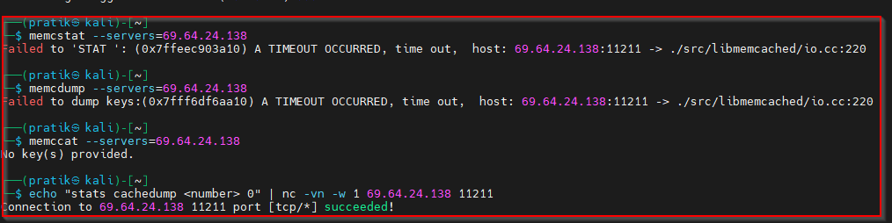
Figure 33 : Memcached Enumeration Using libmemcached Tools
Cyderes used the Metasploit memcached_amp and memcached_udp_version modules against the identified hosts to test for memcached UDP amplification. Both modules completed without reporting any exposed memcached service.
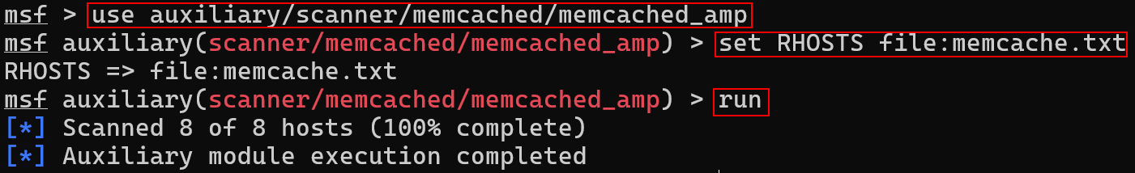
Figure 34 : Memcached Amplification Testing
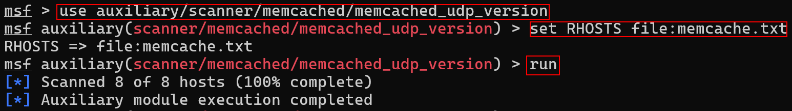
Figure 35 : Memcached UDP Version Testing

SMB
Cyderes identified TCP port 445, used by SMB, open on identified hosts and ran Nmap service detection with the SMB scripts for OS discovery, protocols, security mode, share and user enumeration, and the MS17-010 and MS08-067 checks. The port was reported as open, with the service identified only as microsoft-ds.
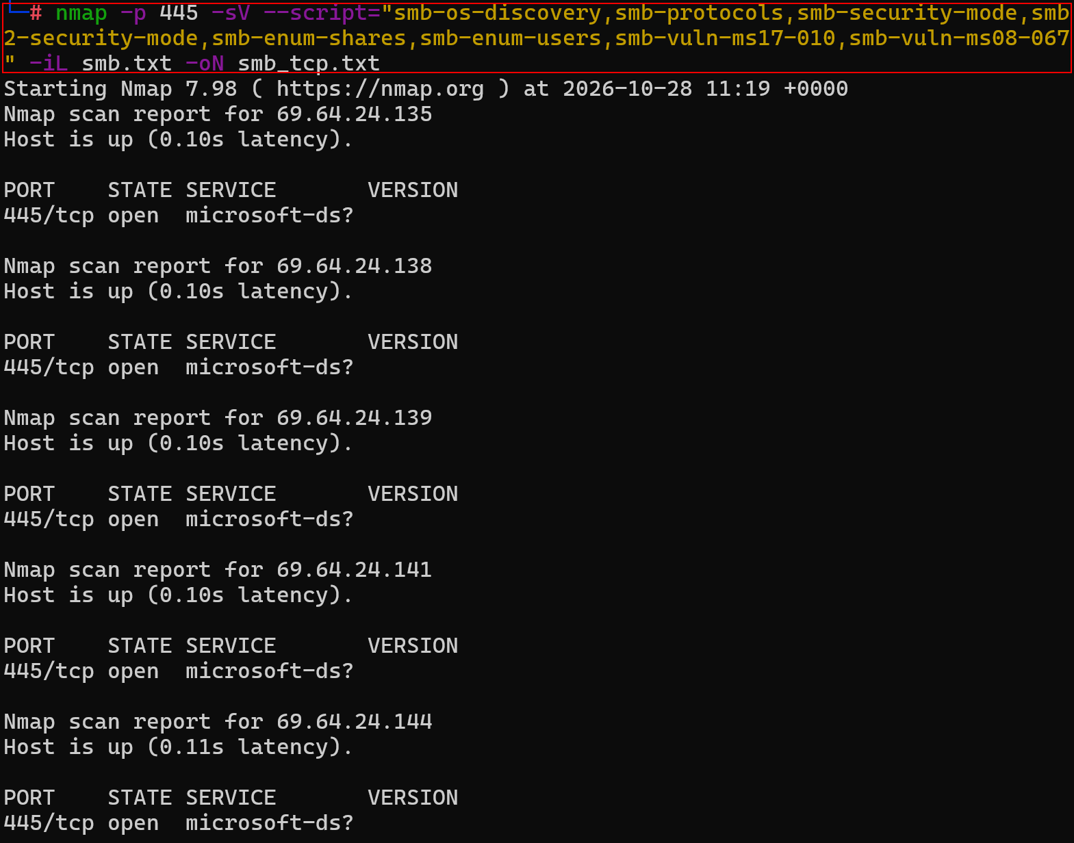
Figure 36 : Nmap SMB Service Detection
Cyderes used the Metasploit smb_version auxiliary module against the identified hosts. The module completed without reporting any SMB version information.
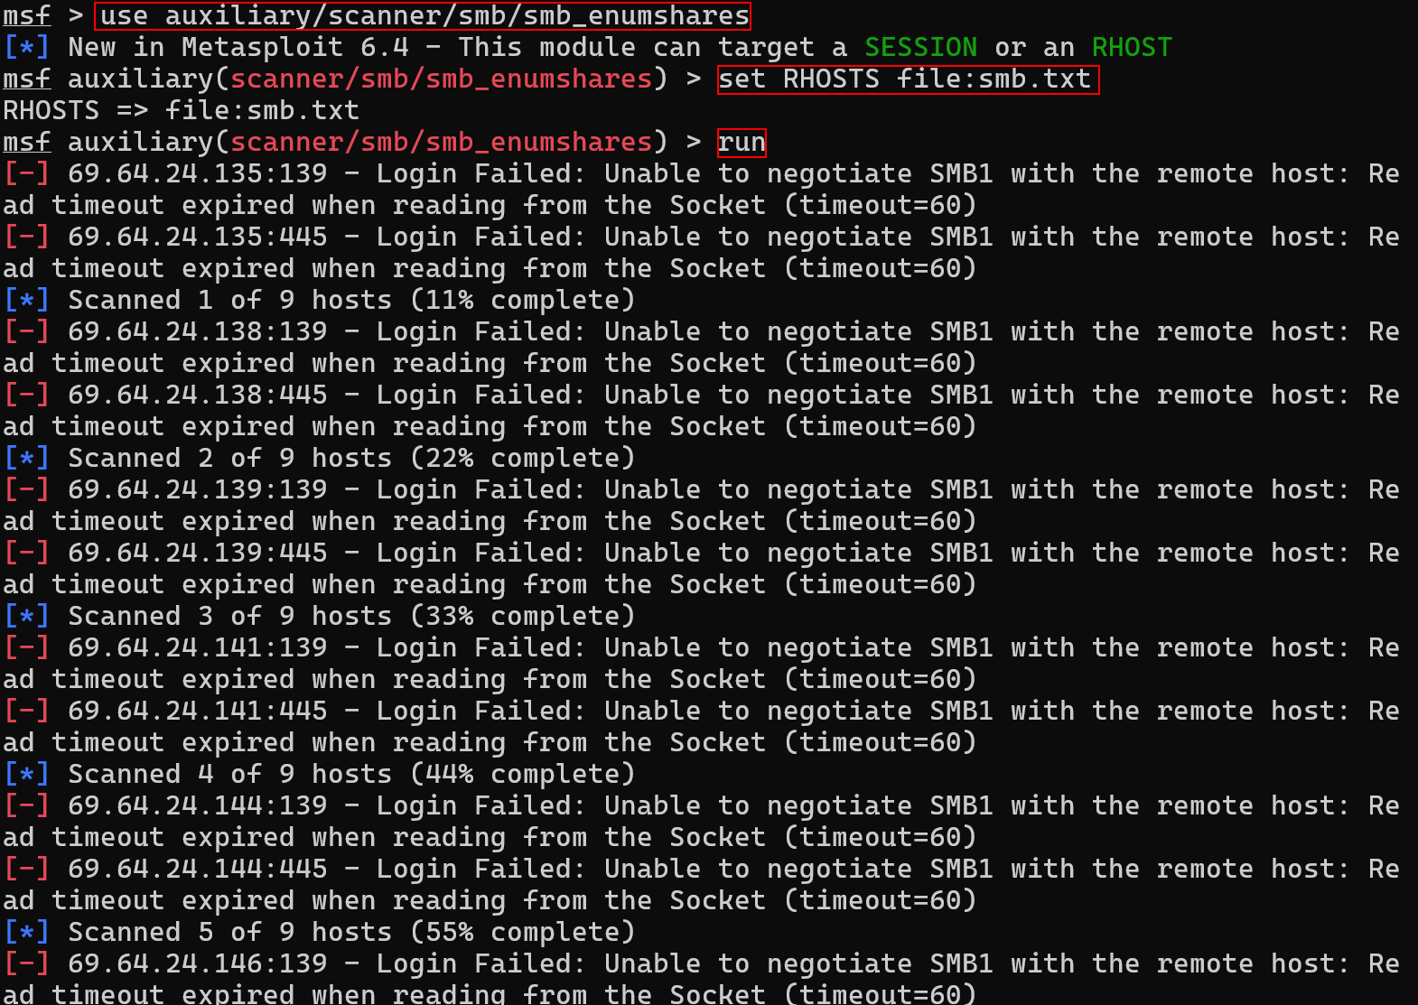
Figure 37 : SMB Version Enumeration
Cyderes used the Metasploit smb_enumshares auxiliary module to enumerate SMB shares. Every attempt on ports 139 and 445 failed with the error Unable to negotiate SMB1 with the remote host after the read timeout expired, and no shares were enumerated.
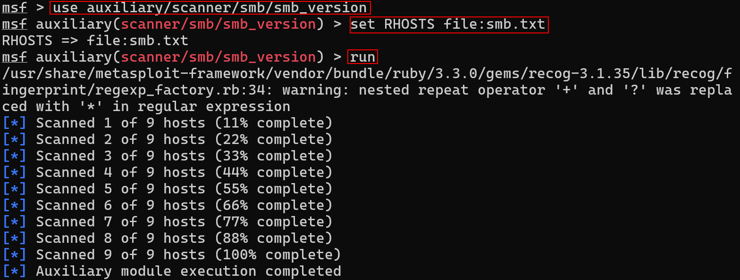
Figure 38 : SMB Share Enumeration
Cyderes tested for MS17-010 using the Metasploit smb_ms17_010 auxiliary module. Every attempt failed with an SMB login error while connecting to the IPC$ tree, so the vulnerability could not be confirmed.
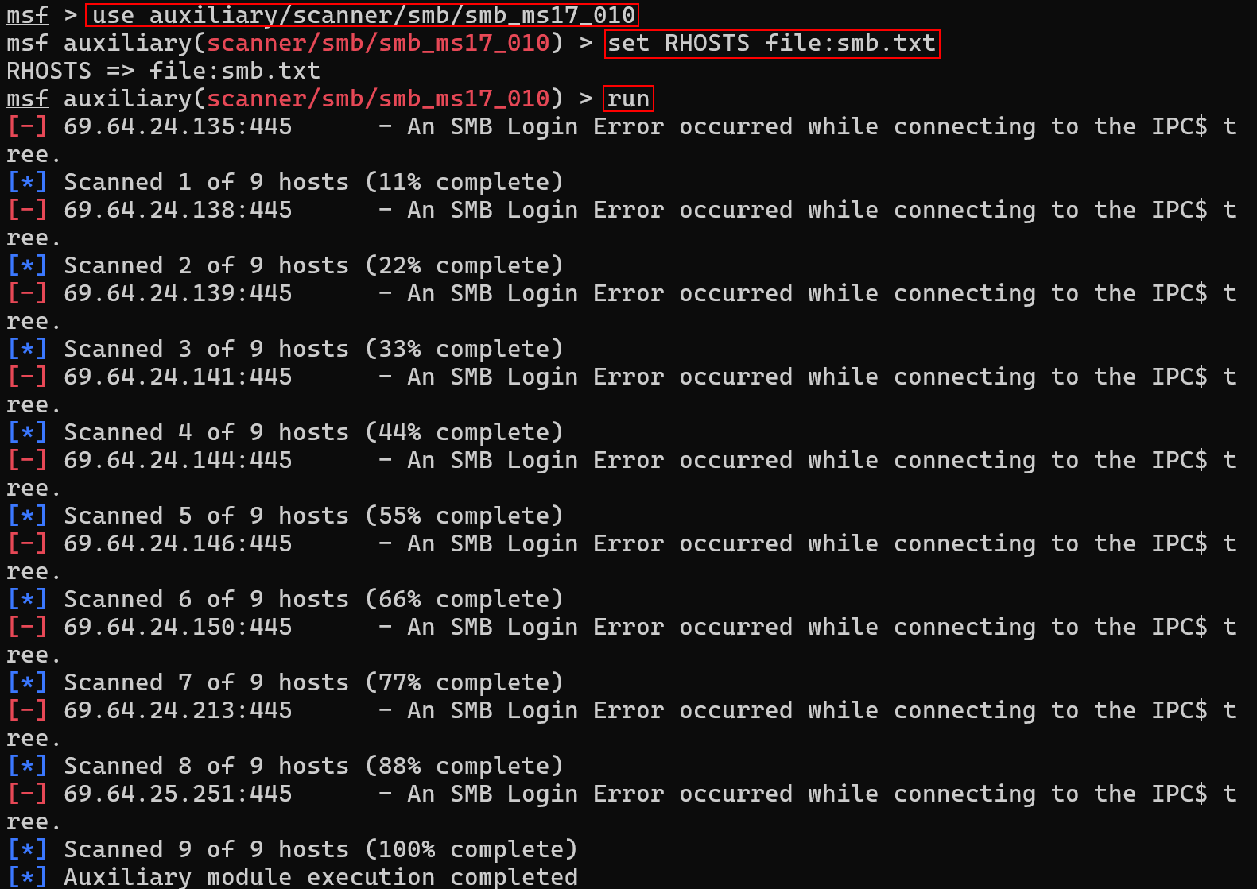
Figure 39 : SMB MS17-010 Testing

DNS
Cyderes used the dig tool to query the DNS service on 208.91.197.27 and test for recursion. The server did not provide recursion for domains outside its authoritative zone and reported that recursion was requested but not available, indicating that DNS recursion and cache snooping were not enabled on the host.
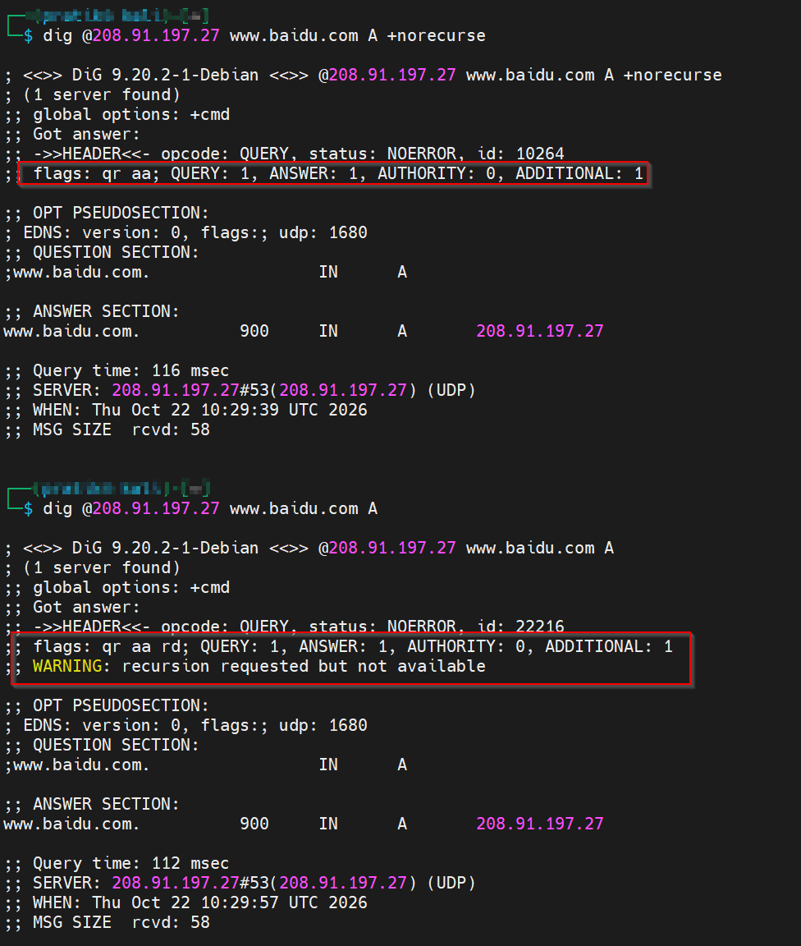
Figure 40 : DNS Recursion and Cache Snooping Testing
Cyderes used the Metasploit dns_amp module to assess the DNS service on 208.91.197.27 for susceptibility to reflection/amplification DDoS attacks. The host returned a response equal in size to the request, indicating it is not susceptible to meaningful amplification.
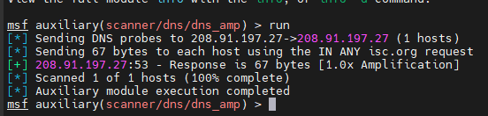
Figure 41 : DNS Amplification Testing

NTP
Cyderes used the Metasploit ntp_monlist module against the identified NTP hosts to test for the monlist amplification weakness. The module completed, but no monlist response was returned by the targets.
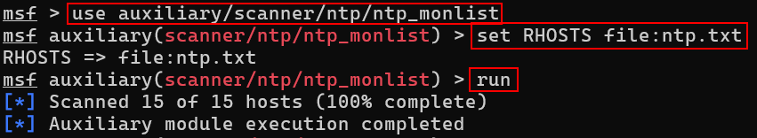
Figure 42 : NTP monlist Testing
Cyderes used the Metasploit ntp_readvar module to send NTP Mode 6 READVAR probes to the identified NTP hosts. The module completed its probes against the targets.
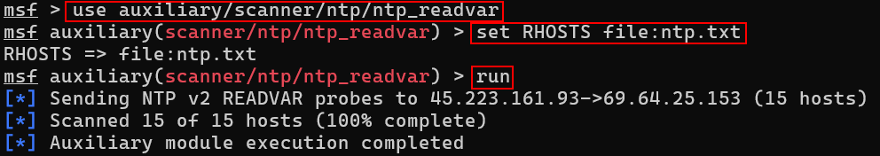
Figure 43 : NTP READVAR Testing

ICMP Timestamp
Cyderes tested the identified hosts for the ICMP Timestamp Request disclosure, tracked as CVE-1999-0524. The hosts responded to ICMP Type 13 Timestamp Requests with a Type 14 Timestamp Reply, disclosing the system clock. The disclosure was confirmed across multiple responsive hosts, including pnfp.celerocompass.com.
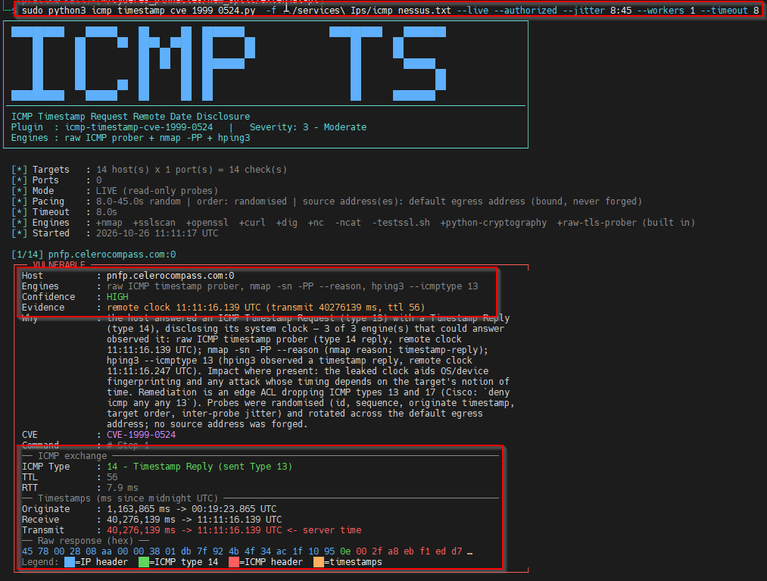
Figure 44 : ICMP Timestamp Request Disclosure
Cyderes also validated the finding using an ICMP Timestamp scanner for CVE-1999-0524 against the identified hosts. Hosts such as 151.101.67.52 and 151.101.131.52 returned ICMP Type 14 Timestamp Replies containing the server time.
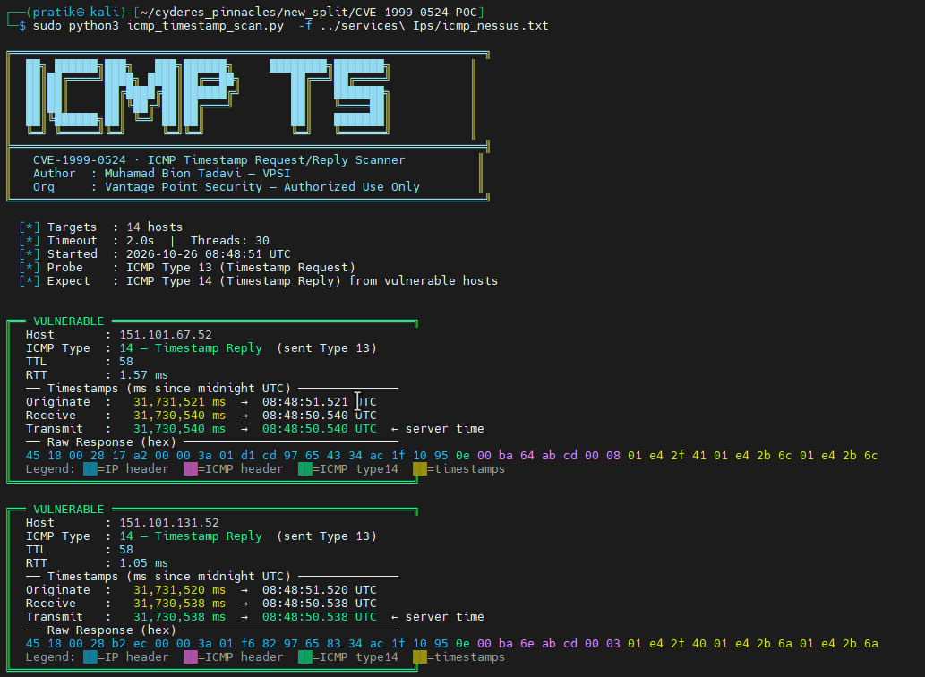
Figure 45 : ICMP Timestamp Scanner Validation

TLS/SSL
Cyderes used sslscan, testssl, and the Nmap ssl-enum-ciphers NSE script to perform comprehensive SSL/TLS configuration testing across all identified web services, assessing supported protocols, cipher suites, certificates, and cryptographic algorithms for known vulnerabilities.
Cyderes used sslscan against 52.73.186.125:443 and confirmed that the legacy SSL version 2 and SSL version 3 protocols, along with TLS 1.0, were enabled on the host. These deprecated protocols contain known cryptographic weaknesses and expose the service to man-in-the-middle and decryption attacks.
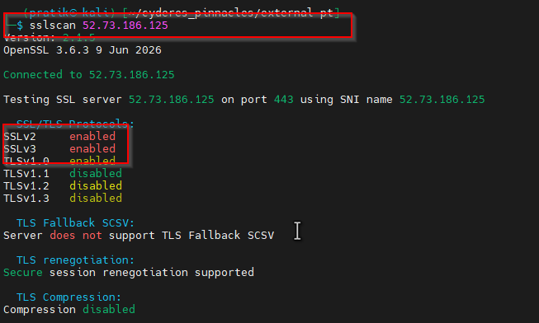
Figure 46 : SSL Version 2 and 3 Protocol Detection
Cyderes identified multiple hosts supporting weak cipher suites, including SHA-1 based MAC suites and static key exchange suites that offer no forward secrecy. Host 100.31.34.16:443 accepted multiple weak cipher suites, and the scan summary confirmed that multiple hosts across the external perimeter were affected.
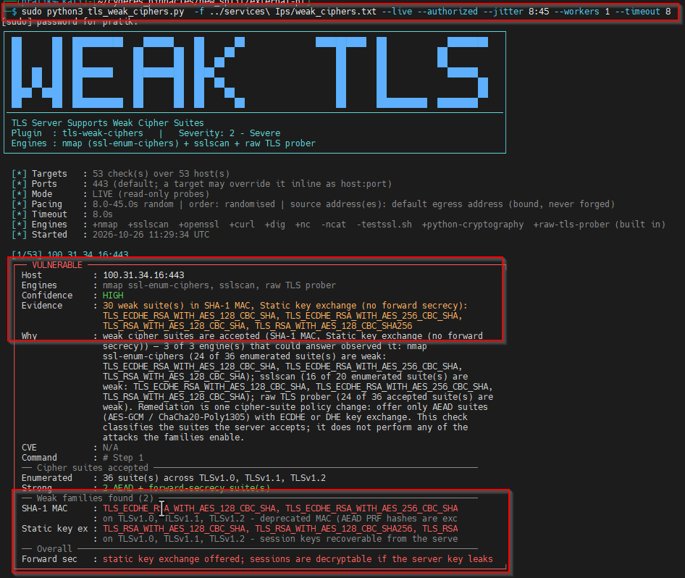
Figure 47 : SSL Vulnerable Cipher Suites
Cyderes assessed the SSL/TLS certificates presented by the identified HTTPS services and identified multiple expired certificates, for example on 52.73.186.125:443, where the certificate was valid only through April 4, 2021.
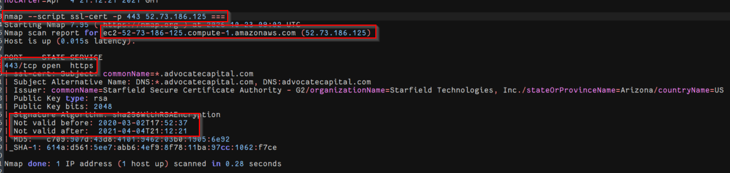
Figure 48 : SSL Certificate Expiry
Cyderes identified self-signed certificates on multiple hosts, for example 128.245.48.11:443. The certificate Subject and Issuer were identical, showing localhost.localdomain and MyCompany, and the certificate was not signed by a recognized certificate authority.
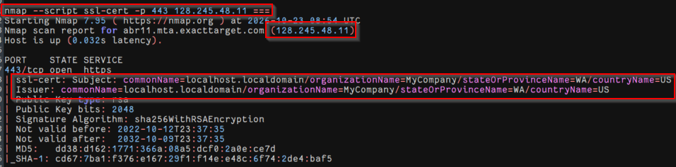
Figure 49 : SSL Self-Signed Certificate
Cyderes confirmed that host 188.114.96.3:443, one of several affected hosts, accepted 64-bit block cipher suites such as 3DES, making it vulnerable to the SWEET32 birthday attack tracked as CVE-2016-2183.
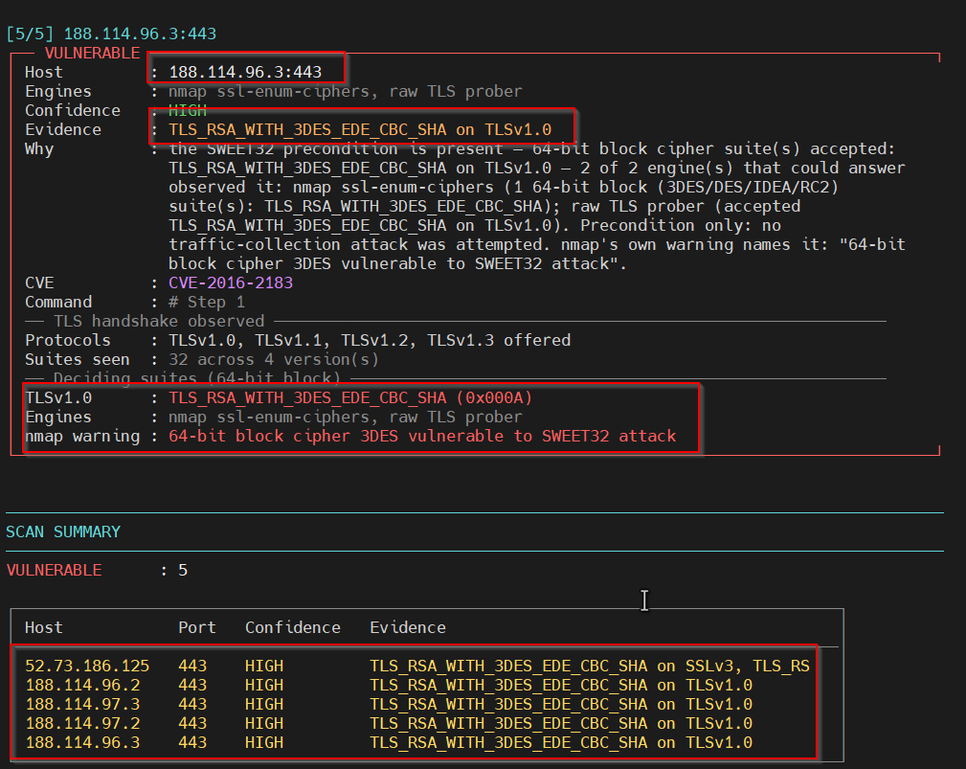
Figure 50 : SSL Medium Strength Cipher Suites - SWEET32
Cyderes confirmed that host 52.73.186.125:443 accepted RC4 cipher suites over SSLv3 and TLSv1.0, making it vulnerable to the Bar Mitzvah attack tracked as CVE-2015-2808.
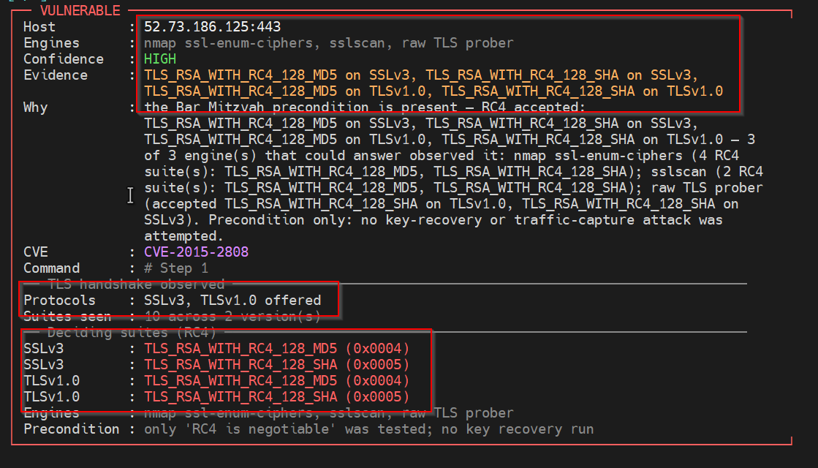
Figure 51 : SSL RC4 Cipher Suites - Bar Mitzvah
Cyderes confirmed that host 52.73.186.125:443 was vulnerable to the POODLE padding-oracle attack tracked as CVE-2014-3566, which confirms an exploitable SSLv3 configuration.
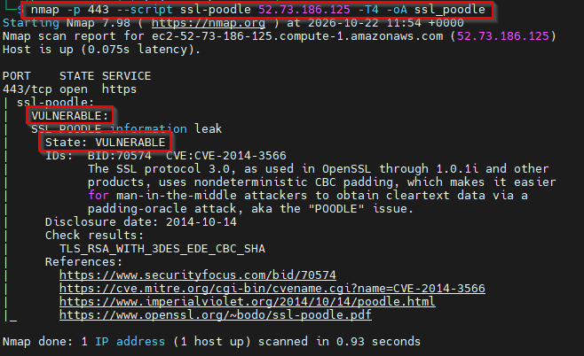
Figure 52 : SSLv3 Padding Oracle - POODLE
Cyderes confirmed that the deprecated TLS 1.0 and TLS 1.1 protocols were negotiable across multiple hosts, including 52.7.151.139:443. Both protocols are deprecated by RFC 8996, and TLS 1.0 additionally carries the BEAST precondition.
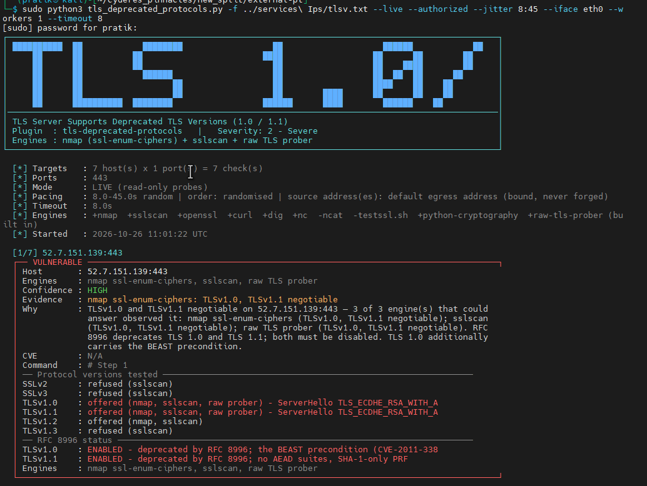
Figure 53 : TLS 1.0 / 1.1 Protocol Detection
Cyderes used the Nmap ssl-dh-params NSE script and confirmed that host 144.125.86.189:443 used a non-safe Diffie-Hellman prime with incorrectly generated group parameters, which weakens the Diffie-Hellman key exchange.
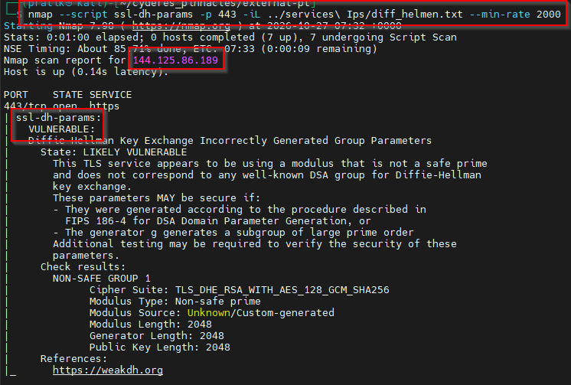
Figure 54 : SSL Certificate Chain Contains Weak Diffie-Hellman Key
Cyderes also confirmed that gp-msi.pnfp.com on 144.125.75.162:443 negotiated TLS_DHE_RSA_WITH_AES_128_GCM_SHA256 using a non-safe prime group of unknown origin.
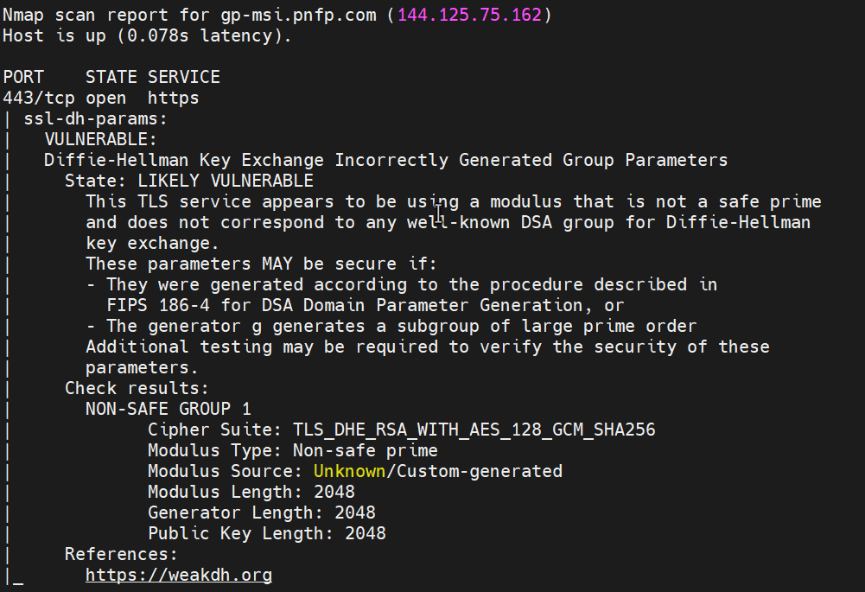
Figure 55 : SSL Certificate Chain Contains Weak Diffie-Hellman Key on 144.125.75.162

Automated Vulnerability Identification & Attack Surface Mapping

Nessus
Cyderes used Tenable Nessus to conduct automated vulnerability scanning across all in-scope hosts. The scan results were reviewed and manually validated. The confirmed findings are documented in the Key Vulnerabilities section of this report.

Nikto
During the automated vulnerability discovery phase, Cyderes deployed Nikto against the organization’s web-facing applications. On host 52.73.186.125:443, which runs Microsoft-IIS/7.5, Nikto reported a missing X-Frame-Options header, a missing Strict-Transport-Security header and an unset X-Content-Type-Options header, and it identified the disclosure of the internal address 10.154.160.170 in a response header.
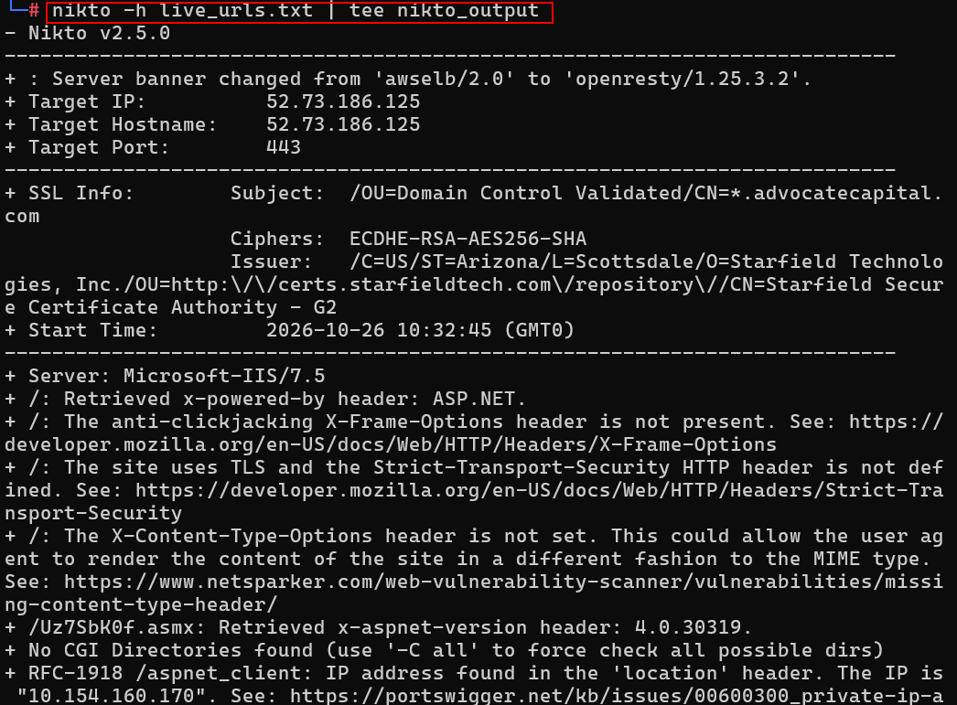
Figure 56 : Nikto Web Server Scan

BurpSuite
Cyderes employed Burp Suite's automated web vulnerability scanner to assess in-scope web applications for common vulnerabilities, including SQL injection, cross-site scripting and information disclosure. The scan identified several instances of email address disclosure, but these were determined to be non-sensitive support and helpdesk contact addresses. No exploitable vulnerabilities were identified during the automated scan.
The Burp Suite logger shows the active scan sending GET, POST and TRACE requests for paths such as /server-status, /.git/config and /v1/graphql to 128.17.80.127. The majority of requests returned an identical 200 response of the same length, indicating a generic response rather than valid content, and no exploitable issue was identified.
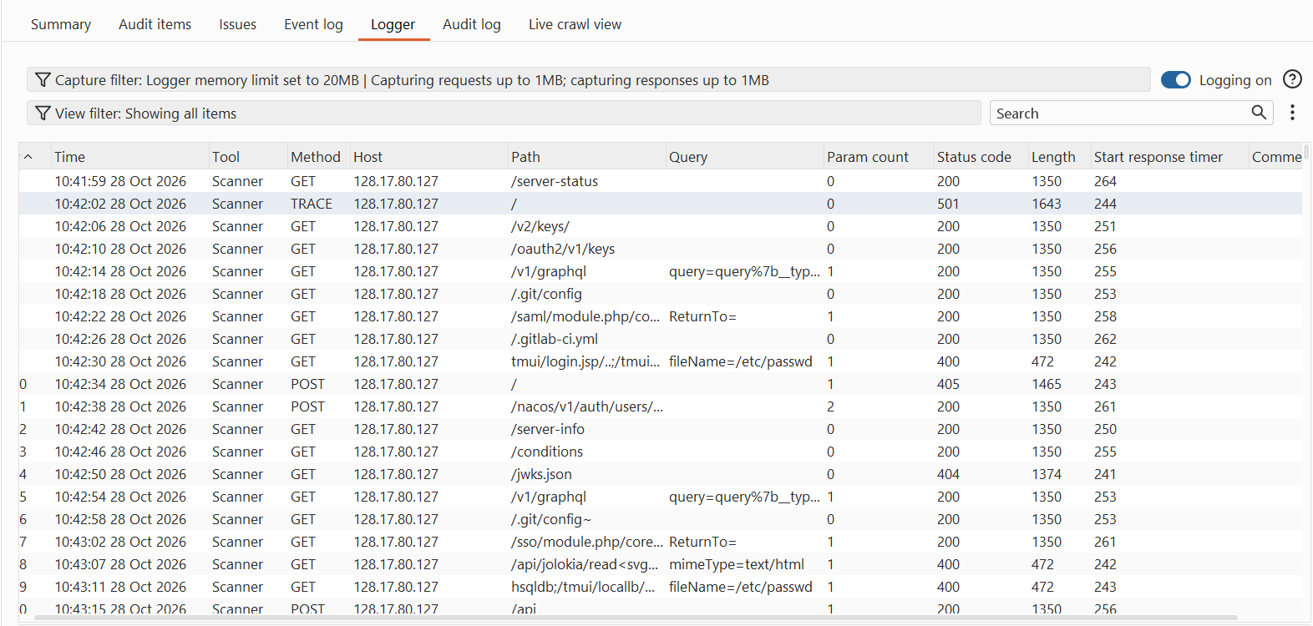
Figure 57 : Burp Suite Active Scan Logger

Nuclei
Cyderes used Nuclei, an open-source template-based vulnerability scanner, to perform automated security testing of the in-scope infrastructure and applications. On pnfpstaging.trafficmanager.net, the scan returned informational and low-severity detections, including a weak TLS 1.2 cipher suite, multiple missing security headers, Microsoft Azure service detection, and a Let’s Encrypt certificate issuer.
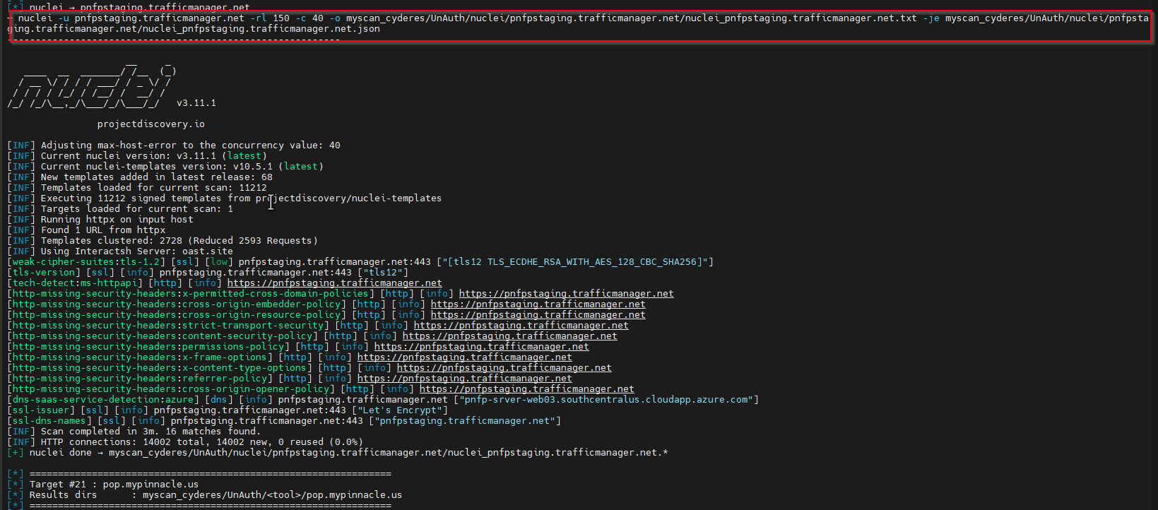
Figure 58 : Nuclei Template Scan

SHCHECK
Cyderes used Shcheck to assess the HTTP security headers of the identified web services. On host 12.132.105.215, the assessment identified multiple missing security headers, including X-Frame-Options, X-Content-Type-Options, Strict-Transport-Security, Content-Security-Policy, Referrer-Policy, Permissions-Policy, Cross-Origin-Embedder-Policy, Cross-Origin-Resource-Policy, and Cross-Origin-Opener-Policy.
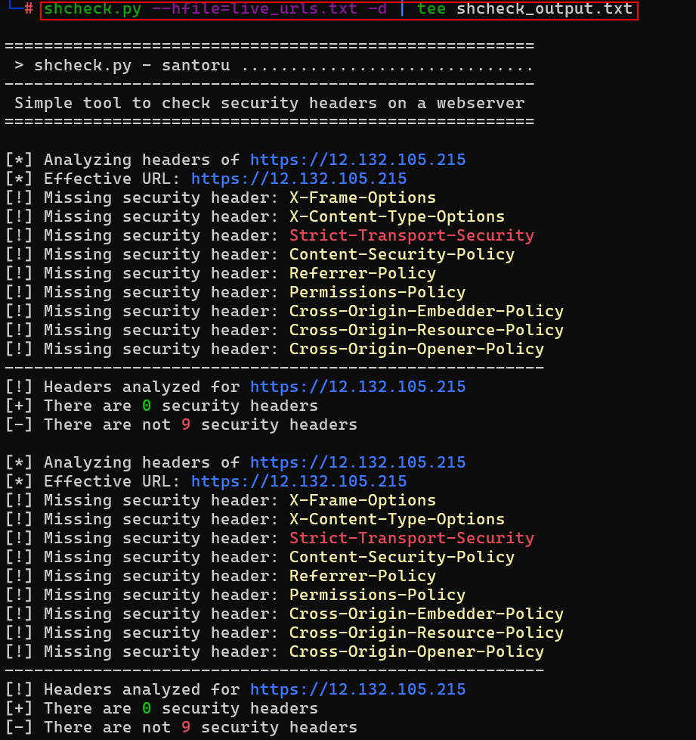
Figure 59 : Security Header Assessment

Web Application Enumeration and Exploitation

HTTPX
Cyderes used httpx to perform web service discovery across all in-scope assets, probing a range of common HTTP/HTTPS ports and collecting status codes, page titles, and technology fingerprints. A number of endpoints returned HTTP 503 and HTTP 400 responses, limiting further enumeration.
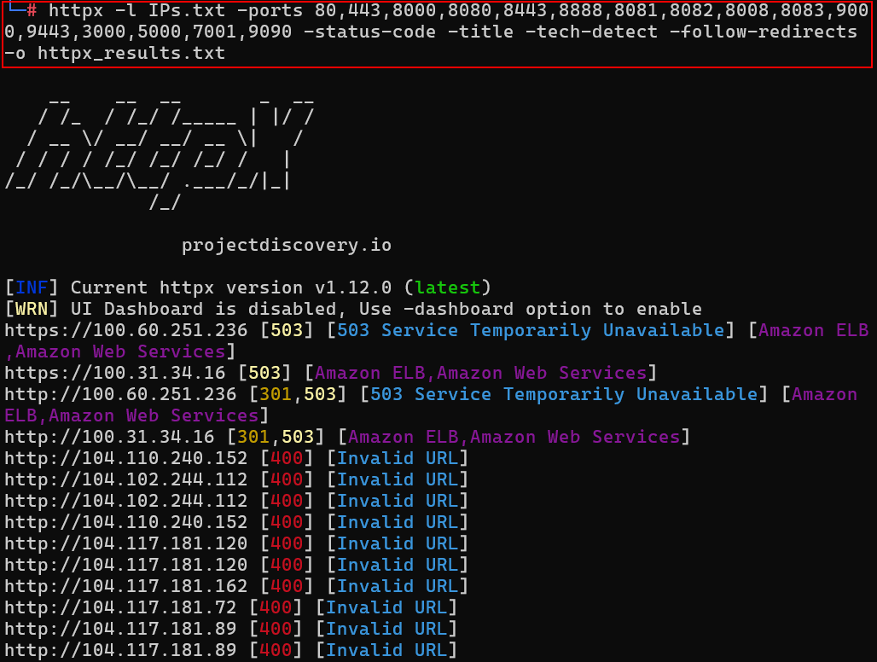
Figure 60 : Web Service Discovery with httpx

EyeWitness
Cyderes employed EyeWitness to perform visual inspection and screenshot capture of all in-scope URLs, enabling rapid visual identification of web applications, portals, and authentication interfaces.
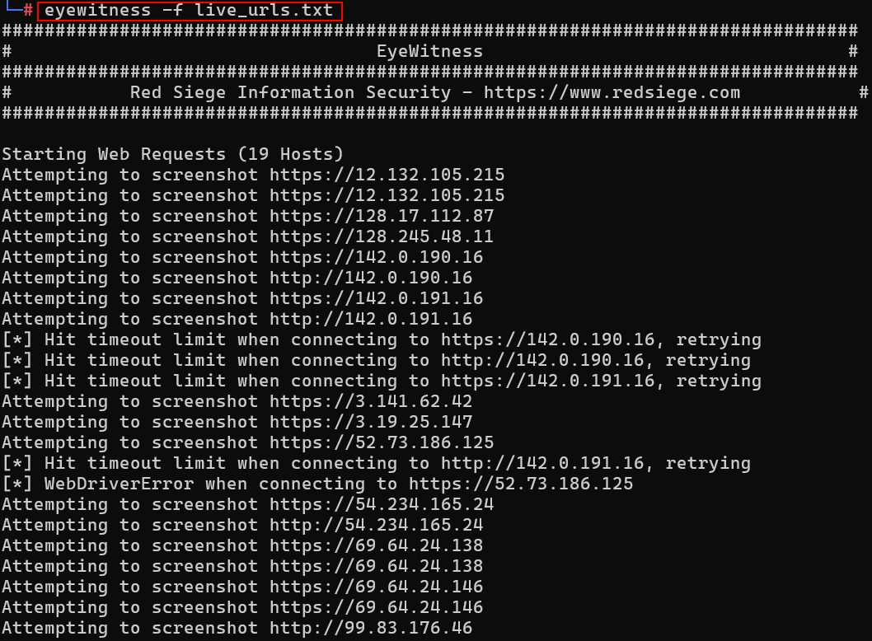
Figure 61 : Visual Web Application Inspection
During the review, Cyderes observed that browsing to one service endpoint displayed the default Windows Communication Foundation service page, which provided configuration examples for metadata publishing, service behaviors, and endpoint definitions, confirming that detailed WCF service information was publicly accessible.

Dirsearch
Cyderes employed dirsearch to perform directory and file enumeration across the in-scope web applications. The scan identified accessible ASP.NET handler endpoints with .ashx, .asmx and .aspx extensions returning HTTP 200, while path-traversal attempts were blocked with HTTP 403 responses. No sensitive files were exposed.
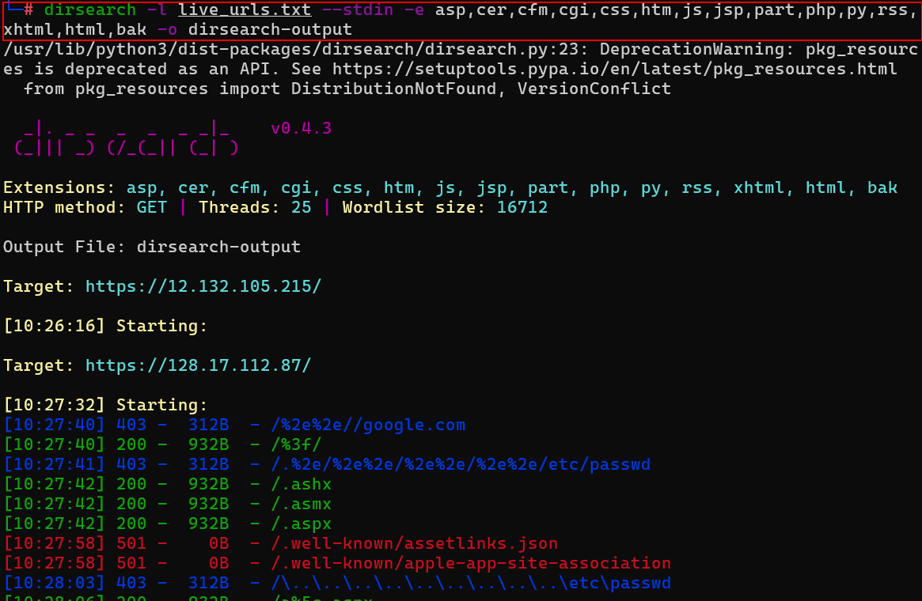
Figure 62 : Directory and File Enumeration

IIS Default Page Enabled
Cyderes identified that several hosts, including advotrac19-origin.advocatecapital.com, served the default Microsoft Internet Information Services welcome page, disclosing the underlying web server technology and indicating a default or incompletely configured deployment.
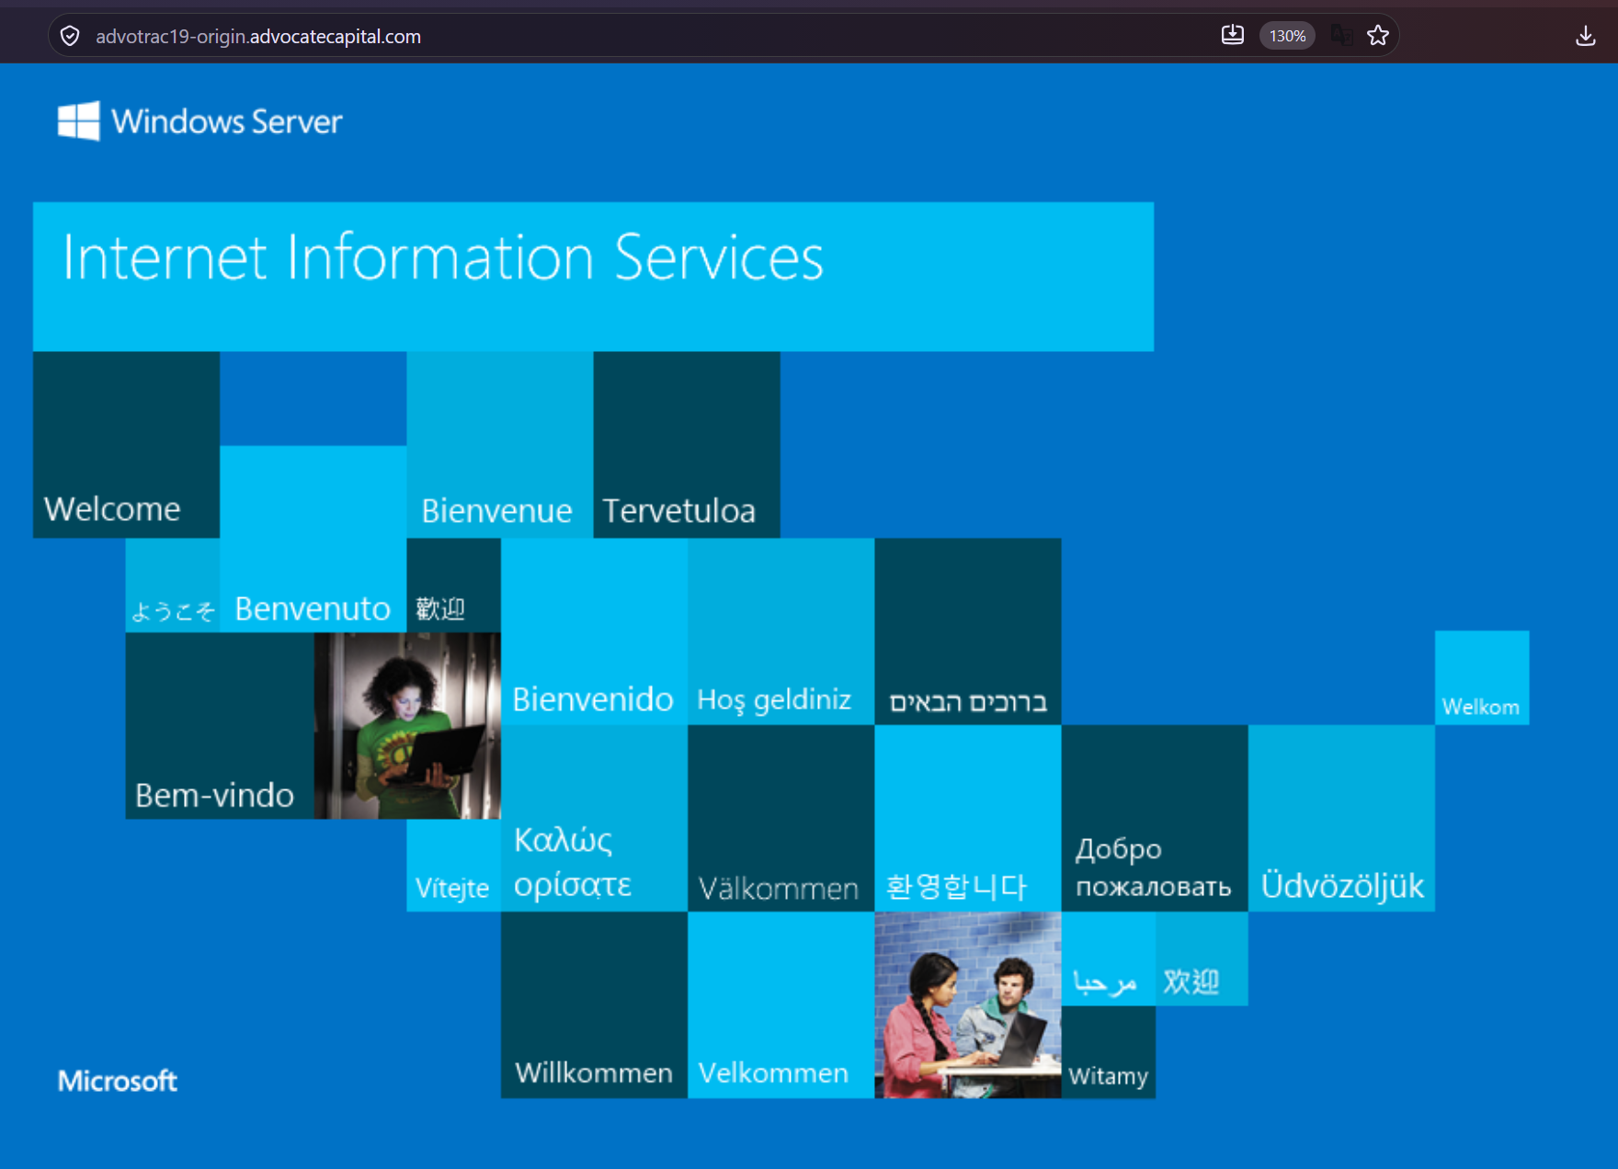
Figure 63 : IIS Default Page Exposed

Web Server HTTP Header Internal IP Disclosure
Cyderes observed that by removing the HTTP Host header and downgrading the request from HTTP/1.1 to HTTP/1.0, the web server at autodiscover.advocapinsurance.com disclosed the internal IP address 10.167.18.17 in the Location response header, whereas a normal HTTP/1.1 request with the Host header redirected to the public hostname.
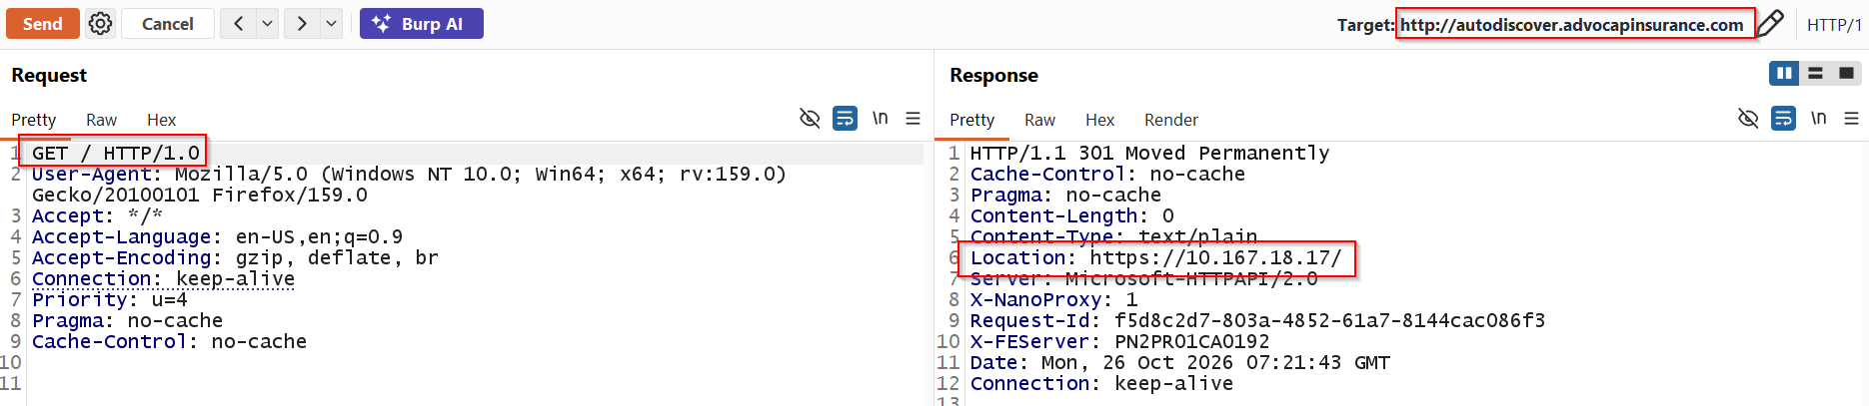
Figure 64 : Internal IP Address Disclosure via HTTP/1.0 Downgrade

HTTP Host Header Attacks
Cyderes tested autodiscover.advocapinsurance.com for host header manipulation by replacing the Host header with a Burp Collaborator domain. The server responded with a 301 redirect whose Location header contained the supplied domain, showing that the client-controlled Host header is trusted when building the redirect.
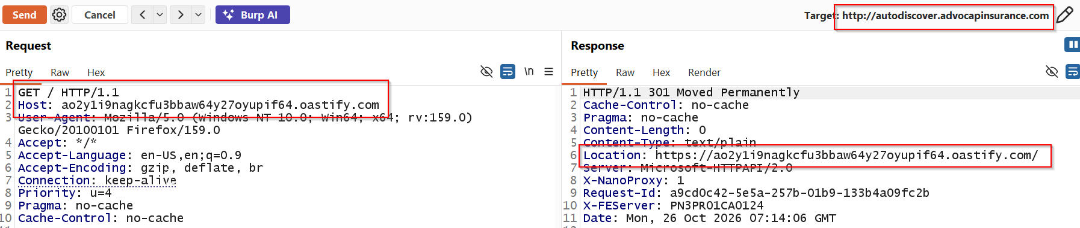
Figure 65 : Attacker-Controlled Host Header Reflected in Redirect Location
Cyderes followed the redirect and confirmed that the request was received by the Burp Collaborator server with a Referer header identifying autodiscover.advocapinsurance.com, confirming that users could be redirected to an attacker-controlled host.
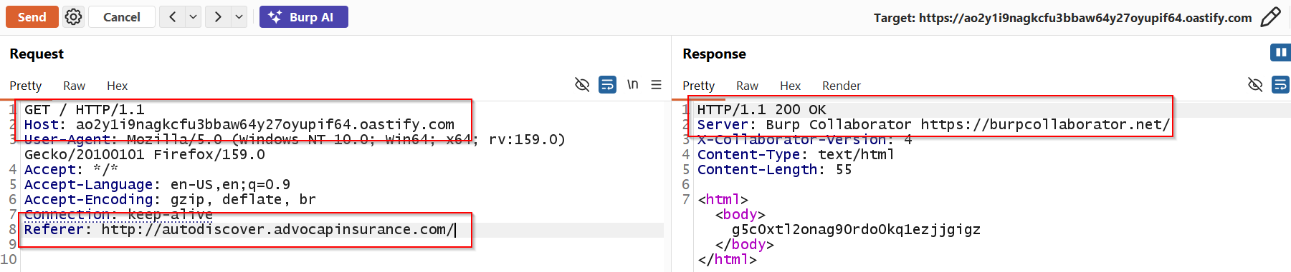
Figure 66 : Redirected Request Received by Burp Collaborator

Outdated Software Components in Use
Cyderes identified outdated client-side software components in use. The host secure.advocatecapital.com was serving DOMPurify version 3.3.3, an outdated version of the library, via /assets/js/purify.min.js.
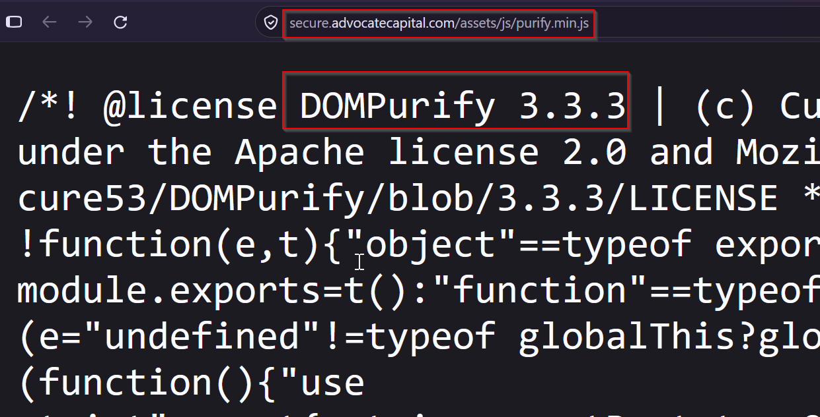
Figure 67 : Outdated Software Component - DOMPurify 3.3.3

Stack Traces in Error Messages
Cyderes identified that host 3.141.62.42 returned a verbose ASP.NET Server Error / Runtime Error page when requesting /common/config/db.ini, disclosing framework and web.config configuration details that could aid an attacker in further targeting the application.
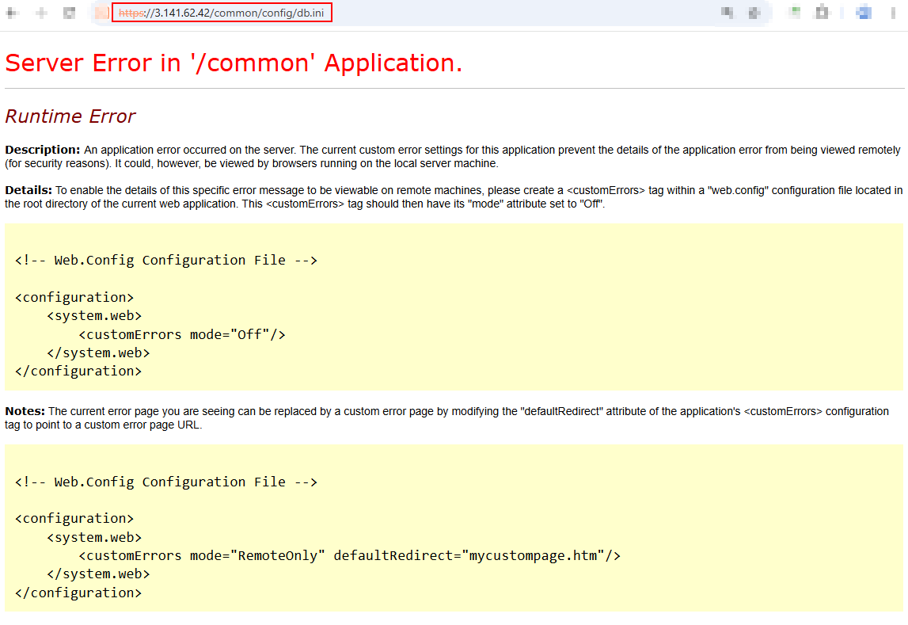
Figure 68 : Verbose Error Message / Stack Trace Disclosure

Web Server Password Auto-Completion
Cyderes identified that the AdvoTrac access-code form hosted at https://testsecure2.advocatecapital.com/ contains an password input field named txtAccessCode that does not set the autocomplete attribute to off, so browsers may offer to store the value entered.
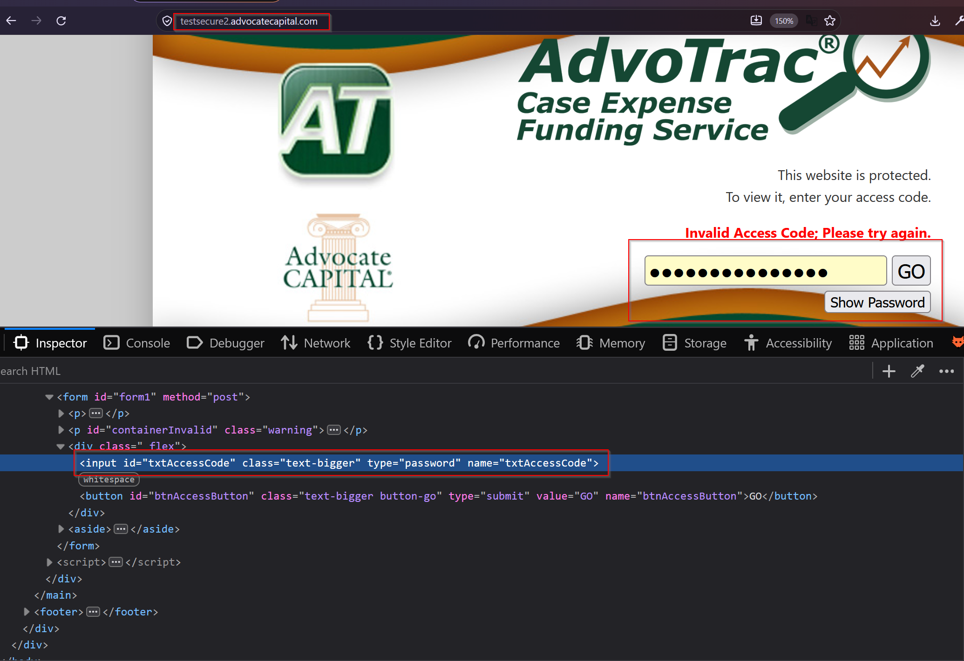
Figure 69 : Password Field Without autocomplete Attribute

Cisco SSL VPN Login Page
Cyderes identified a Cisco SSL VPN service web login interface during web reconnaissance. Subsequently, Burp Suite was utilized to test the interface for common and default Cisco credentials using a wordlist.
Cyderes performed a password brute-force attack using Burp Suite Intruder against the identified Cisco SSL VPN login interface. The testing confirmed that default Cisco credentials are not in use, as the response length and HTTP status code remained consistent across all credential attempts, indicating no successful authentication.

Exploitation Attempts

PHP to Web Shell (PHP2Shell)
Cyderes tested the identified web hosts for PHP-based remote command execution leading to web shell access, known as PHP2Shell, using a dedicated scanner against the live URL set. No hosts were found to be vulnerable.
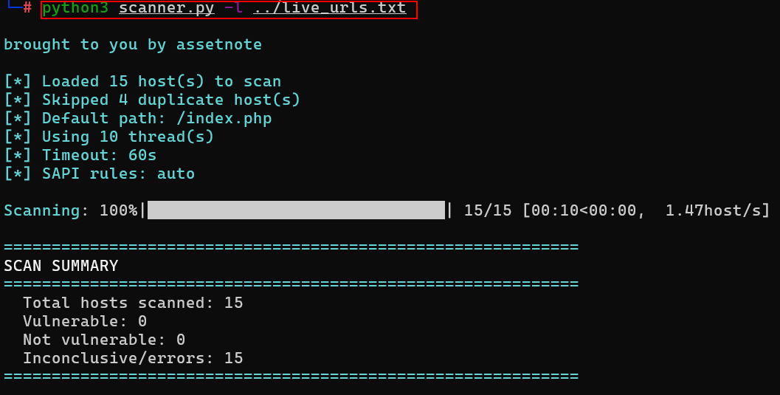
Figure 70 : PHP2Shell Scanner on Live URLs
Cyderes also tested the full in-scope address space using Nuclei PHP2Shell templates. No hosts were found to be vulnerable and no web shell access was obtained.
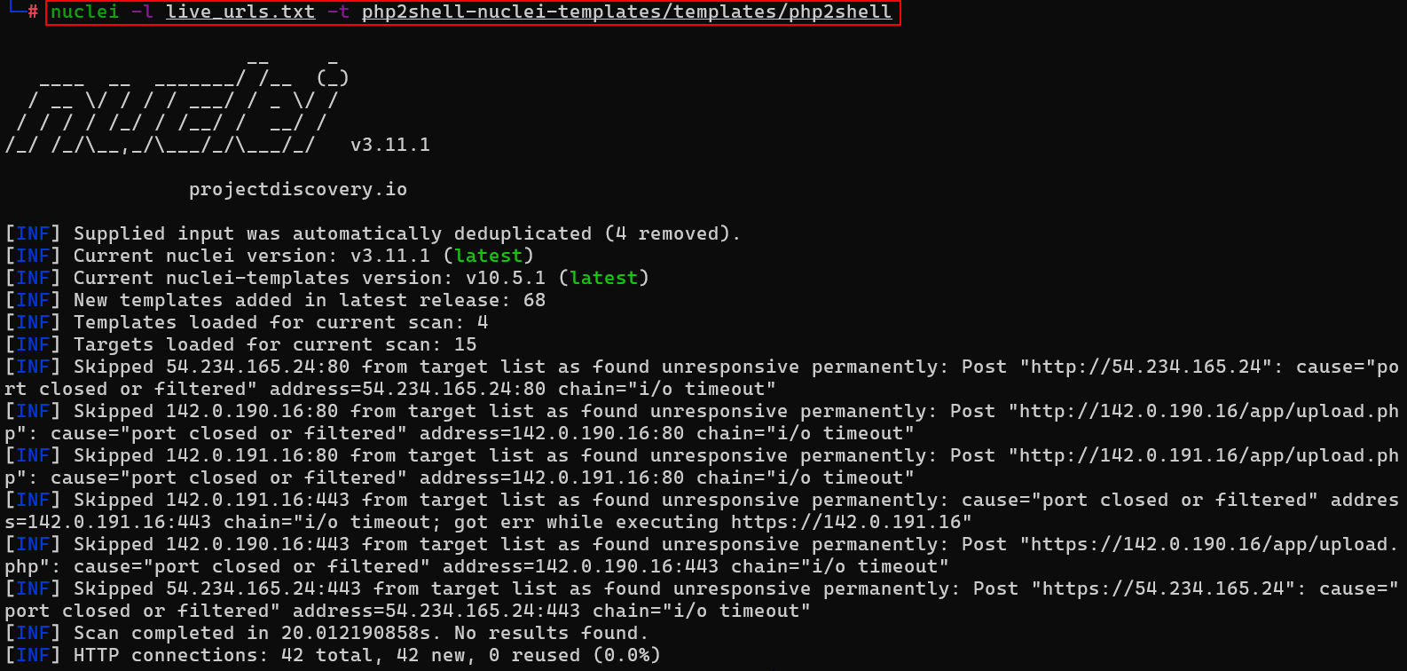
Figure 71 : PHP2Shell Nuclei Template Scan

Node.js to Web Shell (Node2Shell)
Cyderes tested the in-scope hosts for Node.js-based remote command execution leading to web shell access, known as Node2Shell, using a dedicated scanner against the full address space. No hosts were found to be vulnerable and no web shell access was obtained.
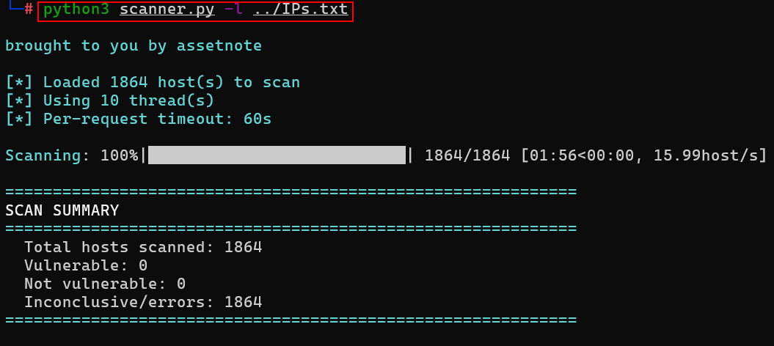
Figure 72 : Node2Shell Scanner

Key Vulnerabilities

External Network
EXT-001 | SSL Version 2 and 3 Protocol Detection | Medium
Description
The remote service accepts connections encrypted using SSL 2.0 and/or SSL 3.0. These versions of SSL are affected by several cryptographic flaws, including:
An insecure padding scheme with CBC ciphers.
Insecure session renegotiation and resumption schemes.
An attacker can exploit these flaws to conduct man-in-the-middle attacks or to decrypt communications between the affected service and clients.
Although SSL/TLS has a secure means for choosing the highest supported version of the protocol (so that these versions will be used only if the client or server support nothing better), many web browsers implement this in an unsafe way that allows an attacker to downgrade a connection (such as in POODLE). Therefore, it is recommended that these protocols be disabled entirely.
NIST has determined that SSL 3.0 is no longer acceptable for secure communications. As of the date of enforcement found in PCI DSS v3.1, any version of SSL will not meet the PCI SSC's definition of 'strong cryptography'.
Impact
An attacker can perform the man in middle attack and sniff the traffic.
Affected Assets
52.73.186.125:443
Replication Steps
Cyderes used sslscan against 52.73.186.125:443 and confirmed that the SSLv2, SSLv3, and TLS 1.0 protocols were enabled on the host.
Figure 73 : SSLv2 / SSLv3 Enabled - sslscan
Cyderes used the Nmap ssl-enum-ciphers NSE script against 52.73.186.125:443 and confirmed the weak 3DES and RC4 cipher suites offered over the legacy SSLv3 protocol.
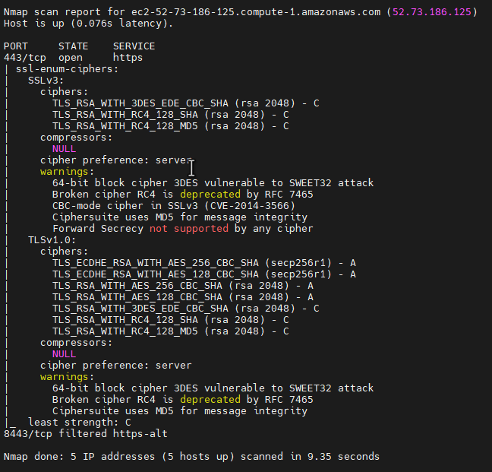
Figure 74 : Weak Cipher Suites over SSLv3 - ssl-enum-ciphers
Recommendations
- Use TLS 1.2 (with approved cipher suites) or higher instead.
Reference
- https://www.schneier.com/academic/paperfiles/paper-ssl.pdf
- https://www.openssl.org/~bodo/ssl-poodle.pdf

EXT-002 | HTTP Host Header Attacks | Low
Description
HTTP Host Header attacks occur when an application trusts client-controlled host-related headers without properly validating them. In addition to the standard Host header, applications and reverse proxies may process headers such as X-Forwarded-Host, X-Host, and X-Forwarded-Server to determine the requested hostname. Improper handling of these headers can allow adversaries to influence application behavior or construct requests using an attacker-controlled hostname.
Impact
Successful exploitation can allow adversaries to manipulate password-reset links, redirects, absolute URLs, or other application-generated content. Depending on the application's functionality and infrastructure, host header manipulation can also contribute to cache poisoning, access-control bypasses, phishing attacks, or other security issues.
Affected Assets
autodiscover.advocapinsurance.com:80
Replication Steps
Cyderes sent a normal request to autodiscover.advocapinsurance.com using GET / HTTP/1.1 with the legitimate Host header. The server responded with a 301 redirect to the public hostname https://autodiscover.advocapinsurance.com/.
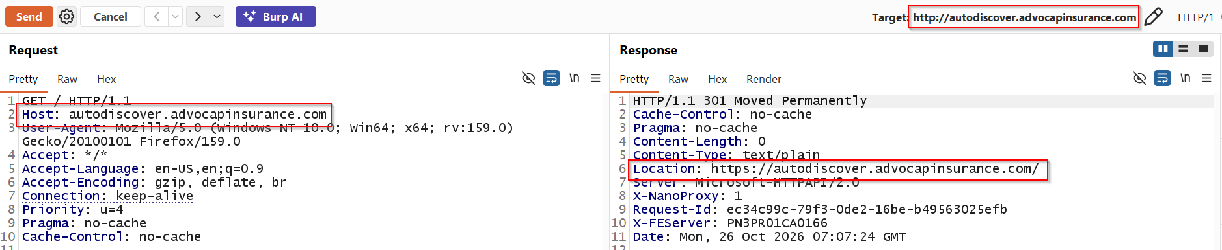
Figure 75 : Baseline Request with Legitimate Host Header
Cyderes then replaced the Host header with a Burp Collaborator domain. The server responded with a 301 redirect, and the Location header pointed to the supplied domain, showing that the client-controlled Host header is trusted.
Figure 76 : Attacker-Controlled Host Header Reflected in Redirect Location
Cyderes followed the redirect and confirmed that the request was received by the Burp Collaborator server with the Referer header set to http://autodiscover.advocapinsurance.com/, confirming that a user could be redirected to an attacker-controlled host.
Figure 77 : Redirected Request Received by Burp Collaborator

Recommendations
- Applications should validate the Host header and all supported host-related headers against an explicit allowlist of trusted hostnames.
- Reverse proxies and load balancers should remove or overwrite client-supplied forwarding headers before forwarding requests to backend applications.
- Applications should use a trusted, server-side canonical hostname when generating password-reset links, redirects, absolute URLs, and other security-sensitive content instead of relying on client-controlled headers.
Reference
- http://acunetix.com/blog/articles/automated-detection-of-host-header-attacks/
- https://portswigger.net/web-security/host-header#how-to-prevent-http-host-header-attacks

EXT-003 | SSL Self-Signed Certificate | Low
Description
A self-signed certificate is an identity certificate that is signed by the same entity whose identity it certifies. The X.509 certificate chain for this service is not signed by a recognized certificate authority. In public key infrastructure (PKI) arrangements, a digital signature from a certificate authority (CA) attests that a particular public key certificate is valid. Each CA has one or more root keys, and the certificates associated with those public keys are "trust anchors" that use a special type of self-signed certificates.
Impact
If the remote host is a public host in production, this nullifies the use of SSL as anyone could establish a man-in-the-middle attack against the remote host.
Affected Assets
128.245.16.50:443
128.245.32.10:443
128.245.48.11:443
view.engage.pnfp.com
Replication Steps
Cyderes used the Nmap ssl-cert NSE script against 128.245.48.11:443 and confirmed a self-signed certificate where the Subject and Issuer were identical, showing localhost.localdomain and MyCompany.
Figure 78 : Self-Signed Certificate - 128.245.48.11
Cyderes confirmed a self-signed certificate on 128.245.32.10:443 with an identical Subject and Issuer.
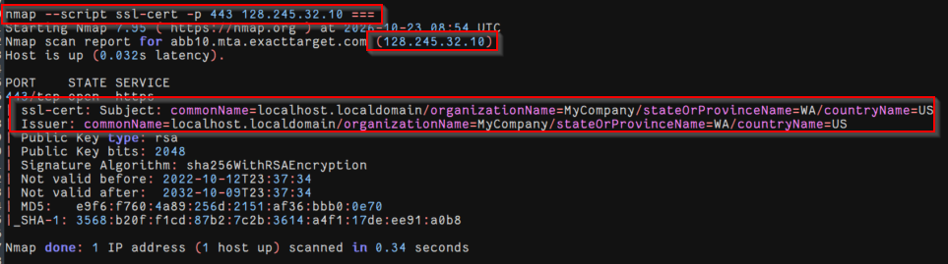
Figure 79 : Self-Signed Certificate - 128.245.32.10
Cyderes confirmed a self-signed certificate on 128.245.16.50:443 with an identical Subject and Issuer.
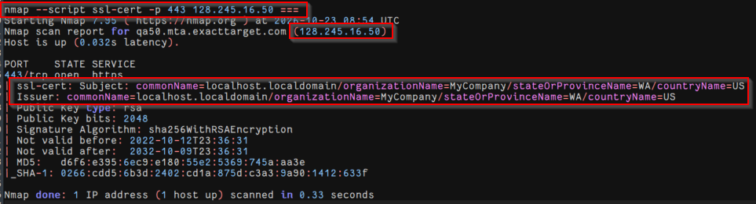
Figure 80 : Self-Signed Certificate - 128.245.16.50
Recommendations
- Windows: A self-signed certificate is an identity certificate that is signed by the same entity whose identity it certifies. The X.509 certificate chain for this service is not signed by a recognized certificate authority. In public key infrastructure (PKI) arrangements, a digital signature from a certificate authority (CA) attests that a particular public key certificate is valid. Each CA has one or more root keys, and the certificates associated with those public keys are "trust anchors" that use a special type of self-signed certificates.
- Linux: If the remote host is a public host in production, this nullifies the use of SSL as anyone could establish a man-in-the-middle attack against the remote host.
Reference
- https://en.wikipedia.org/wiki/Self-signed_certificate
- https://www.sslshopper.com/article-how-to-create-a-self-signed-certificate.html

EXT-004 | SSL Medium Strength Cipher Suites Supported (SWEET32) | Low
Description
The remote host supports the use of SSL ciphers that offer medium strength encryption. Nessus regards medium strength as any encryption that uses key lengths at least 64 bits and less than 112 bits, or else that uses the 3DES encryption suite.
Impact
The remote host supports TLS cipher suites that use 64-bit block ciphers such as Triple DES (3DES), which makes it vulnerable to the SWEET32 birthday attack (CVE-2016-2183). When a large amount of data (about 32 GB) is encrypted with the same key in one long-lived connection, repeated ciphertext blocks begin to appear. A Man-in-the-Middle (MitM) attacker who captures enough of this traffic can use those repeats to recover sensitive data from HTTPS sessions, such as session cookies, and hijack the user’s authenticated session.
Affected Assets
52.73.186.125:443
188.114.96.2:443,8443
188.114.96.3:443,8443
188.114.97.2:443,8443
188.114.97.3:443,8443
Replication Steps
Cyderes used the Nmap ssl-enum-ciphers NSE script against 188.114.96.3:443 and confirmed the service accepted the 64-bit block cipher suite TLS_RSA_WITH_3DES_EDE_CBC_SHA, making it vulnerable to the SWEET32 attack tracked as CVE-2016-2183. Multiple hosts were confirmed vulnerable.
Figure 81 : SWEET32 64-bit Block Cipher 3DES Accepted
Recommendations
- Reconfigure the affected application if possible to avoid use of medium strength ciphers.
Reference
- https://sweet32.info

EXT-005 | SSH Authentication Method | Low
Description
Password-based authentication in Secure Shell (SSH) allows users to log in using a username and password combination. While convenient, this method is more susceptible to attacks such as brute-force, password guessing, and credential stuffing. If weak or reused passwords are used, an attacker may gain unauthorized access to the system. Best security practices recommend using key-based authentication instead of password-based authentication to strengthen SSH access controls.
Impact
Password-based SSH authentication increases the risk of brute-force, password-guessing, and credential-stuffing attacks. If weak or reused credentials are compromised, an attacker could potentially gain unauthorized access to the affected SSH services and underlying systems.
Affected Assets
69.64.24.135:22
199.187.144.52:22000
Replication Steps
Cyderes used the Nmap ssh-auth-methods NSE script against 69.64.24.135:22 and confirmed the service supported password, public-key, and keyboard-interactive authentication. Password-based authentication increases exposure to brute-force attacks.
Figure 82 : SSH Supported Authentication Methods
Recommendations
- Disable SSH password authentication and enable key-based authentication instead.
- Implement account lockout or rate-limiting mechanisms to mitigate brute-force attacks.
- Restrict SSH access using firewall rules or allow access only from trusted IP addresses.
Reference
- https://www.openssh.com/security.html
- https://www.cisecurity.org/benchmark
- https://cheatsheetseries.owasp.org/cheatsheets/Authentication_Cheat_Sheet.html

EXT-006 | SSL Certificate Expiry | Low
Description
It has been observed that the certificate has been expired on the following hosts.
Impact
Letting an SSL Certificate expire can have a number of consequences for the website owner and also for the end user.
Website Owner:
- Reduction in trust as the site becomes unsecure
- Decline in sales and revenue with increased shopping basket abandonments - Corporate brand and reputation adversely affected putting the business at risk
Website User:
- Warning error messages displayed by browsers when visiting the site
- Personal information at risk from man-in-the-middle attacks
- Individual susceptible to fraud and identity theft
Affected Assets
12.132.105.215:443
128.17.80.127:443
52.73.186.125:443
Replication Steps
Cyderes used the Nmap ssl-cert NSE script against 52.73.186.125:443 and confirmed the certificate was expired, valid only through April 4, 2021.
Figure 83 : Expired SSL Certificate - 52.73.186.125
Cyderes inspected the certificate on 12.132.105.215:443 and confirmed it was expired, valid only through January 23, 2026.
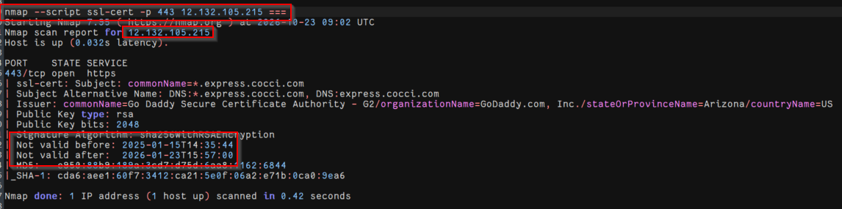
Figure 84 : Expired SSL Certificate - 12.132.105.215
Cyderes inspected the certificate on 128.17.80.127:443 and confirmed it was expired, valid only through May 30, 2024.
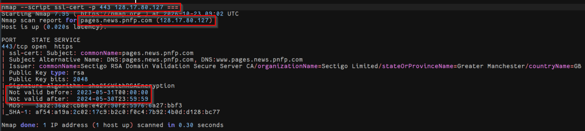
Figure 85 : Expired SSL Certificate - 128.17.80.127
Recommendations
- Regularly monitor and audit all SSL/TLS certificates to identify those nearing expiration and ensure timely renewal.
- Immediately replace any expired certificates to maintain secure, trusted, and uninterrupted communications.
Reference
- https://www.digicert.com/ssl-certificate-installation.htm
- https://www.nist.gov/publications/guidelines-selection-configuration-and-use-transport-layer-security-tls-implementations?pub_id=915295

EXT-007 | Web Server Allows Password Auto-Completion | Low
Description
The remote web server includes at least one HTML form field with an input type of 'password' where the 'autocomplete' attribute is not set to 'off'. While this doesn't pose a direct risk to the server itself, it means that users who fill out these forms may have their credentials saved in their browser. This could potentially compromise confidentiality if users share their computer with others or if their device is compromised in the future.
Impact
Credentials entered into the affected form may be cached by the user's browser, exposing them to anyone who can access the device or browser profile.
Affected Assets
https://testsecure2.advocatecapital.com/
Replication Steps
Cyderes inspected the access-code form served at https://testsecure2.advocatecapital.com/ and observed that the password input field named txtAccessCode is defined without the autocomplete off attribute.
Figure 86 : Password Field Without autocomplete Attribute
Recommendations
- Add the attribute 'autocomplete=off' to these fields to prevent browsers from caching credentials.
Reference
- https://portswigger.net/kb/issues/00500800_password-field-with-autocomplete-enabled

EXT-008 | SSL Vulnerable Cipher Suites Supported | Low
Description
The remote service supports the use of medium strength SSL ciphers such as: DES, 3DES etc. Any encryption suite that uses key lengths at least 64 bits and less than 112 bits, or else that uses the 3DES encryption suite is regarded as a medium strength cipher suite.
Impact
The DES and Triple DES ciphers, as used in the TLS, SSH, and IPSec protocols and other protocols and products, have a birthday bound of approximately four billion blocks, which makes it easier for remote attackers to obtain cleartext data via a birthday attack against a long-duration encrypted session, as demonstrated by an HTTPS session using Triple DES in CBC mode, aka a "Sweet32" attack.
Affected Assets
- Refer Appendix: SSL Vulnerable Cipher Suites Supported
Replication Steps
Cyderes used the Nmap ssl-enum-ciphers NSE script and sslscan against 100.31.34.16:443 and confirmed acceptance of multiple weak cipher suites, including SHA-1 MAC suites and static key exchange suites with no forward secrecy.
Figure 87 : Weak Cipher Suites - 100.31.34.16
Cyderes confirmed that 52.7.151.139:443 likewise accepted multiple weak cipher suites.
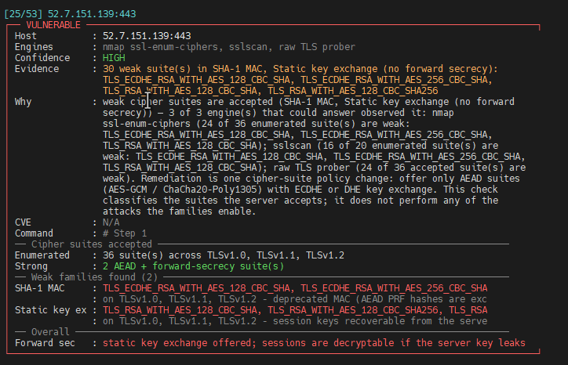
Figure 88 : Weak Cipher Suites - 52.7.151.139
The scan summary confirmed that multiple hosts across the external perimeter were affected by weak cipher suites.
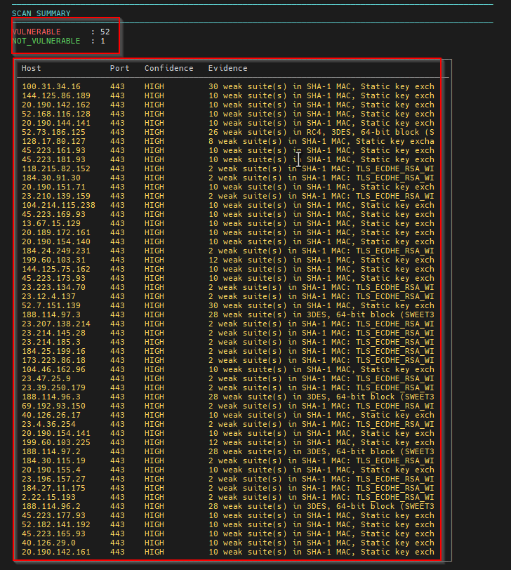
Figure 89 : Weak Cipher Suites - Scan Summary
Recommendations
Windows: The remote service supports the use of medium strength SSL ciphers such as: DES, 3DES etc. Any encryption suite that uses key lengths at least 64 bits and less than 112 bits, or else that uses the 3DES encryption suite is regarded as a medium strength cipher suite. Linux: The DES and Triple DES ciphers, as used in the TLS, SSH, and IPSec protocols and other protocols and products, have a birthday bound of approximately four billion blocks, which makes it easier for remote attackers to obtain cleartext data via a birthday attack against a long-duration encrypted session, as demonstrated by an HTTPS session using Triple DES in CBC mode, aka a "Sweet32" attack.
Reference
- https://support.microsoft.com/en-in/help/245030/how-to-restrict-the-use-of-certain-cryptographic-algorithms-and-protoc
- https://www.digicert.com/cert-inspector-vulnerabilities.htm#server_vulnerabilities
- http://httpd.apache.org/docs/2.0/mod/mod_ssl.html#sslproxyciphersuite
- https://www.digicert.com/ssl-support/apache-disabling-ssl-v3.htm
- https://learn.microsoft.com/en-us/windows-server/security/tls/tls-registry-settings

EXT-009 | TLS Version 1.1 Deprecated Protocol | Low
Description
The remote service accepts connections encrypted using TLS 1.1. TLS 1.1 lacks support for current and recommended cipher suites. Ciphers that support encryption before MAC computation, and authenticated encryption modes such as GCM cannot be used with TLS 1.1
As of March 31, 2020, Endpoints that are not enabled for TLS 1.2 and higher will no longer function properly with major web browsers and major vendors.
Impact
This will allow attacker to sniff the network and decrypt the traffic.
Affected Assets
- Refer Appendix: TLS Version 1.1 Deprecated Protocol
Replication Steps
Cyderes used the Nmap ssl-enum-ciphers NSE script and sslscan and confirmed the deprecated TLS 1.1 protocol was negotiable across multiple hosts, including 52.73.186.125:443. That host also offered the legacy SSLv3 protocol.
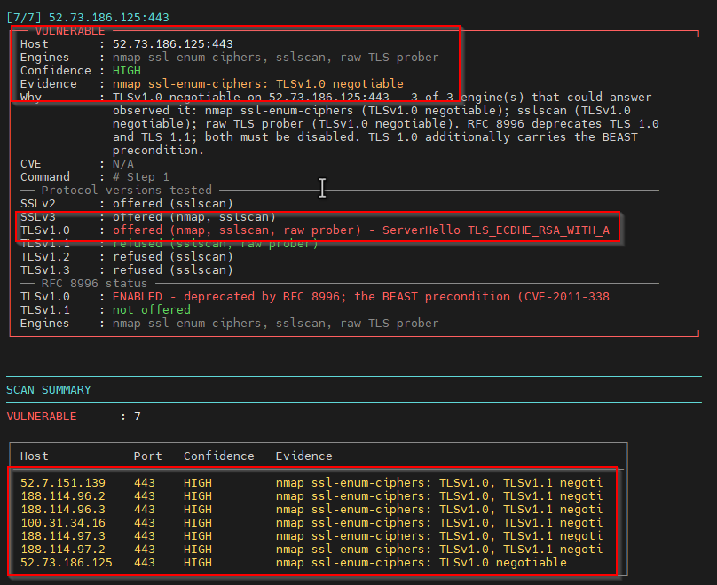
Figure 90 : TLS 1.1 Negotiable - Scan Summary
Recommendations
- Enable support for TLS 1.2 and/or 1.3, and disable support for TLS 1.1.
Reference
- https://datatracker.ietf.org/doc/html/rfc8996
- http://www.nessus.org/u?c8ae820d
- https://www.tenable.com/plugins/nessus/157288

EXT-010 | SSL Vulnerable to Padding Oracle Attack | Low
Description
The remote servers supports SSLv3/TLS 1.0 with at least one CBC cipher suite, indicating that these servers were vulnerable. It also appears that TLS 1.1 and TLS 1.2 is supported on servers. However, the Fallback SCSV mechanism was not supported which allowed connections to be "rolled back" to SSLv3.
Impact
The remote host is affected by a man-in-the-middle (MitM) information disclosure vulnerability known as POODLE. The vulnerability is due to the TLS server not verifying block cipher padding when using a cipher suite that employs a block cipher such as AES and DES. The lack of padding checking can allow encrypted TLS traffic to be decrypted. This vulnerability could allow for the decryption of HTTPS traffic by an unauthorized third party. A MiTM (Man-in-the-Middle) attacker can decrypt a selected byte of a ciphertext in as few as 256 tries if they are able to force a victim application to repeatedly send the same data over newly created SSL 3.0 /TLS 1.0 connections.
Affected Assets
52.73.186.125:443
Replication Steps
Cyderes used the Nmap ssl-poodle NSE script against 52.73.186.125:443 and confirmed the service was vulnerable to the POODLE padding-oracle attack tracked as CVE-2014-3566.
Figure 91 : POODLE Padding Oracle Vulnerability
Recommendations
Windows: The remote servers supports SSLv3/TLS 1.0 with at least one CBC cipher suite, indicating that these servers were vulnerable. It also appears that TLS 1.1 and TLS 1.2 is supported on servers. However, the Fallback SCSV mechanism was not supported which allowed connections to be "rolled back" to SSLv3. Linux: The remote host is affected by a man-in-the-middle (MitM) information disclosure vulnerability known as POODLE. The vulnerability is due to the TLS server not verifying block cipher padding when using a cipher suite that employs a block cipher such as AES and DES. The lack of padding checking can allow encrypted TLS traffic to be decrypted. This vulnerability could allow for the decryption of HTTPS traffic by an unauthorized third party. A MiTM (Man-in-the-Middle) attacker can decrypt a selected byte of a ciphertext in as few as 256 tries if they are able to force a victim application to repeatedly send the same data over newly created SSL 3.0 /TLS 1.0 connections.
Reference
https://support.microsoft.com/en-in/help/245030/how-to-restrict-the-use-of-certain-cryptographic-algorithms-and-protoc http://httpd.apache.org/docs/2.0/mod/mod_ssl.html#sslproxyciphersuite https://www.digicert.com/ssl-support/apache-disabling-ssl-v3.htm
https://learn.microsoft.com/en-us/windows-server/security/tls/tls-registry-settings

EXT-011 | Missing Security-Related Headers | Low
Description
The application did not implement certain HTTP security headers, which may help protect the application against attacks, including Cross-site Scripting (XSS).
Impact
The application does not implement recommended HTTP security headers (such as Strict-Transport-Security (HSTS) or X-Content-Type-Options). This does not directly compromise the host but removes browser-enforced protections against attacks, such as clickjacking, MIME-type sniffing, and protocol downgrade, increasing exposure if a client-side vulnerability is later identified.
Affected Assets
- Refer Appendix: Missing Security Headers by IP
Replication Steps
Cyderes used Shcheck to assess the HTTP security headers of the identified web services and observed multiple security headers missing on the identified hosts. The missing headers for each host are listed in the appendix.
Figure 92 : Security Header Assessment
Recommendations
- Implement the security-related HTTP headers to improve the overall security posture of the application.
Reference
- https://cheatsheetseries.owasp.org/cheatsheets/HTTP_Headers_Cheat_Sheet.html

EXT-012 | TLS Version 1.0 Protocol Detection | Low
Description
The remote service accepts connections encrypted using TLS 1.0. TLS 1.0 has a number of cryptographic design flaws. Modern implementations of TLS 1.0 mitigate these problems, but newer versions of TLS like 1.2 and 1.3 are designed against these flaws and should be used whenever possible.
As of March 31, 2020, Endpoints that aren’t enabled for TLS 1.2 and higher will no longer function properly with major web browsers and major vendors.
PCI DSS v3.2 requires that TLS 1.0 be disabled entirely by June 30, 2018, except for POS POI terminals (and the SSL/TLS termination points to which they connect) that can be verified as not being susceptible to any known exploits.
Impact
This will allow attacker to sniff the data from network.
Affected Assets
- Refer Appendix: TLS Version 1.0 Protocol Detection
Replication Steps
Cyderes used the Nmap ssl-enum-ciphers NSE script and sslscan against 52.7.151.139:443 and confirmed the deprecated TLS 1.0 protocol was negotiable. TLS 1.0 is deprecated by RFC 8996 and is a precondition for the BEAST attack.
Figure 93 : TLS 1.0 Negotiable - 52.7.151.139
Recommendations
- Enable support for TLS 1.2 and 1.3, and disable support for TLS 1.0.
Reference
https://tools.ietf.org/html/draft-ietf-tls-oldversions-deprecate-00
https://datatracker.ietf.org/doc/html/rfc8996
https://www.tenable.com/plugins/nessus/104743

EXT-013 | ICMP Timestamp Request Remote Date Disclosure | Low
Description
The remote host responds to an ICMP Timestamp Request (Type 13) by returning a Timestamp Reply (Type 14) containing the system's current time in milliseconds since midnight UTC. This response leaks metadata about the host's operating system and uptime to unauthenticated remote attackers without requiring any privileges.
Impact
While the risk is minimal, this information allows an attacker to map the network without authentication and fingerprint the operating system more accurately. This data aids attackers in refining their selection of specific exploits (timing attacks or token generation algorithms) against the host, serving as a low-level reconnaissance enabler.
Affected Assets
- Refer Appendix: ICMP Timestamp Request Remote Date Disclosure
Replication Steps
Cyderes used an ICMP timestamp proof-of-concept based on nmap -sn -PP --reason and hping3 --icmptype 13, and confirmed the hosts responded to ICMP Type 13 Timestamp Requests with a Type 14 Timestamp Reply, disclosing the system clock.
Figure 94 : ICMP Timestamp Reply Disclosure
The disclosure was confirmed across multiple responsive hosts, including pnfp.celerocompass.com and multiple pnfp.gpcloudservice.com endpoints.
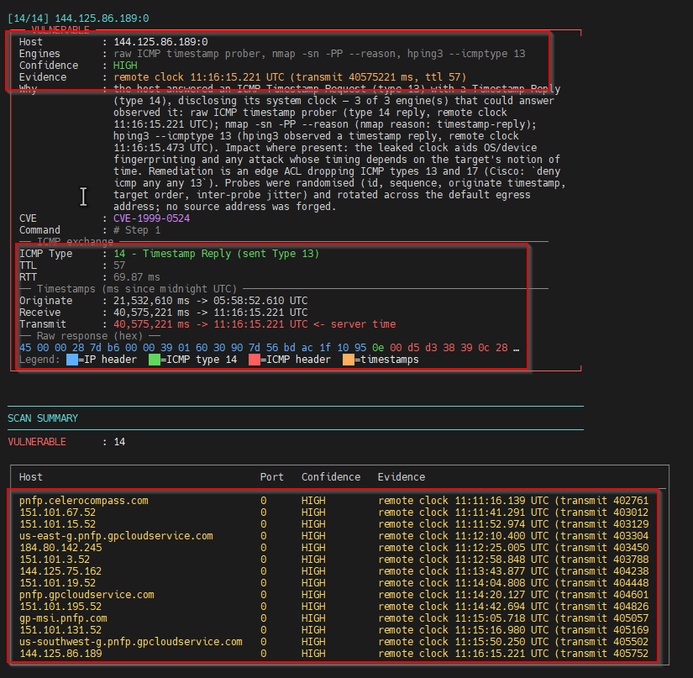
Figure 95 : ICMP Timestamp Disclosure - Affected Hosts
Recommendations
- Firewall Filtering: Block inbound ICMP Type 13 (Timestamp Request) and outbound Type 14 (Timestamp Reply) at the network perimeter.
- Host-Level Configuration: Configure the operating system firewall to drop these specific ICMP packets.
- Disable ICMP Timestamp Responses: Modify OS kernel parameters to ignore timestamp requests.
Reference
- https://retest.dk/vulnerabilities-base/icmp-timestamp-request-remote-date-disclosure-cve-1999-0524/?lang=en
- https://nvd.nist.gov/vuln/detail/CVE-1999-0524

EXT-014 | SSH Weak Algorithms Supported | Low
Description
The remote SSH server is configured to allow weak encryption algorithms such as arcfour and 3des. With reference to RFC4251 ciphers which includes 3DES, ARCFOUR, twofish, serpent, and blowfish have certain security flaws associated with them.
Impact
The "arcfour128" and "arcfour256" algorithm is the same algorithm i.e. the RC4 cipher using a 128-bit key and 256-bit key respectively. Arcfour (and RC4) has problems with weak keys, and should not be used anymore. RFC 4253 also advises against using Arcfour due to an issue with weak keys.
Affected Assets
69.64.24.135:22
199.187.144.52:22000
Replication Steps
Cyderes performed an SSH configuration assessment against 69.64.24.135:22 using ssh-audit and identified weak key exchange algorithms, including ecdh-sha2-nistp256/384/521 and SHA-1 based algorithms.
Figure 96 : SSH Weak Key Exchange Algorithms - 69.64.24.135
Cyderes performed the same ssh-audit assessment against 199.187.144.52:22000 and confirmed weak SHA-1 based key exchange algorithms.
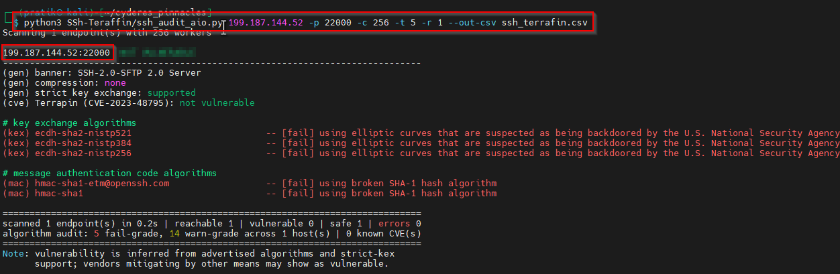
Figure 97 : SSH Weak Algorithms - 199.187.144.52:22000
Recommendations
- Windows: The remote SSH server is configured to allow weak encryption algorithms such as arcfour and 3des. With reference to RFC4251 ciphers which includes 3DES, ARCFOUR, twofish, serpent, and blowfish have certain security flaws associated with them. Linux: The "arcfour128" and "arcfour256" algorithm is the same algorithm i.e. the RC4 cipher using a 128-bit key and 256-bit key respectively. Arcfour (and RC4) has problems with weak keys, and should not be used anymore. RFC 4253 also advises against using Arcfour due to an issue with weak keys.
Reference
- https://tools.ietf.org/html/rfc4253#section-6.3
- https://linux.uits.uconn.edu/2014/06/25/ssh-weak-ciphers-and-mac-algorithms/
- https://www.openssh.com/releasenotes.html
- https://datatracker.ietf.org/doc/html/rfc4253#section-6.3

EXT-015 | SSH Weak MAC Algorithms Enabled | Low
Description
It was observed that the SSH on the host is configured to allow either MD5 or 96-bit MAC algorithms which is considered a weak algorithm.
Impact
Remote SSH host is configured with a default list of ssh MAC algorithms including MD5 and SHA1. These algorithms are no longer considered to be secure for message authentication codes.
Affected Assets
69.64.24.135:22
199.187.144.52:22000
Replication Steps
Cyderes performed an SSH configuration assessment against 69.64.24.135:22 using ssh-audit and identified weak MD5 and SHA-1 based MAC algorithms, including hmac-md5 and hmac-sha1.
Figure 98 : SSH Weak MAC Algorithms - 69.64.24.135
Recommendations
- Windows: It was observed that the SSH on the host is configured to allow either MD5 or 96-bit MAC algorithms which is considered a weak algorithm.
- Linux: Remote SSH host is configured with a default list of ssh MAC algorithms including MD5 and SHA1. These algorithms are no longer considered to be secure for message authentication codes.
Reference
- https://www.netiq.com/documentation/access-manager-44/security-guide/data/t45l3vkp79bz.html
- https://community.arubanetworks.com/t5/Monitoring-Management-Location/How-to-disable-obsolete-SSH-cipher-MAC-algorithms/ta-p/292311
- https://datatracker.ietf.org/doc/html/rfc6151

EXT-016 | Stack traces in error messages | Low
Description
Custom error messages, that are displayed through error handling done by the programmer, must not contain details from framework exception objects. Error messages inside exception objects often contains sensitive information such as stack traces, internal path disclosure, etc.
Impact
The sensitive information could be displayed in the error messages which in turn can aid the attacker in other type of attacks such as directory traversal, buffer overflow, etc. which can adversely affect the confidentiality and integrity of the application.
Affected Assets
https://3.141.62.42/common/config/db.ini
Replication Steps
Cyderes requested the resource https://3.141.62.42/common/config/db.ini and the server returned a verbose ASP.NET Server Error / Runtime Error page disclosing framework and web.config configuration details.
Figure 99 : Verbose ASP.NET Error Page - 3.141.62.42
Recommendations
- Windows: Custom error messages, that are displayed through error handling done by the programmer, must not contain details from framework exception objects. Error messages inside exception objects often contains sensitive information such as stack traces, internal path disclosure, etc. Linux: The sensitive information could be displayed in the error messages which in turn can aid the attacker in other type of attacks such as directory traversal, buffer overflow, etc. which can adversely affect the confidentiality and integrity of the application.
Reference
- https://www.owasp.org/index.php/Improper_Error_Handling
- https://www.owasp.org/index.php/Missing_Error_Handling
- https://cheatsheetseries.owasp.org/cheatsheets/Error_Handling_Cheat_Sheet.html
- https://owasp.org/www-community/Improper_Error_Handling

EXT-017 | SSH Server CBC Mode Ciphers Enabled | Low
Description
SSH when using a block cipher algorithm in Cipher Block Chaining (CBC) mode, makes it easier for remote attackers to recover certain plaintext data from an arbitrary block of ciphertext in an SSH session via unknown vectors.
Impact
A remote user with control of the network between the client and the server can inject connection errors and monitor the SSH error handling response to recover up to 32 bits of plain text from an SSH-protected connection. The attack process will terminate the SSH connection. *Note: - CBC mode connections are affected. - CTR mode connections are not affected.
Affected Assets
69.64.24.135:22
199.187.144.52:22000
Replication Steps
Cyderes performed an SSH configuration assessment against 69.64.24.135:22 using ssh-audit and identified CBC-mode encryption algorithms, including rijndael-cbc and 3des-cbc.
Figure 100 : SSH CBC Mode Ciphers - 69.64.24.135
Recommendations
- Windows: SSH when using a block cipher algorithm in Cipher Block Chaining (CBC) mode, makes it easier for remote attackers to recover certain plaintext data from an arbitrary block of ciphertext in an SSH session via unknown vectors.
- Linux: A remote user with control of the network between the client and the server can inject connection errors and monitor the SSH error handling response to recover up to 32 bits of plain text from an SSH-protected connection. The attack process will terminate the SSH connection.
- *Note: - CBC mode connections are affected. - CTR mode connections are not affected.
Reference
- https://linux.uits.uconn.edu/2014/06/25/ssh-weak-ciphers-and-mac-algorithms/
- https://www.openssh.com/txt/cbc.adv
- https://securitytracker.com/id/1021235
- https://www.kb.cert.org/vuls/id/958563

EXT-018 | SSL RC4 Cipher Suites Supported (Bar Mitzvah) | Low
Description
The remote host supports the use of RC4 cipher suites. The RC4 cipher is flawed in its generation of a pseudo-random stream of bytes so that a wide variety of small biases are introduced into the stream, decreasing its randomness. If plaintext is repeatedly encrypted (e.g., HTTP cookies), and an attacker is able to obtain many (i.e., tens of millions) ciphertexts, the attacker may be able to derive the plaintext.
Impact
Remote attackers may be able to conduct plaintext recovery attacks against the initial bytes of a stream by sniffing network traffic. The weak RC4 cipher has following vulnerabilities: 1. The RC4 algorithm, as used in the TLS protocol and SSL protocol, has many single-byte biases, which makes it easier for remote attackers to conduct plaintext recovery attacks via statistical analysis of cipher text in a large number of sessions that use the same plaintext (CVE-2013-2566). 2. The RC4 algorithm, as used in the TLS protocol and SSL protocol, does not properly combine state data with key data during the initialization phase, which makes it easier for remote attackers to conduct plaintext recovery attacks against the initial bytes of a stream by sniffing network traffic that occasionally relies on keys affected by the Invariance Weakness, and then using a brute force approach involving LSB values, aka the "Bar Mitzvah" issue (CVE-2015-2808)
Affected Assets
52.73.186.125:443
Replication Steps
Cyderes used the Nmap ssl-enum-ciphers NSE script against 52.73.186.125:443 and confirmed acceptance of RC4 cipher suites over SSLv3 and TLSv1.0, which is the Bar Mitzvah issue tracked as CVE-2015-2808.
Figure 101 : SSL RC4 Cipher Suites - Bar Mitzvah
Recommendations
- Windows: The remote host supports the use of RC4 cipher suites. The RC4 cipher is flawed in its generation of a pseudo-random stream of bytes so that a wide variety of small biases are introduced into the stream, decreasing its randomness. If plaintext is repeatedly encrypted (e.g., HTTP cookies), and an attacker is able to obtain many (i.e., tens of millions) ciphertexts, the attacker may be able to derive the plaintext.
- Linux: Remote attackers may be able to conduct plaintext recovery attacks against the initial bytes of a stream by sniffing network traffic. The weak RC4 cipher has following vulnerabilities:
1. The RC4 algorithm, as used in the TLS protocol and SSL protocol, has many single-byte biases, which makes it easier for remote attackers to conduct plaintext recovery attacks via statistical analysis of cipher text in a large number of sessions that use the same plaintext (CVE-2013-2566).
2. The RC4 algorithm, as used in the TLS protocol and SSL protocol, does not properly combine state data with key data during the initialization phase, which makes it easier for remote attackers to conduct plaintext recovery attacks against the initial bytes of a stream by sniffing network traffic that occasionally relies on keys affected by the Invariance Weakness, and then using a brute force approach involving LSB values, aka the "Bar Mitzvah" issue (CVE-2015-2808)
Reference
- https://support.microsoft.com/en-in/help/245030/how-to-restrict-the-use-of-certain-cryptographic-algorithms-and-protoc
- https://www.digicert.com/ssl-support/apache-disabling-ssl-v3.htm
- http://httpd.apache.org/docs/2.0/mod/mod_ssl.html#sslproxyciphersuite
- https://access.redhat.com/solutions/26833
- https://learn.microsoft.com/en-us/windows-server/security/tls/tls-registry-settings

EXT-019 | SSL Certificate Chain Contains Weak Diffie-Hellman key | Low
Description
The remote host allows SSL/TLS connections with one or more Diffie-Hellman moduli less than or equal to 1024 bits. Through cryptanalysis, a third party may be able to find the shared secret in a short amount of time (depending on modulus size and attacker resources).
Impact
Logjam is a security vulnerability against a Diffie-Hellman key exchange ranging from 512-bit (US export-grade) to 1024-bit keys.
Affected Assets
144.125.86.189:443
gp-msi.pnfp.com (144.125.75.162)
Replication Steps
Cyderes used the Nmap ssl-dh-params NSE script against 144.125.86.189:443 and confirmed the service used a non-safe Diffie-Hellman prime with incorrectly generated group parameters.
Figure 102 : Weak Diffie-Hellman Parameters - 144.125.86.189
Recommendations
- Windows: The remote host allows SSL/TLS connections with one or more Diffie-Hellman moduli less than or equal to 1024 bits. Through cryptanalysis, a third party may be able to find the shared secret in a short amount of time (depending on modulus size and attacker resources).
- Linux: Logjam is a security vulnerability against a Diffie-Hellman key exchange ranging from 512-bit (US export-grade) to 1024-bit keys.
Reference
- https://weakdh.org/logjam.html
- https://serverfault.com/questions/693241/how-to-fix-logjam-vulnerability-in-apache-httpd

EXT-020 | Outdated Software Components in Use | Low
Description
Outdated software versions may contain publicly disclosed security vulnerabilities that have been addressed in newer releases. Continued use of unsupported or vulnerable software components may expose applications and systems to known security risks and increase the likelihood of successful exploitation.
Impact
Outdated software exposed applications and systems to known security vulnerabilities. Exploitation of these vulnerabilities resulted in unauthorized access, information disclosure, privilege escalation, remote code execution, application compromise, or other security consequences depending on the affected software and vulnerability.
Affected Assets
https://secure.advocatecapital.com/assets/js/purify.min.js
52.73.186.125:443
Replication Steps
Cyderes reviewed the client-side JavaScript served by secure.advocatecapital.com and identified DOMPurify version 3.3.3, an outdated version, served at /assets/js/purify.min.js.
Figure 103 : Outdated Component - DOMPurify 3.3.3
Recommendations
- It is recommended to upgrade outdated software components to the latest vendor-supported versions that contain applicable security fixes.
- It is also recommended to maintain an inventory of software dependencies and regularly assess these components for known vulnerabilities.
- Security updates should be prioritized based on the severity and exploitability of the associated vulnerabilities.
Reference
- DOMPurify 3.3.3 - https://security.snyk.io/package/npm/dompurify/3.3.3

EXT-021 | IIS Default Page Enabled | Low
Description
It was observed that the version of Microsoft IIS on the remote host can be retrieved from the respective IIS default page.
Impact
Default pages of the server should be removed or should be configured such that the information about the system is not disclosed as well as the services running on the server should not be allowed in public visibility. Using this information the attacker can craft an attack to sabotage the website as well as the services running on it. It also ensures that sensitive Information is not leaked through these pages.
Affected Assets
https://advotrac19-origin.advocatecapital.com/
https://69.64.24.138/
https://69.64.24.146/
https://3.141.62.42/
https://3.19.25.147/
Replication Steps
Cyderes browsed to https://advotrac19-origin.advocatecapital.com/ and observed the server returned the default Microsoft IIS welcome page, disclosing the underlying web server technology.
Figure 104 : Default Microsoft IIS Welcome Page
Recommendations
- Windows: It was observed that the version of Microsoft IIS on the remote host can be retrieved from the respective IIS default page.
- Linux: Default pages of the server should be removed or should be configured such that the information about the system is not disclosed as well as the services running on the server should not be allowed in public visibility. Using this information the attacker can craft an attack to sabotage the website as well as the services running on it. It also ensures that sensitive Information is not leaked through these pages.
Reference
- https://support.microsoft.com/en-in/help/320051/how-to-configure-the-default-document-in-internet-information-services
- https://learn.microsoft.com/en-us/iis/configuration/system.webserver/defaultdocument/

EXT-022 | Web Server HTTP Header Internal IP Disclosure | Low
Description
This may expose internal IP addresses that are usually hidden or masked behind a Network Address Translation (NAT) Firewall or proxy server.
There is a known issue with Microsoft IIS 4.0 doing this in its default configuration. This may also affect other web servers, web applications, web proxies, load balancers and through a variety of misconfigurations related to redirection.
Impact
It will disclose the internal IP addresses and can be used in further attacks.
Affected Assets
- Refer Appendix: Web Server HTTP Header Internal IP Disclosure
Replication Steps
Cyderes sent a normal request to autodiscover.advocapinsurance.com using GET / HTTP/1.1 with the Host header present. The server responded with a 301 redirect to the public hostname https://autodiscover.advocapinsurance.com/.
Figure 105 : Baseline Request with HTTP/1.1 and Host Header
Cyderes then removed the Host header and downgraded the request to GET / HTTP/1.0. The server disclosed the internal IP address 10.167.18.17 in the Location response header as https://10.167.18.17/.
Figure 106 : Internal IP Disclosed via HTTP/1.0 Downgrade
Recommendations
- Mask the IP address information from the HTTP headers.
- Apply configuration suggested by vendor.
Reference
- http://www.nessus.org/u?fe24f941
- http://www.nessus.org/u?8e23582e
- http://www.nessus.org/u?4eedfe2d
- https://www.tenable.com/plugins/nessus/10759

Appendix

Vulnerability Severity Key
Critical
Poses an extremely high risk to the affected system or network. Such a vulnerability can allow an attacker to take complete control over the affected system, exfiltrate sensitive data, or cause significant disruption or damage. A Critical vulnerability is likely to be actively exploited by threat actors, and immediate action is required to mitigate the risk.
High
Poses a significant risk to the affected system or network. Such a vulnerability can allow a threat actor to gain access to sensitive data, execute arbitrary code, or cause moderate disruption or damage to the system. A High vulnerability is likely to be actively exploited by attackers, and prompt action is required to mitigate the risk.
Medium
Poses a moderate risk to the affected system or network. Such a vulnerability can allow a threat actor to gain some level of access or information but is unlikely to result in significant disruption or damage to the system. A Medium vulnerability may be actively exploited by attackers in some cases, but the likelihood and impact of exploitation are generally lower than with higher-rated vulnerabilities.
Low
Poses a relatively low risk to the affected system or network. Such a vulnerability may allow a threat actor to gain some information or perform limited actions but is unlikely to result in significant disruption or damage to the system. A Low vulnerability may be actively exploited by attackers in rare cases, but the likelihood and impact of exploitation are generally low. Mitigation of low-risk vulnerabilities may be a lower priority than those rated as Critical, High, or Medium, but should still be addressed in a timely manner to minimize risk.

Methodology
Cyderes’ Offensive Security methodology draws upon mastery of best practices and decades of aggregate experience. Below is the general approach Cyderes follows, although the specific demands of a given engagement may alter the tactics employed.

Intelligence Gathering
Cyderes collects as much information about the client’s personnel, property and technology as possible. This data is gathered from various sources available on the internet, such as search engines, WHOIS databases, and custom scripts. Cyderes then analyzes the data and removes false positives to ensure accuracy, affording a better understanding of the client’s attack surface and informing the plan of attack.

Vulnerability Analysis
Once an accurate picture of the target network is generated, Cyderes scans the client environment with a suite of tools suited for the technology being tested. Once the scans are completed, Cyderes analyzes the results to determine likely avenues of access, validating each one manually to determine if a vulnerability can be exploited.

Exploitation
During this phase, the primary goal is to access systems or sensitive information. Focusing on tactics with the greatest chance of success (and least impact to the client), Cyderes attempts to exploit all facets of the client’s attack surface, unless specifically prohibited in the rules of engagement (RoE).

Post-Exploitation
Once the system is exploited, Cyderes attempts to accomplish the engagement’s agreed-upon goals. A common tactic, for instance, is to establish full administrative control over a particular network.

Reporting
When the assessment is complete, Cyderes documents all discovered vulnerabilities and exploits, failed attempts, as well as company strengths and opportunities for improvement.

External Scope
The following tables list the external IP addresses and domains that were in scope for this assessment.
IP Addresses
2.16.1.171 | 2.16.1.184 | 2.16.1.185 | 2.16.1.195 | 2.16.1.234
2.16.1.248 | 2.16.6.197 | 2.16.6.219 | 2.16.6.223 | 2.16.6.227
2.16.11.9 | 2.16.11.51 | 2.16.11.72 | 2.16.11.80 | 2.16.27.75
2.16.27.78 | 2.16.27.81 | 2.16.27.87 | 2.16.27.89 | 2.16.27.90
2.16.27.93 | 2.16.27.97 | 2.16.55.137 | 2.16.55.139 | 2.16.55.142
2.16.145.4 | 2.16.145.8 | 2.16.145.11 | 2.16.145.48 | 2.16.165.93
2.16.165.98 | 2.16.165.114 | 2.16.165.124 | 2.16.165.131 | 2.16.165.132
2.16.165.147 | 2.16.165.154 | 2.16.169.9 | 2.16.169.15 | 2.16.169.18
2.16.192.5 | 2.16.204.147 | 2.16.204.149 | 2.16.204.159 | 2.16.247.133
2.16.247.162 | 2.17.47.4 | 2.17.47.6 | 2.17.161.89 | 2.17.161.99
2.18.20.133 | 2.18.20.135 | 2.18.20.137 | 2.18.20.141 | 2.18.27.4
2.18.27.5 | 2.18.27.8 | 2.18.27.14 | 2.18.27.15 | 2.18.27.17
2.18.27.18 | 2.18.27.19 | 2.18.27.20 | 2.18.27.22 | 2.18.27.24
2.18.27.25 | 2.18.27.26 | 2.18.27.32 | 2.18.63.198 | 2.18.63.200
2.18.63.201 | 2.18.63.207 | 2.18.63.209 | 2.18.63.211 | 2.18.63.214
2.18.63.215 | 2.18.63.220 | 2.18.63.227 | 2.18.64.6 | 2.18.64.8
2.18.64.9 | 2.18.64.10 | 2.18.64.19 | 2.18.64.21 | 2.18.64.26
2.18.64.27 | 2.18.64.31 | 2.18.64.34 | 2.18.67.130 | 2.18.67.134
2.18.67.138 | 2.18.67.139 | 2.18.67.140 | 2.18.67.153 | 2.18.67.154
2.18.67.161 | 2.18.67.162 | 2.18.67.163 | 2.18.244.29 | 2.18.244.32
2.19.10.196 | 2.19.10.200 | 2.19.96.171 | 2.19.96.240 | 2.19.120.80
2.19.120.83 | 2.19.120.89 | 2.19.120.97 | 2.19.173.9 | 2.19.176.193
2.19.176.210 | 2.19.183.13 | 2.19.183.49 | 2.19.185.43 | 2.19.250.134
2.19.250.142 | 2.19.251.160 | 2.19.251.170 | 2.20.110.75 | 2.20.110.91
2.20.139.77 | 2.20.139.82 | 2.20.142.4 | 2.20.142.18 | 2.20.142.51
2.20.142.56 | 2.20.142.155 | 2.20.142.160 | 2.20.142.182 | 2.20.142.183
2.20.143.43 | 2.20.143.80 | 2.20.143.115 | 2.20.143.153 | 2.20.180.130
2.20.180.136 | 2.20.180.139 | 2.20.180.148 | 2.20.180.153 | 2.20.180.160
2.21.2.192 | 2.21.2.225 | 2.21.22.58 | 2.21.239.10 | 2.21.239.22
2.21.239.147 | 2.21.239.158 | 2.21.240.15 | 2.21.243.73 | 2.21.243.79
2.21.243.95 | 2.21.243.106 | 2.21.243.109 | 2.21.243.115 | 2.21.243.120
2.21.243.132 | 2.21.243.135 | 2.21.243.149 | 2.21.243.153 | 2.21.243.158
2.21.243.164 | 2.21.243.171 | 2.21.243.175 | 2.21.243.176 | 2.21.243.177
2.21.243.178 | 2.21.243.181 | 2.22.15.193 | 2.22.251.49 | 2.22.251.59
2.23.7.9 | 2.23.7.16 | 2.23.7.18 | 2.23.7.19 | 2.23.7.32
2.23.92.4 | 2.23.92.5 | 2.23.92.13 | 2.23.92.15 | 2.23.92.16
2.23.92.22 | 2.23.92.25 | 2.23.92.28 | 2.23.92.30 | 3.19.25.147
3.33.139.32 | 3.133.236.155 | 3.141.62.42 | 3.162.112.9 | 3.162.112.12
3.162.112.51 | 3.162.112.113 | 3.163.224.60 | 3.163.224.74 | 3.163.224.110
3.163.224.112 | 3.164.163.31 | 3.164.163.81 | 3.164.163.107 | 3.164.163.123
3.165.136.16 | 3.165.136.39 | 3.165.136.69 | 3.165.136.89 | 3.165.160.28
3.165.160.59 | 3.165.160.102 | 3.165.160.128 | 3.165.232.48 | 3.165.232.106
3.165.232.111 | 3.165.232.116 | 3.168.51.18 | 3.168.51.23 | 3.168.51.43
3.168.51.127 | 3.168.102.57 | 3.168.102.93 | 3.168.102.110 | 3.168.102.127
3.169.173.20 | 3.169.173.30 | 3.169.173.42 | 3.169.173.105 | 3.170.42.47
3.170.42.68 | 3.170.42.84 | 3.170.42.113 | 3.171.61.94 | 3.174.170.4
3.174.170.15 | 3.174.170.32 | 3.174.170.80 | 3.175.115.8 | 3.175.115.13
3.175.115.23 | 3.175.115.38 | 3.175.115.55 | 3.175.115.103 | 3.175.115.114
3.175.115.128 | 3.225.69.183 | 3.248.123.157 | 12.132.105.215 | 12.195.183.18
12.195.183.19 | 13.33.88.7 | 13.33.88.58 | 13.33.88.100 | 13.33.88.106
13.35.107.25 | 13.35.107.28 | 13.35.107.42 | 13.35.107.45 | 13.35.107.69
13.35.107.82 | 13.35.107.83 | 13.35.107.128 | 13.35.163.23 | 13.35.163.50
13.35.163.82 | 13.35.163.112 | 13.35.238.16 | 13.35.238.74 | 13.35.238.81
13.35.238.126 | 13.67.15.129 | 13.107.226.41 | 13.107.253.41 | 13.111.18.10
13.111.18.27 | 13.224.30.46 | 13.224.30.87 | 13.224.30.107 | 13.224.30.128
13.224.181.22 | 13.224.181.41 | 13.224.181.43 | 13.224.181.84 | 13.225.196.38
13.225.196.56 | 13.225.196.78 | 13.225.196.117 | 13.226.69.94 | 13.226.69.103
13.226.69.115 | 13.226.69.123 | 13.226.251.56 | 13.226.251.59 | 13.226.251.85
13.226.251.93 | 13.248.175.166 | 13.249.231.9 | 13.249.231.15 | 13.249.231.27
13.249.231.45 | 13.249.231.54 | 13.249.231.72 | 13.249.231.85 | 13.249.231.125
18.65.14.6 | 18.65.14.26 | 18.65.14.35 | 18.65.14.125 | 18.65.244.35
18.65.244.43 | 18.65.244.89 | 18.65.244.95 | 18.65.244.98 | 18.65.244.112
18.67.0.90 | 18.67.93.29 | 18.67.93.33 | 18.67.93.81 | 18.67.93.119
18.154.84.9 | 18.154.84.40 | 18.154.84.80 | 18.154.84.127 | 18.154.101.30
18.154.101.52 | 18.154.101.82 | 18.154.101.111 | 18.160.143.15 | 18.160.143.79
18.160.143.94 | 18.160.143.119 | 18.165.43.108 | 18.165.227.27 | 18.165.227.40
18.165.227.90 | 18.165.227.119 | 18.238.136.28 | 18.238.136.61 | 18.238.136.108
18.238.136.122 | 18.238.176.4 | 18.238.176.31 | 18.238.176.93 | 18.238.176.96
18.238.238.11 | 18.238.238.23 | 18.238.238.92 | 18.238.238.95 | 18.238.243.6
18.238.243.22 | 18.238.243.58 | 18.238.243.91 | 18.239.6.4 | 18.239.6.31
18.239.6.95 | 18.239.6.100 | 18.239.83.8 | 18.239.83.44 | 18.239.83.102
18.239.83.116 | 18.244.124.22 | 18.244.124.37 | 18.244.124.115 | 18.244.124.124
18.245.162.86 | 18.245.162.87 | 18.245.162.108 | 18.245.162.109 | 20.189.172.161
20.190.142.161 | 20.190.142.162 | 20.190.144.141 | 20.190.151.71 | 20.190.154.140
20.190.154.141 | 20.190.155.4 | 23.0.162.36 | 23.0.162.37 | 23.0.162.38
23.0.162.39 | 23.0.162.41 | 23.0.162.42 | 23.0.162.44 | 23.0.162.47
23.0.162.49 | 23.0.162.50 | 23.0.162.51 | 23.0.162.100 | 23.0.162.101
23.0.162.104 | 23.0.162.105 | 23.0.162.109 | 23.0.162.110 | 23.0.162.133
23.0.162.136 | 23.0.162.140 | 23.0.192.7 | 23.1.33.7 | 23.1.33.8
23.1.33.10 | 23.1.33.11 | 23.1.33.12 | 23.1.33.13 | 23.1.33.15
23.1.33.16 | 23.1.33.17 | 23.1.240.56 | 23.1.240.57 | 23.1.240.66
23.1.240.73 | 23.1.240.81 | 23.1.240.83 | 23.1.240.158 | 23.1.240.224
23.3.68.133 | 23.3.68.134 | 23.3.68.137 | 23.3.68.149 | 23.3.68.150
23.3.68.151 | 23.3.68.156 | 23.3.68.158 | 23.3.68.162 | 23.3.68.163
23.3.88.11 | 23.3.88.17 | 23.3.88.40 | 23.3.88.42 | 23.3.88.48
23.3.88.50 | 23.3.89.88 | 23.3.90.49 | 23.4.36.254 | 23.4.84.137
23.4.84.138 | 23.4.84.146 | 23.4.84.152 | 23.4.84.155 | 23.4.84.156
23.4.84.161 | 23.10.249.72 | 23.10.249.89 | 23.11.206.16 | 23.11.206.35
23.11.206.41 | 23.11.207.231 | 23.11.207.235 | 23.11.229.136 | 23.11.229.160
23.11.229.177 | 23.11.229.179 | 23.11.229.185 | 23.11.229.203 | 23.11.229.210
23.11.229.211 | 23.11.229.217 | 23.11.229.219 | 23.11.229.224 | 23.11.229.227
23.11.234.138 | 23.11.234.139 | 23.12.4.137 | 23.12.144.197 | 23.12.144.198
23.12.144.202 | 23.12.144.207 | 23.12.144.212 | 23.12.144.244 | 23.12.144.246
23.12.144.247 | 23.12.145.136 | 23.12.145.138 | 23.12.145.142 | 23.12.145.143
23.12.145.148 | 23.12.145.149 | 23.12.145.150 | 23.12.145.160 | 23.12.146.11
23.12.146.12 | 23.12.146.16 | 23.12.146.19 | 23.12.146.22 | 23.12.146.24
23.12.146.26 | 23.12.146.27 | 23.12.146.32 | 23.12.146.33 | 23.12.146.34
23.12.146.39 | 23.12.147.68 | 23.12.147.69 | 23.12.147.73 | 23.12.147.74
23.12.147.76 | 23.12.147.82 | 23.12.147.86 | 23.12.147.89 | 23.12.147.93
23.12.147.134 | 23.12.147.140 | 23.12.147.141 | 23.12.147.142 | 23.12.147.150
23.12.147.151 | 23.12.147.164 | 23.12.147.165 | 23.13.218.201 | 23.13.218.210
23.13.218.216 | 23.15.2.175 | 23.15.2.237 | 23.15.2.239 | 23.15.140.7
23.15.240.200 | 23.15.240.227 | 23.15.241.35 | 23.32.20.19 | 23.32.20.91
23.32.20.159 | 23.32.20.182 | 23.32.20.214 | 23.32.20.228 | 23.32.20.230
23.32.20.245 | 23.32.39.132 | 23.32.39.134 | 23.32.39.135 | 23.32.39.136
23.32.39.138 | 23.32.39.140 | 23.32.39.142 | 23.32.39.144 | 23.32.39.145
23.32.39.146 | 23.32.39.147 | 23.32.39.148 | 23.32.56.160 | 23.32.56.184
23.32.61.33 | 23.32.61.162 | 23.32.61.170 | 23.33.29.132 | 23.33.29.135
23.33.29.136 | 23.33.29.138 | 23.33.29.141 | 23.33.29.144 | 23.33.29.147
23.33.29.149 | 23.33.40.68 | 23.33.40.70 | 23.33.40.74 | 23.33.40.136
23.33.40.154 | 23.33.92.13 | 23.33.92.135 | 23.33.92.147 | 23.33.92.160
23.33.92.163 | 23.33.92.181 | 23.33.92.182 | 23.33.92.187 | 23.33.238.101
23.33.238.102 | 23.33.238.104 | 23.33.238.105 | 23.33.238.107 | 23.33.238.108
23.33.238.109 | 23.33.238.110 | 23.33.238.111 | 23.33.238.112 | 23.33.238.114
23.33.238.116 | 23.33.238.117 | 23.33.238.119 | 23.35.148.14 | 23.35.148.17
23.35.148.21 | 23.35.148.23 | 23.35.148.39 | 23.35.148.45 | 23.35.148.51
23.35.148.53 | 23.35.148.54 | 23.35.148.62 | 23.35.148.66 | 23.35.148.164
23.35.148.165 | 23.36.162.202 | 23.36.162.209 | 23.36.162.213 | 23.36.162.214
23.36.162.216 | 23.36.162.217 | 23.36.217.55 | 23.36.217.56 | 23.37.92.174
23.37.92.194 | 23.39.47.6 | 23.39.47.10 | 23.39.47.29 | 23.39.47.37
23.39.47.38 | 23.39.47.56 | 23.39.47.147 | 23.39.174.151 | 23.39.174.152
23.39.174.183 | 23.39.174.188 | 23.39.184.7 | 23.39.250.179 | 23.40.18.5
23.40.18.21 | 23.40.40.34 | 23.40.40.49 | 23.40.40.128 | 23.40.40.129
23.40.40.161 | 23.40.40.193 | 23.41.4.70 | 23.41.4.73 | 23.41.4.75
23.41.4.79 | 23.41.4.80 | 23.41.4.84 | 23.41.4.85 | 23.41.4.86
23.41.4.87 | 23.43.161.144 | 23.43.161.146 | 23.43.161.153 | 23.44.111.66
23.44.111.80 | 23.44.138.40 | 23.44.138.50 | 23.44.138.132 | 23.45.12.10
23.45.12.42 | 23.45.12.64 | 23.45.46.4 | 23.45.46.6 | 23.45.46.7
23.45.46.9 | 23.45.46.11 | 23.45.46.15 | 23.45.46.43 | 23.45.46.198
23.45.46.199 | 23.45.46.201 | 23.45.46.202 | 23.45.46.205 | 23.45.46.207
23.45.46.208 | 23.45.46.210 | 23.45.46.211 | 23.45.49.11 | 23.45.49.17
23.45.123.14 | 23.45.123.45 | 23.45.123.52 | 23.45.123.53 | 23.45.123.54
23.45.123.60 | 23.45.123.65 | 23.45.123.66 | 23.45.123.76 | 23.45.123.80
23.45.123.81 | 23.45.123.83 | 23.45.168.49 | 23.45.168.51 | 23.46.10.195
23.46.10.197 | 23.46.10.201 | 23.46.10.204 | 23.46.216.200 | 23.46.216.206
23.46.228.166 | 23.46.228.167 | 23.46.228.168 | 23.46.228.169 | 23.46.228.171
23.46.228.173 | 23.46.228.174 | 23.46.228.175 | 23.46.228.176 | 23.46.228.177
23.46.228.178 | 23.47.25.9 | 23.47.72.5 | 23.47.72.8 | 23.47.72.10
23.47.72.11 | 23.47.72.13 | 23.47.72.14 | 23.47.72.16 | 23.47.72.19
23.47.204.132 | 23.47.204.138 | 23.47.204.139 | 23.47.204.140 | 23.47.204.145
23.47.204.148 | 23.47.204.149 | 23.47.204.151 | 23.47.204.152 | 23.47.204.153
23.47.204.155 | 23.48.8.7 | 23.48.32.132 | 23.48.32.134 | 23.48.32.137
23.48.32.149 | 23.48.104.41 | 23.48.104.42 | 23.48.104.58 | 23.48.104.59
23.48.104.207 | 23.48.104.208 | 23.48.105.196 | 23.48.105.198 | 23.48.105.200
23.48.105.202 | 23.48.105.203 | 23.48.105.206 | 23.48.105.207 | 23.48.105.212
23.48.105.214 | 23.48.105.215 | 23.48.105.216 | 23.48.105.217 | 23.48.165.69
23.48.165.79 | 23.48.165.83 | 23.48.165.84 | 23.48.165.85 | 23.48.165.87
23.48.165.94 | 23.48.203.4 | 23.48.203.5 | 23.48.203.7 | 23.48.203.8
23.48.203.11 | 23.48.203.12 | 23.48.203.14 | 23.48.203.16 | 23.48.203.17
23.48.203.100 | 23.48.203.103 | 23.48.203.111 | 23.48.203.132 | 23.48.203.133
23.48.203.136 | 23.48.203.137 | 23.48.203.138 | 23.48.203.139 | 23.48.203.140
23.48.203.142 | 23.48.203.143 | 23.48.203.145 | 23.48.203.146 | 23.48.203.147
23.48.203.185 | 23.48.224.68 | 23.48.224.69 | 23.48.224.71 | 23.48.224.78
23.48.224.80 | 23.48.224.81 | 23.48.224.201 | 23.48.224.203 | 23.48.224.206
23.48.224.207 | 23.48.224.211 | 23.48.247.228 | 23.48.247.229 | 23.48.247.230
23.48.247.231 | 23.48.247.234 | 23.48.247.235 | 23.48.247.237 | 23.48.247.240
23.48.247.241 | 23.48.247.244 | 23.48.247.245 | 23.49.5.103 | 23.49.5.105
23.49.5.106 | 23.49.5.109 | 23.49.5.110 | 23.49.5.111 | 23.49.5.229
23.49.5.237 | 23.49.105.31 | 23.49.105.40 | 23.49.248.6 | 23.49.248.7
23.49.248.19 | 23.49.248.140 | 23.50.131.132 | 23.50.131.139 | 23.50.131.152
23.50.131.153 | 23.50.232.233 | 23.52.40.18 | 23.52.40.24 | 23.52.40.25
23.52.40.32 | 23.52.40.33 | 23.52.40.42 | 23.52.40.48 | 23.52.40.49
23.52.40.57 | 23.52.40.59 | 23.52.40.64 | 23.52.40.66 | 23.52.40.67
23.52.42.173 | 23.52.42.176 | 23.52.42.181 | 23.52.42.182 | 23.52.42.186
23.52.42.191 | 23.52.42.192 | 23.53.3.132 | 23.53.3.139 | 23.53.3.147
23.53.3.150 | 23.53.11.135 | 23.53.11.136 | 23.53.11.138 | 23.53.11.139
23.53.11.140 | 23.53.11.142 | 23.53.11.144 | 23.53.11.145 | 23.53.11.146
23.53.11.164 | 23.53.11.165 | 23.53.11.167 | 23.53.11.168 | 23.53.11.169
23.53.11.172 | 23.53.11.174 | 23.53.11.175 | 23.53.11.176 | 23.53.11.177
23.53.13.168 | 23.53.13.172 | 23.53.35.132 | 23.53.35.133 | 23.53.35.135
23.53.35.136 | 23.53.35.137 | 23.53.35.140 | 23.53.35.143 | 23.53.35.144
23.53.35.146 | 23.53.35.164 | 23.53.35.165 | 23.53.35.167 | 23.53.35.171
23.53.35.173 | 23.53.35.177 | 23.54.30.8 | 23.54.76.132 | 23.54.76.134
23.54.76.136 | 23.54.76.139 | 23.54.76.140 | 23.54.76.145 | 23.54.76.146
23.54.76.150 | 23.54.76.151 | 23.54.76.152 | 23.55.39.4 | 23.55.39.5
23.55.39.10 | 23.55.39.13 | 23.55.39.15 | 23.55.39.18 | 23.55.44.101
23.55.44.102 | 23.55.44.105 | 23.55.44.107 | 23.55.44.115 | 23.55.143.136
23.55.143.145 | 23.55.143.146 | 23.55.143.147 | 23.55.143.155 | 23.55.143.181
23.55.176.198 | 23.55.176.202 | 23.55.242.163 | 23.55.242.186 | 23.55.242.201
23.55.242.203 | 23.55.242.218 | 23.56.0.100 | 23.56.0.109 | 23.56.110.139
23.56.110.169 | 23.56.110.178 | 23.56.110.179 | 23.56.110.184 | 23.56.110.185
23.56.110.187 | 23.56.237.80 | 23.56.237.102 | 23.56.237.104 | 23.56.237.108
23.56.237.122 | 23.56.237.124 | 23.57.90.12 | 23.57.90.31 | 23.58.144.134
23.58.144.136 | 23.58.144.142 | 23.59.88.34 | 23.59.88.35 | 23.59.88.40
23.59.88.42 | 23.59.88.44 | 23.59.88.47 | 23.59.88.48 | 23.59.88.49
23.59.88.70 | 23.59.88.197 | 23.59.88.207 | 23.59.88.226 | 23.59.88.228
23.59.88.229 | 23.59.88.231 | 23.59.88.232 | 23.59.88.233 | 23.59.88.234
23.59.88.238 | 23.59.88.239 | 23.59.88.241 | 23.61.0.87 | 23.61.11.134
23.61.11.137 | 23.61.11.139 | 23.61.11.142 | 23.61.11.143 | 23.61.11.149
23.61.11.154 | 23.61.11.159 | 23.61.11.166 | 23.61.11.173 | 23.61.11.190
23.61.92.7 | 23.61.205.19 | 23.62.20.27 | 23.62.20.37 | 23.62.20.110
23.62.20.113 | 23.62.33.172 | 23.62.33.175 | 23.62.156.40 | 23.62.156.43
23.62.156.73 | 23.62.226.114 | 23.63.156.42 | 23.64.112.11 | 23.64.112.68
23.64.112.74 | 23.64.112.76 | 23.64.112.77 | 23.64.112.78 | 23.64.112.79
23.64.112.83 | 23.64.112.85 | 23.64.112.86 | 23.64.112.87 | 23.64.114.4
23.64.114.10 | 23.64.114.12 | 23.64.114.14 | 23.64.114.20 | 23.64.114.28
23.64.114.31 | 23.64.114.33 | 23.64.114.38 | 23.64.114.39 | 23.64.114.40
23.64.114.42 | 23.66.101.37 | 23.66.101.39 | 23.66.101.40 | 23.66.101.42
23.66.101.43 | 23.66.101.44 | 23.66.101.46 | 23.66.101.47 | 23.66.101.48
23.66.101.50 | 23.66.101.51 | 23.66.127.132 | 23.66.127.133 | 23.66.127.136
23.66.127.137 | 23.66.127.138 | 23.66.127.141 | 23.66.127.142 | 23.66.127.146
23.66.127.147 | 23.66.127.149 | 23.66.127.150 | 23.66.127.155 | 23.66.127.170
23.72.248.202 | 23.72.248.211 | 23.72.248.214 | 23.72.248.221 | 23.72.248.224
23.73.207.68 | 23.73.207.69 | 23.73.207.70 | 23.73.207.72 | 23.73.207.74
23.73.207.76 | 23.73.207.132 | 23.73.207.135 | 23.73.207.141 | 23.73.207.155
23.73.207.161 | 23.73.207.164 | 23.75.23.2 | 23.75.23.85 | 23.75.23.120
23.75.23.178 | 23.75.23.236 | 23.192.36.46 | 23.192.36.49 | 23.193.46.9
23.193.46.17 | 23.193.46.24 | 23.193.46.25 | 23.193.116.216 | 23.193.116.232
23.194.116.16 | 23.194.116.24 | 23.194.116.37 | 23.194.116.63 | 23.194.116.64
23.194.116.137 | 23.194.116.138 | 23.194.116.139 | 23.194.116.142 | 23.194.116.143
23.194.116.148 | 23.194.116.149 | 23.194.116.150 | 23.194.116.151 | 23.194.116.154
23.194.116.156 | 23.194.116.161 | 23.194.116.163 | 23.194.116.165 | 23.194.116.166
23.194.116.169 | 23.194.116.171 | 23.194.127.16 | 23.194.127.21 | 23.194.127.47
23.194.127.49 | 23.194.127.168 | 23.194.127.172 | 23.194.127.181 | 23.195.81.138
23.195.81.144 | 23.195.81.152 | 23.195.81.162 | 23.195.81.186 | 23.195.81.200
23.195.81.202 | 23.195.107.164 | 23.195.107.167 | 23.195.107.168 | 23.195.107.170
23.195.107.171 | 23.195.107.173 | 23.196.157.27 | 23.198.6.38 | 23.198.6.146
23.198.7.136 | 23.198.7.147 | 23.198.7.172 | 23.198.7.178 | 23.198.7.179
23.199.47.72 | 23.199.47.91 | 23.199.56.164 | 23.199.56.170 | 23.199.232.76
23.200.84.183 | 23.200.86.10 | 23.200.88.59 | 23.200.88.65 | 23.200.145.146
23.200.156.5 | 23.200.156.6 | 23.200.156.9 | 23.200.156.10 | 23.200.156.11
23.200.156.13 | 23.200.156.14 | 23.200.156.19 | 23.200.156.20 | 23.200.156.24
23.200.156.69 | 23.200.156.73 | 23.200.156.81 | 23.200.156.82 | 23.200.156.86
23.200.156.87 | 23.201.34.4 | 23.201.96.159 | 23.201.96.162 | 23.201.195.6
23.202.230.215 | 23.202.230.223 | 23.203.48.134 | 23.203.48.136 | 23.203.48.140
23.203.48.153 | 23.203.48.155 | 23.203.48.162 | 23.203.48.165 | 23.203.48.168
23.203.48.175 | 23.203.48.178 | 23.203.48.181 | 23.203.48.190 | 23.203.48.195
23.203.49.6 | 23.203.49.8 | 23.203.49.17 | 23.203.49.20 | 23.203.49.23
23.203.49.24 | 23.203.49.28 | 23.203.49.30 | 23.203.49.31 | 23.203.49.48
23.203.49.62 | 23.203.49.132 | 23.203.49.133 | 23.203.49.144 | 23.203.49.155
23.203.49.163 | 23.203.49.169 | 23.203.49.174 | 23.203.49.177 | 23.203.49.179
23.203.49.184 | 23.203.49.186 | 23.204.138.8 | 23.204.139.69 | 23.204.139.74
23.204.139.89 | 23.205.104.133 | 23.205.106.7 | 23.205.106.9 | 23.205.106.10
23.205.106.14 | 23.205.106.16 | 23.205.106.18 | 23.205.106.20 | 23.205.106.69
23.205.106.71 | 23.205.106.74 | 23.205.106.77 | 23.205.106.82 | 23.205.106.86
23.205.107.69 | 23.205.107.71 | 23.205.107.74 | 23.205.107.79 | 23.205.107.80
23.205.107.83 | 23.205.107.85 | 23.205.107.86 | 23.205.249.161 | 23.205.249.163
23.207.138.214 | 23.207.162.134 | 23.207.162.143 | 23.207.162.159 | 23.207.162.161
23.207.162.164 | 23.207.162.179 | 23.209.46.135 | 23.209.46.137 | 23.209.46.140
23.209.46.142 | 23.209.46.144 | 23.209.46.150 | 23.209.46.152 | 23.209.46.157
23.209.46.158 | 23.209.46.161 | 23.209.56.7 | 23.209.216.7 | 23.210.7.15
23.210.7.23 | 23.210.7.24 | 23.210.7.28 | 23.210.7.31 | 23.210.7.38
23.210.7.47 | 23.210.7.50 | 23.210.7.62 | 23.210.139.159 | 23.210.215.152
23.210.215.153 | 23.210.215.203 | 23.210.215.208 | 23.210.215.210 | 23.210.215.216
23.210.215.217 | 23.210.215.218 | 23.210.216.137 | 23.210.216.145 | 23.210.216.149
23.210.216.172 | 23.211.124.194 | 23.211.124.197 | 23.211.124.199 | 23.211.124.204
23.211.124.205 | 23.211.124.207 | 23.211.124.208 | 23.211.124.227 | 23.211.124.232
23.211.127.58 | 23.211.127.66 | 23.211.139.200 | 23.211.139.201 | 23.211.139.202
23.211.139.209 | 23.212.62.216 | 23.212.185.139 | 23.212.185.146 | 23.212.248.6
23.212.248.7 | 23.212.248.8 | 23.212.248.24 | 23.212.249.18 | 23.212.249.69
23.212.249.72 | 23.212.249.74 | 23.212.249.76 | 23.212.249.79 | 23.212.249.81
23.212.249.83 | 23.212.249.197 | 23.212.249.198 | 23.212.249.199 | 23.212.249.201
23.212.249.212 | 23.212.250.5 | 23.212.250.13 | 23.212.250.14 | 23.212.250.16
23.212.250.19 | 23.212.250.25 | 23.212.250.26 | 23.212.250.204 | 23.212.250.212
23.212.251.6 | 23.212.251.9 | 23.212.251.14 | 23.212.251.70 | 23.212.251.73
23.212.251.75 | 23.212.251.88 | 23.212.251.89 | 23.212.251.132 | 23.212.251.142
23.212.251.143 | 23.212.251.146 | 23.212.251.151 | 23.212.251.152 | 23.212.251.201
23.212.251.210 | 23.212.251.215 | 23.213.43.213 | 23.213.53.46 | 23.213.53.59
23.213.53.66 | 23.213.53.67 | 23.213.53.69 | 23.213.53.74 | 23.213.186.38
23.213.186.45 | 23.213.186.196 | 23.213.186.197 | 23.213.186.198 | 23.213.186.200
23.213.186.201 | 23.213.186.204 | 23.213.186.206 | 23.213.186.207 | 23.213.186.208
23.213.186.209 | 23.214.22.138 | 23.214.22.230 | 23.214.22.234 | 23.214.22.235
23.214.22.237 | 23.214.88.131 | 23.214.88.185 | 23.214.88.192 | 23.214.88.203
23.214.88.211 | 23.214.145.28 | 23.214.185.3 | 23.215.7.4 | 23.215.7.6
23.215.7.13 | 23.215.7.20 | 23.215.7.21 | 23.215.7.25 | 23.215.7.26
23.215.7.29 | 23.215.7.32 | 23.215.9.173 | 23.215.9.174 | 23.215.9.178
23.215.9.179 | 23.215.11.214 | 23.216.134.142 | 23.216.134.156 | 23.216.145.72
23.216.147.130 | 23.216.147.132 | 23.216.147.133 | 23.216.147.134 | 23.216.147.135
23.216.147.137 | 23.216.147.138 | 23.216.147.139 | 23.216.147.141 | 23.216.147.143
23.216.147.144 | 23.216.147.194 | 23.216.147.197 | 23.216.147.198 | 23.216.147.199
23.216.147.202 | 23.216.147.205 | 23.216.147.206 | 23.216.147.207 | 23.216.147.209
23.216.147.232 | 23.216.149.135 | 23.216.149.136 | 23.216.149.138 | 23.216.149.153
23.216.153.9 | 23.217.76.7 | 23.217.104.177 | 23.217.104.179 | 23.217.201.143
23.217.201.164 | 23.217.201.165 | 23.218.216.198 | 23.218.216.209 | 23.218.216.215
23.218.216.219 | 23.219.0.11 | 23.219.0.16 | 23.219.2.156 | 23.219.64.19
23.219.64.27 | 23.219.64.34 | 23.219.64.40 | 23.219.64.66 | 23.219.64.75
23.219.64.83 | 23.219.78.135 | 23.219.86.185 | 23.219.86.195 | 23.219.89.146
23.219.89.147 | 23.220.112.6 | 23.220.144.74 | 23.220.144.82 | 23.220.144.91
23.220.161.69 | 23.220.161.83 | 23.221.132.6 | 23.221.227.199 | 23.221.227.202
23.221.227.204 | 23.221.227.207 | 23.221.227.208 | 23.221.227.209 | 23.221.227.217
23.221.227.222 | 23.221.227.224 | 23.221.227.227 | 23.222.27.166 | 23.222.27.168
23.222.27.170 | 23.222.200.7 | 23.222.241.36 | 23.222.241.39 | 23.222.241.85
23.222.241.89 | 23.222.244.7 | 23.222.250.4 | 23.222.250.7 | 23.222.250.10
23.222.250.11 | 23.222.250.21 | 23.222.250.29 | 23.222.250.234 | 23.222.250.235
23.222.250.236 | 23.222.250.238 | 23.222.250.239 | 23.222.250.241 | 23.222.250.244
23.222.250.246 | 23.223.134.70 | 32.192.0.232 | 34.13.117.125 | 34.196.226.99
34.226.35.92 | 35.166.83.120 | 40.93.192.4 | 40.99.8.200 | 40.99.9.104
40.99.133.216 | 40.99.134.24 | 40.99.217.104 | 40.99.220.216 | 40.99.232.216
40.103.64.232 | 40.104.46.8 | 40.126.26.17 | 40.126.29.0 | 44.209.172.153
45.223.161.93 | 45.223.165.93 | 45.223.169.93 | 45.223.173.93 | 45.223.177.93
45.223.181.93 | 50.56.234.111 | 50.56.244.90 | 50.240.104.162 | 50.240.104.164
52.7.151.139 | 52.54.111.103 | 52.73.186.125 | 52.84.118.3 | 52.84.118.55
52.84.118.71 | 52.84.118.85 | 52.85.12.10 | 52.85.12.68 | 52.85.12.75
52.85.12.120 | 52.85.129.40 | 52.85.129.65 | 52.85.129.79 | 52.85.129.112
52.86.38.90 | 52.96.42.72 | 52.96.43.168 | 52.96.48.56 | 52.96.79.8
52.96.91.40 | 52.96.97.152 | 52.96.97.168 | 52.96.104.8 | 52.96.104.40
52.96.104.56 | 52.96.113.168 | 52.96.113.184 | 52.96.122.24 | 52.96.122.56
52.96.122.72 | 52.96.122.88 | 52.96.157.120 | 52.96.163.8 | 52.97.214.152
52.97.233.56 | 52.98.8.72 | 52.98.38.72 | 52.98.142.136 | 52.98.143.88
52.101.8.35 | 52.101.8.71 | 52.101.9.4 | 52.101.9.11 | 52.101.10.5
52.101.10.10 | 52.101.10.14 | 52.101.10.18 | 52.101.11.15 | 52.101.40.26
52.101.41.26 | 52.101.41.192 | 52.101.60.148 | 52.168.116.128 | 52.170.164.178
52.182.141.192 | 52.213.47.89 | 54.88.152.129 | 54.196.94.140 | 54.230.79.47
54.230.79.67 | 54.230.79.70 | 54.230.79.77 | 54.230.253.16 | 54.230.253.32
54.230.253.47 | 54.230.253.84 | 54.234.165.24 | 54.235.114.133 | 60.254.143.106
60.254.143.250 | 65.9.142.15 | 65.9.142.55 | 65.9.142.98 | 65.9.142.120
69.64.24.135 | 69.64.24.138 | 69.64.24.139 | 69.64.24.141 | 69.64.24.144
69.64.24.145 | 69.64.24.146 | 69.64.24.150 | 69.64.24.151 | 69.64.24.152
69.64.24.156 | 69.64.24.194 | 69.64.24.213 | 69.64.25.153 | 69.64.25.251
69.87.210.6 | 69.87.210.158 | 69.87.210.161 | 69.87.210.167 | 69.87.210.200
69.87.210.213 | 69.192.93.150 | 72.247.223.163 | 75.2.0.180 | 76.223.58.8
88.221.123.32 | 88.221.123.51 | 95.100.104.5 | 95.100.104.7 | 95.100.104.11
95.100.104.22 | 95.100.104.28 | 95.100.104.30 | 95.100.104.32 | 95.100.104.33
95.100.104.138 | 95.100.104.139 | 95.100.104.187 | 95.100.104.188 | 95.100.104.192
95.100.110.4 | 95.100.110.8 | 95.100.110.9 | 95.100.110.11 | 95.100.110.20
95.100.110.24 | 95.100.110.26 | 95.100.110.77 | 95.100.110.82 | 95.100.110.84
95.100.195.8 | 95.100.195.21 | 95.100.195.29 | 96.7.218.216 | 96.7.218.217
96.7.218.218 | 96.7.218.219 | 96.7.218.224 | 96.7.218.225 | 96.7.218.226
96.7.218.227 | 96.7.218.233 | 96.7.218.240 | 96.7.218.241 | 96.16.248.132
96.16.248.134 | 96.16.248.137 | 96.16.248.148 | 96.16.248.152 | 96.16.248.163
96.16.248.164 | 96.16.248.178 | 96.16.248.182 | 96.17.96.10 | 96.17.96.12
99.83.169.22 | 99.83.176.46 | 99.84.105.9 | 99.84.105.25 | 99.84.105.74
99.84.105.89 | 99.84.118.10 | 99.84.118.54 | 99.84.118.98 | 99.84.118.127
99.86.101.37 | 99.86.101.70 | 99.86.101.97 | 99.86.101.102 | 100.31.34.16
100.60.251.236 | 104.17.87.30 | 104.17.88.30 | 104.17.89.30 | 104.17.90.30
104.17.91.30 | 104.18.6.122 | 104.18.7.122 | 104.21.12.53 | 104.21.18.108
104.46.162.96 | 104.69.222.8 | 104.69.222.67 | 104.69.222.99 | 104.69.222.123
104.71.143.7 | 104.71.143.8 | 104.71.143.9 | 104.71.143.10 | 104.71.143.15
104.71.143.17 | 104.71.143.18 | 104.71.143.19 | 104.71.143.20 | 104.71.143.25
104.71.143.29 | 104.71.143.41 | 104.71.143.43 | 104.71.143.47 | 104.71.143.59
104.71.143.77 | 104.71.143.78 | 104.71.143.81 | 104.71.143.93 | 104.71.143.102
104.71.143.103 | 104.71.143.107 | 104.71.143.110 | 104.71.143.119 | 104.71.143.154
104.71.143.173 | 104.71.143.176 | 104.72.70.87 | 104.72.70.91 | 104.72.70.118
104.72.70.170 | 104.76.210.149 | 104.77.178.143 | 104.77.178.154 | 104.77.178.168
104.88.70.114 | 104.88.70.122 | 104.88.70.147 | 104.88.71.8 | 104.88.71.83
104.88.71.97 | 104.96.163.207 | 104.97.14.131 | 104.102.244.112 | 104.110.240.152
104.117.181.72 | 104.117.181.89 | 104.117.181.120 | 104.117.181.162 | 104.126.37.123
104.126.37.152 | 104.214.115.238 | 108.138.94.48 | 108.138.94.74 | 108.138.94.81
108.138.94.115 | 108.139.29.10 | 108.139.29.24 | 108.139.29.36 | 108.139.29.126
108.156.144.74 | 108.156.144.94 | 108.156.144.95 | 108.156.144.121 | 108.157.173.3
108.157.173.15 | 108.157.173.41 | 108.157.173.75 | 108.157.254.22 | 108.157.254.49
108.157.254.77 | 108.157.254.113 | 108.158.20.65 | 108.158.20.96 | 108.158.20.103
108.158.20.121 | 108.158.32.55 | 108.158.32.90 | 108.158.32.116 | 108.158.32.125
108.171.167.184 | 118.215.82.152 | 128.17.80.127 | 128.17.96.113 | 128.17.112.87
128.245.3.234 | 128.245.16.50 | 128.245.32.10 | 128.245.48.11 | 142.0.190.16
142.0.191.16 | 143.204.160.24 | 144.125.75.162 | 144.125.86.189 | 148.72.30.35
148.163.157.26 | 148.163.159.26 | 149.72.160.238 | 150.171.109.18 | 150.171.109.19
150.171.109.20 | 150.171.109.24 | 150.171.109.25 | 150.171.109.26 | 150.171.109.66
150.171.109.67 | 150.171.109.71 | 150.171.109.72 | 150.171.109.73 | 150.171.109.74
150.171.109.77 | 150.171.109.113 | 150.171.109.115 | 150.171.109.116 | 150.171.109.117
150.171.109.118 | 150.171.109.119 | 150.171.109.145 | 150.171.109.146 | 150.171.109.148
150.171.109.152 | 150.171.109.153 | 150.171.109.154 | 150.171.109.178 | 150.171.109.182
150.171.109.183 | 150.171.109.184 | 150.171.109.210 | 150.171.109.213 | 150.171.109.214
150.171.109.215 | 150.171.109.216 | 150.171.109.217 | 150.171.109.218 | 150.171.109.225
150.171.110.3 | 150.171.110.36 | 150.171.110.65 | 150.171.110.66 | 150.171.110.68
150.171.110.70 | 150.171.110.98 | 150.171.110.101 | 150.171.110.104 | 150.171.110.105
150.171.110.107 | 150.171.110.108 | 150.171.110.117 | 150.171.110.120 | 150.171.110.121
150.171.110.145 | 150.171.110.147 | 150.171.110.151 | 150.171.110.152 | 150.171.110.193
150.171.110.194 | 150.171.110.195 | 150.171.110.209 | 150.171.110.210 | 150.171.110.211
151.101.3.52 | 151.101.15.52 | 151.101.19.52 | 151.101.67.52 | 151.101.131.52
151.101.195.52 | 162.218.104.165 | 162.218.104.175 | 172.67.181.154 | 172.67.193.174
173.222.162.168 | 173.222.162.182 | 173.223.86.18 | 173.223.234.139 | 173.223.234.148
173.223.234.204 | 173.223.234.207 | 173.223.234.211 | 184.24.154.132 | 184.24.249.231
184.25.123.35 | 184.25.199.16 | 184.25.255.54 | 184.25.255.57 | 184.26.91.144
184.26.91.145 | 184.26.91.152 | 184.26.91.239 | 184.27.11.175 | 184.28.235.49
184.28.235.57 | 184.28.235.73 | 184.29.57.13 | 184.29.57.40 | 184.30.91.30
184.30.115.19 | 184.30.150.69 | 184.30.150.110 | 184.30.150.136 | 184.30.150.140
184.30.150.144 | 184.30.150.148 | 184.30.252.7 | 184.51.102.161 | 184.51.102.176
184.51.102.193 | 184.51.102.202 | 184.51.102.209 | 184.80.142.245 | 184.86.250.159
188.114.96.2 | 188.114.96.3 | 188.114.97.2 | 188.114.97.3 | 192.0.54.4
192.0.63.252 | 192.64.119.131 | 198.161.202.222 | 199.60.103.31 | 199.60.103.225
199.122.123.63 | 199.187.144.50 | 199.187.144.52 | 203.134.85.121 | 203.134.85.160
205.178.189.129 | 205.220.171.195 | 205.220.183.103 | 208.91.197.27
Table 1 : External Scope - IP Addresses

Domains
365.pnfp.com.edgekey.net | 700.apply.pnfp.com.edgekey.net | aag-staging.myvalutrac.com.cdn.cloudflare.net
aag.myvalutrac.com.cdn.cloudflare.net | abrigo-staging.myvalutrac.com.cdn.cloudflare.net | acrivalue-staging.myvalutrac.com.cdn.cloudflare.net
acrivalue.myvalutrac.com.cdn.cloudflare.net | admin.jbbcapital.com | admin.mybankbrio.us
advocapinsurance.com | advocapinsurance.com.edgekey.net | advocatecapital.com
advocatecapital.com.edgekey.net | advocatecapital.net | advotrac-origin.advocatecapital.com
advotrac.azureedge.net | advotrac.com | advotrac19-origin.advocatecapital.com
agtexasfarmcredit-staging.myvalutrac.com.cdn.cloudflare.net | agtexasfarmcredit.myvalutrac.com.cdn.cloudflare.net | ajmvaluations-staging.myvalutrac.com.cdn.cloudflare.net
ajmvaluations.myvalutrac.com.cdn.cloudflare.net | amc-staging.myvalutrac.com.cdn.cloudflare.net | amc.myvalutrac.com.cdn.cloudflare.net
amcdirect-staging.myvalutrac.com.cdn.cloudflare.net | amcdirect.myvalutrac.com.cdn.cloudflare.net | amnat-staging.myvalutrac.com.cdn.cloudflare.net
amnat.myvalutrac.com.cdn.cloudflare.net | ams-staging.myvalutrac.com.cdn.cloudflare.net | ams.myvalutrac.com.cdn.cloudflare.net
amvalcorp-staging.myvalutrac.com.cdn.cloudflare.net | amvalcorp.myvalutrac.com.cdn.cloudflare.net | androscogginbank-staging.myvalutrac.com.cdn.cloudflare.net
androscogginbank.myvalutrac.com.cdn.cloudflare.net | annualreport.pnfp.com | annualreport.pnfp.com.edgekey.net
app.bankofnc.us | app.pinnaclebanking.us | app2.pnfp.com.edgekey.net
applicant-openanywhere-associate-pnfp.banno-uat.com | applicant-openanywhere-grizzlies-pnfp.banno-uat.com | applicant-openanywhere-pnfp.banno-uat.com
applicant-openanywhere-titans-pnfp.banno-uat.com | appraisalconnect-staging.myvalutrac.com.cdn.cloudflare.net | appraisalconnect.myvalutrac.com.cdn.cloudflare.net
appraisalfirewall-staging.myvalutrac.com.cdn.cloudflare.net | appraisalfirewall.myvalutrac.com.cdn.cloudflare.net | appraisalmanagementpros-staging.myvalutrac.com.cdn.cloudflare.net
appraisalmanagementpros.myvalutrac.com.cdn.cloudflare.net | appraisalmark-staging.myvalutrac.com.cdn.cloudflare.net | appraisalmark.myvalutrac.com.cdn.cloudflare.net
appraisalmc-staging.myvalutrac.com.cdn.cloudflare.net | appraisalmc.myvalutrac.com.cdn.cloudflare.net | appraisalvision-staging.myvalutrac.com.cdn.cloudflare.net
appraisalvision.myvalutrac.com.cdn.cloudflare.net | appraisalworks-staging.myvalutrac.com.cdn.cloudflare.net | appraisalworks.myvalutrac.com.cdn.cloudflare.net
appraiseradvance-staging.myvalutrac.com.cdn.cloudflare.net | appraiserdirectory-staging.myvalutrac.com.cdn.cloudflare.net | appraiserdirectory.myvalutrac.com.cdn.cloudflare.net
archive.advocatecapital.com | archive.advocatecapital.com.edgekey.net | arushamc-staging.myvalutrac.com.cdn.cloudflare.net
arushamc.myvalutrac.com.cdn.cloudflare.net | asbtx-staging.myvalutrac.com.cdn.cloudflare.net | asbtx.myvalutrac.com.cdn.cloudflare.net
aspire.jbbcapital.com | aspire.pnfp.com.edgekey.net | aspiretest.pnfp.com.edgekey.net
assets.pinnaclenationalbank.us | assetval-staging.myvalutrac.com.cdn.cloudflare.net | assetval.myvalutrac.com.cdn.cloudflare.net
ateam-staging.myvalutrac.com.cdn.cloudflare.net | ateam.myvalutrac.com.cdn.cloudflare.net | auth-staging.myvalutrac.com.cdn.cloudflare.net
auth.pnfp.com | autoconfig.pinnaclebankonline.us | autodiscover.advocapinsurance.com
autodiscover.advocatecapital.com | autodiscover.hpbinsurance.com.edgekey.net | autodiscover.jbbcapital.com
avm-staging.myvalutrac.com.cdn.cloudflare.net | avm.myvalutrac.com.cdn.cloudflare.net | azdemo.advocatecapital.com
azdemo.advocatecapital.com.edgekey.net | azdemoservices.advocatecapital.com | azdemoservices.advocatecapital.com.edgekey.net
backoffice.advocapinsurance.com | backoffice.advocapinsurance.com.edgekey.net | backoffice.advocatecapital.com
backoffice.advocatecapital.com.edgekey.net | backoffice.jbbcapital.com | backoffice.jbbcapital.com.edgekey.net
bangor-staging.myvalutrac.com.cdn.cloudflare.net | bangor.myvalutrac.com.cdn.cloudflare.net | bankatharrington.us
bankbrio.us | banklandmark-staging.myvalutrac.com.cdn.cloudflare.net | banklandmark.myvalutrac.com.cdn.cloudflare.net
bankofcolorado-staging.myvalutrac.com.cdn.cloudflare.net | bankofcolorado.myvalutrac.com.cdn.cloudflare.net | bankofmarin-staging.myvalutrac.com.cdn.cloudflare.net
bankofmarin.myvalutrac.com.cdn.cloudflare.net | bankofnc.us | bankofthesierra-staging.myvalutrac.com.cdn.cloudflare.net
bankofthesierra.myvalutrac.com.cdn.cloudflare.net | barharbor-staging.myvalutrac.com.cdn.cloudflare.net | barharbor.myvalutrac.com.cdn.cloudflare.net
beta.sitecore.pnfp.com.edgekey.net | biller.pnfp.com | blog.pinnaclefinancialpartnersinc.us
briobank.us | brs-staging.myvalutrac.com.cdn.cloudflare.net | brs.myvalutrac.com.cdn.cloudflare.net
builtwell-staging.myvalutrac.com.cdn.cloudflare.net | builtwell.myvalutrac.com.cdn.cloudflare.net | builtwell1-staging.myvalutrac.com.cdn.cloudflare.net
builtwell1.myvalutrac.com.cdn.cloudflare.net | business.pnfp.com | bytelink-staging.myvalutrac.com.cdn.cloudflare.net
bytelink.myvalutrac.com.cdn.cloudflare.net | cachevalleybank-staging.myvalutrac.com.cdn.cloudflare.net | cachevalleybank.myvalutrac.com.cdn.cloudflare.net
californiabankofcommerce-staging.myvalutrac.com.cdn.cloudflare.net | californiabankofcommerce.myvalutrac.com.cdn.cloudflare.net | capfed-staging.myvalutrac.com.cdn.cloudflare.net
capfed.myvalutrac.com.cdn.cloudflare.net | cb-staging.myvalutrac.com.cdn.cloudflare.net | cb.myvalutrac.com.cdn.cloudflare.net
cdn.pinnaclefinancialpartnersinc.us | centra-staging.myvalutrac.com.cdn.cloudflare.net | centra.myvalutrac.com.cdn.cloudflare.net
cfvaluations-staging.myvalutrac.com.cdn.cloudflare.net | cfvaluations.myvalutrac.com.cdn.cloudflare.net | cityside-staging.myvalutrac.com.cdn.cloudflare.net
clearview-staging.myvalutrac.com.cdn.cloudflare.net | clearview.myvalutrac.com.cdn.cloudflare.net | click.engage.pnfp.com
click.news.pnfp.com | cloud.engage.pnfp.com | cnbtn-staging.myvalutrac.com.cdn.cloudflare.net
cnbtn.myvalutrac.com.cdn.cloudflare.net | coast2coast-staging.myvalutrac.com.cdn.cloudflare.net | coast2coast.myvalutrac.com.cdn.cloudflare.net
coastalfcu-staging.myvalutrac.com.cdn.cloudflare.net | coastalfcu.myvalutrac.com.cdn.cloudflare.net | cobra.pnfp.com
connect-staging.myvalutrac.com.cdn.cloudflare.net | connect.myvalutrac.com.cdn.cloudflare.net | countrysideamc-staging.myvalutrac.com.cdn.cloudflare.net
countrysideamc.myvalutrac.com.cdn.cloudflare.net | cpanel.bankofnc.us | cpanel.pinnaclefinancialpartners.us
creditunion1-staging.myvalutrac.com.cdn.cloudflare.net | creditunion1.myvalutrac.com.cdn.cloudflare.net | crestamc-staging.myvalutrac.com.cdn.cloudflare.net
crestamc.myvalutrac.com.cdn.cloudflare.net | cuas-staging.myvalutrac.com.cdn.cloudflare.net | cuas.myvalutrac.com.cdn.cloudflare.net
cuc-staging.myvalutrac.com.cdn.cloudflare.net | cuc.myvalutrac.com.cdn.cloudflare.net | demo-ach-staging.myvalutrac.com.cdn.cloudflare.net
demo-biller.pnfp.com | demo-staging.myvalutrac.com.cdn.cloudflare.net | demo.advocatecapital.com
demo.advocatecapital.com.edgekey.net | demo.myvalutrac.com.cdn.cloudflare.net | dev.future.pnfp.com.edgekey.net
dev.mypinnacle.us | dev.sitecore.pnfp.com.edgekey.net | dev01.apply.pnfp.com.edgekey.net
dev02.apply.pnfp.com.edgekey.net | dhiapi-staging.myvalutrac.com.cdn.cloudflare.net | dhiapi.myvalutrac.com.cdn.cloudflare.net
dhimortgage-staging.myvalutrac.com.cdn.cloudflare.net | dhimortgage.myvalutrac.com.cdn.cloudflare.net | dr.advocatecapital.com
ecu-staging.myvalutrac.com.cdn.cloudflare.net | ecu.myvalutrac.com.cdn.cloudflare.net | egcu-staging.myvalutrac.com.cdn.cloudflare.net
egcu.myvalutrac.com.cdn.cloudflare.net | elitevaluations-staging.myvalutrac.com.cdn.cloudflare.net | elitevaluations.myvalutrac.com.cdn.cloudflare.net
emergency.pnfp.com.edgekey.net | empowerba-staging.myvalutrac.com.cdn.cloudflare.net | empowerba.myvalutrac.com.cdn.cloudflare.net
encompass-staging.myvalutrac.com.cdn.cloudflare.net | encompass.myvalutrac.com.cdn.cloudflare.net | enterpriseenrollment.advocatecapital.com
enterpriseenrollment.mlbins.com.edgekey.net | enterpriseenrollment.pnfp.com.edgekey.net | enterpriseregistration.advocatecapital.com
enterpriseregistration.advocatecapital.net | enterpriseregistration.mlbins.com.edgekey.net | enterpriseregistration.pnfp.com.edgekey.net
epc.myvalutrac.com.cdn.cloudflare.net | eppraisalnetwork-staging.myvalutrac.com.cdn.cloudflare.net | eppraisalnetwork.myvalutrac.com.cdn.cloudflare.net
events.pnfp.com | expressloan.pnfp.com | ezapp.pnfp.com.edgekey.net
fblake-staging.myvalutrac.com.cdn.cloudflare.net | fblake.myvalutrac.com.cdn.cloudflare.net | fcbva-staging.myvalutrac.com.cdn.cloudflare.net
fcbva.myvalutrac.com.cdn.cloudflare.net | fhacatalyst-staging.myvalutrac.com.cdn.cloudflare.net | fham-staging.myvalutrac.com.cdn.cloudflare.net
fham.myvalutrac.com.cdn.cloudflare.net | firewall.advocatecapital.com | firewall.advocatecapital.com.edgekey.net
firstambank-staging.myvalutrac.com.cdn.cloudflare.net | firstambank.myvalutrac.com.cdn.cloudflare.net | firstbank-staging.myvalutrac.com.cdn.cloudflare.net
firstbank.myvalutrac.com.cdn.cloudflare.net | firstbronxamc-staging.myvalutrac.com.cdn.cloudflare.net | firstbronxamc.myvalutrac.com.cdn.cloudflare.net
firstcommunitybank-staging.myvalutrac.com.cdn.cloudflare.net | firstcommunitybank.myvalutrac.com.cdn.cloudflare.net | firstlockhart-staging.myvalutrac.com.cdn.cloudflare.net
firstlockhart.myvalutrac.com.cdn.cloudflare.net | firstrust-staging.myvalutrac.com.cdn.cloudflare.net | firstrust.myvalutrac.com.cdn.cloudflare.net
firstvolunteer-staging.myvalutrac.com.cdn.cloudflare.net | firstvolunteer.myvalutrac.com.cdn.cloudflare.net | fls.myvalutrac.com.cdn.cloudflare.net
focusbank-staging.myvalutrac.com.cdn.cloudflare.net | focusbank.myvalutrac.com.cdn.cloudflare.net | franklinsavingsbank-staging.myvalutrac.com.cdn.cloudflare.net
franklinsavingsbank.myvalutrac.com.cdn.cloudflare.net | freedomfirst-staging.myvalutrac.com.cdn.cloudflare.net | freedomfirst.myvalutrac.com.cdn.cloudflare.net
fsb1879-staging.myvalutrac.com.cdn.cloudflare.net | fsb1879.myvalutrac.com.cdn.cloudflare.net | fsblouise-staging.myvalutrac.com.cdn.cloudflare.net
fsblouise.myvalutrac.com.cdn.cloudflare.net | ftp.advocatecapital.com | future.pnfp.com.edgekey.net
gcbank-staging.myvalutrac.com.cdn.cloudflare.net | gcbank.myvalutrac.com.cdn.cloudflare.net | globaldmsevo-staging.myvalutrac.com.cdn.cloudflare.net
globaldmsevo.myvalutrac.com.cdn.cloudflare.net | gnb-staging.myvalutrac.com.cdn.cloudflare.net | gnb.myvalutrac.com.cdn.cloudflare.net
gp-msi.pnfp.com | gp.pnfp.com | grandsouth.myvalutrac.com.cdn.cloudflare.net
greenvillemortgageman.com | grizzbanking.com | grizzliesbanking.com
grizzliesbanking.com.edgekey.net | grizzliesbanking.us | gsb-staging.myvalutrac.com.cdn.cloudflare.net
gsb.myvalutrac.com.cdn.cloudflare.net | gslb.grizzliesbanking.com | hallmarkmobile.myvalutrac.com.cdn.cloudflare.net
harringtonbank.us | heartlandvaluation-staging.myvalutrac.com.cdn.cloudflare.net | heartlandvaluation.myvalutrac.com.cdn.cloudflare.net
help.bankofnc.us | help.pinnaclebanking.us | hometrustbank-staging.myvalutrac.com.cdn.cloudflare.net
hometrustbank.myvalutrac.com.cdn.cloudflare.net | hpbinsurance.com | hpbinsurance.com.edgekey.net
hpbinsurance.umb.pnfp.com.edgekey.net | hsabrokerage.pnfp.com | htlf-staging.myvalutrac.com.cdn.cloudflare.net
htlf.myvalutrac.com.cdn.cloudflare.net | iappraisal-staging.myvalutrac.com.cdn.cloudflare.net | iappraisal.myvalutrac.com.cdn.cloudflare.net
iloveadvocate.com | iloveadvocate.com.edgekey.net | image.engage.pnfp.com
image.news.pnfp.com | imail2.pnfp.com.edgekey.net | imap.bankbrio.us
imap.mypinnacle.us | imap.pinnaclebankonline.us | imap.pinnaclefinancialbanking.us
img.myvalutrac.com.cdn.cloudflare.net | independentbank-staging.myvalutrac.com.cdn.cloudflare.net | independentbank.myvalutrac.com.cdn.cloudflare.net
info.bankbrio.us | investors.pnfp.com | jbbcapital.com
jbbcapital.com.edgekey.net | jmj-staging.myvalutrac.com.cdn.cloudflare.net | jmj.myvalutrac.com.cdn.cloudflare.net
kandltrailers.com | karismanagement-staging.myvalutrac.com.cdn.cloudflare.net | karismanagement.myvalutrac.com.cdn.cloudflare.net
kennebunksavings-staging.myvalutrac.com.cdn.cloudflare.net | kennebunksavings.myvalutrac.com.cdn.cloudflare.net | lakecitybank-staging.myvalutrac.com.cdn.cloudflare.net
lakecitybank.myvalutrac.com.cdn.cloudflare.net | lawfirmfinancingblog.advocatecapital.com | lawpracticechannel.com
lawpracticechannel.com.edgekey.net | lbtest.advocatecapital.com | lbtest.advocatecapital.com.edgekey.net
legacy.pnfp.com.edgekey.net | lenders1stchoice-staging.myvalutrac.com.cdn.cloudflare.net | lenders1stchoice.myvalutrac.com.cdn.cloudflare.net
licit.lawpracticechannel.com | licit.lawpracticechannel.com.edgekey.net | lists.bankbrio.us
lists.pinnaclefinancialbanking.us | localfirstbank-staging.myvalutrac.com.cdn.cloudflare.net | localfirstbank.myvalutrac.com.cdn.cloudflare.net
localhost.pinnaclebankonline.us | logcp-staging.myvalutrac.com.cdn.cloudflare.net | logcp.myvalutrac.com.cdn.cloudflare.net
login.bankbrio.us | login.briobank.us | login.mybankbrio.us
lyncdiscover.jbbcapital.com | lyncdiscover.mlbins.com.edgekey.net | lyncdiscover.pnfp.com.edgekey.net
m.bankofnc.us | m.mypinnacle.us | m.pinnaclebanking.us
mail.bankbrio.us | mail.jbbcapital.com | mail.pinnaclenationalbank.us
mailer.pnfp.com.edgekey.net | maxvantage-staging.myvalutrac.com.cdn.cloudflare.net | maxvantage.myvalutrac.com.cdn.cloudflare.net
merchantsbank-staging.myvalutrac.com.cdn.cloudflare.net | merchantsbank.myvalutrac.com.cdn.cloudflare.net | mercuryqa.myvalutrac.com.cdn.cloudflare.net
metriq-staging.myvalutrac.com.cdn.cloudflare.net | metriq.myvalutrac.com.cdn.cloudflare.net | mfs-staging.myvalutrac.com.cdn.cloudflare.net
mfs.myvalutrac.com.cdn.cloudflare.net | milbnk-staging.myvalutrac.com.cdn.cloudflare.net | milbnk.myvalutrac.com.cdn.cloudflare.net
mlbins.com | mlbins.com.edgekey.net | mlbins.us
mobile-staging.myvalutrac.com.cdn.cloudflare.net | mobile.bankofnc.us | mobile.myvalutrac.com.cdn.cloudflare.net
mobile.pinnaclefinancialbanking.us | mobile.pinnaclenationalbank.us | moov-staging.myvalutrac.com.cdn.cloudflare.net
mortgagebankamerica-staging.myvalutrac.com.cdn.cloudflare.net | mortgagebankamerica.myvalutrac.com.cdn.cloudflare.net | mosaicvaluation-staging.myvalutrac.com.cdn.cloudflare.net
mosaicvaluation.myvalutrac.com.cdn.cloudflare.net | mountainseed-staging.myvalutrac.com.cdn.cloudflare.net | msoid.mlbins.com.edgekey.net
msoid.pnfp.com.edgekey.net | mx.mypinnacle.us | my.mybankbrio.us
my.pinnaclebankonline.us | mybankbrio.us | mybrb-staging.myvalutrac.com.cdn.cloudflare.net
mybrb.myvalutrac.com.cdn.cloudflare.net | mypinnacle.bank | mypinnacle.com
mypinnacle.com.edgekey.net | mypinnacle.us | mysql.pinnaclefinancialpartnersinc.us
myvalutrac.com.cdn.cloudflare.net | napm-staging.myvalutrac.com.cdn.cloudflare.net | napm.myvalutrac.com.cdn.cloudflare.net
nationalappraisal-staging.myvalutrac.com.cdn.cloudflare.net | nationalappraisal.myvalutrac.com.cdn.cloudflare.net | new.bankofnc.us
new.pinnaclebankonline.us | newaccount.associate.pnfp.com | newaccount.grizzlies.pnfp.com
newaccount.pnfp.com | newaccount.spotlight.pnfp.com | newaccount.titans.pnfp.com
nfmlending-staging.myvalutrac.com.cdn.cloudflare.net | nfmlending.myvalutrac.com.cdn.cloudflare.net | ns.mybankbrio.us
ns.pinnaclefinancialbanking.us | ns2.bankbrio.us | ns2.briobank.us
ns3.bankbrio.us | ns3.pinnaclebanking.us | nsbvt-staging.myvalutrac.com.cdn.cloudflare.net
nsbvt.myvalutrac.com.cdn.cloudflare.net | nvs-staging.myvalutrac.com.cdn.cloudflare.net | nvs.myvalutrac.com.cdn.cloudflare.net
nvv-staging.myvalutrac.com.cdn.cloudflare.net | nvv.myvalutrac.com.cdn.cloudflare.net | oceanbank-staging.myvalutrac.com.cdn.cloudflare.net
oceanbank.myvalutrac.com.cdn.cloudflare.net | old.pinnaclenationalbank.us | openanywhere-associate-pnfp.banno-uat.com
openanywhere-associate-pnfp.banno.com | openanywhere-grizzlies-pnfp.banno-uat.com | openanywhere-grizzlies-pnfp.banno.com
openanywhere-pnfp.banno-uat.com | openanywhere-pnfp.banno.com | openanywhere-titans-pnfp.banno-uat.com
openanywhere-titans-pnfp.banno.com | optatus-staging.myvalutrac.com.cdn.cloudflare.net | optatus.myvalutrac.com.cdn.cloudflare.net
optusbank-staging.myvalutrac.com.cdn.cloudflare.net | optusbank.myvalutrac.com.cdn.cloudflare.net | pages.news.pnfp.com
pinnacle-bank.mail.protection.outlook.com | pinnaclebank-co.mail.protection.outlook.com | pinnaclebankfl-com03b.mail.protection.outlook.com
pinnaclebanking.us | pinnaclebankonline.us | pinnaclecapitalmarkets.com
pinnaclecapitalmarkets.us | pinnaclefinancialbank.com | pinnaclefinancialbank.net
pinnaclefinancialbank.org | pinnaclefinancialbank.us | pinnaclefinancialbanking.com
pinnaclefinancialbanking.info | pinnaclefinancialbanking.us | pinnaclefinancialpartners.us
pinnaclefinancialpartnersinc.us | pinnaclenationalbank.us | pinnacleonlinebank.biz
pinnacleonlinebank.com | pinnacleonlinebank.info | pinnacleonlinebank.net
pinnacleonlinebank.org | pinnacleonlinebank.us | pmc-staging.myvalutrac.com.cdn.cloudflare.net
pmc.myvalutrac.com.cdn.cloudflare.net | pnfp-srver-web03.southcentralus.cloudapp.azure.com | pnfp-staging.myvalutrac.com.cdn.cloudflare.net
pnfp.celerocompass.com | pnfp.com | pnfp.com.dkim.cvent-planner.com
pnfp.com.edgekey.net | pnfp.gpcloudservice.com | pnfp.info
pnfp.myvalutrac.com | pnfp.myvalutrac.com.cdn.cloudflare.net | pnfp.net
pnfp.org | pnfp.rto-benefits.com | pnfp.us
pnfpcapitalmarkets.com | pnfpcapitalmarkets.com.edgekey.net | pnfpcapitalmarkets.us
pnfpcm.com | pnfpcm.com.edgekey.net | pnfpcm.us
pnfpdev-com.mail.protection.outlook.com | pnfpdev.com | pnfpevents.com
pnfpstaging.trafficmanager.net | pop.mypinnacle.us | portal.pinnaclebanking.us
portal.pinnaclefinancialpartners.us | portal.pinnaclenationalbank.us | pos.pnfp.com.edgekey.net
prd0d1wb01.pnfp.corp | preprod.apply.pnfp.com.edgekey.net | preview.advocatecapital.com
pyramidamc-staging.myvalutrac.com.cdn.cloudflare.net | qa.future.pnfp.com.edgekey.net | qa.sitecore.pnfp.com.edgekey.net
qa01.apply.pnfp.com.edgekey.net | qa02.apply.pnfp.com.edgekey.net | rbh-staging.myvalutrac.com.cdn.cloudflare.net
rbh.myvalutrac.com.cdn.cloudflare.net | realec-staging.myvalutrac.com.cdn.cloudflare.net | realec.myvalutrac.com.cdn.cloudflare.net
recm.pnfp.com.edgekey.net | regionalwi-staging.myvalutrac.com.cdn.cloudflare.net | regionalwi.myvalutrac.com.cdn.cloudflare.net
remarkable-staging.myvalutrac.com.cdn.cloudflare.net | remarkable.myvalutrac.com.cdn.cloudflare.net | remote.bankbrio.us
remote.bankofnc.us | resources.hpbinsurance.com.edgekey.net | rgappraisalsca-staging.myvalutrac.com.cdn.cloudflare.net
rgappraisalsca.myvalutrac.com.cdn.cloudflare.net | rr5bh.hpbinsurance.com | rr5bh.pnfp.com
rr5kn.mlbins.com | samco-staging.myvalutrac.com.cdn.cloudflare.net | samco.myvalutrac.com.cdn.cloudflare.net
sbc.pnfp.com.edgekey.net | sccommunitybank-staging.myvalutrac.com.cdn.cloudflare.net | sccommunitybank.myvalutrac.com.cdn.cloudflare.net
scs-staging.myvalutrac.com.cdn.cloudflare.net | scs.myvalutrac.com.cdn.cloudflare.net | scsmidwest-staging.myvalutrac.com.cdn.cloudflare.net
scsmidwest.myvalutrac.com.cdn.cloudflare.net | secmail.pnfp.com | secure-offline.advocatecapital.com
secure.advocatecapital.com | secure.advocatecapital.com.edgekey.net | secure.bankbrio.us
secure.mybankbrio.us | secure.staging.advocatecapital.com | secure2.advocatecapital.com
secure2.staging.advocatecapital.com | securemail2.pnfp.com.edgekey.net | securemailser.pnfp.com
secureshare.pnfp.com.edgekey.net | selector1-advocatecapital-com._domainkey.pnfp365.onmicrosoft.com | selector1-mlbins-com._domainkey.pnfp365.onmicrosoft.com
selector2-pnfp-com._domainkey.pnfp365.onmicrosoft.com | sendgridinbound-staging.myvalutrac.com.cdn.cloudflare.net | sendgridinbound.myvalutrac.com.cdn.cloudflare.net
sendgridlog.myvalutrac.com.cdn.cloudflare.net | sentinel-staging.myvalutrac.com.cdn.cloudflare.net | sentinel.myvalutrac.com.cdn.cloudflare.net
server1.advocatecapital.com | servicefirstmtg-staging.myvalutrac.com.cdn.cloudflare.net | servicefirstmtg.myvalutrac.com.cdn.cloudflare.net
servion-staging.myvalutrac.com.cdn.cloudflare.net | servion.myvalutrac.com.cdn.cloudflare.net | shop.pinnaclefinancialpartnersinc.us
simplenexus-staging.myvalutrac.com.cdn.cloudflare.net | simplenexus.myvalutrac.com.cdn.cloudflare.net | sip.mlbins.com.edgekey.net
sip.pnfp.com | snapshot-staging.myvalutrac.com.cdn.cloudflare.net | snapshot.myvalutrac.com.cdn.cloudflare.net
sni.cloudflaressl.com | socal-staging.myvalutrac.com.cdn.cloudflare.net | socal.myvalutrac.com.cdn.cloudflare.net
socaldirect-staging.myvalutrac.com.cdn.cloudflare.net | socaldirect.myvalutrac.com.cdn.cloudflare.net | southernfirst-staging.myvalutrac.com.cdn.cloudflare.net
southernfirst.myvalutrac.com.cdn.cloudflare.net | southstatebank-staging.myvalutrac.com.cdn.cloudflare.net | southstatebank.myvalutrac.com.cdn.cloudflare.net
southstatebankeb-staging.myvalutrac.com.cdn.cloudflare.net | southstatebankeb.myvalutrac.com.cdn.cloudflare.net | spotlightbanking.com
spotlightbanking.us | stage01.apply.pnfp.com.edgekey.net | stage02.apply.pnfp.com.edgekey.net
staging-recm.pnfp.com.edgekey.net | staging-v7.pnfp.com.edgekey.net | staging-v7.titansbanking.com.edgekey.net
staging.advocapinsurance.com | staging.advocapinsurance.com.edgekey.net | staging.advocatecapital.com
staging.advocatecapital.com.edgekey.net | staging.hpbinsurance.com.edgekey.net | staging.jbbcapital.com
staging.jbbcapital.com.edgekey.net | staging.lawpracticechannel.com | staging.lawpracticechannel.com.edgekey.net
staging.mlbins.com.edgekey.net | staging.mypinnacle.com | staging.mypinnacle.com.edgekey.net
staging.pnfp.com.edgekey.net | staging.pnfpcapitalmarkets.com | staging.pnfpcapitalmarkets.com.edgekey.net
staging.thepinnaclespotlight.com | staging.thepinnaclespotlight.com.edgekey.net | staging.titansbanking.com.edgekey.net
stagingv13.advocapinsurance.com | stagingv13.advocapinsurance.com.edgekey.net | stagingv13.advocatecapital.com.edgekey.net
starlightvaluationgroup-staging.myvalutrac.com.cdn.cloudflare.net | starlightvaluationgroup.myvalutrac.com.cdn.cloudflare.net | stg.future.pnfp.com.edgekey.net
stg.sitecore.pnfp.com.edgekey.net | stxam-staging.myvalutrac.com.cdn.cloudflare.net | stxam.myvalutrac.com.cdn.cloudflare.net
sunrise-staging.myvalutrac.com.cdn.cloudflare.net | sunrise.myvalutrac.com.cdn.cloudflare.net | support-staging.myvalutrac.com.cdn.cloudflare.net
support.myvalutrac.com.cdn.cloudflare.net | support.pinnaclefinancialpartnersinc.us | survey.pnfp.com
swbc-staging.myvalutrac.com.cdn.cloudflare.net | swbc.myvalutrac.com.cdn.cloudflare.net | swiftrealestate-staging.myvalutrac.com.cdn.cloudflare.net
swiftrealestate.myvalutrac.com.cdn.cloudflare.net | synergy-staging.myvalutrac.com.cdn.cloudflare.net | tagamc-staging.myvalutrac.com.cdn.cloudflare.net
tagamc.myvalutrac.com.cdn.cloudflare.net | test.bankofnc.us | test.myvalutrac.com.cdn.cloudflare.net
test.pinnaclefinancialpartnersinc.us | test.pinnaclenationalbank.us | testsecure.advocatecapital.com
testsecure.advocatecapital.com.edgekey.net | testsecure2.advocatecapital.com | texasbaycu-staging.myvalutrac.com.cdn.cloudflare.net
texasbaycu.myvalutrac.com.cdn.cloudflare.net | theadvocateflexline.com | thepinnaclebanking.us
thepinnaclelivebanking.us | thepinnaclespotlight.com | thepinnaclespotlight.com.edgekey.net
thepinnaclespotlight.us | timberlandbank-staging.myvalutrac.com.cdn.cloudflare.net | timberlandbank.myvalutrac.com.cdn.cloudflare.net
titansbanking.bank | titansbanking.com | titansbanking.com.edgekey.net
tm-staging.myvalutrac.com.cdn.cloudflare.net | tm.myvalutrac.com.cdn.cloudflare.net | traditionalbank-staging.myvalutrac.com.cdn.cloudflare.net
traditionalbank.myvalutrac.com.cdn.cloudflare.net | trilateral-staging.myvalutrac.com.cdn.cloudflare.net | trilateral.myvalutrac.com.cdn.cloudflare.net
trunion-staging.myvalutrac.com.cdn.cloudflare.net | trunion.myvalutrac.com.cdn.cloudflare.net | trust.pnfp.com.edgekey.net
ts.advocatecapital.com | uat.apply.pnfp.com.edgekey.net | uat.pinnaclenationalbank.us
uat02.apply.pnfp.com.edgekey.net | uavam-staging.myvalutrac.com.cdn.cloudflare.net | uavam.myvalutrac.com.cdn.cloudflare.net
umb.pnfp.com | umb.pnfp.com.edgekey.net | unitedvaluationgroup-staging.myvalutrac.com.cdn.cloudflare.net
unitedvaluationgroup.myvalutrac.com.cdn.cloudflare.net | unlockme.pnfp.com.edgekey.net | ures-staging.myvalutrac.com.cdn.cloudflare.net
ures.myvalutrac.com.cdn.cloudflare.net | ures2-staging.myvalutrac.com.cdn.cloudflare.net | us-east-g.pnfp.gpcloudservice.com
us-southwest-g.pnfp.gpcloudservice.com | valuationcompliance-staging.myvalutrac.com.cdn.cloudflare.net | valuationcompliance.myvalutrac.com.cdn.cloudflare.net
valuelinkapi-staging.myvalutrac.com.cdn.cloudflare.net | valuelinkapi.myvalutrac.com.cdn.cloudflare.net | valuelinkdirect-staging.myvalutrac.com.cdn.cloudflare.net
valuelinkdirect.myvalutrac.com.cdn.cloudflare.net | valutracone-staging.myvalutrac.com.cdn.cloudflare.net | valutracone.myvalutrac.com.cdn.cloudflare.net
vaultviewportal.us | vdi.advocatecapital.com | vdm.advocatecapital.com
view.engage.pnfp.com | view.news.pnfp.com | visionbank-staging.myvalutrac.com.cdn.cloudflare.net
visionbank.myvalutrac.com.cdn.cloudflare.net | vmsapi.pnfp.com.edgekey.net | vmsapiuat.pnfp.com.edgekey.net
vmsapp-staging.myvalutrac.com.cdn.cloudflare.net | vmsapp.myvalutrac.com.cdn.cloudflare.net | vpn.advocatecapital.com
vpn.jbbcapital.com | vpn.pinnaclefinancialbanking.us | vpn.pinnaclefinancialpartners.us
vtam-staging.myvalutrac.com.cdn.cloudflare.net | vtam.myvalutrac.com.cdn.cloudflare.net | wcu-staging.myvalutrac.com.cdn.cloudflare.net
wcu.myvalutrac.com.cdn.cloudflare.net | web00.myvalutrac.com.cdn.cloudflare.net | web01.myvalutrac.com.cdn.cloudflare.net
web02.myvalutrac.com.cdn.cloudflare.net | web03.myvalutrac.com.cdn.cloudflare.net | web04.myvalutrac.com.cdn.cloudflare.net
webmail.pinnaclebanking.us | webmail.pinnaclenationalbank.us | webservice.advocatecapital.com
webservices.advocatecapital.com | wilcard.pnfp.com.edgekey.net | wildcard.bankofnc.us
wildcard.pinnaclefinancialbanking.us | www-offline.hpbinsurance.com.edgekey.net | www-offline.lawpracticechannel.com
www-offline.lawpracticechannel.com.edgekey.net | www-offline.mlbins.com.edgekey.net | www-offline.pnfp.com.edgekey.net
www-offline.titansbanking.com.edgekey.net | www.advocapinsurance.com | www.advocapinsurance.com.edgekey.net
www.advocatecapital.com | www.advocatecapital.com.edgekey.net | www.bankbrio.us
www.briobank.us | www.greenvillemortgageman.com | www.grizzbanking.com
www.grizzliesbanking.com.edgekey.net | www.hpbinsurance.com | www.hpbinsurance.com.edgekey.net
www.iloveadvocate.com.edgekey.net | www.jbbcapital.com | www.jbbcapital.com.edgekey.net
www.lawpracticechannel.com | www.lawpracticechannel.com.edgekey.net | www.mlbins.com.edgekey.net
www.mypinnacle.bank | www.mypinnacle.com | www.mypinnacle.com.edgekey.net
www.mypinnacle.us | www.pinnaclebanking.us | www.pinnaclebankonline.us
www.pinnaclecapitalmarkets.us | www.pinnaclefinancialpartnersinc.us | www.pinnaclenationalbank.us
www.pnfp.com.edgekey.net | www.pnfpcapitalmarkets.com | www.pnfpcapitalmarkets.com.edgekey.net
www.pnfpcm.com | www.pnfpcm.com.edgekey.net | www.pnfpevents.com
www.theadvocateflexline.com | www.thepinnaclebanking.us | www.thepinnaclelivebanking.us
www.thepinnaclespotlight.com | www.thepinnaclespotlight.com.edgekey.net | www.titansbanking.bank
www.titansbanking.com.edgekey.net | www1.pnfp.com.edgekey.net | www2.pnfp.com.edgekey.net
www8.pnfp.com.edgekey.net | xedgecluster.pnfp.com | xome-staging.myvalutrac.com.cdn.cloudflare.net
xome.myvalutrac.com.cdn.cloudflare.net | yorkrealty-staging.myvalutrac.com.cdn.cloudflare.net | yorkrealty.myvalutrac.com.cdn.cloudflare.net
Table 2 : External Scope - Domains

TCP Open Ports
Address | Port | Protocol | Service | Product | Version
147.92.4.21 | 22 | TCP | SSH
147.92.4.24 | 22 | TCP | SSH
208.82.200.4 | 443 | TCP | HTTPS
147.92.4.21 | 443 | TCP | HTTPS
147.92.4.23 | 443 | TCP | HTTPS
147.92.4.24 | 443 | TCP | HTTPS
147.92.4.22 | 443 | TCP | HTTPS
147.92.4.61 | 443 | TCP | HTTPS
147.92.4.65 | 443 | TCP | HTTPS
147.92.4.69 | 443 | TCP | HTTPS
147.92.4.68 | 443 | TCP | HTTPS
147.92.4.67 | 443 | TCP | HTTPS
147.92.4.62 | 443 | TCP | HTTPS
147.92.4.64 | 443 | TCP | HTTPS
Table 3 : TCP Open Ports

Missing Security Headers by IP
IP Address | Missing Security Headers
12.132.105.215 | X-Frame-Options, X-Content-Type-Options, Strict-Transport-Security, Content-Security-Policy, Referrer-Policy, Permissions-Policy, Cross-Origin-Embedder-Policy, Cross-Origin-Resource-Policy, Cross-Origin-Opener-Policy
128.17.112.87 | X-Frame-Options, X-Content-Type-Options, Strict-Transport-Security, Content-Security-Policy, Referrer-Policy, Permissions-Policy, Cross-Origin-Embedder-Policy, Cross-Origin-Resource-Policy, Cross-Origin-Opener-Policy
128.245.48.11 | X-Frame-Options, X-Content-Type-Options, Strict-Transport-Security, Content-Security-Policy, Referrer-Policy, Permissions-Policy, Cross-Origin-Embedder-Policy, Cross-Origin-Resource-Policy, Cross-Origin-Opener-Policy
3.141.62.42 | X-Frame-Options, Content-Security-Policy, Referrer-Policy, Permissions-Policy, Cross-Origin-Embedder-Policy, Cross-Origin-Resource-Policy, Cross-Origin-Opener-Policy
3.19.25.147 | X-Frame-Options, Content-Security-Policy, Referrer-Policy, Permissions-Policy, Cross-Origin-Embedder-Policy, Cross-Origin-Resource-Policy, Cross-Origin-Opener-Policy
52.73.186.125 | X-Frame-Options, X-Content-Type-Options, Strict-Transport-Security, Content-Security-Policy, Referrer-Policy, Permissions-Policy, Cross-Origin-Embedder-Policy, Cross-Origin-Resource-Policy, Cross-Origin-Opener-Policy
99.83.176.46 | Strict-Transport-Security, Referrer-Policy, Permissions-Policy, Cross-Origin-Embedder-Policy, Cross-Origin-Resource-Policy, Cross-Origin-Opener-Policy
Table 1 : Missing Security Headers

SSL Vulnerable Cipher Suites Supported
The following table lists the external resources affected by this finding identified during the assessment. For findings affecting a large number of hosts, the complete list is provided here for reference.
SSL Vulnerable Cipher Suites Supported
52.73.186.125:443
188.114.96.2:443,8443
188.114.96.3:443,8443
188.114.97.2:443,8443
188.114.97.3:443,8443
100.31.34.16:443
52.7.151.139:443
104.214.115.238:443
104.46.162.96:443
128.17.80.127:443
13.67.15.129:443
144.125.75.162:443
144.125.86.189:443
199.60.103.225:443,8443
199.60.103.31:443,8443
20.189.172.161:443
20.190.142.161:443
20.190.142.162:443
20.190.144.141:443
20.190.151.71:443
20.190.154.140:443
20.190.154.141:443
40.126.26.17:443
40.126.29.0:443
45.223.161.93:443,8443
45.223.165.93:443,8443
45.223.169.93:443,8443
45.223.173.93:443,8443
45.223.177.93:443,8443
45.223.181.93:443,8443
52.168.116.128:443
52.182.141.192:443
118.215.82.152:443
173.223.86.18:443
184.24.249.231:443
184.25.199.16:443
184.27.11.175:443
184.30.115.19:443
184.30.91.30:443
2.22.15.193:443
23.12.4.137:443
23.196.157.27:443
23.207.138.214:443
23.210.139.159:443
23.214.145.28:443
23.214.185.3:443
23.223.134.70:443
23.39.250.179:443
23.4.36.254:443
23.47.25.9:443
69.192.93.150:443
54.234.165.24:443
Table 2 : SSL Vulnerable Cipher Suites Supported - Affected Resources

TLS Version 1.1 Deprecated Protocol
The following table lists the external resources affected by this finding identified during the assessment. For findings affecting a large number of hosts, the complete list is provided here for reference.
TLS Version 1.1 Deprecated Protocol
100.31.34.16:443
188.114.96.2:443,8443
188.114.96.3:443,8443
188.114.97.2:443,8443
188.114.97.3:443,8443
52.7.151.139:443,8443
52.73.186.125:443
Table 3 : TLS Version 1.1 Deprecated Protocol - Affected Resources

TLS Version 1.0 Protocol Detection
The following table lists the external resources affected by this finding identified during the assessment. For findings affecting a large number of hosts, the complete list is provided here for reference.
TLS Version 1.0 Protocol Detection
100.31.34.16:443
188.114.96.2:443,8443
188.114.96.3:443,8443
188.114.97.2:443,8443
188.114.97.3:443,8443
52.7.151.139:443,8443
52.73.186.125:443
Table 4 : TLS Version 1.0 Protocol Detection - Affected Resources

ICMP Timestamp Request Remote Date Disclosure
The following table lists the external resources affected by this finding identified during the assessment. For findings affecting a large number of hosts, the complete list is provided here for reference.
ICMP Timestamp Request Remote Date Disclosure
144.125.75.162
144.125.86.189
151.101.131.52
151.101.15.52
151.101.19.52
151.101.195.52
151.101.3.52
151.101.67.52
184.80.142.245
gp-msi.pnfp.com
pnfp.celerocompass.com
pnfp.gpcloudservice.com
us-east-g.pnfp.gpcloudservice.com
us-southwest-g.pnfp.gpcloudservice.com
Table 5 : ICMP Timestamp Request Remote Date Disclosure - Affected Resources

Web Server HTTP Header Internal IP Disclosure
The following table lists the external resources affected by this finding identified during the assessment. For findings affecting a large number of hosts, the complete list is provided here for reference.
Web Server HTTP Header Internal IP Disclosure
40.99.133.216:80
40.99.134.24:80
40.99.217.104:80
40.99.232.216:80
40.99.9.104:80
52.96.104.56:80
52.96.113.168:80
52.96.122.24:80
52.96.122.56:80
52.96.122.72:80
52.96.122.88:80
52.96.43.168:80
52.96.79.8:80
52.96.91.40:80
52.96.97.152:80
52.96.97.168:80
autodiscover.advocapinsurance.com:80
52.73.186.125:443
Table 6 : Web Server HTTP Header Internal IP Disclosure - Affected Resources

