**ASSIGNMENT – 10**

**Github Link :** **https://github.com/shivkanya7/PL3-Assignment/tree/main/10**

**PRN :2019btecs00202**

**Problem Statement 1:**

Design and develop the website using HTML and CSS that shows your (student) resume and blog in your favourite domain. The website should have the following sections/web pages:

1)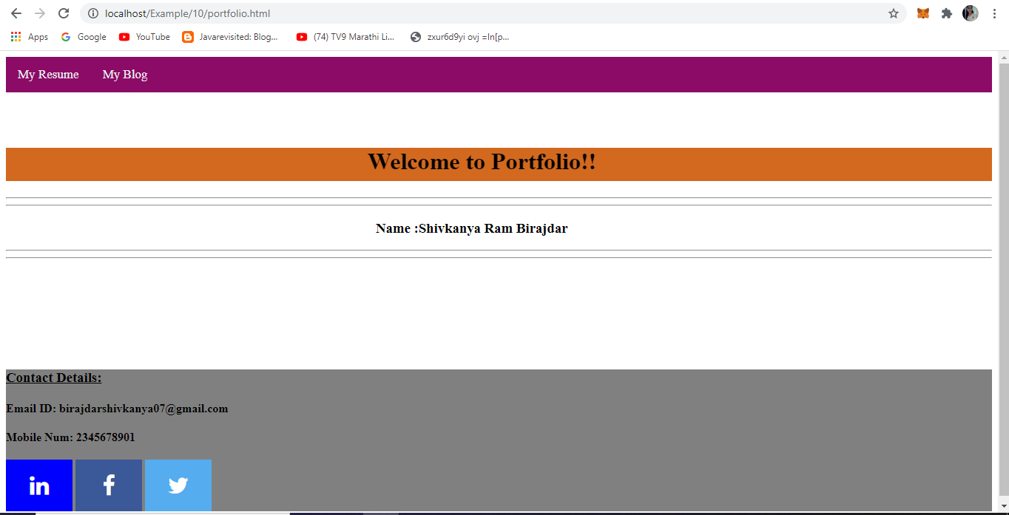

2)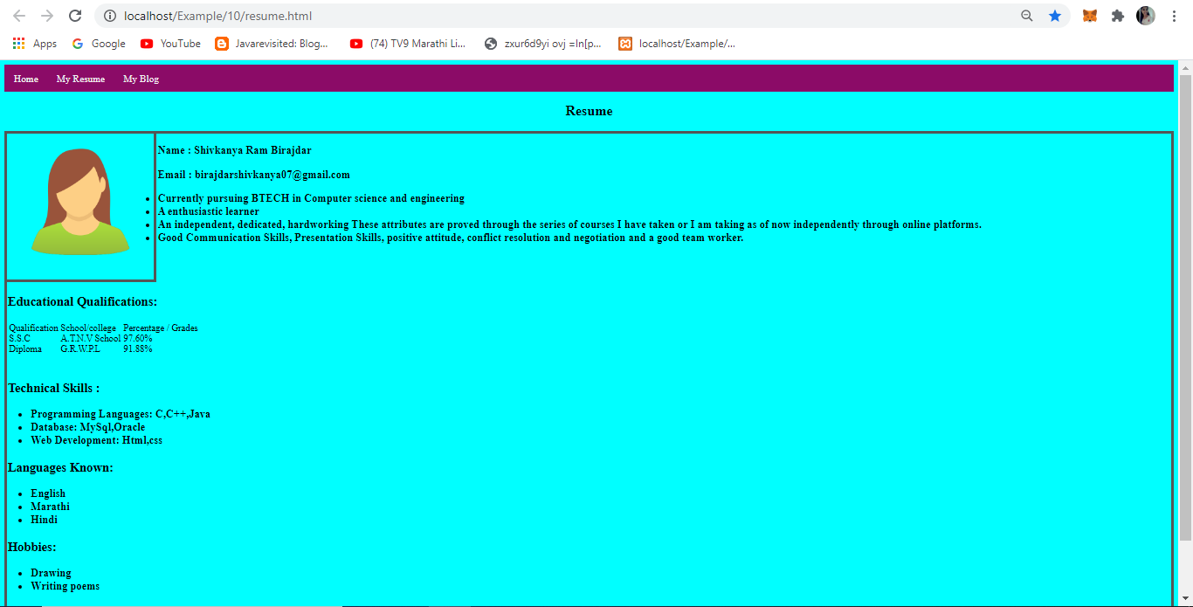

3)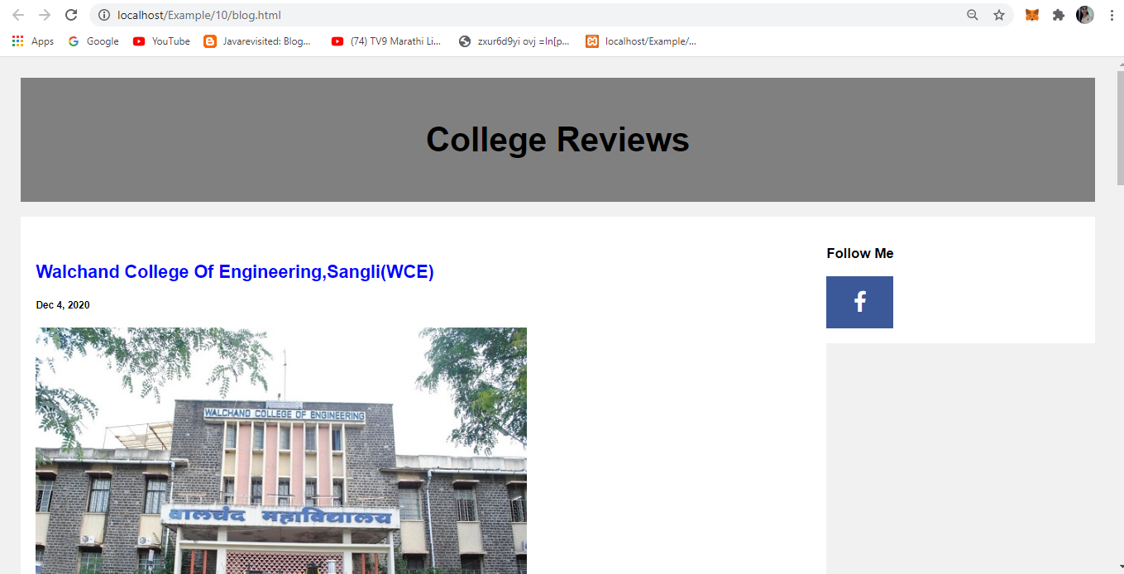

4)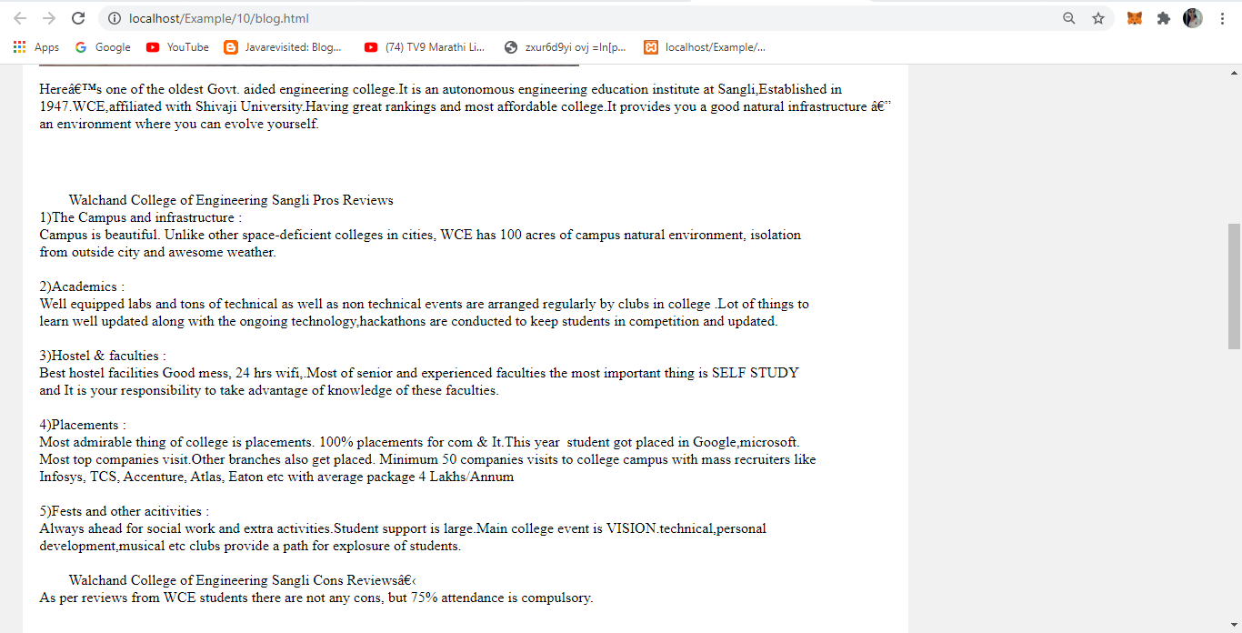

5)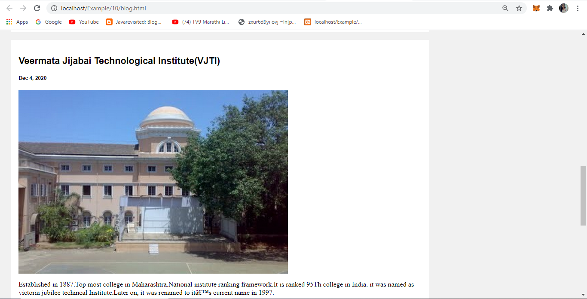

6)