**Assignment 11.2**

1. Create table and put the data into hive table using sqoop import as shown below

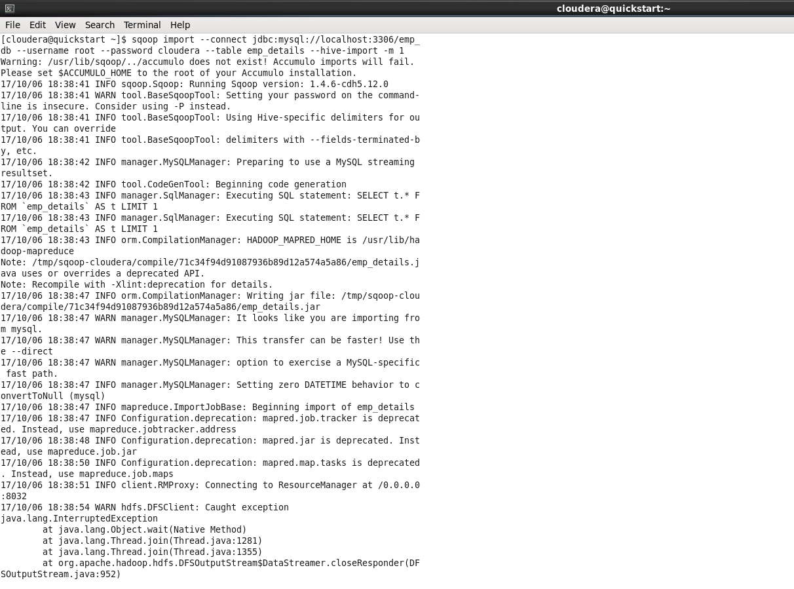

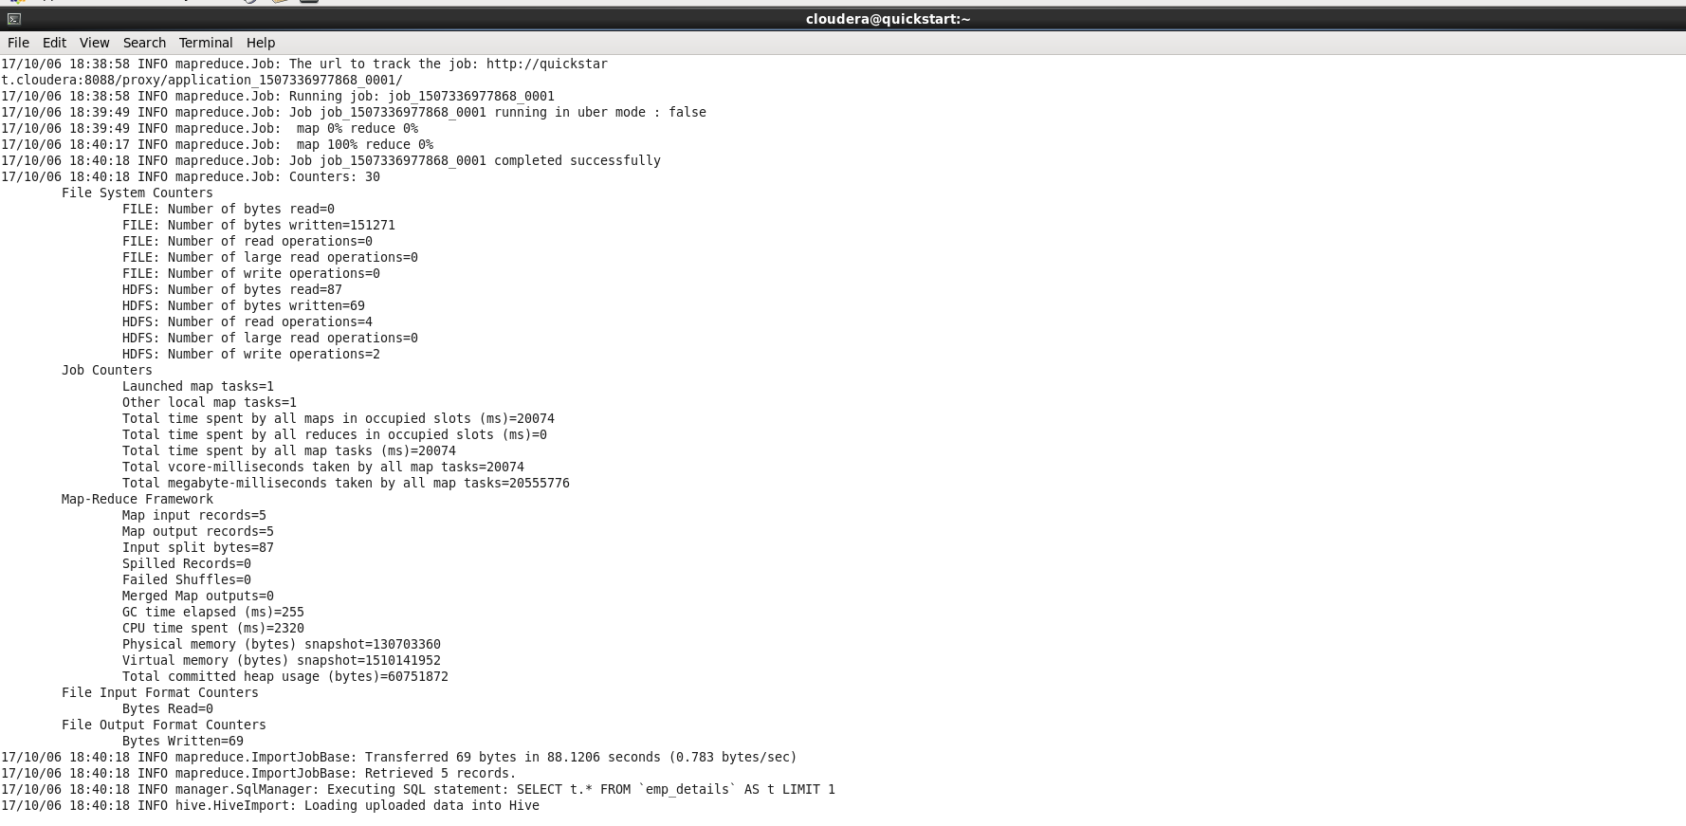

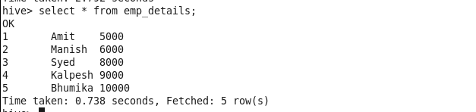

1. Now for incremental load we will use the sqoop import command and after that we cwill create a sqoop job ans then execute that sqoop job as shown below

