**Assignment 13.2**

1. Fibonaccci series using for loop

def fibnumberuseloop(n:Int)={

if(n==0 || n==1) n

else{

var d =0

var a =0

var b =1

var i = 1

for(i<-2 to n) {

d = a + b

a = b

b = d

}

d

}

}

fibnumberuseloop(10)

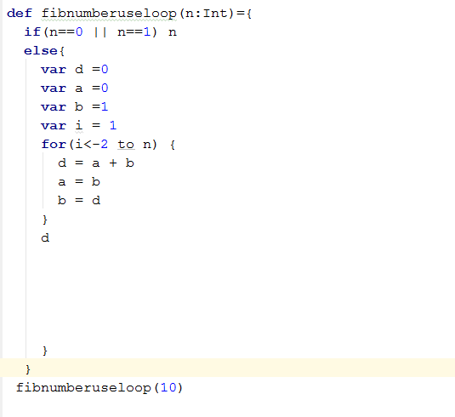

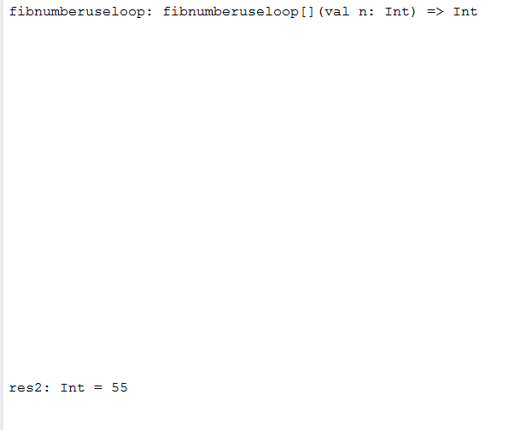

1. **Fibonacci series using Recursion**

def fibnumber(n: Int): Int = {

n match {

case i if i < 2 => i

case i => fibnumber(n-1) + fibnumber(n-2)

}

}

fibnumber(10)

