**Assignment 16.1**

1. find the sum of all numbers

def sum(xs: List[Int]): Int = {

xs match {

case x%2==0 :: tail => x + sum(tail) // if there is an element, add it to the sum of the tail

case Nil => 0 // if there are no elements, then the sum is 0

}

}

var ls = List[Int] (1, 2, 3, 4, 5, 6, 7, 8, 9, 10)

var result = sum(ls)

Output

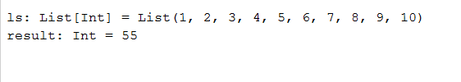

1. find the total elements in the list

var number = ls.size

Output

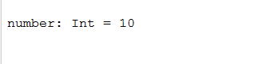

1. calculate the average of the numbers in the list

var average = result / number

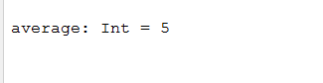

1. find the sum of all the even numbers in the list

ls.collect{

case n: Int if(n%2==0) => n

case n: Int => 0

}.sum



1. find the total number of elements in the list divisible by both 5 and 3

var number1 = ls .filter(((i: Int) => i % 3 == 0 && i % 5==0))

println(n.size)

output