**Assignment 4.2**

1. **Concat**: This command is used to concanete two expression of same type. To implement this command we will first load the dataset by using the command LOAD



Now we will check if our file is loaded or not by using DUMP command



**Output of dump**

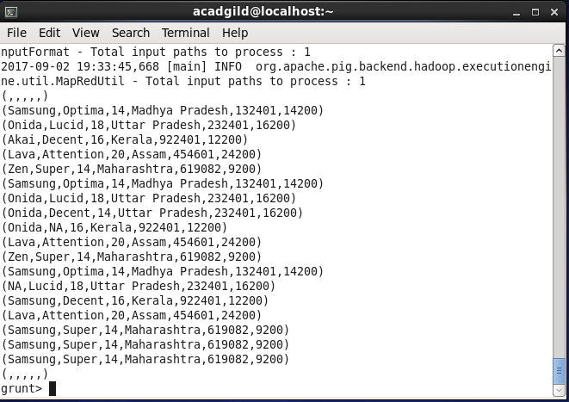

Now we are concat company_name,product_name by using concat command



**Output**

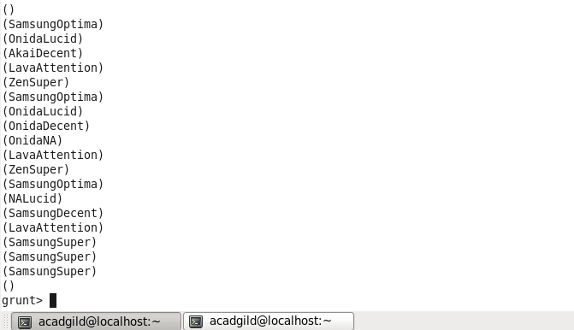

**2)Tokenize :** used to split a string (which contains a group of words) in a single tuple and returns a bag which contains the output of the split operation.

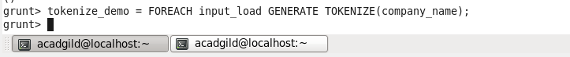

**Output**

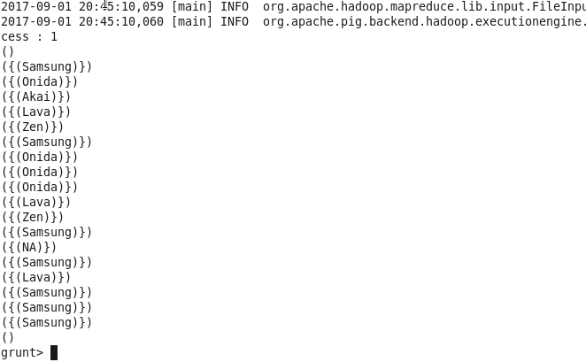

**3)SUM:** used to get the total of the numeric values of a column in a single-column bag. While computing the total, the SUM() function ignores the NULL values.

To get the global sum value, we need to perform a Group All operation, and calculate the sum value using the SUM() function.

To get the sum value of a group, we need to group it using the Group By operator and proceed with the sum function

First we will group it. This is for global sum





Output

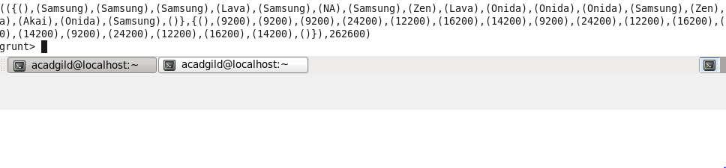

**4)MIN:** is used to get the minimum (lowest) value (numeric or chararray) for a certain column in a single-column bag. While calculating the minimum value, the MIN() function ignores the NULL values



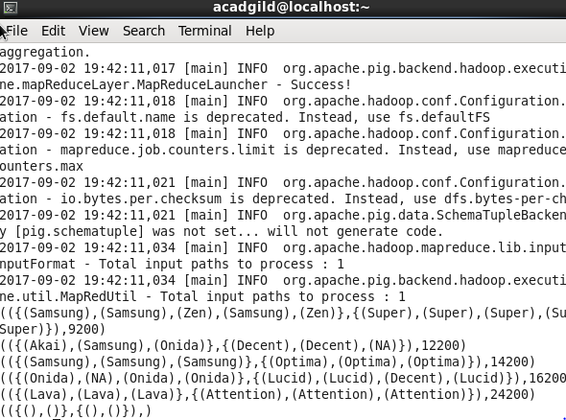

**5) MAX :** used to calculate the highest value for a column (numeric values or chararrays) in a single-column bag. While calculating the maximum value, the Max() function ignores the NULL values**.**



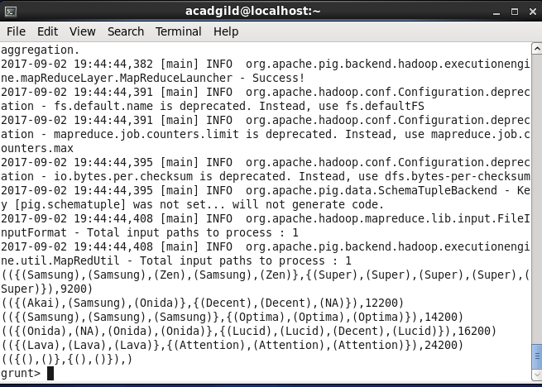

**6) LIMIT** : used to get a limited number of tuples from a relation

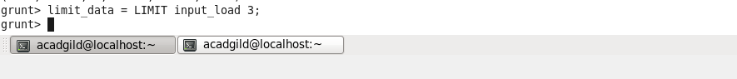

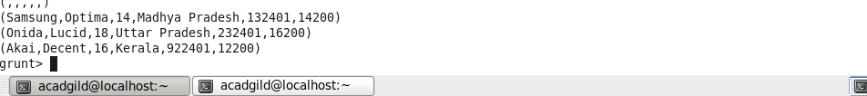

**7) STORE : used to** store the loaded data in the file system



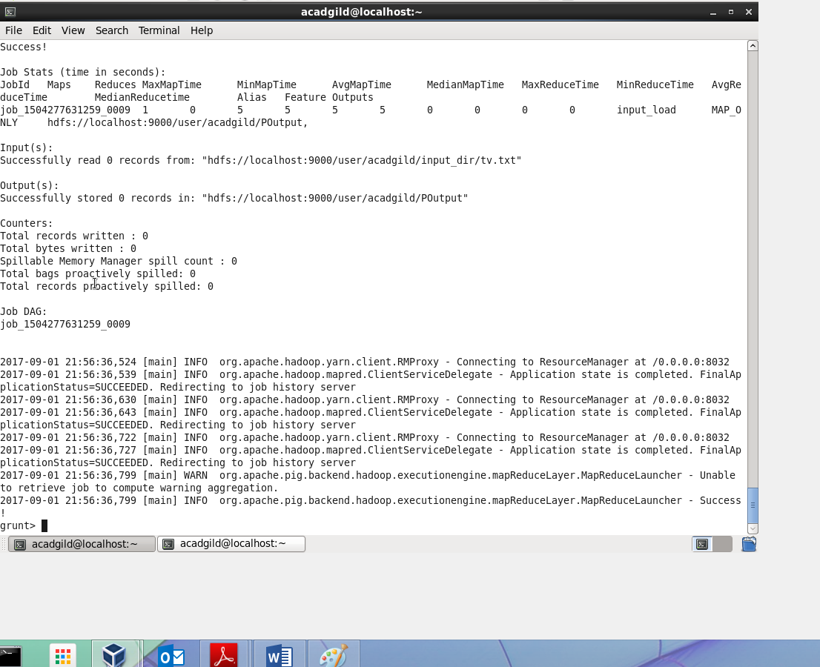

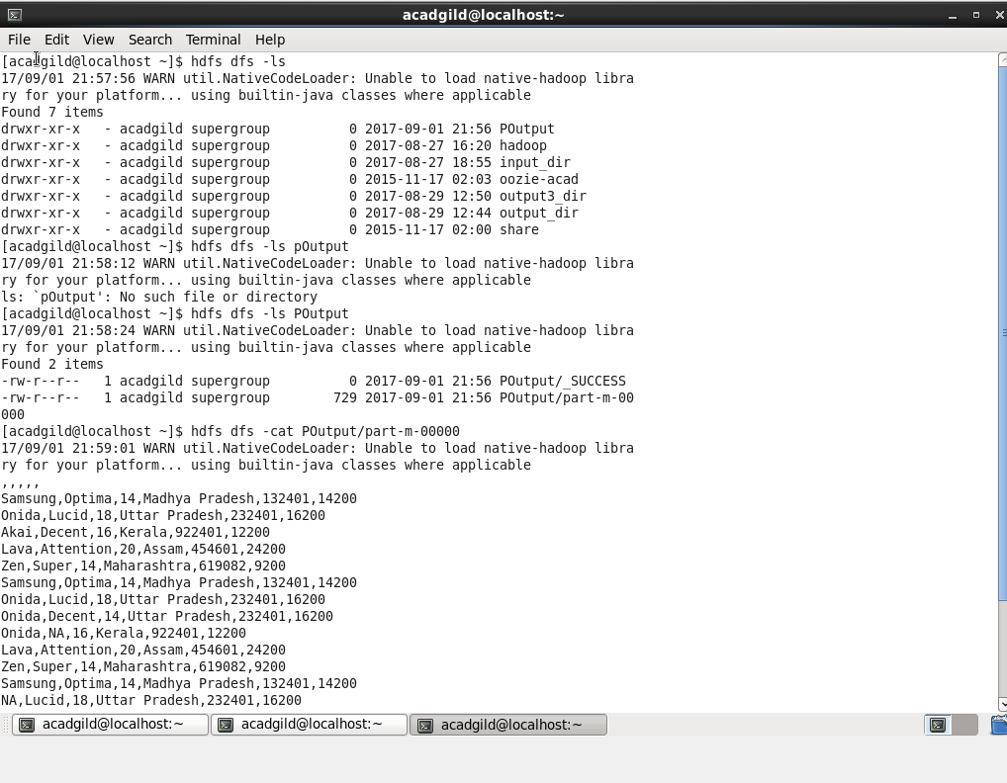

**8)DISTINCT :** used to remove redundant (duplicate) tuples from a relation.



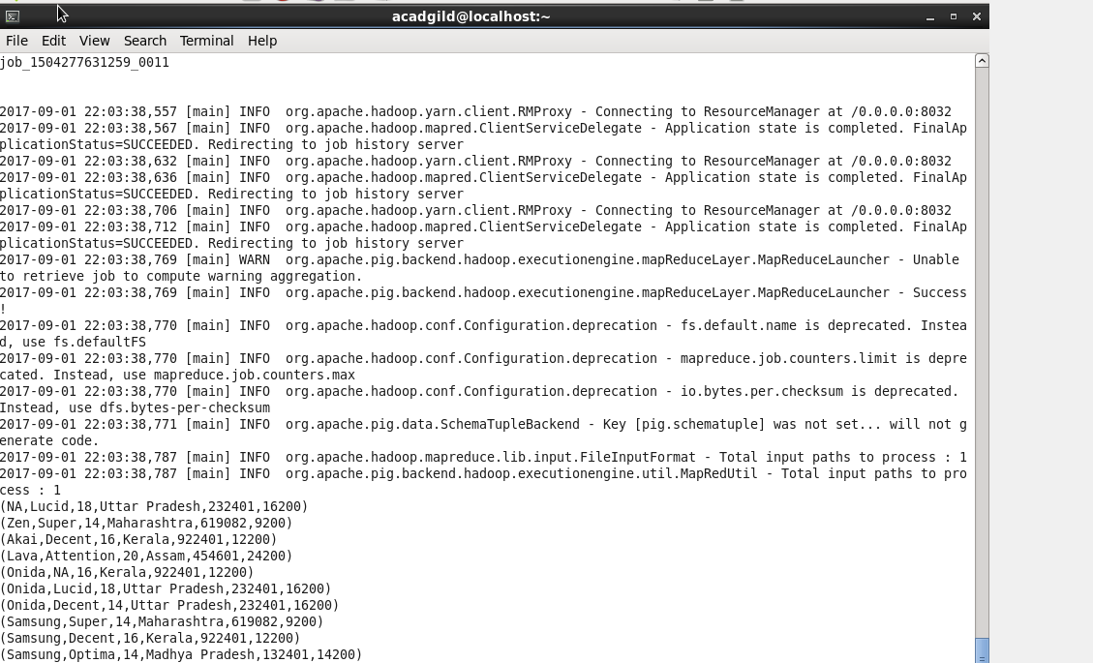

**9)FLATTEN:** Used to unnest tuples as well as bags



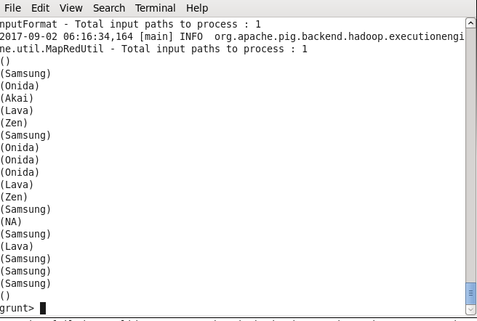

**10) IsEmpty**: used to check if a bag or map is empty.

First we will dump group_demo ,we will get the output as shown below:

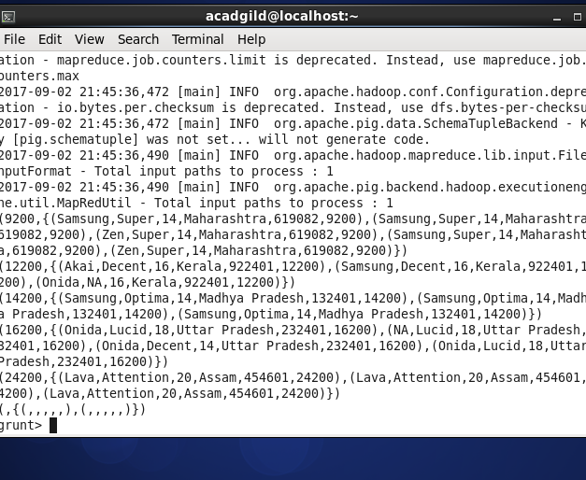

Then after we will use isempty command



Then we will dump it and get the output as shown below we didn’t get any output as thereis no null bag available in Relation

