**Steps to import Acadgild VM**

1. **Download and install virtual box**
2. **Open the virtual box and go to file then we see import Appliance option as shown below click on that option**

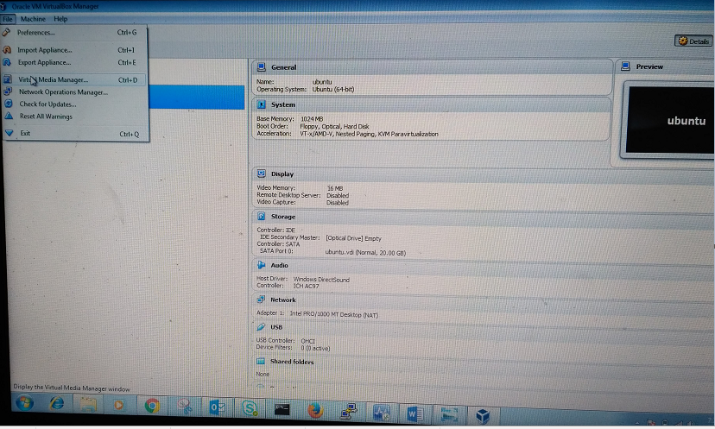

1. **After clicking the import Appliance option we see the below screen**

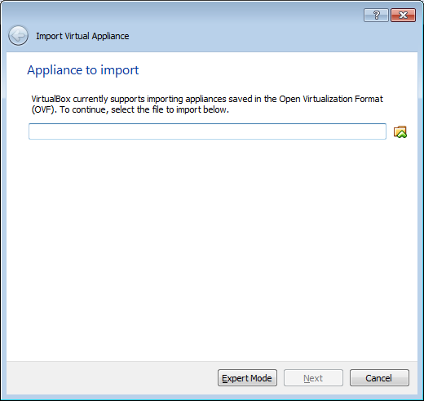

1. **Import Acadgild VM and then click ok**

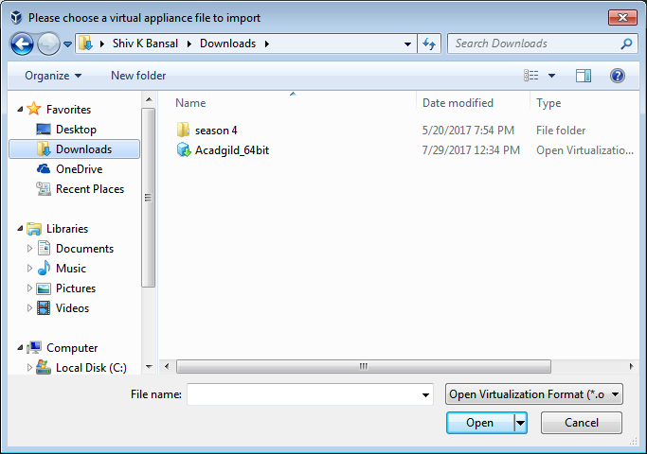

1. **Click Next**

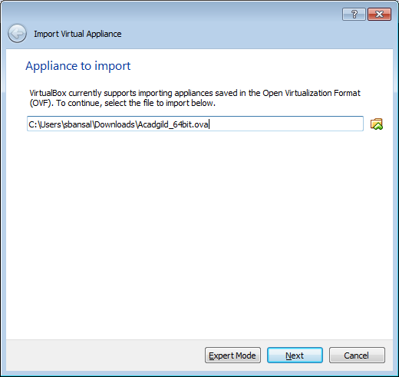

1. **Click Import**

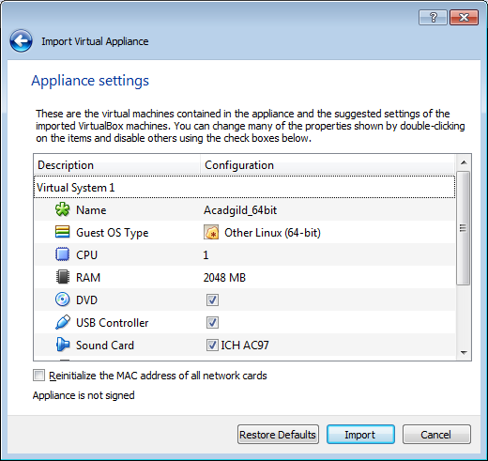

1. **Now VM is importing in Virtual box**

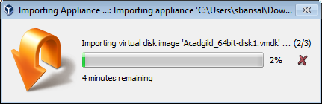

1. **Now click on the start button as shown below**

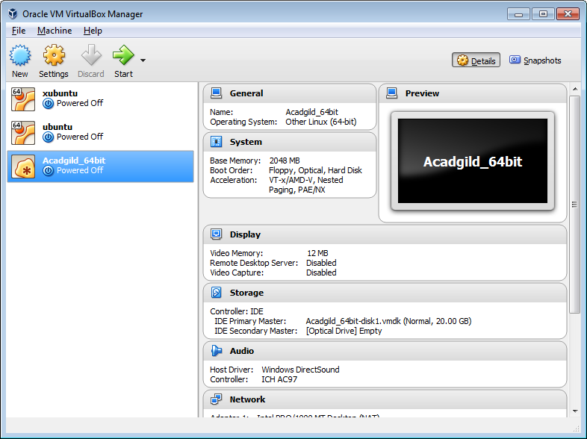

1. **We need to give password to login**

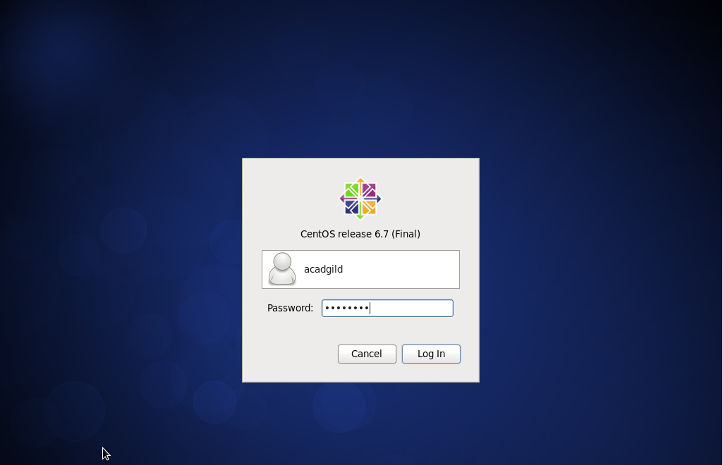

1. **Check the list of daemons by typing command jps**

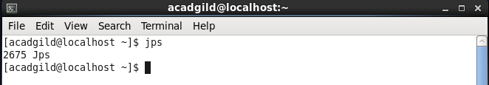

1. **Now start the ssh server by typing command as shown below**

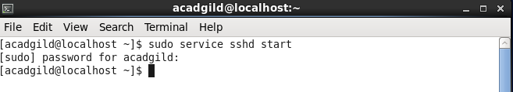

1. **Start all daemons**

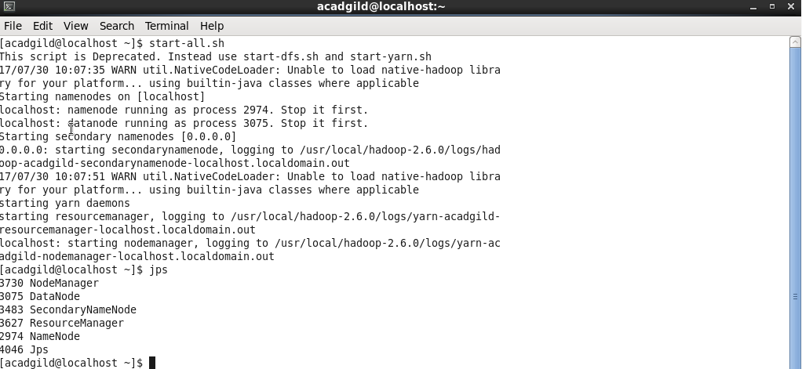

1. **Start history server by typing command as shown below**

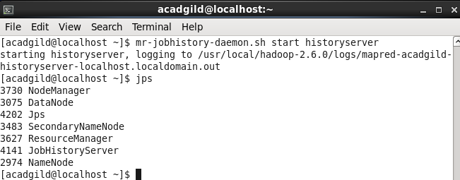

1. **To start the pig in hdfs mode type the command pig**

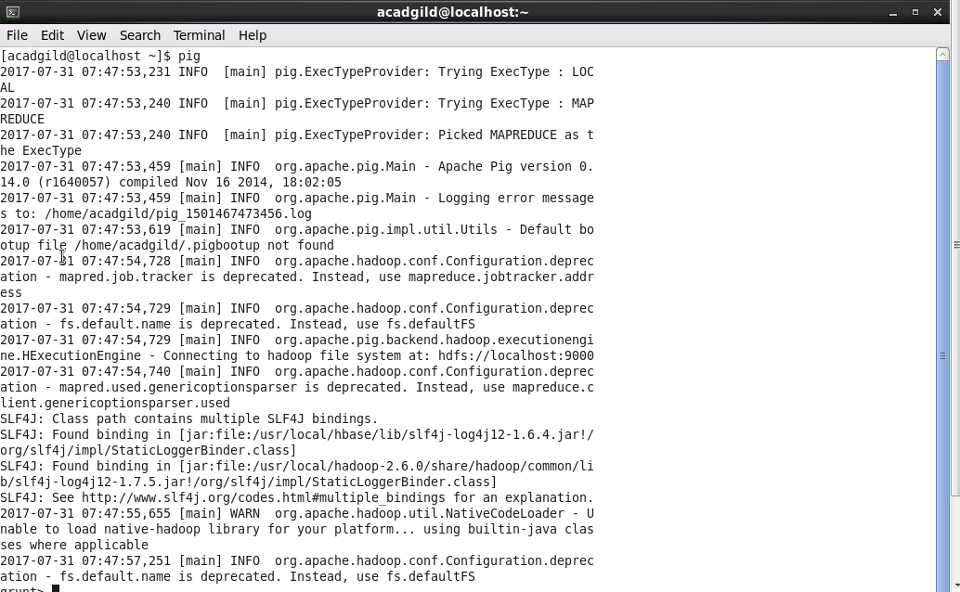

1. **To start hive we need to start mysql first and then type hive as shown below**

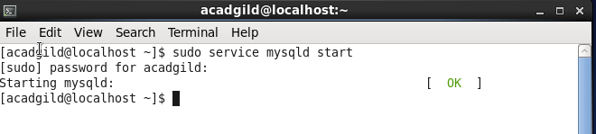

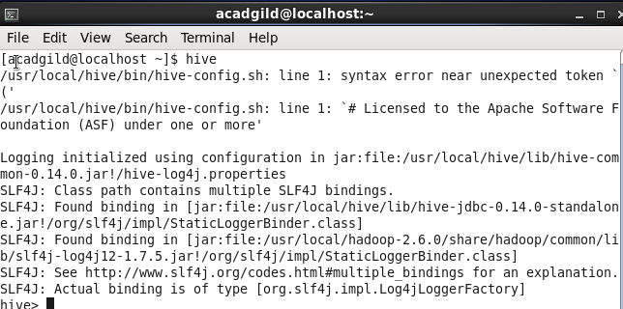

1. **Start the hbase by typing the command as shown below**

