**Linux commands**

**pwd : print working directory. It prints the current directory in which we are working**

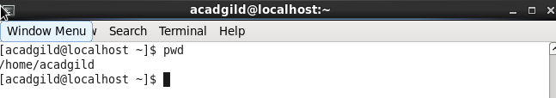

**vi : it is a editor present in linux .it has two modes insert mode and command line mode.**

**In command mode we are unable to perform administrative tasks such as saving the file, movinfg the cursor and executing the commands while in Insert mode we will insert the text into file**

**E.g vi newfile creates a new file and open it in vi editor and by default it is in command mode so to enter a text into file we have to go to insert mode which we can done through pressing I key and to come out from insert mode press ESC key and to come out from vi editor we can do by two ways either by pressing :q key but this key will not save any changes in file so to quit vi editor with saving changes in file press :wq**

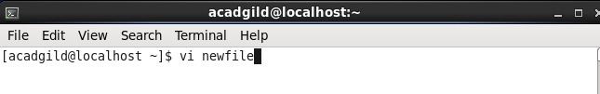

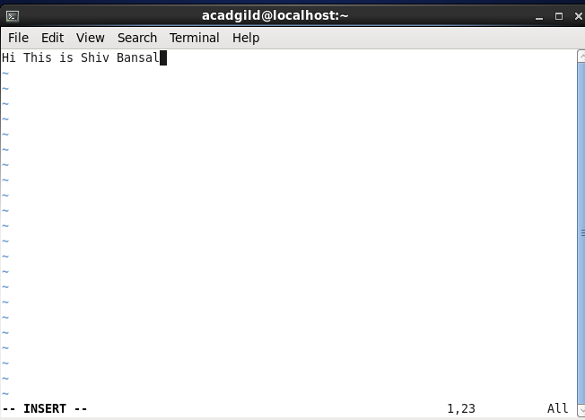

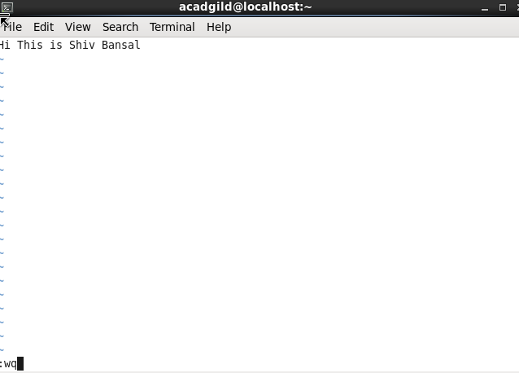

**touch : This command is used to create new file**

**e.g When we earlier list the file there is no file name acadgild but after executing touch command acadgild file is created**

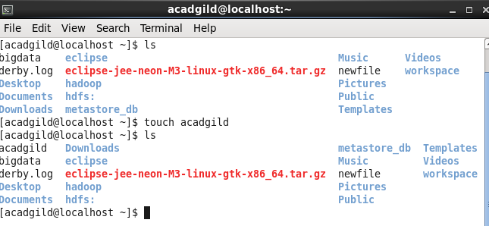

**mkdir: Used to create directory**

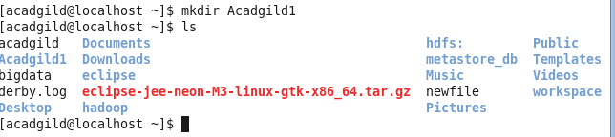

**rm : Used to remove file.**

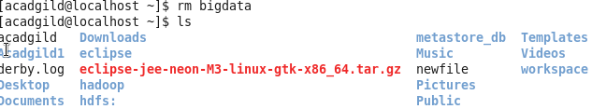

**ls : command is used for listing purpose**

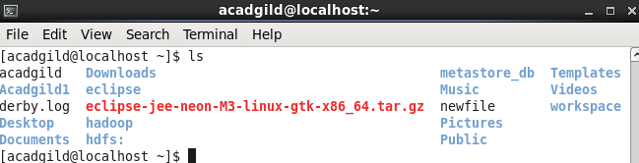

**echo : display a line of text/string on standard output or a file.**

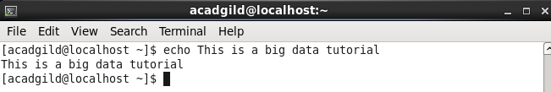

**cat :allows us to create single or multiple files ,concanete files or display output or redirect output in terminal or files**

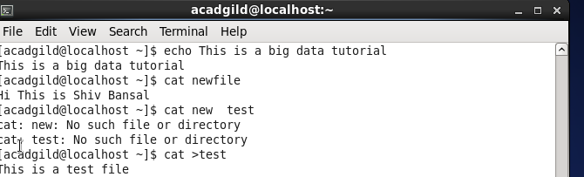

**who : prints all the users who are currently login to system**

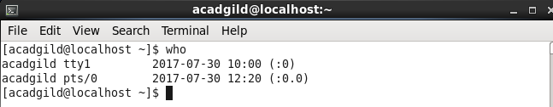

**cd : used for change directory**



**date : used to print or change date and time of system**



**cal : displays the calender at command line**

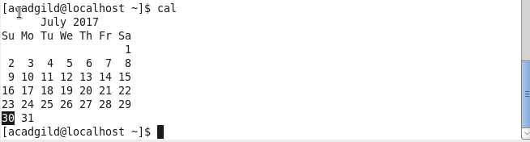

**mv : used to move or rename files**

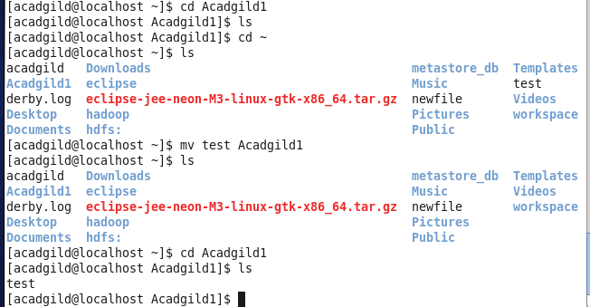

**cp : used to copies files and directories**

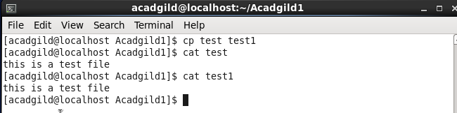

**which: locate the executable file associated with given command**

