Assignment 2.1

**TASK1**

To check if /user/acadgild directory exist or not if it doesn’t exist the create a new directory /user/acadgild/hadoop

1. We check if directory exist using command hdfs dfs –test –d -pathname

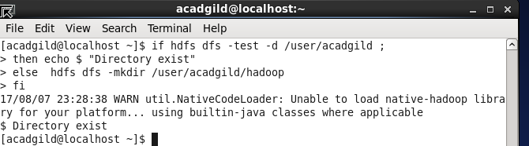

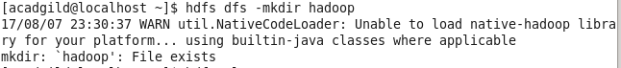

**Task2** :

1)To create file in Hadoop we can do it in two ways either by creating a file in local file system and then copy to HDFS as shown below

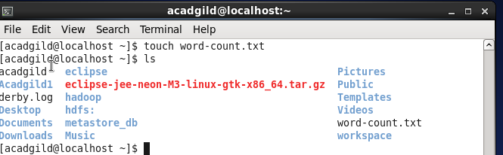

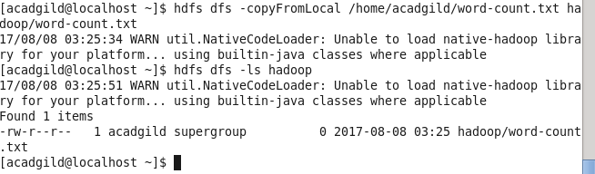

2) using toucz command with this command a zero sized file is created in hdfs

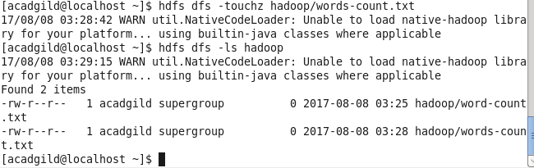

**Appending a file**

To appendtofile whatever we type on screen can be done by echo then message we want to print and then using appendto file command

e.g

echo “This is an acid attack | hdfs dfs –appendToFile -/user/Hadoop/word-count.txt

