**Assignment 2.2**

**Task 3**

**Create a file max-temp.text with 10 records put in it and move it into hdfs**

**Following Steps are performed:**

1. Create a file name max-temp.txt using cat command and redirect the input into file

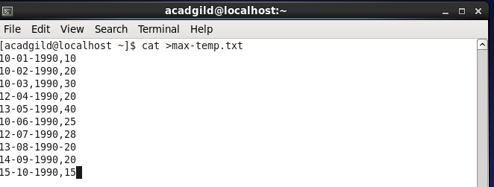

2) Using copyFromLocal command we copy the max-temp.txt file from local to hdfs

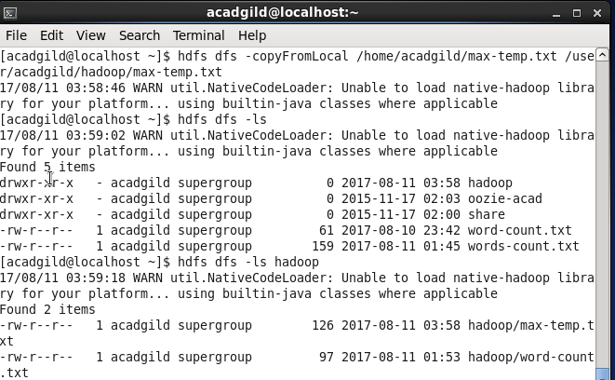

3) Now using cat command we can see the content of file

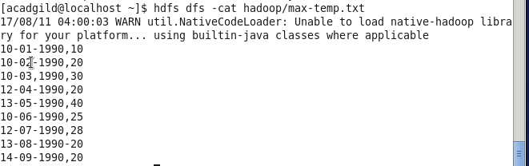

**Task4**

**Change file permission only user and group have file permission and others don’t have any control**

As we see in this image owner has read and write permission and group and others have read permission



After using chmod command we change the file permission now owner and group have full file permission and others don’t have any permission

