**IBM Project**

1. Create a directory in hadoop Using command

Hdfs dfs –mkdir -p IbmProject/Dataset

1. Put all the dataset in the directory using command as shown below

Hdfs dfs –put /home/bansalshiv4329115/join2_genchan*.txt IbmProject/Dataset/

Hdfs dfs –put /home/bansalshiv4329115/join2_genchan*.txt IbmProject/Dataset/

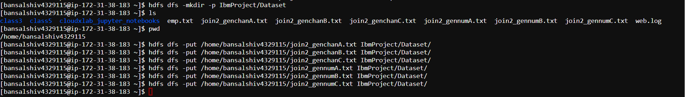

Here is the dataset Present in hdfs

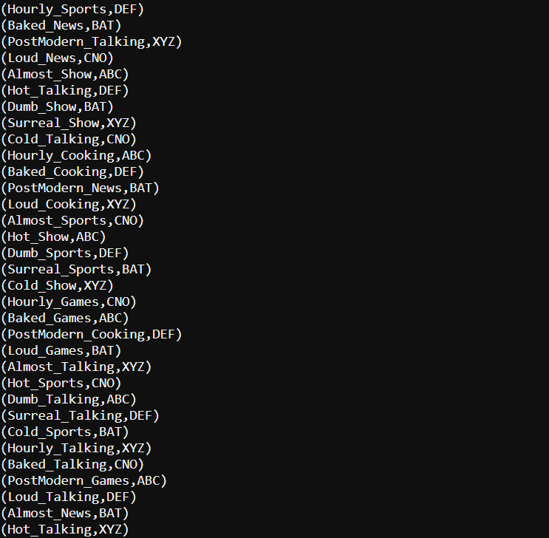

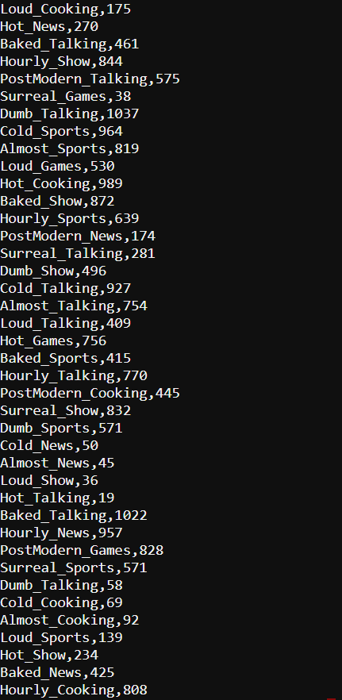

Question 1

What is the total number of viewers for shows on ABC

Step 1 Load the data using pig

data1 = Load 'IbmProject/Dataset/join2_genchanA.txt' Using PigStorage(',') As (title:chararray, channel:chararray);

data2 = Load 'IbmProject/Dataset/join2_genchanB.txt' Using PigStorage(',') As (title:chararray, channel:chararray);

data3 = Load 'IbmProject/Dataset/join2_genchanC.txt' Using PigStorage(',') As (title:chararray, channel:chararray);

data4 = Load 'IbmProject/Dataset/join2_gennumA.txt' Using PigStorage(',') As (title:chararray, view:int);

data5 = Load 'IbmProject/Dataset/join2_gennumB.txt' Using PigStorage(',') As (title:chararray, view:int);

data6 = Load 'IbmProject/Dataset/join2_gennumC.txt' Using PigStorage(',') As (title:chararray, view:int);

union_demo = UNION data1,data2 ;

unio_demo1 = UNION union_demo,data3;

union_demo2 = UNION data4,data5;

union_demo3 = UNION union_demo2,data6;

filter_demo = Filter union_demo1 by channel =='ABC';

join_demo = JOIN filter_demo by title,union_demo3 by title;

group_demo =Group join_demo by $0;

sum_demo = FOREACH group_demo GENERATE group, SUM(join_demo.view);

OUTPUT

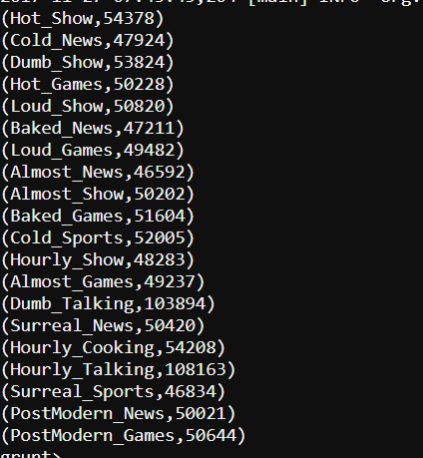

Question 2

What is the number of viewers for the BAT channel?

data1 = Load 'IbmProject/Dataset/join2_genchanA.txt' Using PigStorage(',') As (title:chararray, channel:chararray);

data2 = Load 'IbmProject/Dataset/join2_genchanB.txt' Using PigStorage(',') As (title:chararray, channel:chararray);

data3 = Load 'IbmProject/Dataset/join2_genchanC.txt' Using PigStorage(',') As (title:chararray, channel:chararray);

data4 = Load 'IbmProject/Dataset/join2_gennumA.txt' Using PigStorage(',') As (title:chararray, view:int);

data5 = Load 'IbmProject/Dataset/join2_gennumB.txt' Using PigStorage(',') As (title:chararray, view:int);

data6 = Load 'IbmProject/Dataset/join2_gennumC.txt' Using PigStorage(',') As (title:chararray, view:int);

union_demo = UNION data1,data2 ;

unio_demo1 = UNION union_demo,data3;

union_demo2 = UNION data4,data5;

union_demo3 = UNION union_demo2,data6;

filter_demo = Filter union_demo1 by channel =='BAT';

join_demo = JOIN filter_demo by title,union_demo3 by channel;

group_demo =Group join_demo by $1 ;

sum_demo = FOREACH group_demo GENERATE SUM(join_demo.view);



Question 3 What is the most viewed show on ABC channel?

data1 = Load 'IbmProject/Dataset/join2_genchanA.txt' Using PigStorage(',') As (title:chararray, channel:chararray);

data2 = Load 'IbmProject/Dataset/join2_genchanB.txt' Using PigStorage(',') As (title:chararray, channel:chararray);

data3 = Load 'IbmProject/Dataset/join2_genchanC.txt' Using PigStorage(',') As (title:chararray, channel:chararray);

data4 = Load 'IbmProject/Dataset/join2_gennumA.txt' Using PigStorage(',') As (title:chararray, view:int);

data5 = Load 'IbmProject/Dataset/join2_gennumB.txt' Using PigStorage(',') As (title:chararray, view:int);

data6 = Load 'IbmProject/Dataset/join2_gennumC.txt' Using PigStorage(',') As (title:chararray, view:int);

union_demo = UNION data1,data2 ;

unio_demo1 = UNION union_demo,data3;

union_demo2 = UNION data4,data5;

union_demo3 = UNION union_demo2,data6;

filter_demo = Filter union_demo1 by channel =='ABC';

join_demo = JOIN filter_demo by title,union_demo3 by title;

group_demo =Group join_demo by $ 0;

sum_demo = FOREACH group_demo GENERATE group, SUM(join_demo.view) as total viewer;

order_demo = ORDER sum_demo by $1 DESC;

limit_demo = order_demo limit 1;

**OUTPUT**

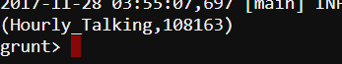

Question 4

What are the aired shows on ZOO,NOX, ABC channels

data1 = Load 'IbmProject/Dataset/join2_genchanA.txt' Using PigStorage(',') As (title:chararray, channel:chararray);

data2 = Load 'IbmProject/Dataset/join2_genchanB.txt' Using PigStorage(',') As (title:chararray, channel:chararray);

data3 = Load 'IbmProject/Dataset/join2_genchanC.txt' Using PigStorage(',') As (title:chararray, channel:chararray);

data4 = Load 'IbmProject/Dataset/join2_gennumA.txt' Using PigStorage(',') As (title:chararray, view:int);

data5 = Load 'IbmProject/Dataset/join2_gennumB.txt' Using PigStorage(',') As (title:chararray, view:int);

data6 = Load 'IbmProject/Dataset/join2_gennumC.txt' Using PigStorage(',') As (title:chararray, view:int);

union_demo = UNION data1,data2 ;

unio_demo1 = UNION union_demo,data3;

union_demo2 = UNION data4,data5;

union_demo3 = UNION union_demo2,data6;

filter_demo = Filter union_demo1 by (channel =='ABC') OR(channel =='NOX') OR (channel =='ZOO') ;

group_demo =Group join_demo by channel;

output_demo = FOREACH group_demo GENERATE Flatten($1);

