PaperLoop Build Journey
  - Hackathon progress report: product journey, user flows, MVP scope, current checkpoint, and build notes
Started Monday, May 25, 2026 | Current checkpoint: Wednesday, May 27, 2026 | Launch target: Sunday, May 31, 2026
Executive Summary
PaperLoop has moved from idea validation and product scoping into a working React + Firebase MVP foundation. The product now demonstrates the core reader journey, e-paper interaction model, subscriber engagement layer, Firebase-backed content, authentication, role-based admin access, and the first publisher edition upload workflow.

Hackathon Flow
Period | Hackathon focus | PaperLoop output
Days 1-2  May 25-26 | Product journey, user flows, MVP scoping | Defined the publisher-first thesis, competitor positioning, core user journeys, MVP boundaries, roadmap, and system architecture.
Wednesday  May 27 | MVP checkpoint | Moved from planning into live product validation: React/Firebase app, Firestore, Storage, Auth, role access, dashboard, reader, article detail, and admin foundation.
Days 4-5  May 28-29 | Build, refine, polish | Next focus: complete publisher workspace polish, improve flows, refine UI states, add stronger demo content, and prepare launch readiness checks.
Sunday  May 31 | Launch and deployment | Target outcome: publicly demoable PaperLoop MVP with Firebase-backed data, auth-gated admin, reader journey, and build-in-public launch material.

Product Journey
The product started with a simple thesis: local and regional newspapers need a better digital bridge than static PDFs or disconnected social media posts. PaperLoop positions itself as a publisher-first e-paper platform where a newspaper edition becomes searchable, clickable, interactive, measurable, and community-ready.
Problem  Traditional newspapers and local publishers often depend on static PDFs, offline distribution, or social sharing without structured reader engagement or analytics. | Opportunity  Regional publishers can use a web-first platform to upload editions, convert pages into article-level experiences, track engagement, and build subscriber relationships.
Product Direction  PaperLoop focuses on full e-paper reading, article hotspots, subscriber discussion, publisher workspace tools, and analytics-backed monetisation. | Differentiation  Instead of acting only as a digital newsstand, PaperLoop connects edition reading, article interaction, community, and publisher operations in one workflow.

Core User Flows
Reader discovery flow: user opens dashboard, searches or filters newspapers, selects a paper, and opens the current edition.
E-paper reading flow: user navigates pages, zooms or fits page, views article hotspots, saves the edition, and opens article posts from the page.
Article engagement flow: user reads the article detail, sees engagement counts, follows the author/publisher context, comments, reacts, or reports content.
Subscriber community flow: signed-in or subscriber users participate in article discussion and help create a community layer around local news.
Publisher admin flow: authorized staff or super admin signs in, enters the admin workspace, creates an edition draft, uploads a source PDF/image, and stores the draft in Firestore/Storage.
Platform admin flow: NeproTech/super admin can validate role-based access, publisher assignments, seeded content, and Firebase-backed workflows.

MVP Scoping
The MVP is intentionally scoped to prove the newspaper reading and publisher workflow loop before moving into heavier automation. OCR, automated page extraction, clipping intelligence, and advanced monetisation remain later work after the current live product foundation is stable.
In MVP now | Proven this week | Later / after MVP
Publisher discovery dashboard | Live Firestore-backed content loaded in app | Native mobile apps
Reader e-paper screen | Hotspots, article cards, save/share controls | OCR/page extraction automation
Article detail and engagement | Comments, reactions, subscriber discussion shell | AI clipping and layout understanding
Admin access and roles | Google plus email/password login with custom claims | Advanced billing/subscription automation
Edition draft upload | Firestore write plus Storage upload path verified | Full moderation operations suite

Current Progress
Product planning  COSTAR-style product framing, competitor analysis, product requirements, roadmap, system architecture, and acceptance criteria are documented. | Frontend foundation  The React/Vite app now has dashboard, reader, article, and admin surfaces with responsive PaperLoop styling.
Firebase infrastructure  Firestore, Storage, Firebase Auth, security rules, seed data, and environment configuration are set up for project paperloop-2e121. | Authentication  Google sign-in and email/password sign-in are enabled. NeproTech is configured as super admin for role-based testing.
Authorization  Role-based access uses Firebase custom claims and Firestore user/staff records to gate the admin workspace and Storage uploads. | Publisher workflow  The first edition draft creation flow uploads source assets to Storage and writes draft metadata into Firestore.

Wednesday MVP Checkpoint - Work Done Today
Confirmed Firebase setup path after billing was enabled and corrected the SDK-compatible Firestore database requirement.
Verified seeded Firestore collections and deployed Firestore/Storage rules.
Enabled and tested Google plus email/password authentication for faster hackathon testing.
Configured NeproTech as super admin with role claims and publisher access for testing protected admin flows.
Validated Storage upload authorization using Auth custom claims and created a real verification edition draft.
Improved the signed-out login UI so email/password sign-in and Gmail sign-in feel cleaner in the top navigation.
Prepared build-in-public material and a LinkedIn progress narrative for visibility, feedback, and early momentum.
Checkpoint Result
By Wednesday, May 27, the MVP has crossed from planning into a working prototype with live backend services. The remaining hackathon window should focus on build refinement, demo quality, deployment readiness, and a clear public launch story before Sunday, May 31.

Build, Refine, Polish Plan
Tighten the publisher admin workspace and make draft creation feel demo-ready.
Polish responsive states, empty states, loading states, and permission-denied states.
Add a crisp demo script showing dashboard -> reader -> article -> subscriber discussion -> admin upload.
Prepare launch/deployment checklist, including Firebase hosting or deployment target, environment review, and final smoke tests.
Continue public LinkedIn updates with progress, screenshots, blockers, learnings, and short demo clips.

Screenshots And Demo Evidence
The screenshots below capture the current MVP surfaces as of the Wednesday checkpoint. They are useful for the hackathon progress document, LinkedIn build-in-public updates, and demo preparation.

Dashboard and newspaper discovery
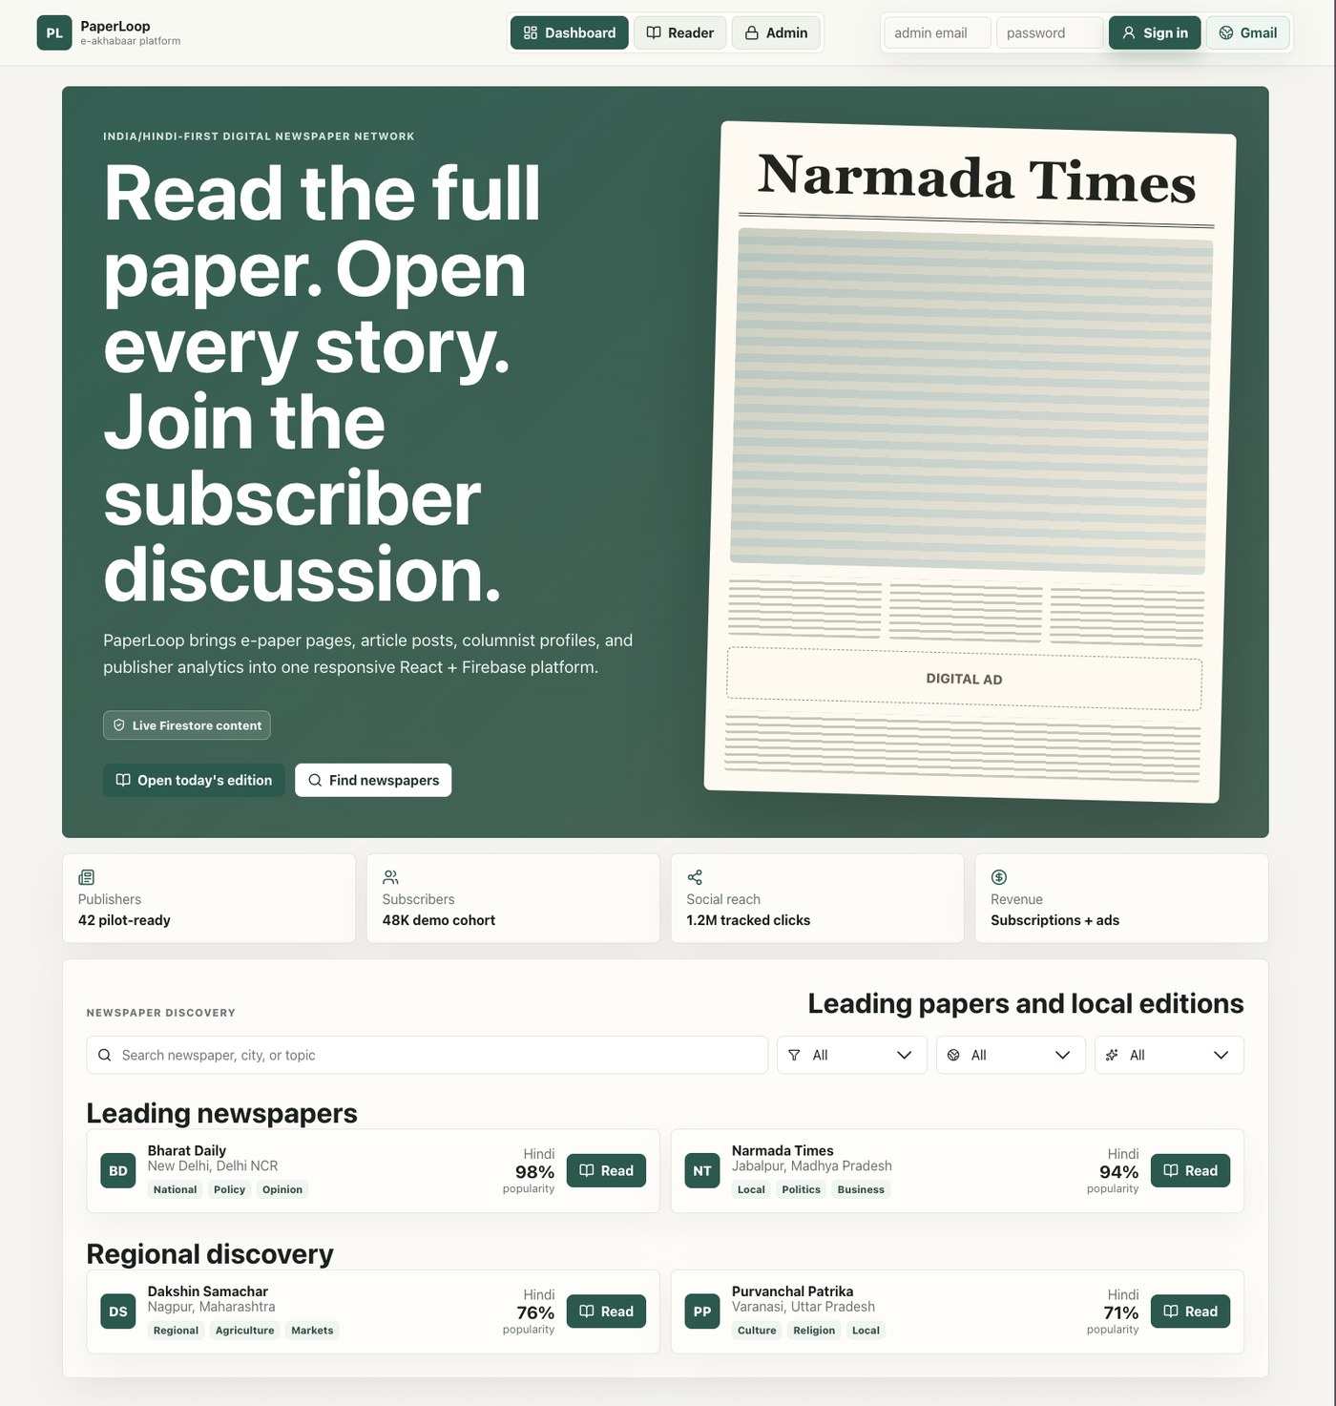
Dashboard view showing the PaperLoop product shell, live Firestore content indicator, publisher discovery, and updated sign-in controls.

Reader e-paper with article hotspots
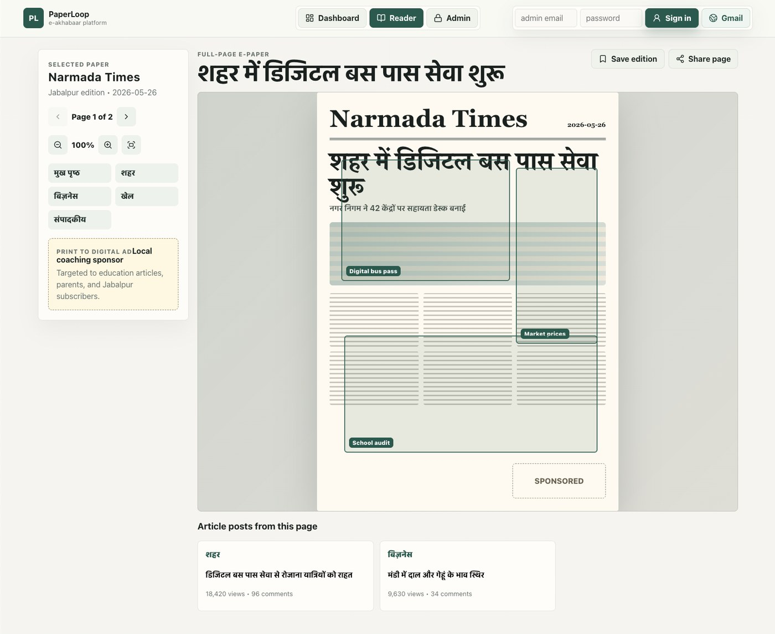
Reader view showing a full e-paper page, article hotspot overlays, article post cards, save/share controls, and publisher edition context.

Article and subscriber engagement
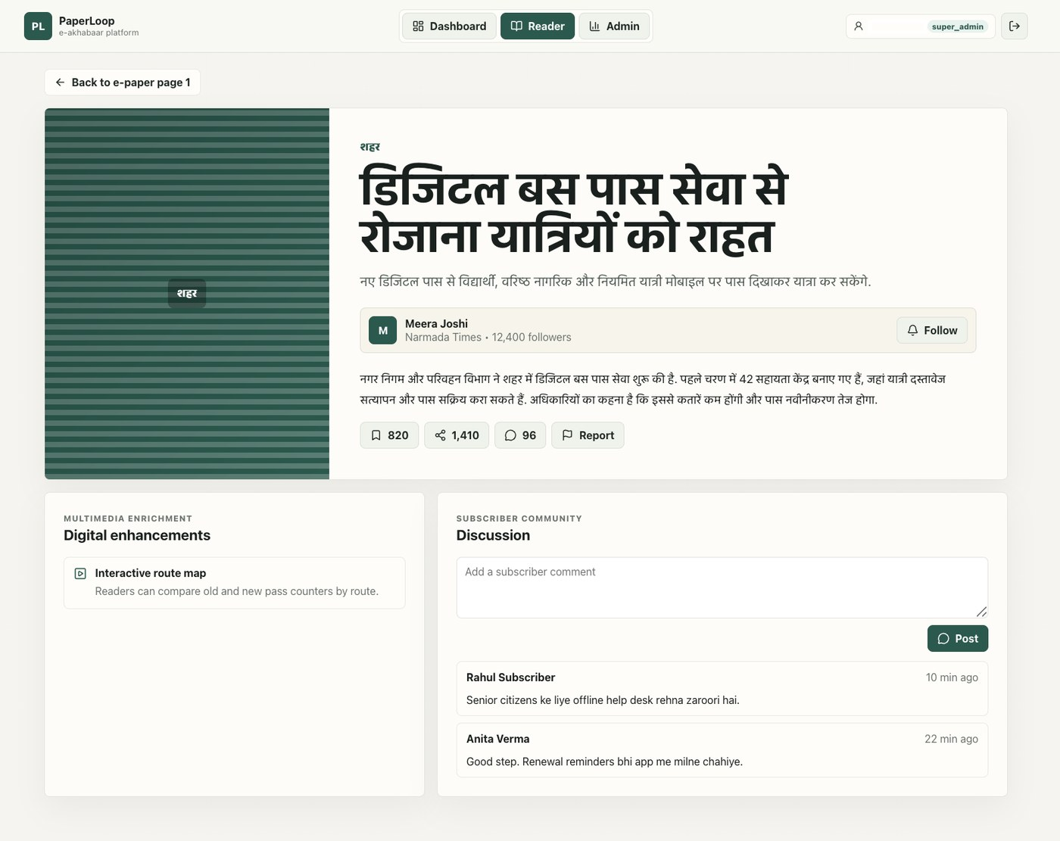
Article detail view showing a clipped story, engagement metrics, digital enhancements, subscriber discussion, and super-admin authenticated state.

Next Milestone
The next milestone is to move from MVP checkpoint to launch readiness: refine the product surface, verify the complete user journey, prepare deployment, and publish the Sunday launch update with a focused demo and clear ask for feedback.

