## **Project 01 - 1 Hour**

## **Deploying a Scalable Web Application with Persistent Storage and Advanced Automation**

### **Objective:**

Deploy a scalable web application using Docker Swarm and Kubernetes, ensuring data persistence using a single shared volume, and automate the process using advanced shell scripting.

### **Overview:**

1. **Step 1**: Set up Docker Swarm and create a service.
2. **Step 2**: Set up Kubernetes using Minikube.
3. **Step 3**: Deploy a web application using Docker Compose.
4. **Step 4**: Use a single shared volume across multiple containers.
5. **Step 5**: Automate the entire process using advanced shell scripting.

### **Step 1: Set up Docker Swarm and Create a Service**

#### **1.1 Initialize Docker Swarm**

# Initialize Docker Swarm

docker swarm init

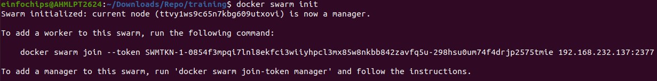

#### **1.2 Create a Docker Swarm Service**

# Create a simple Nginx service in Docker Swarm

docker service create --name nginx-service --publish 8080:80 nginx

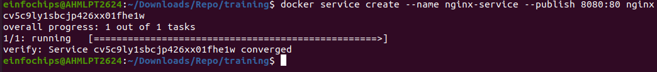

### **Step 2: Set up Kubernetes Using Minikube**

#### **2.1 Start Minikube**

# Start Minikube

minikube start

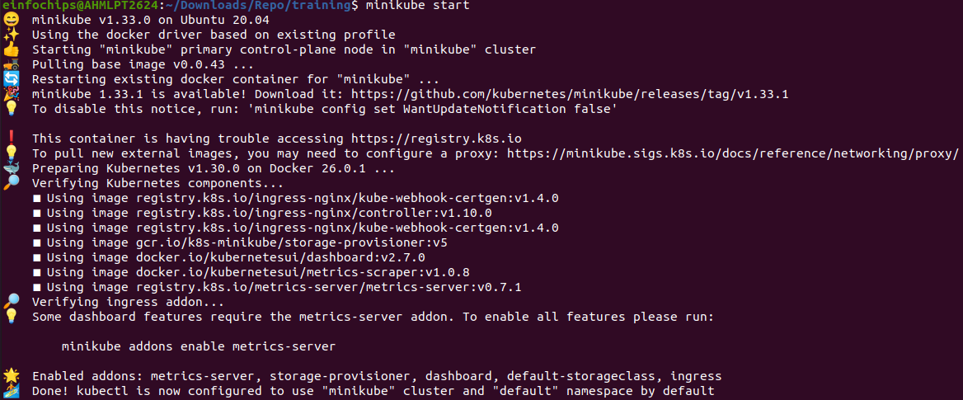

#### **2.2 Deploy a Web App on Kubernetes**

Create a deployment file named webapp-deployment.yaml:

apiVersion: apps/v1

kind: Deployment

metadata:

name: webapp

spec:

replicas: 3

selector:

matchLabels:

app: webapp

template:

metadata:

labels:

app: webapp

spec:

containers:

- name: webapp

image: nginx

ports:

- containerPort: 80

Apply the deployment:

kubectl apply -f webapp-deployment.yaml



#### **2.3 Expose the Deployment**

kubectl expose deployment webapp --type=NodePort --port=80



### **Step 3: Deploy a Web Application Using Docker Compose**

#### **3.1 Create a docker-compose.yml File**

version: '3'

services:

web:

image: nginx

ports:

- "8080:80"

volumes:

- webdata:/usr/share/nginx/html

volumes:

webdata:

#### **3.2 Deploy the Web Application**

# Deploy using Docker Compose

docker-compose up -d



### **Step 4: Use a Single Shared Volume Across Multiple Containers**

#### **4.1 Update docker-compose.yml to Use a Shared Volume**

version: '3'

services:

web1:

image: nginx

ports:

- "8081:80"

volumes:

- shareddata:/usr/share/nginx/html

web2:

image: nginx

ports:

- "8082:80"

volumes:

- shareddata:/usr/share/nginx/html

volumes:

shareddata:

#### **4.2 Deploy with Docker Compose**

# Deploy using Docker Compose

docker-compose up -d

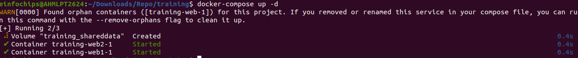

### **Step 5: Automate the Entire Process Using Advanced Shell Scripting**

#### **5.1 Create a Shell Script deploy.sh**

#!/bin/bash

# Initialize Docker Swarm

docker swarm init

# Create Docker Swarm Service

docker service create --name nginx-service --publish 8080:80 nginx

# Start Minikube

minikube start

# Create Kubernetes Deployment

kubectl apply -f webapp-deployment.yaml

# Expose the Deployment

kubectl expose deployment webapp --type=NodePort --port=80

# Deploy Web App Using Docker Compose

docker-compose -f docker-compose-single-volume.yml up -d

echo "Deployment completed successfully!"

#### **5.2 Make the Script Executable**

# Make the script executable

chmod +x deploy.sh

#### **5.3 Run the Script**

# Run the deployment script

./deploy.sh

### 

### 

### **Project 02 - 1 Hour**

### **Comprehensive Deployment of a Multi-Tier Application with CI/CD Pipeline**

### **Objective:**

Deploy a multi-tier application (frontend, backend, and database) using Docker Swarm and Kubernetes, ensuring data persistence using a single shared volume across multiple containers, and automating the entire process using advanced shell scripting and CI/CD pipelines.

### **Overview:**

1. **Step 1**: Set up Docker Swarm and create a multi-tier service.
2. **Step 2**: Set up Kubernetes using Minikube.
3. **Step 3**: Deploy a multi-tier application using Docker Compose.
4. **Step 4**: Use a single shared volume across multiple containers.
5. **Step 5**: Automate the deployment process using advanced shell scripting.

### **Step 1: Set up Docker Swarm and Create a Multi-Tier Service**

#### **1.1 Initialize Docker Swarm**

# Initialize Docker Swarm

docker swarm init

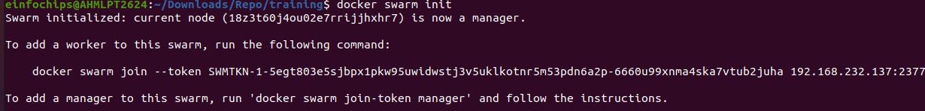

#### **1.2 Create a Multi-Tier Docker Swarm Service**

Create a docker-compose-swarm.yml file:

version: '3.7'

services:

frontend:

image: nginx

ports:

- "8080:80"

deploy:

replicas: 2

volumes:

- shareddata:/usr/share/nginx/html

backend:

image: mybackendimage

ports:

- "8081:80"

deploy:

replicas: 2

volumes:

- shareddata:/app/data

db:

image: postgres

environment:

POSTGRES_DB: mydb

POSTGRES_USER: user

POSTGRES_PASSWORD: password

deploy:

replicas: 1

volumes:

- dbdata:/var/lib/postgresql/data

volumes:

shareddata:

dbdata:

Deploy the stack:

# Deploy the stack using Docker Swarm

docker stack deploy -c docker-compose-swarm.yml myapp

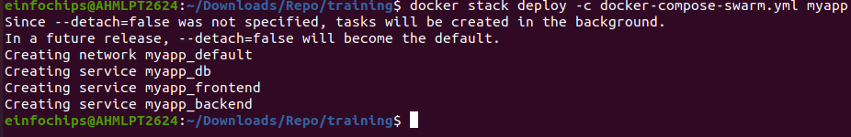

### **Step 2: Set up Kubernetes Using Minikube**

#### **2.1 Start Minikube**

# Start Minikube

minikube start

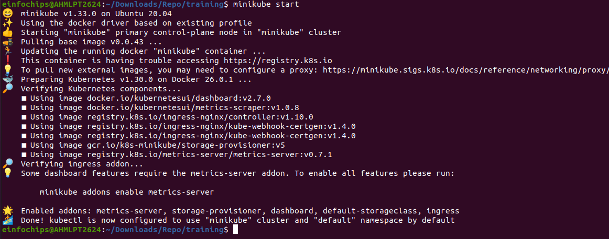

#### **2.2 Create Kubernetes Deployment Files**

Create frontend-deployment.yaml:

apiVersion: apps/v1

kind: Deployment

metadata:

name: frontend

spec:

replicas: 2

selector:

matchLabels:

app: frontend

template:

metadata:

labels:

app: frontend

spec:

containers:

- name: frontend

image: nginx

ports:

- containerPort: 80

volumeMounts:

- name: shareddata

mountPath: /usr/share/nginx/html

volumes:

- name: shareddata

persistentVolumeClaim:

claimName: shared-pvc

Create backend-deployment.yaml:

apiVersion: apps/v1

kind: Deployment

metadata:

name: backend

spec:

replicas: 2

selector:

matchLabels:

app: backend

template:

metadata:

labels:

app: backend

spec:

containers:

- name: backend

image: mybackendimage

ports:

- containerPort: 80

volumeMounts:

- name: shareddata

mountPath: /app/data

volumes:

- name: shareddata

persistentVolumeClaim:

claimName: shared-pvc

Create db-deployment.yaml:

apiVersion: apps/v1

kind: Deployment

metadata:

name: db

spec:

replicas: 1

selector:

matchLabels:

app: db

template:

metadata:

labels:

app: db

spec:

containers:

- name: db

image: postgres

env:

- name: POSTGRES_DB

value: mydb

- name: POSTGRES_USER

value: user

- name: POSTGRES_PASSWORD

value: password

volumeMounts:

- name: dbdata

mountPath: /var/lib/postgresql/data

volumes:

- name: dbdata

persistentVolumeClaim:

claimName: db-pvc

Create shared-pvc.yaml:

apiVersion: v1

kind: PersistentVolumeClaim

metadata:

name: shared-pvc

spec:

accessModes:

- ReadWriteMany

resources:

requests:

storage: 1Gi

Create db-pvc.yaml:

apiVersion: v1

kind: PersistentVolumeClaim

metadata:

name: db-pvc

spec:

accessModes:

- ReadWriteOnce

resources:

requests:

storage: 1Gi

Apply the deployments:

kubectl apply -f shared-pvc.yaml

kubectl apply -f db-pvc.yaml

kubectl apply -f frontend-deployment.yaml

kubectl apply -f backend-deployment.yaml

kubectl apply -f db-deployment.yaml

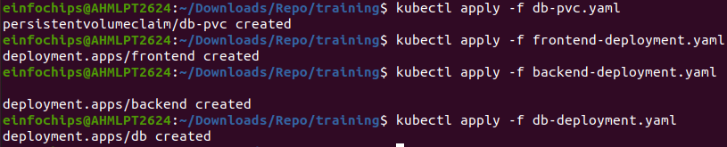

### **Step 3: Deploy a Multi-Tier Application Using Docker Compose**

#### **3.1 Create a docker-compose.yml File**

version: '3'

services:

frontend:

image: nginx

ports:

- "8080:80"

volumes:

- shareddata:/usr/share/nginx/html

backend:

image: mybackendimage

ports:

- "8081:80"

volumes:

- shareddata:/app/data

db:

image: postgres

environment:

POSTGRES_DB: mydb

POSTGRES_USER: user

POSTGRES_PASSWORD: password

volumes:

- dbdata:/var/lib/postgresql/data

volumes:

shareddata:

dbdata:

#### **3.2 Deploy the Application**

# Deploy using Docker Compose

docker-compose up -d

### **Step 4: Use a Single Shared Volume Across Multiple Containers**

Update docker-compose.yml as shown in Step 3.1 to use the shareddata volume across the frontend and backend services.