TASK 1: Local Repository Setup
- Create a new project folder.

- Initialize Git in the folder.
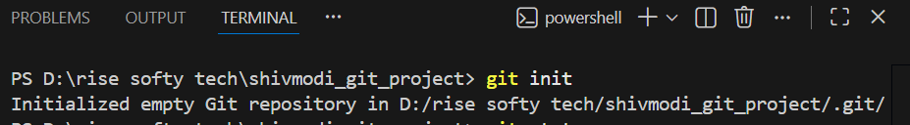
- Create a file named index.txt
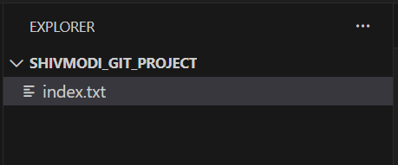
- Add content to the file.
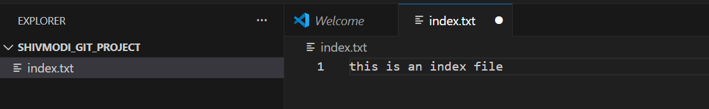
5. Check repository status.
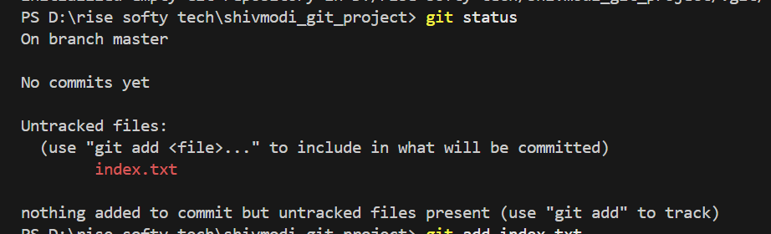
6. Stage all changes.

7. Commit the changes with an appropriate message.
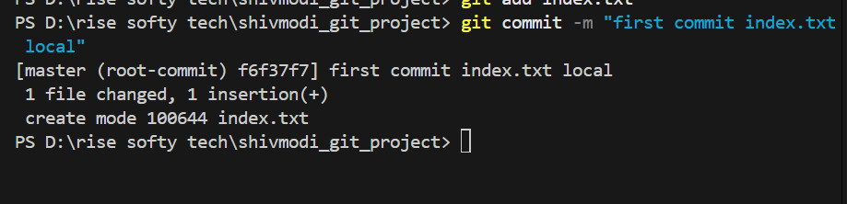

TASK 2: Remote Repository Creation
- Create a new GitHub repository.
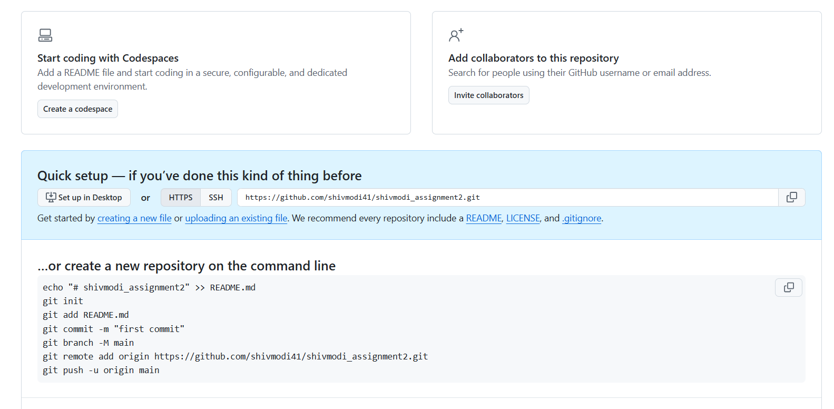

TASK 3: Connect Local Repository to Remote

- Add the GitHub repository as remote origin.
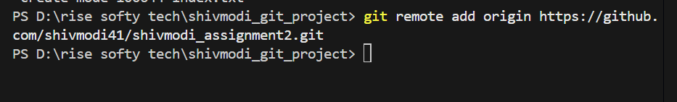

- Verify remote connection.

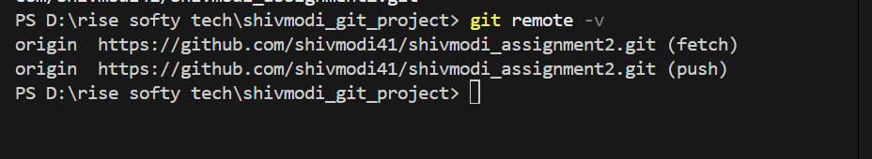
3.Rename the current branch to main.

TASK 4: Push Local Changes to Remote
- Push the local main branch to the remote repository.
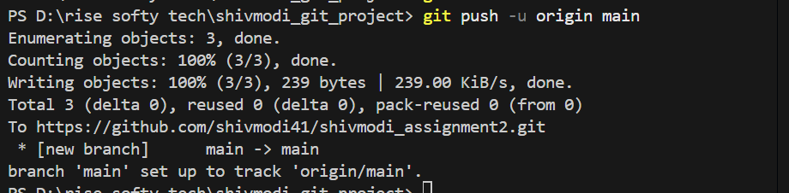

TASK 5: Branch Creation and Work
- Create a new branch named FirstBranch.
2.Switch to the newly created branch.
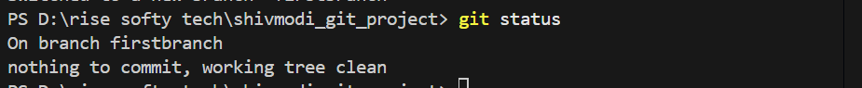

3.Create a new file named notes.txt.
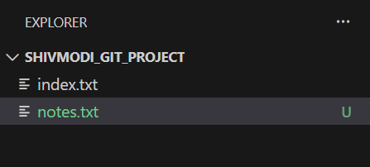
4.Add content to the file.
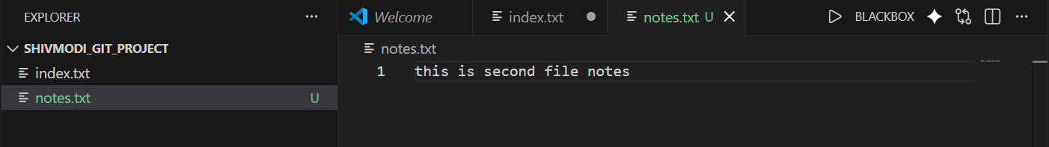
5.Stage the changes.
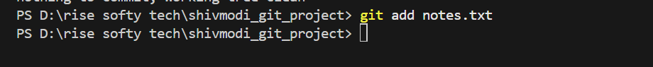
6.Commit the changes.
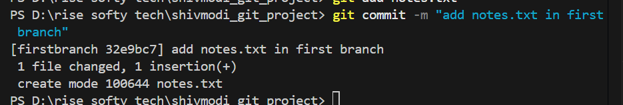

TASK 6: Merge Branch into Main
- Switch back to the main branch.
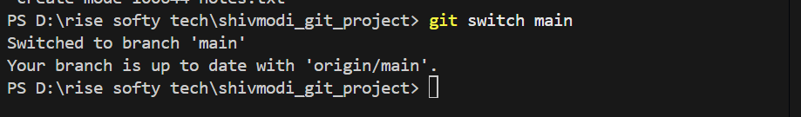

2.Merge FirstBranch into main.
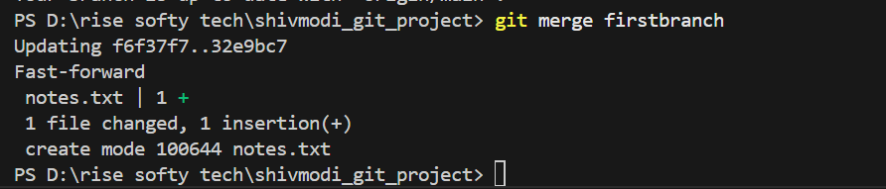

TASK 7 – Final Sync with Remote
- Push the updated main branch to the remote repository.
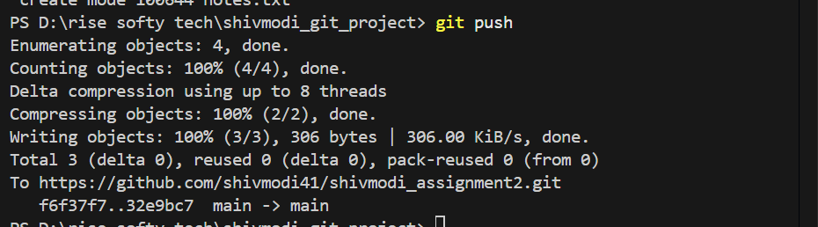

TASK 8 – Simple Pull
- Navigate to the correct local Git repository folder.
- Verify the current branch is main.
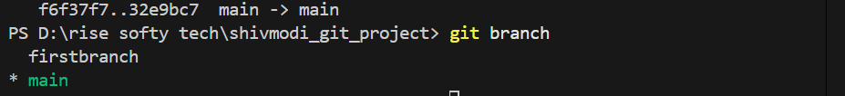
- Check the working tree status.
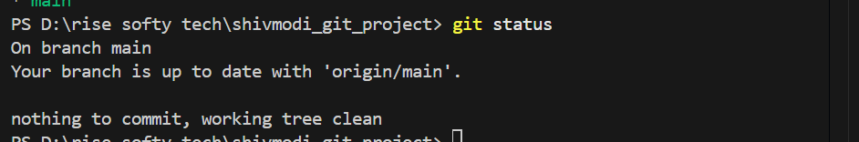

- Pull the latest changes from the remote repository.
- Verify that the pull is successful.
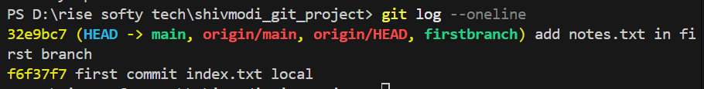

TASK 9 – Push and Pull with Conflict Resolution
- Navigate to the correct local Git repository fold
- Ensure you are on the main branch.
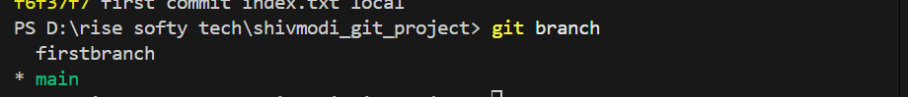
- Change the content of the index.txt file and save the changes

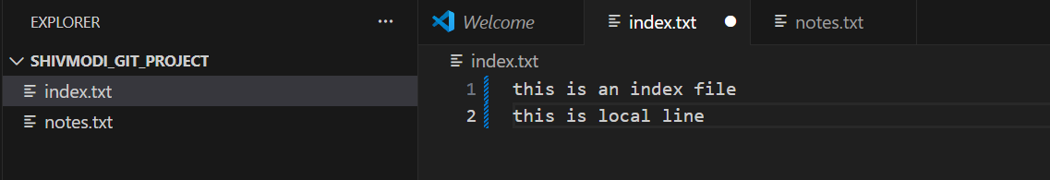
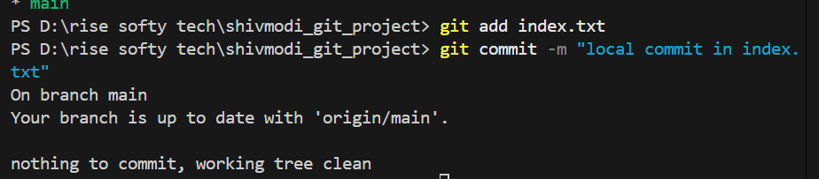
- Navigate to the correct remote Git repository folder.

- Ensure you are on the main branch.
6.Change the content of the index.txt file and save the change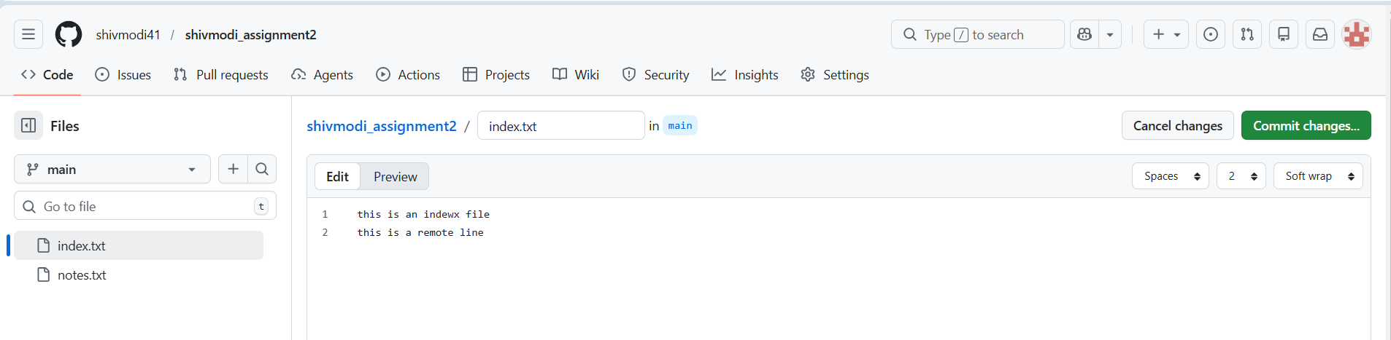

7.Attempt to push local changes to the remote repository.

8.Observe the push rejection error.
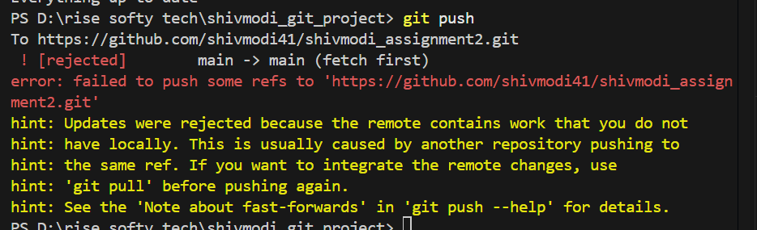
9. Pull remote changes into the local branch.
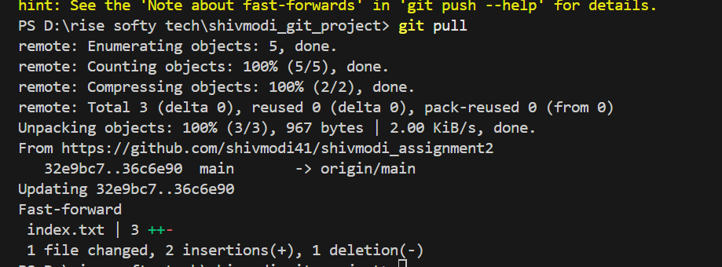

10. Resolve merge conflict if it occurs.
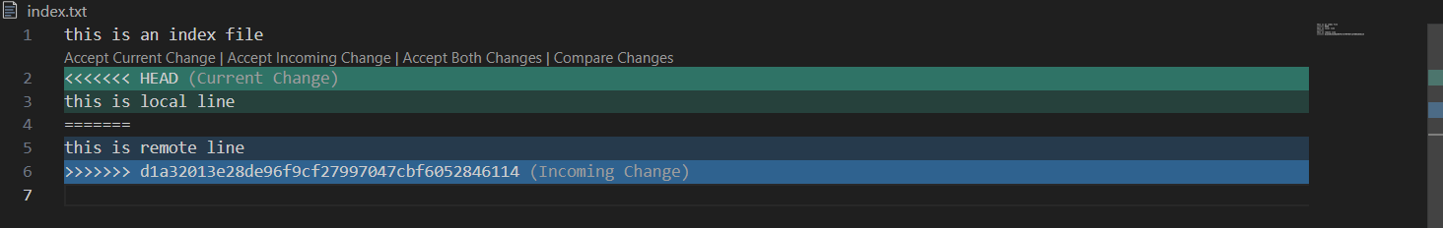
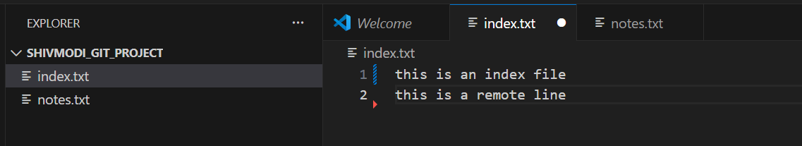
- Commit the merge resolution.
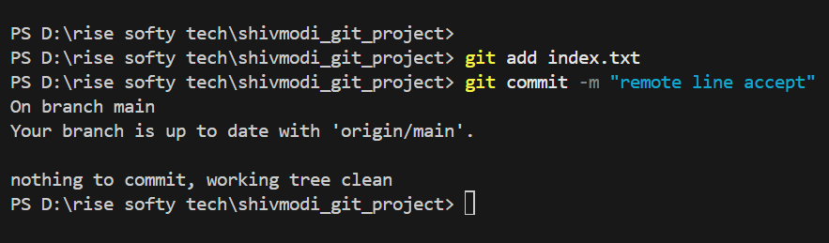
- Push the updated branch to the remote repository.

TASK 10 - Clone an Existing Repository
- Copy the GitHub repository URL.
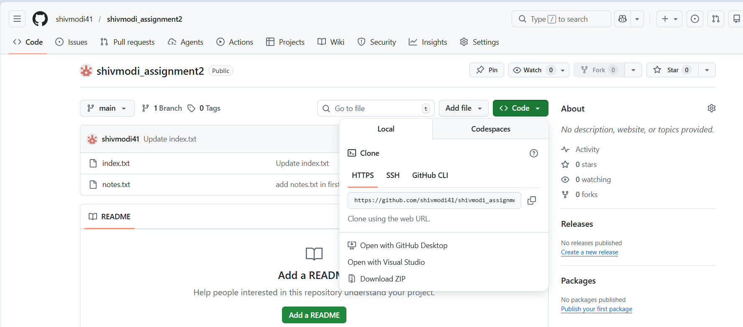
2.Navigate to a parent directory (not inside another repo) in local.

3.Clone the remote repository.

4.Navigate into the cloned folder.
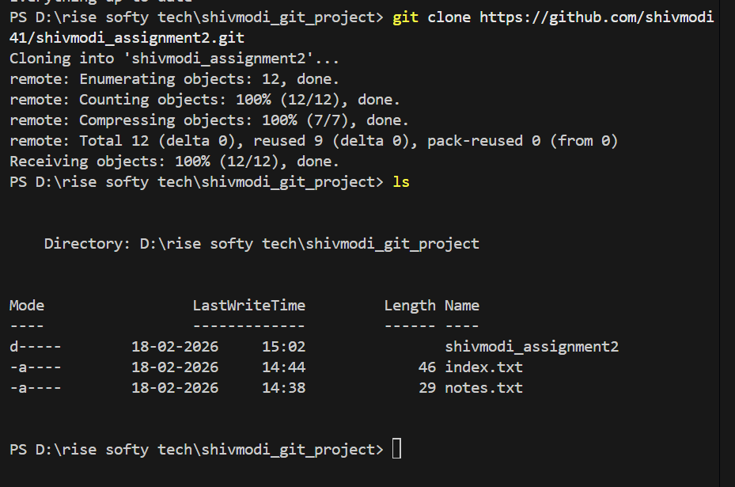
5. Verify the current branch.
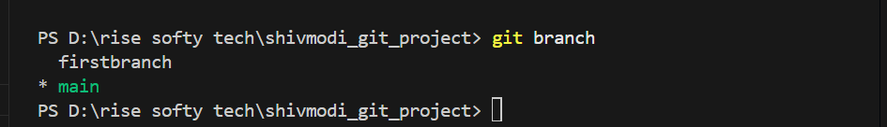
6.Verify the remote connection.
