**Scala_Assignment**

**TASK-1**

Below linked, document steps to download and import Acadgild Spark VM in the Oracle

Virtual Box.

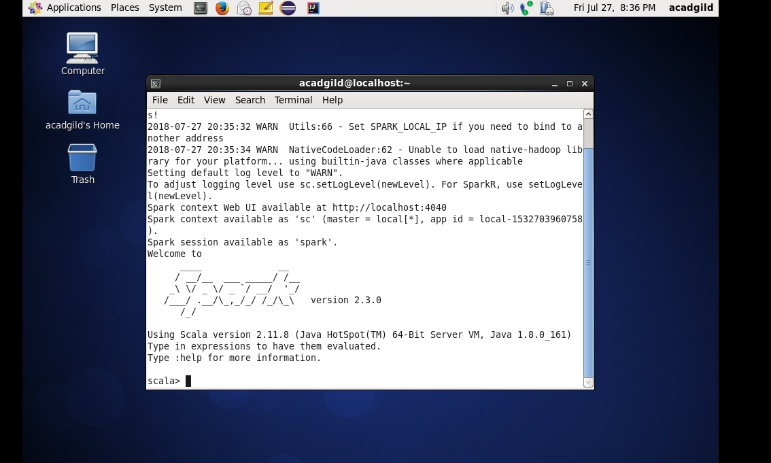

1. **Installed Oracle Virtual Machine Box.**
2. **Downloaded Acadgild VM with Spark**
3. **Launched the Spark.**

**TASK-2**

Given a list of strings - List[String] (“alpha”, “gamma”, “omega”, “zeta”, “beta”)

1) find count of all strings with length 4

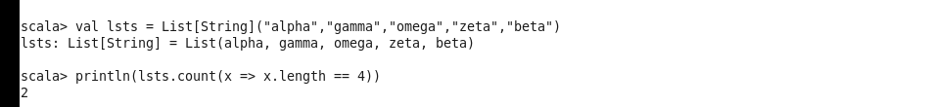

**Here Lambda “=>” function and length function is used to determine the answer**

2) Convert the list of string to a list of integers, where each string is mapped to , its

corresponding length

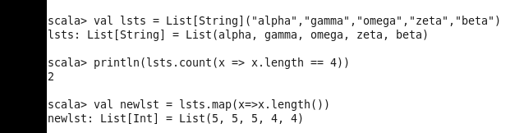

**Here Map function is used to create a new list from the existing list.**

**3)** find count of all strings which contain alphabet ‘m’

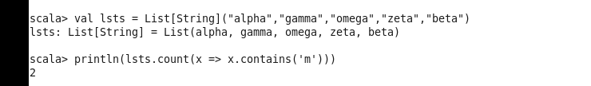

**Here lambda and the contains function is used to achieve the results**

**4)** - find the count of all strings which start with the alphabet ‘a’

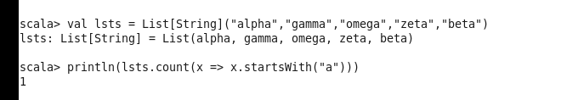

**Here lambda and the startsWith function of a string is used**

**TASK-3**

Create a Scala application to find the GCD of two numbers.

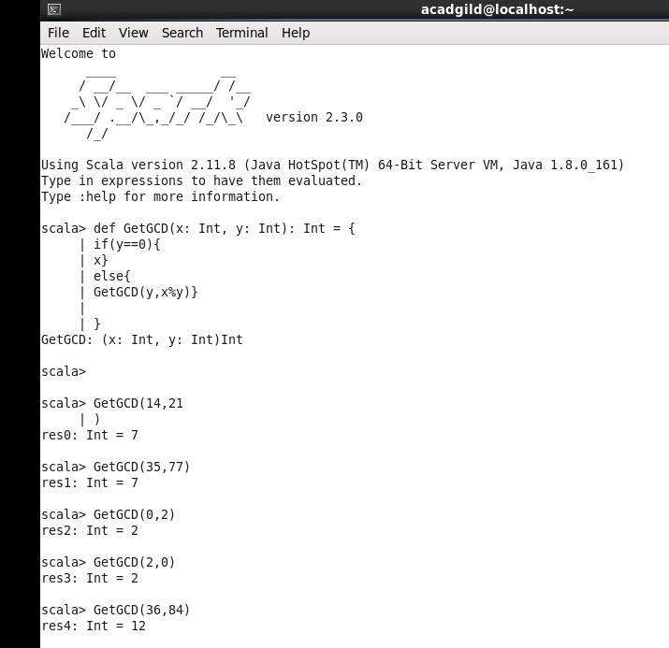

**Here GCD Function created using the Recursive method.**

**Inputs X and Y are Integers and Output is an Integer**