**Spark_Assignment-2**

**Task-1**

**SourceCode: In Github with filename “Fibonacci.scala”**

A Fibonacci series (starting from 1) written in order without any spaces in between,

producing a sequence of digits.

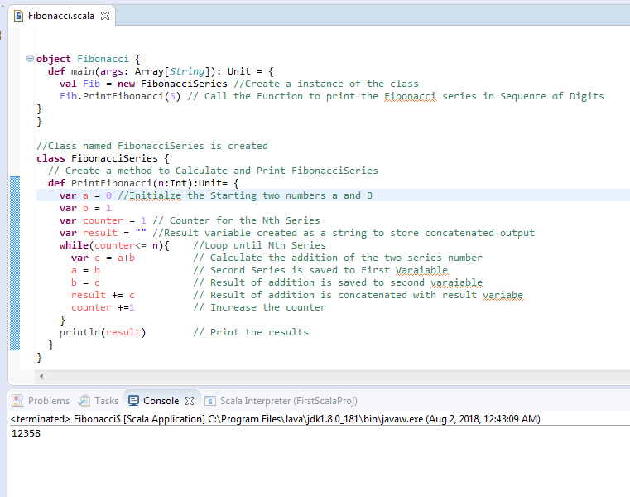

**For the Nth Series Input as 5, the result printed above is “12358”**

Write a Scala application to find the Nth digit in the sequence.

* Write the function using standard for loop
* Write the function using recursion

**Here Two Methods “FibNormalLoop” and “FibRecursion” is created to get the results for the above questions.**

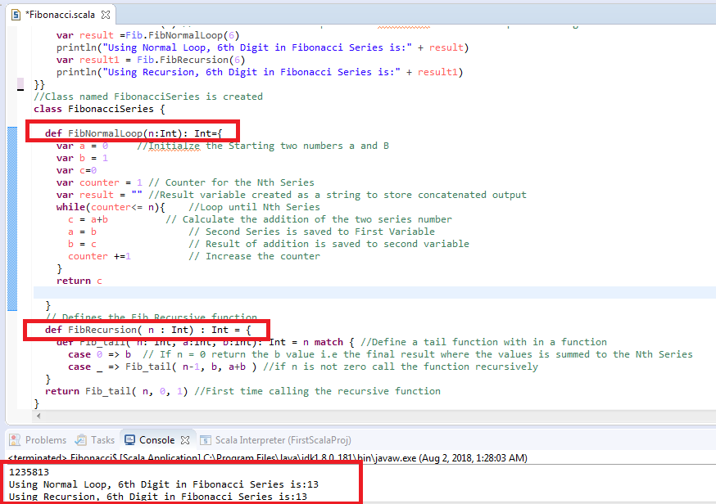

**Task 2**

**SourceCode in Github with file name:** “**Rational.scala”**

Create a calculator to work with rational numbers.

Requirements:

➢ It should provide capability to add, subtract, divide and multiply rational

numbers

➢ Create a method to compute GCD (this will come in handy during operations on

rational)

Add option to work with whole numbers which are also rational numbers i.e. (n/1)

- achieve the above using auxiliary constructors

- enable method overloading to enable each function to work with numbers and rational.

**Class Creation:**

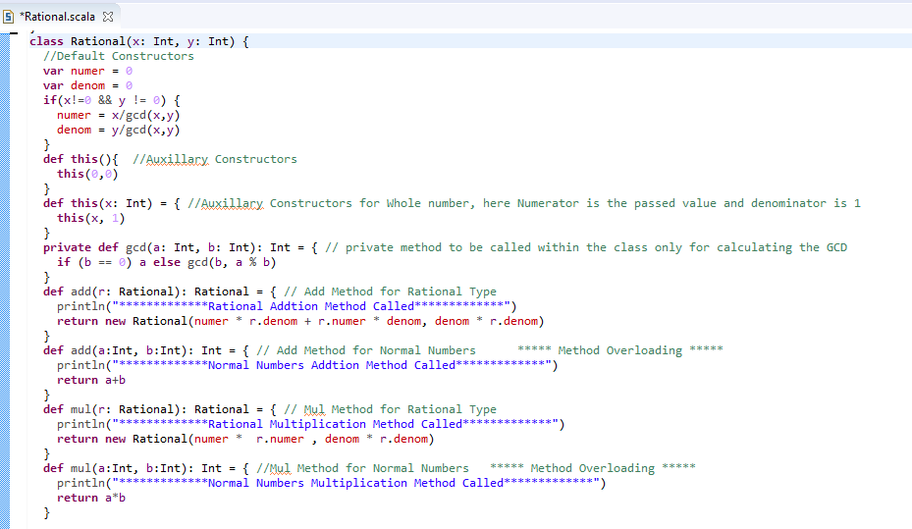

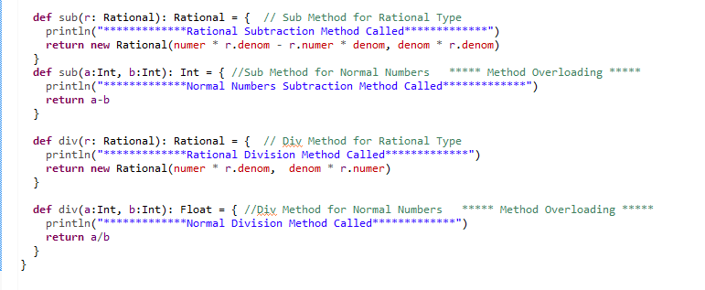

**MAIN METHOD:**

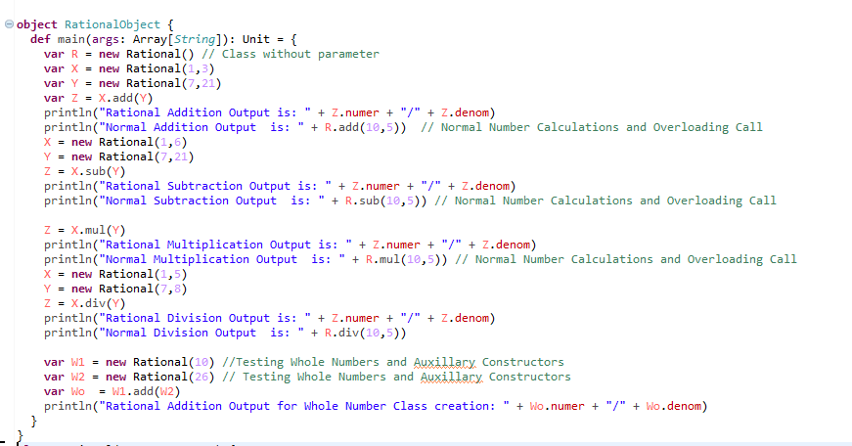

**Output:**

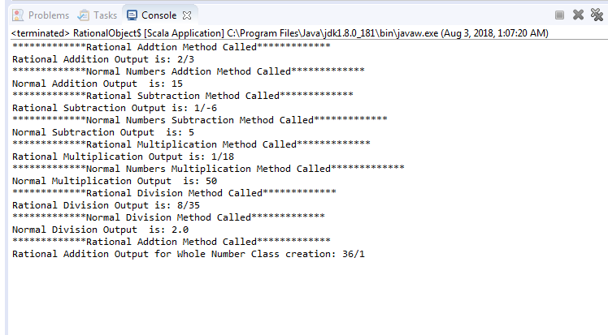

**Task 3**

1 .Write a simple program to show inheritance in scala.

2. Write a simple program to show multiple inheritances in scala.

**SourceCode: In Github with filename “Inheritance.scala”**

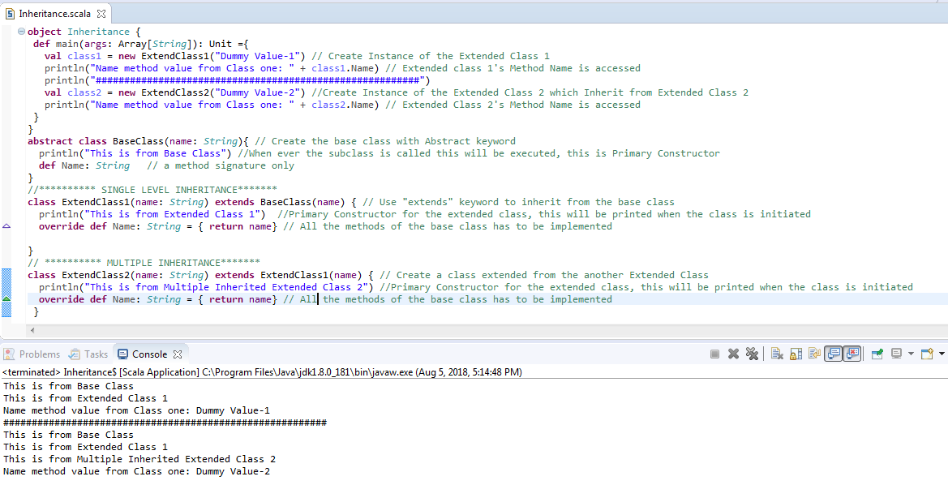

3.Write a program to print the prices of 4 courses of Acadgild : Android-12999,Big Data

Development-17999, Big Data Development-17999, Spark-19999 using match and add a

default condition if the user enters any other course

**SourceCode: In Github with filename “PartialFunctionMatch.scala”**

