**Property Management System**

* ***Insertion of data in tables:***

1. PERSON table:

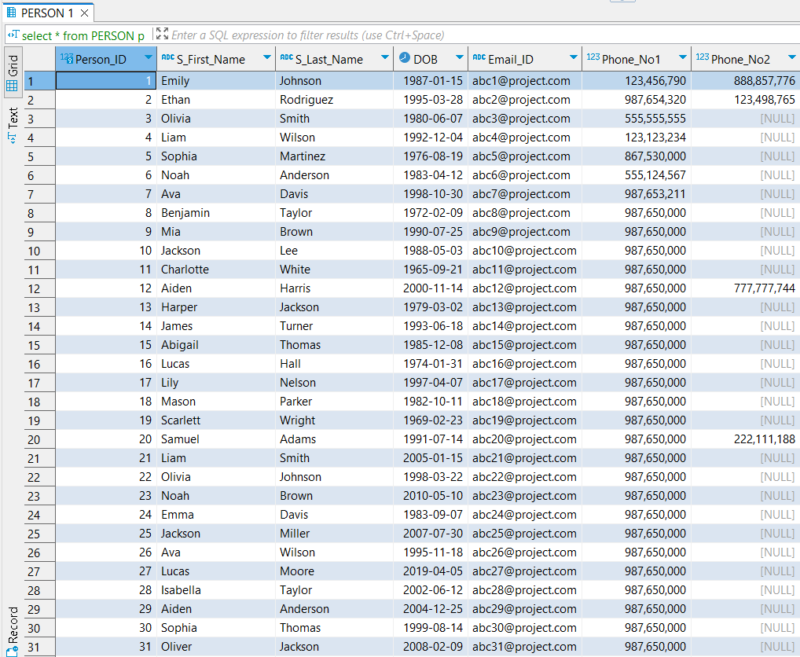

1. PROSPECTIVE_TENANT table:

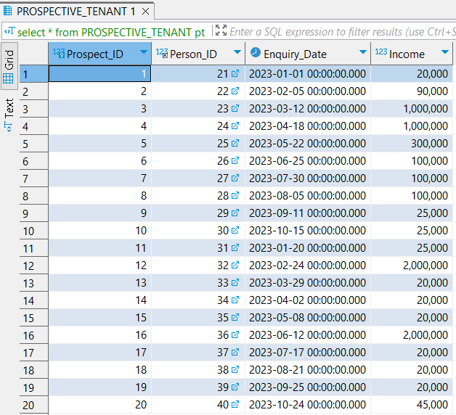

1. TENANT table:

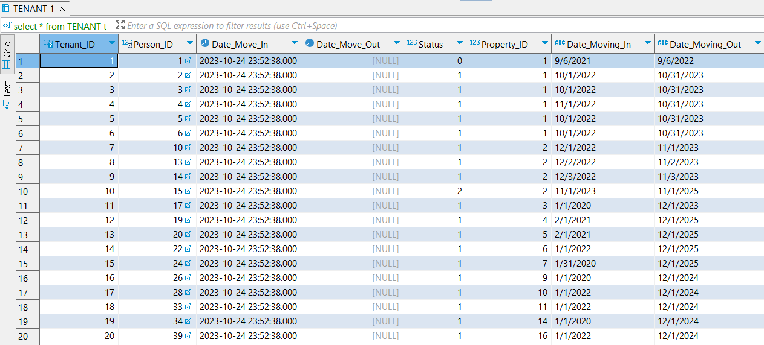

1. PROPERTY table:

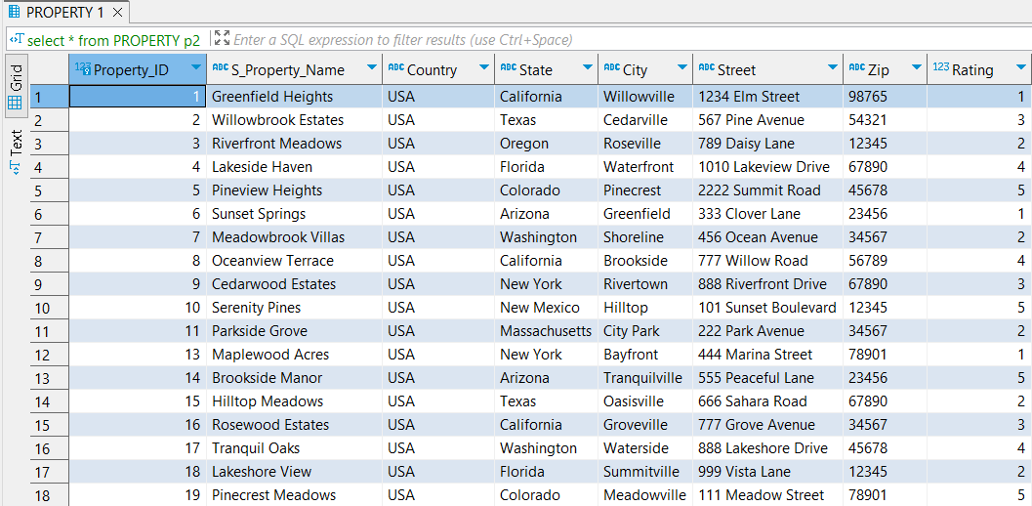

1. UNIT table:

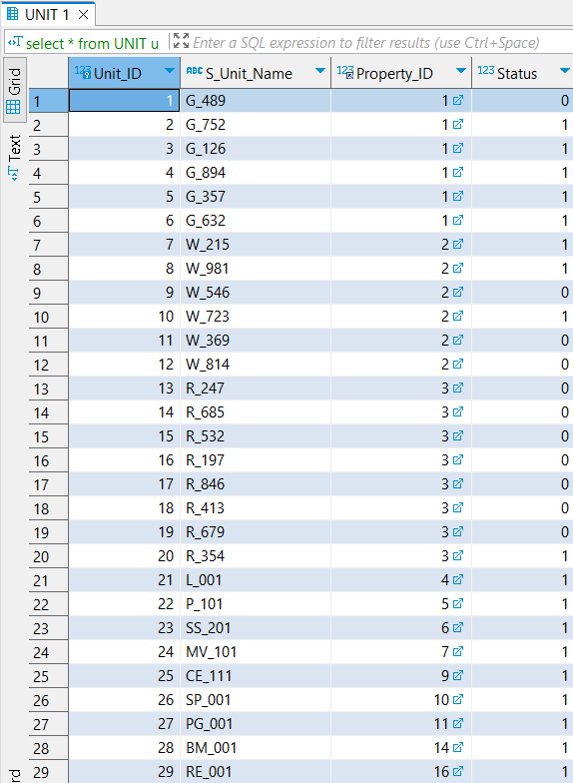

1. UNIT_ASSIGNMENT table:

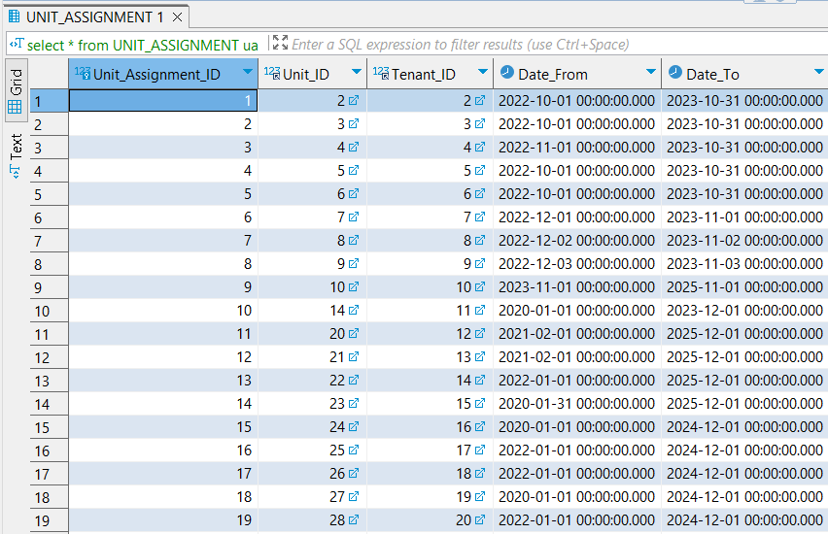

1. TENANT_AMENDMENT table:

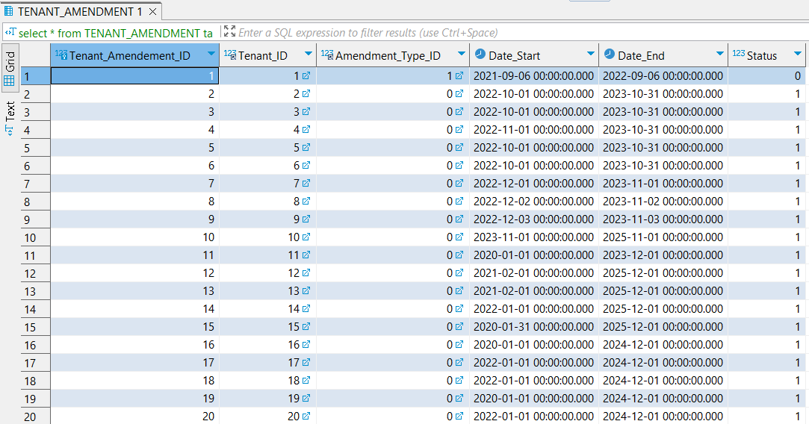

1. CHARGE_DETAILS table:

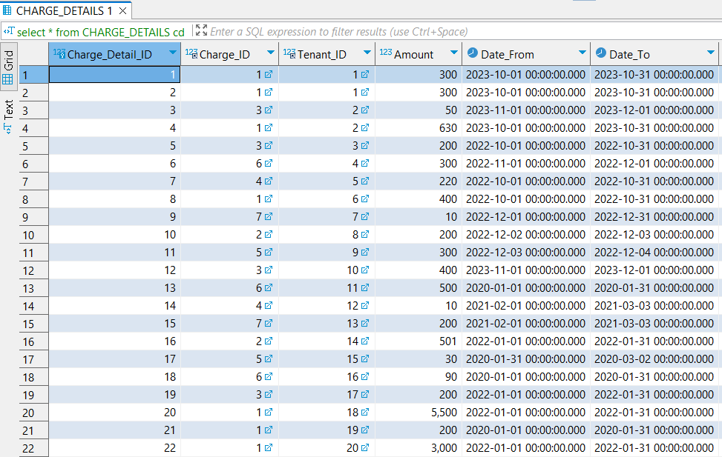

1. CHARGE_TYPE table:

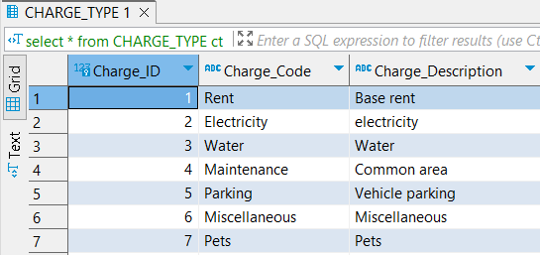

1. AMENDMENT_TYPE table: