**Property Management System**

* ***ER Diagram from DBeaver:***

* ***Physical Entity Relationship Model:***

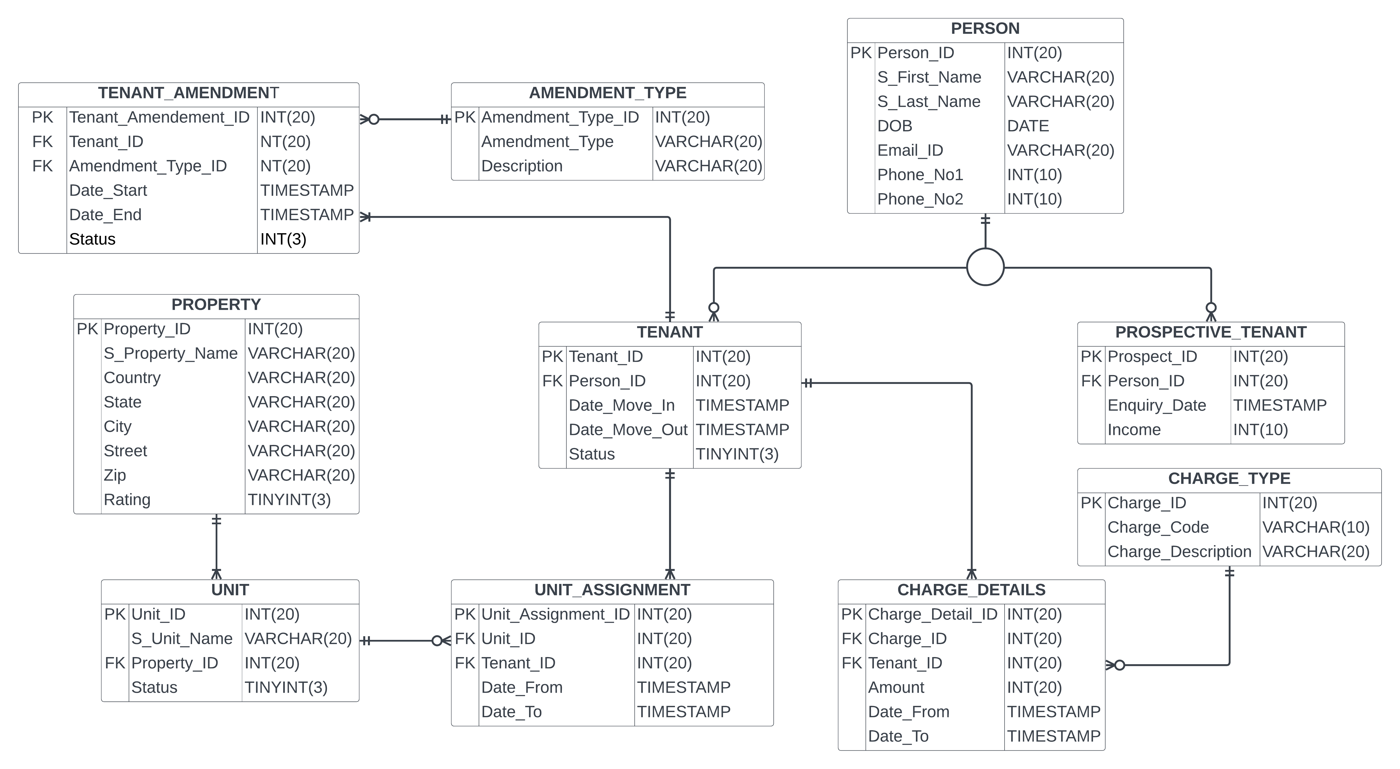

d