**INTRODUCTION TO ORACLE:**

**ORACLE IS A RELATIONAL DATABASE AN RDBMS PRODUCT FROM ORACLE CORPORATION IN 1979.WHICH IS USED TO STORE DATA (OR) INFORMATION PERMANANTLY i.e. IN HARD DISK ALONG WITH SECURITY.**

**ORACLE IS A PLATFORM INDEPENDENT AN RDBMS PRODUCT.IT MEANS THAT IT CAN DEPLOYEE (INSTALL) IN ANY OS LIKE WINDOWS, LINUX, UNIX, SOLARIES, MAC.....etc.**

**PLATFORM:**

**- IT A COMBINATION OF OPERATING SYSTEM AND MICRO PROCESSOR.THESE ARE AGAIN CLASSIFIED INTO TWO TYPES.**

**1) PLATFORM INDEPENDENT:**

**- IT SUPPORTS ANY OS WITH THE COMBINATION OF ANY MICRO PROCESSOR.**

**EX: ORACLE, MYSQL, JAVA, .NET....etc**

**2) PLATFORM DEPENDENT:**

**- IT SUPPORTS ONLY ONE OS WITH COMBINATION OF ANY MICRO PROCESSOR.**

**EX: C - LANGUAGE.**

**Versions of ORACLE:**

|  |  |  |
| --- | --- | --- |
| **Year** | **Version** | **Features** |
| **1979** | **Oracle 1.0** | **Not Public released** |
| **1980** | **Oracle 2.0** | **First Public released,**  **Basic SQL functionalities.** |
| **1982** | **Oracle 3.0** | **First Portable DB.** |
| **1984** | **Oracle 4.0** | **Introduced read consistency.** |
| **1986** | **Oracle 5.0** | **Introduced client-server architecture.** |
| **1988** | **Oracle 6.0** | **Introduced PL/SQL** |
| **1992** | **Oracle 7.0** | **Integrity Constraints introduced,**  **Varchar data type changed into Varchar2,Stored procedures, functions and triggers** |
| **1997** | **Oracle 8.0** | **Object Oriented Features, Table partitioning, Instead Triggers** |
| **1998** | **Oracle 8i(Internet)** | **Rollup, cube methods, Columns increased per a table up to 1000** |
| **2001** | **Oracle 9i** | **Renaming Column,Ansi Joins** |
| **2004** | **Oracle 10g(grid technologies)** | **Introduced Admin side operations, flashback query, Indicate of clauses, regular expressions** |
| **2007** | **Oracle 11g** | **Read only tables, virtual tables, integer data type, using sequence, enables and disables triggers.** |
| **2013** | **Oracle12c**  **(cloud technology)** | **Truncate table cascade, multiple indexes,invisiable column, sequence session, new auto increment by using**  **Identity.** |
| **2018** | **Oracle18c** | **Polymorphic Table Functions, Active Directory Integration** |
| **2019** | **Oracle19c** | **Active Data Guard DML Redirection, Automatic Index Creation,SQL Queries on Object Stores** |

**WORKING WITH ORACLE:**

**WHEN WE INSTALL ORACLE SOFTWARE INTERNALLY TWO COMPONENTS ARE INSTALLED.THOSE ARE,**

**1. ORACLE CLIENT**

**2. ORACLE SERVER**

**1. ORACLE CLIENT:**

**BY USING ORACLE CLIENT TOOL USER CAN PERFORM THE FOLLOWING THREE OPERATIONS ARE**

* **USER CAN CONNECT TO ORACLE SERVER**
* **USER CAN SEND REQUEST TO ORACLE SERVER**
* **USER CAN RECEIVE RESPONSE FROM ORACLE SERVER.**

**Ex: SQLPLUS, TOAD, SQL DEVELOPER, SQL NAVIGATOR…………………..etc**

**2. ORACLE SERVER:**

**ORACLE SERVER MANAGE TWO MORE SUB COMPONENTS INTERNALLY THOSE ARE,**

* **INSTANCE**
* **DATABASE**

**INSTANCE WILL ACT AS TEMPORARY MEMORY WHICH WILL ALLOCATE FROM RAM AND STORED DATA / INFORMATION TEMPORARY WHERE AS DATABASE IS A PERMANENT MEMORY WHICH WILL ALLOCATE FROM HARDDISK AND STORED DATA PERMANENTLY.**

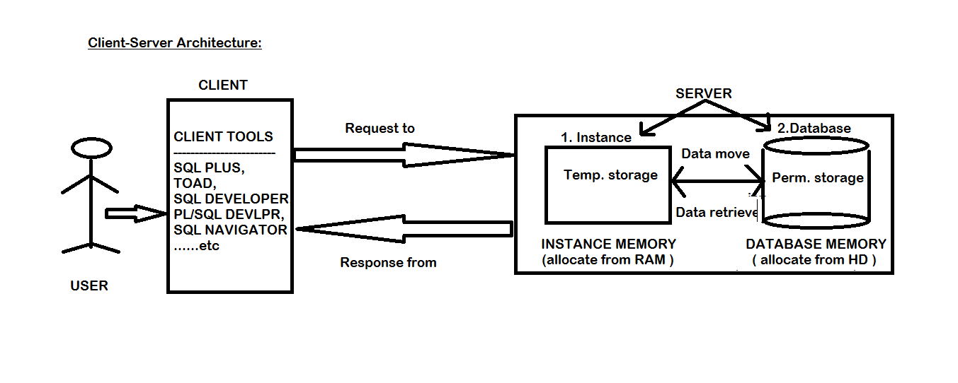

**NOTE: WHEN WE WANT TO WORK ON ORACLE DATABASE THEN WE FOLLOW THE FOLLOWING TWO STEPS PROCEDURE**

1. **CONNECT TO ORACLE:**

**IF USER WANTS TO CONNECT TO ORACLE THEN WE REQUIRED A DATABASE TOOL IS CALLED AS “SQLPLUS” WHICH WAS INBUILTED IN ORALCE SOFTWARE.**

1. **COMMUNICATE WITH DATABASE:**

**IF USER WANTS TO COMMUNICATE WITH DATABASE THEN WE NEED A DATABASE COMMUNICATION LANGUAGE IS CALLED AS “SQL”.**

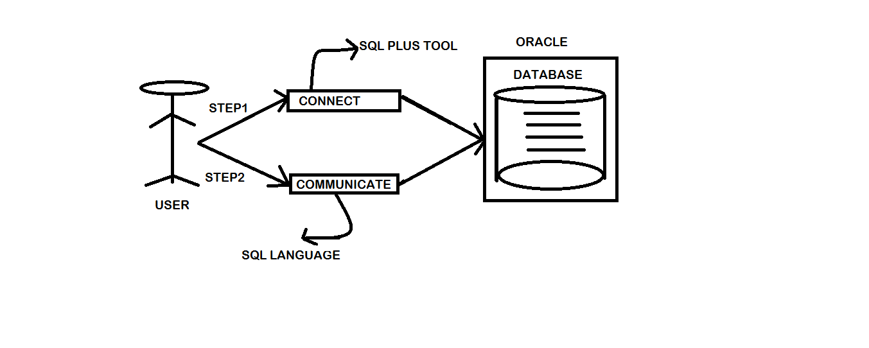

**HOW TO CONNECT TO ORACLE:**

**BEFORE CONNECT TO ORACLE DATABASE WE NEED TO KNOW THE TYPES OF EDITIONS IN ORACLE SOFTWARE.EVERY ORACLE SOFTWARE IS HAVING TWO TYPES OF EDITION S THOSE ARE**

1. **ORACLE EXPRESS EDITION**
2. **ORACLE ENTERPRISE EDITION**

**THE ABOVE TWO EDITIONS ARE HAVING DEFAULT USERNAME IS “SYSTEM” AND PASSWORD IS “MANAGER” WHEREAS IN ORACLE ENTERPRISE EDITION WE HAVE ONE MORE EXTRA USER ALONG WITH SYSTEM USER THAT IS MAY BE “SCOTT” AND PASSWORD IS “TIGER”.**

**STEPS TO CONNECT TO ORACLE:**

**> GO TO ALL PROGRAMS**

**> GO TO ORACLE 11g/12c/18c/19c FLODER**

**> OPEN APPLICATION DEVELOPMENT FLODER**

**> CLICK ON SQL PLUSE ICON**

**> ENTER USERNAME: SYSTEM | SCOTT**

**> ENTER PASSWORD: MANAGER | TIGER**

**NOTE: WHEN WE CONNECT TO ORACLE DB SOME TIMES WE WILL FACE A PROBLEM IS,**

**ERROR: ORA-28000: THE ACCOUNT IS LOCKED.**

**TO OVERCOME THE ABOVE ERROR THEN WE FOLLOW THE FOLLOWING STEPS ARE**

**SOLUTION:**

**STEP1: CONNECT TO ORACLE WITH SYSDBA (SYSTEM DATABASE ADMIN)**

**SYNTAX:**

**ENTER USERNAME: \ SYS AS SYSDBA**

**ENTER PASSWORD: SYS**

**CONNECTED.**

**STEP2: TO UNLOCK USER:**

**SYNTAX:**

**SQL> ALTER USER <USER NAME> ACCOUNT UNLOCK / LOCK;**

**EX:**

**SQL> ALTER USER SYSTEM ACCOUNT UNLOCK;**

**SQL> ALTER USER SCOTT ACCOUNT UNLOCK;**

**STEP3: NOW CONNECT TO ORACLE WITH EITHER SYSTEM (OR) SCOTT USER:**

**ENTER USERNAME: SCOTT**

**ENTER PASSWORD: TIGER**

**CONNECTED.**

**TO VIEW ALL LIST OF TABLES IN ORACLE DATABASE:**

**SYNTAX:**

**SQL> SELECT * FROM TAB;**

**TO VIEW DATA OF A PARTICULAR TABLE:**

**SYNTAX:**

**SQL> SELECT * FROM <TABLE NAME>;**

**EX:**

**SQL> SELECT * FROM EMP;**

**NOTE: WHEN WE WANT TO DISPLAY THE INFORMATION / DATA OF A PARTICULAR TABLE IN PROPER SYSTEMATICALLY THEN WE NEED TO SET THE FOLLOWING TWO PROPERTIES ARE,**

**1) PAGESIZE n:**

**- NUMBER OF ROWS DISPLAYED PER A PAGE.HERE "n" IS REPRESENTED NO.OF ROWS. BY DEFAULT A SINGLE PAGE IS DISPLAYED 14 ROWS.**

**SYNTAX:**

**SQL> SET PAGESIZE n;**

**EX:**

**SQL> SET PAGESIZE 100;**

**2) LINES n:**

**- NUMBER OF CHARACTERS IN A SINGLE LINE.HERE "n" IS REPRESENT NO.OF CHARACTERS.**

**SYNTAX:**

**SQL> SET LINES n;**

**EX:**

**SQL> SET LINES 100;**

**TO CLEAR SQL PLUS EDITOR SCREEN:**

**SYNTAX:**

**SQL> CL SCR;**

**(OR)**

**SHIFT+DELETE (FROM KEYBOARD)**

**TO DISCONNECT / EXIT FROM ORACLE DATABASE:**

**SQL> EXIT;**