Software Testing Assignment

Module–1(Fundamental)

* What is SDLC
* What is software testing?
* What is agile methodology?
* What is SRS
* What is oops
* Write Basic Concepts of oops
* What is object
* What is class
* What is encapsulation
* What is inheritance
* What is polymorphism
* Draw Use case on Online book shopping
* Draw Use case on online bill payment system (paytm)
* Write SDLC phases with basic introduction
* Explain Phases of the waterfall model
* Write phases of spiral model
* Write agile manifesto principles
* Explain working methodology of agile model and also write pros and cons.
* Draw use case on Online shopping product using COD.
* Draw use case on Online shopping product using payment gateway

1. **What is SDLC?**

* SDLC stands for Software Development life Cycle.
* It is the process to Develop Software which is basis on design requirements test cases coding etc.

1. **What is software testing?**

* It is a process to check whether the software is completed, correct way and quality.

1. **What is agile methodology?**

* Agile Methodology is combination of Iterative & Incremental Model.
* Focus on process adaptability and customer satisfaction.
* Rapidly process
* Product into small incremental builds.
* **Advantages:-**
* Very realistic approach.
* Promote Teamwork.
* Functionality can be developed rapidly
* Changing Requirements.
* Give Flexibility to Developers.
* **Disadvantages:-**
* Complex management Dependencies.
* Move Risky.
* Leader and agile PM More experiences.
* Depends heavily on customer interaction.
* Minimum Document generated.

1. **What is SRS?**

* SRS stands for software requirements specifications.
* SRS defines the Documentation of the software like its designing, requirements.

1. **What is oops?**

* It is an object oriented languages which are helpful for creating different software to do some task.
* It is a realistic approach.

1. **Write Basic Concepts of oops?**

* Object oriented languages having six concept which are:-
* Object
* Class
* Encapsulation
* Abstraction
* Inheritance
* Polymorphisms

1. **What is object?**

* An object represents the smallest unit or entity with well defined role in the software or program

1. **What is class?**

* Class is defined as a blueprint of an object which contain on object property and its behavior and it will not run without any declaration of an object in main class.

1. **What is encapsulation?**

* An Encapsulation means raping up data [Property & Behavior] of an object into single unit that is called Encapsulation.

1. **What is inheritance?**

* Inheritance means inheritance in one class properties to another class.
* There are five Inheritances.
* Single
* Multilevel
* Multiple
* Herichial
* Hybrid

1. **What is polymorphism?**
   * Poly=Many & Morphism=Form.
   * It allows the different object to response to the same message in different way.
   * Two type 1]Overloading->Compile time 2]Overriding->Runtime.
2. **Write SDLC phases with basic introduction?**

* 6 Phases include:-

1. Requirement->Customer Need. Static=>Formal & Informal.
2. Analysis->Model & Specify the Requirements.
3. Design->Model & Specify Solution.
4. Implementation->Coding.
5. Testing->Build
6. Maintenance->Closure.
7. **Explain Phases of the waterfall model?**

* Requirement are very well documented clear and fixed.
* Product definition is stable.
* Technology is understood.
* Project is short.
* No dynamic, no ambiguous requirements.
* 6 Phases include:-
* Requirement->Customer Need. Static=>Formal & Informal.
* Analysis->Model & Specify the Requirements.
* Design->Model & Specify Solution.
* Implementation->Coding.
* Testing->Build
* Maintenance->Closure.

**Advantages:-**

* Easy & simple to understood and use.
* Clear defined stages.
* Well understood milestone.
* Easy to manage, for small project.

**Disadvantages:-**

* + High amount of risk.
  + Not suitable for large project.
  + We cannot see project middle of the phase.
  + Requirements are not change.
  + Not dynamic, technology not change.

1. **Write phases of spiral model?**

* The Spiral Model is a risk-driven model, meaning that the focus is on managing risk through multiple iterations of the software development process.
* It has four phases:
* Requirement analysis
* Risk Analysis
* Develop and test
* Reviewandplanning
* **Advantages:-**
* Flexible changes are allowed in spiral model.
* Development can be distributed into smaller parts.
* More clarity for Developers and Test engineers.
* It will provide the wide use of prototypes.
* **Disadvantages:-**
* Not suitable for the small and low-risk product because it could be costly for a smaller project.
* It is a traditional model, and thus developers only did the testing job as well.
* There is no requirement of review process and no parallel deliverables allowed in the spiral model.
* management is a bit difficult.

1. **Explain working methodology of agile model and also write pros and cons.**

* Agile methodology is a project management framework that breaks projects down into several dynamic phases, commonly known as sprints.
* The Agile framework is an iterative methodology.
* After every sprint, teams reflect and look back to see if there was anything that could be improved so they can adjust their strategy for the next sprint.
* **Advantages:-**
* Very realistic approach.
* Promote Teamwork.
* Functionality can be developed rapidly
* Changing Requirements.
* Give Flexibility to Developers.
* **Disadvantages:-**
* Complex management Dependencies.
* Move Risky.
* Leader and agile PM More experiences.
* Depends heavily on customer interaction.
* Minimum Document generated.

1. **Write agile manifesto principles**

* The Agile framework is an iterative methodology.
* After every sprint, teams reflect and look back to see if there was anything that could be improved so they can adjust their strategy for the next sprint.

1. **Draw Use case on Online book shopping**

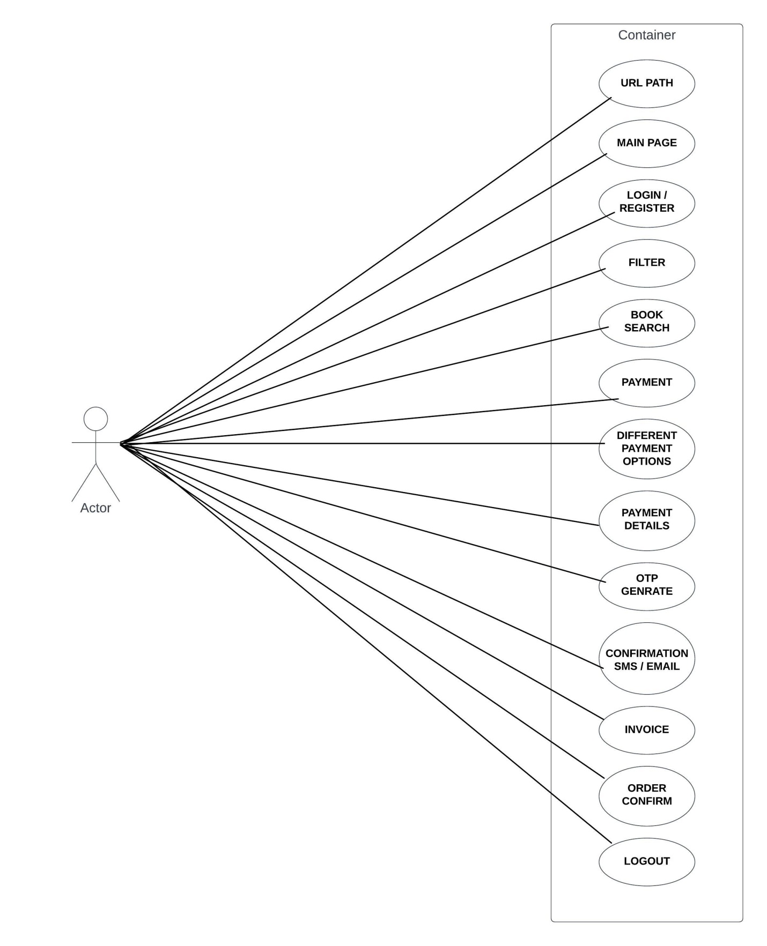

1. **Draw Use case on online bill payment system**

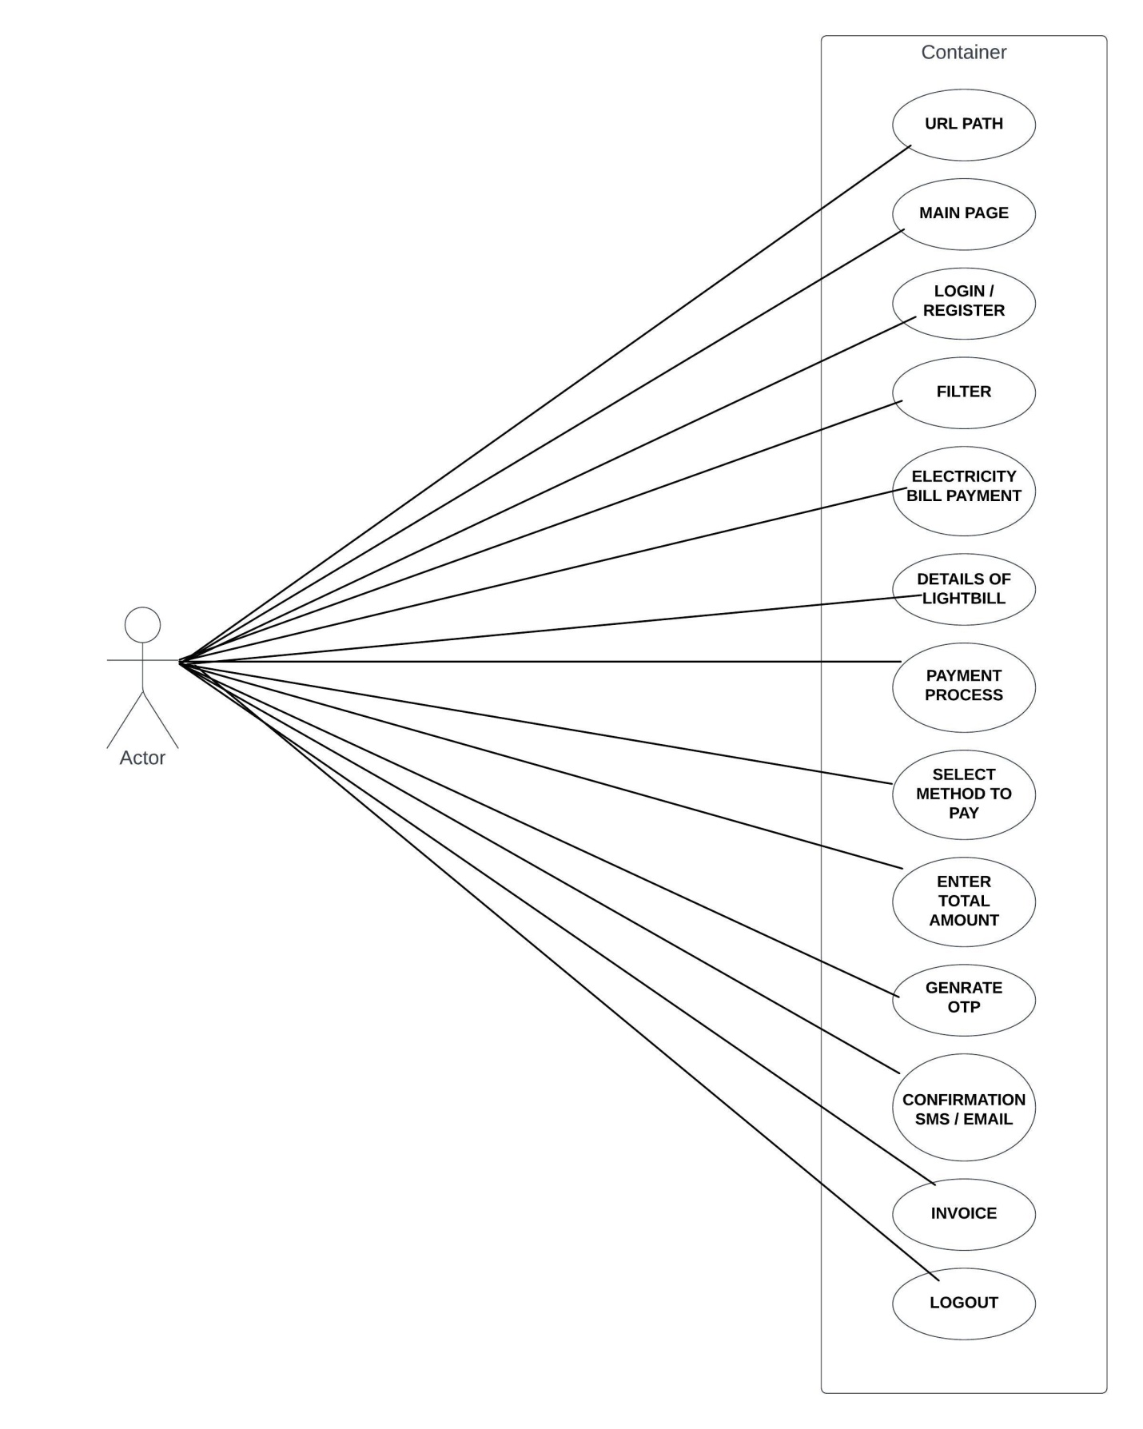

1. **Draw use case on Online shopping product using COD.**

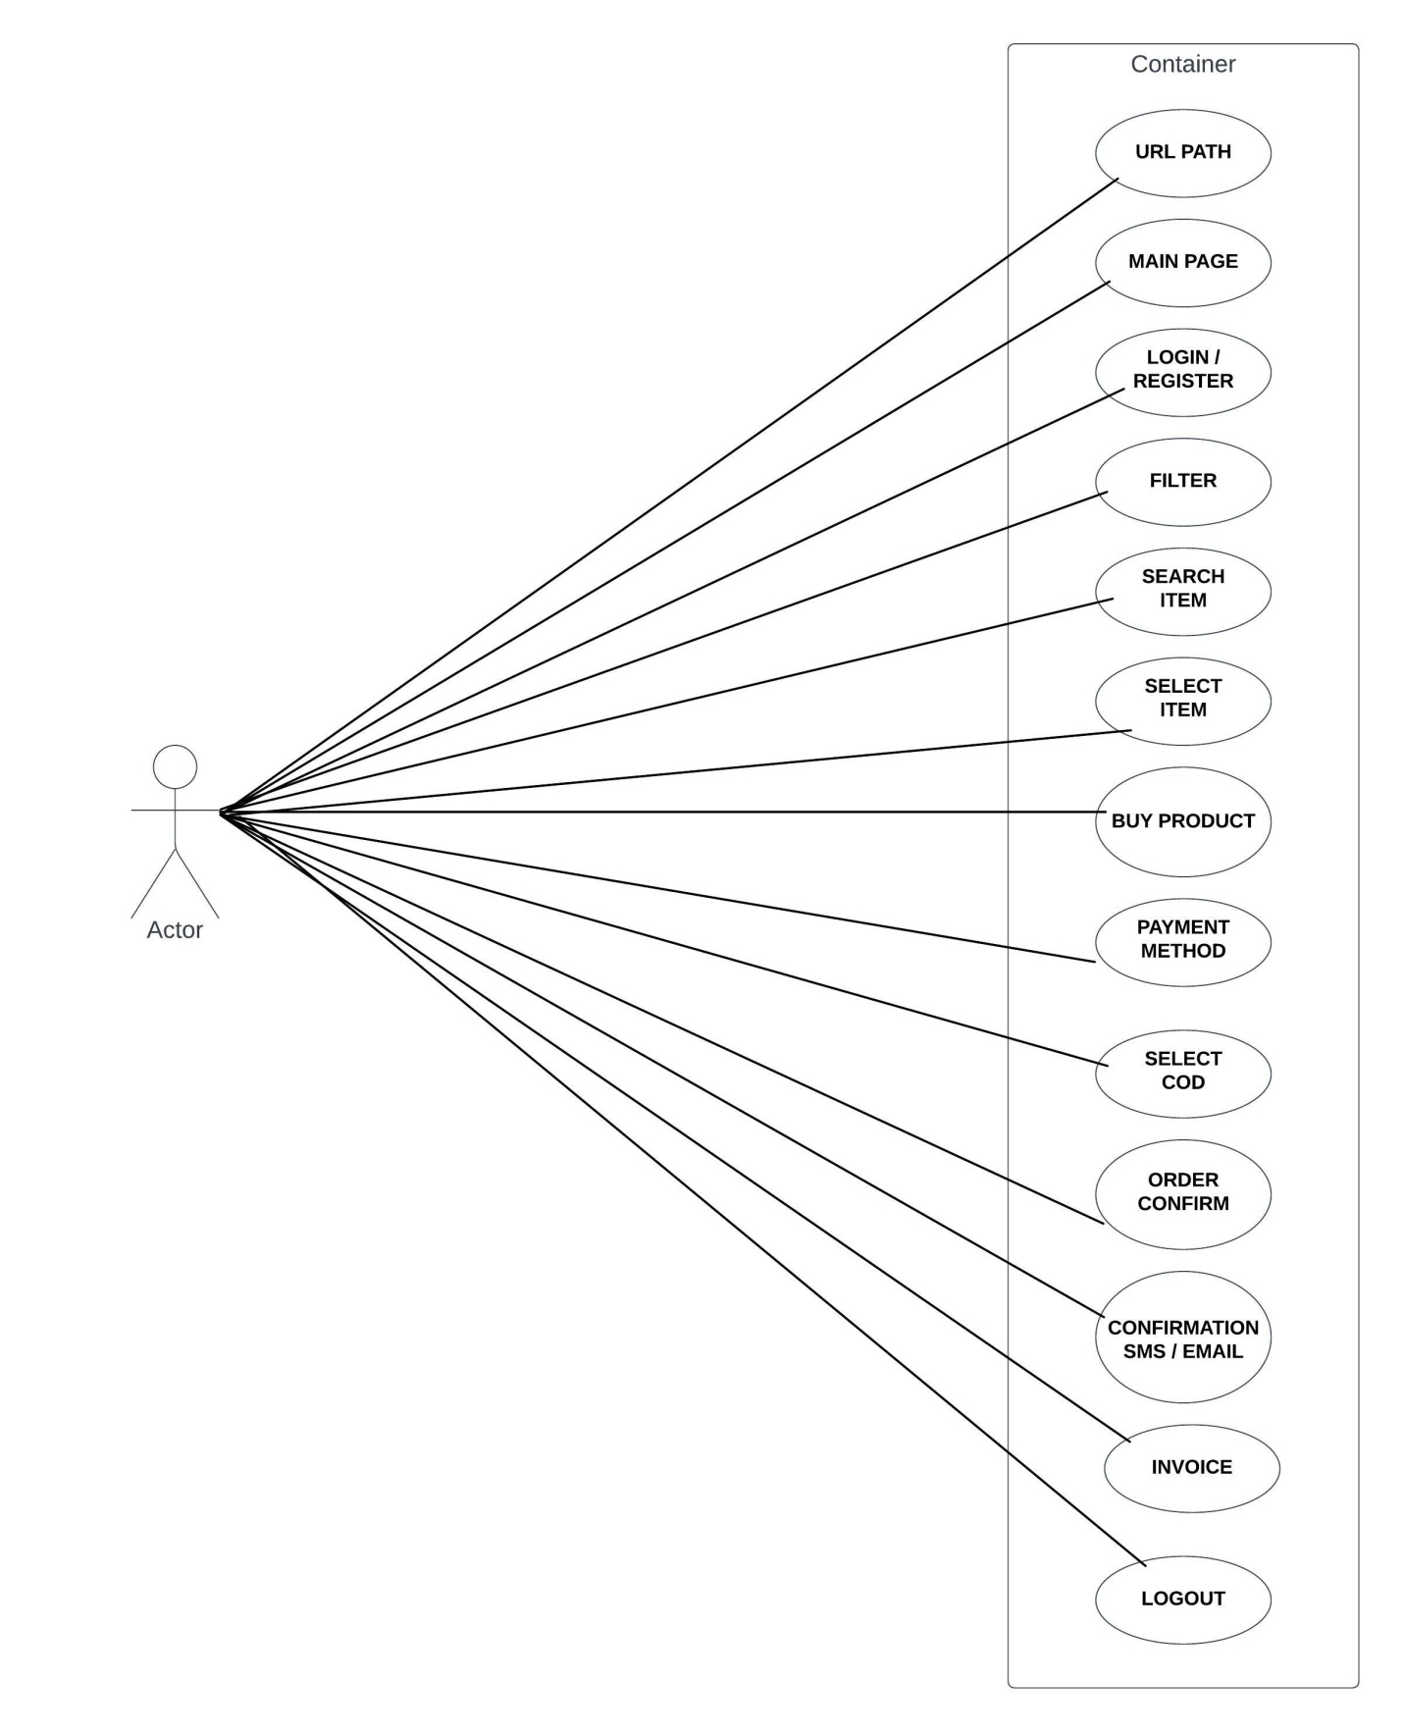

1. **Draw use case on Online shopping product using payment gateway**

