

DESIGN PROJECT (PS-1)
IDENTIFICATION AND COUNTING OF PIPES IN A STACK USING MATLAB IMAGE PROCESSING TOOLBOX
(BITS F221)
UNDER
Dr. ALPESH DHORAJIA

BY
MAYUR ASHIA
SHIVAKSHIT PATRI
AT


Acknowledgement

Theory of any subject is important but without its knowledge it becomes useless particularly for technical students. A technical student can’t become perfect engineer or technician without perfect understanding of their branches.
Hence industrial training provides a golden opportunity for all technical students.
In the field of polymer science and engineering, much progress has been made in the last decade, in the terms of fundamental understanding as well as development of each and every process for manufacturing different polymeric products.
Training is essential for us to get acknowledged and get use to know our environment and the people in the industry.
It reinforces the knowledge gained in the classroom and in labs.
It provides the opportunity to know and learn many aspect or facets of the real world and also correlate theoretical knowledge with practical solutions.
So, we take this opportunity to express our gratitude to those who have helped us during our tenure of our training to make its purpose fulfilled.
Firstly, we would like to thank Mr. Sanjay Prabhu Desai and Mr. A.R. Deshpande who guided us during our training. We extend our sincere thanks to Mr. V.S Patil, Mr Sunil Soni for their valuable help and cooperation during the training period. We also thank all the operation staff members of Supreme who directly or indirectly help us during our training program at Supreme.

We would also thank our respected Instructor Mr. Alpesh.M.Dorajia who helped us go through our first industry exposure, so that we can do our best in the field.

Abstract sheet

BIRLA INSTITUTE OF TECHNOLOGY AND SCIENCE PILANI (RAJASTHAN)

Practice School Division
Centre: Jalgaon
Station: Supreme Industries Limited
Duration: 56 days Date of Start: 23 May 2014
Date of Submission: 20 June 2014
Title of the Project: IDENTIFICATION AND COUNTING OF PIPES IN A STACK USING MATLAB IMAGE PROCESSING TOOLBOX

ID No. /Name(s)/ Mayur Ashia (2012B3A3554H)
Shivakshit Patri (2012AAPS168H)

Discipline(s) of the Students: Economics, EEE, EC

Name(s) & Designation(s) of the Experts
Mr. V.S Patil (PROJ & ENGG DEPT MAINTAINENCE)
Mr. Sunil Soni (IT DEPT)

Name(s) of the PS Mr. Alpesh.M.Dorajia
Faculty

Keywords: Image-processing, Matlab Software
Project area: PROJ AND ENGG and IT Dept.
Abstract: We are required to find number of pipes after loading and give
Their total count. We used image processing toolbox in MATLAB
SOFTWARE

Signature(s) of the Student(s) Signature(s) of the Faculty
Date: Date:

Contents

- What is MATLAB?
- MATLAB Programming/Image Processing Toolbox
- Key Features
- BASIC IDEA BEHIND USING MATLAB?
- OUR SOLUTION
- DETAILS
- In matlab we use the following code.
- WHAT DO WE GET? STEPWISE?
- STEPWISE BREAKDOWN OF LOGIC
- PROBLEMS
- Limitations.
- FURTHER SCOPE

WHAT IS MATLAB?
MATLAB (matrix laboratory) is a multi-paradigm numerical computing environment and fourth-generation programming language. Developed by Math Works, MATLAB allows matrix manipulations, plotting of functions and data, implementation of algorithms, creation of user interfaces, and interfacing with programs written in other languages, including C, C++, Java, and FORTRAN.

Although MATLAB is intended primarily for numerical computing, an optional toolbox uses the MuPAD symbolic engine, allowing access to symbolic computing capabilities. An additional package, Simulink, adds graphical multi-domain simulation and Model-Based Design for dynamic and embedded systems.

MATLAB Programming/Image Processing Toolbox
The core MATLAB package comes with several rudimentary functions (to be described later) that can be used to load, save, and perform custom functions on images. However, it is often necessary to perform more complicated operations on images. The image processing toolbox allows such manipulations as:
- Direct visualization of images in MATLAB
- Color space conversions (e.g. between RGB, HSV, L*a*b*, and so on)
- Object grouping and data collection
- Filtering and fast convolution
- Fourier analysis of images
- Image arithmetic
- Morphological operations and many other
Image Processing Toolbox™ provides a comprehensive set of reference-standard algorithms, functions, and apps for image processing, analysis, visualization, and algorithm development. You can perform image analysis, image segmentation, image enhancement, noise reduction, geometric transformations, and image registration. Many toolbox functions support multicore processors, GPUs, and C-code generation.

Image Processing Toolbox supports a diverse set of image types, including high dynamic range, giga pixel resolution, embedded ICC profile, and tomographic. Visualization functions and apps let you explore images and videos, examine a region of pixels, adjust color and contrast, create contours or histograms, and manipulate regions of interest (ROIs). The toolbox supports workflows for processing, displaying, and navigating large images.

Key Features
- Image analysis, including segmentation, morphology, statistics, and measurement & Image enhancement, filtering, and de-blurring
- Geometric transformations and intensity-based image registration methods
- Image transforms, including FFT, DCT, Radon, and fan-beam projection
- Large image workflows, including block processing, tiling, and multi-resolution display
- Visualization apps, including Image Viewer and Video Viewer
- Multicore- and GPU-enabled functions, and C-code generation support.

BASIC IDEA BEHIND USING MATLAB?
The project required us to find the number of pipes loaded in a truck before delivering them to their destination. The task required us to differentiate between pipes of various size and to give their individual count to the operating supervisor at the plant.

This practice would help the employees save time, as well as reduce errors, as at times their were mistakes done while sending a consignment which results in embarrassment as well cost of transport which is huge considering it is about half of the entire cost.

This problem is being faced by the entire industry.
We were also told that pipes are stacked telescopically increasing the complexity of the problem.

We came up with the idea of using Matlab because it is a very powerful tool for solving mathematical problems and also includes different in built functions.

This was a basic problem of image-processing and Matlab had an inbuilt toolbox just for it.

OUR SOLUTION
Our solution to the problem was to take an image of the pipes after they were loaded. And with the help of Matlab to count the number of circles in the image equivalent to number of pipes.
We used inbuilt functions in matlab for image processing further details of step by step procedure is given below.

DETAILS

First step is to take an image after loading through high definition camera.
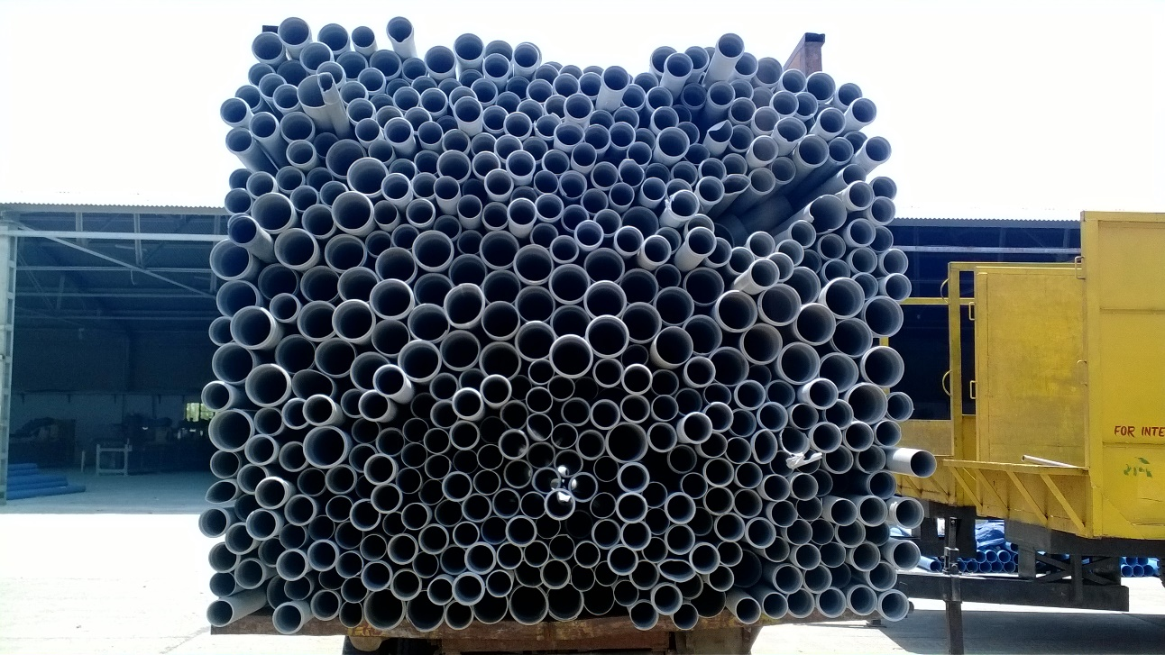
The image was taken through a camera of a smartphone.
5 mega-pixel resolution

In matlab we use the following code.

function varargout = Supreme(varargin)
% SUPREME MATLAB code for Supreme.fig
% SUPREME, by itself, creates a new SUPREME or raises the existing
% singleton*.
%
% H = SUPREME returns the handle to a new SUPREME or the handle to
% the existing singleton*.
%
% SUPREME('CALLBACK',hObject,eventData,handles,...) calls the local
% function named CALLBACK in SUPREME.M with the given input arguments.
%
% SUPREME('Property','Value',...) creates a new SUPREME or raises the
% existing singleton*. Starting from the left, property value pairs are
% applied to the SUPREME before Supreme_OpeningFcn gets called. An
% unrecognized property name or invalid value makes property application
% stop. All inputs are passed to Supreme_OpeningFcn via varargin.
%
% *See SUPREME Options on GUIDE's Tools menu. Choose "SUPREME allows only one
% instance to run (singleton)".
%
% See also: GUIDE, GUIDATA, GUIHANDLES

% Edit the above text to modify the response to help Supreme

% Last Modified by GUIDE v2.5 11-Jul-2014 05:55:17

% Begin initialization code - DO NOT EDIT
gui_Singleton = 1;
gui_State = struct('gui_Name', mfilename, ...
'gui_Singleton', gui_Singleton, ...
'gui_OpeningFcn', @Supreme_OpeningFcn, ...
'gui_OutputFcn', @Supreme_OutputFcn, ...
'gui_LayoutFcn', [] , ...
'gui_Callback', []);
if nargin && ischar(varargin{1})
gui_State.gui_Callback = str2func(varargin{1});
end

if nargout
[varargout{1:nargout}] = gui_mainfcn(gui_State, varargin{:});
else
gui_mainfcn(gui_State, varargin{:});
end
% End initialization code - DO NOT EDIT

% --- Executes just before Supreme is made visible.
function Supreme_OpeningFcn(hObject, eventdata, handles, varargin)
% This function has no output args, see OutputFcn.
% hObject handle to figure
% eventdata reserved - to be defined in a future version of MATLAB
% handles structure with handles and user data (see GUIDATA)
% varargin command line arguments to Supreme (see VARARGIN)

% Choose default command line output for Supreme
handles.output = hObject;

% Update handles structure
guidata(hObject, handles);

% UIWAIT makes Supreme wait for user response (see UIRESUME)
% uiwait(handles.figure1);

% --- Outputs from this function are returned to the command line.
function varargout = Supreme_OutputFcn(hObject, eventdata, handles)
% varargout cell array for returning output args (see VARARGOUT);
% hObject handle to figure
% eventdata reserved - to be defined in a future version of MATLAB
% handles structure with handles and user data (see GUIDATA)

% Get default command line output from handles structure
varargout{1} = handles.output;

% --- Executes on button press in pushbutton1.
function pushbutton1_Callback(hObject, eventdata, handles)
% hObject handle to pushbutton1 (see GCBO)
% eventdata reserved - to be defined in a future version of MATLAB
% handles structure with handles and user data (see GUIDATA)
[filename pathname] = uigetfile({'*.jpg';'*.bmp'},'Browse Image');
address = strcat(pathname,filename);
axes(handles.axes1);
imshow(address);
handles.address = address;
set(handles.slider5,'Value',33);
guidata(hObject,handles);

function edit1_Callback(hObject, eventdata, handles)
% hObject handle to edit1 (see GCBO)
% eventdata reserved - to be defined in a future version of MATLAB
% handles structure with handles and user data (see GUIDATA)

% Hints: get(hObject,'String') returns contents of edit1 as text
% str2double(get(hObject,'String')) returns contents of edit1 as a double

% --- Executes during object creation, after setting all properties.
function edit1_CreateFcn(hObject, eventdata, handles)
% hObject handle to edit1 (see GCBO)
% eventdata reserved - to be defined in a future version of MATLAB
% handles empty - handles not created until after all CreateFcns called

% Hint: edit controls usually have a white background on Windows.
% See ISPC and COMPUTER.
if ispc && isequal(get(hObject,'BackgroundColor'), get(0,'defaultUicontrolBackgroundColor'))
set(hObject,'BackgroundColor','white');
end

% --- Executes on button press in pushbutton2.
function pushbutton2_Callback(hObject, eventdata, handles)
% hObject handle to pushbutton2 (see GCBO)
% eventdata reserved - to be defined in a future version of MATLAB
% handles structure with handles and user data (see GUIDATA)
address = handles.address;
img = imcomplement(im2bw(imread(address)));
rmin = round(str2num(get(handles.edit2,'string')));
rmax = 3*rmin;
[centres radii] = imfindcircles(img,[rmin rmax]);
axes(handles.axes2);
imshow(imread(address));
hold on
viscircles(centres,radii,'EdgeColor','b');
hold off
nop = size(radii,1);
set(handles.edit1,'string',nop);

% --- Executes on slider movement.
function slider5_Callback(hObject, eventdata, handles)
% hObject handle to slider5 (see GCBO)
% eventdata reserved - to be defined in a future version of MATLAB
% handles structure with handles and user data (see GUIDATA)

% Hints: get(hObject,'Value') returns position of slider
% get(hObject,'Min') and get(hObject,'Max') to determine range of slider
slider_value = get(handles.slider5,'Value');
set(handles.edit2,'string',slider_value);

% --- Executes during object creation, after setting all properties.
function slider5_CreateFcn(hObject, eventdata, handles)
% hObject handle to slider5 (see GCBO)
% eventdata reserved - to be defined in a future version of MATLAB
% handles empty - handles not created until after all CreateFcns called

% Hint: slider controls usually have a light gray background.
if isequal(get(hObject,'BackgroundColor'), get(0,'defaultUicontrolBackgroundColor'))
set(hObject,'BackgroundColor',[.9 .9 .9]);
end

function edit2_Callback(hObject, eventdata, handles)
% hObject handle to edit2 (see GCBO)
% eventdata reserved - to be defined in a future version of MATLAB
% handles structure with handles and user data (see GUIDATA)

% Hints: get(hObject,'String') returns contents of edit2 as text
% str2double(get(hObject,'String')) returns contents of edit2 as a double

% --- Executes during object creation, after setting all properties.
function edit2_CreateFcn(hObject, eventdata, handles)
% hObject handle to edit2 (see GCBO)
% eventdata reserved - to be defined in a future version of MATLAB
% handles empty - handles not created until after all CreateFcns called

% Hint: edit controls usually have a white background on Windows.
% See ISPC and COMPUTER.
if ispc && isequal(get(hObject,'BackgroundColor'), get(0,'defaultUicontrolBackgroundColor'))
set(hObject,'BackgroundColor','white');
end

WHAT DO WE GET? STEPWISE?
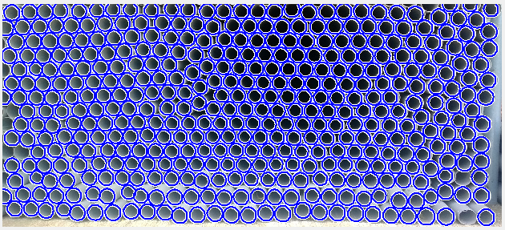
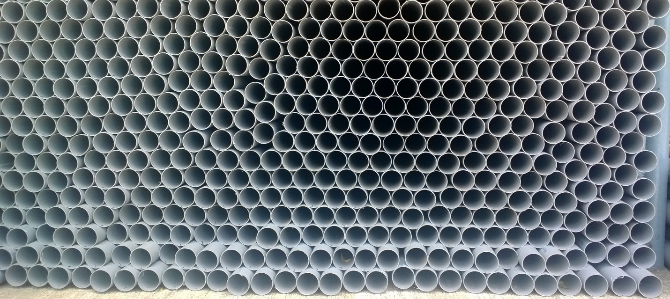
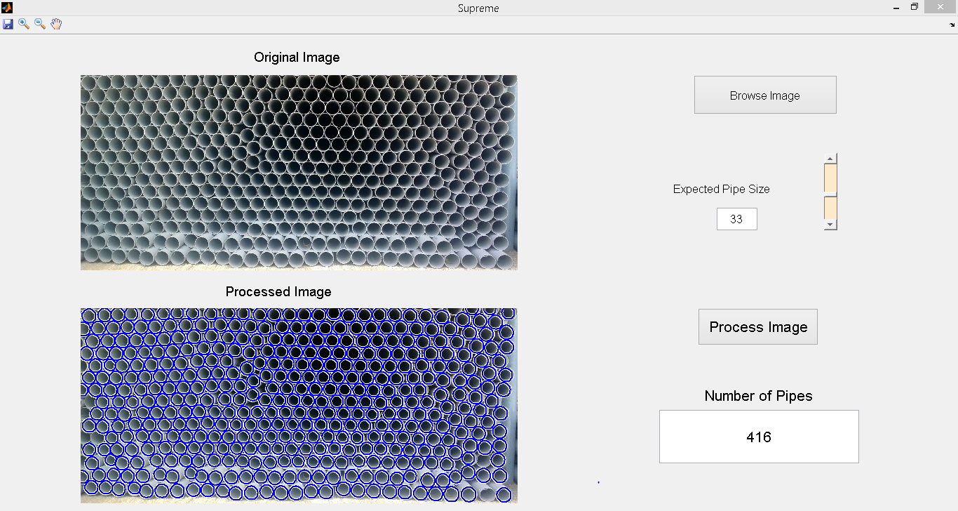

STEPWISE BREAKDOWN OF LOGIC
Uploaded image is first of all converted to a black and white image (logical image).
In our code we instruct the tool to look for dark circles. The computer basically looks in a range set by us (30-60 pixels) for dark pixels and their surrounding pixels. And whether the other pixels make a circle within range and automatically looks for center.

In the second image we can see the circles which are identified by the software being highlighted.
And in the last image we see, our user interface. Displaying the number of circles identified in our case number of pipes.

PROBLEMS
We see that few pipes were not recognized.
This is because the software was not able to identify them or they do not appear to be proper circles.
One more problem is physical factors such as sunlight and depend completely on quality of photograph.

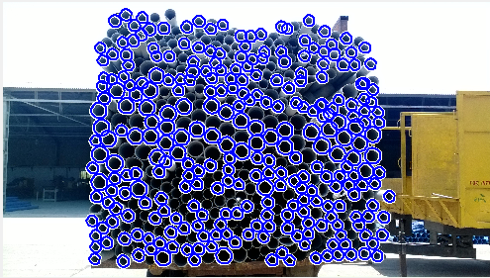
Thus it is important to take care of various factors such as lighting, distance, stacking in same plane in frontal view as tool would not be able to recognize them vice-versa.

As we see in above image that as pipes are stacked properly almost zero error has been made.

Limitations.
There are a few limitations such as, we can only give count of total pipes and not individual count of pipes according to their sizes in same loading.

This is a problem of perception and requires us to take care of a lot of factors.

FURTHER SCOPE
With further development in part and proper physical conditions and steps we can improve further.
By taking pictures using a high-definition camera and proper stacking and keeping the pipes at proper distance after loading, as well as taking care of lighting we can even get individual count of pipes with almost no error.

A part of problems solution lies in machine learning and though complex it can easily give us results with no error.

It is quite easy to use Matlab and our application can be easily adopted on mobile (android run) .We just need matlab-mobile software and we can upload our program on it.

So count is just a click away this will save time as well as can be easily put to practice.

On other devices same program can be made by usage of open C++, as it has a complete library dedicated to image processing.

One can even use lab-view and octave which are direct substitutes to Matlab.

CONCLUSION
With our project we can successfully count the number of pipes in a truck after loading.
This will help reduce human error that occurs frequently, during counting by laborers.
Further improvement can also be done by evolving the presented logic as well as taking care of physical factors.

This is bound to make profit for the industry, which faces serious problem of misplacing pipes while transportation and handling.

Costs such as transportation are sure to be cut down which in turn will result in more profit.

For more information. One can refer to matlab website and software itself has one of the best offline tutorials. Student version of software is available for download as well as Industrial version on website.

