ASSIGNMENT - 8
Title: Write a program to implement RSA Algorithm and write a conclusion on the strength of RSA Algorithm.

Theory
The RSA (Rivest-Shamir-Adleman) algorithm is the most widely used public-key cryptosystem in the world. It was the first algorithm known to be suitable for both digital signatures and encryption. Its security relies on the practical difficulty of factoring the product of two large prime numbers.
RSA is an asymmetric algorithm, meaning it uses two different keys:
- Public Key: This key is shared with everyone. It is used to encrypt messages.
- Private Key: This key is kept secret by the owner. It is used to decrypt messages.
The core process involves three stages:

1. Key Generation
This is the process of creating the public and private keys.
- Choose two large prime numbers, p and q.
  - These must be kept secret.
- Compute n = p * q.
  - n is the modulus for both the public and private keys. Its length (in bits) is the key length.
- Compute the totient of n: phi(n) = (p-1) * (q-1).
  - This value is also kept secret.
- Choose a public exponent e.
  - e must be an integer such that 1 < e < phi(n) and gcd(e, phi(n)) = 1 (i.e., e and phi(n) are coprime).
  - A common choice for e is 65537.
- Compute the private exponent d.
  - d is the modular multiplicative inverse of e modulo phi(n).
  - It must satisfy the congruence d * e = 1 (mod phi(n)).
The keys are:
- Public Key: {e, n}
- Private Key: {d, n}

2. Encryption
To encrypt a message M (which must be an integer M < n), the sender uses the recipient's public key {e, n}.
Ciphertext C = (M^e) mod n

3. Decryption
To decrypt the ciphertext C, the recipient uses their own private key {d, n}.
Message M = (C^d) mod n

Small Example of RSA
Let's walk through the process with very small prime numbers.
- Key Generation:
  - Select Primes: Choose p = 3 and q = 11.
  - Compute n: n = p * q = 3 * 11 = 33.
  - Compute phi(n): phi(n) = (p-1) * (q-1) = (3-1) * (11-1) = 2 * 10 = 20.
  - Choose e: We need a number coprime to 20. Let's choose e = 7.
  - Compute d: Find d such that d * 7 = 1 (mod 20).
    - We can see that 3 * 7 = 21.
    - 21 mod 20 = 1.
    - Therefore, d = 3.
  - Keys:
    - Public Key: {e, n} = {7, 33}
    - Private Key: {d, n} = {3, 33}
- Encryption:
  - Let our message M = 5 (note: 5 < 33).
  - We use the public key {7, 33} to encrypt.
  - C = (M^e) mod n = (5^7) mod 33
  - 5^2 = 25 (mod 33)
  - 5^4 = 25^2 = 625. 625 / 33 = 18 with a remainder of 31. So, 5^4 = 31 (mod 33).
  - 5^7 = 5^4 * 5^2 * 5^1 = (31 * 25 * 5) mod 33
  - 31 * 25 = 775. 775 / 33 = 23 with a remainder of 16. So, 31 * 25 = 16 (mod 33).
  - 16 * 5 = 80. 80 / 33 = 2 with a remainder of 14.
  - C = 14. The encrypted ciphertext is 14.
- Decryption:
  - The recipient receives the ciphertext C = 14.
  - They use their private key {3, 33} to decrypt.
  - M' = (C^d) mod n = (14^3) mod 33
  - 14^2 = 196. 196 / 33 = 5 with a remainder of 31. So, 14^2 = 31 (mod 33).
  - 14^3 = 14^2 * 14 = (31 * 14) mod 33
  - 31 * 14 = 434. 434 / 33 = 13 with a remainder of 5.
  - M' = 5.
  - The original message M = 5 is successfully recovered.

Steps to Execution
To run the provided C++ program:
- Save the Code: Save the program code (from the section below) as a C++ file (e.g., rsa.cpp).
- Compile the Program: Open a terminal or command prompt and navigate to the directory where you saved the file. Compile the code using a C++ compiler like g++.
g++ rsa.cpp -o rsa
- Run the Executable:
./rsa
- Follow Menu Prompts:
  - The program will display a menu.
  - Select '1' to generate keys. You will be prompted to enter two prime numbers (e.g., 3 and 11). The program will then display the generated Public Key and Private Key.
  - Select '2' to encrypt a message. You must have generated keys first. Enter your message as an integer (e.g., 5). The program will output the encrypted ciphertext.
  - Select '3' to decrypt a message. You must have generated keys first. Enter the ciphertext (e.g., the 14 from our example). The program will output the original decrypted message.
  - Select '4' to exit the program.

Technical Stack
- Programming Language: C++
- Core Libraries:
  - <iostream>: For handling standard console input and output (cin, cout, endl).
  - <algorithm>: For the std::__gcd function, used to find the greatest common divisor to select a valid public exponent e. (Note: std::gcd is standard in C++17, but __gcd is a common extension).
- Compiler: A standard C++ compiler (e.g., g++, Clang, MSVC).
- Core Concepts: The program implements modular arithmetic, including a function for modular exponentiation (power) and a function for finding the modular inverse (modInverse).

Conclusion
This project successfully demonstrates a functional, albeit simplified, implementation of the RSA algorithm. The program correctly generates public and private keys, encrypts plaintext messages, and decrypts ciphertext, confirming the mathematical principles of the algorithm.

On the Strength of the RSA Algorithm
The strength of the RSA algorithm is not based on the complexity of the encryption or decryption process itself, but on the computational difficulty of a specific mathematical problem: integer factorization.
- The "Trapdoor" Function: RSA's security relies on a "trapdoor" function. It is very easy to perform the function in one direction (multiplication) but extremely difficult to reverse it (factorization) without a special piece of information (the "trapdoor").
  - Easy: Multiplying two large prime numbers, p and q, to get n is computationally trivial,.
  - Hard: Given only the public modulus n, finding the original prime factors p and q is known as the "integer factorization problem."
- Why Factoring Breaks RSA: An attacker who only has the public key {e, n} can break the encryption if they can find d. To find d, they must first find phi(n) = (p-1) * (q-1). To find phi(n), they must find p and q. Therefore, any attacker who can factor n into p and q can compromise the entire system.
- Strength is Proportional to Key Size: The "hardness" of the factorization problem is directly related to the size of n (the key size).
  - For the small numbers in our example (n=33), factorization is trivial.
  - For modern applications, RSA keys are typically 2048, 3072, or 4096 bits long.
  - Factoring a 2048-bit number using the best-known classical algorithms (like the General Number Field Sieve) is considered computationally infeasible. It would take the most powerful supercomputers on Earth many thousands of years to complete.
- Future Threats: The primary long-term threat to RSA is the development of large-scale, fault-tolerant quantum computers.
  - Shor's Algorithm: This is a quantum algorithm that can factor large numbers efficiently.
  - If a sufficiently powerful quantum computer is built, it will be able to break RSA (and many other cryptosystems) quickly.
  - This threat is the main driver behind the research and standardization of "post-quantum cryptography" (PQC), which is based on mathematical problems thought to be hard for both classical and quantum computers.
In summary, the strength of RSA is formidable and relies on a well-understood mathematical problem. It remains the backbone of internet security for now. Its security is not absolute but is a function of key size and the current state of computing technology.
CODE:
#include <iostream>
#include <numeric>
#include <algorithm>

// Using __gcd for broader compiler compatibility
using std::cout;
using std::cin;
using std::endl;

// Function to compute (base^expo) % m
// Using long long for intermediate multiplication to prevent overflow
long long power(long long base, long long expo, long long m) {
long long res = 1;
base = base % m;
while (expo > 0) {
if (expo % 2 == 1) // if (expo & 1)
res = (res * base) % m;
base = (base * base) % m;
expo = expo / 2; // expo >>= 1
}
return res;
}

// Function to find modular inverse of e modulo phi
// This is a simple (but inefficient) brute-force search
long long modInverse(long long e, long long phi) {
for (long long d = 2; d < phi; d++) {
if ((e * d) % phi == 1)
return d;
}
return -1; // Should not happen if e and phi are coprime
}

// Function to generate keys
void generateKeys(long long &e, long long &d, long long &n) {
long long p, q;
cout << "Enter a prime number (p): ";
cin >> p;
cout << "Enter another prime number (q): ";
cin >> q;

// TODO: Add primality test for p and q for a robust implementation

n = p * q;
long long phi = (p - 1) * (q - 1);

// Choose e, where 1 < e < phi and gcd(e, phi) == 1
for (e = 2; e < phi; e++) {
if (std::__gcd(e, phi) == 1) // Using std::__gcd
break;
}

// Compute d such that e * d ≡ 1 (mod phi)
d = modInverse(e, phi);

cout << "\nKeys generated successfully." << endl;
cout << "Public Key (e, n): (" << e << ", " << n << ")" << endl;
cout << "Private Key (d, n): (" << d << ", " << n << ")" << endl;
}

// Encrypt message using public key (e, n)
long long encrypt(long long m, long long e, long long n) {
return power(m, e, n);
}

// Decrypt message using private key (d, n)
long long decrypt(long long c, long long d, long long n) {
return power(c, d, n);
}

int main() {
// Using long long to handle potentially large numbers
long long e = 0, d = 0, n = 0;
int choice;

while (true) {
cout << "\n--- RSA Algorithm Menu ---" << endl;
cout << "1. Generate Keys" << endl;
cout << "2. Encrypt Message" << endl;
cout << "3. Decrypt Message" << endl;
cout << "4. Exit" << endl;
cout << "Enter your choice: ";
cin >> choice;

switch (choice) {
case 1:
generateKeys(e, d, n);
break;
case 2:
if (n == 0) {
cout << "Please generate keys first (Option 1)." << endl;
} else {
long long M;
cout << "Enter message (as an integer): ";
cin >> M;
long long C = encrypt(M, e, n);
cout << "Encrypted Message (Ciphertext): " << C << endl;
}
break;
case 3:
if (n == 0) {
cout << "Please generate keys first (Option 1)." << endl;
} else {
long long C;
cout << "Enter ciphertext (as an integer): ";
cin >> C;
long long decrypted_M = decrypt(C, d, n);
cout << "Decrypted Message: " << decrypted_M << endl;
}
break;
case 4:
cout << "Exiting." << endl;
return 0;
default:
cout << "Invalid choice. Please try again." << endl;
}
}

return 0;
}

OUTPUT:
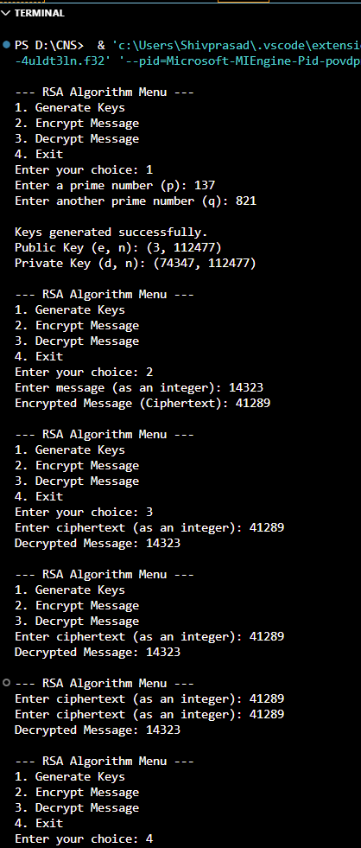
Name: Shivprasad A. Mahind
PRN: 123B1B266
Batch: D3

