Synthetic Data Factory
Design document — MDX, CF-Edit and the generator committee
A research program toward a tier-1 publication
Version 1.0 · 2026-09-06 · studies referenced by codename (cond_a, cond_b, …) throughout

Contents
- 1. Executive summary
- 2. Problem setting and constraints
- 3. System overview
- 4. Architecture A — MDX: mixture-of-experts diffusion transformer
- 5. Architecture B — CF-Edit: counterfactual anomaly synthesis
- 6. Architecture C — generator committee and two-regime selection
- 7. Design resolutions (this iteration)
- 8. Evaluation protocol
- 9. Experimental matrix and compute budget
- 10. Path to a tier-1 paper
- 11. Risks and mitigations
- 12. Current empirical state and roadmap

1. Executive summary
The Synthetic Data Factory turns small private clinical imaging studies (hundreds to a few thousand images each) into measurable detector improvements by generating, auditing and selecting synthetic training images. The design has three layers:
- MDX (A): one from-scratch pixel-space diffusion transformer trained jointly across studies, with hard-routed per-study low-rank experts. It gives cross-study transfer under scarcity and a frozen-trunk onboarding guarantee — new studies are added without touching, even bitwise, what was already learned.
- CF-Edit (B): the paper's primary claim. Instead of generating anomalous images from pure noise, partially noise a REAL normal image and denoise it under the anomalous label. The result is a minimal-difference counterfactual pair that straddles the decision boundary — precisely the examples detectors learn most from — at zero additional training cost.
- Committee + select (C): heterogeneous generator arms across the prior spectrum (prior-free 35–80M MDX vs pretrained 0.86B / 2.6B LoRA arms), pooled and composed by a detector-scored selection stage. This converts 'which prior should synthetic medical data come from?' from a bet into an ablation table.
Primary publishable claim: counterfactual pairs from label-swapped diffusion editing beat pure generation for rare-condition detector training under extreme data scarcity. Secondary: the frozen-trunk onboarding guarantee as a systems contribution. Target venues: CVPR / ICML / NeurIPS main track, with MICCAI/MIDL as the domain-venue fallback; a public-dataset reproducibility lane (HAM10000 rare classes + one more public paired dataset) makes the results verifiable by reviewers.

2. Problem setting and constraints
- Data: private multi-study clinical datasets, roughly 0.3k–3.3k images per study, with curated evaluation splits. Studies are referred to by codename (cond_a, cond_b, …). Real class names, dataset slugs and paths live only in gitignored local overlays.
- Hard metric: paired-seed detector lift — macro-F1 on the curated, 100% real test split, real-only vs augmented, identical seeds.
- Compute: a single 16 GB T4 GPU session at a time, ~30 h GPU/week shared with other projects. Every experiment must justify its GPU minutes.
- Privacy: client data lives only in private Kaggle datasets end-to-end; only pipeline code is public. The memorization audit is a mandatory OUTPUT gate (cosine similarity ≥ 0.985 to any training image ⇒ quarantined by the augment stage) — required both for privacy and for any augmentation claim to be scientifically valid.
- Splits: grouped (no near-duplicate leakage across splits), stratified, deterministic. Synthetic data only ever augments the train split; val and test stay real forever.

3. System overview
The pipeline is staged (audit → train_joint / train_lora → sample / counterfact → quality_gate → select → augment → train_detector → evaluate), each stage a resumable CLI entrypoint executed on Kaggle by the kernel runner against the pushed git revision. Every synthetic image carries a manifest row (synthetic=true, generator arm, and — for CF-Edit — the source image id).
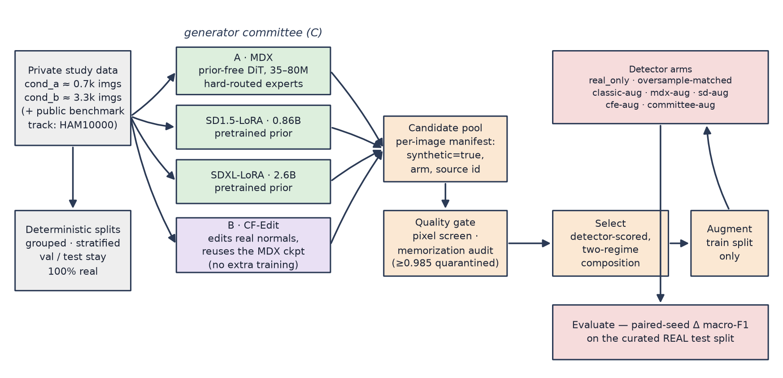
Figure 1 — End-to-end system. Generator arms feed one audited pool; selection composes the augmentation set; evaluation is always paired-seed macro-F1 on real test data.

4. Architecture A — MDX: mixture-of-experts diffusion transformer
MDX is a from-scratch pixel-space DiT (~35M parameters at dim 384; ~80M at dim 512 / depth 16) trained jointly on every study's train split. Patch size is chosen as resolution/16, so the sequence is always 256 tokens at any resolution — the same trunk trains at 64/128/256 px without architectural change.
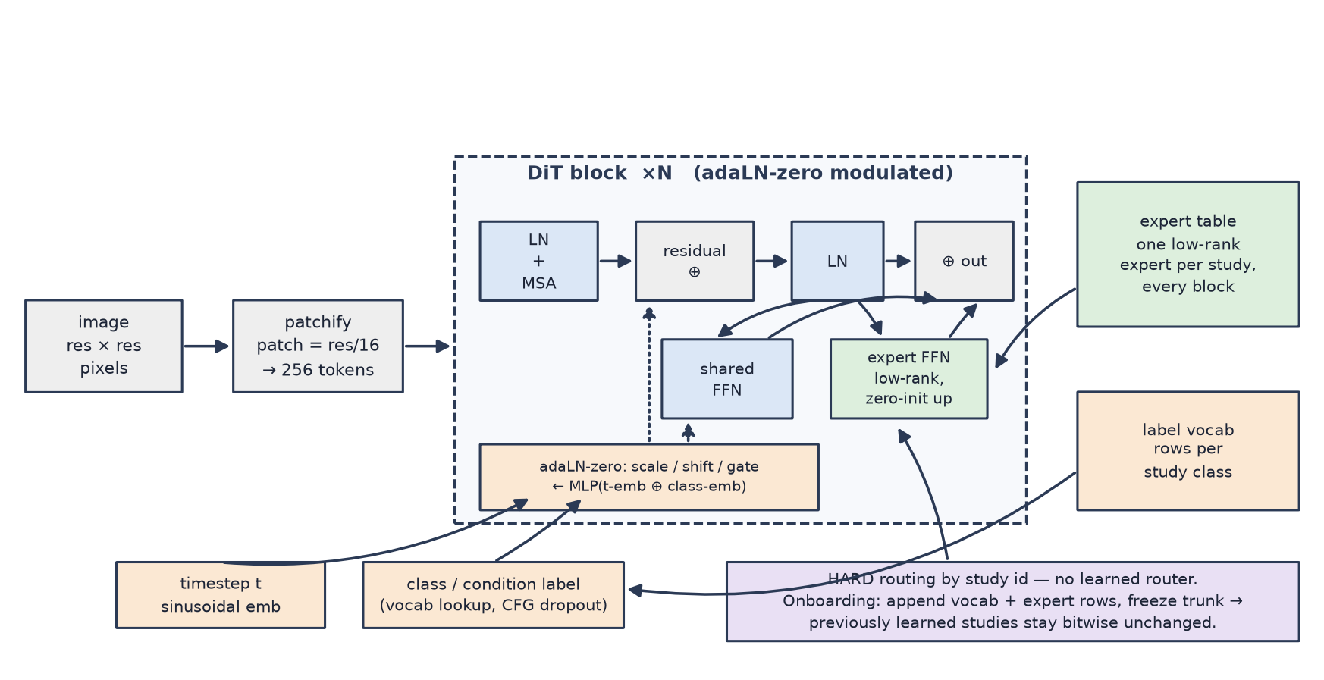
Figure 2 — One MDX block. The shared FFN carries general image statistics; a per-study low-rank expert (zero-initialized up-projection) carries study-specific signal and is hard-routed by study id. adaLN-zero modulates every block from (timestep ⊕ class) embeddings.
Design rationale:
- Joint trunk — cross-study transfer under scarcity. A 0.7k-image study borrows general image statistics (edges, anatomy-scale structure, lighting) from a 3.3k-image one. Tested against an equal-compute per-class DDPM baseline.
- Hard routing, not learned soft MoE routing. Tiny datasets cannot estimate a router, and a mis-trained router silently corrupts every study. The study id is known at train and sample time, so routing needs no learning at all.
- Zero-initialized expert up-projections. At step 0 each expert is an exact no-op, so early training is pure trunk learning; experts grow into the residual only as study-specific signal warrants.
- Frozen-trunk onboarding — a hard guarantee. New studies append rows to the label vocab and expert tables; with freeze_trunk=1 only the new rows receive gradients, so previously learned studies are BITWISE unchanged. Most continual-learning work can only approximate this. Onboarding cost: minutes.
- Classifier-free guidance via label dropout (the expert route is kept during dropout — the null token is per-study, so guidance sharpens class identity, not study identity).
- EMA weights for sampling; self-describing checkpoints (vocab + architecture JSON embedded) so a checkpoint alone is sufficient to resume, onboard, or sample.
Positioning: eDiff-I ensembles denoisers over timestep bands; DiT-MoE scales token-level soft-routed experts for capacity. Neither targets the multi-dataset scarce-data regime, and neither gives the frozen-trunk onboarding guarantee. The closest neighbor is adapter-per-task continual diffusion; our delta is shared-trunk joint pretraining across private clinical studies plus study-level expert routing.

5. Architecture B — CF-Edit: counterfactual anomaly synthesis
The highest-leverage observation in this problem: clinical datasets come with paired class structure — the same anatomy imaged the same way, with and without the condition. Generating an anomalous image from pure noise wastes model capacity reproducing what real data already provides (pose, lighting, device signature, background). CF-Edit instead:
- 1. takes a REAL image of the normal class (train split only);
- 2. diffuses it forward to an intermediate timestep t = s·T (SDEdit-style partial noising: global structure survives, appearance detail is destroyed);
- 3. denoises with the TARGET (anomalous) label under CFG, routed through the study's expert.
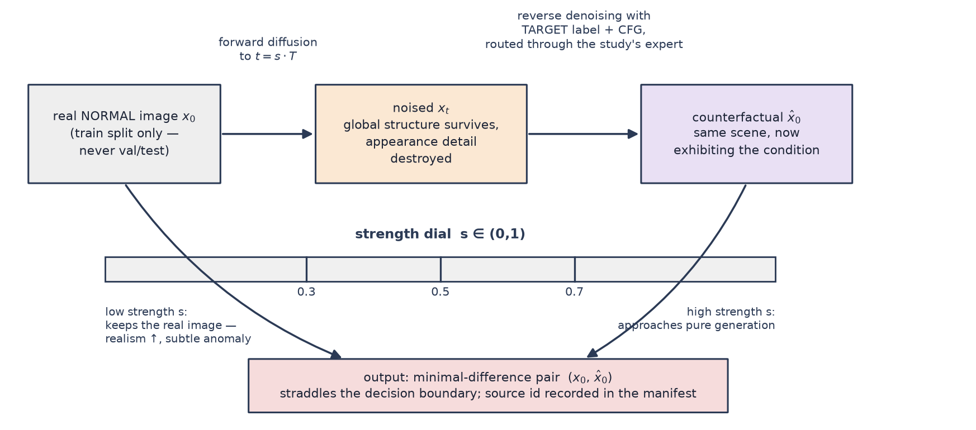
Figure 3 — CF-Edit. The strength dial s interpolates between 'barely edited real image' and 'pure generation'; each output is paired with its source in the manifest.
Why this should beat pure generation for detector training:
- Sample efficiency — the generator only has to know the DIFFERENCE between classes, exactly what the joint conditional model concentrates in its class embeddings and experts.
- Hard pairs by construction — each real normal yields a minimal-difference (normal, anomalous) pair straddling the decision boundary; the recorded pairing also enables paired training objectives later (contrastive or margin losses over pairs).
- Label correctness is auditable — the select stage scores every counterfactual with the real-only detector; edits too weak to express the condition are filtered before training, and the flagged rate itself measures the generator's class separation.
- Cost — zero additional training (reuses the MDX checkpoint) and LOWER sampling cost than pure generation (only the last s-fraction of the reverse trajectory is run).
Positioning: SDEdit edits with a prompt, not a learned per-study class swap; counterfactual-explanation methods produce per-classifier gradients, not training data; AnoDDPM-style medical work runs the opposite direction (remove the anomaly to detect it). Using label-swapped partial denoising of real normals as a data factory for rare-condition detectors, on sub-1k private datasets, with a memorization audit, is an open slot in the literature.

6. Architecture C — generator committee and two-regime selection
Heterogeneous arms span the prior spectrum: prior-free MDX (no pretraining leakage, data-hungry) vs pretrained LoRA arms at ~0.86B (SD1.5) and ~2.6B (SDXL) (sample-efficient, but import a natural-image prior of unknown relevance to clinical pixels). All arms sample into one pool; the select stage composes the augmentation set. CF-Edit slots in as just another arm.
Two-regime selection (design resolution R1 — see §7): a single best-first ranking by detector confidence would systematically discard exactly the boundary-straddling images CF-Edit exists to produce. Selection therefore runs per-regime:
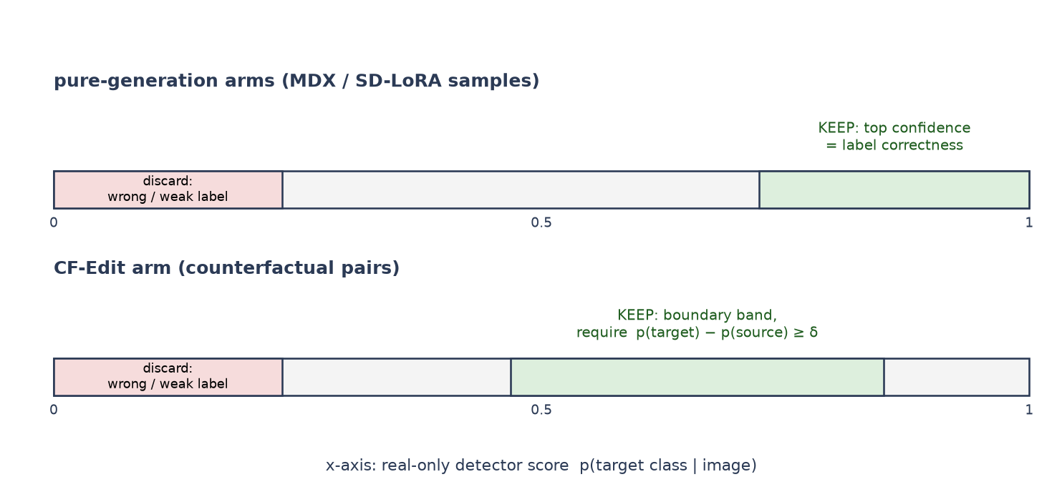
Figure 4 — Selection regimes. Pure-generation arms keep top-confidence samples (confidence = label correctness). CF-Edit keeps a boundary band, requiring the edit to have moved class by a margin δ while staying informative.
- Pure-generation arms: rank by p(target); keep best-first. High confidence means the label is right — the sample teaches the class prototype.
- CF-Edit arm: keep if p(target) − p(source) ≥ δ (the edit expressed the condition), then PREFER samples closest to the decision boundary (|p(target) − 0.5| small). These are the hard examples; trivially easy edits add little.
- Round-robin blending across arms best-first within each arm's regime, up to the per-class augmentation budget.
The empirical question the committee answers — where along the prior spectrum does useful synthetic medical data come from at each dataset size? — is unresolved and practically important: privacy and licensing arguments favor prior-free generation, quality arguments favor foundation priors. The committee makes it an ablation table instead of a bet.

7. Design resolutions (this iteration)
# | Tension | Resolution
R1 | Best-first selection contradicts CF-Edit's value proposition (it would drop boundary-straddling pairs). | Two-regime select (§6): confidence-ranked for pure generation; margin-then-boundary-band for CF-Edit. Implement before M3 burns GPU.
R2 | Experts are FFN-only. For structural conditions the class difference may live in early (structure-stage) denoising that FFN experts under-serve. | Cheap probe first: if CF-Edit at s=0.3 cannot move class on cond_a, that is evidence of a structure-stage capacity bottleneck → then ablate attention-path experts and timestep-band-sliced experts (architecture D) at equal rank budget.
R3 | Committee comparisons at mixed resolutions (MDX 128px vs SD 512px) conflate architecture with resolution. | Run the CF-Edit strength sweep at 128px first (cheap); replicate the winning configuration at 256px before any cross-arm table is reported. All detector arms train at one fixed input resolution regardless of generator output size.
R4 | A counterfactual is legitimately similar to its own source image — a naive memorization audit would flag every CF-Edit output. | The audit excludes the recorded source image for CF-Edit outputs, but ALSO audits against the source class: an edit that failed to move class is a near-copy by design and must be caught. Verify the counterfact manifest/gate wiring before M3.

8. Evaluation protocol
- Paired-seed detector deltas: real-only vs each augmented arm, identical seeds, reported as mean ± sd of macro-F1 on the curated real test split, with a paired test across seeds (3 seeds minimum for screening, 5 for reported tables).
- Balance-matched real-oversampling control arm — so lift cannot be explained by class-balance shift alone (this control caught an off-target melanoma-recall artifact in the HAM10000 pilot).
- Classical-augmentation control arm (standard photometric + geometric policy) — so lift cannot be explained by generic augmentation effects.
- Memorization audit on every reported set: max cosine similarity to train embeddings, flagged ≥ 0.985 quarantined; for CF-Edit the audit runs with source-exclusion + source-class check (R4). The flagged rate is itself reported.
- Per-class F1 deltas reported alongside macro-F1 — rare-class lift is the actual product; macro movement alone can hide off-target effects.

9. Experimental matrix and compute budget
Detector arms × datasets. Every cell is a paired-seed Δ macro-F1 against the same real_only baseline; controls isolate the explanation.
Arm | What it isolates | cond_a | HAM-rare (public) | cond_b
real_only | baseline | 0.9216 (done) | done (pilot) | 0.9897 — at ceiling, excluded
oversample-matched | class-balance shift | planned | planned | —
classic-aug | generic augmentation | planned | planned | —
mdx-aug | prior-free generation | planned | planned | —
sd15-aug | 0.86B pretrained prior | M2b in flight | done (pilot: vasc F1 +0.050±0.013) | —
sdxl-aug | 2.6B pretrained prior | stretch | stretch | —
cfe-aug (s sweep) | counterfactual pairs vs pure gen | planned (primary claim) | planned | —
committee-aug | selection across arms | planned | planned | —

cond_b's real-only baseline is already at ceiling (0.9897 macro-F1), so it contributes to MDX joint-training transfer (bigger sibling study) and to the onboarding demonstration, not to augmentation claims. Compute discipline: strength sweeps and screening at 128px (~20 min/run on T4); only winners replicate at 256px and across 5 seeds. Estimated total for the matrix: roughly 25–35 T4-hours, spread over weekly budget.

10. Path to a tier-1 paper
What a CVPR/ICML/NeurIPS reviewer will demand, and how the design answers it:
Reviewer demand | Our answer
A crisp, falsifiable novel claim | CF-Edit: counterfactual pairs beat pure generation for rare-condition detector training under scarcity — tested arm-vs-arm with paired seeds on the same pool budget.
Reproducibility on public data | A public lane run with the identical pipeline: HAM10000 rare classes (akiec/df/vasc) + one additional public paired normal/abnormal dataset (candidate: a chest-X-ray normal/pneumonia set — public, paired structure, license-friendly). Private studies become the in-the-wild evidence; public lane is what reviewers rerun.
Strong baselines | Not just real_only: balance-matched oversampling, classical augmentation policy, pretrained-LoRA generation at two scales, prior-free generation, and (stretch) a GAN baseline (StyleGAN2-ADA is the standard small-data GAN).
Ablations | Strength sweep (s = 0.3/0.5/0.7), selection policy (best-first vs two-regime), expert placement (FFN vs attention vs timestep-band, equal rank budget), joint vs single-study trunk, resolution (128 vs 256), synthetic volume dose–response.
Statistical rigor | Paired seeds (5 for reported tables), mean ± sd, paired test; per-class deltas; controls that kill the two obvious alternative explanations.
Privacy story (medical data) | Private data never leaves private storage; memorization audit with quarantine is part of the pipeline, and the frozen-trunk guarantee bounds cross-study contamination at onboarding time.

Venue plan (today = 2026-09-06):
Venue | Deadline (approx.) | Fit / call
CVPR 2027 | ~mid-Nov 2026 | Aggressive: ~10 weeks for the full matrix + writing. Feasible only if M3–M5 land clean on the first pass. Treat as a stretch target.
ICML 2027 | ~late Jan 2027 | Realistic primary target: matrix + 5-seed replication + public lane fit comfortably.
NeurIPS 2027 | ~May 2027 | Comfortable fallback; also fits the Datasets & Benchmarks track if the factory framing outgrows the method framing.
MICCAI 2027 | ~Feb–Mar 2027 | Domain fallback with high acceptance odds for this topic; a MIDL/MICCAI-workshop version can precede the main-conference push without burning novelty.

- Anonymity note: the public repo already describes the research program. For double-blind submission either make the repo private for the review window or scrub the paper of links; decide before the first deadline.
- Framing note: lead with CF-Edit (the claim), present MDX as the enabling model and the committee as the measurement instrument. The frozen-trunk guarantee is one strong section, not the title.

11. Risks and mitigations
Risk | Signal | Mitigation
CF-Edit cannot move class at low strength | s=0.3 probe: p(target) ≈ p(source) | Raise s; R2 expert-placement ablation; more joint-training steps; fall back to claiming the committee/selection result.
Memorization on sub-1k studies | audit flagged-rate high | Quarantine is automatic; reduce steps / add dropout; report flagged rate honestly — it strengthens the privacy story.
Detector ceiling too close (cond_a 0.9216) | deltas within seed noise | Per-class rare-condition F1 is the headline metric, not macro; scarcity ablation (train on 25%/50% subsets) widens headroom and IS the paper's regime anyway.
Compute contention (shared 30 h/week) | GPU slots held by other kernels | Screen at 128px; never two concurrent kernel versions; queue via `kernels status` checks; Colab/cloud adapter is the approved overflow route.
Pretrained arms leak natural-image bias into medical pixels | sd/sdxl samples pass gate but hurt detector | That result is itself a finding the committee is designed to surface; selection filters it operationally.
Scooping (public repo describes the ideas) | — | Workshop paper early to timestamp the idea, or repo private until submission (owner's call, see §10).

12. Current empirical state and roadmap
Milestone | Status | Key numbers
HAM10000 pilot (M5, public lane) | done | 3 seeds × 2 arms, 400 gated synthetic images; vasc F1 +0.050 ± 0.013; balance-shift artifact caught by control.
Real-only baselines (client lane) | done | cond_a macro-F1 0.9216 (the target with headroom); cond_b 0.9897 (ceiling — excluded from augmentation).
MDX CPU test suite | done | 12/12 on Kaggle CPU.
M1 joint sanity (64px) | done | loss 0.442 → 0.065, 33.8M.
M2 joint trunk (128px) | done | 79M trunk, 6000 steps, loss 0.489 → 0.0446, 22 min T4; 64/64 samples pass pixel screen; checkpoint published to the artifacts dataset.
M2b SD1.5 heavy arm on cond_a | in flight | 1200 steps @ 512px, batch 2 × accum 2 (batch 16 OOMs a T4 — proven); collect pending.
M3 samples + CF-Edit sweep | next | ~100/class MDX samples + counterfactuals at s = 0.3/0.5/0.7 from the published checkpoint + per-class quality gates. Blocked on R1 + R4 code first.

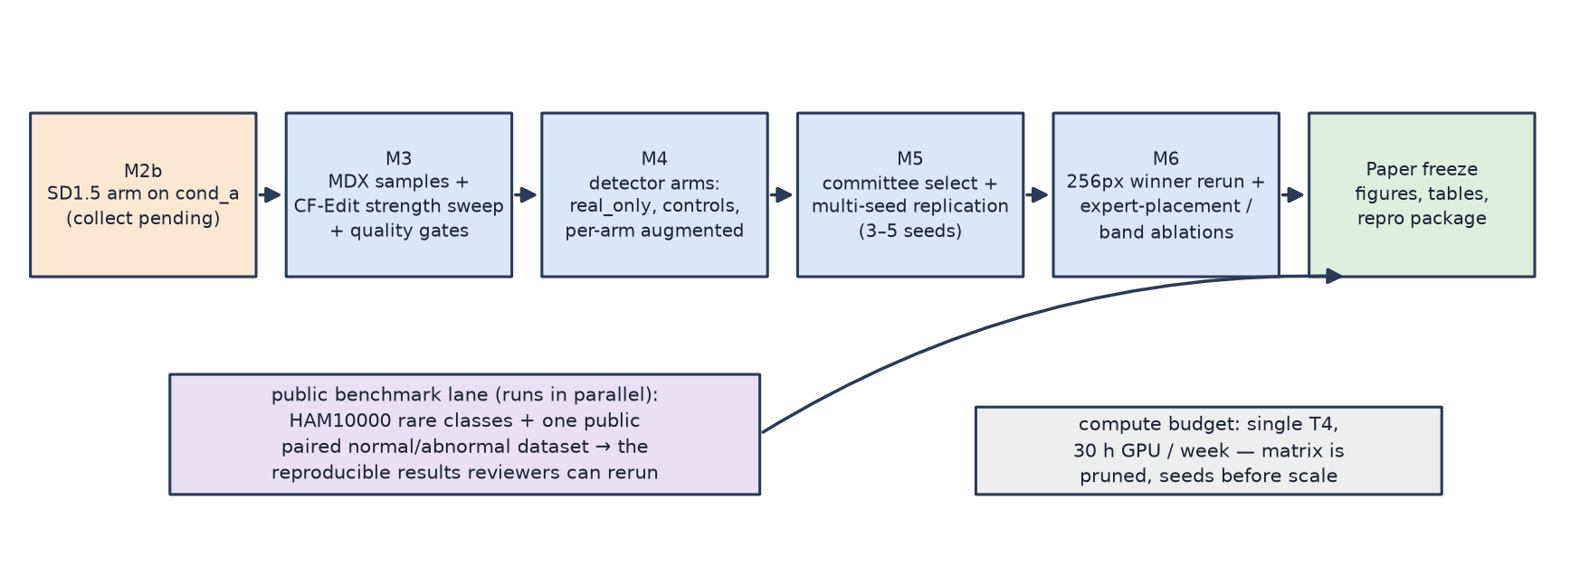
Figure 5 — Roadmap. The public benchmark lane runs the identical pipeline and produces the reviewer-reproducible results; private studies are the in-the-wild evidence.
GPU spent this cycle: ~1 h of the 30 h/week budget. The design's guiding discipline stands: screen cheap, replicate winners, and never report a number without its control.

