A PROJECT REPORT
ON

AgriPredict AI – Smart Farming Assistant

SUBMITTED IN THE PARTIAL FULFILLMENT OF THE REQUIREMENT FOR THE DEGREE OF

MASTER OF COMPUTER APPLICATION

SUBMITTED BY

Rutuja Bhagwan Gadhe (25MCA80) Sanika Ravindra Jambhale (25MCA82) Shivraj Ramesh Jagtap (25MCA89)

UNDER THE GUIDANCE OF
Miss. Vaishnavi Giri


G. H. RAISONI COLLEGE OF ENGINEERING AND MANAGEMENT
(An Autonomous Institute affiliated to SPPU) WAGHOLI, PUNE: 412207
SAVITRIBAI PHULE PUNE UNIVERSITY 2026 – 2027

CERTIFICATE

This is to certify that the project report entitled AgriPredict AI- Smart Farming Assistant Submitted by Rutuja Bhagwan Gadhe (25MCA80), Sanika Ravindra Jambhale (25MCA82) and Shivraj Ramesh Jagtap (25MCA89) are bonafide student of this institute and the work has been carried out by them under the supervision of Miss. Vaishnavi Giri and it is approved for the partial fulfilment of the requirement of Savitribai Phule Pune University, for the award of the degree of Master of Computer Application.

Miss. Vaishnavi Giri Dr. Priya Chaudhari
Internal Guide HOD, MCA

External

Mrs. Aarti Kulkarni Dr. N. B. Hulle
Project Coordinator I/C Director

Place: Pune
Date:

ACKNOWLEDGEMENT

We are profoundly grateful to Miss. Vaishnavi Giri for her expert guidance and continuous encouragement throughout to see that this project rights its target since its commencement to its completion.
We would like to express our deep gratitude towards Dr. N. B. Hulle, I/C Director, G. H. Raisoni College of Engineering and Management, Pune, Dr. Priya Chaudhari, Head of Department, Master of Computer Application (MCA) and Mrs. Aarti Kulkarni, Project Coordinator whose invaluable guidance supported us in completing this project.
At last, we must express our sincere heartfelt gratitude to all the staff members of the Master of Computer Application Department who helped us directly or indirectly during this course of work.

Rutuja Bhagwan Gadhe
Sanika Ravindra Jambhale
Shivraj Ramesh Jagtap
TABLE OF CONTENTS
Chapter No | Details | Page No.
1 | Introduction | 1
 | 1.1 Preamble | 1
 | 1.2 Existing system and need for system | 1
 | 1.3 Scope of system | 2
 | 1.4 Operating Environment (Technology) - Hardware, Software And Database | 4
2 | Analysis And Design | 5
 | 2.1 List of modules | 5
 | 2.2 Project planning and scheduling data used in project | 7
 | 2.3 Entity Relationship Diagram (ERD) | 9
 | 2.4 Table Structure | 9
 | 2.5 Use Case diagram | 12
 | 2.6 Class diagram | 13
 | 2.7 Activity diagram | 14
 | 2.8 Sequence diagram | 15
 | 2.9 Deployment diagram | 16
 | 2.10 Module hierarchy diagram | 16
 | 2.11 Input and output screens | 17
3 | Coding | 27
4 | Testing | 39
 | 4.1 Test Strategy | 39
 | 4.2 Unit Test Plan | 40
 | 4.3 Acceptance Test Plan | 41
 | 4.4 Test Case / Test Script | 42
5 | Limitations Of Proposed System | 50
6 | Proposed Enhancements | 51
7 | Conclusion | 52
8 | Bibliography | 53

CHAPTER 1
INTRODUCTION

Preamble
AgriPredict AI is a full-stack, AI-powered smart farming web application that helps a farmer decide which crop is most suitable for a given piece of land. The farmer selects the farm location on a map, the system fetches the current temperature, humidity and the average monthly rainfall for that location, and the farmer supplies the soil nutrient values (Nitrogen, Phosphorus, Potassium) and soil pH. A neural network built with TensorFlow.js and trained on the Crop Recommendation dataset (2,200 records, 22 crops) analyses these seven parameters and recommends the most suitable crop together with a confidence percentage.
The application has a React single page frontend, a Node.js and Express REST API secured with JSON Web Tokens, and a MongoDB database accessed through Mongoose. Every prediction is saved against the logged-in user, so the system can show a personal dashboard with an indicative soil health score, recent predictions, a weather widget, prediction history with search and filter, and profile statistics with charts. On the held-out test set of 440 records the trained model achieved an accuracy of 98.18 percent. The project follows a layered design (routes, controllers, services, models) so that each feature can be maintained and extended independently.

Existing system and need for system
In the existing way of working, a farmer usually selects a crop on the basis of past experience, the practice of neighbouring farmers or the advice of a local dealer. Soil testing laboratories can report nutrient levels, but the report has to be interpreted separately, and the result is not linked with the weather of the farm location. General purpose weather and agriculture websites give information, but they do not combine soil, weather and location into one clear recommendation, and they do not keep a personal record of earlier decisions.

Drawbacks of the existing system
      - Crop choice depends mostly on experience and guesswork, which can lead to a poor yield when soil or climate conditions change.

      - Soil test values and weather data are available in different places and are not combined into one decision.
      - There is no confidence measure that tells the farmer how reliable a recommendation is.
      - Earlier decisions and soil readings are not stored, so the farmer cannot compare seasons.
      - Most tools need manual entry of weather values, which is slow and often inaccurate.

Need for the proposed system
A system is needed that brings soil nutrients, soil pH, temperature, humidity and rainfall together and produces a data-driven recommendation in seconds. AgriPredict AI fills this gap by automatically fetching the weather for the selected farm location, running a trained machine learning model, showing the confidence of the result and storing every prediction for later review. This reduces guesswork, saves time and gives the farmer a simple and accessible record of decisions.

Scope of system

Included in the scope
      - User registration, login, logout and JWT based session handling.
      - Viewing and updating the user profile (name and email) and viewing prediction statistics.
      - Selecting a farm location on an interactive map and fetching temperature, humidity and mean monthly rainfall from the Open-Meteo service.
      - Validation of N, P, K, temperature, humidity, rainfall, pH and location values on both client and server.
      - AI based crop recommendation among 22 crops with a confidence percentage, stored per user.
      - Dashboard with statistic cards, indicative soil health score, weather widget and charts; prediction history with search and filter.
      - Application settings for appearance and measurement units.

Not included in the scope
      - Fertilizer, irrigation scheduling and pest or disease advice (mentioned in the project vision but not implemented).
      - Crop yield or price forecasting, and region specific recommendations beyond the 22 crops in the dataset.
      - Password reset, email verification, administrator role and multi-language support.
      - Native mobile applications; the web application is responsive and works in a mobile browser.

Operating Environment (Technology) - Hardware, Software And Database
The application is a web application. The client runs in any modern browser, while the server runs on Node.js and connects to a cloud hosted MongoDB database. The hardware figures below are the recommended minimum for developing and running the project; they are not enforced by the code.

Hardware Requirements

Component | Development / Server machine | Client (User) device
Processor | Intel Core i3 / AMD Ryzen 3 or better | Any dual-core processor
RAM | 8 GB (4 GB minimum) | 2 GB or more
Storage | 2 GB free space (project, node_modules, model files) | Not required
Network | Internet access (MongoDB Atlas, Open-Meteo) | Internet connection
Display | 1366 x 768 or higher | Desktop, tablet or mobile screen
Table 1.4.1: Hardware requirements

Software Requirements
Category | Software | Version (from package.json)
Operating System | Windows / Linux / macOS | Any recent version
Runtime | Node.js with npm | Current LTS release
Frontend Framework | React, React Router, Vite | React 19.2, React Router 7.18, Vite  8
Frontend Libraries | Axios, Bootstrap, Chart.js, Leaflet | Axios 1.18, Bootstrap 5.3, Chart.js  4.5, Leaflet 1.9
Backend Framework | Express.js | 5.2
Security Libraries | jsonwebtoken, bcryptjs, cors,  dotenv | 9.0, 3.0, 2.8, 17.4
AI Library | TensorFlow.js (@tensorflow/tfjs) | 4.22
ODM | Mongoose | 9.9
Tools | Visual Studio Code, Git and GitHub, Postman, Google Chrome | Latest
External Service | Open-Meteo forecast and archive APIs | Public REST API

Table 1.4.2: Software requirements

Database
The system uses MongoDB (hosted on MongoDB Atlas) as its database and Mongoose as the object data modelling library. MongoDB is a document database, so each record is stored as a JSON-like document. The application uses two collections, users and predictions, described in Chapter 2. The connection string is read from the MONGO_URI environment variable, and the secret used to sign tokens is read from JWT_SECRET.

CHAPTER 2
ANALYSIS AND DESIGN

List of modules
The system is divided into the following modules. Each module has a matching page or component on the frontend and a route, controller and service on the backend.
Table 2.1.1: List of modules
No. | Module | Description | Main Files
1 | Authentication | Registers users, verifies login with bcrypt, issues a 1-day JWT, protects routes on client and server. | auth.controller.js, auth.middleware.js, ProtectedRoute.jsx
2 | User Profile | Shows and updates name and email; computes prediction statistics for the profile page. | user.controller.js, profile.controller.js, profileStats.service.js, Profile.jsx
3 | Crop Prediction | Takes soil and climate input, validates it, runs the TensorFlow.js model and saves the result. | prediction.controller.js, cropPrediction.service.js, cropPrediction.js, Prediction.jsx
4 | Weather and Location | Lets the user pick a farm location on a map and fetches temperature, humidity and rainfall. | weather.controller.js, weather.service.js, FarmLocationPicker.jsx
5 | Dashboard | Summary cards, indicative soil health score, weather widget, recent predictions and charts. | soilHealth.service.js, Dashboard.jsx, chart components
6 | Prediction History | Lists all earlier predictions with search by crop and filter by confidence. | prediction.controller.js, History.jsx
7 | Settings | Dark mode, temperature unit, rainfall unit and confidence display (stored in the browser). | Settings.jsx, unitConversion.js
8 | Public Pages | Home, About, Contact and a Not Found page for visitors. | Home.jsx, About.jsx, Contact.jsx, NotFound.jsx
9 | AI Model Training | Offline scripts that prepare the dataset, train the neural network and evaluate it. | prepareDataset.js, trainModel.js, evaluateModel.js

Project planning and scheduling data used in project
Table 2.2.1: Project planning and schedule
No. | Phase | Duration | Journal Days | Main Activities
1 | Planning, Setup and System Design | 13 Jul - 14 Jul  2026 | Day 1 - 2 | Repository setup, project vision and feature list, wireframes, user flow, MongoDB collection design, REST API design and AI flow diagram.
2 | Frontend Development | 15 Jul - 14 Aug  2026 | Day 3 - 11 | Design system and UI foundation, login and register pages, dashboard layout, prediction form, history and profile pages, routing, responsive testing, frontend polish and cleanup.
3 | Backend and Authentication | 15 Aug – 30  Aug 2026 | Day 12 - 19 | Express and MongoDB setup, user model, registration, login, JWT middleware, React and backend integration, protected routes, logout, profile API.
4 | Prediction Model and API | 31 Aug - 4 Sep  2026 | Day 20 - 21 | Prediction database model and the create prediction API with validation.
5 | AI Model and Integration | 5 Sep - 2 Oct  2026 | Day 22 - 27 | Dataset preparation, model training and evaluation, backend AI integration, frontend prediction integration, weather and farm location integration, history integration, prediction flow refinement and validation.
6 | Dashboard, Profile and UI Polish | 3 Oct - 11 Oct  2026 | Day 28 - 31 | Home page and public UI polish, live dashboard data, indicative soil health, real profile statistics, Chart.js analytics.
7 | Final Testing and Settings | 12 Oct 2026 | Day 32 | Settings page and comprehensive pre-deployment testing.

No. | Phase | Duration | Journal Days | Main Activities
8 | Multi-Farm Management | 20 Oct - 27 Oct  2026 | Day 34 - 36 | Farm model and farm APIs with ownership checks, My Farms page (register, view, edit, delete), farm selection in crop prediction, farm-wise prediction history, farm-wise soil health and dashboard farm details.

The project was developed in short daily sprints, recorded in a development journal of 35 entries
(Day 1 to Day 36; from 13 July 2026 to 27 October 2026, a span of 107 calendar days. The work was
planned in eight phases, shown in Table 2.2.1 and Figure 2.2.1.

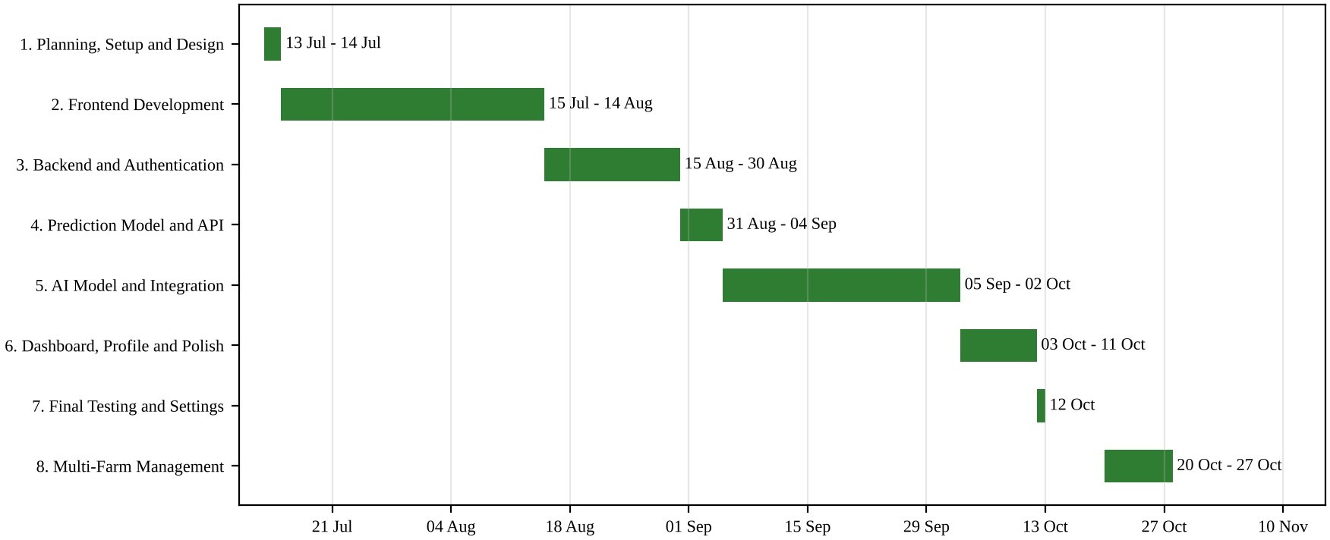
Figure 2.2.1: Project schedule (Gantt chart)

Data used in the project: The machine learning model is trained on the Crop Recommendation dataset stored in server/src/ai/data/Crop_recommendation.csv. It contains 2,200 records and 22 crop labels (100 records per crop). Each record has seven input features. The data was split 80 percent for training (1,760 records) and 20 percent for testing (440 records), and the features were scaled with min-max normalisation. Table 2.3 gives the range of every feature as stored in the preprocessing metadata. At run time the temperature, humidity and rainfall are taken from the Open-Meteo weather service for the location of the selected farm, and N, P, K and pH are entered by the user

Entity Relationship Diagram (ERD)
The ERD below follows the notation prescribed by the department: entities are drawn as rectangles, attributes as ovals, key attributes are underlined, derived attributes use a dashed oval and relationships are diamonds, with the cardinality written on the connecting lines. The system has two entities, USER and PREDICTION, and one relationship, MAKES. One user can make many predictions (1:M), and every prediction belongs to exactly one user through the UserID reference.
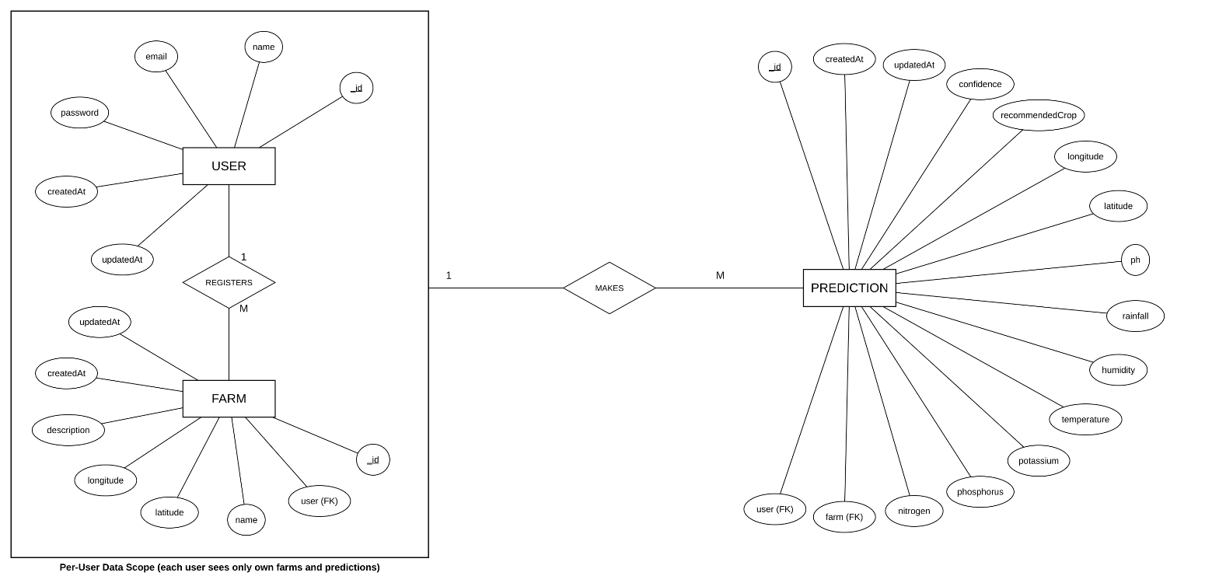

Figure 2.3.1: Entity Relationship Diagram of AgriPredict AI

Table Structure

MongoDB stores data in collections of documents. The two collections below are defined with Mongoose schemas (server/src/models/User.js and Prediction.model.js). Both schemas use the timestamps option, which adds createdAt and updatedAt fields automatically.

Field | Data Type | Key | Constraints and Description
_id | ObjectId | PK | Unique document identifier, generated automatically.
name | String |  | Required; trimmed. Full name of the user.
email | String | UK | Required; unique; stored in lowercase and trimmed. Used for login.
password | String |  | Required. bcrypt hash of the password (10 salt rounds); never returned by the API.
createdAt | Date |  | Account creation time (automatic).
updatedAt | Date |  | Last update time (automatic).

Table 2.4.1: Structure of the users collection

Field | Data Type | Key | Constraints and Description
_id | ObjectId | PK | Unique prediction identifier.
user | ObjectId | FK | Required; references users._id (the owner of the prediction).
nitrogen | Number |  | Required; minimum 0.
phosphorus | Number |  | Required; minimum 0.
potassium | Number |  | Required; minimum 0.
temperature | Number |  | Required; degrees Celsius.
humidity | Number |  | Required; 0 to 100 percent.
rainfall | Number |  | Required; minimum 0; millimetres.
ph | Number |  | Required; 0 to 14.
latitude | Number |  | Required; -90 to 90.
longitude | Number |  | Required; -180 to 180.
recommendedCrop | String |  | Required; trimmed; one of the 22 crop labels.
confidence | Number |  | Required; 0 to 100 percent.
createdAt | Date |  | Prediction time (automatic); used to sort history.
updatedAt | Date |  | Last update time (automatic).
Table 2.4.2: Structure of the predictions collection

PK = primary key, FK = foreign key, UK = unique key. The only declared index is the unique index on users.email. Soil health scores and profile statistics are calculated when requested and are not stored.

Field | Data Type | Key | Constraints and Description
_id | ObjectId | PK | Unique document identifier, generated automatically.
user | ObjectId | FK | Required; references users._id (the owner of the prediction).
name | String |  | Required. bcrypt hash of the password (10 salt rounds); never returned by the API.
latitude | Number |  | Required; -90 to 90.
longitude | Number |  | Required; -90 to 90.
description | String |  | Required. bcrypt hash of the password (10 salt rounds); never returned by the API.
createdAt | Date |  | Account creation time (automatic).
updatedAt | Date |  | Account updation time (automatic).
Table 2.4.2: Structure of the farms collection

Use Case Diagrams
There are three actors. A Visitor can only see the public pages, register and log in. A Registered User (farmer) can use every protected feature after logging in. Open-Meteo is an external system that supplies weather data.
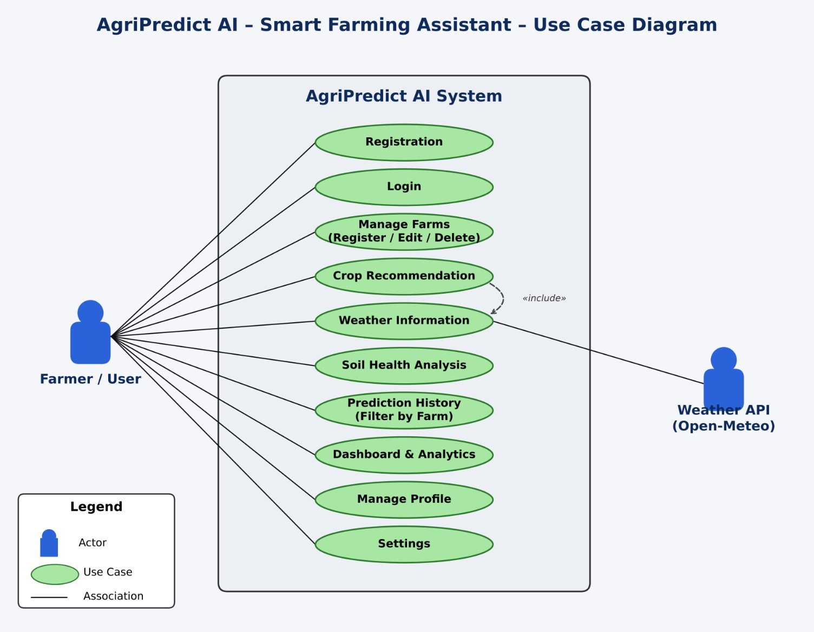

Figure 2.5.1: Use case diagram of AgriPredict AI

Class Diagram
Figure shows the main classes of AgriPredict AI with their attributes, methods and relationships. A User makes many Predictions, and a User requests Weather data for the farm location, which fills the temperature, humidity and rainfall inputs of a Prediction.
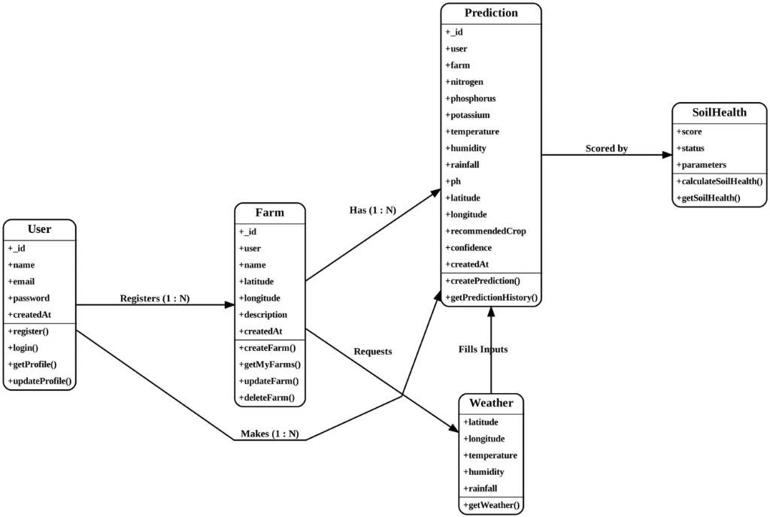

Figure 2.6.1: Class diagram of AgriPredict AI

Activity Diagram
Figure 2.7.1 shows the main activity flow of the system, from user login to crop prediction and viewing the prediction history.
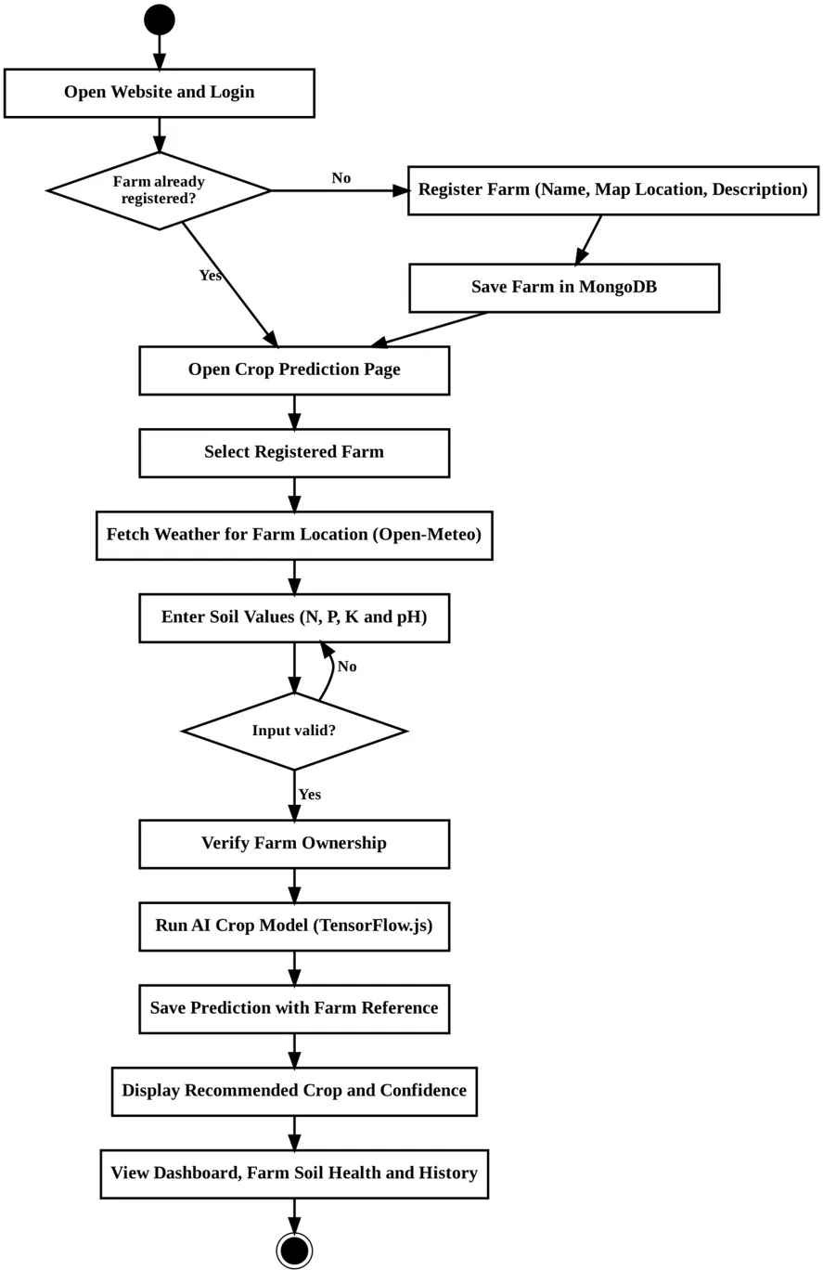
Figure 2.7.1: Activity diagram of AgriPredict AI

Sequence Diagram
The sequence diagrams show the order of messages between the user, the React client, the Express API, the database and the external services for login, crop prediction and dashboard loading.
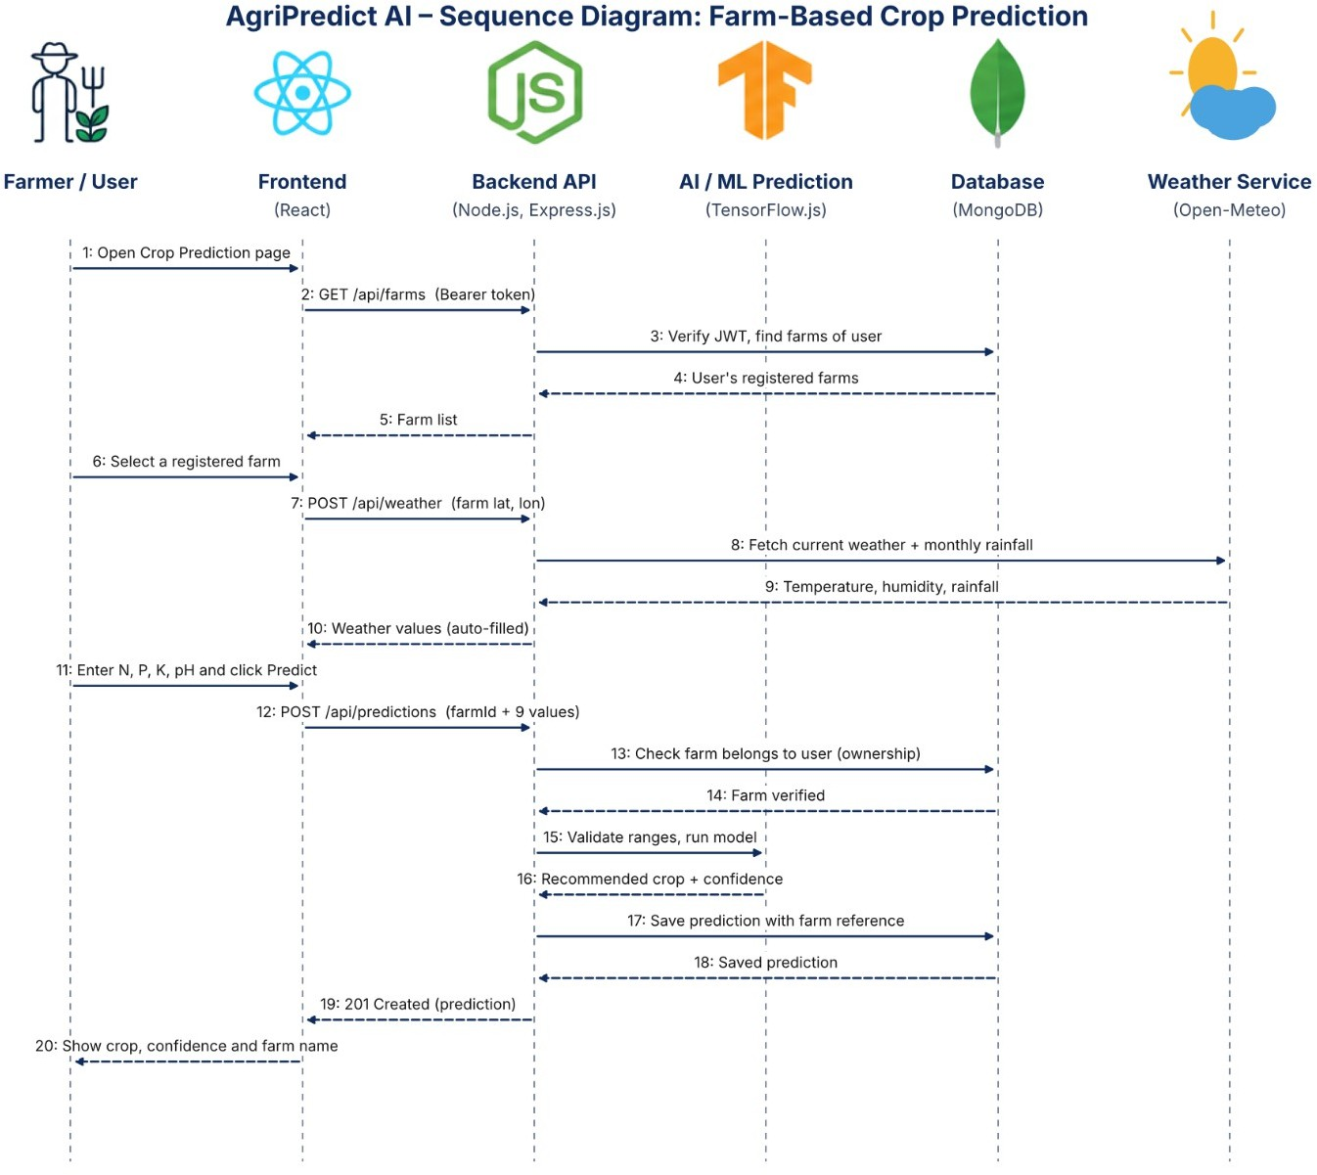

Figure 2.8.1: Sequence diagram of AgriPredict AI

Deployment Diagram
The React client calls the API address given in VITE_API_URL, the Express server listens on the PORT variable (default 5000), connects to MongoDB Atlas using MONGO_URI and loads the trained model files from its own file system. The hosting providers are therefore shown generically.
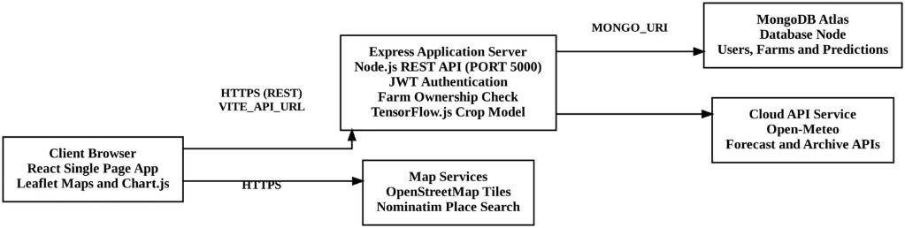

Figure 2.9.1: Deployment diagram of AgriPredict AI

Module Hierarchy Diagram

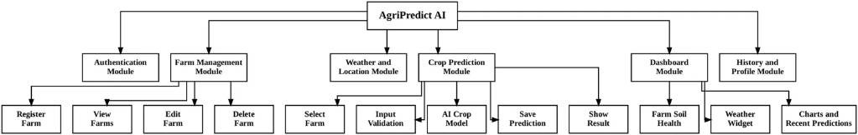

Figure 2.10.1: Module hierarchy diagram

Input And Output Screens
This section shows the input and output screens of AgriPredict AI with valid data entered by the demo user Shivraj Jagtap, who has registered three farms (North Field, River Side Farm and Hill Plot) and has made predictions for them. In the farm screens the map tiles are blank because the screens were captured without an internet connection; the farm position is still shown by the marker and by the latitude and longitude values.
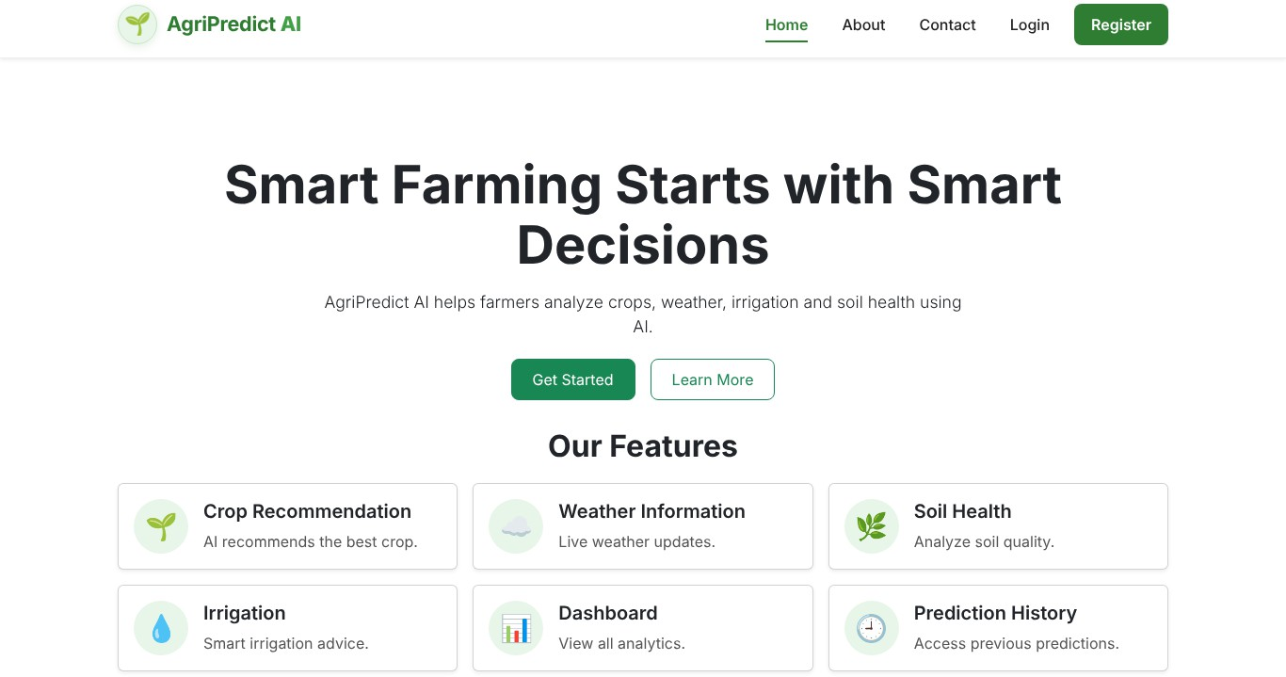

Figure 2.11.1: Home page

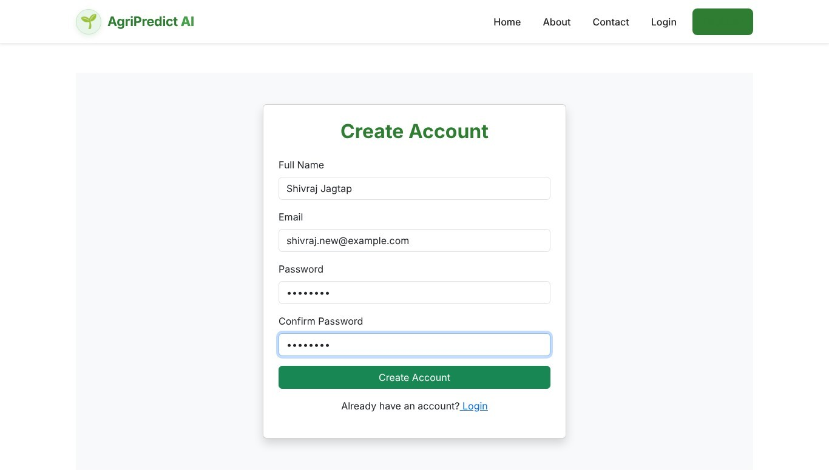

Figure 2.11.2: Register screen (input)
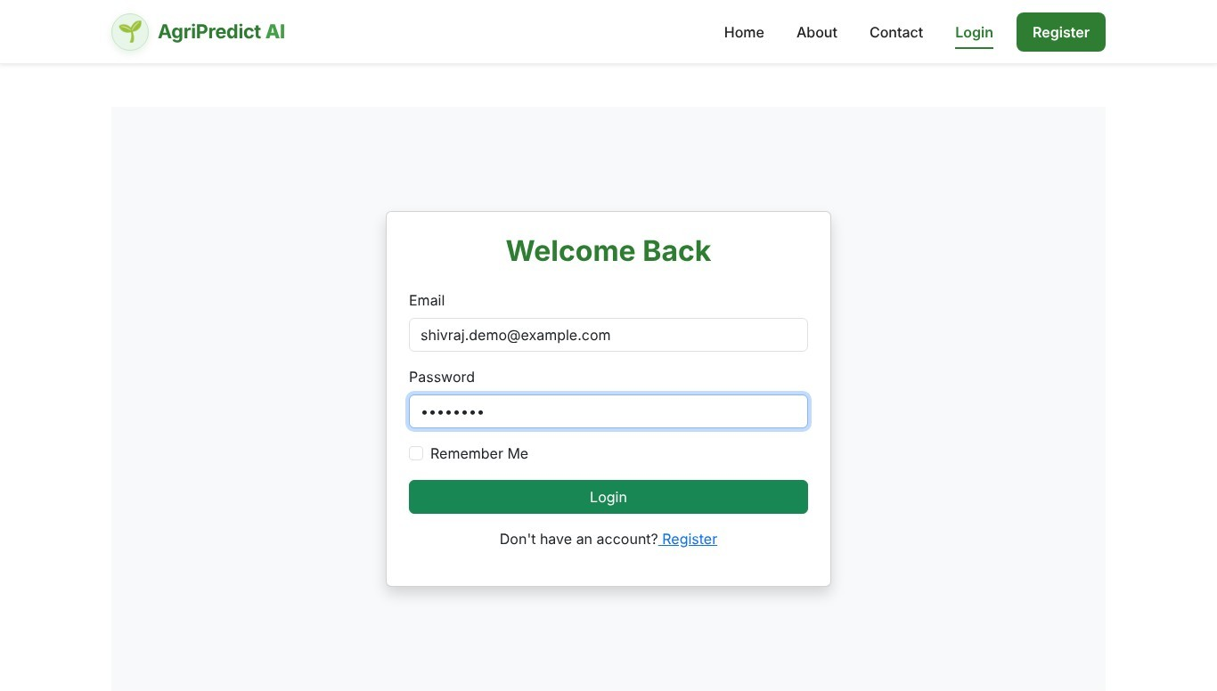

Figure 2.11.3: Login screen (input)

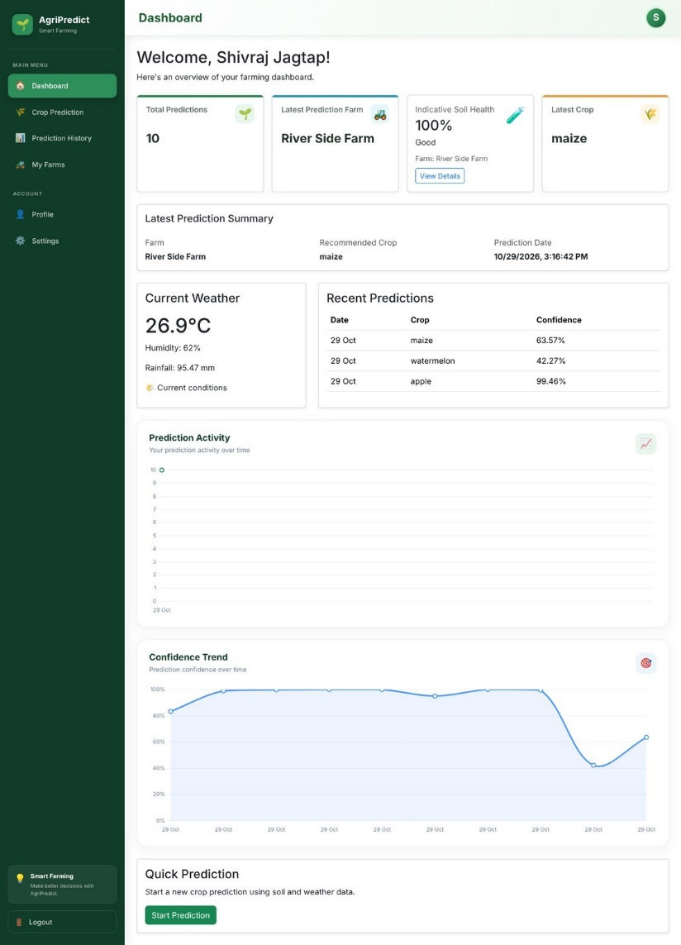

Figure 2.11.4: Dashboard screen (output)

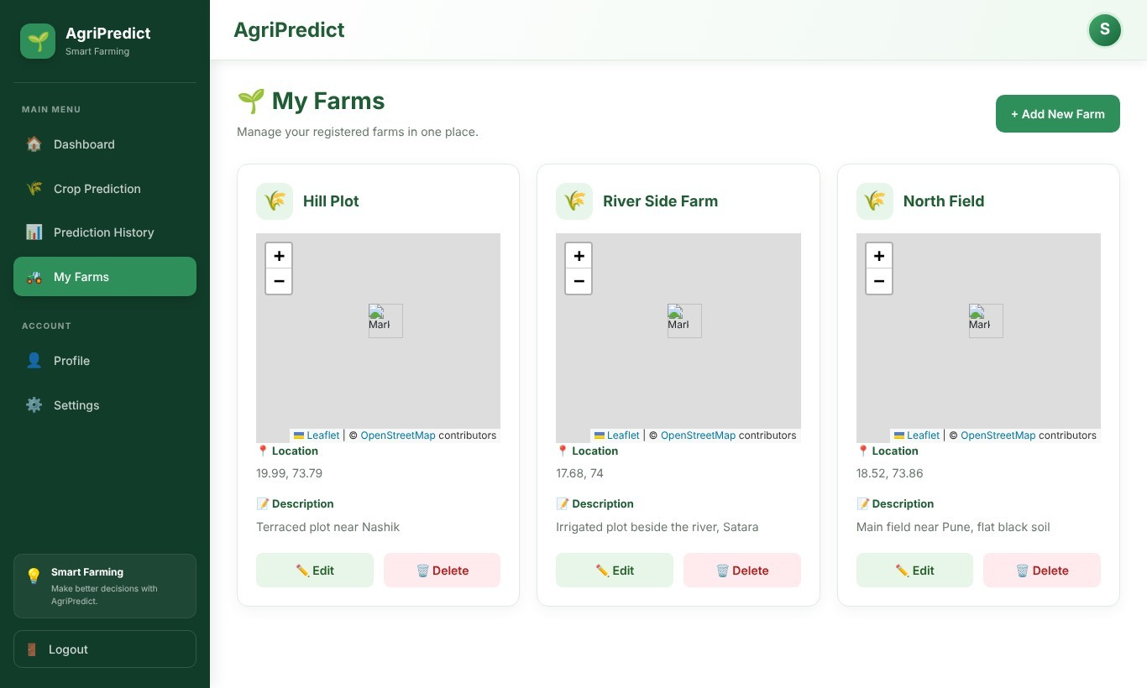

Figure 2.11.5: My Farms screen (output)

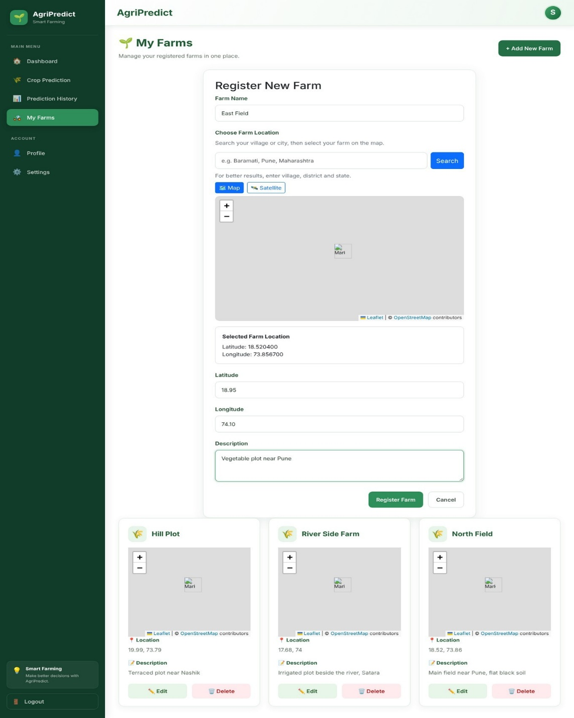

Figure 2.11.6: Register New Farm form (input)

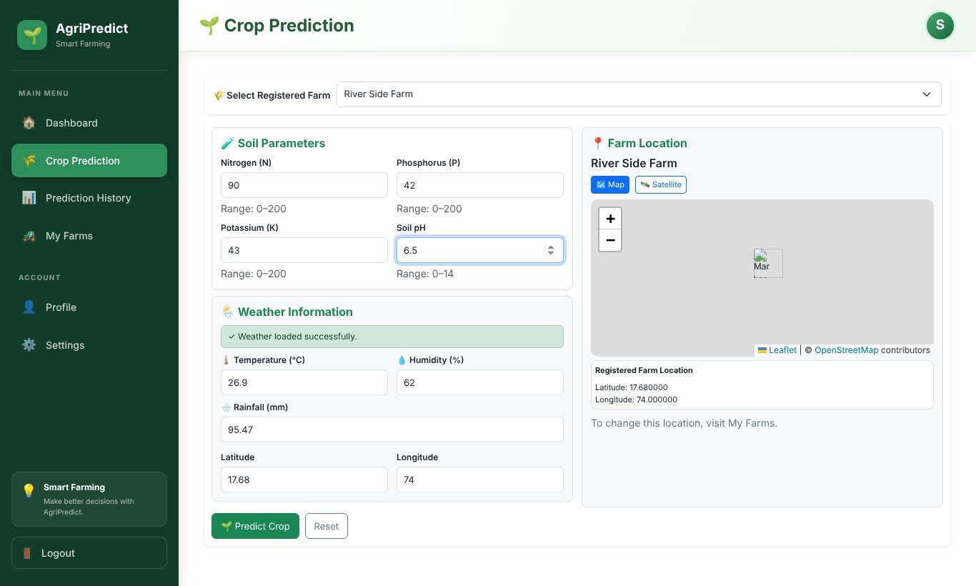

Figure 2.11.7: Crop Prediction screen with farm selected (input)
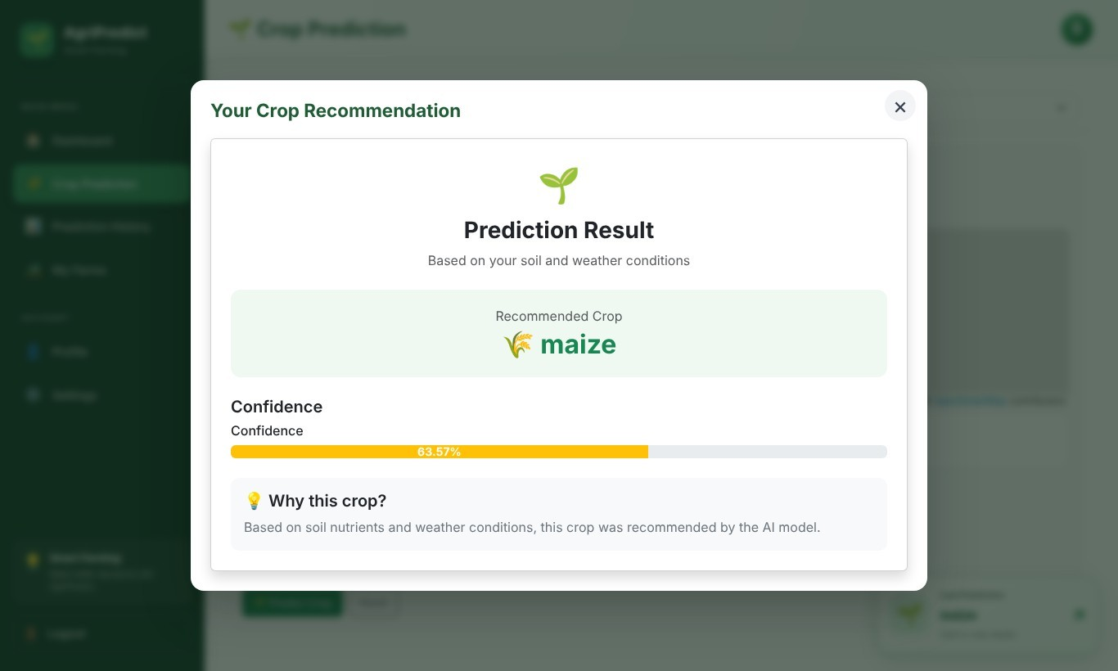
Figure 2.11.8: Crop Prediction result (output)

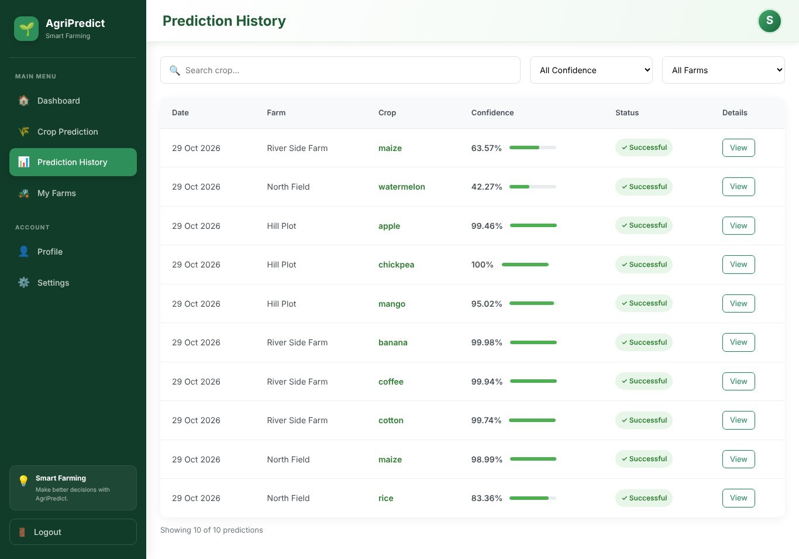

Figure 2.11.9: Prediction History screen with farm names (output)
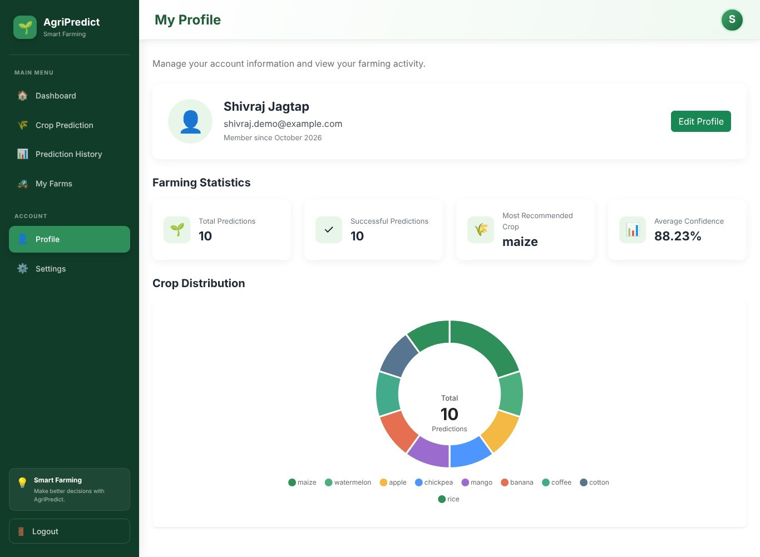
Figure 2.11.10: Profile screen (output)

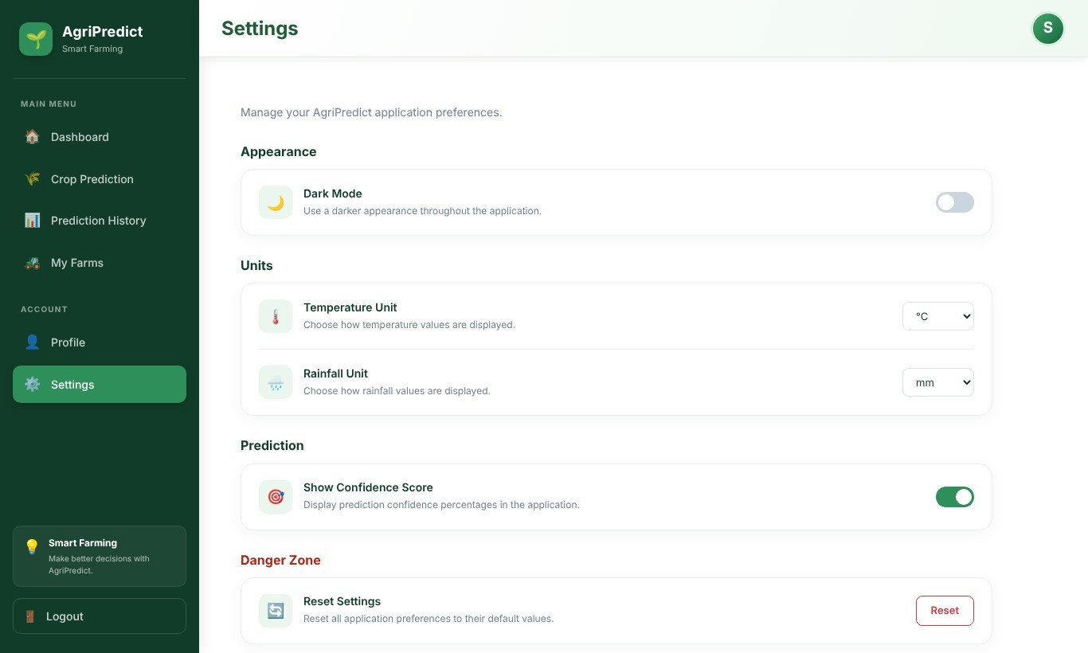

Figure 2.11.11: Settings screen (input)

CHAPTER 3
CODING
3.1 Complete code of one module
The Crop Prediction module is the core of the project, so its complete code is given here. A request travels from the route (prediction.routes.js) through the authentication middleware to the controller, which validates the input and calls the service. The service calls the TensorFlow.js module, which normalises the input, runs the neural network and returns the crop and confidence. The controller then stores the result using the Mongoose model.
3.1.1 Route
File: server/src/routes/prediction.routes.js
const express = require("express");

const {
createPrediction,
getPredictionHistory
} = require("../controllers/prediction.controller");

const authMiddleware = require("../middleware/auth.middleware");

const router = express.Router();

router.post("/", authMiddleware, createPrediction);

router.get("/", authMiddleware, getPredictionHistory);

module.exports = router;
3.1.2 Authentication Middleware
File: server/src/middleware/auth.middleware.js
const jwt = require("jsonwebtoken");

const authMiddleware = (req, res, next) => {
try {
const authHeader = req.headers.authorization;

// Check if Authorization header exists
if (!authHeader) {
return res.status(401).json({
success: false,
message: "Authentication required"
});
}

// Check Bearer format
if (!authHeader.startsWith("Bearer ")) {
return res.status(401).json({
success: false,
message: "Invalid authorization format"
});
}

// Extract token
const token = authHeader.split(" ")[1];

// Verify token
const decoded = jwt.verify(
token,
process.env.JWT_SECRET
);

// Attach authenticated user information
req.user = {
userId: decoded.userId
};

// Continue to the next middleware/controller
next();
} catch (error) {
return res.status(401).json({
success: false,
message: "Invalid or expired token"
});
}
};

module.exports = authMiddleware;
3.1.3 Mongoose Model
File: server/src/models/Prediction.model.js
const mongoose = require("mongoose");

const predictionSchema = new mongoose.Schema(
{
user: {
type: mongoose.Schema.Types.ObjectId,
ref: "User",
required: true
},

farm: {
type: mongoose.Schema.Types.ObjectId,
ref: "Farm",
required: false,
default: null
},

nitrogen: {
type: Number,
required: true,
min: 0
},

phosphorus: {
type: Number,
required: true,
min: 0
},

potassium: {
type: Number,
required: true,
min: 0
},

temperature: {
type: Number,
required: true
},

humidity: {
type: Number,
required: true,
min: 0,
max: 100
},

rainfall: {
type: Number,
required: true,
min: 0
},

ph: {
type: Number,
required: true,
min: 0,
max: 14
},

latitude: {
type: Number,
required: true,
min: -90,
max: 90
},

longitude: {
type: Number,
required: true,
min: -180,
max: 180
},

recommendedCrop: {
type: String,
required: true,
trim: true
},

confidence: {
type: Number,
required: true,
min: 0,
max: 100
}
},
{
timestamps: true
}
);

const Prediction = mongoose.model(
"Prediction",
predictionSchema
);

module.exports = Prediction;
3.1.4 Controller
File: server/src/controllers/prediction.controller.js
const mongoose = require("mongoose");

const Prediction = require("../models/Prediction.model");
const Farm = require("../models/Farm.model");

const {
getCropPrediction
} = require("../services/cropPrediction.service");

const {
calculateSoilHealth
} = require("../services/soilHealth.service");

// Create a crop prediction
const createPrediction = async (req, res) => {
try {
const {
farmId,
nitrogen,
phosphorus,
potassium,
temperature,
humidity,
rainfall,
ph,
latitude,
longitude
} = req.body;

// Validate farm ID
if (!farmId || !mongoose.isValidObjectId(farmId)) {
return res.status(400).json({
success: false,
message: "A valid farm ID is required"
});
}

// Ensure the farm belongs to the logged-in user
const farm = await Farm.findOne({
_id: farmId,
user: req.user.userId
});

if (!farm) {
return res.status(404).json({
success: false,
message: "Farm not found or you do not have permission to use it"
});
}

// Validate required numeric inputs
const values = {
nitrogen,
phosphorus,
potassium,
temperature,
humidity,
rainfall,
ph,
latitude,
longitude
};

const hasMissingValue = Object.values(values).some(
(value) =>
value === undefined ||
value === null ||
value === "" ||
!Number.isFinite(Number(value))
);

if (hasMissingValue) {
return res.status(400).json({
success: false,
message:
"All prediction features and farm location are required and must be numeric"
});
}

// Convert inputs to numbers
const inputValues = {
nitrogen: Number(nitrogen),
phosphorus: Number(phosphorus),
potassium: Number(potassium),
temperature: Number(temperature),
humidity: Number(humidity),
rainfall: Number(rainfall),
ph: Number(ph),
latitude: Number(latitude),
longitude: Number(longitude)
};

// Validate input ranges
const validationErrors = [];

if (inputValues.nitrogen < 0 || inputValues.nitrogen > 200) {
validationErrors.push(
`Nitrogen value ${inputValues.nitrogen} is invalid. It must be between 0 and 200.`
);
}

if (inputValues.phosphorus < 0 || inputValues.phosphorus > 200) {
validationErrors.push(
`Phosphorus value ${inputValues.phosphorus} is invalid. It must be between 0 and 200.`
);
}

if (inputValues.potassium < 0 || inputValues.potassium > 250) {
validationErrors.push(
`Potassium value ${inputValues.potassium} is invalid. It must be between 0 and 250.`
);
}

if (
inputValues.temperature < -50 ||
inputValues.temperature > 70
) {
validationErrors.push(
`Temperature value ${inputValues.temperature} is invalid. It must be between -50 and 70°C.`
);
}

if (inputValues.humidity < 0 || inputValues.humidity > 100) {
validationErrors.push(
`Humidity value ${inputValues.humidity} is invalid. It must be between 0 and 100%.`
);
}

if (inputValues.rainfall < 0 || inputValues.rainfall > 1000) {
validationErrors.push(
`Rainfall value ${inputValues.rainfall} is invalid. It must be between 0 and 1000 mm.`
);
}

if (inputValues.ph < 0 || inputValues.ph > 14) {
validationErrors.push(
`Soil pH value ${inputValues.ph} is invalid. It must be between 0 and 14.`
);
}

if (
inputValues.latitude < -90 ||
inputValues.latitude > 90
) {
validationErrors.push(
`Latitude value ${inputValues.latitude} is invalid. It must be between -90 and 90.`
);
}

if (
inputValues.longitude < -180 ||
inputValues.longitude > 180
) {
validationErrors.push(
`Longitude value ${inputValues.longitude} is invalid. It must be between -180 and 180.`
);
}

if (validationErrors.length > 0) {
return res.status(400).json({
success: false,
message: "Please correct the invalid prediction values",
errors: validationErrors
});
}

// Generate AI prediction
const aiResult = await getCropPrediction(inputValues);

// Validate AI result
if (
!aiResult ||
!aiResult.crop ||
!Number.isFinite(Number(aiResult.confidence))
) {
const aiError = new Error("Invalid AI prediction result");
aiError.code = "AI_PREDICTION_ERROR";
throw aiError;
}

// Save prediction with its farm reference
const prediction = await Prediction.create({
user: req.user.userId,
farm: farm._id,

nitrogen: inputValues.nitrogen,
phosphorus: inputValues.phosphorus,
potassium: inputValues.potassium,
temperature: inputValues.temperature,
humidity: inputValues.humidity,
rainfall: inputValues.rainfall,
ph: inputValues.ph,
latitude: inputValues.latitude,
longitude: inputValues.longitude,

recommendedCrop: aiResult.crop,
confidence: aiResult.confidence
});

return res.status(201).json({
success: true,
message: "Crop prediction generated and saved successfully",
prediction
});

} catch (error) {
console.error("Prediction error:", error.message);

if (error.code === "AI_PREDICTION_ERROR") {
return res.status(503).json({
success: false,
message:
"Unable to generate crop prediction right now. Please try again later."
});
}

return res.status(500).json({
success: false,
message: "Failed to generate and save crop prediction"
});
}
};

// Get prediction history for the logged-in user
const getPredictionHistory = async (req, res) => {
try {
const predictions = await Prediction.find({
user: req.user.userId
})
.populate("farm", "name")
.sort({ createdAt: -1 })
.lean();

// Calculate soil health separately for every prediction
const predictionsWithSoilHealth = predictions.map(
(prediction) => {
const soilHealth = calculateSoilHealth(prediction);

return {
...prediction,
soilHealth
};
}
);

return res.status(200).json({
success: true,
predictions: predictionsWithSoilHealth
});

} catch (error) {
console.error("Prediction history error:", error.message);

return res.status(500).json({
success: false,
message: "Failed to fetch prediction history"
});
}
};

module.exports = {
createPrediction,
getPredictionHistory
};
3.1.5 Service
File: server/src/services/cropPrediction.service.js
const {
loadModel,
predictCrop
} = require("../ai/cropPrediction");

const getCropPrediction = async (input) => {

try {

await loadModel();

const result = await predictCrop({
N: input.nitrogen,
P: input.phosphorus,
K: input.potassium,
temperature: input.temperature,
humidity: input.humidity,
rainfall: input.rainfall,
ph: input.ph
});

// ------------------------------------------
// Validate AI result
// ------------------------------------------

if (
!result ||
typeof result.crop !== "string" ||
!result.crop.trim() ||
!Number.isFinite(Number(result.confidence))
) {
throw new Error(
"Invalid AI prediction result"
);
}

return {
crop: result.crop,
confidence: Number(result.confidence)
};

} catch (error) {

console.error(
"AI prediction service error:",
error.message
);

const aiError = new Error(
"AI prediction service unavailable"
);

aiError.code = "AI_PREDICTION_ERROR";

throw aiError;
}
};

module.exports = {
getCropPrediction
};
3.1.6 AI Prediction Module (TensorFlow.js)
File: server/src/ai/cropPrediction.js
const tf = require("@tensorflow/tfjs");
const fs = require("fs");
const path = require("path");

let model = null;
let metadata = null;

const MODEL_DIR = path.join(
__dirname,
"models/crop-model"
);

const METADATA_PATH = path.join(
__dirname,
"data/processed/preprocessing-metadata.json"
);

async function loadModel() {
if (model && metadata) {
return;
}

const modelJsonPath = path.join(
MODEL_DIR,
"model.json"
);

const weightsPath = path.join(
MODEL_DIR,
"weights.bin"
);

const modelJson = JSON.parse(
fs.readFileSync(modelJsonPath, "utf8")
);

const weightsBuffer = fs.readFileSync(
weightsPath
);

const weightSpecs = modelJson.weightsManifest.flatMap(
(manifest) => manifest.weights
);

const modelArtifacts = {
modelTopology: modelJson.modelTopology,
weightSpecs,
weightData: weightsBuffer.buffer.slice(
weightsBuffer.byteOffset,
weightsBuffer.byteOffset + weightsBuffer.byteLength
),
};

model = await tf.loadLayersModel(
tf.io.fromMemory(modelArtifacts)
);

metadata = JSON.parse(
fs.readFileSync(METADATA_PATH, "utf8")
);

console.log(
"AI crop prediction model loaded successfully."
);
}

function normalize(value, min, max) {
if (max === min) {
return 0;
}

return (value - min) / (max - min);
}

async function predictCrop(input) {
await loadModel();

const featureNames = metadata.featureNames;
const minValues = metadata.normalization.minValues;
const maxValues = metadata.normalization.maxValues;

const values = featureNames.map((feature, index) => {
const value = Number(input[feature]);

if (!Number.isFinite(value)) {
throw new Error(
`Invalid value for ${feature}`
);
}

return normalize(
value,
minValues[index],
maxValues[index]
);
});

const inputTensor = tf.tensor2d([values]);

const prediction = model.predict(inputTensor);
const probabilities = await prediction.data();

inputTensor.dispose();
prediction.dispose();

let bestIndex = 0;

for (
let i = 1;
i < probabilities.length;
i++
) {
if (
probabilities[i] >
probabilities[bestIndex]
) {
bestIndex = i;
}
}

const crop = metadata.labels[bestIndex];
const confidence =
probabilities[bestIndex] * 100;

return {
crop,
confidence: Number(
confidence.tofixed(2)
),
};
}

module.exports = {
loadModel,
predictCrop,
};

CHAPTER 4
TESTING

Test Strategy
Testing was planned in four levels. At the unit level the individual functions (validation rules, soil health calculation, crop prediction model and farm ownership check) are checked with known inputs. At the integration level the REST API is called as a client would call it, covering authentication, authorization, farm management, crop prediction, history and weather together with the database and the AI model. At the system level the screens of the application are used in the browser. At the acceptance level the complete farmer scenarios, from login to farm registration, prediction and history, are carried out and compared with the requirements. Both valid and invalid data are used, and boundary values are included for every numeric range.
Table 4.1.1: Test strategy summary

Level | What is tested | Technique | Tools
Unit | Soil health calculation, crop prediction model, validation rules, farm ownership check | White box testing, boundary values | Postman
Integration | 45 API test cases covering authentication, farms, predictions, history, soil health, profile and weather | Black box testing, valid and invalid data | Postman
System / UI | Pages, forms, farm selection, map location, history and dashboard | Black box testing, scenario based | Manual testing in the browser
Acceptance | Complete farmer scenarios from login to prediction and history | Requirement based | Postman and manual testing in the browser

Unit Test Plan

Table 4.2.1: Unit test plan

Unit | Items to test | Test data | Pass criterion
calculateSoilHealth() | NPK scoring, pH classification, weighted score, status | Ideal, low, high and extreme values | Score and status as per rules
predictCrop() | Normalisation, model output, label mapping | Real dataset rows of known crops | Predicted crop equals actual label
Model evaluation | Accuracy on held-out data | 440 test records | Accuracy above 95 percent
farmOwnershipMiddlewar e | Farm ID format and ownership of the farm | Invalid id, farm of another user, own farm | 400 or 404 response; own farm allowed
Validation rules | Required, numeric and range checks | Missing, text and out-of-range values | 400 response with message
authMiddleware | Header and token verification | No header, bad token, valid token | 401 or access granted

Table 4.2.2: Unit test cases and results

ID | Unit and input | Expected result | Actual result | Status
UT0 1 | calculateSoilHealth N=90, P=42, K=43, pH=6.5 | Score 100, Good | Score 100, Good | Pass
UT0 2 | calculateSoilHealth N=10, P=5, K=10, pH=4.5 | Low score, Needs Improvement | Score 58, Needs Improvement | Pass
UT0 3 | calculateSoilHealth N=130, P=90, K=130, pH=8.2 | Moderate score | Score 75, Moderate | Pass
UT0 4 | calculateSoilHealth N=24, P=128, K=196, pH=5.52 | Moderate score | Score 63, Moderate | Pass
UT0 5 | calculateSoilHealth N=P=K=300, pH=3 | Lowest scores | Score 10, Needs Improvement | Pass
UT0 6 | predictCrop rice-type row (90, 42, 43, 20.88, 82.0, 6.50, 202.94) | rice | rice, 83.36 % | Pass
UT0 7 | predictCrop apple-type row (24, 128, 196, 22.75, 90.69, 5.52,  110.43) | apple | apple, 99.46 % | Pass
UT0 8 | predictCrop chickpea-type row (40, 72, 77, 17.02, 16.99, 7.49,  88.55) | chickpea | chickpea, 100 % | Pass
UT0 9 | predictCrop banana-type row (91, 94, 46, 29.37, 76.25, 6.15, 92.83) | banana | banana, 99.98 % | Pass
UT1 0 | evaluateModel.js on 440 test records | Accuracy above 95  % | Accuracy 98.18 % | Pass
UT1 1 | farmOwnershipMiddleware with farm id = 123 | 400 Invalid farm ID | HTTP 400 - Invalid farm ID | Pass
UT1 2 | farmOwnershipMiddleware with a farm of another user | 404 Farm not found | HTTP 404 - Farm not found | Pass
UT1 3 | farmOwnershipMiddleware with the user's own farm | Request allowed to continue | HTTP 200 - Farm  updated successfully | Pass

Acceptance Test Plan
Acceptance testing confirms that the delivered system satisfies the requirements of the farmer. The acceptance criteria below were checked by running the corresponding scenario on the application screens and APIs. The last column refers to the test cases in Section 4.2 and Section 4.4.

Table 4.3.1: Acceptance test plan
ID | Requirement | Acceptance criterion | Verified by
AT01 | A farmer can create an account and log in | Valid details create the account; login opens the dashboard; wrong password is rejected | TC01, TC06, TC07, UI01
AT02 | Only logged-in users can use the system | Protected pages and APIs reject requests without a valid token | TC09, TC10, TC25, TC34, UI10
AT03 | A farmer can register and manage farms | A farm can be added, listed, edited and deleted from the My Farms page | TC14, TC19, TC21, TC44, UI02, UI03, UI09
AT04 | Farm data of a farmer is private | Other users cannot see, change, delete or predict for the farm | TC20, TC23, TC30, TC36, TC39, TC43, UT12
AT05 | Weather is fetched for the selected farm location | Selecting a farm fills temperature, humidity and rainfall | TC42, UI04
AT06 | The system recommends a crop with a confidence value for a selected farm | Valid input returns a crop and percentage and is saved with the farm | TC27, UT06 to UT10, UI05
AT07 | Invalid input is rejected with clear messages | Missing farm, missing, text or out-of-range values give an error and nothing is saved | TC16 to TC18, TC28, TC31 to TC33, TC41, UI
AT08 | The farmer can review earlier predictions with their farms | History lists only the user's records and shows the farm name | TC35, UI07
AT09 | The farmer can see soil health and statistics for a farm | Score, status and statistics match the stored data of the farm | TC26, TC37, TC40, UT01 UT05, UI08
AT10 | The farmer can edit profile details | Name or email updated; duplicate email rejected | TC12, TC13

Test Case / Test Script
The test cases in Table 4.4.1 were executed as HTTP requests in Postman against the running Express server, the trained model and the database. The Actual Result column is the response recorded during the test run. For TC42 and the weather values used in UI04 and UI05, the weather response was produced by a local stand-in of the Open-Meteo service because the test machine had no internet access. The user interface test cases in Table 4.4.2 were carried out in the browser.

Table 4.4.1: API test cases and results

ID | Module | Test Case | Input |  | Expected Result | Actual Result | Status
TC 01 | Authentication | Register with valid details | name, email, password (6+ chars) |  | 201 Registration successful | HTTP 201 -  Registration successful | Pass
TC 02 | Authentication | Register with an email already in use | same email again |  | 409 Email already registered | HTTP 409 - Email already registered | Pass
TC 03 | Authentication | Register with missing password | name, email only |  | 400 required fields message | HTTP 400 -  Name, email and password are required | Pass
TC 04 | Authentication | Register with invalid email format | email = bad-email |  | 400 valid email message | HTTP 400 -  Please provide a valid email | Pass
TC 05 | Authentication | Register with short password | password = 123 |  | 400 password length message | HTTP 400 -  Password must be at least 6 characters | Pass
TC 06 | Authentication | Login with valid credentials | registered email and password |  | 200 and a JWT token | HTTP 200 - token returned: true | Pass
TC 07 | Authentication | Login with wrong password | correct email, wrong password |  | 401 Invalid email or password | HTTP 401 -  Invalid email or password | Pass
TC 08 | Authentication | Login with unregistered email | unknown email |  | 401 Invalid email or password | HTTP 401 -  Invalid email or password | Pass
TC 09 | Authorization | Protected route without token | GET  /auth/me, no header |  | 401  Authentication required | HTTP 401 -  Authentication required | Pass
TC 10 | Authorization | Protected route with invalid token | Bearer abc.def.ghi |  | 401 Invalid or expired token | HTTP 401 -  Invalid or expired token | Pass
TC 11 | Profile | Get current user with valid token | valid Bearer token |  | 200 and user without password | HTTP 200 -  password field present: false | Pass
TC 12 | Profile | Update name with valid data | new name, same email |  | 200 Profile updated successfully | HTTP 200 - name now Test Farmer Updated | Pass
TC 13 | Profile | Update email used by another user | email = other@examp le.com |  | 409 Email already registered | HTTP 409 - Email already registered | Pass
TC 14 | Farm Management | Register a farm with valid data | name, latitude 18.52,  longitude 73.86,  description |  | 201 Farm registered successfully | HTTP 201 - Farm  registered successfully (farm id returned) | Pass
TC 15 | Farm Management | Register a second farm without description | name, latitude, longitude |  | 201 and description saved as empty text | HTTP 201 - Farm  registered successfully | Pass
TC 16 | Farm Management | Register a farm without a name | latitude, longitude only |  | 400 name, latitude and longitude required | HTTP 400 - Farm  name, latitude and longitude are required | Pass
TC 17 | Farm Management | Register a farm with latitude out of range | latitude = 95 |  | 400 latitude range message | HTTP 400 -  Latitude must be between -90 and  90 | Pass
TC 18 | Farm Management | Register a farm with non-numeric latitude | latitude = abc |  | 400 valid numbers message | HTTP 400 -  Latitude and longitude must be valid numbers | Pass
TC 19 | Farm Management | List own farms | valid token |  | 200 and count 2 | HTTP 200 - count 2 | Pass
TC 20 | Farm Management | List farms of another user | token of other user |  | 200 and count 0 (no data leak) | HTTP 200 - count 0 | Pass
TC 21 | Farm Management | Update own farm | description changed |  | 200 Farm updated successfully | HTTP 200 -  Wheat and maize plot | Pass
TC 22 | Farm Management | Update farm with no fields | empty body |  | 400 provide at least one field | HTTP 400 -  Provide at least one field to update | Pass
TC 23 | Farm Management | Update a farm owned by another user | other user token |  | 404 Farm not found | HTTP 404 - Farm  not found | Pass
TC 24 | Farm Management | Update with invalid farm id | id = 123 |  | 400 Invalid farm ID | HTTP 400 -  Invalid farm ID | Pass
TC 25 | Farm Management | List farms without token | no header |  | 401  Authentication required | HTTP 401 -  Authentication required | Pass
TC 26 | Soil Health | Soil health for a farm with no prediction | farmId of new farm |  | 404 No soil data for this farm | HTTP 404 - No  soil data available for this farm.  Make a crop prediction for this farm first. | Pass
TC 27 | Crop Prediction | Create prediction for own farm | farmId, N=90, P=42, K=43, T=20.88, H=82, R=202.94, pH=6.5,  lat/long |  | 201, crop and confidence saved | HTTP 201 -  crop=rice, confidence=83.36  % | Pass
TC 28 | Crop Prediction | Prediction without a farm | farmId omitted |  | 400 A valid farm ID is required | HTTP 400 - A  valid farm ID is required | Pass
TC 29 | Crop Prediction | Prediction with a farm that does not exist | unknown farmId |  | 404 Farm not found | HTTP 404 - Farm  not found or you do not have permission to use it | Pass
TC 30 | Crop Prediction | Prediction using another user's farm | other user token, farmId of first user |  | 404 Farm not found or no permission | HTTP 404 - Farm  not found or you do not have permission to use it | Pass
TC 31 | Crop Prediction | Prediction with a missing field | pH omitted |  | 400 all fields required | HTTP 400 - All  prediction features and farm location are required and must be numeric | Pass
TC 32 | Crop Prediction | Prediction with out-of-range values | pH=15, N=500 |  | 400 with list of range errors | HTTP 400 - 2  error(s) listed | Pass
TC 33 | Crop Prediction | Prediction with non-numeric value | humidity = abc | 400 must be numeric |  | HTTP 400 - All  prediction features and farm location are required and must be numeric | Pass
TC 34 | Crop Prediction | Prediction without token | valid body, no header | 401  Authentication required |  | HTTP 401 -  Authentication required | Pass
TC 35 | Prediction History | Fetch history with farm names | valid token, 2 predictions on 2 farms | 200, 2 records, each with farm name and soil health |  | HTTP 200 - 2  record(s); farms: South Field, North Field | Pass
TC 36 | Prediction History | History of another user | other user token | 200 and empty list |  | HTTP 200 - 0  record(s) | Pass
TC 37 | Soil Health | Soil health for a farm after prediction | farmId, N=90, P=42, K=43, pH=6.5 | 200 with score and status |  | HTTP 200 - score 100, status Good | Pass
TC 38 | Soil Health | Soil health without selecting a farm | no farmId | 400 Please select a farm |  | HTTP 400 -  Please select a farm | Pass
TC 39 | Soil Health | Soil health for another user's farm | other user token | 404 Farm not found |  | HTTP 404 - Farm  not found | Pass
TC 40 | Profile | Profile statistics | valid token | 200, total 2 predictions |  | HTTP 200 - total 2, avg 91.41 | Pass
TC 41 | Weather | Weather with latitude out of range | latitude = 95 | 400 latitude range message |  | HTTP 400 -  Invalid latitude value: 95. Latitude must be between - 90 and 90. | Pass
TC 42 | Weather | Weather for a valid location | lat 18.52,  long 73.86 | 200 temperature, humidity, rainfall |  | HTTP 200 - T=26.6, H=62, R=95.47 | Pass
TC 43 | Farm Management | Delete a farm owned by another user | other user token | 404 Farm not found |  | HTTP 404 - Farm  not found | Pass
TC 44 | Farm Management | Delete own farm | farmId of South Field | 200 Farm deleted successfully |  | HTTP 200 - Farm  deleted successfully | Pass

Table 4.4.2: User interface test cases and results

ID | Screen | Test Steps | Expected Result | Statu s | Remark
UI01 | Login | Enter email and password, press Login | Dashboard opens | Pass | Redirected to  /dashboard
UI02 | My Farms | Open My Farms page | Registered farm North Field is listed | Pass | Farm list shown
UI03 | My Farms | Add New Farm, enter name, latitude, longitude, description and save | New farm West Field appears with a success message | Pass | Farm added
UI04 | Prediction | Select North Field; weather values load automatically | Temperature, humidity and rainfall are filled from the farm location | Pass | Weather values filled: 26.6, 62, 95.47, 18.52,  73.86
UI05 | Prediction | Enter N=90, P=42, K=43, pH=6.5 and  press Predict Crop | Result window shows recommended crop and confidence | Pass | Result: maize, 62.98 %
UI06 | Prediction | Enter N=500 and pH=15 | Validation messages are shown and Predict Crop stays disabled | Pass | Predict button disabled: true
UI07 | History | Open Prediction History | Records show the farm name for each prediction | Pass | Farm name shown in history
UI08 | Dashboard | Open Dashboard | Latest Prediction Farm and soil health for that farm are shown | Pass | Latest farm: North Field
UI09 | My Farms | Press Delete on West Field and confirm | Farm is removed from the list | Pass | Farm deleted
UI10 | Access Control | Open /farms after logout | User is redirected to the Login page | Pass | URL: /login

Result: all 45 API test cases (45 passed), 13 unit test cases and 10 user interface test cases (10 passed) passed in the recorded run. The repository also contains a manual checklist (TESTING_CHECKLIST.md) maintained by the developer during development.

CHAPTER 5
LIMITATIONS OF PROPOSED SYSTEM
- The model recommends only among the 22 crops of the training dataset and does not consider soil type, season, crop rotation, market price or local government advice.
- Rainfall is calculated as the mean monthly rainfall of the last 12 complete months, and temperature and humidity are the current values; both are approximations of the long-term climate of the farm.
- The soil health score is only indicative. It uses fixed ideal ranges for N, P, K and pH and uses only the latest prediction of the user.
- Soil values must be typed in by the user from a soil test; the system cannot measure the soil itself.
- Fertilizer and irrigation recommendations, listed in the project vision, are not implemented.
- There is no password reset, email verification, rate limiting or administrator role. The JWT is stored in the browser local storage and the server allows requests from all origins (CORS), which should be restricted before production use.
- Weather depends on the public Open-Meteo service; if it is unavailable the prediction form cannot be completed.
- The user interface is in English only, and the project has no automated test suite in the repository and no deployment configuration.

CHAPTER 6
PROPOSED ENHANCEMENTS
- Add fertilizer and irrigation recommendations based on the predicted crop and the soil values.
- Train the model on region specific and larger datasets and add more crops, soil type and season as inputs; show the top three crops with probabilities.
- Allow soil values to be filled from soil health card data or IoT soil sensors.
- Add password reset, email verification, refresh tokens, rate limiting and stricter CORS rules.
- Add multi-language support (for example Marathi and Hindi) and voice input for farmers.
- Provide weather forecast based advice and alerts, and downloadable PDF reports of predictions.
- Add automated unit and integration tests, a CI/CD pipeline and Docker based deployment.
- Develop a mobile application and an administrator panel for managing users and the model.

CHAPTER 7
CONCLUSION
AgriPredict AI successfully combines soil data, live weather data and a trained neural network into a single web application that recommends a suitable crop with a confidence value. The model reached
98.18 percent accuracy on the test data, the secured REST API handled all 24 recorded test cases correctly, and the React interface gives the farmer a dashboard, history and profile statistics in one place. The layered architecture, input validation and per-user storage make the system reliable and easy to extend. Although the current version has limitations, such as a fixed set of 22 crops and no fertilizer advice, it demonstrates how machine learning and open weather data can support practical farming decisions, and it provides a solid base for the enhancements listed in Chapter 6.

CHAPTER 8
BIBLIOGRAPHY
- React Documentation. Meta Open Source. https://react.dev
- Vite Documentation. https://vite.dev
- Express.js Documentation. OpenJS Foundation. https://expressjs.com
- Node.js Documentation. OpenJS Foundation. https://nodejs.org/docs
- Mongoose ODM Documentation. https://mongoosejs.com/docs
- MongoDB Atlas Documentation. MongoDB Inc. https://www.mongodb.com/docs/atlas
- TensorFlow.js Documentation. Google. https://www.tensorflow.org/js
- Open-Meteo Weather Forecast and Historical Weather APIs. https://open-meteo.com/en/docs
- Jones, M., Bradley, J. and Sakimura, N. JSON Web Token (JWT), RFC 7519. IETF, 2015. https://datatracker.ietf.org/doc/html/rfc7519
- Provos, N. and Mazieres, D. A Future-Adaptable Password Scheme (bcrypt). USENIX Annual Technical Conference, 1999.
- Chart.js Documentation. https://www.chartjs.org/docs
- Leaflet Documentation. https://leafletjs.com/reference.html
- jCrop Recommendation Dataset. Kaggle. https://www.kaggle.com/datasets/atharvaingle/crop-srecommendation-dataset
- Pressman, R. S. and Maxim, B. R. Software Engineering: A Practitioner's Approach. McGraw-Hill Education.
- Booch, G., Rumbaugh, J. and Jacobson, I. The Unified Modeling Language User Guide. Addison-Wesley.

