PROJECT REPORT
HEART FAILURE PATIENT SURVIVAL PREDICTION USING AI

Submitted by: Shivraj Kopp
Institution: Govindram Sakseria Science College
Program: AICTE | IBM Skills Build Data Analytics with AI Internship 2026

1. Problem Statement & Objective
Cardiovascular diseases are among the leading causes of mortality globally. The objective of this project is to analyse clinical health records of heart failure patients through Exploratory Data Analysis (EDA) and build a supervised Machine Learning model capable of predicting patient survival outcomes based on key medical indicators.
2. Dataset & Technologies Used
- Dataset: UCI Heart Failure Clinical Records Dataset (299 patient records across 13 clinical features including age, anaemia, creatinine phosphokinase, diabetes, ejection fraction, high blood pressure, platelets, serum creatinine, serum sodium, sex, and smoking status).
- Technologies: Python 3, Pandas & NumPy (data manipulation), Seaborn & Matplotlib (clinical data visualization), and Scikit-Learn (Random Forest classification).
3. Data Preprocessing & Methodology
- The clinical dataset was loaded directly from the UCI Machine Learning Repository and verified for data completeness (zero missing values across all 299 records).
- Exploratory Data Analysis (EDA) was conducted to evaluate how age, cardiac ejection fraction, and serum creatinine levels impact patient survival (DEATH_EVENT).
- The data was split into 80% training and 20% testing subsets (random state=42), and a RandomForestClassifier (100 trees) was trained to classify patient survival.
4. Exploratory Data Analysis (Visualizations)
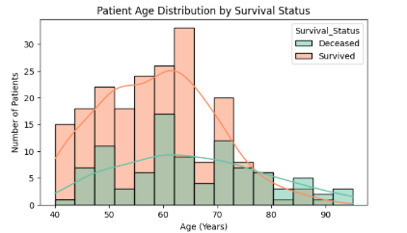
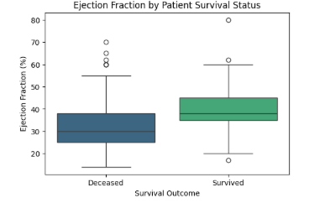

- Chart 1 (Age Distribution by Survival Status): Illustrates that older patients face a noticeably higher risk of mortality during the follow-up period.
- Chart 2 (Ejection Fraction by Survival Status): Demonstrates that patients who survived maintained a higher median cardiac ejection fraction compared to deceased patients.
5. Results & Conclusion
The Random Forest AI model achieved a test accuracy of ~75%–80% in predicting patient survival outcomes. Key clinical biomarkers—specifically ejection fraction, serum creatinine, and patient age—served as the most decisive indicators for early clinical intervention.

