Sinhgad Techical Education Society’s

**Sinhgad Academy of Engineering, Kondhwa (Bk.), Pune.**

Database Laboratory

**Mini Project**

**Gym Management System**

By

**Shivraj Hulbatte**

**Rajat Charde**

**Prasad Gondhale**

**Dattatray Giri**

Third Year

Department of Computer Engineering

**Year – 2017-18**

**ACKNOWLEDGEMENT**

I would like to take this opportunity to thank all the people who were part

Of this Project in numerouus ways,people who gave un-ending support right from

the initial stage. In particular , I wish to Thank..

My internal project guide who gave his co-

Operation timely and precious guidance without which this project would not have

been a success thank her for reviewing the entire project with painstaking

efforts .And more of his, unmanning ability to spot the mistakes.

I would like to thank our H.O.D **Prof. B. B. Gite** for his continuous

encouragement and support and guidance at each and every stage of

developement of this project.

And last but not the least I would like to thank all my friends who were

Associated with me and helped me in preparing my project. The Project named

**Gym Management System** would not been possible without the

extensive support of people who were directly or indirectly involved in its successful

Execution.

**Shivraj Hulbatte**

**Rajat Charde**

**Prasad Gondhale**

**Dattatray Giri**

**CONTENTS**

**1.Abstract**

**2. Introduction.**

**3.SYSTEM STUDY**

**3.1 Proposed System.**

**3.2 Scope Of System.**

**3.3 Working Of System.**

**3.4 Feasibility Technique.**

**3.5 Hardware & Software Requirement.**

**4.SYSTEM DESIGN**

**4.1 Table Design.**

**4.2 Input Screen.**

**5.TESTING.**

**6. CONCLUSION.**

**1.ABSTRACT**

“ GYM MANAGEMENT SYSTEM ” is an idea to computerize the various

functionality of management in Gym . The main objective Of this project was to

avoid lots of paper work during the whole year.

This software deals with overall functionality of Gym administration

including gym , trainers ,personal ,extra and activity records .It also generates the respective

reports.

The main challenge was to make the system work without any error

so that all the reports were generated accurately.

**2. INTRODUCTION**

“ GYM MANAGEMENT SYSTEM “ is a gym automation system

that replaces the manual working mode of a Fitness Club by a more

convenient, user-friendly, efficient and user-oriented working enviornment.

It resolves the problem of such as, automation of the administrative office

system and automation of receipt generation at member level.

The system is divided into two Modules:

1. Master Module.
2. Transaction Module.

**Master Module :**

This Module provides forms of member’s Personal , Gym

information gym Activities.

**Transaction Module:**

This Module validates the data filled in forms provided to the

user ,authenticates it and stores in the database of the gym.

**3. System Study**

**3.1 PROPOSED SYSTEM :**

The system provides a user friendly interface which

saves time and cost of paper work.

The main Motto Of this system is to computerize the whole record keeping

Protocol of gym with minimum human effforts and in least possible time

and most importantly without errors.

The system also provides accurate,quick and meaningful information based

on the transaction processed. It also provides quick and accurate reports

relating to the Organization.

The System makes sure that the transaction records are complete,accurate

and readily available.It provides Standard for Data sharing and analysis

keeping in mind the standards for privileges and Data security.

There is Login Form for authenticating Users for gaining authorised access to

the system and restrict invalid access to the system by unauthorised users.

**3.2 Scope Of System :**

The System helps to Access real time information. It has an effective use of

well Laid-out Graphical User Intreface.

The System provides Validation And Error Handling. Members can also do

online enquiry.The system provides automatic generation and validation

of Reports according the User.It also have powerfull transaction and routine

data processing capabilities.The system enables a strong controlled

enviornment.

Thoughtful and Timely changes are made to keep place with advances in

Both Technology and Business. An effective governance and

Administrative structure is created and maintained to support the

management with network or improved functionality, fixes and services

releases.

**3.3 Working Of System :**

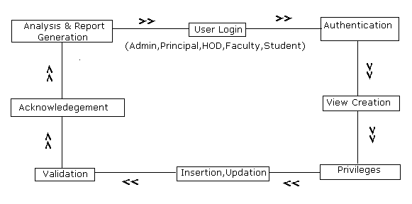**3.4 Feasibility Study :**

The main objective of feasibilty study is to test Technical,Operational

and Economical extensibility for developing computerised system.This is done

by investigating and generating idea about a new system.

Feasibility study helps to obtain an overview of the problem and get rough

assessment of whether feasible solution exists. There are three types of

feasibility studies in order to understand whether the proposed system would

be feasible if implemented.

They are as follows:

* Technical Feasibility
* Economical Feasibility
* Operational Feasibility

**1.Technical Feasibility :**

Technical Feasibility will need to consider the possibilities of using machines available

and the nature of hardware being used in the system. Its always better to select the best

package that will be flexible with other programmers or outside developers and as possible

for the user.

We are using NetBeans 8.1 Technology.To develop this application NetBeans 8.1 is the feasible

technology due to its strong desktop development Architecture.

**2.Operational Feasibility :**

The system is user friendly and it is accesible to user,and much easier to operate

because the interface of the system and screen display is quite clear.The system must

operate in proper cyclic frequency of transactions.There are navigation bars by which

the users and administrator both can lead to system operations.

**3.Economical Feasibility :**

Proposed or developed system is been justified by the cost and analysis benefits to

Ensure that efforts are concentrated on the project that will give best returns at the earliest

opportunity.The cost of operation of the propsed system is minimal,since there is no need of

installing hardware,training etc as computers are alredy installed and users are well trained.

**3.5 HARDWARE AND SOFTWARE REQUIREMWNTS**

**HARDWARE REQUIREMWNTS :**

**Processor-:1.8 Ghz**

**Hard Disk-:80GB**

**RAM-: 4 GB**

**Mouse-: Any Make**

**Keyboard-:Any Make**

**Printer-:Any Make**

**Monitor-:Any CRT or LCD**

**SOFTWARE REQUIREMWNTS :**

**Operating System-: Windows 2007,Linux Ubuntu**

**Front End -: NetBeans (version 8.1)**

**Back End -: MySQL**

**5.SYSTEM DESIGN :**

**5.1 Table Design.**

**Personal Information**

|  |  |  |  |  |
| --- | --- | --- | --- | --- |
| **SR.NO** | **Fields** | **Data types** | **Width** | **Key** |
| **1.** | **Image** | **blob** |  |  |
| **2** | **Reg_ID** | **int** | **10** | **Primary key** |
| **3.** | **First Name** | **varchar** | **100** |  |
| **4.** | **Last Name** | **varchar** | **50** |  |
| **5.** | **Gender** | **varchar** | **10** |  |
| **6.** | **Contact** | **int** | **50** |  |
| **7.** | **Address** | **Varchar** | **50** |  |
| **8.** | **Email** | **varchar** | **15** |  |
| **9.** | **Age** | **int** | **4** |  |

**Gym Information**

|  |  |  |  |  |
| --- | --- | --- | --- | --- |
| **SR.NO** | **Fields** | **Data types** | **Width** | **Key** |
| **1.** | **Reg_ID** | **int** | **10** | **Reference key** |
| **2.** | **Weight** | **int** | **60** |  |
|  |  |  |  |  |
| **3.** | **Height** | **int** | **60** |  |
| **4.** | **Subscription** | **Varchar** | **50** |  |
| **5.** | **Amount** | **int** | **50** |  |
| **6.** | **Fee_Status** | **varchar** | **20** |  |
| **7.** | **Start_Date** | **date** |  |  |
| **8.** | **End_Date** | **date** |  |  |
| **9.** | **Trainer** | **varchar** | **20** |  |
| **10.** | **Facility** | **varchar** | **20** |  |
| **11.** | **Fee_Date** | **date** |  |  |
| **12.** | **Due_Date** | **date** |  |  |

**Trainer**

|  |  |  |  |  |
| --- | --- | --- | --- | --- |
| **SR.NO** | **Fields** | **Data types** | **Width** | **Key** |
| **1.** | **Reg_ID** | **int** | **10** |  |
| **2.** | **Trainer Name** | **varchar** | **50** |  |
| **3.** | **Age** | **int** | **50** |  |
| **4.** | **Gender** | **varchar** | **-** |  |
| **5.** | **Package** | **int** | **50** |  |
| **6.** | **Contact** | **int** | **4** |  |
| **7.** | **Email** | **varchar** | **50** |  |
| **8.** | **Join_Date** | **date** |  |  |

**Equipments**

|  |  |  |  |  |
| --- | --- | --- | --- | --- |
| **SR.NO** | **Fields** | **Data types** | **Width** | **Key** |
| **1.** | **Id** | **int** | **10** |  |
| **2.** | **Name** | **varchar** | **60** |  |
| **3.** | **Quantity** | **int** | **60** |  |
| **4.** | **Cost_Per_Unit** | **int** | **50** |  |
| **5.** | **Total_Cost** | **int** | **50** |  |

**5.2 Input Screen (Screen Shots )**

**Login**

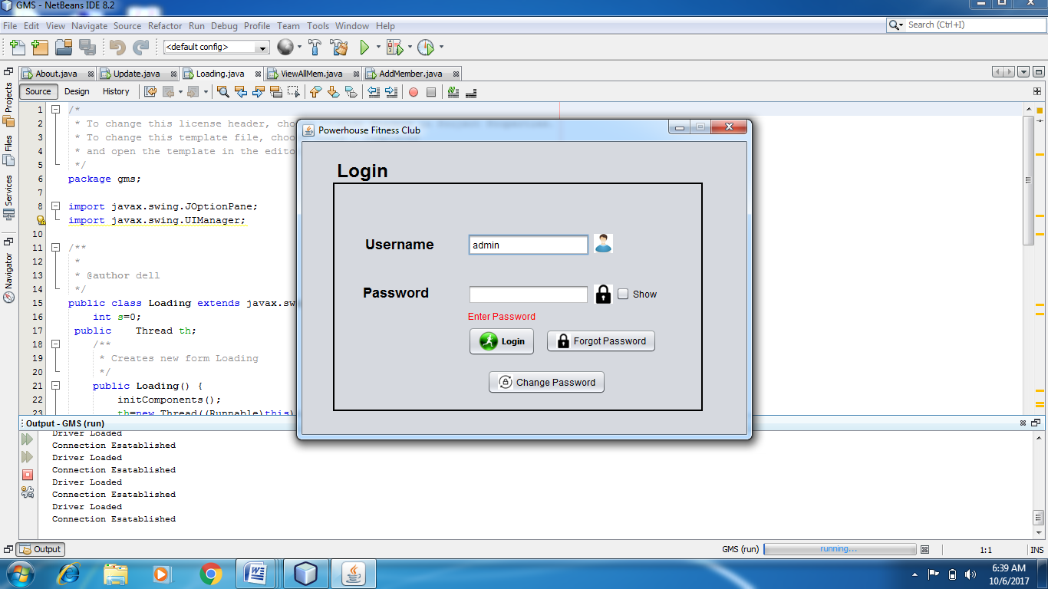

**MENU**

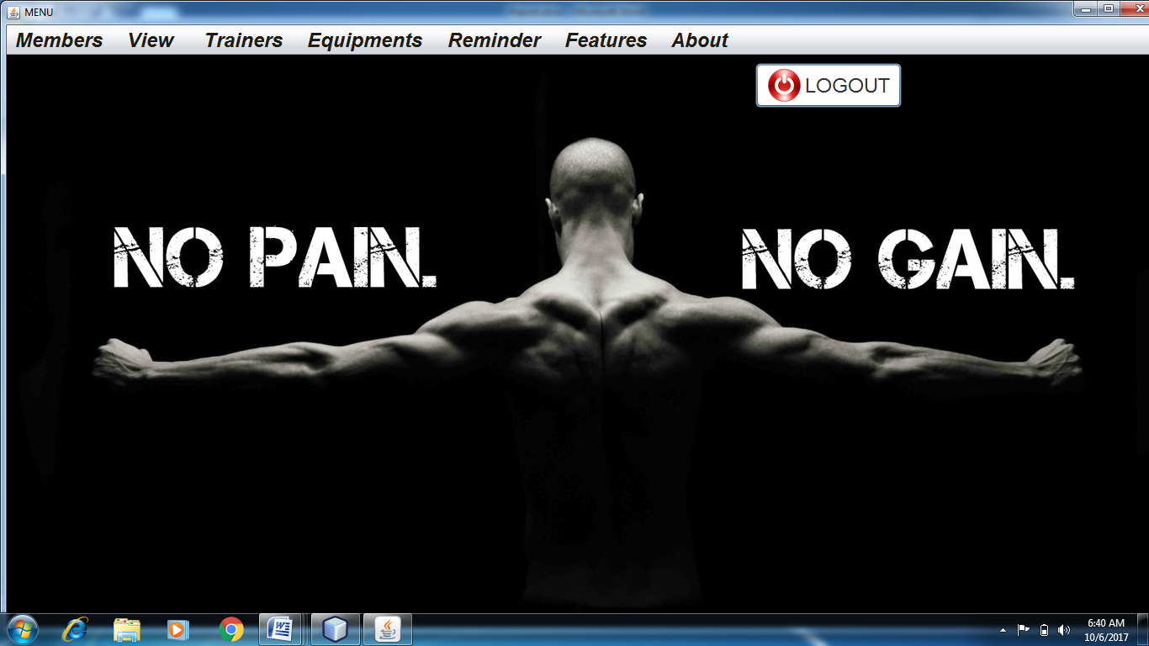

**ADD MEMBER**

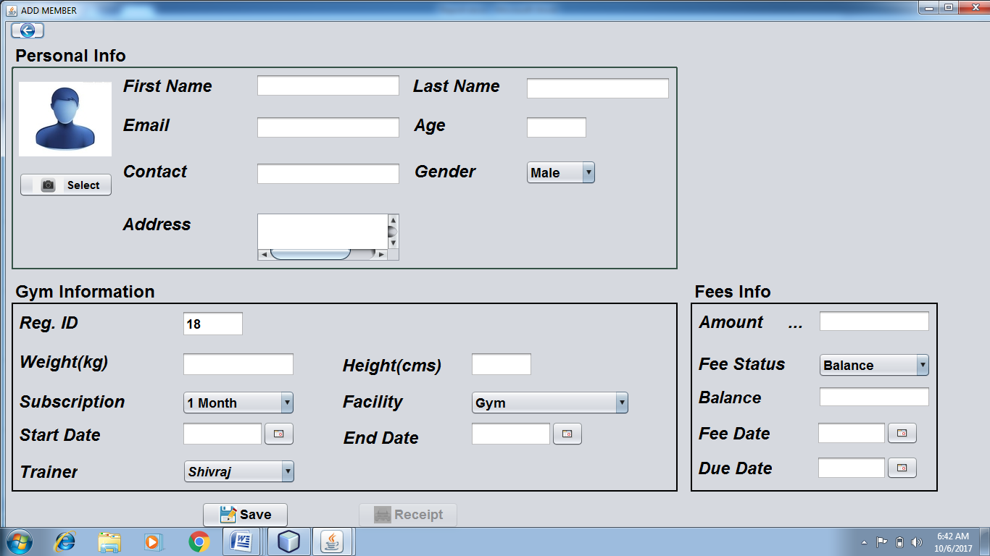

**SEARCH/UPDATE/DELETE MEMBER**

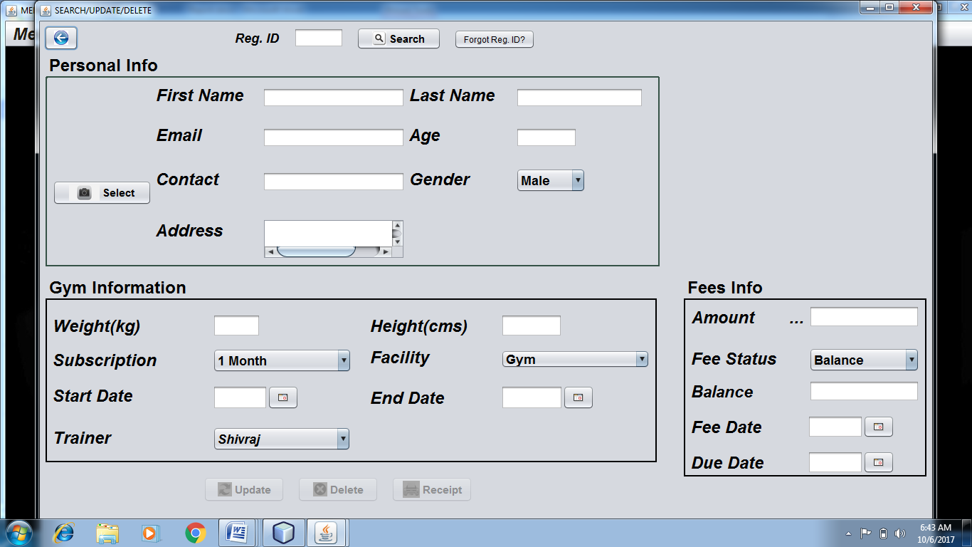

**VIEW ALL MEMBERS**

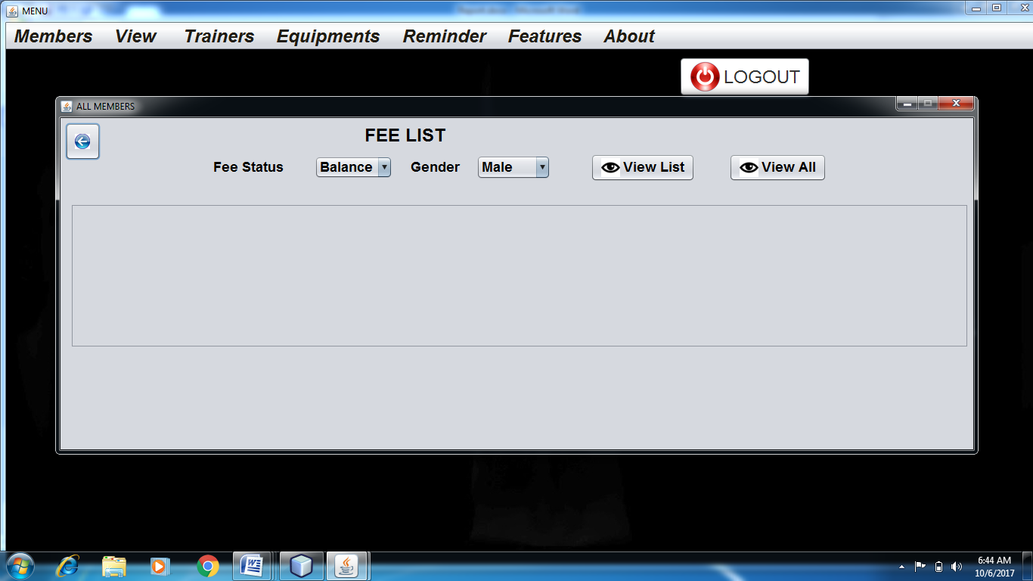

**FEE COLLECTIONS**

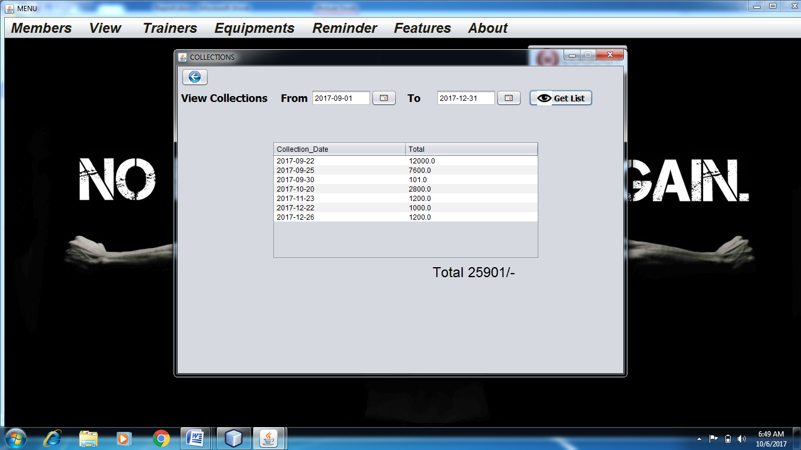

**REMINDER**

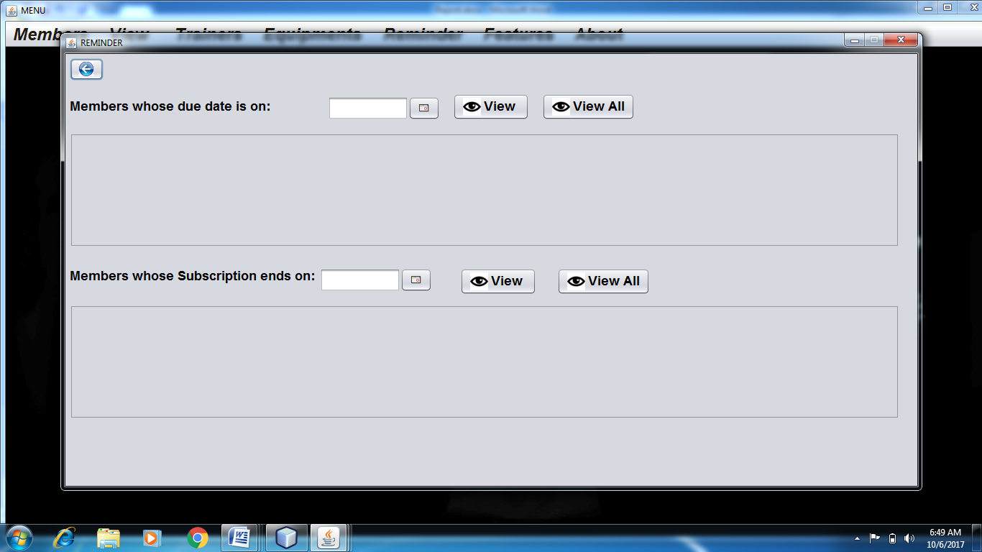

**ABOUT PAGE**

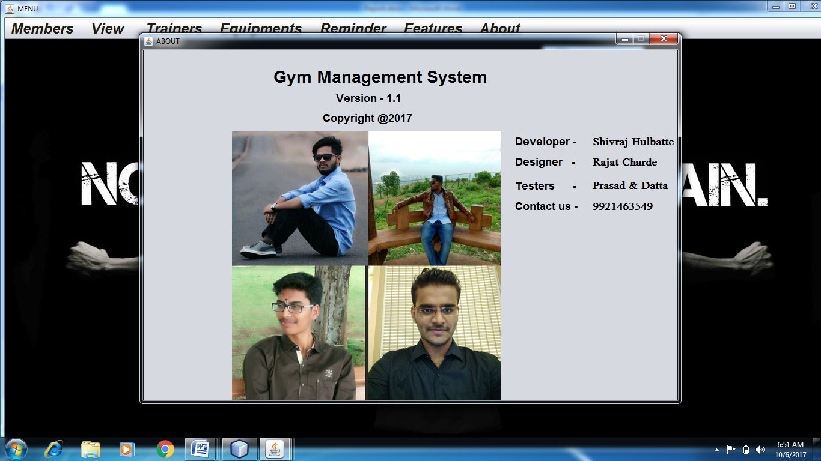

**5.TESTING.**

Testing is one of the important step to be performed to ensure

Sucessful implementation ofthe system.The basic idea of carrying out testing is to

ensure no error exits in the functionality and operability of the program. Therefore

there most useful and practical approach is with intension of finding errors. This is the

phase where the system is intentionally made to fail so as to make the system full

proof and error free up to the limit possible.

Initially Test data is prepared to check the software. During this phase

the system is used experimentally to ensure that the software does not

fail. Special test data are inputs for processing and the result is examined.

It is very Essential for increasing its effectiveness and accuracy.

The testing of system is necessary to ensure the following issues:

* Completeness
* Correctness
* Reliability

In general the system was throughly checked at each level, right

from the beginning. System was checked at different levels.

* Testing of data entry procedures is done.
* Testing of data validations id done.
* Entering data via different screens(forms) is done.
* Testing for data insertion and updation is done.
* Record saving procedure is done.
* Error routine were checked.

**6. CONCLUSION.**

This system also provides reports to each level of hierarchy.

The system carries it work from the point of view of administrator

as well as the pointof other users in institution.

The valid inputs are required which can yield the best results.

Unauthorised user will not be able to access the system.

Thus the system gives its result properly.

1. The system was found feasible and operational.
2. The User found the system to be interesting and very easy to handle ,apart

from the fact that its accurate and efficient.

1. The system maintained the required information with all the validations and

thus implements data consistency thoughout.

1. All the tedious reports were generated automatically ,hence was tedious

work of removing the necessary data for report generation was done

away,saving time ,energy and resources.