Assignmnet 7

Aim:
To configure Jenkins to automatically detect changes in multiple GitHub repositories and deploy the updated files to the web server using automatic build triggers. Webhook triggering was attempted, but due to configuration issues(error 404 in github webhook), Poll SCM was used to achieve the same automatic deployment functionality.

Step 1 – Create GitHub repositories
Created three repositories:
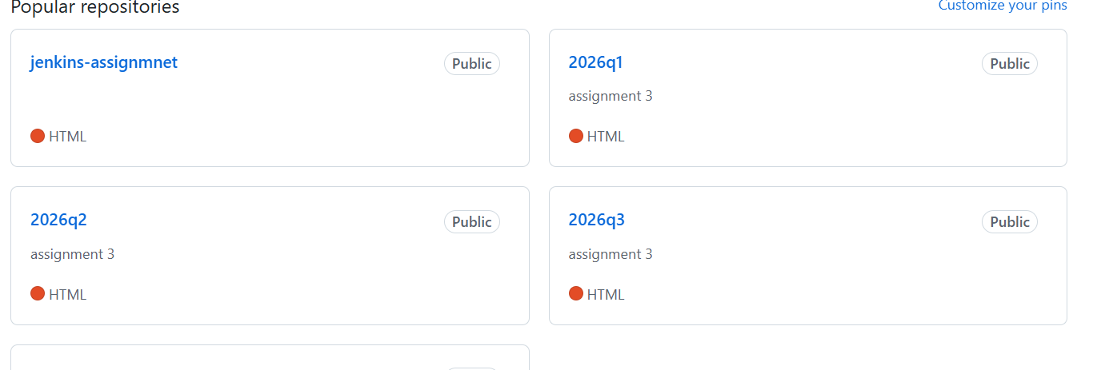
Create Jenkins Job for repo1

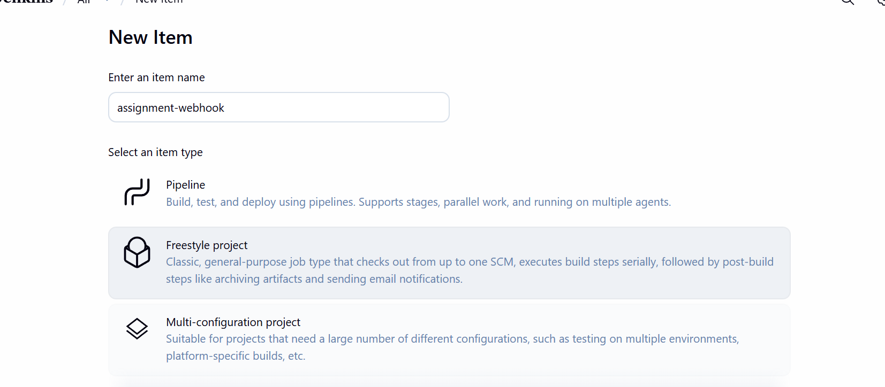

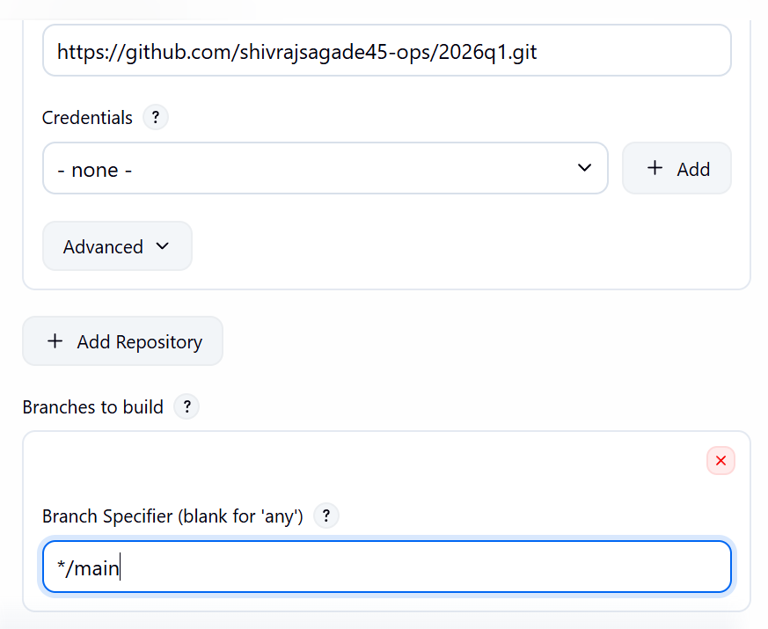
step __ 2 configure the the github info

Step 4 – Enable automatic trigger
Build Triggers → Tick:
poll scm
Schedule:
* * * * *
(This checks repository every minute)
Webhook was attempted but returned 404 error, so Poll SCM was used.

Step 3 __ add the execute shell
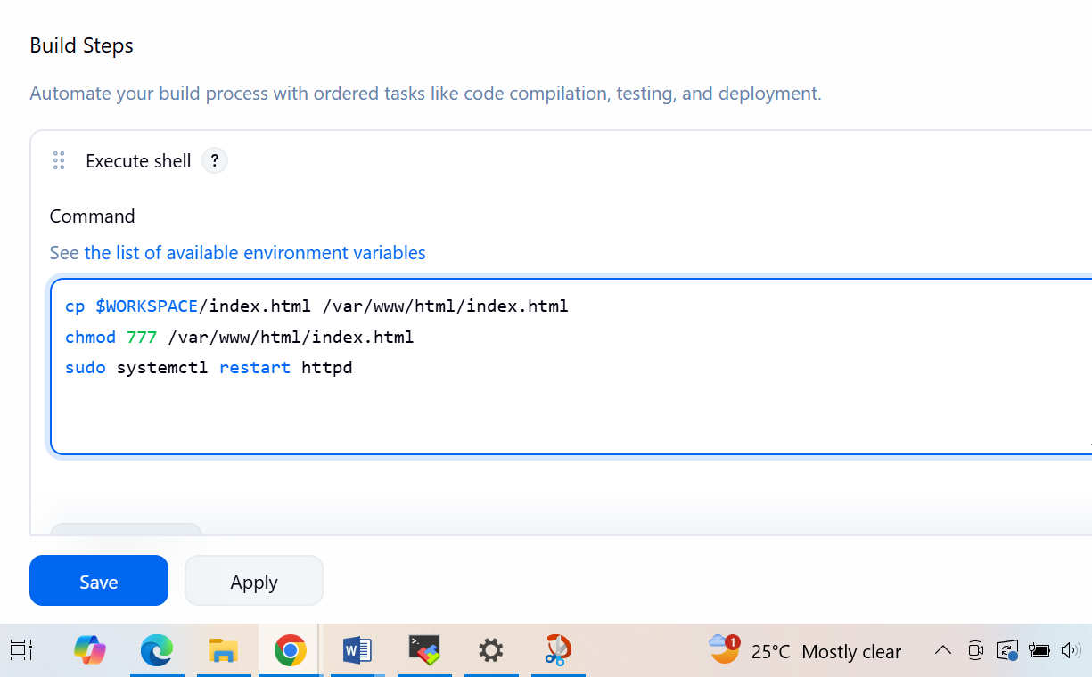

Create job for repo2 and repo3
Repeat same steps

To test changing the repo 3 which is 2026q3
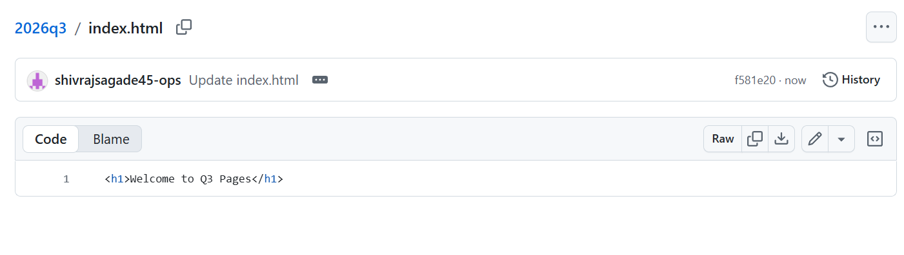
output
