Assignment 4

Aim :- Create a private Git repository containing an index.html file. Using Jenkins, fetch the file from the repository and deploy it to an AWS S3 bucket configured for static website hosting

STEP 1 — Create Private GitHub Repo
- Go to GitHub → New repo
- Name → assignmen 3
- Select → Private
- Create file → index.html

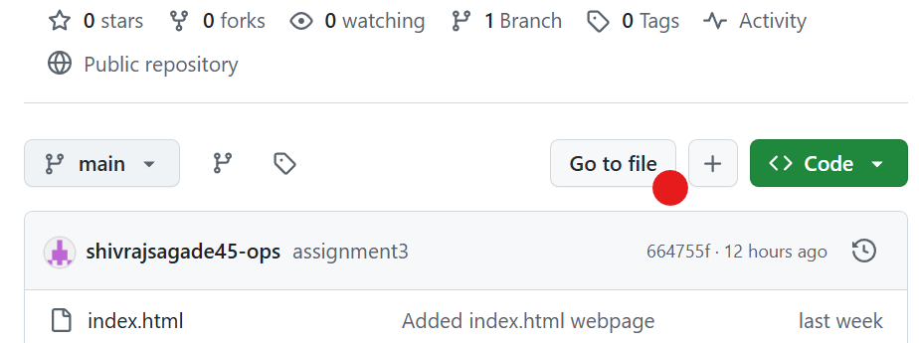

STEP 2 ;- Create S3 Bucket
AWS → S3 → Create bucket
Name:

jenkins-bucket1234

Region → same as EC2
Uncheck:

Block all public access

Create bucket.

STEP 3 — Enable Static Website Hosting
Open bucket → Properties → Static website hosting
Enable
Index document:

index.html

Save.

STEP 4 — Create IAM Role (EC2 → S3 Full Access)
AWS → IAM → Roles → Create role
Select:

EC2

Attach policy:

AmazonS3FullAccess

Attach that policy to the ec2 instance

STEP 5 — Create git-repo Folder in Jenkins

STEP 6 — Create Jenkins Job
give name and select the freestyle project then ok

add the git repo in the jenkins
Source Code Management → Git and add credentials

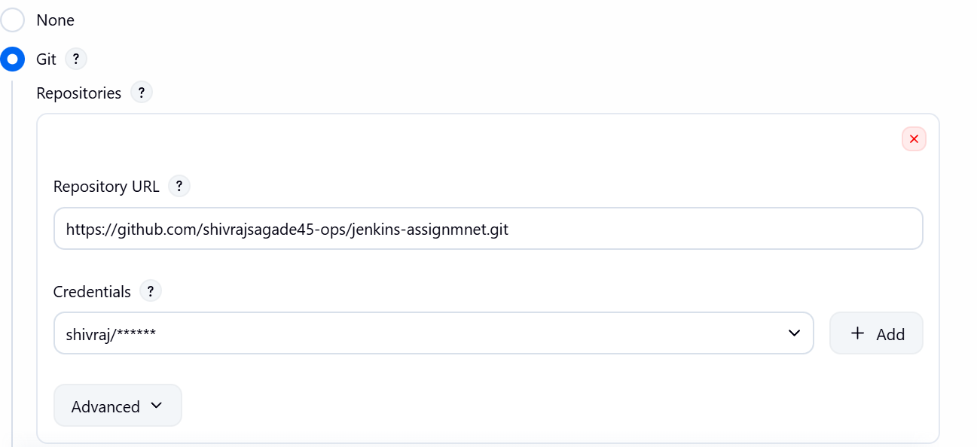
tick the delete workspace before the build

STEP 7 — Add Execute Shell

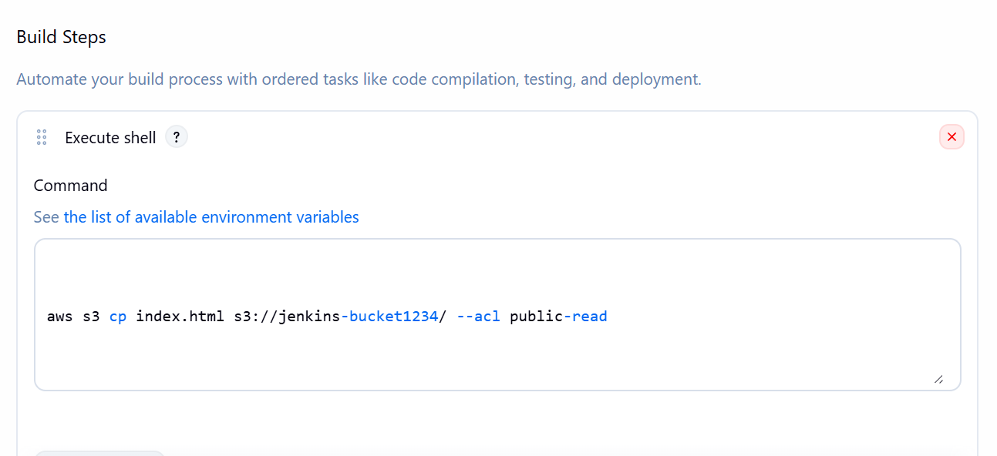
build the job

and now you should see the index.html in the s3 bucket

STEP 8 — Open Static Website URL

You should see your HTML page.

