Assignmnet 5

Aim:
To clone a GitHub repository into the Jenkins master, build the project using Maven to generate a WAR file from the pom.xml, upload each build to an AWS S3 bucket with a timestamped name, and deploy the latest WAR file to the Apache Tomcat webapps directory as LoginWebApp.war.

1. Install Maven in Jenkins EC2

2 .Add maven to environment variables

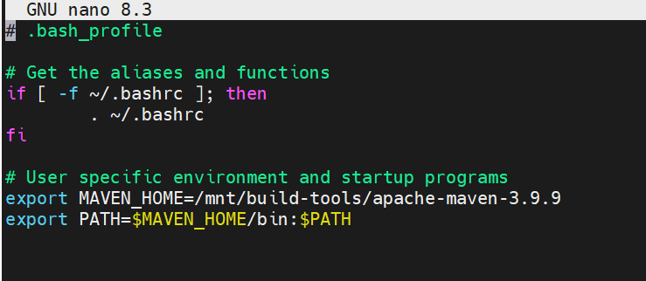

3 . Configure Maven in Jenkins

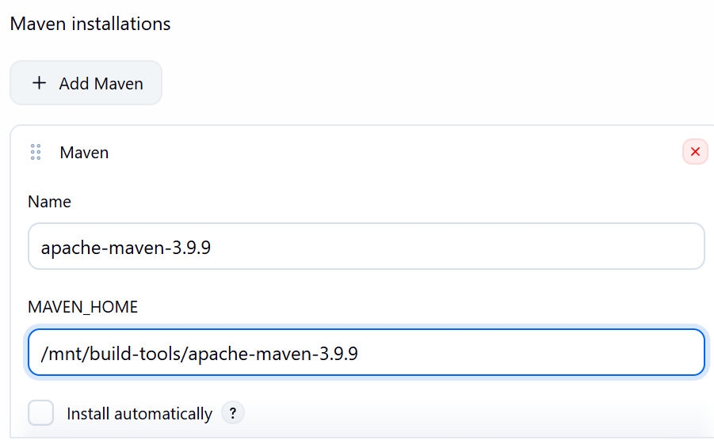

4. Install Git

sudo yum install git -y

5 — Create S3 bucket

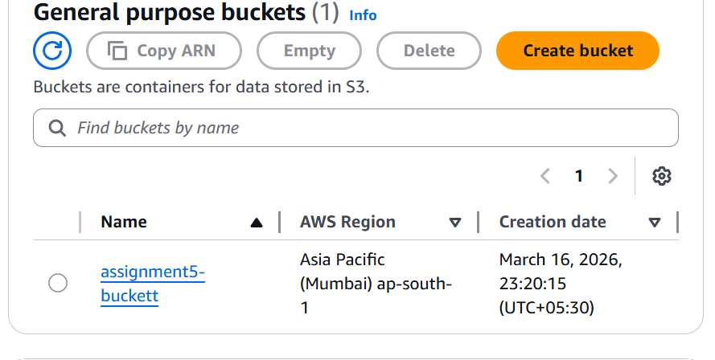

and attach the role to ec2 instance

;- AmazonS3FullAccess

6. Create folder for workspace

mkdir /mnt/project

7. Create Jenkins Job

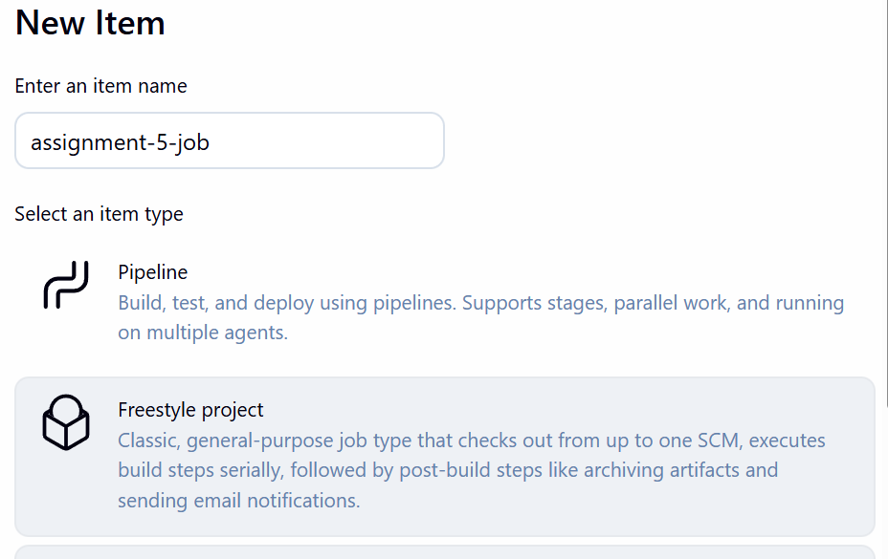

8 .Add Git repo
Source Code Management → Git and add Custom workspace
Tick:

Use custom workspace

Path:

/mnt/project

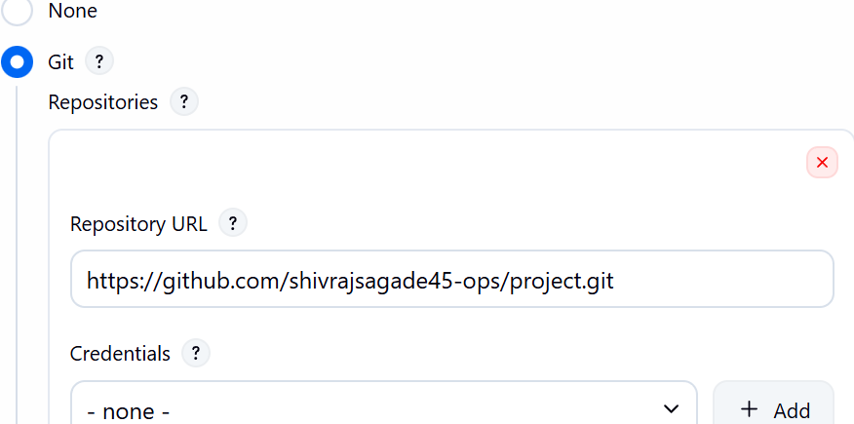

Delete workspace before build

9 .now create this

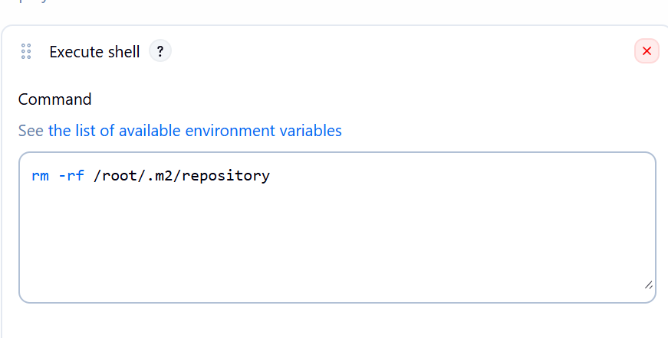
this forcefully deletes the entire Maven local repository

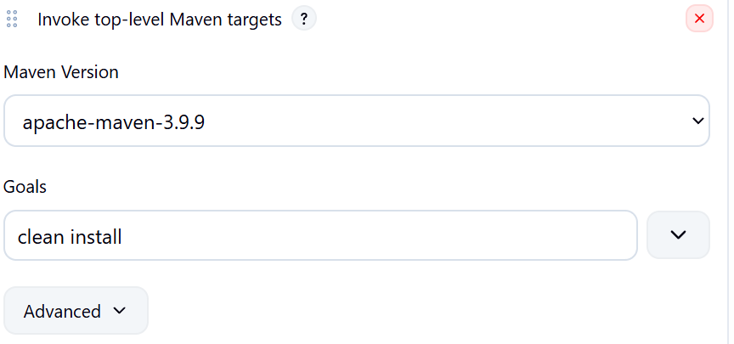

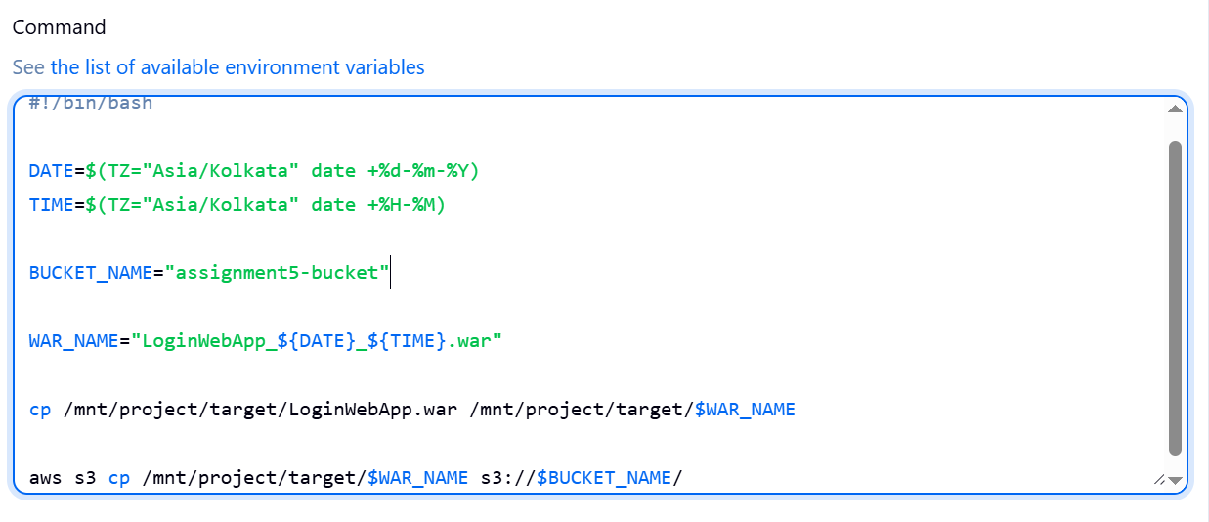

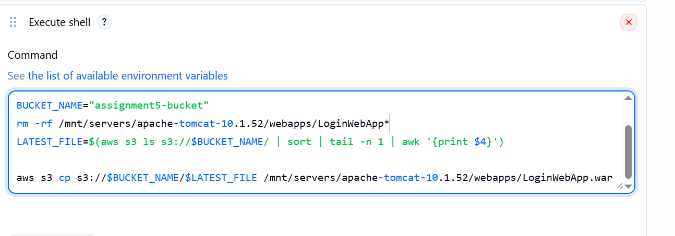

now click on build
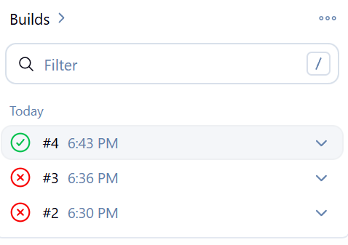

War file is in the bucket as you can see

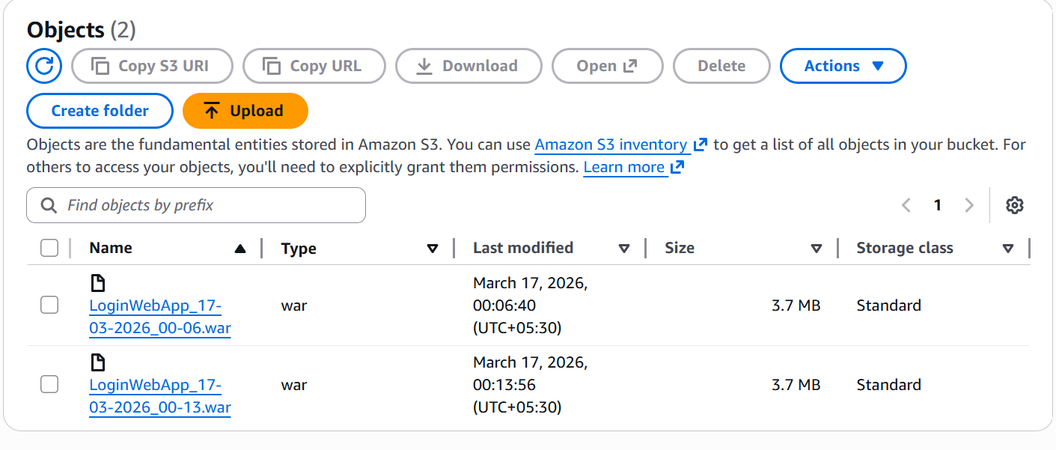

output
