Assignment 8

Aim:
To configure Jenkins master and multiple slave nodes to build and deploy different GitHub repositories on different machines so that changes in each repository are automatically deployed on the respective node using Poll SCM.

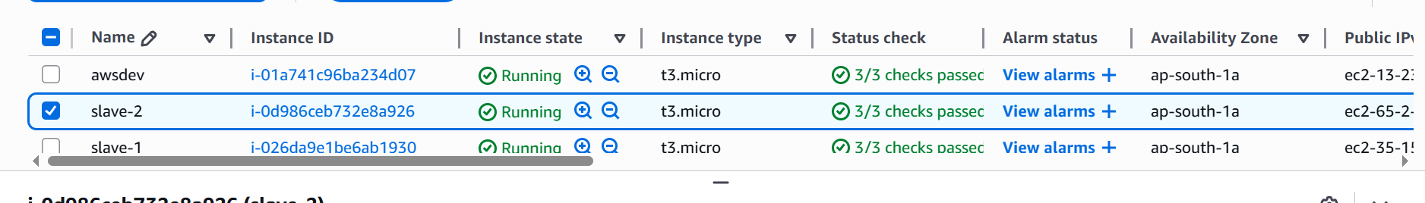

Create 3 instances and 3 repos 2026q1 , 2026q2 , 2026q3

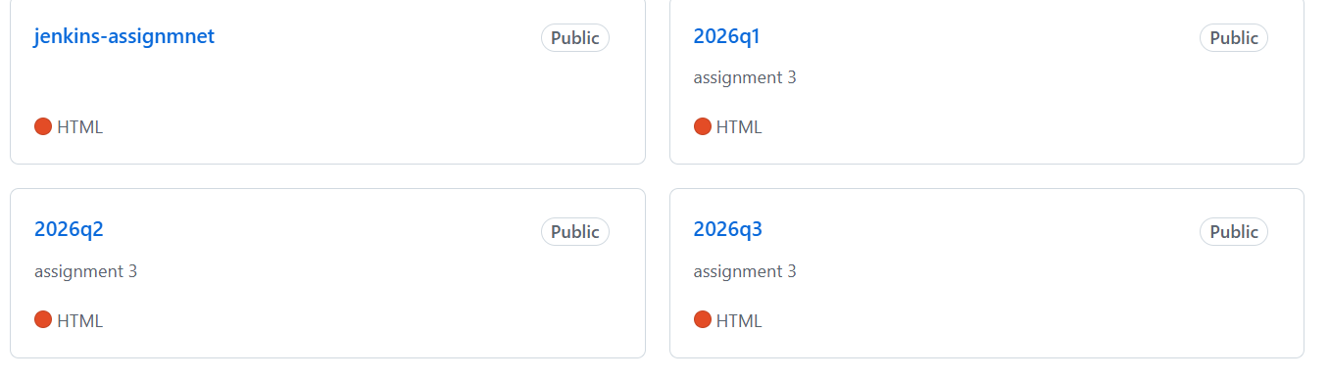

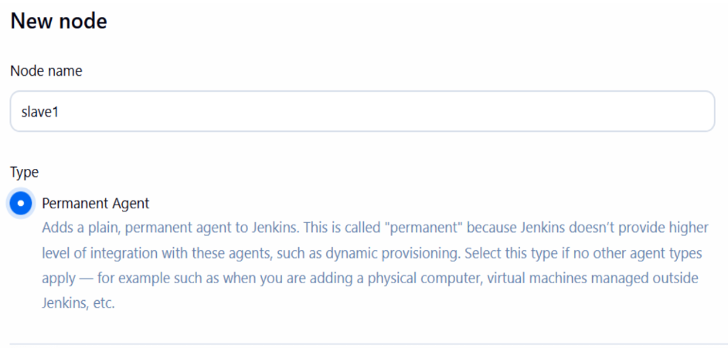
Add slave nodes in Jenkins

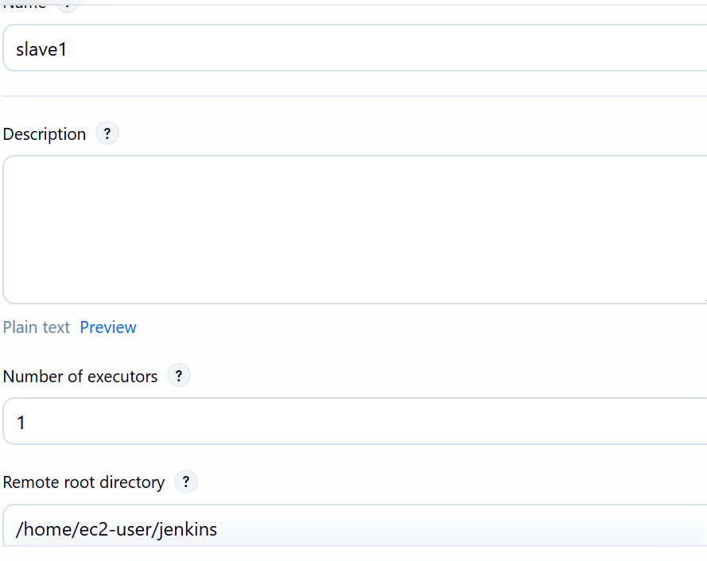
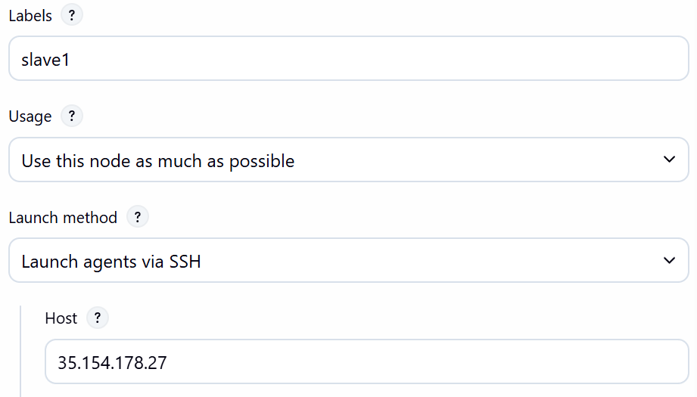
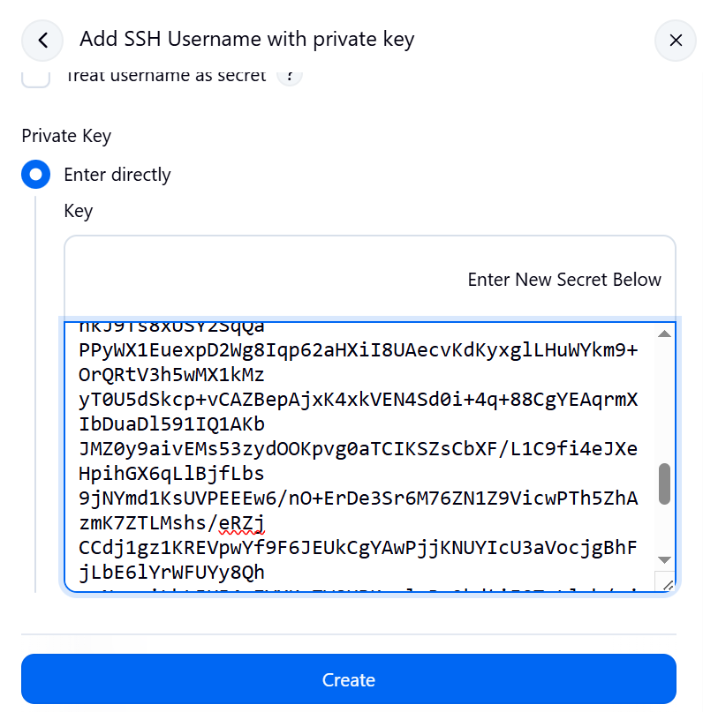

Save.
Repeat for slave2.

It should look like this

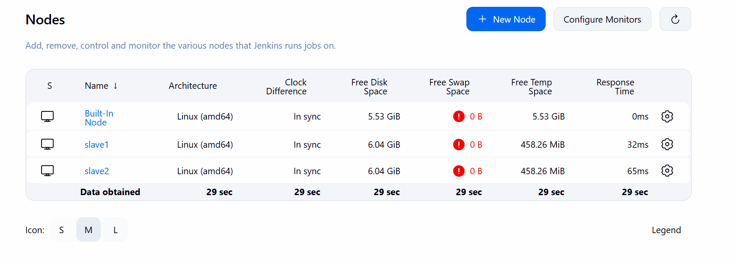

after this create the job for each

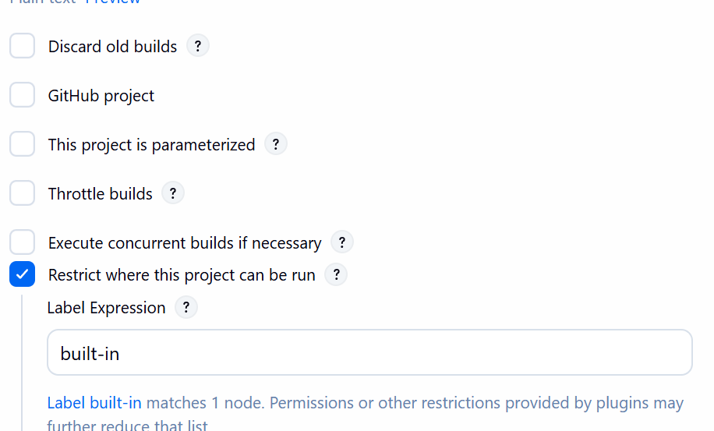

add github repo info

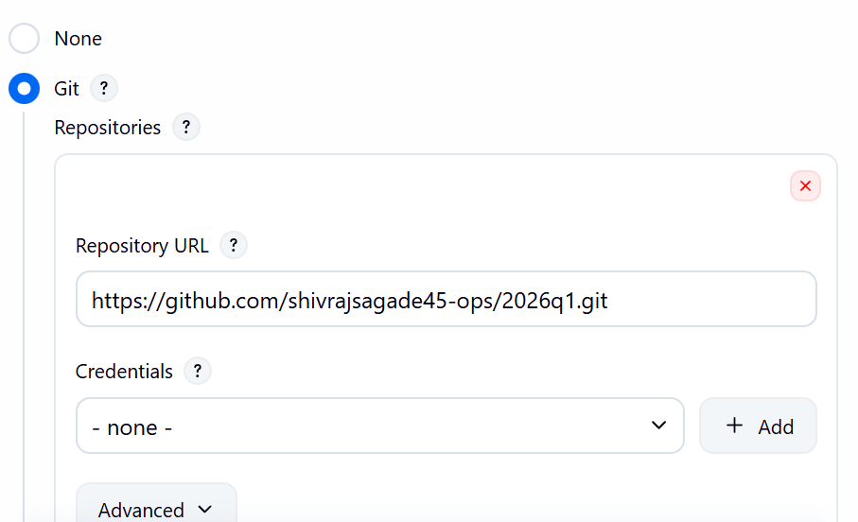
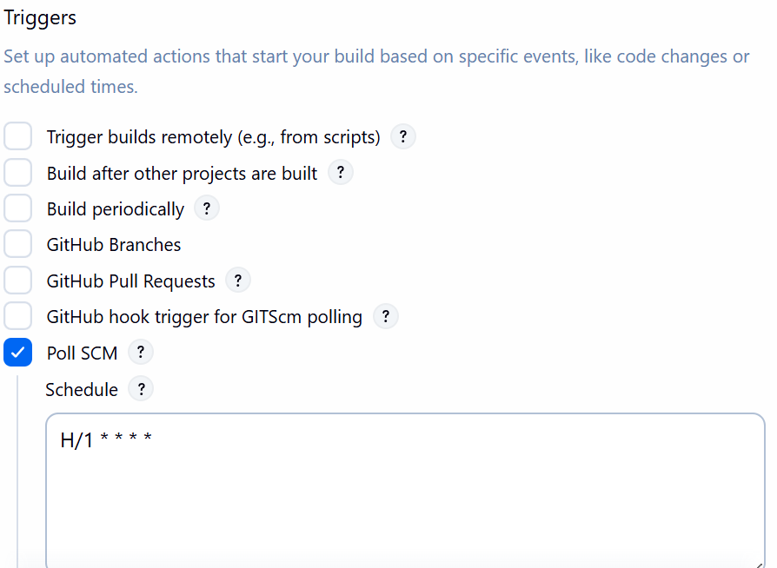
using poll scm

execute shell :-
cp $WORKSPACE/index.html /var/www/html/index.html
chmod 777 /var/www/html/index.html
sudo systemctl restart httpd

apply and save

do this for other 2 also….

Now lets change the repo

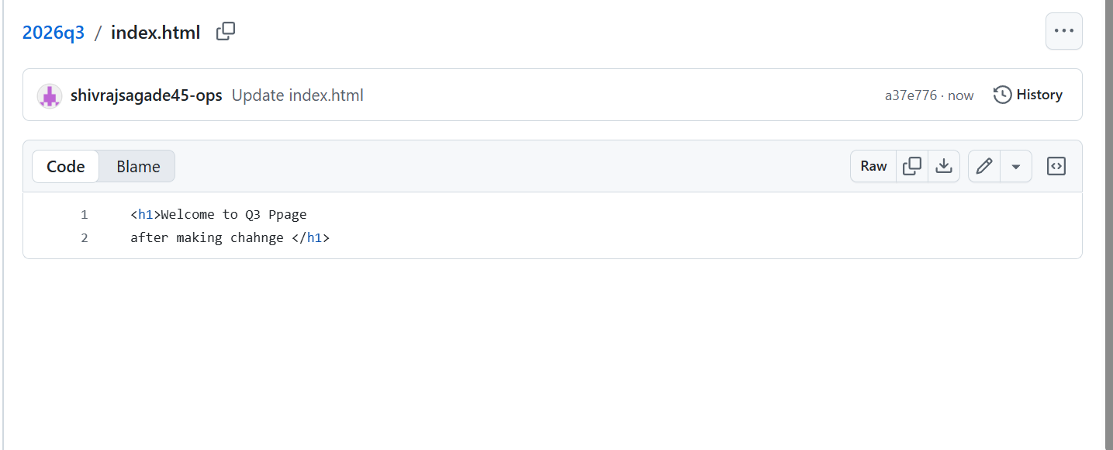
job is triggered


output


