Asssignment 1

Aim
To create a Jenkins job that installs the Apache HTTPD web server and deploys a simple index.html page so that it can be accessed through a web browser.

Step 1: Create a Jenkins Job
- Open the Jenkins dashboard.
- Click New Item.
- Enter a project name.
- Select Freestyle Project.
- Click OK.
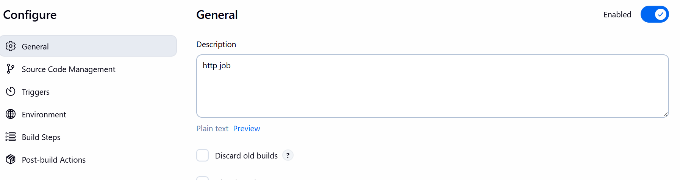

Step 2: Configure Environment
- Scroll to the Environment section.
- Enable the option Delete workspace before build starts.
This ensures every build runs with a fresh workspace and avoids conflicts from previous builds.

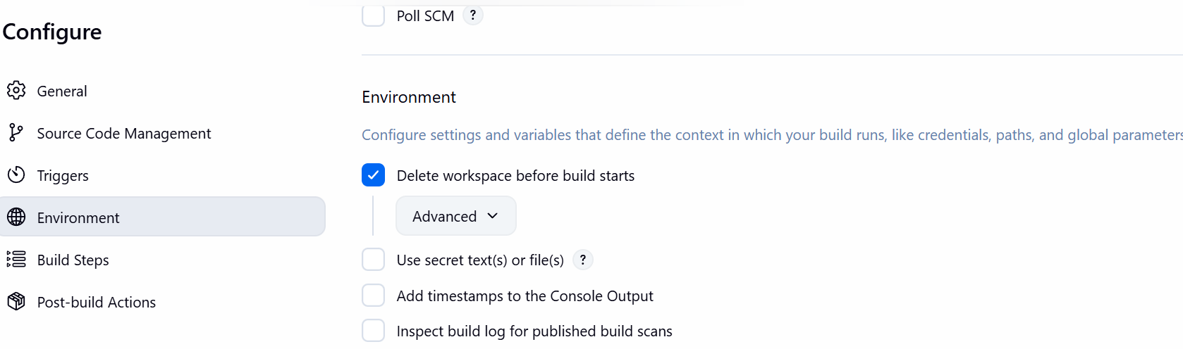
Step 3 Add Build Steps
- Scroll to Build Steps.
- Click Add Build Step → Execute Shell.
- Add the following commands:

sudo yum install httpd -y
service httpd start
echo "welcome to san andreas" >> /var/www/html/index.html
chmod 777 /var/www/html/index.html
chkconfig httpd on

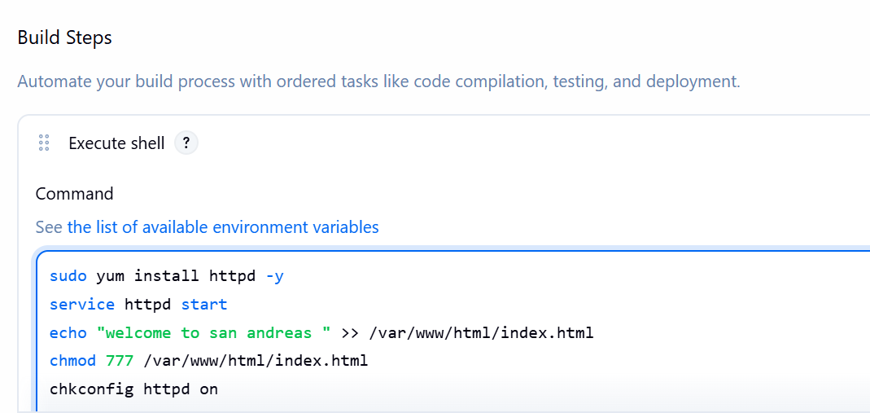

Step 4: Run the Jenkins Job
- Click Save.
- Click Build Now to run the job.
- If the job runs successfully, a green check mark will appear in the build history.
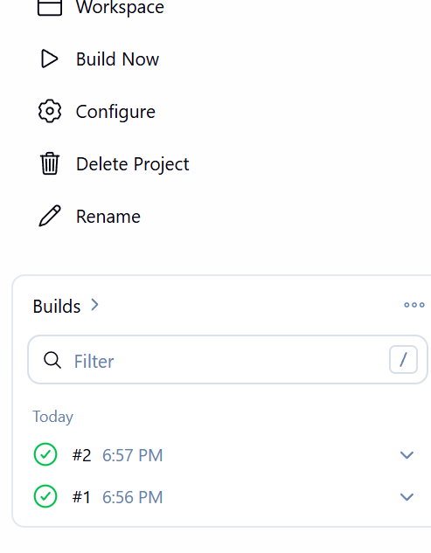

Step 6: Verify the Output
- Open a web browser.
- Enter the public IP address of the server.
