Assignment 2

Aim
To create a Jenkins job that pulls source code from a GitHub repository and deploys the index.html file to the Apache HTTPD web server so the webpage can be accessed through a browser.

Step 1: Create a GitHub Repository and Upload Code
First, the index.html file was uploaded to a GitHub repository using Git commands.
Commands used:

git init
git add index.html
git commit -m "Added index.html webpage"
git branch -M main
git remote add origin https://github.com/shivrajsagade45-ops/jenkins-assignmnet.git
git push origin main

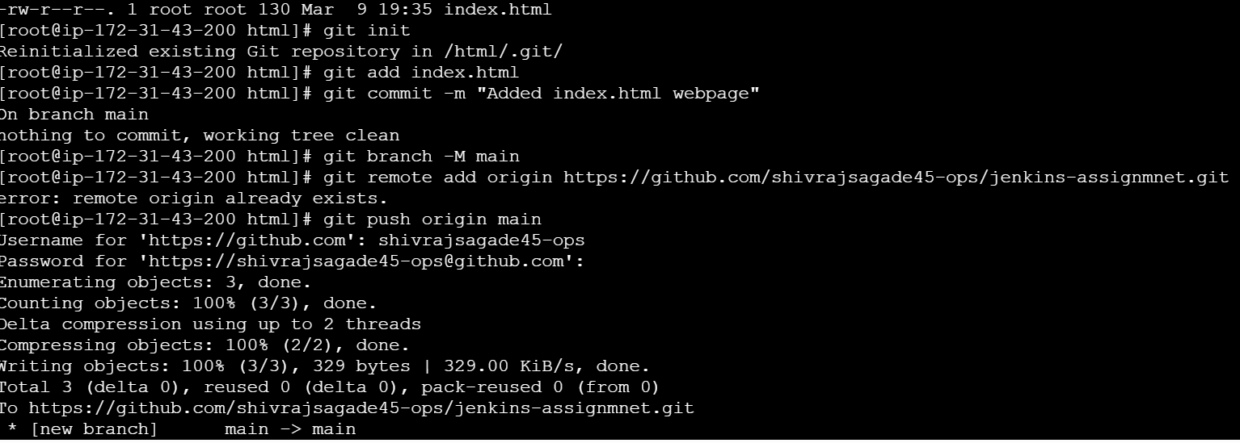

Step 2: Create a Jenkins Job
- Open the Jenkins dashboard.
- Click New Item.
- Enter the project name deploying index html.
- Select Freestyle Project.
- Click OK.
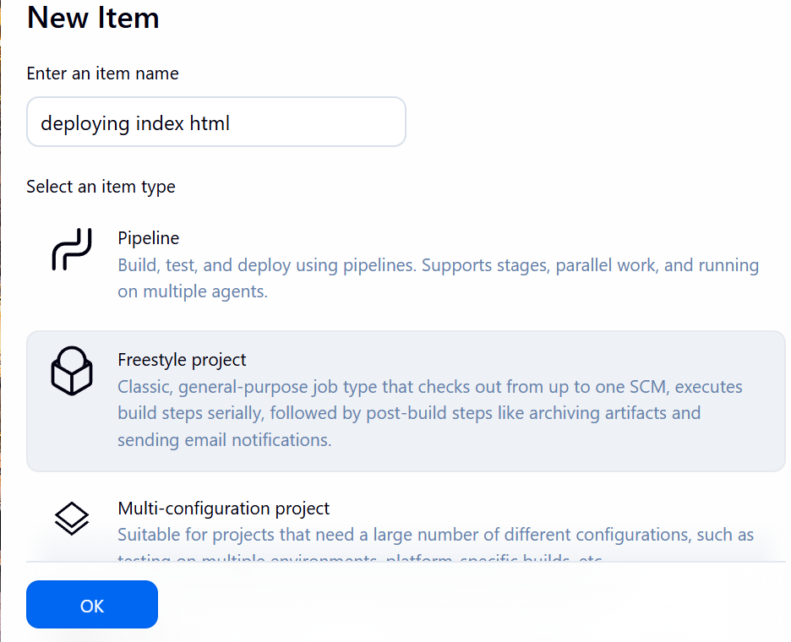

Step 3: Configure Source Code Management
- Scroll to Source Code Management.
- Select Git.
- Enter the repository URL:
Add GitHub credentials.
This allows Jenkins to pull the code from GitHub automatically.
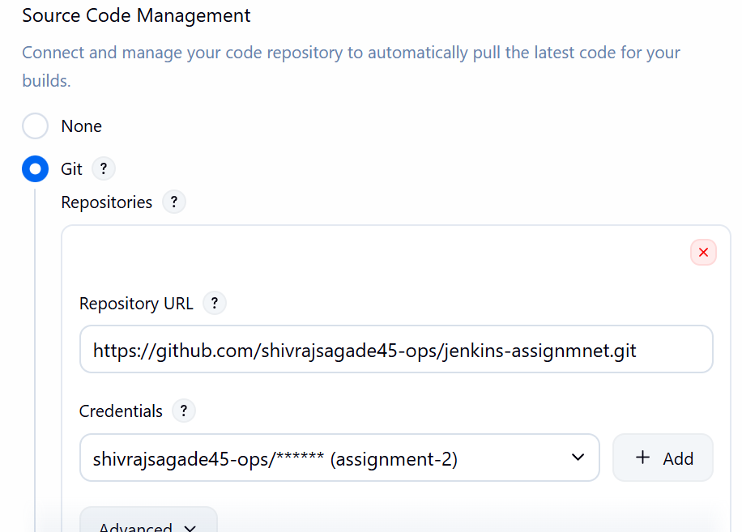

Step 4: Add Build Steps
Scroll down to Build Steps and select Execute Shell.
Add the following commands:

cp index.html /var/www/html/index.html
chmod 644 /var/www/html/index.html

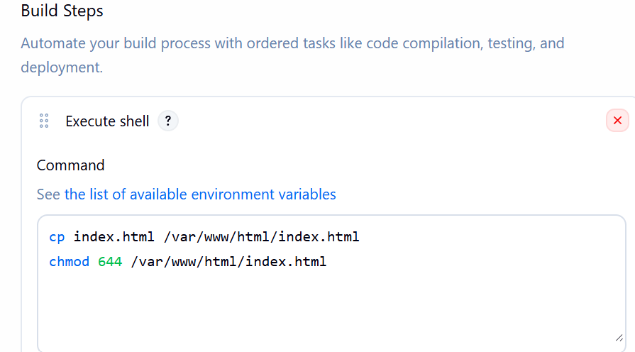

Step 5: Run the Jenkins Job
- Click Save.
- Click Build Now to execute the job.
- Jenkins will pull the code from GitHub and deploy the webpage.
If the build is successful, the job will show a green status.

Step 6: Verify the Output
Open a browser and enter the server's public IP address:

