Provide procedure details for all systems in PCI scope (domain system / server, network device, application, and database) on How unique password is allocated at the time of new user password creation and password reset request with user identity verification?   
-   
  
If any setting configured to enforce the change of user password at first logon, provide the screenshot for such setting

How it is ensured that password is changed at first logon?

**AWS Console Users**

**Policy**: - Every time a new user is created in AWS. change password at first logon in enabled.

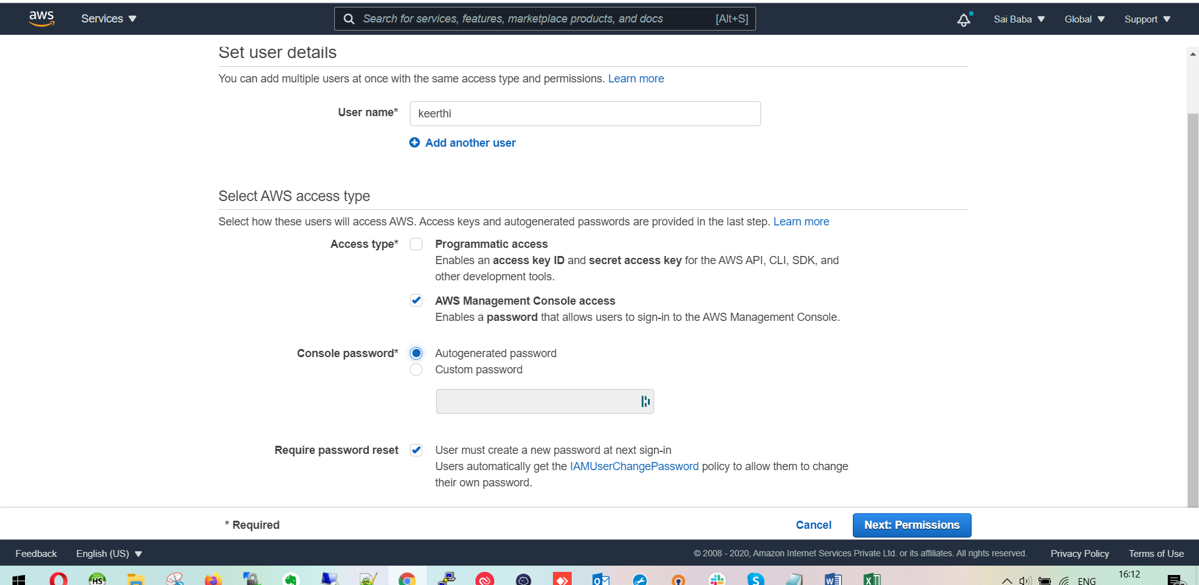

**For Servers**

After creating users and creating his SSH keys

To force a user to change his/her password, first of all the password must have expired and to cause a user’s password to expire, you can use the **passwd command**

*passwd --expire* ***username***

Which will immediately expire newly setup password.

Next, when user will login with his credentials he will get prompt to setup new password.

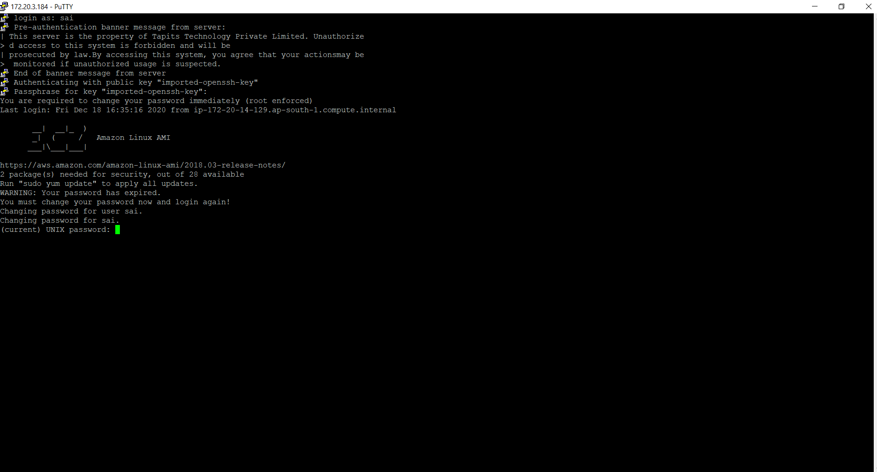

**Password Create reset procedure:**

We follow standard procedure for password reset with minimum 8 characters including 1 uppercase, lowercase and 1 special character

Note: We follow new password as per our password policy