1. 1BFH9X2
2. Reporting details from AirWatch Console

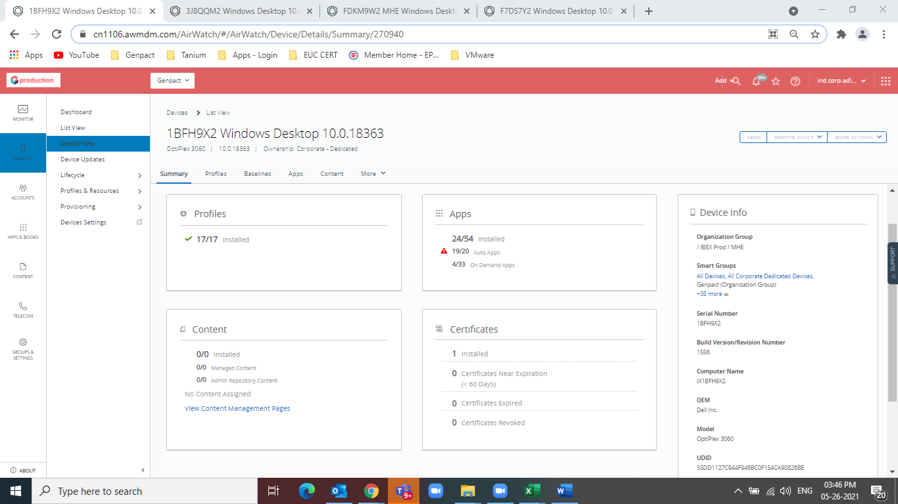

1. Policies applied

* BCM Baseline

1. 3J8QQM2
2. Reporting details from AirWatch Console

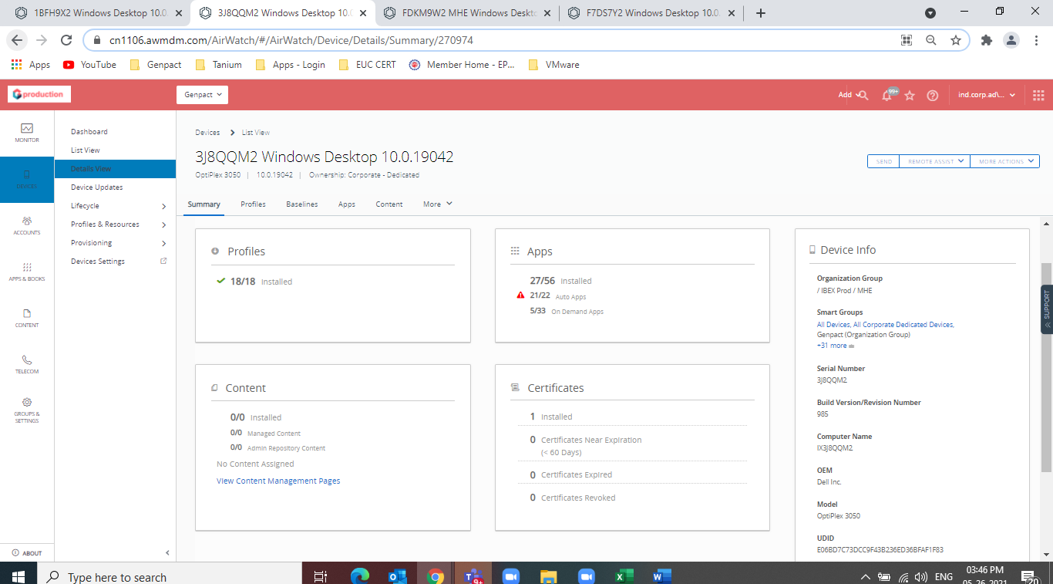

1. Policies applied

* BCM Baseline

1. FDKM9W2
2. Reporting details from AirWatch Console

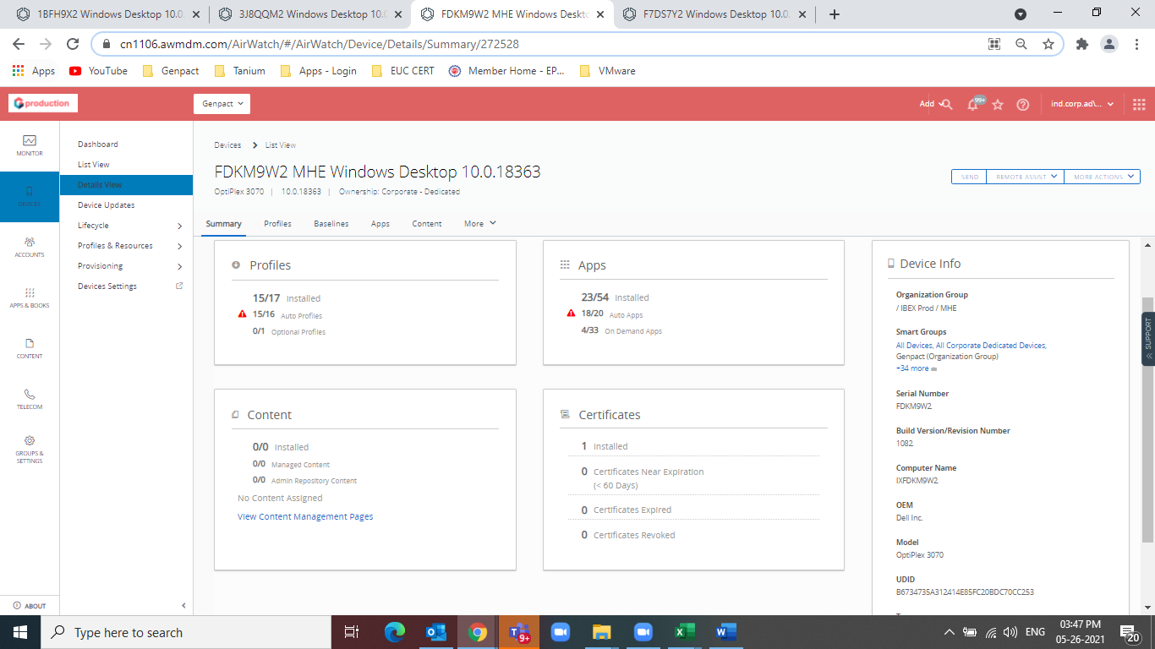

1. Policies applied

* BCM Baseline

1. F7DS7Y2
2. Reporting details from AirWatch Console

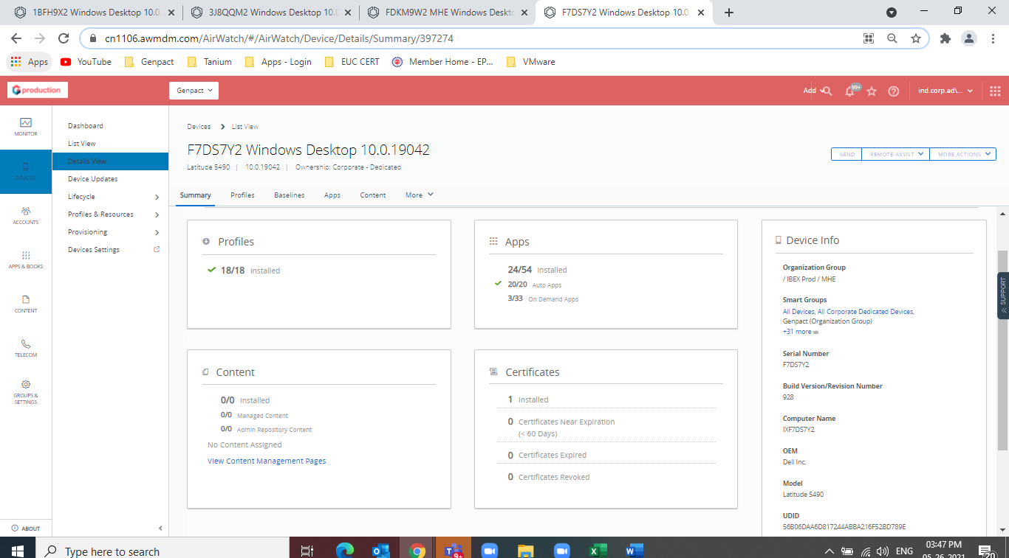

1. Policies applied

* BCM Baseline