Work Instruction

Process Drivers Line Calls

Prepared By

| Document Owner(s) | Role |
| --- | --- |
|  |  |
|  |  |

Version Control

| Version | Status | Date | Author | Change Description |
| --- | --- | --- | --- | --- |
| V1.0 | Outdated | June 16, 2021 | NA | SOP for Admin - Drivers Line Process |
| V2.0 | Effective | June 7, 2021 | Project team | Migrated the SOP to the new template with the required additions |
| V3.0 | Draft | 12 Aug 21 | Emma Pitfield | Updated to include GenKey processes |
| V4.0 | Update | 16 Aug 21 | Mary Petrevski | Updated call scripting |
| V5.0 | Update | 16 Aug 21 | Chandra Mohan | Minor updates |
| V6.0 | Update | 25 Aug 21 | Chandra Mohan | Updated script for greeting customer with new system update and VISA or Mastercard only accepted  Updated steps on how to download receipt copy of a declined transaction. Updates script for declined transaction |

Document Location

(insert link to where the document is stored on Sharepoint)

Approved By

| Name | Project / Organisation Role | Version Approved | Sign-off | Date |
| --- | --- | --- | --- | --- |
| Mary Petrevski | Manager Credit Services | V3.0 |  |  |
|  |  |  |  |  |

Contents

1. Introduction 4

1.1 Overview 4

1.2 Scope 4

1.3 Prerequisites 4

1.4 Applicable Systems and Transaction Codes 4

1.5 Definitions and Abbreviations 4

2. Overview 5

2.1 Frequently Asked Questions 5

2.2 Dos and Don’ts 5

2.3 Process Map 6

3. Process Steps 7

3.1 Gathering Required Details upon Receiving COD Call 7

3.2 Payment Verification 7

3.3 Processing Payment 8

Processing Payment via GenKey 8

Create Customer Interaction Notes for Payment 18

3.4 Declining COD Delivery 20

Create Customer Interaction Notes for Non Delivery 21

4. Call Scripting 23

5. Trouble Shooting 25

6. Controls 25

7. Process Summary and Wrap Up 26

Checklist 26

8. Supporting Documentation 26

9. Additional Information 26

Escalation Matrix 26

Competencies for the Task 27

# 1. Introduction

## 1.1 Overview

This SOP details the Drivers Line Process as per Credit and Collections Policy.

## 1.2 Scope

The following activities are included in this document:

* Order transactions from COD accounts to assist drivers who do not have EPOD who may call to process customer credit/debit card payments.

The following activities are NOT included in this document:

* LWA process

## 1.3 Prerequisites

The following are required prior to this process being performed:

* Inbound call from driver or distribution

## 1.4 Applicable Systems and Transaction Codes

| **System** | **Transaction** |
| --- | --- |
| MS Outlook | To send and receive mails |
| SAP | T create customer interaction notes |

## 1.5 Definitions and Abbreviations

| **Term** | **Definition** |
| --- | --- |
| LWA | Leave with Authority |
| COD | Cash on Delivery |
| SAP | System Application Product |
| POD | Proof of Delivery |
| FZ | Fat Zebra |

# 2. Overview

## 2.1 Frequently Asked Questions

| **Question** | **Answer** |
| --- | --- |
| NA | NA |

## 2.2 Dos and Don’ts

| **Do** | **Don’t** |
| --- | --- |
| NA | NA |

## 2.3 Process Map

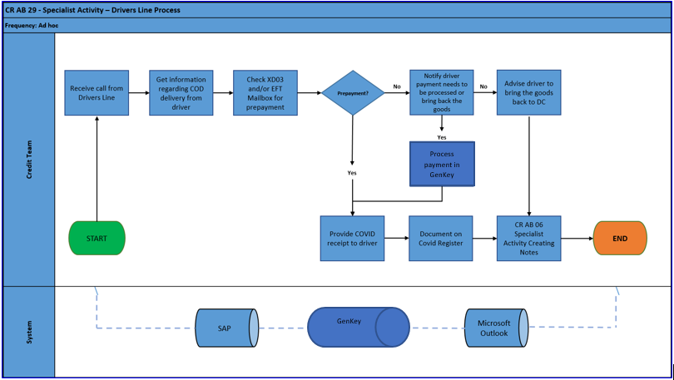

# 3. Process Steps

To proceed with the Driver’s Line process, the AR Administrator performs the following steps.

## 3.1 Gathering Required Details upon Receiving COD Call

Driver or Distribution dials the driver’s line 1 800 068 580 to confirm or process payment. If driver has no EPOD or is unable to process payment via EPOD, they need to call the Drivers Line to confirm if pre-payment has been made or allow Collection Specialist to process the payment via credit/debit card before leaving the goods. If there is no prepayment and customer cannot make a payment, the driver will need to bring back the goods to Distribution Centre.

Once the call is received, Collection Specialist should obtain the below details which will then be entered on their assigned COVID Register found inside the individual COVID Registry folder under the path T:\Credit -ALB\ALB COVID Receipt Register.

1. Delivery number as given by the driver
2. Account number
3. Trading name
4. Invoice amount
5. Caller’s name – should be either the Driver or Distribution Centre
6. Payment Verification – if an EFT prepayment has been made or credit card payment needs to be processed.



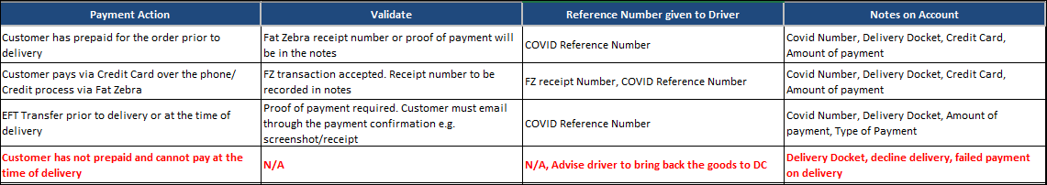

## 3.2 Payment Verification

1. After the above details are gathered, Collections Specialist should inform Driver that account will have to be reviewed and place the call on hold.
2. Collection Specialist can now start checking XD03 for notes if prepayment has been made. EFT Mailbox should also be checked for proof of payment.
3. Credit Controller is required to check FBL5N whether there is/are open invoices. If there are open overdue invoices, advice driver that payment is required to clear the balance on top of the delivery amount, unless the unpaid invoice is in dispute e.g., pending DC credit.
4. If prepayment has been made, Collection Specialist should inform the Driver or DC the COD reference number and refer to the work instruction **CR AB 06 Creating Notes**.

## 3.3 Processing Payment

1. Once confirmed that payment should be processed for the delivery, ask to speak with customer who owns the card or/is authorised to make the payment.
2. In case customer is not available and wants driver to provide the card details, Collection Specialist should obtain authorisation from customer allowing the driver to provide the card details over the phone.

### Processing Payment via GenKey

#### Initialise Application

To run the application, double click over the App icon or right click to show the context menu and click on Open.



#### Scripting for Conversations with Customer

**Please refer to step no. 4 below for “call scripting” section for detail script to be used**

Before taking payment, we need to confirm the amount of the Delivery Docket number from SAP. Follow the steps to confirm the amount:

1. From the **SAP Easy Access** scree enter **VL03N** in the command field and press **Enter**. The **Display Outbound Delivery** screen is displayed.

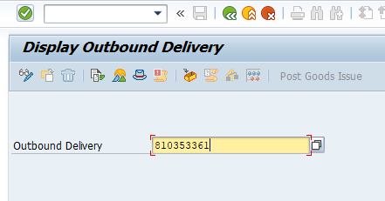

1. Complete the following field:

|  |  |
| --- | --- |
| **Field** | **Description** |
| **Outbound Delivery** | Enter the 9 digit delivery number |

1. Click  from the Application Toolbar to view the document flow.
2. Click once on the **Standard Order** line to select it.

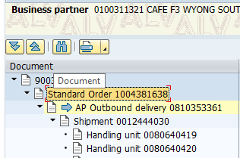

1. Click  from the Application toolbar.

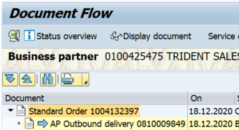

1. Select **Goto>Header>Conditions** from the Menu bar

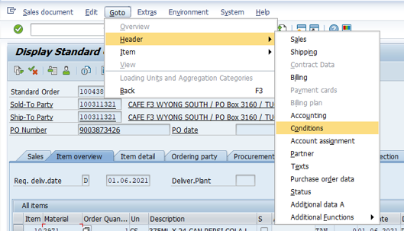

1. Scroll down to the bottom of the screen to determine total value of delivery.

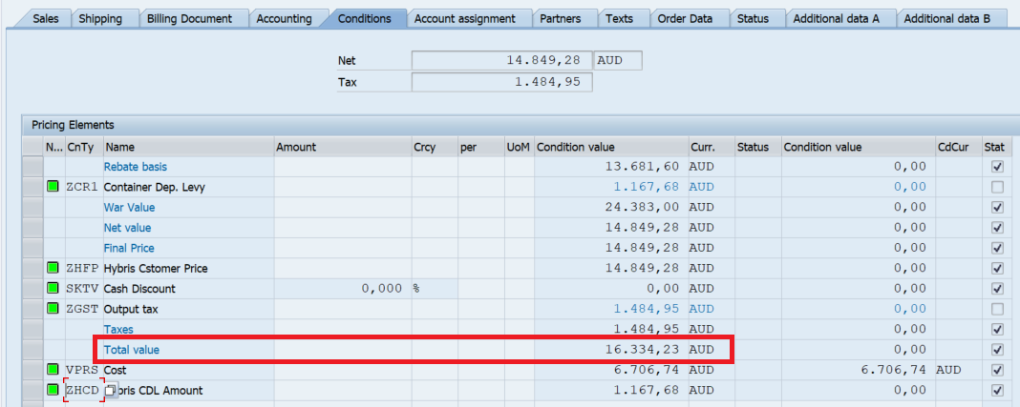

1. Review the **Total Value** condition line. This is the amount to be paid by customer for the given delivery number.
2. In the event the customer wants to make less payment due to damage of stock of short delivery, please confirm the same with Driver before processing payment for a lesser amount.

#### Initiate capturing card details in GenKey

For details of call scripting associated with this process see **4. Call Scripting** on **page 23**.

1. Request the credit card holder name and enter it on the [CC Holder] field. Confirm spelling of the name **DO NOT GUESS** as this could prevent the payment being processed.

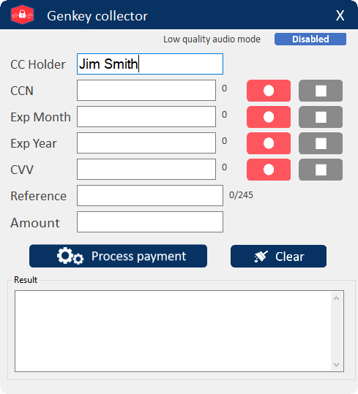

1. For the credit card number, press the  button next to the **CCN** field. After pressing, the button will turn greyed out and the  button will be enabled, the capturing process will start.

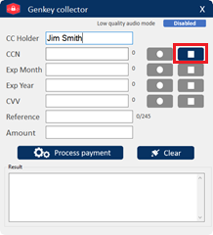



1. Request the caller to dial in the 16 digits credit card number using the phone keypad followed by the “**Hash/#**” key. When the caller pushes the “Hash/#” key, the capturing process will stop automatically and return the captured information. In case the credit card number is invalid it will show a “Invalid Credit Card” message on the field.

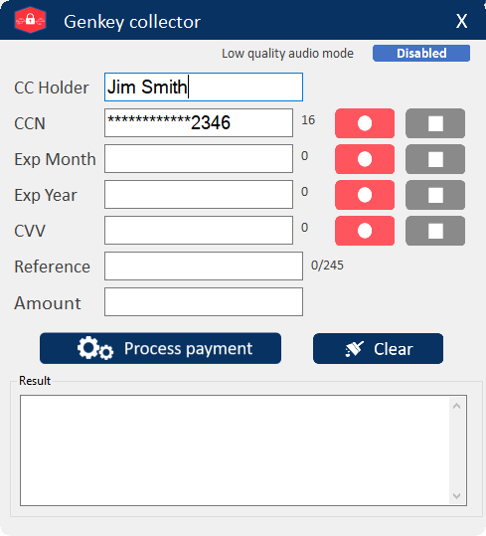 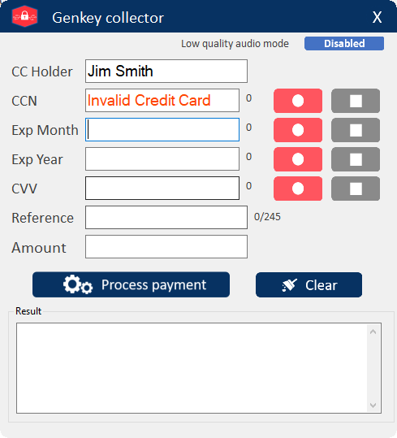

**Note:** To manually stop the capturing process, press the  button next to the **CCN** field.

1. For the expiration month, press the  button next to the **Exp Month** field. After pressing, the button will turn greyed out and the  button will be enabled, the capturing process will start.

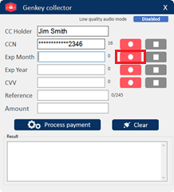 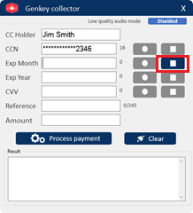

1. Request the caller to dial in the 2 digits expiration month using the phone keypad followed by the “Hash/#” key. When the caller pushes the “Hash/Pound/#” key, the capturing process will stop automatically and return the captured information. In case the expiration month is invalid it will show a “Invalid Month” message on the field.

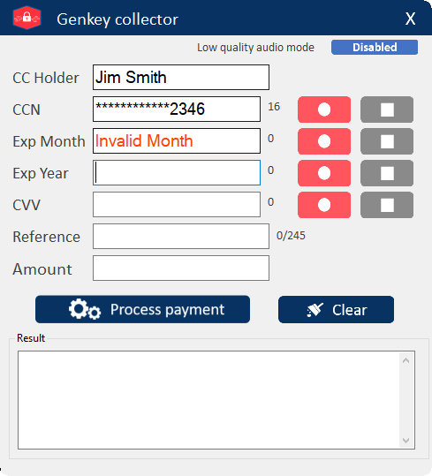

**Note**: To manually stop the capturing process, press the  button next to the **Exp Month** field.



1. For the expiration year, press the  button next to the **Exp Year** field. After pressing, the button will turn greyed out and the  button will be enabled, the capturing process will start.

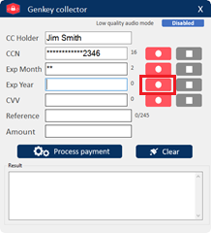 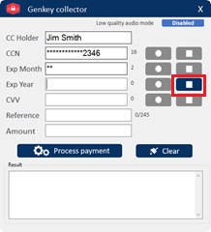

1. Request the caller to dial in the 2 digits expiration year using the phone keypad followed by the “Hash/#” key. When the caller pushes the “Hash/Pound/#” key, the capturing process will stop automatically and return the captured information. In case the expiration year is invalid it will show a “Invalid Year” message on the field.

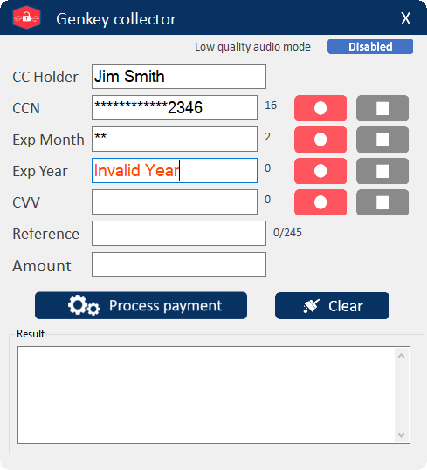

**Note**: To manually stop the capturing process, press the  button next to the **Expiry Year** field.



**Note Expiration Date additional validation**: In case the combination of the expiration month and expiration year is in the past, it will show a “Invalid Exp Date” on the last field captured.

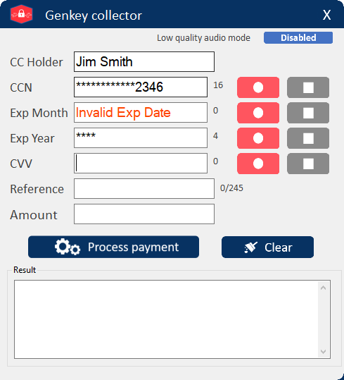 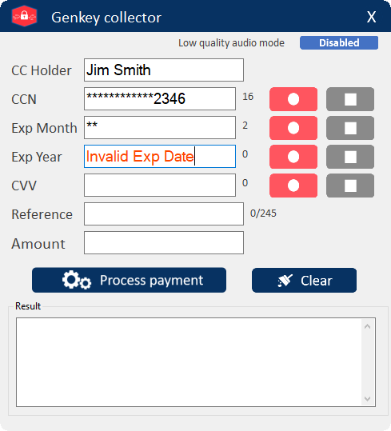

1. For the CVV, press the  button next to the **CVV** field. After pressing, the button will turn greyed out and the  button will be enabled, the capturing process will start.

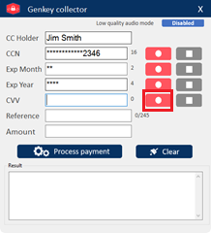 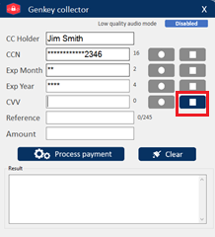

1. Request the caller to dial in the 2 digits expiration year using the phone keypad followed by the “Hash/#” key. When the caller pushes the “Hash/#” key, the capturing process will stop automatically and return the captured information. In case the expiration year is invalid it will show a “Invalid Year” message on the field.

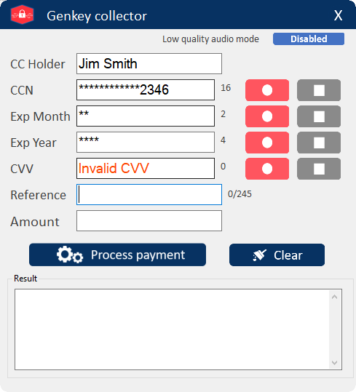

**Note**: To manually stop the capturing process, press the  button next to the **CVV** field.



1. Type in the reference number of the payment on the **Reference** field.  
   **Note**: the reference can contain uppercase and lowercase letters, numbers from 0 to 9 and the following special characters - _ ' , . ; :

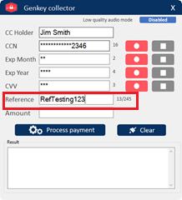

1. Request the payment amount and type it on the **Amount** field.   
   **Note:** GenKey Collector can process payments up to 100,000 AUD.

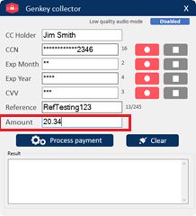

1. Once all fields are completed, say **“Just confirming that I’ll be charging you credit card for $xx.xx amount – let me process that now.”** Then click on the [**Process payment**] Button. **Note**: All fields are mandatory.

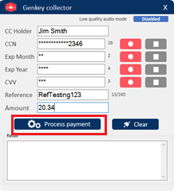

1. After completing the process, it will display the transaction results in the **Result** field. It will display ‘Approved” and authentication details where no errors were found. If error are found it will display as “Payment error” in the **Result** field and the list of errors will display.

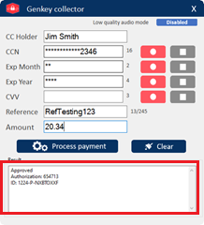 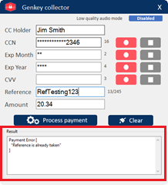

1. To Reset or clear all fields click the  button.

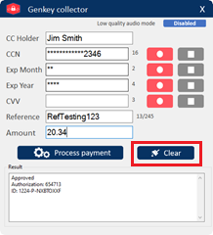 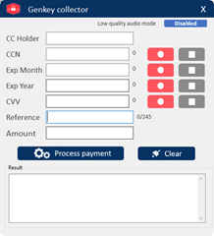

1. The operator will need to ensure that the transaction is captured in Fat Zebra. In some cases, the customer may request a receipt number. The receipt number can be obtained from Fatzebra once payment is successful.
2. If customer does not want to receive an email confirmation, Collection Specialist can provide the reference number of the payment and the COD reference number of the call. Document the COVID prepaid details on the COVID Register saved on the following path: **T:\Credit -ALB\ALB COVID Receipt Register**
3. In the event the payment is not successful due to a message which says “Acquirer Busy” as per below screenshot, please try to take the payment one more time as a second attempt. If it still gives the same message as “Acquirer Busy”, we need to look for the value of the order, if it is < $500, provide the COVID receipt number to driver and ask him to deliver with authority. If the order value is > $501, message Mary for an approval. We need to validate the customer phone number and email address and send the payment link from Fatzebra for the customer to be able to pay later. The customer needs to make the payment within 4 hours to avoid a block of the account, credit team may contact the customer within 4 hours if the payment is not made.

|  |  |
| --- | --- |
| Authority Level | Title |
| <$500 | Credit Manager |
| >$501 | Credit Services Manager |
|  |  |

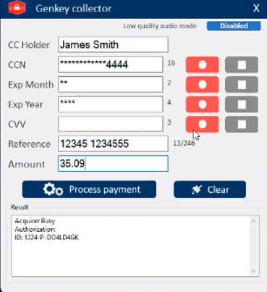

1. In the event the payment is declined, we can see the declined receipt number on FatZebra portal as per below screenshot

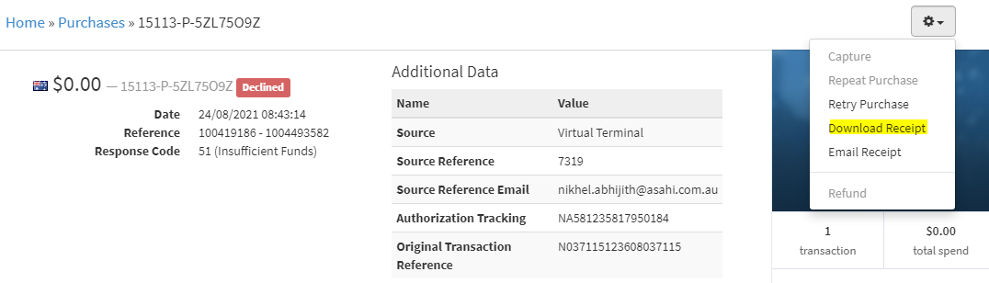

1. Click on download receipt from above option and it will download a PDF receipt copy of the declined transaction who looks like blow, the same can be shared with customer as per requirement.

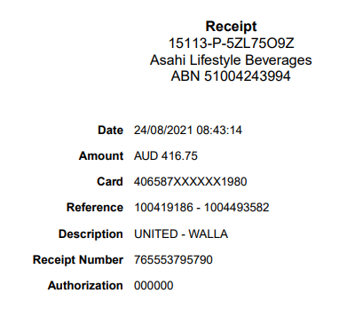

### Create Customer Interaction Notes for Payment

Refer to SOP “CR AB 06 –Specialist Activity – Creating Notes V1.0” or follow the instructions below.

1. From the **SAP Easy Access** screen enter **XD03** in the command field and press **Enter**. The **Customer Display: Initial Screen** is displayed.

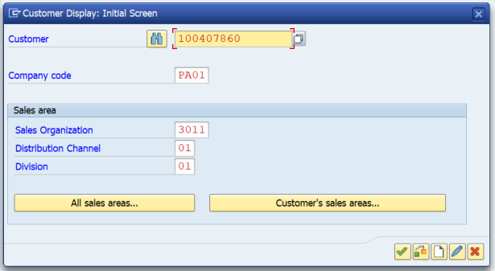

1. Complete the following fields:

| **Field** | **Description** |
| --- | --- |
| **Customer** | Enter the customer account number or use the drop down to search. |
| **Company Code** | Enter **PA01** |
| **Sales Organization** | Always enter **3011** |
| **Distribution Channel** | Always enter **01** |
| **Division** | Always enter **01** |

1. Press **Enter**. The **Display Customer: General Data** screen is displayed.

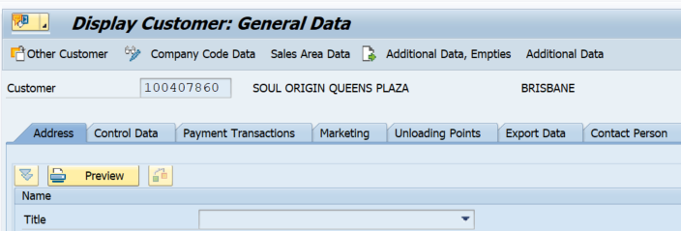

1. Click the drop down on the  button and then select **Attachment List**. The **Service: Attachment list** window is displayed.

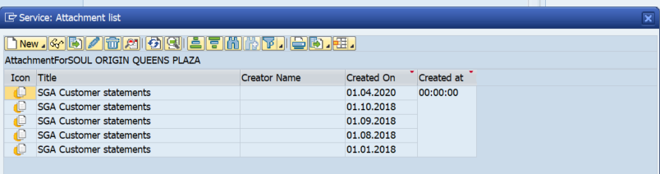

1. Click  and select **Create Note**. The **Create Note** window is displayed.

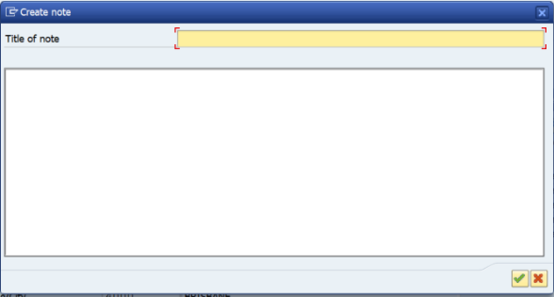

1. Complete the following fields:

| **Field** | **Description** |
| --- | --- |
| **Title of note** | Enter the the COVID number, Delivery Docket, Amount of payment. |
| **(Main body)** | Copy and paste the receipt details = Is this all the text from the Result field in GenKEy as the text below is more than what is in GenKey? |

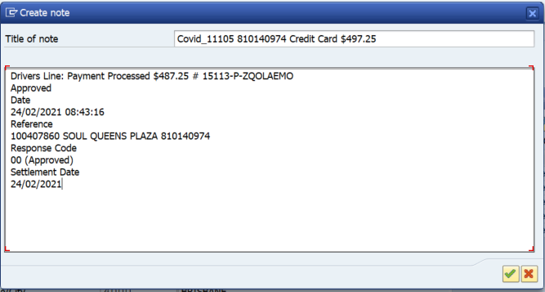

1. Click  to save the details, the **Service: Attachment** list window is redisplayed with the new entry recorded.

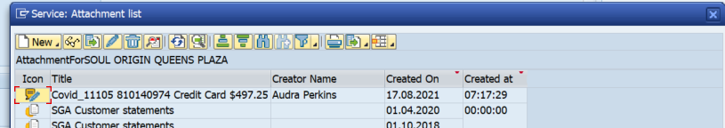

1. Click .

**Note:** For Payment Validation calls that do not involve processing payments, notes should indicate **COVID Number, Delivery Docket, Amount of payment, Type of Payment.**

Attach the remittance or proof of payment in XD03. Where do they get this? Shouldn’t we add the steps for this as well?

## 3.4 Declining COD Delivery

If customer has not prepaid and cannot make a payment at time of delivery, Collection Specialist will inform Driver or DC the following.

Reason delivery was declined.

Customer is required to pay (credit/debit card or EFT) for the delivery to pursue.

* If customer cannot pay, Driver should return goods to the warehouse.

The Customer Specialist should update the below columns on COVID Register:



Once updated then add the relevant notes to the customer record in SAP.

### Create Customer Interaction Notes for Non Delivery

1. From the **SAP Easy Access** screen enter **XD03** in the command field and press **Enter**. The **Customer Display: Initial Screen** screen is displayed.



1. Complete the following fields:

| **Field** | **Description** |
| --- | --- |
| **Customer** | Enter the customer account number or use the drop down to search. |
| **Company Code** | Enter **PA01** |
| **Sales Organization** | Always enter **3011** |
| **Distribution Channel** | Always enter **01** |
| **Division** | Always enter **01** |

1. Press **Enter**. The **Display Customer: General Data** screen is displayed.



1. Click the drop down on the  button and then select **Attachment List**. The **Service: Attachment list** window is displayed.



1. Click  and select **Create Note**. The **Create Note** window is displayed.



#### Document Notes where Delivery has not been made

1. Complete the following fields:

| **Field** | **Description** |
| --- | --- |
| **Title of note** | Enter the the Drivers Line – Denied Delivery and reason, for example, Drivers Line: Denied Delivery No Payment Sighted. |
| **(Main body)** | Enter the reason and the delivery docket number – what else is all this -and where is it from? |

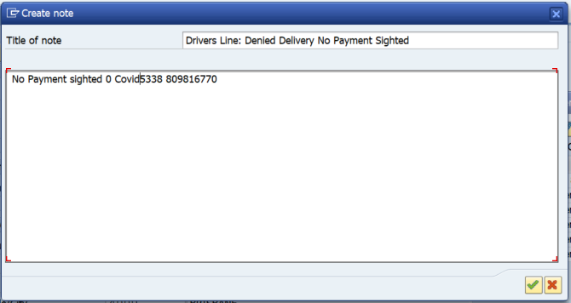

1. Click  to save the details, the **Service: Attachment** list window is redisplayed with the new entry recorded.

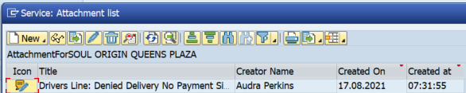

1. Click .

This completes the procedure.

# 4. Call Scripting

Please use the following scripting when managing the customer calls:

| **Scenario** | **Response** |
| --- | --- |
| Opening Script | **Agent:** Welcome to Asahi Lifestyle Beverages, the home of Schweppes, this is ….…. how may I help you?  **Hint**: The caller may be the customer or the driver  **Agent:** Am I speaking with the Driver or the customer?  **Hint**: If the customer is on the phone please ask them to pass the phone to the driver  **Agent**: Ask the Driver to confirm the delivery number and the amount  **Hint**: Remember to validate the details in SAP VL03N  **Hint**: Remember to record the person’s name you are talking to. |
| Initiating the card capture | **Agent:** To Driver: please can you pass the phone over to the customer or credit card holder  **Agent**: To customer: Hello, Before we proceed with the payment, I would like to inform you that we only accept VISA or Mastercard payments. As per the new system you are now able to enter the card details from your phone key pad and I will guid you through the steps.  Can you please confirm the amount you are paying today?  Can I please take the name of the card holder?  **Hint**: If agent is not sure about how the name is spelt, they should always check. the payment might get rejected if incorrect. Ensure that the Card holders name is confirmed, with spelling. **Do not guess**.  **If the customer starts to say their card number:**  **Agent:** I am sorry to interrupt you, but as per the new systems I will need you to key the credit card number into your phone keypad when prompted. I will step you through the process is this ok? |
| Capturing the card information | **Agent:** Please enter your 16-digit credit card number, followed by the hash Key  **Hint**: Once the card number is captured, confirm with the caller  **Agent:** Please confirm the last 4 digits of the credit card, to ensure that the system captured it correctly  **Hint**: If the entry result is incorrect  **Agent:** It looks like the system did not capture the number fully, could you please re-enter the 16-digit credit card number followed by the hash key.  **Hint:** If the entry is valid – continue  **Agent:** Please enter the 2-digit expiry month followed by the hash key  **Hint:** If the entry result is incorrect  **Agent:** It looks like the system did not capture the number fully, could you please re-enter 2-digit expiry month followed by the hash key.  **Hint:** If the entry is valid – continue  **Agent:** Please enter the 4-digit expiry year followed by the hash key  **Hint:** If the entry result is incorrect  **Agent:** It looks like the system did not capture the number fully, could you please re-enter 4-digit expiry year followed by the hash key.  **Hint:** If the entry is valid – continue  **Agent:** Please enter the 3-digit CVV number followed by the hash key*. The CVV number can be found on the back of the card*  **Hint:** If the entry result is incorrect  **Agent:** It looks like the system did not capture the number fully, could you please re-enter 3-digit CVV number followed by the hash key.  **Hint:** If the entry is valid – continue |
| Validating the payment:  Successful | **Agent:** The payment was successful – thankyou. Your receipt number is.... (quote 6 digit receipt number receipt number on Fat Zebra) |
| Validating the payment:  Invalid Funds | **Agent:** The payment did not go through – would you like to try again?  **After another attempt**  **Agent:** *The payment did not go through, would you like to try with an alternative card?* |
| Validating the payment:  Declined | **Agent:** I am sorry but the payment has been declined, would you like to try again?  **After another attempt**  **Agent:** *The payment did not go through, would you like to try with an alternative card?* |
| Validating the payment:  Expired | **Agent:** The payment did not go through – would you like to try again? |
| Validating the payment:  Acquirer busy | **Agent:** Sorrythere appears to be an issue at our end – please can you try entering the card again (*run through the whole payment from* *scratch*). If it is still not successful ask the customer if you can call them back and let the driver know to leave the goods. This should be clearly marked in the Covid Drivers line tracker. **NOTE**: this step should only be done if the Acquirer Busy message appears on the second attempt and for no other reason. |
| Communication to Driver for successful payment | After successful payment please ask customer to hand the phone back to driver, give the COVID receipt number (from COVID summary file) to driver and confirm them to deliver the stock basis payment confirmation. |
| Communication to Driver for unsuccessful payment | In case of a declined or unsuccessful payment, please ask the driver to not deliver the stock, this must be recorded on the COVID register file. |

# 5. Trouble Shooting

| **If** | **Then** |
| --- | --- |
| NA | NA |

# 6. Controls

| **Control** | **Activity** |
| --- | --- |
| NA | NA |

# 7. Process Summary and Wrap Up

Once the AR Administrator completes all the steps in this SOP, they would be able to process the driver’s line calls.

## Checklist

You should have now completed the following

| **Activity** | **Complete?** |
| --- | --- |
| Received call from Driver’s line |  |
| Got information regarding the COD delivery from driver |  |
| Checked XD03 and/or EFT mailbox for prepayment |  |
| If yes, provided COVID receipt to driver |  |
| Documented on COVID Register |  |
| Created customer interaction notes |  |
| If not, notified the driver the payment needs to be processed to bring back the goods |  |
| Advised the driver to bring the goods back to DC |  |
| Processed the payment in FAT Zebra |  |

# 8. Supporting Documentation

The following are other learning artifacts that support this process

| **Document** | **Description** | **Link** |
| --- | --- | --- |
| NA | NA | NA |

# 9. Additional Information

## Escalation Matrix

| **Name** | **Designation** | **Escalation level** | **Email Id** |
| --- | --- | --- | --- |
| Roghan Anderson | SBS Finance Ops Manager | Level 5 | Roghan.anderson@asahi.com.au |
| Mary Petreski | Credit Manager | Level 4 | Mary.Petreski@asahi.com.au |
| Mohan Chandra Sahu | Offshore - Manager | Level 3 | Chandra.MohanSahu@asahi.com.au |
| Archit Bhasin | Offshore Team Lead | Level 2 | Archit.Bhasin@asahi.com.au |

## Competencies for the Task

| **Knowledge** | **Skills** |
| --- | --- |
| Credit Collection experience | Attention to detail |