MINI PROJECT REPORT
(Project Term Aug-Dec, 2016)

BIT CALCULATOR

Submitted by

NAME OF STUDENT ROLL NUMBER

SHIV RATAN GUPTA B33
NISHA DHAKA B47
GYAN PRAKASH PANDEY B45

SECTION GROUP

K1527 B

Course Code: INT-213

Under the Guidance of
(Miss Deepika, Assistant Professor)

School of Computer Science and Engineering



DECLARATION
I hereby declare that the mini project work entitled “Bit Calculator” is an authentic record of my own work carried out in B.Tech degree in Computer Science and Engineering from Lovely Professional University, Phagwara, under the guidance of Miss Deepika January to May 2016. All the information furnished in this mini project report is based on my own intensive work and is genuine.

Name of Student: Shiv Ratan Gupta, Nisha Dhaka, Gyan Prakash Pandey
Section: K1527
Registration Number: 11505183, 11509317,
Roll Number: B33, B47, B45

CERTIFICATE

This is to certify that the declaration statement made by the student is correct to the best of my knowledge and belief. He have completed this Mini Project under my guidance and supervision. The present work is the result of his/her original investigation, effort and study. No part of the work has ever been submitted for any other degree at any University. The Mini Project is fit for the submission and partial fulfillment of the conditions for the award of B.Tech degree in Computer Science and Engineering from Lovely Professional University, Phagwara.

Miss Deepika

Assistant Professor

School of Computer Science and Engineering,
Lovely Professional University,
Phagwara, Punjab.

Date : 04-11-2016

ACKNOWLEDGEMENT

I take this opportunity to present my votes of thanks to all those guidepost who really acted as lightening pillars to enlighten my way throughout this project that has led to successful and satisfactory completion of this study.

I am really grateful to Deepika mam for providing me with an opportunity to undertake this project and providing me with all the facilities. I am highly thankful to mam for her active support, valuable time and advice, whole-hearted guidance, sincere cooperation and pains-taking involvement during the study and in completing the assignment of preparing the said project within the time stipulated.

Lastly, I am thankful to all those, particularly the various friends , who have been instrumental in creating proper, healthy and conductive environment and including new and fresh innovative ideas for me during the project, without their help, it would have been extremely difficult for me to prepare the project in a time bound framework.

INDEX

Declaration…………………………………………………………………………… i
Certificate…………………………………………………………………………….. ii
Acknowledgement …………………………………………………………………… iii
1. Introduction of the Project………………………………………………………… 1
2. Problem Statement…………………………………………………………………. 2
3. Feasibility Analysis of the Project…………………………………………………. 3
4. Requirements of Project……………………………………………………………. 4
5. Flowcharts…………………………………………………………………………... 5
6. Current Status of the project………………………………………………………... 6
7. Limitations of the Project (If any)………………………………………………….. 7
8. Bibliography………………………………………………………………………… 8

Introduction of the project

This project is not a personal project this is a group project. We are creating GUI interface to perform bitwise operations AND,OR,NOT,XOR operation on two decimal numbers .This programme also consist of explanation button which show the user explanation of the programme. And this programme is written in python programming language this is helps us to calculate any bitwise operation. In this programme two tkinter window are there first window show the result and second window is showing the explanation of the result.

PROBLEM STATEMENT

The first step involved creating a sustainable class with all the necessary variables included to store the data which was to be entered by the user. After entering user input we are created some buttons when we click to the button the operations are perform. Most problem in this project we have faces how to store the data, and how to retrieve the data in tkinter window. And we also face the problem of functions.

FEASIBILITY ANALYSIS OF THE PROGRAM

This programme is accurately calculate the bitwise operation like AND, NOT, OR, XOR. This programme is take user input and convert this input in binary number this programme is also show the result in binary. And this programme have a explanation button which show the explanation of the programme.

FLOW CHARTS
CHOICE

NUMBER1
NUMBER2
OPERATION

RESULT

EXPLAINATION

Requirements of project

This project is very important for logical purpose. This programme is help us to calculate any bitwise operation. This programme is also use for computer design and this is programme is used in computer manufacturing in the large scale

GANTT CHART

Week 1 Week 2 Week 3 Week 4 Week 5 Week6 Week7 Week8

GUI
Design

Python
Programming

Bug Fixing

Tkinter window
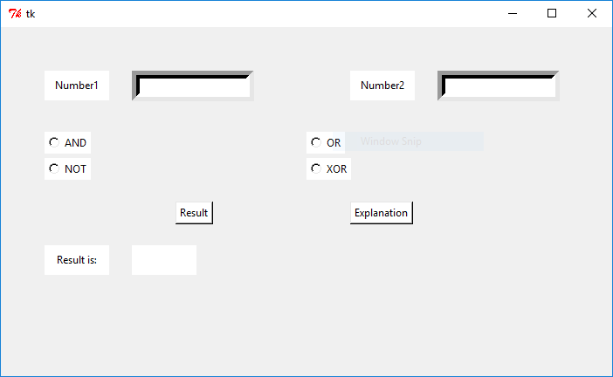

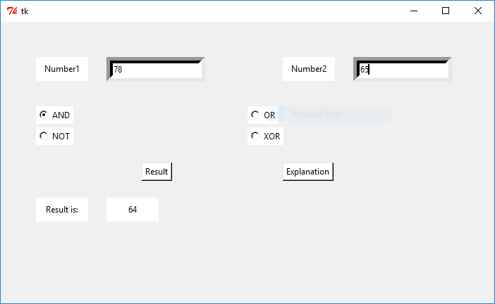

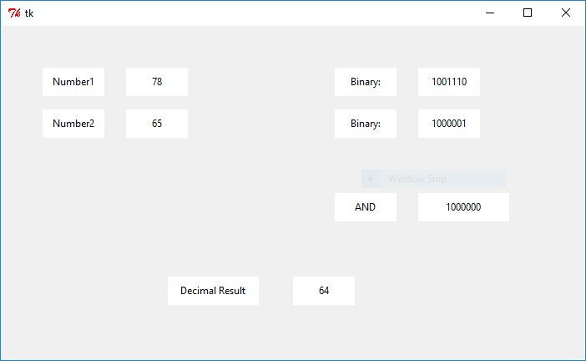

Bibliography

1.www.tutorialpoint.com

2.www.coursera.org

