 **RESUME** 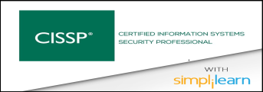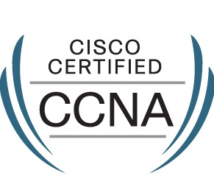 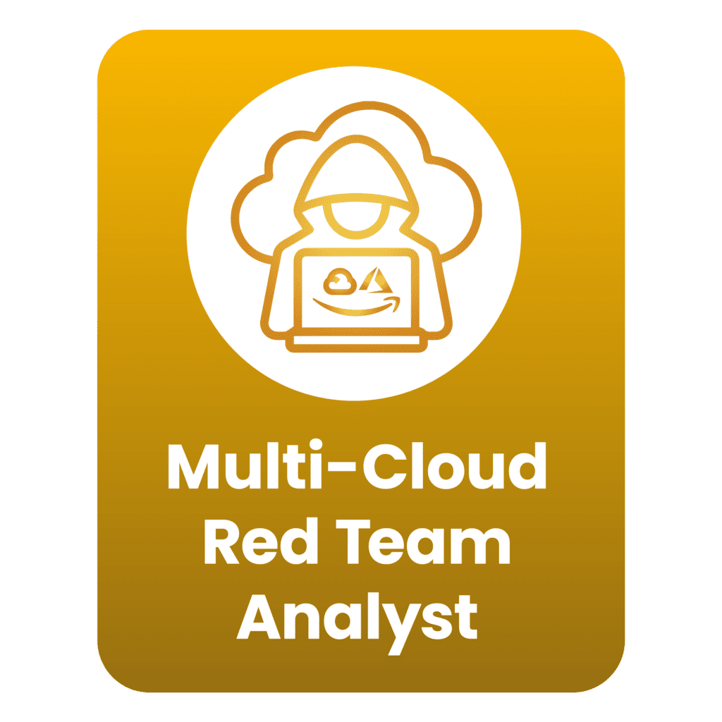 

SHIVSHANKAR R. PATRA

**Contact: +91-9768754019 E-Mail:** [**shiv.r.patra@gmail.com**](mailto:shiv.r.patra@gmail.com)

|  |
| --- |
| **JOB OBJECTIVE** |

Seeking middle level assignments in IT networking operations in IT sector.

Location Preference: Mumbai, Pune.

|  |
| --- |
| **PROFILE SUMMARY** |

* A dynamic professional with nearly 8.0 years of experience in IT Security & Cyber Security.
* Currently associated with **MCX-Multi Commodity Exchange of India LTD**, Mumbai in IT A Manager – IT Security.

|  |
| --- |
| **TECHNICAL SKILLS** |

|  |  |
| --- | --- |
| * Vulnerability / Network Tool | * Nessus Tenable-SC, Wireshark, Burp Suite, Kali Linux, Metasploit, Caldera, Thick Client, Red Team operation * Internal Audit & External Audit. |
| * Security Devices | * Cyber Ark, Bluecoat Proxy ASG-400, F5 WAF, Aruba Controller 7030, Aruba NAC, Google Cloud Security, Intrusion detection System (IDS), Intrusion Prevention Systems (IPS), Trend Micro. |
| * Network Devices | * Cisco router, Cisco Switch, juniper Switch, Aruba Switch. |
| * Monitoring Devices | * SIEM tool (DNIF), Dark trace V3.0.5, Smokescreen tool, FireEye (threat detection), shadow map. |
| * Firewalls | * Checkpoint R81.20 (12600, 12400), Fortigate OSv5 (1240B,1200D,2500E), Cisco ASA 5530 |
| * Cloud | * GCP, Azure, |

|  |
| --- |
| **ORGANISATIONAL EXPERIENCE** |

**July -2023 – Till date : MCX- Multi Commodity Exchange of India LTD.**

Designation : **Information Security (IT- Assistant Manager)**

**Responsibilities**

**As Security Team**

* Train and manage the team of consultants to perform application penetration testing, vulnerability assessments for thick client – base application, source code reviews, and configuration reviews.
* Propose, plan, & execute Red Team operations based on threats to organization.
* Exploiting bugs and weaknesses in the target s infrastructure. This highlights gaps in the organization technical security that require fixing, thus improving its security posture.
* Cloud Application & infrastructure Security testing like as Google & Azure Cloud.
* Hands-on experience with commercial and open-source tools e.g., Burp suite Professional, Metasploit and Kali Linux.
* Experience with Network Architecture Review and Firewall Rule-base Audit.
* Strong understanding of OWASP top 10 and SANS top 25 programming errors.
* Threat Hunting, attack identification, investigation, correlation and suggesting mitigation measures.
* Experience on Vulnerability Assessment and Penetration Testing for Infrastructure / network / web application / databases.
* All network devices such as Routers, Switches, Firewall, Wi-Fi Devices (Aruba), and VC devices of performed Security testing on quarterly.
* Help our clients to secure their Public Cloud environment by implementing new concepts, techniques, and best practices to maintain a secure and compliant end-to-end cloud ecosystem.
* Perform penetration testing of various thick client software, web applications, and communications infrastructure to assist in hardening the cybersecurity posture against malicious actors.
* Cyber Security Including such as ISO27001, PCI-DSS, Business continuity plan (BCP) and Business continuity incident (BCI).
* Perform and Report Application audits, Vulnerability Assessments/Penetration testing for IT infrastructure including network devices, operating systems, Databases, applications, etc.

**Projects: -**

* Red Teaming
* Tenable SC+
* CTEM (Continuous Threat Exposure Management)
* Secure Code Review
* Secure network Architecture (SNA)
* Threat Assessment
* DevSecOps

**August -2021 – July-2023 : Mahindra & Mahindra Finance Services Ltd.**

Designation : **Information Security Administrator (IT- Manager)**

**Client Site: Mahindra & Mahindra Finance Services Ltd**

**April -2017 – August-21 : Karvy InfoTech Ltd (Formerly Known as HCL**

**Services Limited**

**Qseap InfoTech PVT LTD**

**EQUUS India PVTLTD**

Designation : **Network Security Administrator**

**Responsibilities**

**As Security Team**

* Hand - on Experience on, Checkpoint Firewall, F5 WAF, Anti-Apt, Aruba NAC, Fortigate Firewall, Cyber Ark, Forcepoint DLP and Zscaler proxy solution.
* On-boarding of new application in F5 WAF, packet Broker and handle critical issue for same
* Schedule and implement IPSEC VPN.
* Hand - on Experience on, routing concepts & protocol – EX-subnetting and OSPF, EIGRP and BGP.
* Prepare and review of firewall rule and existing policy.
* Managed the operational activities for designed implementation and maintain support.
* Deployment and configuration of cloud services (GCP, Azure) ensuring high availability, performance, and security.

**Projects: -**

* WAF & Reverse Proxy – F5
* SIEM (DNIF)
* Proxy server – Bluecoat, Zscaler
* Cyber Ark (PIM/ PAM)
* DLP (Symantec)
* DC migration
* Application Migration to Google Cloud
* DR Drill
* IPv6 – Public traffic

**September -2015 to April-2017 : Wipro InfoTech, Mumbai**

Designation : Network Engineer

Franchisee: HSB InfoTech PVT LTD

**March -2014 – January -2015 : Wipro InfoTech, Mumbai (UCO Bank Client)**

Designation : Network Operation Engineer

Franchisee: ACE Computer & Services

**Responsibilities:**

* Working on Reliance 4G project network Implementation, Deployment & maintenance of IP/MPLS network & basic knowledge of LTE, FTTX & Wi-Fi base architecture.
* Implementing network security policies and procedures
* Hand - on Experience on, Checkpoint Firewall, Cisco ASA Firewall and FortiGate Firewall.
* Experience with implementing and maintaining encryption techniques and standards (3DES, PKI, MD5, SSH, SSL), in a client and site-to-site configuration.
* Experience in administrating authentication controls (Radius, RSA/Secure ID and TACACS+) in the enterprise.
* Root cause analysis of network failures in terms of protocol & hardware in Core network comprising of Cisco & Juniper.
* Diagnose and resolve IP MPLS/DCN network issues and troubleshooting issues related to the routing protocol like MPLS, BGP& IS-IS on ASR9K, ASR901, ASR903, ASR920 router & Switch.

|  |
| --- |
| **EDUCATION QUALIFICATION** |

|  |  |  |  |
| --- | --- | --- | --- |
| QUALIFICATION | YEAR | BOARD | PERCENTAGE |
| B.COM | 2013 | MUMBAI UNIVERSITY | 62.00 |
| H.S.C | 2010 | MAHARASHTRA | 70.00 |
| S.S.C. | 2008 | MAHARASHTRA | 70.30 |

|  |
| --- |
| **PROFESSIONAL CERTIFICATIONS** |

* Cisco Certified Network Associate (CCNA) from Prometric Centre, Mumbai.
* Diploma in hardware and Networking from, Mumbai.
* ITIL (Information Technology Infrastructure Library) Training from Wipro InfoTech.
* CISSP Completed in simplilearn.

**PERSONAL INFORMATION**

Nationality : Indian

Date of Birth : 6th January 1993

Marital Status : Married

Language Knows : English, Hindi, Marathi, and Oriya.

Place: Mumbai

Date: (SHIVSHANKAR PATRA)