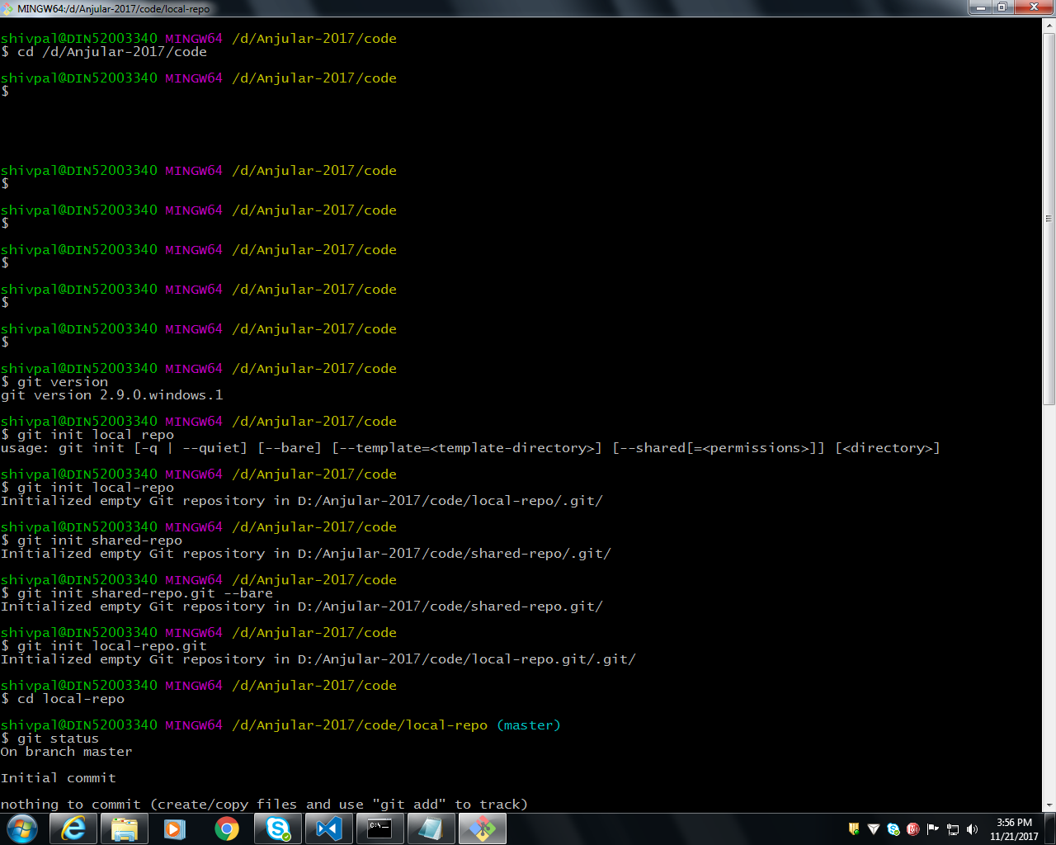

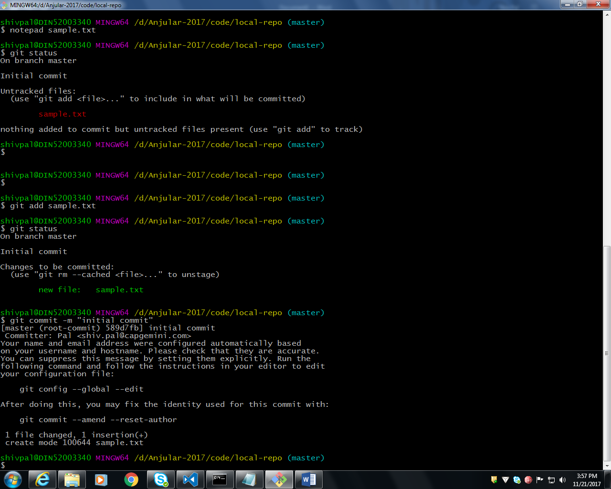

Local Repo

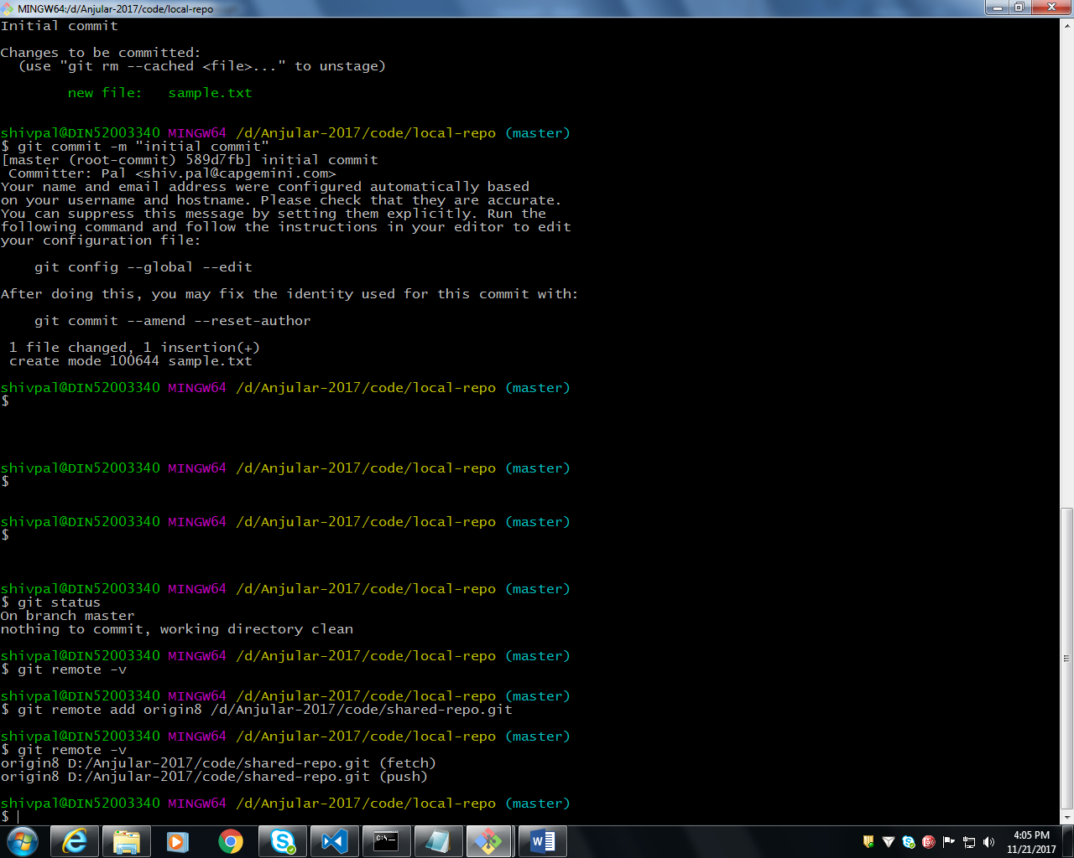

Remote Repo

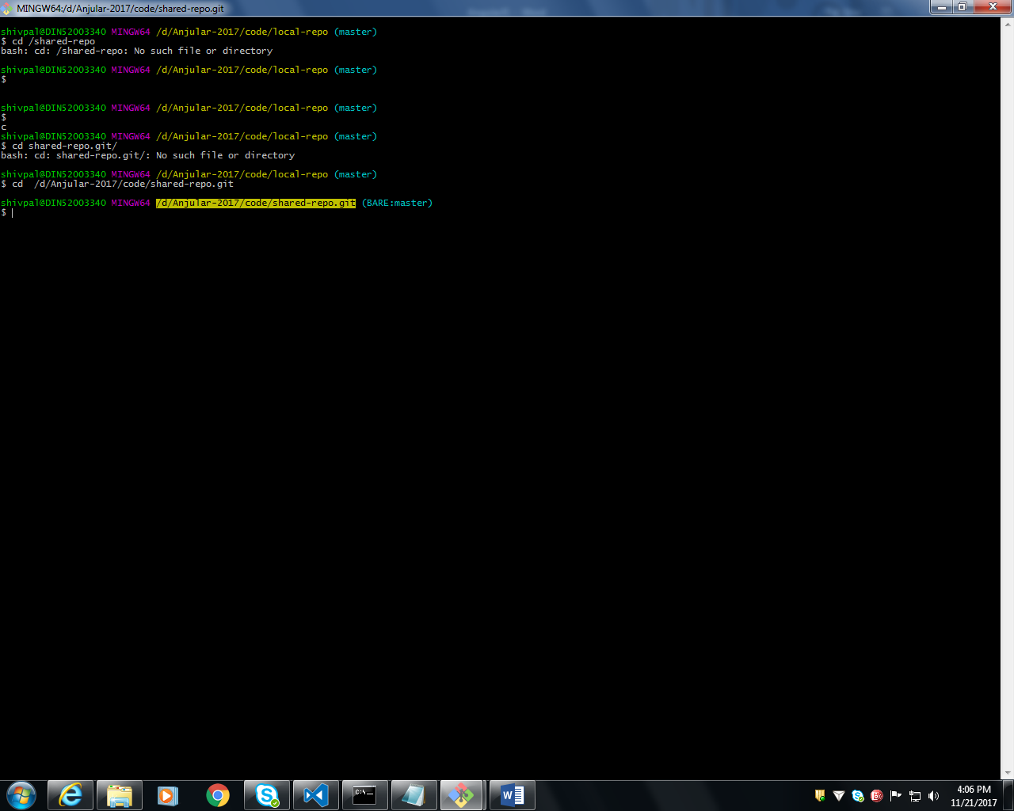

Local Repo Push New Branch with alias name: origin8

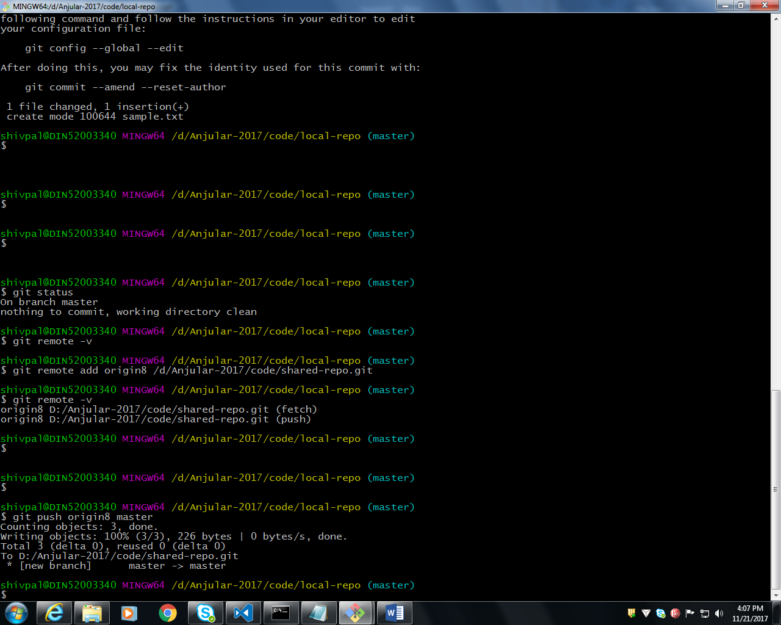

ng2-fundamentals.git

 git remote add origin https://github.com/shivsagarpal/ng2-fundamentals.git

Date: 23/11/2017

\\DIN56003454\ADM Tools\docs\For Angular