$$K_{D}= .19$$
$$K_{D}= .131$$

$$K_{D}= .09$$
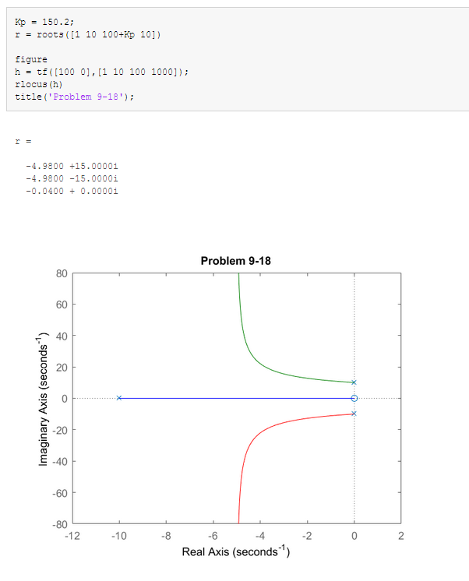

kp <= 4.97
Adding Kd does not really help. As shown, in order to get a similar overshoot and rise time (higher frequency), the Kd is very small.

Kd = 11700/2, Kp = 11700, Ki = 100

