Sampling frequency=5000, sampling time=0.002

1. For input frequency =100Hz

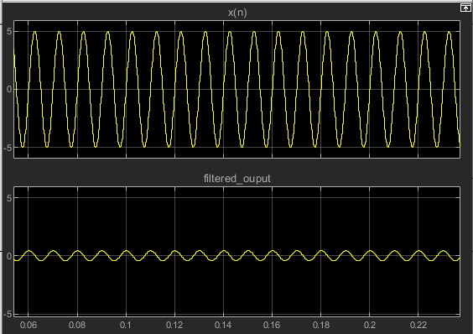

2. For input frequency = 1kHz

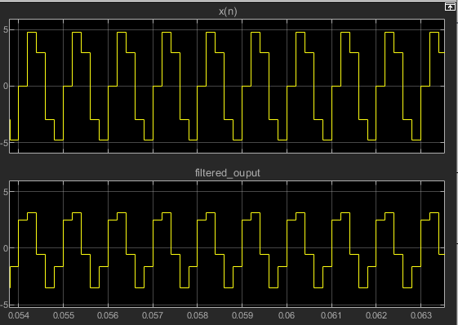

3. For input frequency = 2.5kHz

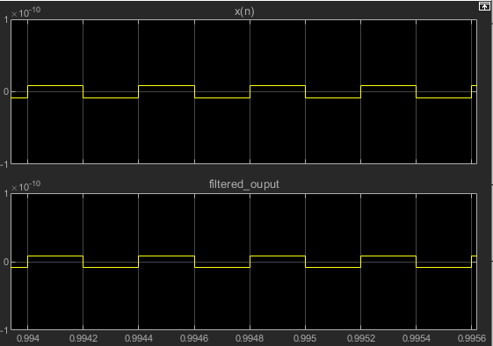

4. For input frequency = 5kHz

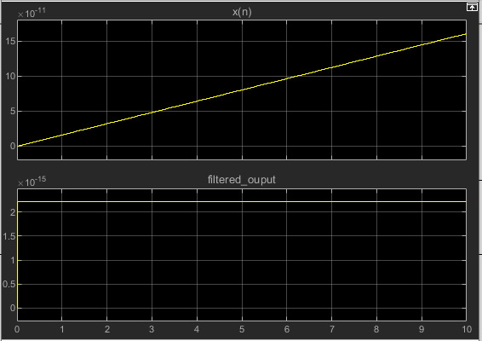

5. For input frequency = 10kHz

