1. Initial condition in Integrator is 0

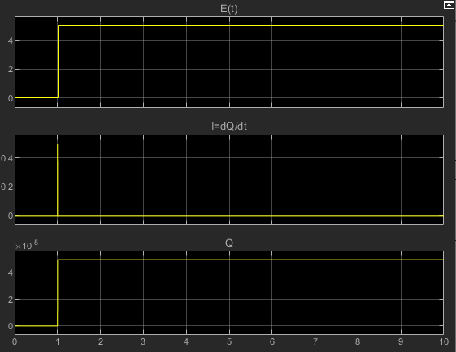

2. Initial condition in Integrator is 10e-4

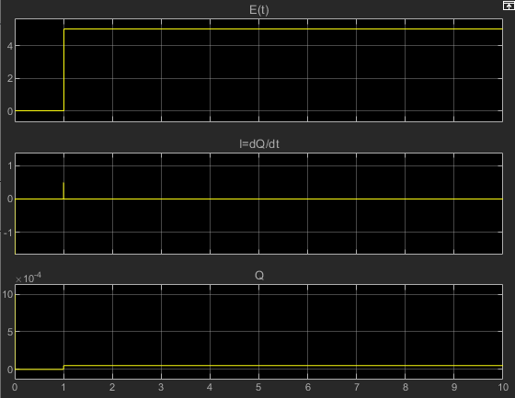

3. Initial condition in Integrator is 1

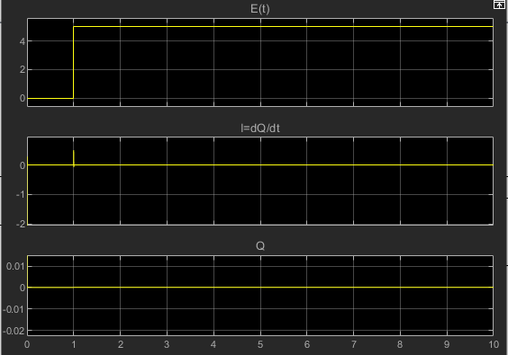

4. Initial condition in Integrator is 10e-5

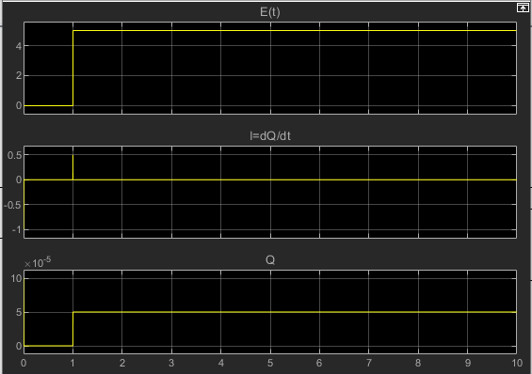

5. Initial condition in Integrator is 0.1

