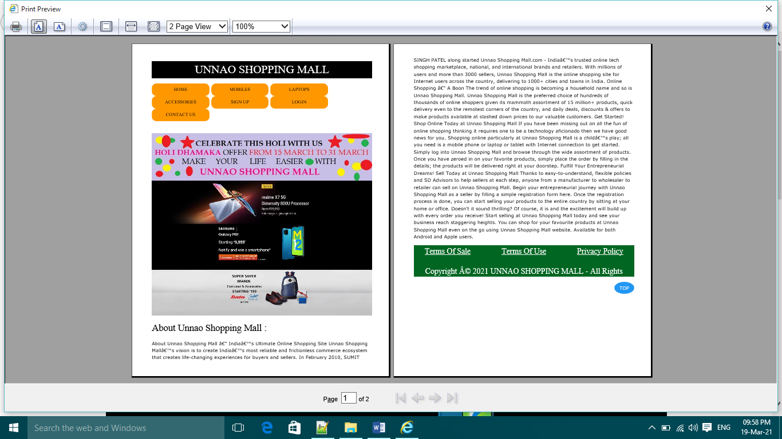

<!DOCTYPE html>

<html>

<head>

<title> Unnao Shopping Mall </title>

<link rel="stylesheet" type="text/css" href="w3css/w3.css">

<link rel="stylesheet" type="text/css" href="css/main.css">

</head>

<body>

<h1 class="w3-panel w3-center w3-black w3-serif" id="top"> UNNAO SHOPPING MALL </h1>

<DIV> <a href="index.html" class="w3-button w3-orange w3-hover-blue w3-serif"> HOME </a> <a href="mobile.html" class="w3-button w3-orange w3-hover-blue w3-serif"> MOBILES </a> <a href="laptop.html" class="w3-button w3-orange w3-hover-blue w3-serif"> LAPTOPS </a> <a href="accessories.html" class="w3-button w3-orange w3-hover-blue w3-serif"> ACCESSORIES </a > <a href="registration.html" class="w3-button w3-orange w3-hover-blue w3-serif"> SIGN UP </a> <a href="login.html" class="w3-button w3-orange w3-hover-blue w3-serif"> LOGIN </a> <a href="contact.html" class="w3-button w3-orange w3-hover-blue w3-serif"> CONTACT US </a> </DIV> <br>

<div class="w3-content w3-section" > <img class="mySlides" src="images/img1.jpg" style="width:100%"> <img class="mySlides" src="images/img2.jpg" style="width:100%"> <img class="mySlides" src="images/img3.jpg" style="width:100%"> <img class="mySlides" src="images/img4.jpg" style="width:100%"> </div>

<script>

var myIndex = 0;

carousel();

function carousel() {

var i;

var x = document.getElementsByClassName("mySlides");

for (i = 0; i < x.length; i++) {

x[i].style.display = "none";

}

myIndex++;

if (myIndex > x.length) {myIndex = 1}

x[myIndex-1].style.display = "block";

setTimeout(carousel, 1500); // Change image every 2 seconds

}

</script>

<h2 class="w3-serif"> About Unnao Shopping Mall : </h2>

<p>About Unnao Shopping Mall – India’s Ultimate Online Shopping Site Unnao Shopping Mall’s vision is to create India’s most reliable and frictionless commerce ecosystem that creates life-changing experiences for buyers and sellers. In February 2010, SUMIT SINGH PATEL along started Unnao Shopping Mall.com - India’s trusted online tech shopping marketplace, national, and international brands and retailers. With millions of users and more than 3000 sellers, Unnao Shopping Mall is the online shopping site for Internet users across the country, delivering to 1000+ cities and towns in India. Online Shopping – A Boon The trend of online shopping is becoming a household name and so is Unnao Shopping Mall. Unnao Shopping Mall is the preferred choice of hundreds of thousands of online shoppers given its mammoth assortment of 15 million+ products, quick delivery even to the remotest corners of the country, and daily deals, discounts & offers to make products available at slashed down prices to our valuable customers. Get Started! Shop Online Today at Unnao Shopping Mall If you have been missing out on all the fun of online shopping thinking it requires one to be a technology aficionado then we have good news for you. Shopping online particularly at Unnao Shopping Mall is a child’s play; all you need is a mobile phone or laptop or tablet with Internet connection to get started. Simply log into Unnao Shopping Mall and browse through the wide assortment of products. Once you have zeroed in on your favorite products, simply place the order by filling in the details; the products will be delivered right at your doorstep. Fulfill Your Entrepreneurial Dreams! Sell Today at Unnao Shopping Mall Thanks to easy-to-understand, flexible policies and SD Advisors to help sellers at each step, anyone from a manufacturer to wholesaler to retailer can sell on Unnao Shopping Mall. Begin your entrepreneurial journey with Unnao Shopping Mall as a seller by filling a simple registration form here. Once the registration process is done, you can start selling your products to the entire country by sitting at your home or office. Doesn't it sound thrilling? Of course, it is and the excitement will build up with every order you receive! Start selling at Unnao Shopping Mall today and see your business reach staggering heights. You can shop for your favourite products at Unnao Shopping Mall even on the go using Unnao Shopping Mall website. Available for both Android and Apple users.</p>

<div class=" w3-panel w3-serif" style="background-color:#006622;height: 100px;font-size: 25px; color: white;"><center><a href="termsofsale.html" class="w3-left"> Terms Of Sale </a><a href="termsofuse.html" >Terms Of Use</a>

<a href="privacy.html" class="w3-right"> Privacy Policy </a> </center> <P class="w3-center w3-text-white">Copyright © 2021 UNNAO SHOPPING MALL - All Rights Reserved.</P></div>

<a href="#top" class="w3-button w3-circle w3-blue w3-right"> TOP </a>

</body>

</html>

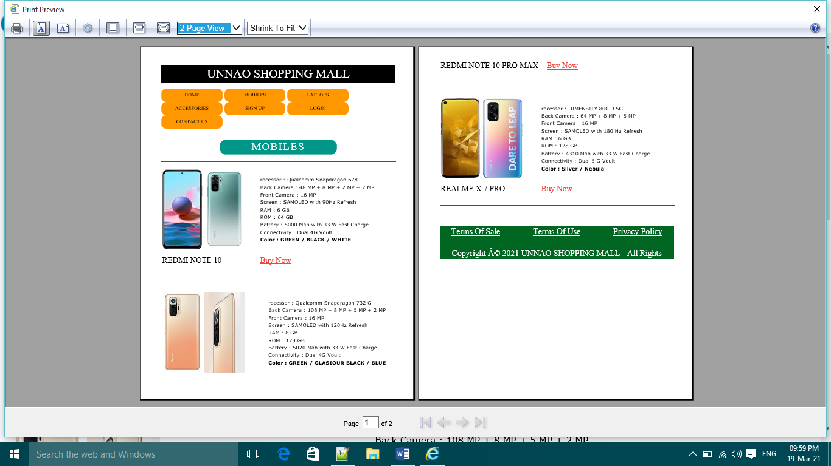

<!DOCTYPE html>

<html>

<head>

<title>Mobile</title>

<link rel="stylesheet" type="text/css" href="w3css/w3.css">

<link rel="stylesheet" type="text/css" href="css/main.css">

<style type="text/css"> td img{width:120px; height: 240px}

table{width: 100%}</style>

</head>

<body>

<h1 class="w3-panel w3-center w3-black w3-serif" id="top"> UNNAO SHOPPING MALL </h1>

<DIV> <a href="index.html" class="w3-button w3-orange w3-hover-blue w3-serif"> HOME </a> <a href="mobile.html" class="w3-button w3-orange w3-hover-blue w3-serif"> MOBILES </a> <a href="laptop.html" class="w3-button w3-orange w3-hover-blue w3-serif"> LAPTOPS </a> <a href="accessories.html" class="w3-button w3-orange w3-hover-blue w3-serif"> ACCESSORIES </a > <a href="registration.html" class="w3-button w3-orange w3-hover-blue w3-serif"> SIGN UP </a> <a href="login.html" class="w3-button w3-orange w3-hover-blue w3-serif"> LOGIN </a> <a href="contact.html" class="w3-button w3-orange w3-hover-blue w3-serif"> CONTACT US </a> </DIV> <br>

<center><h2 class="w-panel w3-teal w3-center w3-serif w3-wide" style="width: 50%; border-radius: 20px"> MOBILES </h2></center>

<hr width="100%">

<table> <tr> <td> <img src="images/img5.jpg"> <img src="images/img6.jpg"> </td> <td> rocessor : Qualcomm Snapdragon 678<br> Back Camera : 48 MP + 8 MP + 2 MP + 2 MP <br> Front Camera : 16 MP <br> Screen : SAMOLED with 90Hz Refresh <br> RAM : 6 GB <br> ROM : 64 GB <br> Battery : 5000 Mah with 33 W Fast Charge <br> Connectivity : Dual 4G Voult <br> <B>Color : GREEN / BLACK / WHITE </B> </td> </tr> <tr> <td class= " w3-serif w3-xlarge"> REDMI NOTE 10 </td> <TD class="w3-text-red w3-serif w3-xlarge"> <a href="payment.html"> Buy Now </a></TD> </tr> </table>

<hr width="100%"> <br>

<table> <tr> <td> <img src="images/img7.jpg"> <img src="images/img8.jpg"> </td> <td> rocessor : Qualcomm Snapdragon 732 G<br> Back Camera : 108 MP + 8 MP + 5 MP + 2 MP <br> Front Camera : 16 MP <br> Screen : SAMOLED with 120Hz Refresh <br> RAM : 8 GB <br> ROM : 128 GB <br> Battery : 5020 Mah with 33 W Fast Charge <br> Connectivity : Dual 4G Voult <br> <B>Color : GREEN / GLASIOUR BLACK / BLUE </B> </td> </tr> <tr> <td class= " w3-serif w3-xlarge"> REDMI NOTE 10 PRO MAX </td> <TD class="w3-text-red w3-serif w3-xlarge"> <a href="payment.html"> Buy Now </a></TD> </tr> </table>

<hr width="100%"> <br>

<table> <tr> <td> <img src="images/img9.jpg"> <img src="images/img10.jpg"> </td> <td> rocessor : DIMENSITY 800 U 5G <br> Back Camera : 64 MP + 8 MP + 5 MP <br> Front Camera : 16 MP <br> Screen : SAMOLED with 180 Hz Refresh <br> RAM : 6 GB <br> ROM : 128 GB <br> Battery : 4310 Mah with 33 W Fast Charge <br> Connectivity : Dual 5 G Voult <br> <B>Color : Silver / Nebula </B> </td> </tr> <tr> <td class= " w3-serif w3-xlarge"> REALME X 7 PRO </td> <TD class="w3-text-red w3-serif w3-xlarge"> <a href="payment.html"> Buy Now </a></TD> </tr> </table> <hr width="100%"> <br>

<div class=" w3-panel w3-serif" style="background-color:#006622;height: 100px;font-size: 25px; color: white;"><center><a href="termsofsale.html" class="w3-left"> Terms Of Sale </a><a href="termsofuse.html" >Terms Of Use</a>

<a href="privacy.html" class="w3-right"> Privacy Policy </a> </center> <P class="w3-center w3-text-white">Copyright © 2021 UNNAO SHOPPING MALL - All Rights Reserved.</P></div>

</body>

</html>

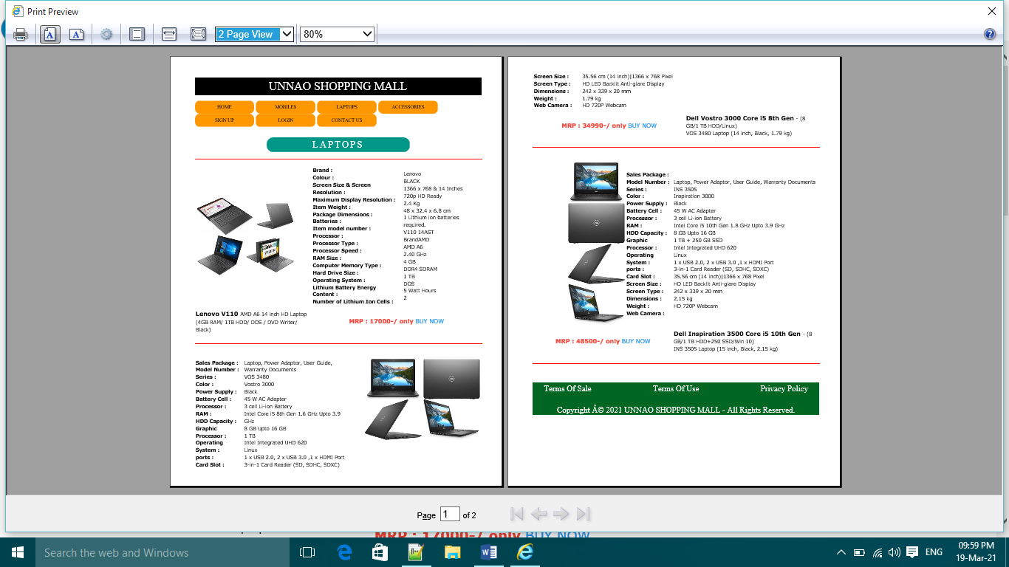

<!DOCTYPE html>

<html>

<head>

<title> Laptop </title>

<link rel="stylesheet" type="text/css" href="w3css/w3.css">

<link rel="stylesheet" type="text/css" href="css/main.css">

</head>

<body>

<h1 class="w3-panel w3-center w3-black w3-serif" id="top"> UNNAO SHOPPING MALL </h1>

<DIV> <a href="index.html" class="w3-button w3-orange w3-hover-blue w3-serif"> HOME </a> <a href="mobile.html" class="w3-button w3-orange w3-hover-blue w3-serif"> MOBILES </a> <a href="laptop.html" class="w3-button w3-orange w3-hover-blue w3-serif"> LAPTOPS </a> <a href="accessories.html" class="w3-button w3-orange w3-hover-blue w3-serif"> ACCESSORIES </a > <a href="registration.html" class="w3-button w3-orange w3-hover-blue w3-serif"> SIGN UP </a> <a href="login.html" class="w3-button w3-orange w3-hover-blue w3-serif"> LOGIN </a> <a href="contact.html" class="w3-button w3-orange w3-hover-blue w3-serif"> CONTACT US </a> </DIV> <br>

<center><h2 class="w-panel w3-teal w3-center w3-serif w3-wide" style="width: 50%; border-radius: 20px"> LAPTOPS </h2></center>

<hr width="100%">

<table> <tr><td> <img src="images/v110.jpg"> <img src="images/v1101.jpg"> <br> <img src="images/v1102.jpg"> <img src="images/v1103.jpg"> </td>

<td> <b>Brand : <br> Colour : <br>Screen Size & Screen Resolution : <br>Maximum Display Resolution : <br>Item Weight : <br>Package Dimensions : <br>Batteries : <br>Item model number : <br>Processor : <br>Processor Type : <br>Processor Speed : <br>RAM Size : <br>Computer Memory Type : <br>Hard Drive Size : <br>Operating System : <br>Lithium Battery Energy Content : <br>Number of Lithium Ion Cells : </b></td>

<td> Lenovo <br> BLACK <br> 1366 x 768 & 14 Inches <br> 720p HD Ready <br> 2.4 Kg <br> 48 x 32.4 x 6.8 cm <br> 1 Lithium ion batteries required. <br> V110 14AST <br> BrandAMD <br> AMD A6 <br> 2.40 GHz <br> 4 GB <br> DDR4 SDRAM <br> 1 TB <br> DOS <br> 5 Watt Hours <br> 2 <br> </td> </tr>

<tr><td> <b class="w3-large">Lenovo V110 </b> AMD A6 14 inch HD Laptop <br>(4GB RAM/ 1TB HDD/ DOS / DVD Writer/ Black) </td> <TD colspan="2" align="center"> <b class="w3-large w3-text-red"> MRP : 17000-/ only </b><a href="payment.html" class="w3-large w3-text-blue"> BUY NOW </a> </td> </tr> </table>

<hr width="100%"> <br>

<table>

<tr><td> <b> Sales Package : <br> Model Number : <br> Series : <br> Color : <br> Power Supply : <br> Battery Cell : <br> Processor : <br> RAM : <br> HDD Capacity : <br> Graphic Processor : <br> Operating System : <br> ports : <br> Card Slot : <br> Screen Size : <br> Screen Type : <br> Dimensions : <br> Weight : <br> Web Camera : <br> </b> </td><td>Laptop, Power Adaptor, User Guide, Warranty Documents <br> VOS 3480<br> Vostro 3000<br> Black<br> 45 W AC Adapter<br> 3 cell Li-ion Battery<br> Intel Core i5 8th Gen 1.6 GHz Upto 3.9 GHz<br> 8 GB Upto 16 GB<br> 1 TB<br> Intel Integrated UHD 620<br> Linux<br> 1 x USB 2.0, 2 x USB 3.0 ,1 x HDMI Port<br> 3-in-1 Card Reader (SD, SDHC, SDXC)<br> 35.56 cm (14 inch)|1366 x 768 Pixel<br> HD LED Backlit Anti-glare Display<br> 242 x 339 x 20 mm<br> 1.79 kg<br> HD 720P Webcam<br> </td><td align="right"> <img src="images/dv2.jpeg"> <img src="images/dv3.jpeg"> <br> <img src="images/dv4.jpeg"> <img src="images/dv1.jpeg"> </td> </tr>

<tr><td colspan="2" align="center" > <b class="w3-large w3-text-red"> MRP : 34990-/ only </b> <a href="payment.html" class="w3-large w3-text-blue"> BUY NOW </a> </td><td> <b class="w3-large"> Dell Vostro 3000 Core i5 8th Gen </b>- (8 GB/1 TB HDD/Linux) <br> VOS 3480 Laptop (14 inch, Black, 1.79 kg) </td> </tr> </table>

<hr width="100%"> <br>

<table>

<tr><td align="right"> <img src="images/dv2.jpeg"> <img src="images/dv3.jpeg"> <br> <img src="images/dv4.jpeg"> <img src="images/dv1.jpeg"> </td> <td> <b> Sales Package : <br> Model Number : <br> Series : <br> Color : <br> Power Supply : <br> Battery Cell : <br> Processor : <br> RAM : <br> HDD Capacity : <br> Graphic Processor : <br> Operating System : <br> ports : <br> Card Slot : <br> Screen Size : <br> Screen Type : <br> Dimensions : <br> Weight : <br> Web Camera : <br> </b> </td><td>Laptop, Power Adaptor, User Guide, Warranty Documents <br>INS 3505 <br> Inspiration 3000<br> Black<br> 45 W AC Adapter<br> 3 cell Li-ion Battery<br> Intel Core i5 10th Gen 1.8 GHz Upto 3.9 GHz<br> 8 GB Upto 16 GB<br> 1 TB + 250 GB SSD<br> Intel Integrated UHD 620<br> Linux<br> 1 x USB 2.0, 2 x USB 3.0 ,1 x HDMI Port<br> 3-in-1 Card Reader (SD, SDHC, SDXC)<br> 35.56 cm (14 inch)|1366 x 768 Pixel<br> HD LED Backlit Anti-glare Display<br> 242 x 339 x 20 mm<br> 2.15 kg<br> HD 720P Webcam<br> </td> </tr>

<tr><td colspan="2" align="center" > <b class="w3-large w3-text-red"> MRP : 48500-/ only </b> <a href="payment.html" class="w3-large w3-text-blue"> BUY NOW </a> </td><td> <b class="w3-large"> Dell Inspiration 3500 Core i5 10th Gen </b>- (8 GB/1 TB HDD+250 SSD/Win 10) <br> INS 3505 Laptop (15 inch, Black, 2.15 kg) </td> </tr> </table> <hr width="100%"> <br> <div class=" w3-panel w3-serif" style="background-color:#006622;height: 100px;font-size: 25px; color: white;"><center><a href="termsofsale.html" class="w3-left"> Terms Of Sale </a><a href="termsofuse.html" >Terms Of Use</a>

<a href="privacy.html" class="w3-right"> Privacy Policy </a> </center> <P class="w3-center w3-text-white">Copyright © 2021 UNNAO SHOPPING MALL - All Rights Reserved.</P></div>

</body>

</html>

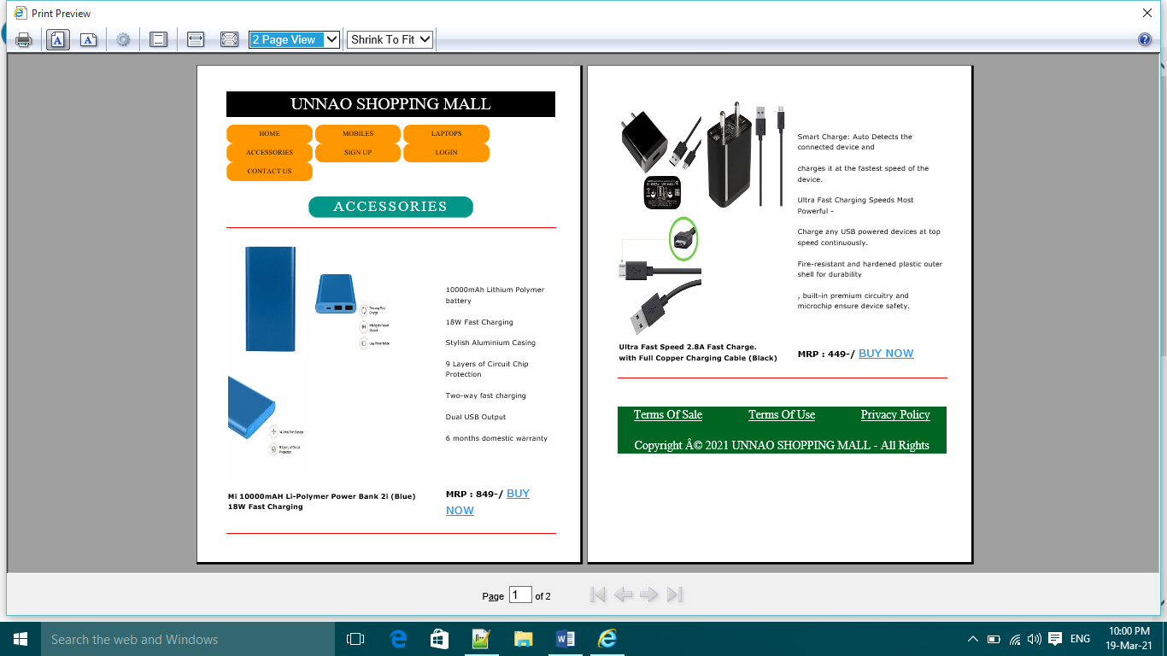<!DOCTYPE html>

<html>

<head>

<title>Accessories</title>

<link rel="stylesheet" type="text/css" href="w3css/w3.css">

<link rel="stylesheet" type="text/css" href="css/main.css">

</head>

<body>

<h1 class="w3-panel w3-center w3-black w3-serif" id="top"> UNNAO SHOPPING MALL </h1>

<DIV> <a href="index.html" class="w3-button w3-orange w3-hover-blue w3-serif"> HOME </a> <a href="mobile.html" class="w3-button w3-orange w3-hover-blue w3-serif"> MOBILES </a> <a href="laptop.html" class="w3-button w3-orange w3-hover-blue w3-serif"> LAPTOPS </a> <a href="accessories.html" class="w3-button w3-orange w3-hover-blue w3-serif"> ACCESSORIES </a > <a href="registration.html" class="w3-button w3-orange w3-hover-blue w3-serif"> SIGN UP </a> <a href="login.html" class="w3-button w3-orange w3-hover-blue w3-serif"> LOGIN </a> <a href="contact.html" class="w3-button w3-orange w3-hover-blue w3-serif"> CONTACT US </a> </DIV> <br>

<center><h2 class="w-panel w3-teal w3-center w3-serif w3-wide" style="width: 50%; border-radius: 20px"> ACCESSORIES </h2></center>

<hr width="100%">

<table><tr> <td> <img src="images/11.jpg"> <img src="images/12.jpg"> <img src="images/13.jpg"> </td> <td> <br>10000mAh Lithium Polymer battery<br> <br>18W Fast Charging<br> <br>Stylish Aluminium Casing<br> <br>9 Layers of Circuit Chip Protection<br> <br>Two-way fast charging<br> <br>Dual USB Output<br> <br>6 months domestic warranty<br> </td></tr><tr> <td><b> Mi 10000mAH Li-Polymer Power Bank 2i (Blue) <br> 18W Fast Charging </b> </td> <td> <b class="w3-large"> MRP : 849-/ </b><a href="payment.html" class="w3-xlarge w3-text-blue">BUY NOW </a> </td> </tr> </table>

<hr width="100%"> <br>

<table> <tr><td> <img src="images/c1.jpg"> <img src="images/c2.jpg" border="1"> <img src="images/c4.jpg"> </td><td> <br> Smart Charge: Auto Detects the connected device and <br> <br> charges it at the fastest speed of the device.<br> <br>Ultra Fast Charging Speeds Most Powerful - <br> <br> Charge any USB powered devices at top speed continuously.<br> <br>Fire-resistant and hardened plastic outer shell for durability <br> <br>, built-in premium circuitry and microchip ensure device safety.<br> </td> </tr> <tr> <td> <b>Ultra Fast Speed 2.8A Fast Charge. <br> with Full Copper Charging Cable (Black)</b> </td> <td> <b class="w3-large"> MRP : 449-/ </b> <a href="payment.html" class="w3-xlarge w3-text-blue">BUY NOW </a> </font> </td> </tr> </table>

<hr width="100%"> <br>

<div class=" w3-panel w3-serif" style="background-color:#006622;height: 100px;font-size: 25px; color: white;"><center><a href="termsofsale.html" class="w3-left"> Terms Of Sale </a><a href="termsofuse.html" >Terms Of Use</a>

<a href="privacy.html" class="w3-right"> Privacy Policy </a> </center> <P class="w3-center w3-text-white">Copyright © 2021 UNNAO SHOPPING MALL - All Rights Reserved.</P></div>

</body>

</html>

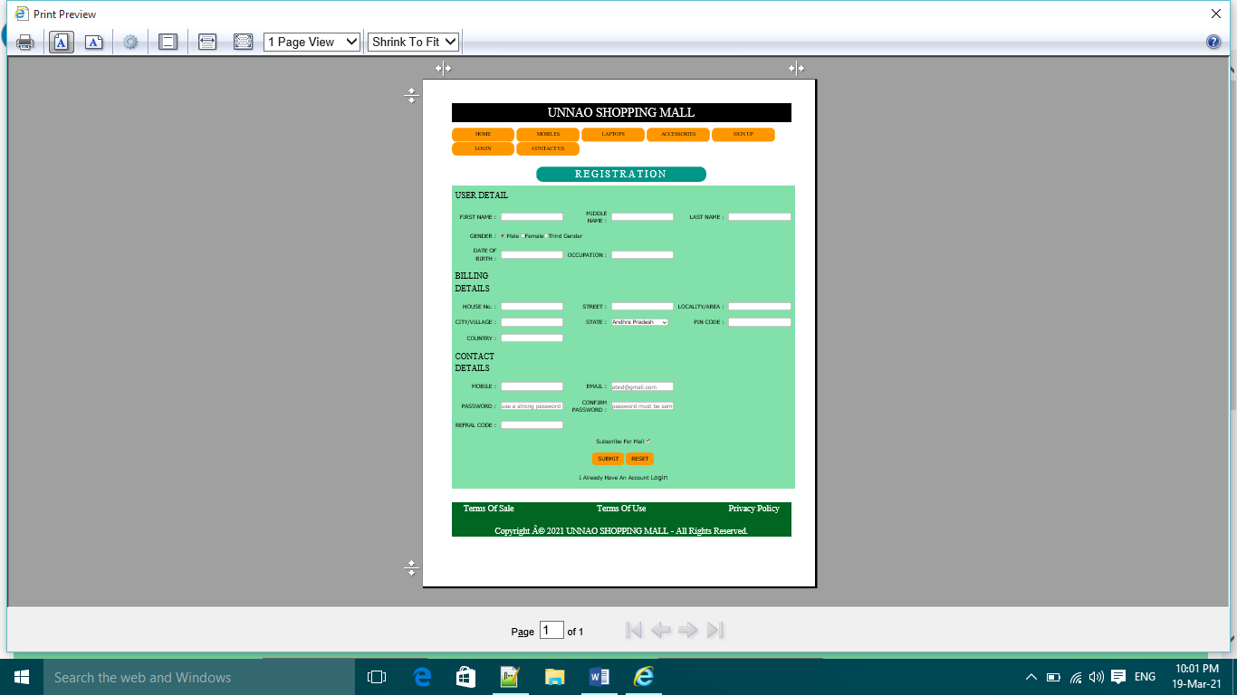<!DOCTYPE html>

<html>

<head>

<title> Registration </title>

<link rel="stylesheet" type="text/css" href="w3css/w3.css">

<link rel="stylesheet" type="text/css" href="css/main.css">

</head>

<body>

<h1 class="w3-panel w3-center w3-black w3-serif" id="top"> UNNAO SHOPPING MALL </h1>

<DIV> <a href="index.html" class="w3-button w3-orange w3-hover-blue w3-serif"> HOME </a> <a href="mobile.html" class="w3-button w3-orange w3-hover-blue w3-serif"> MOBILES </a> <a href="laptop.html" class="w3-button w3-orange w3-hover-blue w3-serif"> LAPTOPS </a> <a href="accessories.html" class="w3-button w3-orange w3-hover-blue w3-serif"> ACCESSORIES </a > <a href="registration.html" class="w3-button w3-orange w3-hover-blue w3-serif"> SIGN UP </a> <a href="login.html" class="w3-button w3-orange w3-hover-blue w3-serif"> LOGIN </a> <a href="contact.html" class="w3-button w3-orange w3-hover-blue w3-serif"> CONTACT US </a> </DIV> <br>

<center><h2 class="w-panel w3-teal w3-center w3-serif w3-wide" style="width: 50%; border-radius: 20px"> REGISTRATION </h2></center>

<form>

<table cellspacing="10" style="width:100%; background-color: #82E0AA">

<tr><td colspan="2" class="w3-xlarge w3-serif"> USER DETAIL </td></tr>

<tr><td align="right"> FIRST NAME : </td><td align="left"> <input required name="first name" type="text"> </td><td align="right"> MIDDLE NAME : </td><td align="left"> <input type="text" name="middle name"> </td><td align="right"> LAST NAME : </td><td align="left"> <input type="text" name="last name"> </td></tr>

<tr><td align="right">GENDER : </td><td colspan="2" align="left"><input type="radio" name="gender" value="male" checked> Male

<input type="radio" value="female" name="gender">Female<input type="radio" value="third gender" name="gender">Third Gender </td></tr>

<tr><td align="right">DATE OF BIRTH : </td><td align="left"> <input required type="date"> </td><td align="right">OCCUPATION : </td><td align="left"> <INPUT TYPE="text" name="occupation"> </td></tr>

<tr><td class="w3-xlarge w3-serif"> BILLING DETAILS </td></tr>

<tr><td align="right">HOUSE No. : </td><td align="left"> <input required type="number" name="house number"> </td><td align="right">STREET : </td><td align="left"> <input type="text" name="street"> </td><td align="right"> LOCALITY/AREA : </td><td align="left"> <input type="text" name="locality"> </td></tr>

<tr><td align="right"> CITY/VILLAGE : </td><td align="left"> <input required type="text" name="city/village"> </td><td align="right"> STATE : </td><td align="left"> <select > <option> Andhra Pradesh </option> <option> Arunachal Pradesh </option> <option> Assam </option> <option>Bihar </option> <option> Goa </option> <option> Gujarat </option> <option> Haryana </option><option> Himachal Pradesh </option> <option> Jharkhand </option> <option> Karnataka </option> <option> Kerala </option> <option> Madhya Pradesh </option> <option> Maharashtra </option> <option> Manipur </option> <option> Meghalaya </option> <option> Mizoram </option> <option> Nagaland </option> <option> Punjab </option> <option> Rajasthan </option><option> Sikkim </option> <option> Tamil Nadu </option> <option> Telangana </option> <option> Tripura </option> <option> Uttar Pradesh </option> <option> Uttarakhand </option> <option> West Bengal </option><option> Delhi </option><option> Delhi </option><option> Puducherry </option> </select> </td><td align="right">PIN CODE : </td><td align="left"> <input required type="text" pattern="[0-9]{6}" name="pin code" > </td></tr><tr><td align="right">COUNTRY : </td><td align="left"> <input type="text" name="country"> </td></tr><tr><td class="w3-xlarge w3-serif"> CONTACT DETAILS </td> </tr><tr><td align="right">MOBILE :</td> <td align="left"> <input type="number" name="phone" pattern="[0-9]{10}"> </td><td align="right">EMAIL : </td><td align="left"> <input type="email" name="mail id" placeholder="abcd@gmail.com"> </td></tr><tr><td align="right">PASSWORD : </td> <td align="left"> <input type="password" maxlength="16" minlenght="8" name="password" placeholder="use a strong password"> </td><td align="right">CONFIRM PASSWORD : </td> <td align="left"> <input type="password" maxlength="16" minlenght="8" name="confirm password" placeholder="password must be same"> </td></tr><tr><td align="right"> REFRAL CODE : </td> <td align="left"> <input type="text" name="refral code"> </td></tr><tr><td colspan="6" align="center">Subscribe For Mail <input type="checkbox" checked name="subscribe" value="yes"> </td></tr><tr><td colspan="6" align="center"> <input type="submit" NAME="submit" value="SUBMIT" class="w3-button w3-orange w3-round-large w3-hover-blue"> <input type="reset" value="RESET" class="w3-button w3-submit w3-orange w3-round-large w3-hover-blue"> </td> </tr>

<tr><td colspan="6" align="center"> I Already Have An Account <a href="login.html" class="w3-large"> Login </a> </td></tr> </table><br></form>

<div class=" w3-panel w3-serif" style="background-color:#006622;height: 100px;font-size: 25px; color: white;"><center><a href="termsofsale.html" class="w3-left"> Terms Of Sale </a><a href="termsofuse.html" >Terms Of Use</a>

<a href="privacy.html" class="w3-right"> Privacy Policy </a> </center> <P class="w3-center w3-text-white">Copyright © 2021 UNNAO SHOPPING MALL - All Rights Reserved.</P></div>

</body>

</html>

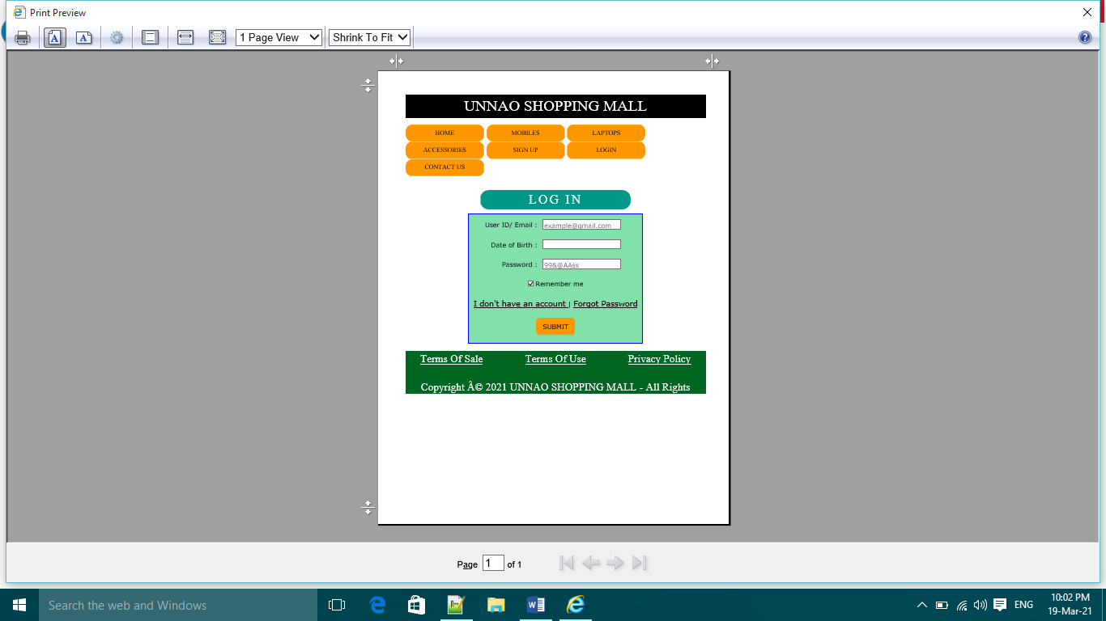<!DOCTYPE html>

<html>

<head>

<title>Login</title>

<link rel="stylesheet" type="text/css" href="w3css/w3.css">

<link rel="stylesheet" type="text/css" href="css/main.css">

</head>

<body>

<h1 class="w3-panel w3-center w3-black w3-serif" id="top"> UNNAO SHOPPING MALL </h1>

<DIV> <a href="index.html" class="w3-button w3-orange w3-hover-blue w3-serif"> HOME </a> <a href="mobile.html" class="w3-button w3-orange w3-hover-blue w3-serif"> MOBILES </a> <a href="laptop.html" class="w3-button w3-orange w3-hover-blue w3-serif"> LAPTOPS </a> <a href="accessories.html" class="w3-button w3-orange w3-hover-blue w3-serif"> ACCESSORIES </a > <a href="registration.html" class="w3-button w3-orange w3-hover-blue w3-serif"> SIGN UP </a> <a href="login.html" class="w3-button w3-orange w3-hover-blue w3-serif"> LOGIN </a> <a href="contact.html" class="w3-button w3-orange w3-hover-blue w3-serif"> CONTACT US </a> </DIV> <br>

<center><h2 class="w-panel w3-teal w3-center w3-serif w3-wide" style="width: 50%; border-radius: 20px"> LOG IN </h2></center>

<FORM>

<table align="center" cellspacing="10" style="border: 2px solid blue;background-color: #82E0AA ">

<tr><td align="right"> User ID/ Email : </td> <td align="left"> <input TYPE="email" name="user ID" placeholder="example@gmail.com"> </td></tr>

<tr><td align="right"> Date of Birth : </td><td align="left"> <input type="date" name="date of birth"> </td></tr>

<tr><td align="right"> Password : </td> <td align="left"> <input type="PASSWORD" name="password" maxlength="16" minlength="8" placeholder="99&@AAss"> </td></tr>

<tr><td align="center" colspan="2"> <input type="checkbox" name="remember me" checked value="yes"> Remember me </td></tr>

<tr><td align="center" colspan="2"> <a href="registration.html" class="w3-large"> I don't have an account </a> | <a href="https://www.evernote.com/ForgotPassword.action" class="w3-large">Forgot Password </a> </td></tr>

<tr><td colspan="2" align="center"> <input type="submit" name="submit" value="SUBMIT" class="w3-button w3-orange w3-hover-blue w3-round-large"> </td></tr></table>

</FORM>

<div class=" w3-panel w3-serif" style="background-color:#006622;height: 100px;font-size: 25px; color: white;"><center><a href="termsofsale.html" class="w3-left"> Terms Of Sale </a><a href="termsofuse.html" >Terms Of Use</a>

<a href="privacy.html" class="w3-right"> Privacy Policy </a> </center> <P class="w3-center w3-text-white">Copyright © 2021 UNNAO SHOPPING MALL - All Rights Reserved.</P></div>

</body>

</html>

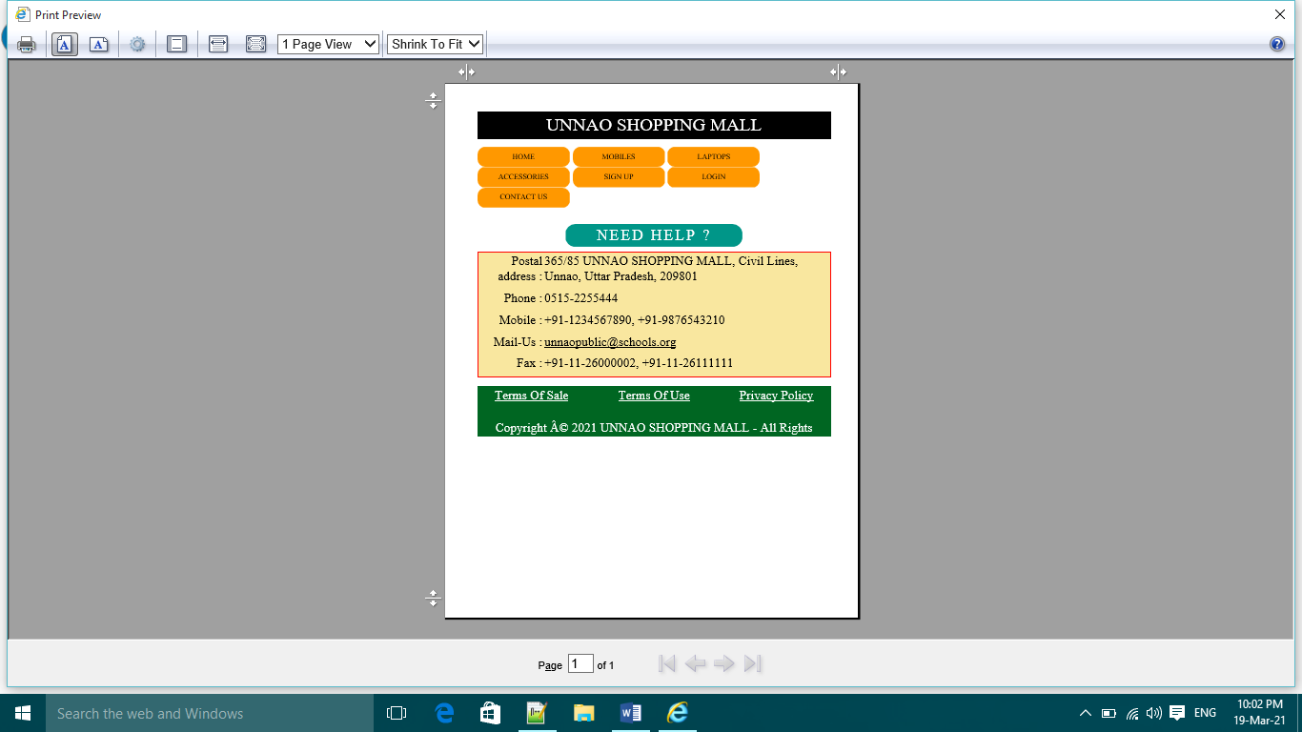<!DOCTYPE html>

<html>

<head>

<title> Contact Us</title>

<link rel="stylesheet" type="text/css" href="w3css/w3.css">

<link rel="stylesheet" type="text/css" href="css/main.css">

</head>

<body>

<h1 class="w3-panel w3-center w3-black w3-serif" id="top"> UNNAO SHOPPING MALL </h1>

<DIV> <a href="index.html" class="w3-button w3-orange w3-hover-blue w3-serif"> HOME </a> <a href="mobile.html" class="w3-button w3-orange w3-hover-blue w3-serif"> MOBILES </a> <a href="laptop.html" class="w3-button w3-orange w3-hover-blue w3-serif"> LAPTOPS </a> <a href="accessories.html" class="w3-button w3-orange w3-hover-blue w3-serif"> ACCESSORIES </a > <a href="registration.html" class="w3-button w3-orange w3-hover-blue w3-serif"> SIGN UP </a> <a href="login.html" class="w3-button w3-orange w3-hover-blue w3-serif"> LOGIN </a> <a href="contact.html" class="w3-button w3-orange w3-hover-blue w3-serif"> CONTACT US </a> </DIV> <br>

<center><h2 class="w-panel w3-teal w3-center w3-serif w3-wide" style="width: 50%; border-radius: 20px"> NEED HELP ? </h2></center><table id="table1" class="w3-serif" style="line-height:30px" align="center">

<tr><td class="w3-right-align">Postal address :</td><td> 365/85 UNNAO SHOPPING MALL, Civil Lines, Unnao, Uttar Pradesh, 209801 </td></tr><tr> <td class="w3-right-align">Phone :</td><td> 0515-2255444</td> </tr>

<tr> <td class="w3-right-align">Mobile :</td> <td> +91-1234567890, +91-9876543210 </td> </tr>

<tr> <td class="w3-right-align">Mail-Us :</td> <td> <a id="a" href="mailto:unnaoshopping@gmail.com"> unnaopublic@schools.org </a></td> </tr><tr> <td class="w3-right-align">Fax :</td> <td> +91-11-26000002, +91-11-26111111</td> </tr></table>

<div class=" w3-panel w3-serif" style="background-color:#006622;height: 100px;font-size: 25px; color: white;"><center><a href="termsofsale.html" class="w3-left"> Terms Of Sale </a><a href="termsofuse.html" >Terms Of Use</a> <a href="privacy.html" class="w3-right"> Privacy Policy </a> </center> <P class="w3-center w3-text-white">Copyright © 2021 UNNAO SHOPPING MALL - All Rights Reserved.</P></div>

</body></html>

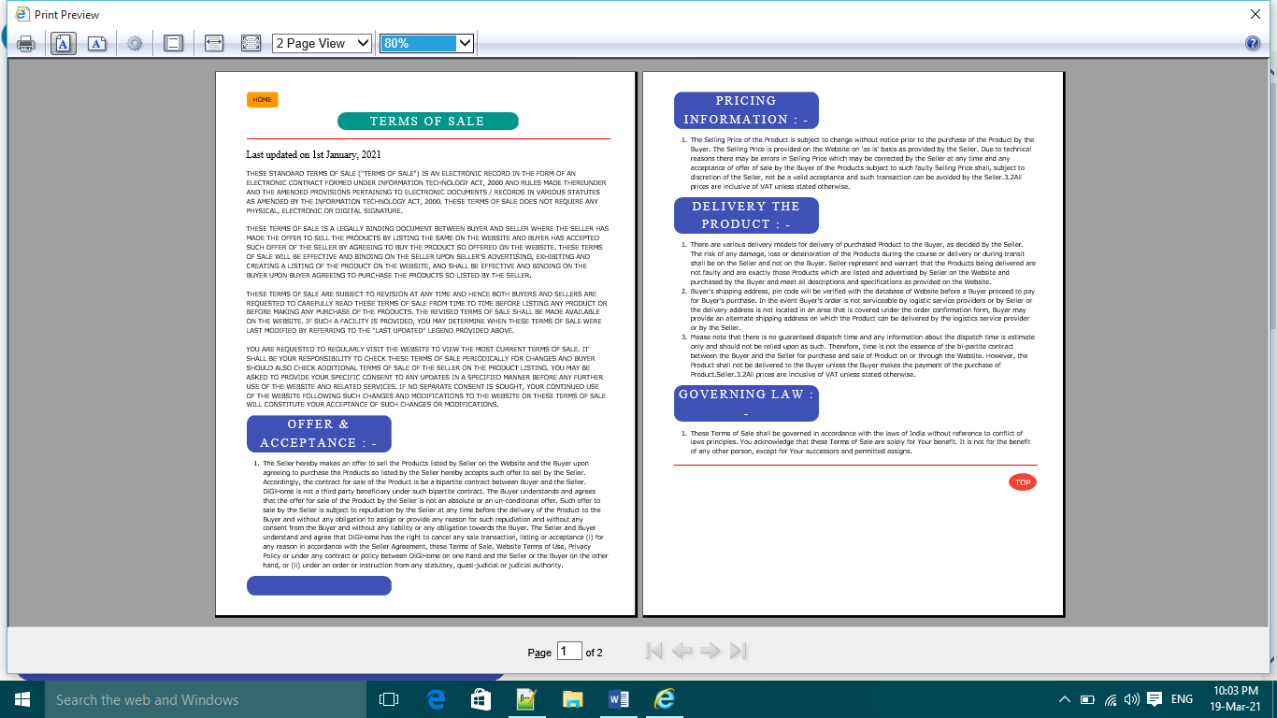<!DOCTYPE html>

<html>

<head>

<title>Term Of Sale</title>

<link rel="stylesheet" type="text/css" href="w3css/w3.css">

<link rel="stylesheet" type="text/css" href="css/main.css">

</head>

<body>

<a href="index.html" id="top" class="w3-button w3-orange w3-hover-blue w3-round-large"> HOME </a>

<center><h2 class="w-panel w3-teal w3-center w3-serif w3-wide" style="width: 50%; border-radius: 20px"> TERMS OF SALE </h2></center>

<hr width="100%"><h3 class="w3-serif">Last updated on 1st January, 2021</h3> <p style="text-transform: uppercase;"> THESE STANDARD TERMS OF SALE ("TERMS OF SALE") IS AN ELECTRONIC RECORD IN THE FORM OF AN ELECTRONIC CONTRACT FORMED UNDER INFORMATION TECHNOLOGY ACT, 2000 AND RULES MADE THEREUNDER AND THE AMENDED PROVISIONS PERTAINING TO ELECTRONIC DOCUMENTS / RECORDS IN VARIOUS STATUTES AS AMENDED BY THE INFORMATION TECHNOLOGY ACT, 2000. THESE TERMS OF SALE DOES NOT REQUIRE ANY PHYSICAL, ELECTRONIC OR DIGITAL SIGNATURE.<br><br>THESE TERMS OF SALE IS A LEGALLY BINDING DOCUMENT BETWEEN BUYER AND SELLER WHERE THE SELLER HAS MADE THE OFFER TO SELL THE PRODUCTS BY LISTING THE SAME ON THE WEBSITE AND BUYER HAS ACCEPTED SUCH OFFER OF THE SELLER BY AGREEING TO BUY THE PRODUCT SO OFFERED ON THE WEBSITE. THESE TERMS OF SALE WILL BE EFFECTIVE AND BINDING ON THE SELLER UPON SELLER'S ADVERTISING, EXHIBITING AND CREATING A LISTING OF THE PRODUCT ON THE WEBSITE, AND SHALL BE EFFECTIVE AND BINDING ON THE BUYER UPON BUYER AGREEING TO PURCHASE THE PRODUCTS SO LISTED BY THE SELLER.<br><br>These Terms of Sale are subject to revision at any time and hence both Buyers and Sellers are requested to carefully read these Terms of Sale from time to time before listing any Product or before making any purchase of the Products. The revised Terms of Sale shall be made available on the Website. If such a facility is provided, You may determine when these Terms of Sale were last modified by referring to the "Last Updated" legend provided above.<br><br>You are requested to regularly visit the Website to view the most current Terms of Sale. It shall be Your responsibility to check these Terms of Sale periodically for changes and Buyer should also check Additional Terms of Sale of the Seller on the Product listing. You may be asked to provide Your specific consent to any updates in a specified manner before any further use of the Website and related services. If no separate consent is sought, Your continued use of the Website following such changes and modifications to the Website or these Terms of Sale will constitute Your acceptance of such changes or modifications.</p>

<h2 class="w-panel w3-indigo w3-center w3-serif w3-wide" style="width: 40%; border-radius: 20px"> OFFER & ACCEPTANCE : - </h2>

<ol><li> The Seller hereby makes an offer to sell the Products listed by Seller on the Website and the Buyer upon agreeing to purchase the Products so listed by the Seller hereby accepts such offer to sell by the Seller. Accordingly, the contract for sale of the Product is be a bipartite contract between Buyer and the Seller. DiGiHome is not a third party beneficiary under such bipartite contract. The Buyer understands and agrees that the offer for sale of the Product by the Seller is not an absolute or an un-conditional offer. Such offer to sale by the Seller is subject to repudiation by the Seller at any time before the delivery of the Product to the Buyer and without any obligation to assign or provide any reason for such repudiation and without any consent from the Buyer and without any liability or any obligation towards the Buyer. The Seller and Buyer understand and agree that DiGiHome has the right to cancel any sale transaction, listing or acceptance (i) for any reason in accordance with the Seller Agreement, these Terms of Sale, Website Terms of Use, Privacy Policy or under any contract or policy between DiGiHome on one hand and the Seller or the Buyer on the other hand, or (ii) under an order or instruction from any statutory, quasi-judicial or judicial authority.</li></ol>

<h2 class="w-panel w3-indigo w3-center w3-serif w3-wide" style="width: 40%; border-radius: 20px"> PRICING INFORMATION : - </h2>

<ol><li>The Selling Price of the Product is subject to change without notice prior to the purchase of the Product by the Buyer. The Selling Price is provided on the Website on 'as is' basis as provided by the Seller. Due to technical reasons there may be errors in Selling Price which may be corrected by the Seller at any time and any acceptance of offer of sale by the Buyer of the Products subject to such faulty Selling Price shall, subject to discretion of the Seller, not be a valid acceptance and such transaction can be avoided by the Seller.3.2All prices are inclusive of VAT unless stated otherwise.</li></ol>

<h2 class="w-panel w3-indigo w3-center w3-serif w3-wide" style="width: 40%; border-radius: 20px"> DELIVERY THE PRODUCT : - </h2>

<ol><li> There are various delivery models for delivery of purchased Product to the Buyer, as decided by the Seller. The risk of any damage, loss or deterioration of the Products during the course or delivery or during transit shall be on the Seller and not on the Buyer. Seller represent and warrant that the Products being delivered are not faulty and are exactly those Products which are listed and advertised by Seller on the Website and purchased by the Buyer and meet all descriptions and specifications as provided on the Website.</li>

<li>Buyer's shipping address, pin code will be verified with the database of Website before a Buyer proceed to pay for Buyer's purchase. In the event Buyer's order is not serviceable by logistic service providers or by Seller or the delivery address is not located in an area that is covered under the order confirmation form, Buyer may provide an alternate shipping address on which the Product can be delivered by the logistics service provider or by the Seller.</li>

<li>Please note that there is no guaranteed dispatch time and any information about the dispatch time is estimate only and should not be relied upon as such. Therefore, time is not the essence of the bi-partite contract between the Buyer and the Seller for purchase and sale of Product on or through the Website. However, the Product shall not be delivered to the Buyer unless the Buyer makes the payment of the purchase of Product.Seller.3.2All prices are inclusive of VAT unless stated otherwise.</li></ol><h2 class="w-panel w3-indigo w3-center w3-serif w3-wide" style="width: 40%; border-radius: 20px"> GOVERNING LAW : - </h2><ol><li>These Terms of Sale shall be governed in accordance with the laws of India without reference to conflict of laws principles. You acknowledge that these Terms of Sale are solely for Your benefit. It is not for the benefit of any other person, except for Your successors and permitted assigns.</li></ol><hr width="100%"><a href="#top" class="w3-red w3-hover-blue w3-button w3-large w3-circle w3-right"> TOP </a></body>

</html>

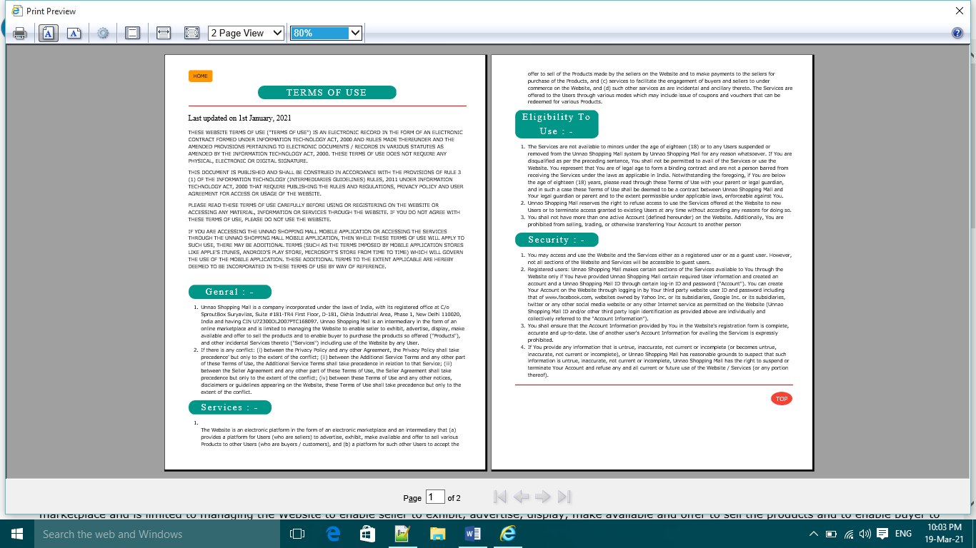<!DOCTYPE html>

<html>

<head>

<title> Terms Of Use </title>

<link rel="stylesheet" type="text/css" href="w3css/w3.css">

<link rel="stylesheet" type="text/css" href="css/main.css">

</head>

<body>

<a href="index.html" id="top" class="w3-button w3-orange w3-hover-blue w3-round-large"> HOME </a>

<center><h2 class="w-panel w3-teal w3-center w3-serif w3-wide" style="width: 50%; border-radius: 20px"> TERMS OF USE </h2></center>

<hr width="100%">

<h3 class="w3-serif">Last updated on 1st January, 2021</h3>

<div style="text-transform: uppercase;">

<p>THESE WEBSITE TERMS OF USE ("TERMS OF USE") IS AN ELECTRONIC RECORD IN THE FORM OF AN ELECTRONIC CONTRACT FORMED UNDER INFORMATION TECHNOLOGY ACT, 2000 AND RULES MADE THEREUNDER AND THE AMENDED PROVISIONS PERTAINING TO ELECTRONIC DOCUMENTS / RECORDS IN VARIOUS STATUTES AS AMENDED BY THE INFORMATION TECHNOLOGY ACT, 2000. THESE TERMS OF USE DOES NOT REQUIRE ANY PHYSICAL, ELECTRONIC OR DIGITAL SIGNATURE.</p>

<p>THIS DOCUMENT IS PUBLISHED AND SHALL BE CONSTRUED IN ACCORDANCE WITH THE PROVISIONS OF RULE 3 (1) OF THE INFORMATION TECHNOLOGY (INTERMEDIARIES GUIDELINES) RULES, 2011 UNDER INFORMATION TECHNOLOGY ACT, 2000 THAT REQUIRE PUBLISHING THE RULES AND REGULATIONS, PRIVACY POLICY AND USER AGREEMENT FOR ACCESS OR USAGE OF THE WEBSITE.</p>

<p>PLEASE READ THESE TERMS OF USE CAREFULLY BEFORE USING OR REGISTERING ON THE WEBSITE OR ACCESSING ANY MATERIAL, INFORMATION OR SERVICES THROUGH THE WEBSITE. IF YOU DO NOT AGREE WITH THESE TERMS OF USE, PLEASE DO NOT USE THE WEBSITE.</p>

<p>If you are accessing the Unnao Shopping Mall mobile application or accessing the Services through the Unnao Shopping Mall mobile application, then while these Terms of Use will apply to such use, there may be additional terms (such as the terms imposed by mobile application stores like Apple's iTunes, Android's play store, Microsoft's store from time to time) which will govern the use of the mobile application. These additional terms to the extent applicable are hereby deemed to be incorporated in these Terms of Use by way of reference. </p><BR></div>

<h2 class="w-panel w3-teal w3-center w3-serif w3-wide" style="width: 30%; border-radius: 20px"> Genral : - </h2>

<ol><li>Unnao Shopping Mall is a company incorporated under the laws of India, with its registered office at C/o SproutBox Suryavilas, Suite #181-TR4 First Floor, D-181, Okhla Industrial Area, Phase 1, New Delhi 110020, India and having CIN U72300DL2007PTC168097. Unnao Shopping Mall is an intermediary in the form of an online marketplace and is limited to managing the Website to enable seller to exhibit, advertise, display, make available and offer to sell the products and to enable buyer to purchase the products so offered ("Products"), and other incidental Services thereto ("Services") including use of the Website by any User.

</li>

<li>If there is any conflict: (i) between the Privacy Policy and any other Agreement, the Privacy Policy shall take precedence' but only to the extent of the conflict; (ii) between the Additional Service Terms and any other part of these Terms of Use, the Additional Service Terms shall take precedence in relation to that Service; (iii) between the Seller Agreement and any other part of these Terms of Use, the Seller Agreement shall take precedence but only to the extent of the conflict; (iv) between these Terms of Use and any other notices, disclaimers or guidelines appearing on the Website, these Terms of Use shall take precedence but only to the extent of the conflict.</li></ol>

<h2 class="w-panel w3-teal w3-center w3-serif w3-wide" style="width: 30%; border-radius: 20px"> Services : - </h2><ol><li> </li> The Website is an electronic platform in the form of an electronic marketplace and an intermediary that (a) provides a platform for Users (who are sellers) to advertise, exhibit, make available and offer to sell various Products to other Users (who are buyers / customers), and (b) a platform for such other Users to accept the offer to sell of the Products made by the sellers on the Website and to make payments to the sellers for purchase of the Products, and (c) services to facilitate the engagement of buyers and sellers to under commerce on the Website, and (d) such other services as are incidental and ancillary thereto. The Services are offered to the Users through various modes which may include issue of coupons and vouchers that can be redeemed for various Products. </ol>

<h2 class="w-panel w3-teal w3-center w3-serif w3-wide" style="width: 30%; border-radius: 20px"> Eligibility To Use : - </h2>

<ol>

<li>The Services are not available to minors under the age of eighteen (18) or to any Users suspended or removed from the Unnao Shopping Mall system by Unnao Shopping Mall for any reason whatsoever. If You are disqualified as per the preceding sentence, You shall not be permitted to avail of the Services or use the Website. You represent that You are of legal age to form a binding contract and are not a person barred from receiving the Services under the laws as applicable in India. Notwithstanding the foregoing, if You are below the age of eighteen (18) years, please read through these Terms of Use with your parent or legal guardian, and in such a case these Terms of Use shall be deemed to be a contract between Unnao Shopping Mall and Your legal guardian or parent and to the extent permissible under applicable laws, enforceable against You.</li>

<li>Unnao Shopping Mall reserves the right to refuse access to use the Services offered at the Website to new Users or to terminate access granted to existing Users at any time without according any reasons for doing so.</li>

<li>You shall not have more than one active Account (defined hereunder) on the Website. Additionally, You are prohibited from selling, trading, or otherwise transferring Your Account to another person</li>

</ol>

<h2 class="w-panel w3-teal w3-center w3-serif w3-wide" style="width: 30%; border-radius: 20px"> Security : - </h2><ol>

<li>You may access and use the Website and the Services either as a registered user or as a guest user. However, not all sections of the Website and Services will be accessible to guest users.</li><li>

Registered users: Unnao Shopping Mall makes certain sections of the Services available to You through the Website only if You have provided Unnao Shopping Mall certain required User information and created an account and a Unnao Shopping Mall ID through certain log-in ID and password ("Account"). You can create Your Account on the Website through logging in by Your third party website user ID and password including that of www.facebook.com, websites owned by Yahoo Inc. or its subsidiaries, Google Inc. or its subsidiaries, twitter or any other social media website or any other Internet service as permitted on the Website (Unnao Shopping Mall ID and/or other third party login identification as provided above are individually and collectively referred to the "Account Information").</li><li>

You shall ensure that the Account Information provided by You in the Website's registration form is complete, accurate and up-to-date. Use of another user's Account Information for availing the Services is expressly prohibited.</li><li>

If You provide any information that is untrue, inaccurate, not current or incomplete (or becomes untrue, inaccurate, not current or incomplete), or Unnao Shopping Mall has reasonable grounds to suspect that such information is untrue, inaccurate, not current or incomplete, Unnao Shopping Mall has the right to suspend or terminate Your Account and refuse any and all current or future use of the Website / Services (or any portion thereof).

</li>

</ol> <hr width="100%">

<a href="#top" class="w3-red w3-hover-blue w3-button w3-large w3-circle w3-right"> TOP </a>

</body>

</html>

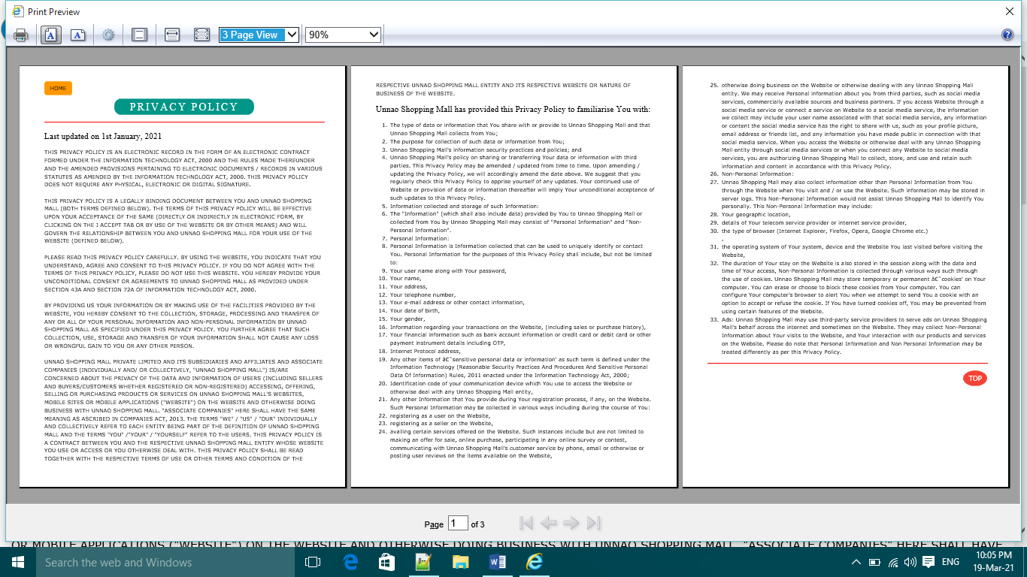<!DOCTYPE html>

<html>

<head>

<title>Privacy Policy</title>

<link rel="stylesheet" type="text/css" href="w3css/w3.css">

<link rel="stylesheet" type="text/css" href="css/main.css">

</head>

<body>

<a href="index.html" id="top" class="w3-button w3-orange w3-hover-blue w3-round-large"> HOME </a>

<center><h2 class="w-panel w3-teal w3-center w3-serif w3-wide" style="width: 50%; border-radius: 20px"> PRIVACY POLICY </h2></center>

<hr width="100%">

<h3 class="w3-serif">Last updated on 1st January, 2021</h3>

<P style="text-transform: uppercase;" >THIS PRIVACY POLICY IS AN ELECTRONIC RECORD IN THE FORM OF AN ELECTRONIC CONTRACT FORMED UNDER THE INFORMATION TECHNOLOGY ACT, 2000 AND THE RULES MADE THEREUNDER AND THE AMENDED PROVISIONS PERTAINING TO ELECTRONIC DOCUMENTS / RECORDS IN VARIOUS STATUTES AS AMENDED BY THE INFORMATION TECHNOLOGY ACT, 2000. THIS PRIVACY POLICY DOES NOT REQUIRE ANY PHYSICAL, ELECTRONIC OR DIGITAL SIGNATURE.<br><br>

THIS PRIVACY POLICY IS A LEGALLY BINDING DOCUMENT BETWEEN YOU AND Unnao Shopping Mall (BOTH TERMS DEFINED BELOW). THE TERMS OF THIS PRIVACY POLICY WILL BE EFFECTIVE UPON YOUR ACCEPTANCE OF THE SAME (DIRECTLY OR INDIRECTLY IN ELECTRONIC FORM, BY CLICKING ON THE I ACCEPT TAB OR BY USE OF THE WEBSITE OR BY OTHER MEANS) AND WILL GOVERN THE RELATIONSHIP BETWEEN YOU AND Unnao Shopping Mall FOR YOUR USE OF THE WEBSITE (DEFINED BELOW).<br><br>

PLEASE READ THIS PRIVACY POLICY CAREFULLY. BY USING THE WEBSITE, YOU INDICATE THAT YOU UNDERSTAND, AGREE AND CONSENT TO THIS PRIVACY POLICY. IF YOU DO NOT AGREE WITH THE TERMS OF THIS PRIVACY POLICY, PLEASE DO NOT USE THIS WEBSITE. YOU HEREBY PROVIDE YOUR UNCONDITIONAL CONSENT OR AGREEMENTS TO Unnao Shopping Mall AS PROVIDED UNDER SECTION 43A AND SECTION 72A OF INFORMATION TECHNOLOGY ACT, 2000.<br><br>

By providing us your Information or by making use of the facilities provided by the Website, You hereby consent to the collection, storage, processing and transfer of any or all of Your Personal Information and Non-Personal Information by Unnao Shopping Mall as specified under this Privacy Policy. You further agree that such collection, use, storage and transfer of Your Information shall not cause any loss or wrongful gain to you or any other person.<br><br>

Unnao Shopping Mall Private Limited and its subsidiaries and affiliates and Associate Companies (individually and/ or collectively, "Unnao Shopping Mall") is/are concerned about the privacy of the data and information of users (including sellers and buyers/customers whether registered or non-registered) accessing, offering, selling or purchasing products or services on Unnao Shopping Mall's websites, mobile sites or mobile applications ("Website") on the Website and otherwise doing business with Unnao Shopping Mall. "Associate Companies" here shall have the same meaning as ascribed in Companies Act, 2013. The terms "We" / "Us" / "Our" individually and collectively refer to each entity being part of the definition of Unnao Shopping Mall and the terms "You" /"Your" / "Yourself" refer to the users. This Privacy Policy is a contract between You and the respective Unnao Shopping Mall entity whose Website You use or access or You otherwise deal with. This Privacy Policy shall be read together with the respective Terms Of Use or other terms and condition of the respective Unnao Shopping Mall entity and its respective Website or nature of business of the Website.</P>

<h3 class="w3-serif">Unnao Shopping Mall has provided this Privacy Policy to familiarise You with:</h3>

<ol><li>The type of data or information that You share with or provide to Unnao Shopping Mall and that Unnao Shopping Mall collects from You;</li>

<li>The purpose for collection of such data or information from You;</li>

<li>Unnao Shopping Mall's information security practices and policies; and</li>

<li>Unnao Shopping Mall's policy on sharing or transferring Your data or information with third parties. This Privacy Policy may be amended / updated from time to time. Upon amending / updating the Privacy Policy, we will accordingly amend the date above. We suggest that you regularly check this Privacy Policy to apprise yourself of any updates. Your continued use of Website or provision of data or information thereafter will imply Your unconditional acceptance of such updates to this Privacy Policy.</li>

<li>Information collected and storage of such Information:</li>

<li>The "Information" (which shall also include data) provided by You to Unnao Shopping Mall or collected from You by Unnao Shopping Mall may consist of "Personal Information" and "Non-Personal Information".</li>

<li>Personal Information:</li>

<li>Personal Information is Information collected that can be used to uniquely identify or contact You. Personal Information for the purposes of this Privacy Policy shall include, but not be limited to:</li>

<li>Your user name along with Your password,</li>

<li>Your name,</li><li>Your address,</li><li>Your telephone number,</li><li>Your e-mail address or other contact information,</li><li>Your date of birth,</li><li>Your gender,</li><li>Information regarding your transactions on the Website, (including sales or purchase history),</li>

<li>Your financial information such as bank account information or credit card or debit card or other payment instrument details including OTP,</li>

<li>Internet Protocol address,</li>

<li>Any other items of ‘sensitive personal data or information' as such term is defined under the Information Technology (Reasonable Security Practices And Procedures And Sensitive Personal Data Of Information) Rules, 2011 enacted under the Information Technology Act, 2000;</li>

<li>Identification code of your communication device which You use to access the Website or otherwise deal with any Unnao Shopping Mall entity,</li>

<li>Any other Information that You provide during Your registration process, if any, on the Website. Such Personal Information may be collected in various ways including during the course of You:</li>

<li>registering as a user on the Website,</li>

<li>registering as a seller on the Website,</li>

<li>availing certain services offered on the Website. Such instances include but are not limited to making an offer for sale, online purchase, participating in any online survey or contest, communicating with Unnao Shopping Mall's customer service by phone, email or otherwise or posting user reviews on the items available on the Website, </li>

<li>otherwise doing business on the Website or otherwise dealing with any Unnao Shopping Mall entity. We may receive Personal information about you from third parties, such as social media services, commercially available sources and business partners. If you access Website through a social media service or connect a service on Website to a social media service, the information we collect may include your user name associated with that social media service, any information or content the social media service has the right to share with us, such as your profile picture, email address or friends list, and any information you have made public in connection with that social media service. When you access the Website or otherwise deal with any Unnao Shopping Mall entity through social media services or when you connect any Website to social media services, you are authorizing Unnao Shopping Mall to collect, store, and use and retain such information and content in accordance with this Privacy Policy.</li>

<li>Non-Personal Information:</li>

<li>Unnao Shopping Mall may also collect information other than Personal Information from You through the Website when You visit and / or use the Website. Such information may be stored in server logs. This Non-Personal Information would not assist Unnao Shopping Mall to identify You personally. This Non-Personal Information may include:</li></li>

<li>Your geographic location,</li>

<li>details of Your telecom service provider or internet service provider,</li>

<li>the type of browser (Internet Explorer, Firefox, Opera, Google Chrome etc.)</li>,

<li>the operating system of Your system, device and the Website You last visited before visiting the Website,</li>

<li>The duration of Your stay on the Website is also stored in the session along with the date and time of Your access, Non-Personal Information is collected through various ways such through the use of cookies. Unnao Shopping Mall may store temporary or permanent ‘cookies' on Your computer. You can erase or choose to block these cookies from Your computer. You can configure Your computer's browser to alert You when we attempt to send You a cookie with an option to accept or refuse the cookie. If You have turned cookies off, You may be prevented from using certain features of the Website.</li>

<li>Ads: Unnao Shopping Mall may use third-party service providers to serve ads on Unnao Shopping Mall's behalf across the internet and sometimes on the Website. They may collect Non-Personal Information about Your visits to the Website, and Your interaction with our products and services on the Website. Please do note that Personal Information and Non Personal Information may be treated differently as per this Privacy Policy.</li>

</ol><hr width="100%"><a href="#top" class="w3-red w3-hover-blue w3-button w3-large w3-circle w3-right"> TOP </a></body>

</html>

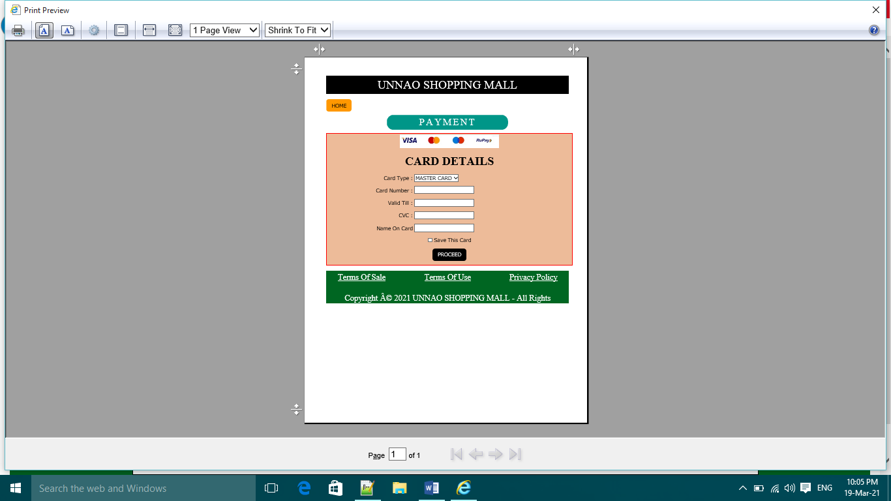<!DOCTYPE html>

<html>

<head>

<title> Payment </title>

<link rel="stylesheet" type="text/css" href="w3css/w3.css">

<link rel="stylesheet" type="text/css" href="css/main.css">

</head>

<body>

<h1 class="w3-panel w3-center w3-black w3-serif" id="top"> UNNAO SHOPPING MALL </h1>

<a href="index.html" id="top" class="w3-button w3-orange w3-hover-blue w3-round-large"> HOME </a>

<center><h2 class="w-panel w3-teal w3-center w3-serif w3-wide" style="width: 50%; border-radius: 20px"> PAYMENT </h2></center>

<table align="center" style="width: 750px; border: 2px solid red; height: 150px; background-color: #EDBB99">

<tr> <td align="center" colspan="2"> <img src="images/card.jpg"> </td> </tr>

<tr><td align="center" colspan="2"> <b class="w3-serif w3-xxlarge">CARD DETAILS</b></td></tr>

<form onsubmit="register()">

<tr><td align="right"> Card Type : </td><td> <select><option> MASTER CARD </option><option> VISA CARD </option><option> RUPAY </option><option> MAESTRO </option></select></td></tr>

<tr><td align="right"> Card Number : </td><td> <input required type="text" name="card number" pattern="[0-9]{16}"></td></tr>

<tr><td align="right"> Valid Till : </td><td><input required type="month" name="Valid Till"> </td></tr>

<tr><td align="right"> CVC : </td><td><input required type="password" pattern="[0-9]{3}" name="CVC"></td></tr>

<tr><td align="right"> Name On Card </td><td> <input required type="text" Name="Card HOlder"></td></tr>

<tr><td colspan="2" align="center"> <input type="checkbox" name="save this card" value="yes"> Save This Card </td></tr>

<tr><td colspan="2" align="center"><input required type="submit" value="PROCEED" Name="submit" class="w3-button w3-round-large w3-black"></td></tr></form></table>

<script type="text/javascript">

function register()

{

if (confirm("Are You Want To Proceed This Payment"))

{

alert("You Are Done Your Payment. You Will Get Your Order Soon");

} else

{

alert("First Complete Your Payment");

}

document.getElementById("demo").innerHTML = txt;

}

</script>

<div class=" w3-panel w3-serif" style="background-color:#006622;height: 100px;font-size: 25px; color: white;"><center><a href="termsofsale.html" class="w3-left"> Terms Of Sale </a><a href="termsofuse.html" >Terms Of Use</a>

<a href="privacy.html" class="w3-right"> Privacy Policy </a> </center> <P class="w3-center w3-text-white">Copyright © 2021 UNNAO SHOPPING MALL - All Rights Reserved.</P></div>

</body>

</html>