

**TraxiT - A Tracking Device**

**Project Management**

**MGT 1034**

**Fall Semester 2021-2022**





**TraxiT - A Tracking Device**

Project Report submitted in partial fulfilment of the requirements for the course of **Project Management**

**( MGT 1034 )**

By

**Mayank Sharma(19BCE1145)**

**Shivam Sibal(19BAI1006)**



**Fall Semester 2021-2022**



**DECLARATION**

We hereby declare that the project entitled **“TraxiT - A Tracking Device”** submitted by us in partial fulfillment of the requirements for the course “Project Management-MGT1034”, is a record of bonafide work carried out by us under the course faculty of **Dr.Meenakshi Sankaran.** We further declare that the work reported in this project has not been submitted and will not be submitted, either in part or in full, for any other course of this institute or of any other institute or university.



**CERTIFICATE**

The project report entitled “**TraxiT - A Tracking Device**” is prepared and submitted by **Mayank Sharma(Register No: 19BCE1145), Shivam Sibal(19BAI1006)** Ithas been found satisfactory in terms of scope, quality and presentation as partial fulfillment of the course “ Project Management-MGT1034”in VIT University, Chennai Campus,India.

**(Name & Signature of the Course Faculty)**

**ACKNOWLEDGEMENT**

We wish to express our sincere thanks and deep sense of gratitude to our project guide, **Dr. Meenakshi Sankaran,** for her consistent encouragement and valuable guidance offered to us in a pleasant manner throughout the course of the project work.We are extremely grateful to **Dr. Jagadeesh Kannan**, Dean of the School of Computer Science and Engineering, VIT Chennai, for extending the facilities of the School towards our project and for his unstinting support. We express our thanks to our Head of the Department **Dr. P Nithyanandam** for his support throughout the course of this project. We also take this opportunity to thank all the faculty of the School for their support and their wisdom imparted to us throughout the course. We thank our parents, family, and friends for bearing with us throughout the course of our project and for the opportunity they provided us in undergoing this course in such a prestigious institution.

**ABSTRACT**

Due to the hectic and busy schedules in modern day homes, it gets very difficult to keep track of all the small; yet important items. It can become very irritating, if you don’t find the right things at the right place. Simple issues like; forgetting the key during the morning rush hour, or trying to frantically find your wallet/ purse while there’s a delivery right at your doorstep; can turn a happy day into a dull one pretty quickly. Although this doesn’t seem like a very big problem, it can be a huge relief for people who are not able to keep themselves organized throughout the day. We aim to reduce this chaos, by introducing a brand-new range of devices that can help you keep track of your belongings even in hasty situations. Wouldn’t it be such a great way of offering that extra peace of mind that all is not lost even if you misplace your keys. Wouldn’t it bring such relief to your mind, that if someone takes your keys or wallets, you have a chance to retrieve them. As a part of our prototype, we would present a design that can be used as a keychain or a small stick-on inside your wallet/purse/handbag. This tracker would have a small chip that would be linked to your mobile via a mobile application. In case you forget your item, you can quickly open the application and search for the item. This would not only reduce the stress, but also keep you calm during a time like this. Since this device is small and can be used as a keychain, it would not feel awkward to carry. In the case of wallets, we plan on hiding the device completely inside the wallet/purse. The cost for the product would be kept at the minimum, in order to maximize the coverage of the product. Once we get satisfied and repetitive customers, we would plan on expanding the production and broaden the area of service. The only thing we want is the customer to be on the right track.

**CONTENTS**

| **S No.** | **Topic** | **Page** |
| --- | --- | --- |
| 1 | Introduction | 8 |
| 2 | Nature of Project | 8 |
| 3 | Product Design | 9 |
| 4 | Business Model Canvas | 9 |
| 5 | Importance | 10 |
| 6 | Challenges | 10 |
| 7 | Beneficiaries | 11 |
| 8 | Statement of Project(SOP) | 11 |
| 9 | Uniqueness | 12 |
| 10 | TEFR | 13 |
| 11 | Cost Estimation | 14 |
| 12 | Final Pricing | 15 |
| 13 | Interviews | 16 |
| 14 | Project Network Diagram | 16 |
| 15 | Events | 17 |
| 16 | Risks and Uncertainties Expected | 17 |
| 17 | Contingency Plan | 18 |
| 18 | Privacy Measures and Facilities | 19 |
| 19 | WBS | 20 |
| 20 | Skills Gained | 21 |
| 21 | Conclusion | 21 |
| 22 | References | 22 |

**INTRODUCTION**

Traxit- A Tracking Device is used to track small items like wallets,keys,purses etc. It is a design that can be used as a keychain or a small stick-on inside your wallet/purse/handbag. This tracker would have a small chip that would be linked to your mobile via a mobile application. In case you forget your item, you can quickly open the application and search for the item. This would not only reduce the stress, but also keep you calm during a time like this. Since this device is small and can be used as a keychain, it would not feel awkward to carry. In the case of wallets, we plan on hiding the device completely inside the wallet/purse.

**NATURE OF PROJECT**

It is a **Commercial** project as in this project we set up a tool that has an impact on the sector or society of people. The goal of this project is to improve the people’s livelihood. This project has a significant effect on its users or the part of the society to reduce their stress and tension. This tool can be improved and developed further with the time and new features can be improved in it to provide more facilities to the people and improve their lives. So,this tool has a highly developmental nature.

**PRODUCT DESIGN**

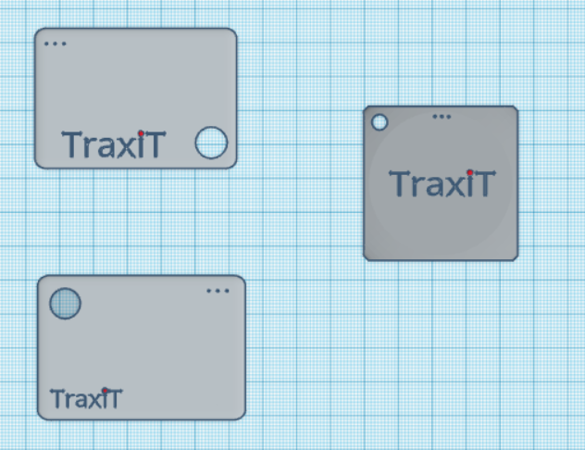

**BUSINESS MODEL CANVAS**

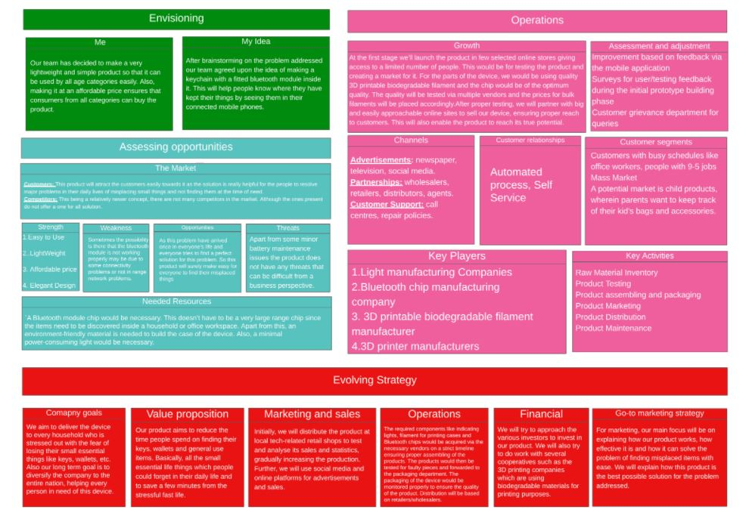

**The Following Link is to the Business Model Canvas:** <https://drive.google.com/file/d/11PET4zc--C97QyZeQPYBhLWe4YblsqQI/view?usp=sharing>

**IMPORTANCE**

The importance of this project is to reduce the stress of the people who usually forgets to carry all their items while going somewhere in a hurry. So it will give the people a sense of satisfaction that they carried everything and nothing is missing. Due to the hectic and busy schedules in modern day homes, it gets very difficult to keep track of all the small; yet important items. It can become very irritating, if you don’t find the right things at the right place. Simple issues like; forgetting the key during the morning rush hour, or trying to frantically find your wallet/ purse while there’s a delivery right at your doorstep, can turn a happy day into a dull one pretty quickly. Although this doesn’t seem like a very big problem, it can be a huge relief for people who are not able to keep themselves organized throughout the day. We aim to reduce this chaos, by introducing a brand-new range of devices that can help you keep track of your belongings even in hasty situations.

**CHALLENGES**

After choosing item tracker as our solution in our project, various problems pertaining to both, software and hardware, have risen. Item tracking requires high precision hardware as well as a robust software that can alert the users to the whereabouts of their forgotten item. Another issue that arises when developing small scale items would be of it’s longevity and resistance to wear and tear. This was a serious issue when developing our product as it is cumbersome to replace the keychain/stick-on whenever it experiences any wear and tear. Another major issue that has arisen in product development is the effectiveness of the software implemented in specific situations, for example, multiple items put together in a cluttered space, which can render the process of identifying a single item difficult among other objects.

**BENEFICIARIES**

**Direct Beneficiaries:**

The direct beneficiaries involved in our project and stand to be benefited directly from our project includes all people who are living in houses (owned, living in rented spaces etc.).The above-mentioned beneficiary is also our target audience.

**Indirect Beneficiaries:**

Manufacturers and factory workers involved in the manufacturing process of our product in mass quantities will benefit from our project as more jobs are created and their families will benefit as well due to the new stream of income generated by this job.

**STATEMENT OF PROJECT(SOP)**

Problem statement of this project is once the home appliances are being forgotten the owner cannot track their vehicle. They do not know where to find the vehicle and the chances to get their vehicle back is very low. It makes it so hard to track the vehicle when there is no evidence. So this system will track and monitor the home location. But how can the location of Houses be tracked using an Android application? For this time being, the tracking system has been nominated as one of the best tracking systems for the losses of home things. Generally, GPS tracking uses a system of satellites orbiting earth to find the actual location. So by improving this system, it uses GPS and Android based smartphones.

**UNIQUENESS**

Certain aspects of our project that makes it unique and stands out from the rest of the projects that implement project tracking is:

1. **Economic feasibility**
   1. The low cost of producing the trackers
   2. Low market price, making it accessible to anyone, also making it possible to buy multiple units for various items in an affordable price
2. **Technological** 
   1. Product is designed ergonomically so that a unit can be attached to virtually any household item.
   2. The chip includes a bluetooth module, which is essential for communication to smartphones.
3. **Research**
   1. Diligent market research of the target audience (ie. people living in owned/rented spaces with common household items) to acquire their needs and requirements for tracking household items, for developing our product to satisfy the specified target audience by fulfilling their needs.
   2. Holding meetings with various suppliers from different industries to gather data and requirements on assembly and production of technologies and hardware products, to ensure maximum efficiency of production and the quality of our product.

**TEFR**

**Technical Considerations:**

* A Bluetooth module chip would be necessary. This doesn’t have to be a very large range chip since the items need to be discovered inside a household or office workspace.
* Apart from this, an environment-friendly material is needed to build the case of the device. Also, a minimal power-consuming light would be necessary
* This tracker would have a small chip that would be linked to your mobile via a mobile application. In case you forget your item, you can quickly open the application and search for the item. This would not only reduce the stress, but also keep you calm during a time like this.
* Since this device is small and can be used as a keychain, it would not feel awkward to carry.
* Improvement based on feedback via the mobile application
* Surveys for user/testing feedback during the initial prototype building phase
* Customer grievance department for queries

**Economic Considerations:**

* The cost for the product would be kept at the minimum, in order to maximize the coverage of the product.
* Once we get satisfied and repetitive customers, we would plan on expanding the production and broaden the area of service.
* The only thing we want is the customer to be on the right track.

**Financial Considerations:**

* We will try to approach the various investors to invest in our product. We will also try to do work with several cooperatives such as the 3D printing companies which are using biodegradable materials for printing purposes .

**Marketing aspects:**

* Our product aims to reduce the time people spend on finding their keys, wallets and general use items.
* Basically, all the small essential life things which people could forget in their daily life and to save a few minutes from the stressful fast life.
* Initially, we will distribute the product at local tech-related retail shops to test and analyse its sales and statistics, gradually increasing the production.
* Further, we will use social media and online platforms for advertisements and sales.

**COST ESTIMATION**

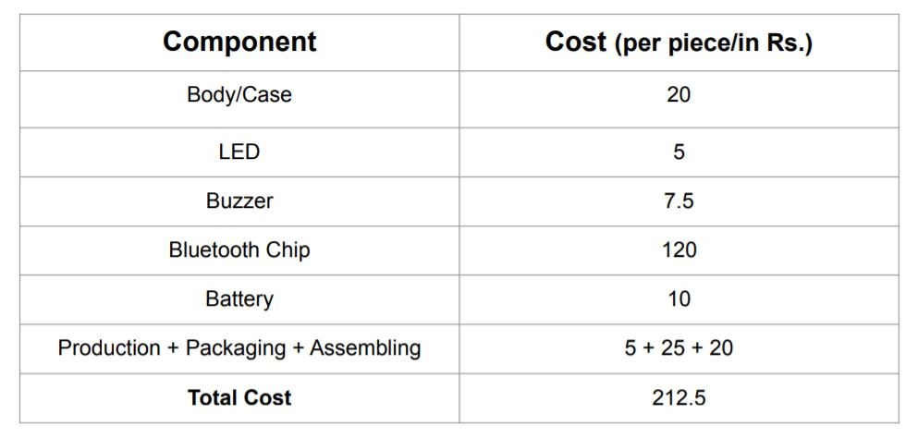

**FINAL PRICING**

1 unit = Rs. 349 only

Set of 2 = Rs. 599 only

If we aim for 10,000 units for one quarter (testing and development phase)

300 X 200 build area -> 29.0 cm X 19.0 cm available for printing

(212.5*10,000 = 21,25,000)(product) + (15,000 * 2 = 30,000)(machinery) + (approx 15-20000)(App building) +

(15,000*3 = 45,000)(Staff cost) + (5000*3 = 15,000)(warehouse cost) + (10,000)(office expenses) +

(1,00,000)(Advertisement)

**Total initial investment** = **23,45,000**

**Total Revenue** = 349 * 10,000 = **34,90,000**

**Total Profit for the first quarter** = 34,90,000 - 23,45,000 = **11,45,000**

**Once the testing phase is over, the machinery and app building cost would be recovered. After this if we maintain at least 10,000 units sold per quarter, profit will increase to a minimum of 11,95,000 per quarter.**

**INTERVIEWS**

We have taken interviews of our target customers and also the people already in business of making, selling and distributing such electronic items in the market. The following are the links to the interviews:

**Written Interview with a Supplier:** [https://docs.google.com/document/d/1-SMrWK31dcUm1RtteUhUMxCj8-Y-3UCW-wb5B44e3b4/edit ?usp=sharing](https://docs.google.com/document/d/1-SMrWK31dcUm1RtteUhUMxCj8-Y-3UCW-wb5B44e3b4/edit)

**Written Interview with a Customer :** [https://docs.google.com/document/d/1GvjCW2r2CzZw3SWKn31z9x8kTIhmMX20VwMBHVprZKI/edit ?usp=sharing](https://docs.google.com/document/d/1GvjCW2r2CzZw3SWKn31z9x8kTIhmMX20VwMBHVprZKI/edit)

**PROJECT NETWORK DIAGRAM**

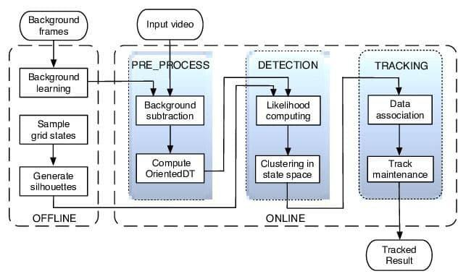

**EVENTS**

**Estimation Time:**

* Short Term Project

**Money:**

* Affordable price(Detailed Pricing is discussed)

**Resources:**

* A Bluetooth module chip, LED, Battery
* An environment-friendly material is needed to build the case of the device
* A minimal power-consuming light would be necessary
* We will use social media and online platforms for advertisements and sales

**RISK AND UNCERTAINTIES EXPECTED**

* Sometimes the possibility is there that the Bluetooth module is not working properly may be due to some connectivity problems or not in range network problems.
* External forces acting on the tracking device (eg. wear and tear of the device, excess pressure damaging the device and/or components inside it, etc.).
* Smartphone incompatibility with the tracker.
* Global chip shortage leading to steep rise in the price of components

**CONTINGENCY PLAN**

Resource Prioritization and Risks involved with the specified resources:

1. **Manufacturing**
   1. Risks involved:
      1. Manufacturers and workers quit/resign during product manufacturing.
   2. Contingency plan:
      1. New contracts shall be drafted to new manufacturing firms and new workers will be hired with revision in contract details to reduce above mentioned risk from occurring again.
2. **Technological issues**
   1. Risks involved:
      1. Bluetooth Module malfunction leading to loss of communication to smartphone.
   2. Contingency plan:
      1. A toll-free number is provided within the product package from which the customer can call and report the issue. If the issue cannot be resolved the customer can get the item for repair within 3 months of purchase (warranty period).

**PRIVACY MEASURES AND FACILITIES**

1. As our product - *TraxiT* connected to one’s phone via bluetooth(with encrypted communication technology), as it prevents third party apps from gaining access to the item’s location and data, also it gives the owners a sense of security and reassurance about the safety of their items.
2. Due to the popularity of the bluetooth module in recent times, it has newer security features that restrict access to third party software without the user’s consent.
3. Its design is made in a way that it will be convenient for everyone to use it not only for a limited number of things but for a variety like wallets, handbags, etc.
4. It also has space for an LED light in its design which will also make it visible from a distance, making things easy to find.
5. The Toll Free Number provided with the product will be very much of use to the customers in case of any technical problem in the product.

**WBS**

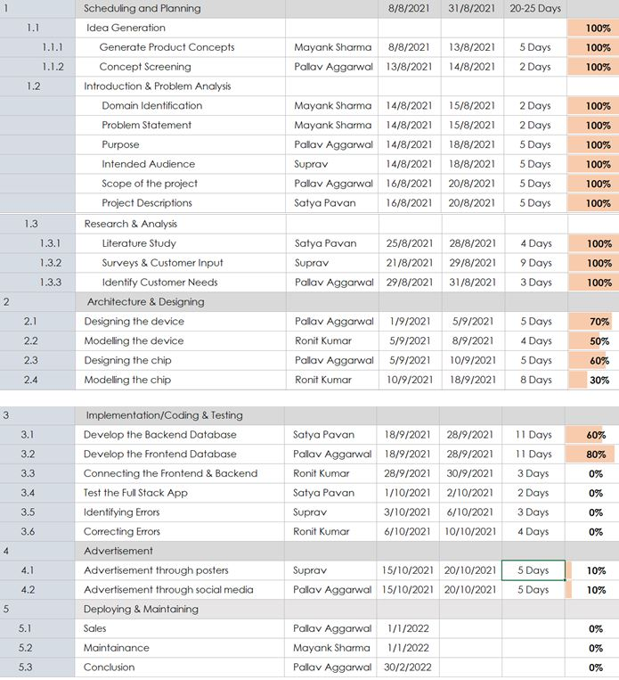

**The following link will take to the WBS:**

<https://docs.google.com/spreadsheets/d/1oyYs1723Nu-rffhd7qHbed79DFgri2ip/edit?usp=sharing&ouid=111170897356259846818&rtpof=true&sd=true>

**SKILLS GAINED**

In the duration of the gestation, planning and implementation of our project, there have been many successes, failures and challenges that we had to overcome, we have learned the following skills that can potentially help us create/improve upon future projects:

* Ability to analyse the market, identify trends in consumers, etc
  + This skill will help us in future projects to precisely identify the needs and requirements of the target audience.
* Networking, establishing connections with people in the business and getting insights from them on how to improve.
* Knowledge of starting up a new business and various allied qualities attached to it.

**CONCLUSION**

Due to the hectic and busy schedules in modern day homes, it gets very difficult to keep track of all the small; yet important items. It can become very irritating, if you don’t find the right things at the right place. Simple issues like; forgetting the key during the morning rush hour, or trying to frantically find your wallet/ purse while there’s a delivery right at your doorstep; can turn a happy day into a dull one pretty quickly. *Traxit*- A Tracking Device is used to track small items like wallets,keys,purses etc. It is a design that can be used as a keychain or a small stick-on inside your wallet/purse/handbag. This tracker would have a small chip that would be linked to your mobile via a mobile application. In case you forget your item, you can quickly open the application and search for the item. This would not only reduce the stress, but also keep you calm during a time like this. Since this device is small and can be used as a keychain, it would not feel awkward to carry.*The biggest thing guaranteed is the customer to be on the right track.*

**REFERENCES**

1. <https://chipolo.net/en/blogs/bluetooth-trackers-how-it-works>
2. <https://chipolo.net/en/blogs/difference-between-bluetooth-trackers-and-gps-trackers>
3. <https://electronics.howstuffworks.com/bluetooth-surveillance.htm>
4. <https://www.lucidchart.com/blog/how-to-create-a-work-breakdown-structure-and-why-you-should>
5. <https://www.tinkercad.com/things>
6. <https://www.investopedia.com/terms/m/marketing-strategy.asp>
7. <https://www.engagebay.com/blog/powerful-marketing-strategies/>
8. <https://www.entrepreneur.com/article/299335>
9. <https://www.businessmodelsinc.com/about-bmi/tools/business-model-canvas/>
10. <https://articles.bplans.com/estimating-realistic-start-up-costs/>
11. <https://www.nerdwallet.com/article/small-business/how-to-calculate-startup-costs-for-small-business>