
KLE TECHNOLOGICAL UNIVERSITY
Department of Bachelor Computer Applications
Team Memebers:
1. NIKHILKUMAR M.P – 01FE24ICA021
2. RAKESH ALAGAWADI – 01FE24ICA020
3. MRUTYUNJAY M – 01FE24ICA017
4. SHIVAPPA M – 01FE24ICA033

Theme:
Search and Ranking System.
GATE 0 – PROBLEM FORMULATION
Rental Property Search and Ranking System

A1. Problem Statement and Stakeholders

Problem statement
People searching for rental properties often depend on multiple websites, agents, social-media posts and informal contacts. Property details such as rent, deposit, location, number of rooms, amenities and availability may be incomplete or inconsistent. Users must compare listings manually, and search results may not appear in an order that reflects their needs. Duplicate, outdated or misleading listings can waste time and make it difficult to identify suitable properties. The proposed Rental Property Search and Ranking System provides structured property listings, filters and a ranking method so users can find and compare relevant rental properties more efficiently.

Stakeholders and how they are affected
Stakeholder | How they are affected by the problem
Property seeker / tenant | Spends time checking many sources; may miss suitable listings; cannot easily compare rent, deposit, amenities and location in one place.
Property owner / landlord | May receive unsuitable enquiries; listing information may be repeated or become outdated; availability is not always communicated clearly.
Platform administrator | Needs to manage users and listings, remove duplicates or invalid entries, and monitor the quality of property information.
Property agent / listing manager | May need to update the same property details repeatedly and respond to repeated questions about rent, location and availability.

Note: stakeholder impact in this table is based on the stated project problem. Confirm it through short interviews or a questionnaire with at least one property seeker and, where possible, one property owner or administrator before submission.

A2. AS-IS and TO-BE Workflow
The AS-IS workflow describes the current manual process and should be checked with a real property seeker. The TO-BE workflow describes the proposed search, filtering, ranking and comparison process.

AS-IS workflow (current manual process)
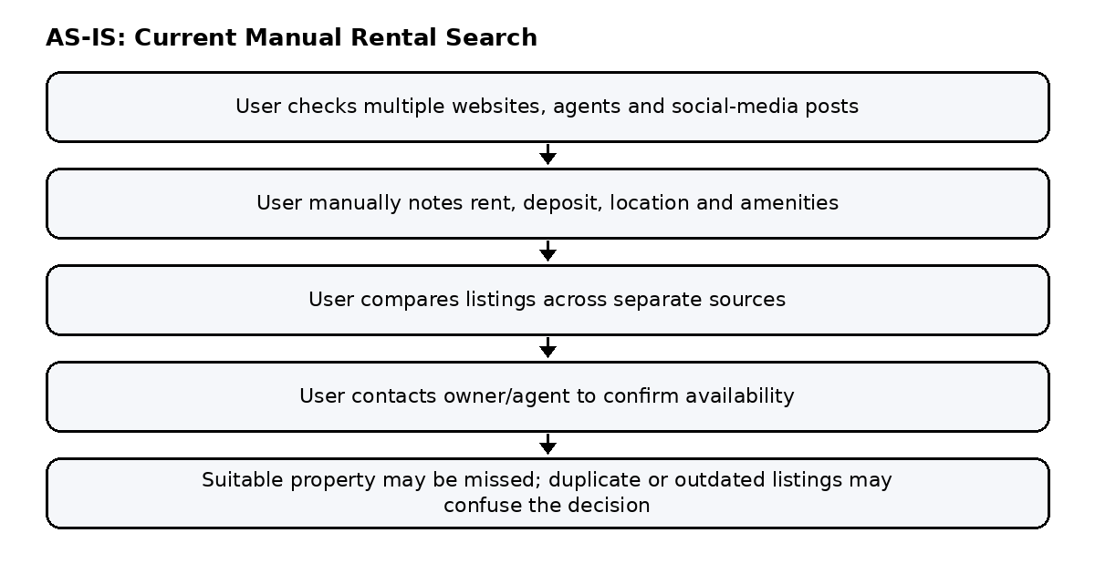
Figure A2-1: AS-IS workflow – manual rental property search

TO-BE workflow (proposed system)
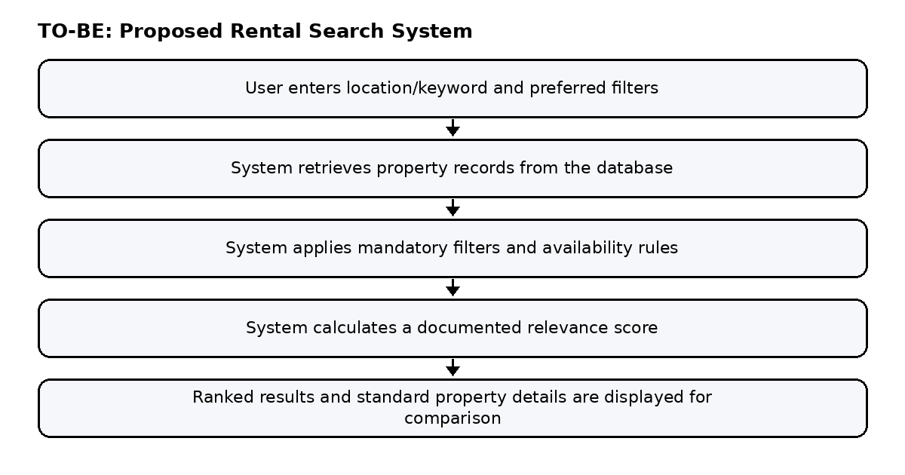
Figure A2-2: TO-BE workflow – Rental Property Search and Ranking System
Use Case Diagram:

What changes
Step | AS-IS (manual) | TO-BE (platform)
Search | Checks multiple websites, agents or social-media posts separately. | Searches a centralised set of property listings.
Filtering | Compares rent, location and facilities manually. | Applies selected filters such as rent range, location, type and bedrooms.
Ranking | Order may be arbitrary or based on the source website. | Displays matching listings using a documented relevance score.
Comparison | Opens several listings and compares details from memory or notes. | Shows standardised property details for easier comparison.
Listing quality | Duplicate or outdated listings may remain unnoticed. | Admin can review listings; availability and listing status are checked.

A3. Scope, Out-of-Scope, Feasibility and Risk

Scope
- User registration, login and user profile (if included in the approved synopsis).
- Property listing creation and management with rent, location, property type, bedrooms, deposit, amenities and availability.
- Property search by keyword and location, with filters such as rent range, property type, bedrooms and amenities.
- Ranking of matching listings using a documented relevance score based on the user's selected criteria.
- Property detail view and side-by-side comparison of key details; save or shortlist properties if included in the synopsis.
- Administrator functions to review listings, manage users and remove duplicate, invalid or outdated listings.

Out of scope
- Online rent payment, deposit payment or payment-gateway integration.
- Native mobile application, unless explicitly included in the approved synopsis.
- AI/ML-based personalised recommendations beyond the agreed ranking method.
- Live integration with external property portals or paid real-estate APIs.
- Legal verification, ownership certification or guarantee that every listing is genuine.

Feasibility
Dimension | Assessment
Technical | Feasible as a web application using the programming language, database and framework approved for the project. Search filters, sorting and CRUD operations are standard features.
Schedule | Feasible if developed in stages: authentication, property data, search and filters, ranking, comparison, then admin and testing.
Resources | Suitable for a BCA mini-project team with basic web-development and database skills; a standard student laptop is sufficient.
Data | Use a clearly labelled sample dataset of rental properties. Do not present sample listings as verified live listings.
Academic | Combines programming, database design, search logic, ranking, interface design, testing and documentation.

Risk note
Risk | Likelihood | Impact | Mitigation
Incomplete or inaccurate property data | High | High | Use required fields and validate entries; label sample data clearly.
Ranking gives unexpected results | Medium | High | Document the scoring formula, test sample searches and confirm the order with the project guide.
Duplicate or outdated listings | Medium | High | Use unique listing identifiers and provide an admin review/status process.
Scope creep into payments or live external APIs | Medium | Medium | Keep excluded features out of the first version; list them as future enhancements.
Team unfamiliar with search/indexing | Medium | Medium | Build a small prototype early and compare search results on a prepared dataset.

A4. Integration Map v1
This map shows which course areas the project draws on and where each appears in the system. The course areas below are proposed examples; replace them with the official course areas required by the current BCA semester before submission.
# | Course area (proposed) | Where it appears in the project | Key deliverable
1 | Programming and Problem Solving | Search/filter logic, validation, relevance-score calculation and ranking. | Working search and ranking functions
2 | Database Management Systems | Property, user and listing records; query filters; duplicate checks and indexes if used. | Database schema and data dictionary
3 | Web Technology / Full-Stack Development | Search page, property detail page, comparison interface and admin screens. | Working web application
4 | Software Engineering | Requirements, workflows, module design, testing and documentation. | Synopsis, diagrams and test cases
5 | Information Security / Computer Networks (confirm with syllabus) | Authentication, role-based access and safe handling of user/listing data. | Authentication and access-control design

Coverage check: Programming, DBMS, Web Technology and Software Engineering have concrete deliverables. Confirm the fifth course area against the official semester list.

B1. Governing Rule and Rule-Checked Records

Governing rule (one sentence)
A property should appear in the search results only when it matches the user's required filters, is marked available, and has a valid listing record; matching properties must be ordered using the ranking score defined by the team.

Record that currently gets decided wrongly
In the current manual process, the property listing and its relevance to the user's needs can be judged incorrectly. A user may overlook a suitable property because details are scattered across sources, filters are applied inconsistently, or listings are displayed without a clear ranking rule. An unavailable or duplicate listing may also be treated as a valid option. The proposed system checks listing fields and availability, applies the selected filters, and orders matching properties using a documented score.

Rule-Checked Records Register
The register below contains illustrative test records. Replace or expand them with actual sample property records once the project dataset is prepared.
Record ID | Rule checked | Expected decision | Manual process risk | Status
PROP-001 | Required filters | Show only properties matching the selected rent/location/type filters. | Suitable listings may be missed or unsuitable ones included. | Sample
PROP-002 | Availability | Exclude listings marked unavailable. | User may contact an owner for a property no longer available. | Sample
PROP-003 | Duplicate listing | Flag or avoid showing the same property more than once where detectable. | Duplicate posts distort result counts. | Sample
PROP-004 | Ranking score | Sort matching properties by the documented relevance score. | Results appear in an unexplained or inconsistent order. | Sample
PROP-005 | Required property details | Show rent, deposit, location and key attributes for each result. | User compares incomplete or misleading information. | Sample

Gate 0 Evidence Checklist
# | Evidence required | Where covered | Status
A1 | Problem statement with stakeholders named (who is affected, and how) | Section A1 | Drafted – confirm with stakeholders
A2 | AS-IS workflow and TO-BE workflow drawn | Section A2, Figures A2-1 and A2-2 | Text labels updated; verify/redraw diagrams for rental-property workflow
A3 | Scope and out-of-scope list; feasibility and risk note | Section A3 | Drafted
A4 | Integration Map v1 – course areas and project deliverables | Section A4 | Drafted – confirm official course areas
B1 | Governing rule in one sentence; record currently decided wrongly is named | Section B1 | Drafted

